**SURP**

**PaccMannRL: De novo generation of hit-like anticancer molecules from transcriptomic data via reinforcement learning is a research paper that proposes a novel AI-driven framework for designing potential anticancer drugs from scratch (de novo), guided by the gene expression profiles (transcriptomic data) of cancer cells. Here's a simplified breakdown of what the paper does and how it works:**

**PaccMann stands for “Predictive Assay-conditioned Chemical Manners.”** **framework combining deep learning models for molecular generation (SMILES‑VAE) and gene‑expression embedding (Profile‑VAE), then fine‑tuned with Reinforcement Learning (RL).**

**De novo=creating entirely new molecular structures** rather than modifying existing drugs. **explore uncharted regions** of chemical space (≈10³⁰–10⁶⁰ possible molecules) and discover **novel candidates** with desired properties.

**Transcriptome** = the complete set of **RNA transcripts** (gene‐expression levels) in a cell or tissue. Provides a **“molecular fingerprint”** of a tumor’s state—used here to **condition** the molecule generator so drugs are tailored to specific cancer profiles.

**Potency** in drug discovery refers to **how much of a compound is needed to produce a given biological effect**. Lower IC₅₀ → higher potency. **standardized way** to compare different compounds

**IC₅₀** is the concentration of a drug or compound required to inhibit a given biological process **by 50%**.

**A) Guided Walk Through Chemical Space**

1. **Unbiased Start:**
   * We begin with a “vanilla” molecule generator that knows only about general bioactive chemicals (no cancer info).
2. **Sampling & Screening:**
   * It spits out random compounds, which we immediately “test” in silico (on a computer) against the cancer cell’s gene‑expression profile.
3. **Feedback Loop:**
   * Each compound’s predicted potency (IC₅₀) becomes a **reward signal**.
   * The generator uses that reward to **steer itself**—slowly biasing sampling toward regions of chemical space rich in effective drugs.

**B–D) How Training Actually Works**

1. **Agent = Two VAEs Fused Together**
   * **Omics VAE (Profile VAE):**
     + Takes the tumor’s transcriptomic profile (gene‑expression data) and encodes it into a compressed “profile vector.”
   * **Molecule VAE (SMILES VAE):**
     + Knows how to decode a latent vector into a valid chemical structure (SMILES string).
2. **Generating a Candidate (see C)**
   * **Start** with the profile vector from the Omics VAE.
   * **(Optional) Prime it** by also encoding a known drug or functional group—this nudges the generator toward familiar scaffolds.
   * **Decode** through the Molecule VAE to get a new compound.
3. **Critic Scores the Compound (see D)**
   * We have a separate **predictive model** that takes:
     + The **new molecule**
     + The **same gene‑expression profile**
   * It outputs a **predicted IC₅₀** (how potent the drug would be).
4. **Reward & Reinforcement Learning**
   * The lower the predicted IC₅₀, the higher the reward.
   * The generator adjusts its internal weights (via policy gradients or actor‑critic methods) to **make high‑reward molecules more likely** next time.
   * Over many iterations, it “learns” to focus on **manifolds** (subspaces) of chemical space where potent, cancer‑targeting hits live.

Profile VAE

Trained on 10,000 bulk RNA seq from TCGA(cancer genome ATlast)

Architecture 1)Stacked dense (fully‑connected) layers.

2)Trained as a **denoising VAE** (add noise to inputs, force decoder to reconstruct) to boost robustness.Forces the model to learn **robust, generalizable features** of the data, rather than simply memorizing exact values.

Provides a **meaningful embedding** of a tumor’s transcriptome. When fused with the molecule VAE, this embedding “conditions” drug generation on the specific cancer profile.

|  |
| --- |
| SMILES VAE (SVAE) |

|  |
| --- |
| ~1.4 million bioactive compounds from **ChEMBL**  Architecture= Stack‑augmented GRU encoder/decoder    **96.2% valid** SMILES (vs. 95% in prior work)   * **99.7% unique** among 10 000 samples * **100% novel** (none in training set) * Tanimoto similarity mostly **0.2–0.6** to ChEMBL, showing **diverse novelty What it measures: For each generated molecule, you compute its Extended-Connectivity Fingerprint (ECFP) and compare it to fingerprints of ChEMBL molecules** |
| * The purpose of the SVAE was to learn the syntax of SMILES and general semantics about bioactive compound. |

Supplies a strong **chemical prior**—any latent point decoded is almost guaranteed to be a syntactically correct, drug‑like molecule. This ensures that RL fine‑tuning explores **chemically plausible** space.

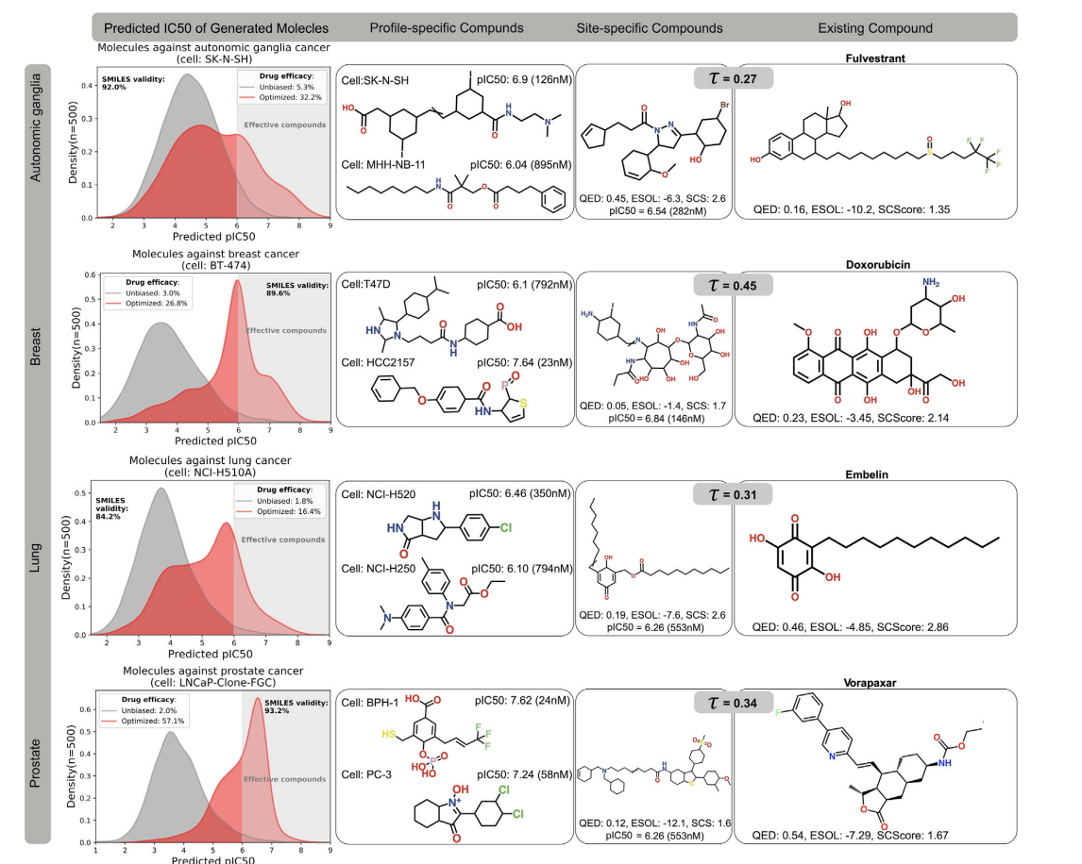

**🔴 LEFT COLUMN: Predicted IC50 of Generated Molecules**

* **IC50** is the concentration of drug needed to inhibit 50% of cancer cells (lower = better).
* **pIC50 = -log10(IC50)**: Higher pIC50 means more effective.

**What’s plotted:**

* **Grey curve** = baseline (unoptimized SVAE samples).
* **Red curve** = optimized model (after reinforcement learning).
* **Vertical line at pIC50 = 6** (corresponds to IC50 = 1μM): This is the threshold — compounds to the **right** are considered effective.

**🧪 MIDDLE COLUMNS: Molecules Generated**

**🔷 Profile-Specific Compounds (Middle Column 1)**

* These are compounds generated **for a specific cell line** within that cancer type.
* Shown with their **predicted pIC50**.

**🔶 Site-Specific Compounds (Middle Column 2)**

* Generated **for the general cancer type**, not tied to a specific cell line.
* Think of these as “average-profile” drugs for that cancer.

**💊 RIGHT COLUMN: Closest Real Drug (Tanimoto Similarity)**

* Shows a **known anticancer drug** from databases that is **structurally similar** to the generated molecule.
* **Tanimoto similarity (T)** is shown at the top (0 to 1 scale). Higher = more similar.

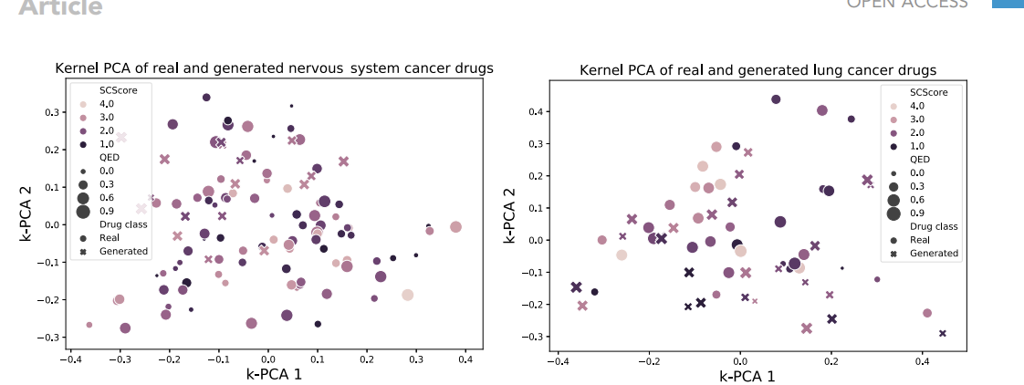

They used **kernel PCA** to show that **generated drugs "mix well"** with real drugs in chemical space.

This means the generator produces compounds that are **diverse**, **realistic**, and **similar in drug-likeness** to actual drugs.

Also shows **some real and generated drugs** are complex or not perfect on scores like:

* **QED (drug-likeness)** — range: 0 (worst) to 1 (best)
* **SCScore (synthetic difficulty)** — range: 1 (easiest) to 5 (hardest)

The second column presents candidate compounds with a high predicted efficacy against a particular cell line that was not seen during training. The third column showcases generated compounds that were optimized to be effective against all cell line profiles of the given cancer type in each row. In the fourth column, we present an existing anticancer compound (approved against at least one type of cancer) that was in the top-3 neighborhood of the generated compound in the third column. The existing and generated compounds are compared in terms of Tanimoto structural similarity between RDKit fingerprints as well as three chemical scores crucial in drug design, namely druglikeness (QED, 0 worst, 1 best), synthetic complexity (SCS or SCScore, 1 best, 5 worst), and solubility (ESOL, given in M/L