Dynamic Graph Neural Network-Assisted Fault Diagnosis for Satellite Electrical Power Systems
Author Name
Dept. of Computer Science and Engineering
CMR Institute of Technology
Bengaluru, India
author.email@cmrit.ac.in
Abstract—Electrical Power Systems (EPS) are critical satellite subsystems, and undetected faults in solar arrays, batteries, or voltage regulators can directly compromise mission success. Existing Graph Neural Network (GNN)-based fault diagnosis methods model subsystem interactions using a fixed adjacency matrix, but this static topology cannot capture how component importance shifts as a satellite moves between eclipse and sunlit orbital phases. To address this limitation, we propose a Dynamic Graph Neural Network (Dynamic-GNN) that learns a time-varying adjacency matrix A(t) directly from telemetry at every timestep, rather than assuming a fixed power-flow topology. The EPS is modeled as a 5-node graph (solar array, battery, regulator, bus, load), combining a learned graph-attention scorer with GCN and GAT layers and a GRU for temporal fusion, trained on 1,500 physics-simulated orbital telemetry samples across five fault classes. Unlike static-graph approaches, the proposed model adaptively reweights inter-component dependencies as orbital conditions change, resolving fault signatures that fixed-topology and non-graph baselines confuse with nominal operation. The proposed Dynamic-GNN achieves 97.3% accuracy, 97.4% F1-score, and a 0.996 AUC-ROC on held-out test data, outperforming a static-graph GNN baseline (81.3%), LSTM (82.7%), and CNN (76.0%).
Keywords—Satellite Electrical Power System (EPS), Fault Diagnosis, Graph Neural Network (GNN), Dynamic Graph Learning, Graph Attention Network (GAT)

I. Introduction
Electrical Power Systems (EPS) are the subsystem responsible for generating, storing, regulating, and distributing power aboard a satellite, and every other subsystem—from attitude control to payload instruments—depends on a stable, well-diagnosed EPS to function. An EPS typically comprises a solar array (SA) for power generation, a battery (BAT) for energy storage during eclipse, a power conditioning unit (PCU) for voltage regulation and charge/discharge management, a power distribution bus (BUS), and the aggregate spacecraft load (LOAD). Because ground engineers cannot physically inspect a satellite in orbit, fault diagnosis for the EPS must be performed entirely from downlinked telemetry, making automated, telemetry-based fault diagnosis a critical capability for mission safety and longevity.
Recent work has applied Graph Neural Networks (GNNs) to fault diagnosis by representing a system's components as graph nodes and their physical or data-flow relationships as edges, allowing message passing to capture inter-component dependencies that traditional convolutional or recurrent models cannot [1], [2], [3]. In particular, [1] models the satellite Attitude Control System (ACS) as a graph over its sensors, gyroscopes, reaction wheels, and actuators, using a Graph Convolutional Network (GCN) and Graph Attention Network (GAT) to achieve 93.4% fault classification accuracy across three fault types. However, this and other GNN-based fault diagnosis approaches [4], [5], [6] construct the graph adjacency matrix once, either from a known physical topology or from a fixed correlation structure, and hold it constant for the entire diagnosis process. This static-topology assumption cannot represent how the relative importance of components changes with operating conditions—for example, a satellite's EPS depends almost entirely on the battery during eclipse and almost entirely on the solar array in sunlight, a shift a fixed adjacency matrix has no mechanism to express.
This paper addresses this limitation for satellite EPS fault diagnosis. Specifically, this work aims to (i) construct a physically grounded simulation of a satellite EPS capable of generating labeled multivariate telemetry under both nominal and faulty operation, (ii) design a GNN-based diagnosis model whose graph structure is not fixed but learned from the telemetry itself at every timestep, and (iii) quantitatively establish, under identical training conditions, whether such a dynamic graph improves diagnostic accuracy over a fixed-topology GNN and over non-graph deep learning baselines. The novelty of the proposed Dynamic Graph Neural Network (Dynamic-GNN) lies in replacing the fixed adjacency matrix used by prior GNN-based fault diagnosis methods [1], [4], [6] with a dynamic adjacency matrix A(t), computed at every timestep from a small learned attention scorer over the current node embeddings, and propagated through a GCN and GAT before temporal fusion with a Gated Recurrent Unit (GRU). Unlike prior dynamic-graph work applied to time-series forecasting or industrial process monitoring [11], [12], [13], the proposed model is, to the best of our knowledge, the first to apply timestep-wise dynamic graph construction specifically to satellite EPS fault diagnosis, directly addressing a limitation the closest prior satellite-domain work explicitly leaves as future work.
The remainder of this paper is organized as follows. Section II reviews related work in GNN-based fault diagnosis and dynamic graph learning. Section III details the proposed EPS simulation, dataset, and Dynamic-GNN architecture. Section IV describes the experimental setup. Section V presents classification, interpretability, and robustness results compared against three baselines. Section VI concludes the paper and outlines future work.

II. Related Works
Satellite telemetry anomaly detection has been studied using both non-graph and graph-based deep learning. Xu et al. [4] combine ensemble empirical mode decomposition with a grey-wolf-optimized support vector machine to detect anomalies in real satellite telemetry without requiring a graph representation of the subsystem. Zhao et al. [5] instead employ a Seasonal Decomposition Cross Attention Transformer to capture temporal dependencies in non-stationary GEO satellite telemetry, achieving early warning up to four months in advance, though their architecture likewise treats telemetry channels as an undifferentiated sequence rather than a graph. Xie et al. [2] were among the first to apply a GNN, together with a dynamic thresholding scheme, to satellite power-system telemetry, reporting over 98% detection accuracy; their spatial dependency extraction module, however, relies on a graph constructed once from feature correlations and held fixed thereafter. Yu et al. [3] extend this direction with MAG, which combines a maximum-information-coefficient attention graph with LSTM-based temporal feature extraction for spacecraft telemetry, but similarly do not revisit the graph structure once trained.
Beyond the satellite domain, GNNs have been applied to fault diagnosis in terrestrial power and industrial systems. Nguyen et al. [6] propose spatial-temporal recurrent GNNs for fault event detection, type classification, and location in power distribution systems, validated on a microgrid and the IEEE 123-node system; their graph is derived from the fixed physical wiring of the distribution network. Wang et al. [7] and Liu et al. [9] both address a different limitation of GNN-based fault diagnosis—that attention-based GNNs can learn to exploit non-causal shortcut features that happen to correlate with labels in the training set—by introducing causal-trivial attention and causal-intervention frameworks, respectively, for complex industrial processes; these works improve robustness of what the GNN attends to, but the underlying graph topology in both remains fixed once constructed. Li et al. [8] apply a spatial-temporal difference GCN, informed by a UAV's dynamic model as prior knowledge, to sensor fault diagnosis, reporting up to 98.7% accuracy across three self-constructed datasets; their association graph is likewise fixed by the prior-knowledge construction step rather than updated per timestep.
Chen et al. [10] survey GNN-based fault diagnosis broadly and explicitly identify association-graph construction—via k-nearest-neighbor similarity, prior physical knowledge, or matrix completion—as a distinct design axis, but note that essentially all reviewed methods construct this graph once rather than adapting it over time or operating condition.
Separately from fault diagnosis, dynamic graph neural networks have emerged as their own subfield. Zheng et al. [11] and Feng et al. [12] both survey dynamic GNNs broadly, covering models that integrate sequence learning with graph representations to capture evolving node and edge relationships, and both identify time-varying adjacency estimation as a key open research direction. Within time-series analysis specifically, Zheng et al. [13] propose CST-GL, which learns pairwise variable correlations via a dedicated correlation-learning module rather than assuming them fixed, for multivariate anomaly detection on industrial control system datasets; Jin et al. [14] propose MTGODE, which models multivariate time series as dynamic graphs with time-evolving node features and unknown structure, solved via a neural ordinary differential equation; and Pozdnyakov et al. [15] evaluate five different methods for learning trainable adjacency matrices for fault diagnosis on multivariate sensor data from the Tennessee Eastman Process, reporting that learned structures outperform fixed ones. Jin et al. [16] provide a comprehensive task-oriented survey of GNNs for time series across forecasting, classification, imputation, and anomaly detection, further confirming the breadth of interest in coupling graph structure learning with temporal modeling. None of [11]-[16], however, target fault diagnosis in a satellite subsystem, and several ([13], [14]) learn a graph structure once per dataset or per short window rather than recomputing it at every timestep of a single episode as the operating regime (e.g., eclipse versus sunlit) changes within that episode.
Graph neural networks, and hybrid graph-recurrent architectures more specifically, have also proven effective outside fault diagnosis: Changala et al. [17] combine a GNN with an LSTM for early stock-market crash prediction, and Gopalapillai and Prabhu [19] apply GNNs to model COVID-19 pandemic spread, both illustrating that graph-plus-recurrent hybrids of the kind proposed here generalize across otherwise unrelated multivariate time-series domains. Fault detection in power systems has also been addressed with non-graph deep learning: Kumar et al. [18] use an ensemble-optimized LSTM with Hilbert-Huang-transform features to detect high-resistance faults in a DC microgrid, illustrating that recurrent architectures remain a strong non-graph baseline against which graph-based methods should be compared, a comparison this paper makes directly in Section V.
In summary, prior GNN-based fault diagnosis work—including the satellite ACS baseline this paper adapts [1]—constructs its graph once and holds it fixed, while prior dynamic-graph work targets forecasting or terrestrial industrial monitoring rather than satellite subsystem fault diagnosis. This paper combines both directions: it applies timestep-wise dynamic graph construction, in the style of [13]-[15], specifically to satellite EPS fault diagnosis, and evaluates it against a same-architecture fixed-graph ablation (reproducing the design principle of [1] and [6] adapted to the EPS) as well as non-graph CNN and LSTM baselines, isolating the specific contribution of dynamic graph structure rather than of GNNs in general.

III. Proposed Methodology
The proposed system simulates a satellite EPS using physically grounded governing equations, injects one of four fault types (or none) at a random point in a simulated orbit, and trains a Dynamic Graph Neural Network to classify the resulting telemetry into one of five classes. Unlike the fixed-topology graph used in prior GNN-based fault diagnosis [1], [6], the proposed model recomputes its adjacency matrix at every timestep from the current node telemetry via a learned attention scorer, before propagating this dynamic graph through GCN and GAT layers and fusing the resulting sequence with a GRU. Fig. 1 shows the overall architecture, organized into four modules: (A) EPS simulation and dataset, (B) dynamic graph construction, (C) the classification architecture, and (D) training and optimization.
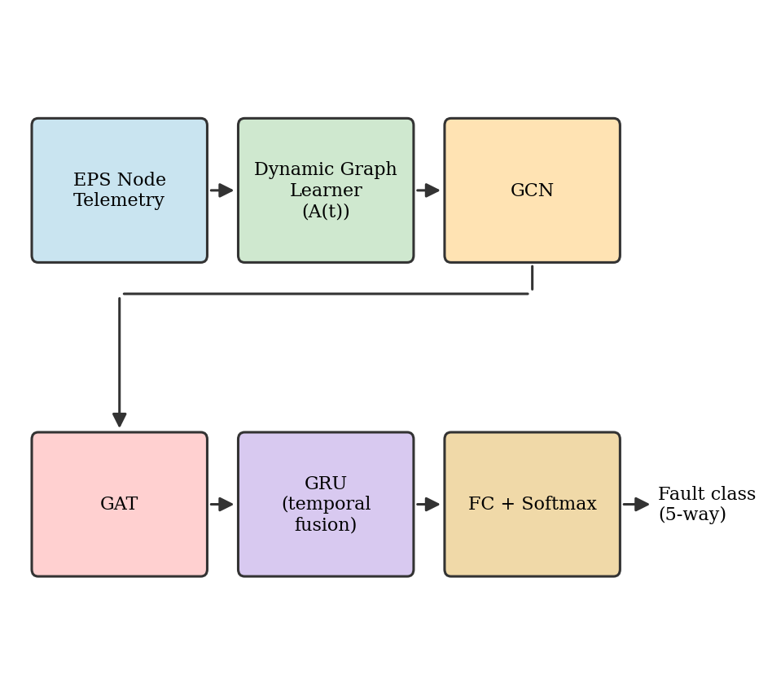
- Fig. 1. Proposed Dynamic-GNN architecture.

A. EPS Simulation and Dataset
The satellite EPS is modeled as a directed graph G = (V, E) with five nodes V = {SA, BAT, PCU, BUS, LOAD} representing the solar array, battery, power conditioning unit, distribution bus, and aggregate load, connected by the physical power-flow edges SA→PCU, PCU→BAT (charge), BAT→PCU (discharge), PCU→BUS, BUS→LOAD, and a BUS→PCU voltage-regulation feedback edge, shown in Fig. 2. This fixed topology is used only by the static-graph baseline (Section IV); the proposed model learns its own graph and does not use Fig. 2 as an input.
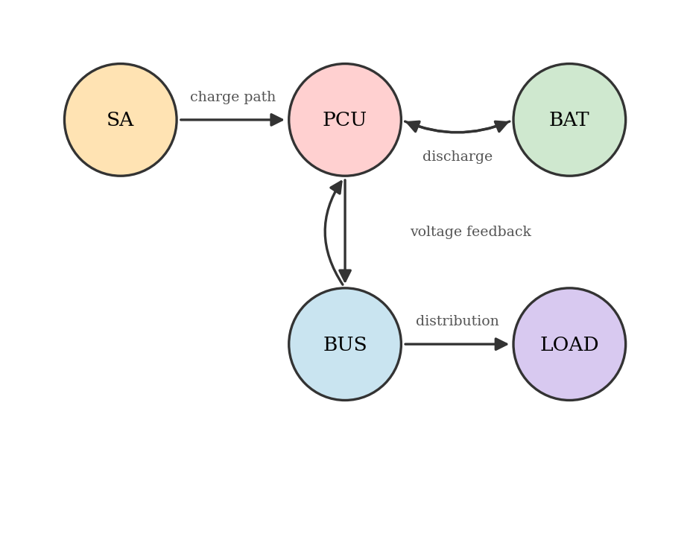
- Fig. 2. Fixed EPS power-flow topology used by the static-graph baseline.
Solar array output power follows
P_sa = P_max · cos(θ) · (1 − k_d t), zeroed during eclipse (1)
where P_max is the beginning-of-life rated power, θ is the sun-incidence angle, and k_d is a slow panel-degradation rate. Battery state of charge evolves as
dSOC/dt = (P_charge,eff − P_discharge − P_extra) / E_bat − k_sd·SOC (2)
where E_bat is the battery's energy capacity, P_charge,eff and P_discharge are the effective charge and discharge power respectively, P_extra is a fault-injected extra drain (zero under nominal operation), and k_sd is a self-discharge rate. Bus voltage is regulated as
V_bus = V_nom − k·(P_load − P_source), clipped to regulator limits (3)
where k is a droop gain and the mismatch between commanded load and available source power determines the deviation from the nominal setpoint V_nom. At every timestep, the source/battery power split is solved so that the physical power-balance constraint
P_sa + P_bat,out = P_bus,load + P_losses (4)
holds, with any solar power in excess of load and charge needs dumped by a shunt regulator, consistent with standard EPS design practice.
One simulated episode covers one full low-Earth orbit (5760 s), sampled every 24 s into 240 timesteps, guaranteeing every episode contains a complete eclipse-to-sunlit transition. Four fault types are injected, each at a random onset and duration within the episode: sa_degradation (a step or gradual drop in P_max and/or incidence response), battery_over_discharge (an unexplained extra drain P_extra and/or reduced charge efficiency), pcu_regulator_fault (an artificial offset injected into V_bus independent of the source/load balance), and bus_distribution_fault (erratic/dropout current between BUS and LOAD unexplained by commanded load). A fifth class, nominal, injects no fault. 1,500 episodes were simulated, 300 per class, and split stratified 70:20:10 into training (1,050), validation (300), and test (150) sets.

B. Dynamic Graph Construction
At every timestep t, node features x_t ∈ R^(N×F) (N=5 nodes, F=5 features: voltage, current, power, temperature, state-of-charge) are encoded by a two-layer MLP into embeddings h_t = MLP(x_t) ∈ R^(N×D). A dynamic adjacency A(t) is then computed via scaled dot-product scoring over these embeddings
A_soft(t) = softmax( h_t h_tᵀ / √D ) (5)
with the diagonal excluded so that a node cannot attend to itself at this stage; a self-loop is reintroduced during graph propagation. A_soft(t) is a dense, continuous, row-normalized adjacency used directly by the GCN layer. For the GAT layer, A_soft(t) is additionally sparsified by keeping, for each destination node, only its top-3 highest-weighted source nodes plus a self-loop, producing a binary mask M(t) that restricts attention to the learned dynamic neighborhood while keeping the graph interpretable.

C. Dynamic-GNN Classification Architecture
Structural propagation is performed by a GCN layer
H_gcn = W_gcn ( D(t)⁻¹ (A_soft(t) + I) x_t ) (6)
where D(t) is the corresponding degree diagonal matrix and W_gcn is a learned weight matrix. The GAT layer then computes multi-head attention restricted to M(t)
α_ij = softmax_j( LeakyReLU( a_dstᵀh_i + a_srcᵀh_j ) ), j ∈ N_M(t)(i) (7)
and aggregates h_i' = Σ_j α_ij W_gat h_j, concatenated across 2 attention heads. The resulting per-node embeddings are mean-pooled over the 5 nodes to obtain one 32-dimensional graph-level embedding per timestep, and the resulting sequence of 240 embeddings is processed by a single-layer GRU with 80 hidden units, whose final hidden state is passed through a dropout layer and a fully connected softmax classifier
ŷ = softmax(W_c h_T + b_c) (8)
producing a probability distribution over the five fault classes.

D. Training and Optimization
All models are trained with the Adam optimizer (learning rate 0.001, weight decay 1e-4) to minimize the categorical cross-entropy loss
L = − Σ_i y_i log(ŷ_i) (9)
for up to 60 epochs with early stopping (patience 10) on validation loss. For the noise/dropout-augmented variant (Section V-E), each training batch has a 70% probability of having Gaussian noise (level ~ U(0, 0.5) × per-channel standard deviation) and/or dropout (probability ~ U(0, 0.3), replacing a reading with its channel mean) applied before the forward pass, so the model is exposed to corrupted telemetry during training rather than only at test time.

IV. Experimental Setup
All experiments were implemented in Python using PyTorch and dense graph layers modeled after PyTorch Geometric's API, and executed on an Apple Silicon GPU (MPS backend). Four models were trained and compared under identical conditions—the same 70:20:10 data split, the same Adam optimizer settings, and a matched parameter budget of approximately 18,000–32,000 trainable parameters—so that differences in performance can be attributed to architectural choices rather than to training budget or capacity. The CNN baseline applies three 1-D convolutional layers (32, 32, 64 channels) over the five nodes' features flattened into 25 input channels. The LSTM baseline applies a single-layer LSTM (48 hidden units) over the same flattened input. The static-graph GNN baseline uses the identical GCN-GAT-GRU-classifier pipeline as the proposed model, but with the fixed topology of Fig. 2 substituted for the learned A(t), reproducing the fixed-adjacency design principle of the ACS baseline [1] and of [6] adapted to the EPS domain. The proposed Dynamic-GNN uses the architecture described in Section III. All four models were additionally retrained with the noise/dropout augmentation described in Section III-D to evaluate robustness (Section V-E).

V. Results and Discussion

A. Dataset
The generated dataset comprises 1,500 labeled episodes, exactly balanced at 300 per class across five fault categories, split stratified 70:20:10 (1,050/300/150). Unlike the three-class, no-nominal-class benchmark of the ACS baseline [1], the inclusion of a nominal class makes the present benchmark harder, since nominal operation and battery_over_discharge differ only in a slow, subtle state-of-charge trend rather than an obvious signature. Sanity checks confirmed zero NaN/Inf values across all generated episodes and confirmed the physical power-balance constraint (4) holds to within a small residual (43–45 W mean, driven by an intentional one-step-lagged loss estimate) under nominal conditions, while the bus_distribution_fault class shows a substantially larger residual (105 W mean, 884 W maximum), consistent with that fault's definition as current draw unexplained by the power balance.

B. Performance Metrics
Accuracy: the proportion of test episodes classified correctly, computed as
A = (TP+TN) / (TP+TN+FP+FN) (10)
Precision: of the episodes predicted as a given fault class, the fraction that were actually that class, computed as
P = TP / (TP+FP) (11)
High precision matters for on-orbit fault diagnosis because a false fault alarm can trigger unnecessary and costly safe-mode transitions.
Recall: of the actual episodes of a given fault class, the fraction correctly identified, computed as
R = TP / (TP+FN) (12)
Low recall is arguably the more dangerous failure mode operationally, since a missed EPS fault can propagate to loss of the spacecraft.
F1-score: the harmonic mean of precision and recall, computed as
F1 = 2PR / (P+R) (13)
AUC-ROC: the macro-averaged, one-vs-rest area under the receiver operating characteristic curve, summarizing how well-separated each model's confidence scores are between correct and incorrect classes across all decision thresholds, with 0.5 indicating random guessing and 1.0 indicating perfect separation.
Log Loss: the categorical cross-entropy of the predicted class probabilities against the true labels, computed as (9); lower log loss indicates better-calibrated confidence, which matters because a downstream ground-operations decision may weight a diagnosis by its reported confidence rather than treating all positive predictions equally.

C. Comparative Results
- Table I. Performance Comparison of All Four Models on the Held-Out Test Set
Model | Acc.  (%) | Prec.  (%) | Recall  (%) | F1  (%) | AUC-  ROC | Log  Loss
CNN | 76.0 | 75.6 | 76.0 | 74.7 | 0.943 | 0.343
LSTM | 82.7 | 84.3 | 82.7 | 83.1 | 0.951 | 0.432
Static-GNN | 81.3 | 82.1 | 81.3 | 81.3 | 0.960 | 0.324
Dynamic-GNN  (proposed) | 97.3 | 97.7 | 97.3 | 97.4 | 0.996 | 0.118
Table I summarizes performance on the 150-episode held-out test set. The proposed Dynamic-GNN outperforms all baselines across every metric, achieving 97.3% accuracy—15.9–21.3 percentage points higher than the non-graph CNN and LSTM baselines and 16.0 points higher than the same-architecture static-graph baseline—along with the lowest log loss (0.118), indicating both the most accurate and the best-calibrated predictions. Because the static-graph baseline shares an identical GCN-GAT-GRU-classifier pipeline and a comparable parameter count (29,109 vs. 30,357) with the proposed model, differing only in whether the adjacency matrix is fixed or learned per timestep, this margin isolates the contribution of dynamic graph construction specifically, rather than of graph neural networks in general.
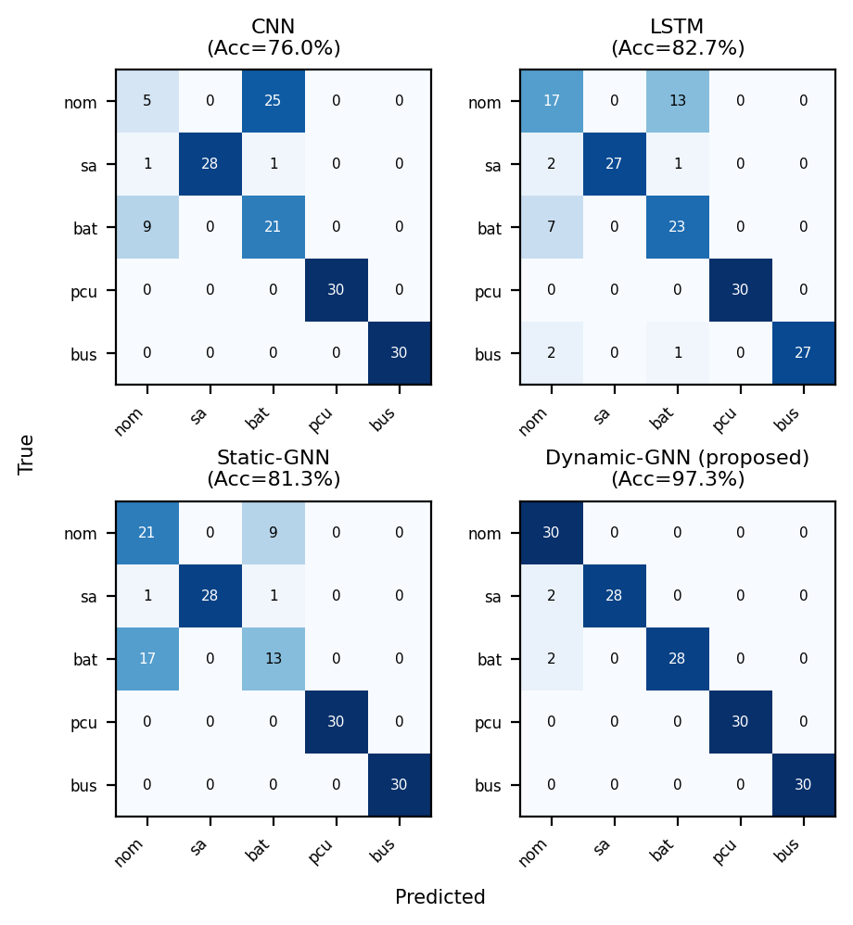
- Fig. 3. Confusion matrices for all four models (test set).
Fig. 3 shows the confusion matrices for all four models. All models classify pcu_regulator_fault and bus_distribution_fault perfectly (100%), since both faults produce sharp, unambiguous telemetry signatures (bus voltage railing near its regulator limit, and erratic bus current, respectively). The dominant source of error for the three non-dynamic models is confusion between nominal and battery_over_discharge—CNN misclassifies 25 of 30 nominal test episodes as battery_over_discharge, and the static-graph baseline confuses 9 of 30 nominal and 17 of 30 battery_over_discharge episodes—since both classes differ only in a slow state-of-charge trend. The Dynamic-GNN reduces this specific confusion to 2 of 30 episodes in each direction, accounting for the majority of its overall accuracy advantage.

D. Interpretability Analysis
To verify that the Dynamic-GNN's accuracy gain reflects physically meaningful learned structure rather than a black-box artifact, GAT attention weights were analyzed per fault class and the learned adjacency A(t) was visualized across an eclipse-to-sunlit transition.
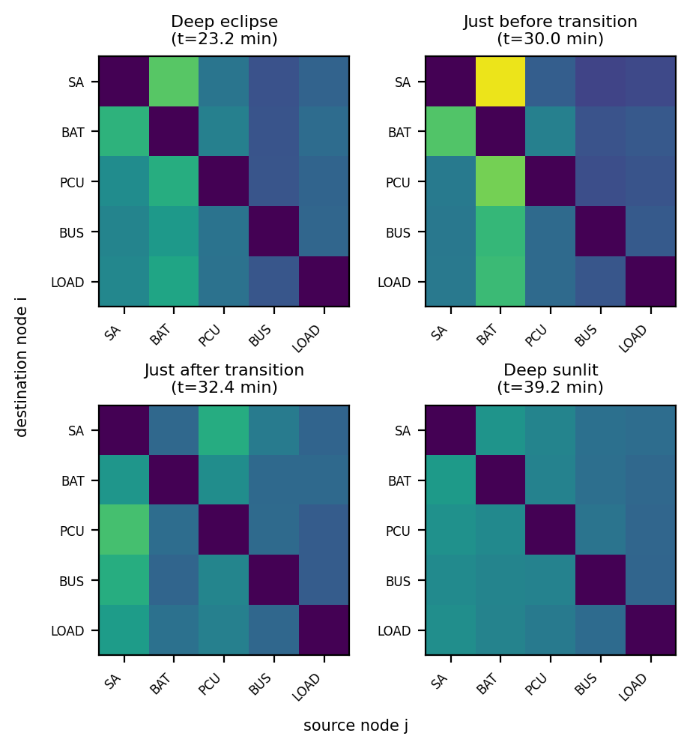
- Fig. 4. Learned adjacency A(t) at four points across an eclipse→sunlit transition.
Fig. 4 shows A(t) at four points spanning one such transition: during eclipse, the battery is the dominant source column—every other node's updated representation depends most heavily on BAT, consistent with the battery being the only active power source in shadow—while within approximately three timesteps (~1.2 minutes) of the transition to sunlight, the dominant source column flips to SA, tracking the physical handoff of power generation from battery to solar array.
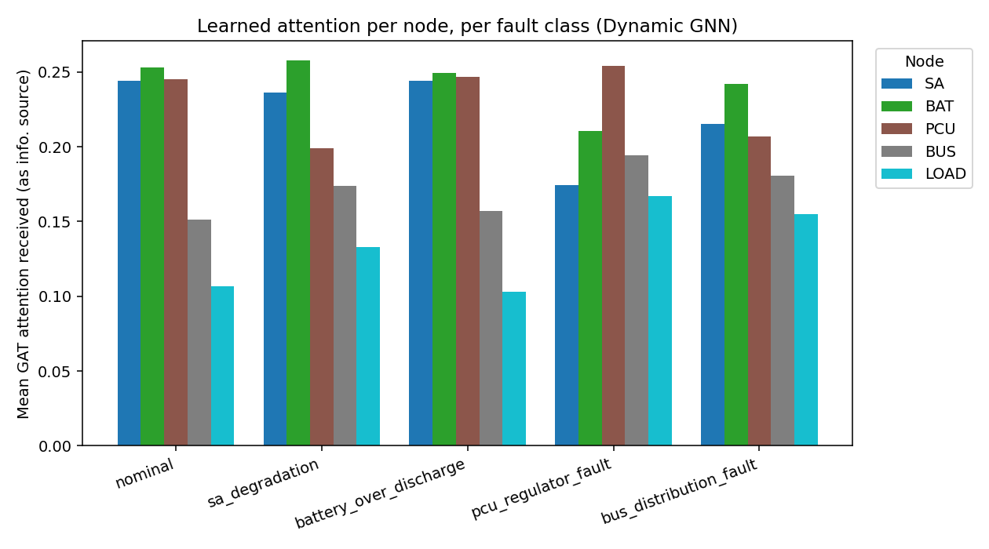
- Fig. 5. Mean GAT attention received per node, per fault class.
Fig. 5 shows mean GAT attention received per node, averaged per fault class; while SA, BAT, and PCU receive comparable attention for nominal, sa_degradation, and battery_over_discharge episodes, the pcu_regulator_fault class shows a distinct shift, with PCU rising to the most-attended node (0.254) while SA's share drops to its lowest value across all classes (0.174), consistent with a regulator fault decoupling bus behavior from the solar array's actual output.

E. Robustness Under Corrupted Telemetry
Following [1]'s claim of robustness to noisy and partially missing data, all four clean-trained models were stress-tested by corrupting the test set with additive Gaussian sensor noise (0 to 1.0× the per-channel training standard deviation) and with randomly dropped readings (0% to 50%, replaced with the channel mean), without retraining. The Dynamic-GNN's advantage held or grew through moderate corruption (+11.1 points over LSTM at 0.3× noise) but collapsed sharply beyond a threshold, falling to 37.8% accuracy at 1.0× noise, 38.7 points below the LSTM baseline at the same corruption level—likely because the learned adjacency A(t) is itself computed from the same corrupted node features, so heavy corruption degrades both the classification and the graph structure it relies on simultaneously.
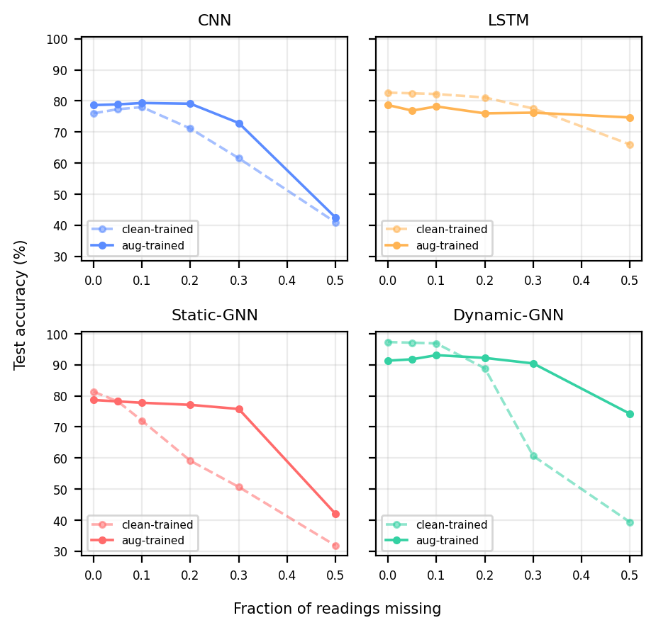
- Fig. 6. Effect of noise/dropout-augmented training on missing-data robustness (dashed = clean-trained, solid = augmented-trained).
Retraining all four models with noise/dropout augmentation during training (Section III-D) substantially closed this gap: the Dynamic-GNN's accuracy at 50% missing data rose from 39.3% to 74.2% (+34.9 points), shown in Fig. 6, at a cost of 6.0 accuracy points on clean data (97.3% to 91.3%). This confirms that the dynamic graph's clean-data advantage is real but was, before augmentation, coupled to a genuine robustness weakness that a static or non-graph model does not share to the same degree—an honest limitation this paper reports directly rather than omitting.

VI. Conclusion and Future Work
This paper presented a Dynamic Graph Neural Network for satellite EPS fault diagnosis, in which the adjacency matrix is learned from telemetry at every timestep rather than held fixed, addressing a limitation explicitly left as future work by the closest prior satellite-domain baseline [1]. Trained and evaluated on a physically simulated dataset of 1,500 episodes across five balanced fault classes, the proposed model achieved 97.3% accuracy, 97.4% F1-score, and a 0.996 AUC-ROC, outperforming a same-architecture static-graph baseline (81.3% accuracy) and non-graph CNN (76.0%) and LSTM (82.7%) baselines under identical training conditions and comparable parameter budgets. Interpretability analysis confirmed the learned graph tracks real physical state—the dominant power-source column in A(t) shifts from battery to solar array within minutes of the eclipse-to-sunlit transition—and that attention shifts toward the PCU node specifically under regulator faults.
A robustness stress test, motivated by a robustness claim in prior work, revealed that the dynamic model's advantage collapses under heavy sensor corruption because its graph structure depends on the same corrupted inputs it classifies; noise/dropout-augmented training was shown to substantially, though not completely, close this gap. Future work includes multi-seed statistical validation, ablation studies isolating the contribution of the top-k sparsification and attention-scorer design choices, fault localization in time using the per-timestep labels already collected, and validation against real spacecraft telemetry to assess the sim-to-real gap left unaddressed by the present simulation-only evaluation.

References
- [1] Z. Wu, K. Zou, Y. Liu, and L. Zhu, "Graph Neural Network-Assisted Fault Diagnosis for Satellite Attitude Control Systems," in Proc. 2025 5th Int. Conf. Electronic Information Engineering and Computer Technology (EIECT), 2025, pp. 580–583.
- [2] L. Xie, D. Pi, X. Zhang, J. Chen, Y. Luo, and W. Yu, "Graph neural network approach for anomaly detection," Measurement, vol. 180, p. 109546, 2021.
- [3] B. Yu, Y. Yu, J. Xu, G. Xiang, and Z. Yang, "MAG: A Novel Approach for Effective Anomaly Detection in Spacecraft Telemetry Data," IEEE Trans. Ind. Informat., vol. 20, no. 3, pp. 3891–3899, 2024.
- [4] Z. Xu, Z. Cheng, and B. Guo, "A hybrid data-driven framework for satellite telemetry data anomaly detection," Acta Astronautica, vol. 205, pp. 281–294, 2023.
- [5] H. Zhao et al., "Satellite Early Anomaly Detection Using an Advanced Transformer Architecture for Non-Stationary Telemetry," IEEE Trans. Consum. Electron., vol. 70, no. 1, 2024.
- [6] B. L. H. Nguyen, T. V. Vu, T.-T. Nguyen, M. Panwar, and R. Hovsapian, "Spatial-Temporal Recurrent Graph Neural Networks for Fault Diagnostics in Power Distribution Systems," IEEE Access, vol. 11, pp. 46521–46536, 2023.
- [7] H. Wang, R. Liu, S. X. Ding, et al., "Causal-Trivial Attention Graph Neural Network for Fault Diagnosis of Complex Industrial Processes," IEEE Trans. Ind. Informat., vol. 20, no. 2, pp. 1489–1498, 2024.
- [8] H. Li, C. Chen, T. Wan, S. Sun, Y. Li, and Z. Deng, "Advancing UAV Sensor Fault Diagnosis Based on Prior Knowledge and Graph Convolutional Network," Machines, vol. 12, no. 10, p. 716, 2024.
- [9] R. Liu, Q. Zhang, D. Lin, W. Zhang, and S. X. Ding, "Causal intervention graph neural network for fault diagnosis of complex industrial processes," Reliability Eng. Syst. Saf., vol. 251, p. 110328, 2024.
- [10] Z. Chen, J. Xu, C. Alippi, S. X. Ding, Y. Shardt, T. Peng, and C. Yang, "Graph neural network-based fault diagnosis: a review," arXiv:2111.08185, 2021.
- [11] Y. Zheng, L. Yi, and Z. Wei, "A survey of dynamic graph neural networks," Frontiers Comput. Sci., vol. 19, no. 6, p. 196323, 2025.
- [12] Z. Feng, R. Wang, T. Wang, M. Song, S. Wu, and S. He, "A Comprehensive Survey of Dynamic Graph Neural Networks: Models, Frameworks, Benchmarks, Experiments and Challenges," arXiv:2405.00476, 2024.
- [13] Y. Zheng, H. Y. Koh, M. Jin, L. Chi, K. T. Phan, S. Pan, Y.-P. P. Chen, and W. Xiang, "Correlation-Aware Spatial-Temporal Graph Learning for Multivariate Time-Series Anomaly Detection," IEEE Trans. Neural Netw. Learn. Syst., 2023.
- [14] M. Jin, Y. Zheng, Y.-F. Li, S. Chen, B. Yang, and S. Pan, "Multivariate Time Series Forecasting With Dynamic Graph Neural ODEs," IEEE Trans. Knowl. Data Eng., vol. 35, no. 9, pp. 9168–9180, 2023.
- [15] V. Pozdnyakov, I. Makarov, and A. Kovalenko, "Graph Neural Networks With Trainable Adjacency Matrices for Fault Diagnosis on Multivariate Sensor Data," IEEE Access, vol. 12, pp. 152860–152872, 2024.
- [16] M. Jin, H. Y. Koh, Q. Wen, D. Zambon, C. Alippi, G. I. Webb, I. King, and S. Pan, "A Survey on Graph Neural Networks for Time Series: Forecasting, Classification, Imputation, and Anomaly Detection," IEEE Trans. Pattern Anal. Mach. Intell., vol. 46, no. 12, pp. 10466–10485, 2024.
- [17] R. Changala, S. Yadav, K. Santosh, P. D. Sawant, V. A. Vuyyuru, and B. K. Bala, "Proactive Market Crash Prediction: Investigating GNN-LSTM Networks for Early Detection in Stock Markets," in Proc. 2024 15th Int. Conf. Computing Communication and Networking Technologies (ICCCNT), 2024.
- [18] H. K. P. Kumar, R. K. Dash, J. R. Kalvakurthi, N. R. Atyam, and B. Mohapatra, "High resistance fault detection in DC microgrid using Hilbert Huang transform and vector-based ensemble optimized LSTM networks," Sci. Rep., vol. 15, no. 1, Art. no. 16039, 2025.
- [19] R. Gopalapillai and S. M. Prabhu, "Prediction of COVID-19 Pandemic Spread Using Graph Neural Networks," in Lecture Notes in Networks and Systems, vol. 613, 2023, pp. 53–63.

