Aim:
To simulate and analyze the throughput performance of an LTE system by varying bandwidth, Signal-to-Noise Ratio (SNR), modulation order, coding rate, and the number of users.

Program:
clc;
clear;
close all;

% LTE Parameters
bandwidth = [1.4 3 5 10 15 20]; % MHz
SNR = 0:2:30; % dB
codingRate = 3/4; % Coding Rate
userLoad = 20; % Number of users

figure;
hold on;

for bw = bandwidth

throughput = zeros(size(SNR));

for i = 1:length(SNR)

% Modulation Selection
if SNR(i) < 10
bitsPerSymbol = 2; % QPSK
elseif SNR(i) < 20
bitsPerSymbol = 4; % 16-QAM
else
bitsPerSymbol = 6; % 64-QAM
end

% LTE Throughput Formula (Approximate)
throughput(i) = (bw*1e6*bitsPerSymbol*codingRate)/(userLoad*1000);

end

plot(SNR,throughput,'LineWidth',2);

end

xlabel('SNR (dB)');
ylabel('Throughput (Mbps)');
title('LTE Throughput Performance');
legend('1.4 MHz','3 MHz','5 MHz','10 MHz','15 MHz','20 MHz');
grid on;

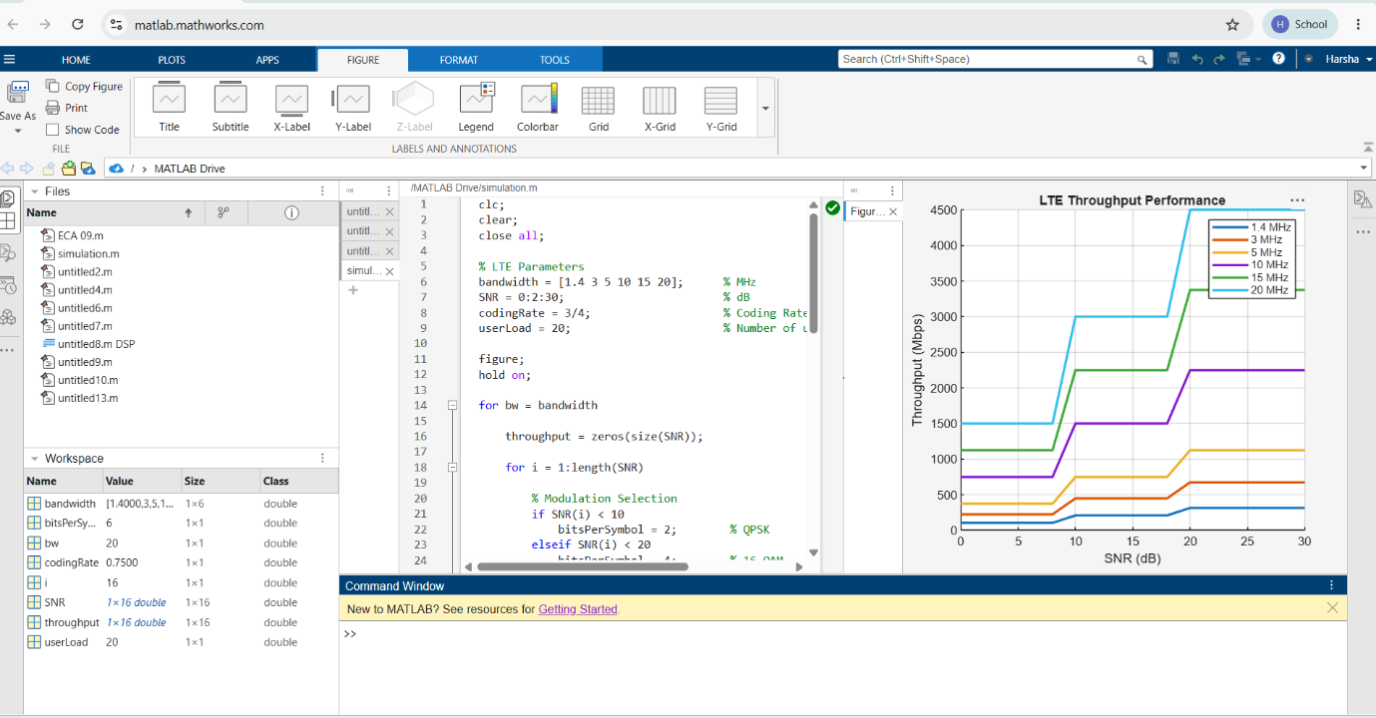
output:

