1. Question-1. This is a sticks and stones question.

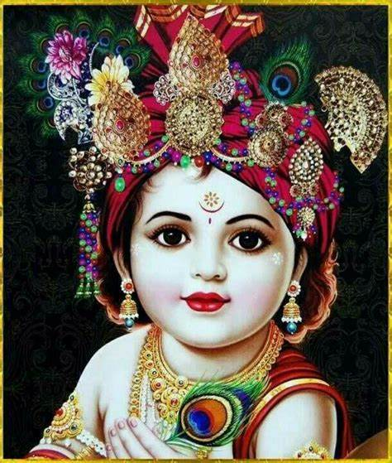

1. Quesiton-2
2. Question-3
3. Question-4