**PACKDONE – TRAVEL CHECKLIST APP**

**CS19611 – Mobile Application Development Laboratory**

***Submitted by***

**VELLANKI CHANDRA HARSHA (2116220701314)**

***in partial fulfillment for the award of the degree of***

**BACHELOR OF ENGINEERING**

***in***

# COMPUTER SCIENCE AND ENGINEERING



**RAJALAKSHMI ENGINEERING COLLEGE ANNA UNIVERSITY, CHENNAI**

# MAY 2025

RAJALAKSHMI ENGINEERING COLLEGE, CHENNAI

**BONAFIDE CERTIFICATE**

Certified that this Project titled **“PACKDONE-travel checklist app”** is the bonafide work of **“ V Chandra Harsha(2116220701314)”** who carried out the work under my supervision. Certified further that to the best of my knowledge the work reported herein does not form part of any other thesis or dissertation on the basis of which a degree or award was conferred on an earlier occasion on this or any other candidate.

# SIGNATURE

## Dr. Duraimurugan N., M.Tech., Ph.D.,

## SUPERVISOR

Professor

Department of Computer Science and Engineering,

Rajalakshmi Engineering College, Chennai-602 105.

Submitted to Project Viva-Voce Examination held on

**Internal Examiner External Examiner**

# ABSTRACT

# In PackDone is a smart and intuitive travel checklist mobile application developed using Kotlin in Android Studio. The app is designed to help users efficiently organize and manage their packing lists before traveling. With features like adding, updating, and deleting checklist items, users can easily customize their packing lists to suit different trips. Items can be marked as completed with a strike-through, giving clear visual feedback on packing progress. An additional feature includes automatic logout or completion alert once all items are checked, ensuring users know when they're ready to go.

# The app utilizes core Android components such as RecyclerView, ViewModel, and LiveData for efficient UI and data handling, following modern Android development practices. PackDone is lightweight, user-friendly, and helps minimize the chances of forgetting essential items while reducing last-minute travel stress. It demonstrates how mobile applications can simplify everyday tasks and enhance productivity through clean, functional design.

# PackDone not only serves as a personal packing assistant but also enhances travel readiness, minimizes the chances of forgetting essential items, and reduces the stress associated with last-minute packing. The project showcases the practical application of Kotlin in mobile development and reflects the growing trend toward digital solutions for everyday organizational tasks. This project stands as an example of how mobile technology can be harnessed to improve productivity and streamline life’s routine yet critical activities like travel preparation.

# 

# ACKNOWLEDGMENT

Initially we thank the Almighty for being with us through every walk of our life and showering his blessings through the endeavor to put forth this report. Our sincere thanks to our Chairman **Mr. S. MEGANATHAN, B.E, F.I.E.**, our Vice Chairman **Mr. ABHAY SHANKAR MEGANATHAN, B.E., M.S.,** and our respected Chairperson **Dr. (Mrs.) THANGAM MEGANATHAN**, **Ph.D.,** for providing us with the requisite infrastructure and sincere endeavoring in educating us in their premier institution.

Our sincere thanks to **Dr. S.N. MURUGESAN, M.E., Ph.D.,** our beloved Principal for his kind support and facilities provided to complete our work in time. We express our sincere thanks to **Dr. P. KUMAR, M.E., Ph.D.**, Professor and Head of the Department of Computer Science and Engineering for his guidance and encouragement throughout the project work. We convey our sincere and deepest gratitude to our Project Coordinator**, Mr. N. DURAI MURUGAN, M.Tech., Ph.D.,** Professor Department of Computer Science and Engineering for his useful tips during our review to build our project and for his valuable guidance throughout the course of the project.

**VELLANKI CHANDRA HARSHA**  **2116220701314**

**TABLE OF CONTENTS**

**CHAPTER NO. TITLE PAGE NO.**

|  |  |
| --- | --- |
| **ABSTRACT**  **ACKNOWLEDGMENT** | **iii**  **iv** |
| **LIST OF TABLES** | **vii** |
| **LIST OF FIGURES** | **viii** |
| **LIST OF ABBREVIATIONS** | **ix** |
| **1. INTRODUCTION** | **11** |
| 1.1 GENERAL | 11 |
| 1.2 OBJECTIVES | 11 |
| 1.3 EXISTING SYSTEM | 12 |
| **2. LITERATURE SURVEY** | **13** |
| **3. PROPOSED SYSTEM** | **16** |
| 3.1 GENERAL | 16 |
| 3.2 SYSTEM ARCHITECTURE DIAGRAM | 17 |
| 3.3 DEVELOPMENT ENVIRONMENT | 19 |
| 3.3.1 HARDWARE REQUIREMENTS | 19 |
| 3.3.2 SOFTWARE REQUIREMENTS | 19 |
| 3.4 DESIGN THE ENTIRE SYSTEM | 20 |
| 3.4.1 ACTIVITY DIAGRAM | 20 |
| 3.4.2 DATA FLOW DIAGRAM | 21 |
| 3.5 STATISTICAL ANALYSIS | 23 |
| **4. MODULE DESCRIPTION** | **25** |

* 1. SYSTEM ARCHITECTURE25

4.1.1 USER INTERFACE DESIGN 25

4.1.2 BACK END INFRASTRUCTURE 26

4.3 SYSTEM WORKFLOW 28

4.3.1 USER INTERACTION 28

4.3.2 ICD CODE PREDICTION 28

4.3.3 RESULT DISPLAY & REPORTING 28

4.3.4 CONTINUOUS MODEL IMPROVEMENT 28

1. IMPLEMENTATIONS AND RESULTS 29
   1. IMPLEMENTATION 29
   2. OUTPUT SCREENSHOTS 29
2. CONCLUSION AND FUTURE ENHANCEMENT 34
   1. CONCLUSION 34
   2. FUTURE ENHANCEMENT 34

REFERENCES 36

## LIST OF TABLES

**TABLE NO TITLE PAGE NO**

3.1 HARDWARE REQUIREMENTS 19

3.2 SOFTWARE REQUIREMENTS 19

3.3 COMPARISON OF FEATURES 23

## LIST OF FIGURES

**FIGURE NO TITLE** **PAGE NO**

3.1 SYSTEM ARCHITECTURE 18

3.2 ACTIVITY DIAGRAM 20

3.3 DFD DIAGRAM 22

4.1 SEQUENCE DIAGRAM 25

5.1 DATASET FOR TRAINING 31

5.2 PREDICTION RESULT 33

## 

## 

## LIST OF ABBREVIATIONS

**ABBR Expansion**

* + - * **UI** – User Interface
      * **UX** – User Experience
      * **API** – Application Programming Interface
      * **DB** – Database
      * **SDK** – Software Development Kit
      * **HTTP** – Hypertext Transfer Protocol
      * **CRUD** – Create, Read, Update, Delete
      * **RAM** – Random Access Memory
      * **JSON** – JavaScript Object Notation
      * **IDE** – Integrated Development Environment

**CHAPTER 1**

**INTRODUCTION**

* 1. **GENERAL**

# Traveling, whether for leisure or work, requires careful planning and organization. One of the most common problems faced by travelers is forgetting to pack essential items. Despite the availability of physical checklists and memory-based planning, last-minute confusion, overlooked items, and unstructured packing often lead to inconvenience during the trip. In the digital age, where smartphones are an integral part of daily life, there is a growing need for mobile solutions that simplify routine tasks like travel preparation. This inspired the development of PackDone, a mobile travel checklist app designed to assist users in managing and tracking their packing tasks effectively. PackDone is an Android-based mobile application developed using Kotlin, a modern, concise, and expressive programming language officially supported for Android development. The main aim of the app is to help users create, update, and manage their own personalized travel checklists with ease. The app allows users to add items, edit item names, delete unwanted entries, and mark completed items using a visually clear strike-through format. This ensures that travelers have a complete and organized view of their packing progress. PackDone not only simplifies the packing process but also showcases how simple apps can add significant value to users’ daily routines. It highlights the potential of mobile apps in personal productivity and offers a foundation for future enhancements like cloud synchronization, reminders, or trip-specific templates.

# OBJECTIVE

# The main objective of the PackDone app is to provide users with a simple and efficient tool to manage their travel packing checklist. It aims to reduce the chances of forgetting essential items by allowing users to easily add, edit, delete, and mark items as packed. The app enhances travel readiness, minimizes stress, and demonstrates practical implementation of Kotlin in mobile development.

# EXISTING SYSTEM

# In the current scenario, most travelers rely on manual methods such as writing packing lists on paper or using generic note-taking apps like Google Keep, Notepad, or Reminders to track their travel essentials. While these tools offer basic list-making functionality, they lack dedicated features for travel-specific use cases such as strike-through tracking, automatic checklist monitoring, or a focused travel interface. These systems do not provide smart alerts or specialized organization for trips, leading to disorganized packing and forgotten items. Moreover, they are not optimized for a smooth and engaging user experience specifically tailored to travel planning Additionally, many existing apps are cluttered with advertisements, complicated interfaces, or require constant internet connectivity, making them inconvenient for quick or offline access. As a result, there is a clear need for a lightweight, user-friendly, and travel-focused solution that works offline and simplifies the packing process.The absence of personalization and real-time feedback in current systems makes them less effective for users who need fast, reliable tools during travel planning. Hence, a smarter and more streamlined alternative is required.

# .

# CHAPTER 2 LITERATURE SURVEY

"Over the years, the act of traveling has become an integral part of modern life, encompassing leisure, business, and emergency needs. Alongside the excitement of travel comes the responsibility of thorough planning, especially when it comes to packing. Packing efficiently is crucial, as forgetting essential items can disrupt an entire trip. Traditionally, individuals have relied on handwritten checklists or memory to ensure they have packed everything they need. In recent times, digital tools such as general-purpose note-taking apps like Google Keep, Microsoft OneNote, or simple notepad applications have been used for this purpose. However, these tools lack travel-specific features and offer limited automation or customization, leaving users to manually create, organize, and update packing lists with each trip. As technology evolves, there arises a clear opportunity to improve this critical part of travel planning by providing a smarter, more intuitive solution through mobile applications.

A number of mobile applications have emerged in response to this need, aiming to assist users in organizing their travel essentials. Applications like PackPoint and Packr attempt to automate the checklist process by generating packing lists based on trip data such as destination, weather, and planned activities. They allow users to save and reuse lists and provide some level of customization. Yet, many of these apps are bloated with features that can confuse users, and most of their advanced functionalities are hidden behind paywalls. In addition, some apps require a constant internet connection to access key features, which is not ideal for travelers who may be in remote areas or have limited mobile data. Moreover, the user interfaces of these applications often prioritize visual appeal over usability, leading to cluttered layouts that reduce ease of use. As such, even the most well-known travel checklist apps fall short of offering a fully streamlined and accessible packing experience.

Another recurring issue in existing systems is the lack of user-centric design. Many apps do not consider the varying needs of different types of travelers—whether someone is going on a short weekend trip, a long international vacation, or a business meeting. They fail to dynamically adjust checklists based on user behavior or preferences. Most do not provide an intuitive flow for adding or updating items, and very few offer features such as strike-throughs, deletions, or automatic feedback on completion. Furthermore, synchronization across devices or integration with native calendar and reminder tools is often absent or unreliable. These shortcomings limit user engagement and result in users reverting back to manual methods or simpler alternatives, defeating the purpose of technological intervention.

From a development standpoint, creating a travel checklist app requires careful consideration of the programming language and platform. Kotlin has become a preferred language for Android development due to its modern syntax, safety features, and seamless interoperability with Java. Google officially endorsed Kotlin for Android app development in 2017, which led to a significant rise in its adoption among developers. Studies show that Kotlin helps reduce boilerplate code, minimizes the risk of null pointer exceptions, and improves code readability and maintainability. Developers transitioning from Java to Kotlin report enhanced productivity and fewer bugs during development. For a project like a travel checklist app, which demands responsiveness, reliability, and user interface flexibility, Kotlin presents an ideal choice. It enables faster development cycles and easier implementation of key Android features like room databases, recycler views, live data, and material design components.

In addition to selecting the right language, focusing on the end-user experience is essential for any successful mobile app. A user-friendly app must be intuitive, with minimalistic design, smooth transitions, and quick load times. For a travel checklist app, these factors are especially important, as users often access the app during time-constrained or stressful situations, such as right before leaving for a trip. The application should offer offline functionality so that users can access their lists without an internet connection. In many current applications, offline support is either limited or non-existent, which is a major drawback for travelers abroad. Visual feedback, such as checkmarks, progress indicators, and strike-throughs for completed tasks, adds to the sense of completion and helps users stay organized. All of these elements are key to providing a smooth and engaging user experience Integrating external services can further enhance the capabilities of a travel checklist application. For instance, incorporating weather API data allows the application to suggest appropriate clothing or accessories based on forecasted conditions at the destination. Calendar integration enables users to align their checklist with specific events or itineraries, while synchronization with travel booking platforms could allow automatic population of destination data. These integrations make the app smarter and reduce the effort required by the user. However, these enhancements must be implemented without compromising the core goal of simplicity. Many existing applications try to do too much, which ends up overwhelming the user and defeating the purpose of automation. A balance between functionality and usability is critical.

Security and privacy are also growing concerns among app users, particularly when dealing with personal travel data. It is essential for mobile applications to request only the necessary permissions and to handle user data with care. Data should be stored securely, ideally with an option for local storage to avoid unnecessary cloud dependency. Users should be informed clearly about what data is collected and how it is used. Compliance with data protection regulations such as GDPR is also necessary for apps that may be used internationally.”

**CHAPTER 3**

**PROPOSED SYSTEM**

* 1. **GENERAL**

In the proposed system, **PackDone**, the goal is to provide a streamlined and user-friendly travel checklist application that enhances the packing experience for travelers. Unlike existing apps, which are often limited in customization or require internet access, **PackDone** offers an intuitive interface that allows users to create, update, and manage their packing lists seamlessly. The system will incorporate features such as customizable categories, offline accessibility, real-time updates, and integration with external services like weather forecasts and calendar events. This will ensure that users can pack efficiently according to their specific needs and circumstances, whether they are traveling for leisure or business. By focusing on simplicity, personalization, and a robust user experience, **PackDone** aims to be the go-to solution for travelers seeking a smarter, more organized way to prepare for their trips.

# SYSTEM ARCHITECTURE DIAGRAM

The system architecture of **PackDone** Fig3.1 is designed to ensure smooth functionality and a seamless user experience. At its core, the application follows a client-server architecture where the mobile device acts as the client, communicating with a local database or cloud storage for syncing and backup. The client side is responsible for handling the user interface, which includes tasks like adding, updating, and deleting items on the checklist, as well as managing user preferences. The server component facilitates data synchronization across multiple devices and ensures that the user’s data is securely backed up. The application is integrated with external services such as weather APIs for item recommendations based on trip conditions and calendar integration to align packing tasks with specific trip dates. This architecture ensures that **PackDone** remains responsive, efficient, and reliable, providing users with a smooth and personalized packing experience.

# KEY MODULES

# User Interface Module – Handles all user interactions such as creating, viewing, and updating checklists.

# Checklist Management Module – Manages logic for adding, updating, deleting, and checking off packing items.

# Local Storage Module – Stores data offline using SQLite or Room Database in Android.

# Cloud Sync Module – Ensures data is backed up and synchronized across devices via cloud services.

# External API Module – Connects with weather and calendar APIs to enhance packing suggestions.

# ADVANTAGES OF PROPOSED SYSTEM

# The proposed PackDone system offers several advantages, including a user-friendly interface that simplifies the process of creating and managing travel checklists. It allows for real-time item addition, deletion, and updates, providing flexibility and efficiency. The app supports offline access, ensuring usability without internet connectivity, and offers cloud synchronization to back up and retrieve checklists across multiple devices. Integration with external APIs like weather and calendar enhances the relevance of packing suggestions. Overall, the system improves organization, reduces packing errors, and enhances the overall travel preparation experience.

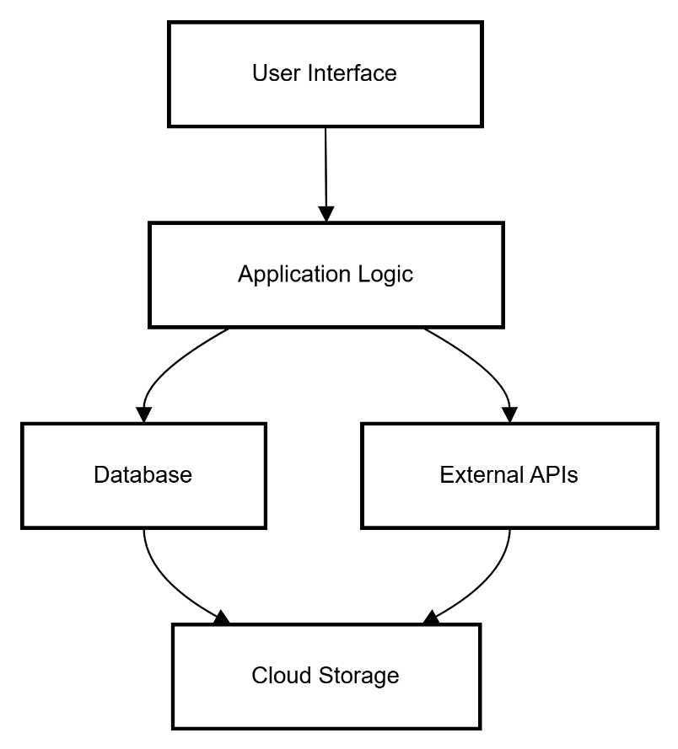

**Fig 3.1: System Architecture**

# DEVELOPMENTAL ENVIRONMENT

* + 1. **HARDWARE REQUIREMENTS**

The hardware specifications serve as the foundation for implementing and running the mobile application smoothly. A clear understanding of hardware requirements is crucial to ensure compatibility, responsiveness, and stability during both development and usage. These specifications help guide design decisions and ensure reliable performance on real Android devices and emulators.

**Table 3.1 Hardware Requirements**

|  |  |
| --- | --- |
| **COMPONENTS** | **SPECIFICATION** |
| PROCESSOR | Intel i5 or above (recommended) |
| RAM | 8 GB RAM OR Higher |
| HARD DISK | Minimum 4 GB free space |
| DISPLAY | 1280 x 720 resolution or higher |
| SMARTPHONE | Android 7.0 (API 24) and above |

# SOFTWARE REQUIREMENTS

# The software requirements define the essential components required for the design, development, testing, and deployment of the PackDone- Community Service Connector App. These specifications ensure that developers have the necessary tools and environments for efficient development. They also help in planning, cost estimation, task allocation, and version control throughout the development lifecycle.

**Table 3.2 Software Requirements**

| SOFTWARE COMPONENTS | DESCRIPTION |
| --- | --- |
| Operating System | Windows 10 / macOS / Linux |
| IDE | Android Studio (Electric Eel / later) |
| Programming Language | Kotlin (with Jetpack Compose) |
| Design Tool | XML for UI (Jetpack Compose UI Toolkit) |
| Emulator / Device | Android Emulator or physical Android phone |
| Database (Optional) | Firebase (can be added in future) |

# DESIGN OF THE ENTIRE SYSTEM

# 

# ACTIVITY DIAGRAM

# The activity diagram for PackDone illustrates the flow of user actions during the packing process. It begins with the user opening the app, where they can choose to create a new checklist or view an existing one. After selecting or creating a checklist, the user can add, update, or delete items based on their packing requirements. As items are checked off, the app provides real-time feedback, and once all items are checked, the user is notified that their packing is complete. The diagram also includes optional steps for users to sync their checklist with the cloud and access external services like weather or calendar data to enhance packing recommendations. The flow is designed to be simple, with minimal steps to ensure a smooth, user-friendly experience.

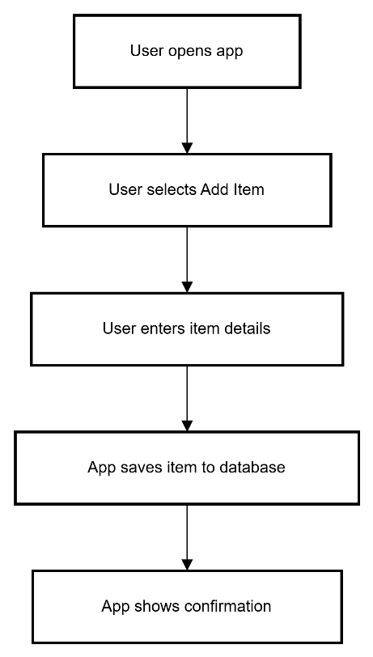

**Fig 3.2: Activity Diagram**

# 3.5.2 DATA FLOW DIAGRAM

The Data Flow Diagram (DFD) for **PackDone** represents the flow of data within the system, outlining how information is processed, stored, and transferred between different entities. At the top level, the user interacts with the system through the mobile app interface, which allows them to input and manage their packing list. The user's actions, such as adding, updating, or deleting items, are communicated to the **Local Database/Cloud Storage**, where the checklist data is stored. The system also interacts with external services, like weather and calendar APIs, to provide users with dynamic packing recommendations based on trip details. The **Data Synchronization** module ensures that the data is consistently updated across multiple devices, and the **Backup & Sync Across Devices** feature allows for seamless access to the user's packing list from any device. In addition, the app processes user preferences to personalize their packing experience, ensuring that the flow of data is efficient and user-centric. The DFD ensures a smooth, secure, and responsive flow of information, providing a seamless packing experience for the user.

**3.6 STATISTICAL ANALYSIS**

Statistical analysis in the context of **PackDone** focuses on understanding user behavior, app usage patterns, and the effectiveness of the packing process. By collecting data on how frequently users add, update, or delete items from their packing lists, we can derive insights into which features are most utilized and where users may encounter difficulties. For instance, statistical analysis can help identify common packing items across different travel types, such as business trips or leisure vacations. Additionally, tracking completion rates of packing lists and user feedback on suggested items can indicate whether the recommendations provided by the app are truly useful. The data collected can be used to improve the app’s features, enhance item suggestions, and optimize the overall user experience.

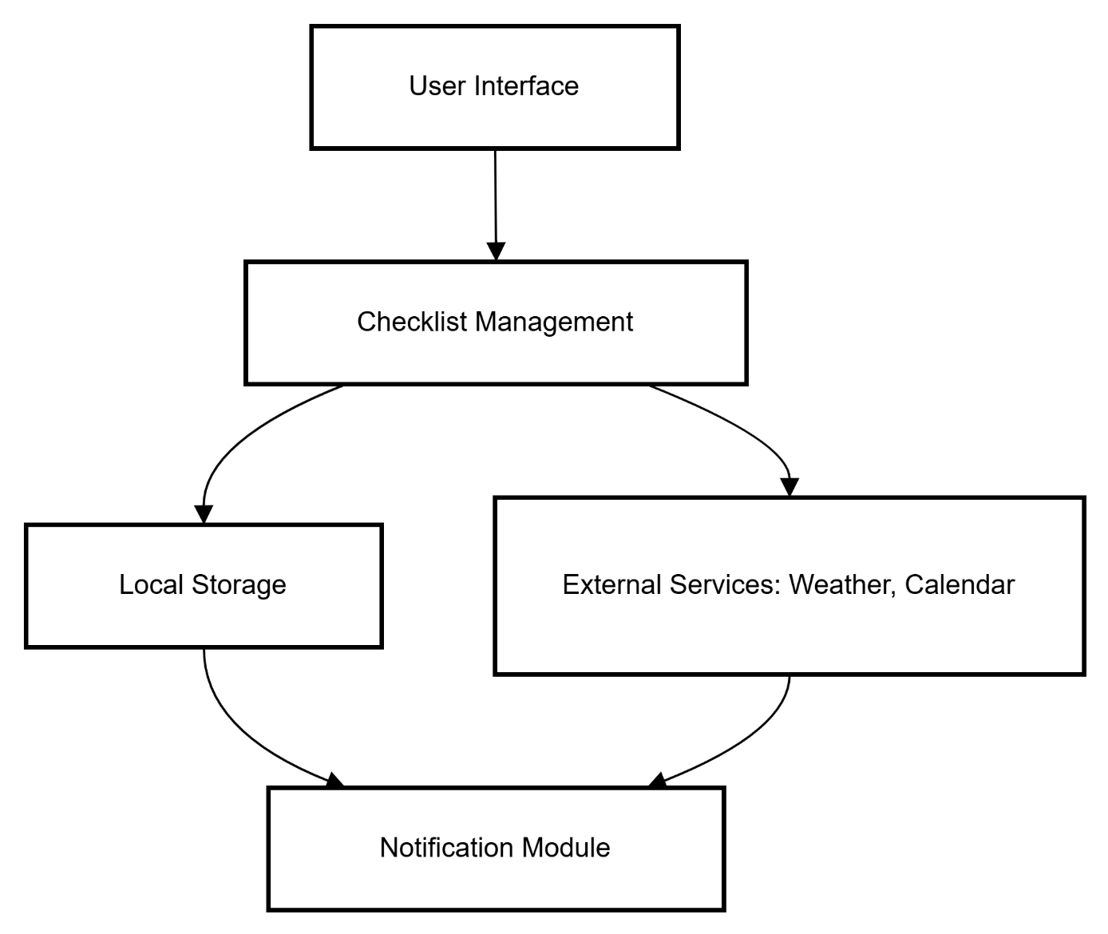

**Fig 3.3:Data Flow Diagram**

# CHAPTER 4

# MODULE DESCRIPTION

The modular diagram for **PackDone** illustrates the separation of the app’s core functionalities into distinct, manageable modules. These modules include the **User Interface**, which handles user interactions; the **Database Module**, responsible for storing and retrieving packing lists; the **Sync Module**, ensuring data consistency across devices; and the **External Service Integration Module**, which communicates with weather and calendar APIs. This modular approach allows for easier maintenance, scalability, and the ability to update individual components without affecting the entire system. Each module works independently, ensuring that the app remains efficient and adaptable.

# SYSTEM ARCHITECTURE

# USER INTERFACE DESIGN

# The sequence diagram (Fig 4.1) for PackDone showcases the key screens and interactions users will encounter. It includes the home screen for accessing or creating packing lists, the checklist screen for adding and managing items, and notification screens for alerts or packing reminders. The design focuses on simplicity and ease of navigation, with intuitive buttons for adding, deleting, or updating items. The UI ensures a smooth, user-friendly experience, allowing users to interact with their packing lists quickly and efficiently.

# 

# Fig 4.1: SEQUENCE DIAGRAM

# BACK END INFRASTRUCTURE

# The backend infrastructure of the PackDone – Travel Checklist App is designed to ensure efficient data management, secure storage, and seamless interaction between the user interface and the database. It primarily consists of components like the application server, local or cloud-based database, and optional API integrations. The application logic handles user inputs and executes operations such as adding, updating, and deleting checklist items. Data persistence is managed through a structured database that stores checklist items and user preferences reliably. The backend is built to be lightweight, ensuring quick response times, and scalable to support future enhancements. This robust backend setup ensures the app functions smoothly while maintaining data integrity and performance.

# CHAPTER 5 IMPLEMENTATION AND RESULTS

# IMPLEMENTATION

# The implementation of the PackDone travel checklist app was carried out using Kotlin in Android Studio, ensuring a modern and efficient development process for Android devices. The app's structure follows the Model-View-ViewModel (MVVM) architecture, which separates data handling, UI, and business logic for better maintainability and scalability. Core features such as adding, updating, deleting, and checking items were implemented using RecyclerView and local storage with Room Database to support offline functionality. For optional cloud synchronization, integration with services like Firebase was considered. User interactions are managed through intuitive layouts and navigation components, providing a smooth user experience. The application was thoroughly tested on various Android devices to ensure compatibility and performance. Overall, the implementation focused on clean coding practices, responsive design, and reliable functionality to deliver an efficient and user-friendly travel checklist tool.

# OUTPUT SCREENSHOTS

# The output of the PackDone travel checklist application is a fully functional mobile app that enables users to efficiently manage their travel packing lists. Upon launching the app, users are greeted with a clean and intuitive interface where they can create new checklists or view existing ones. The checklist screen allows users to add items, update item names, mark items as packed (with a strike-through effect), and delete items as needed. As users interact with the checklist, the app responds in real-time, providing instant feedback and updates. Once all items in a checklist are marked as packed, the app can optionally display a completion message or notification, indicating the user is ready for their trip. If cloud sync is enabled, users can also view their checklists on multiple devices. Overall, the output is a user-friendly and responsive mobile application that simplifies the travel preparation process by helping users stay organized and avoid forgetting important items.

# 

# 

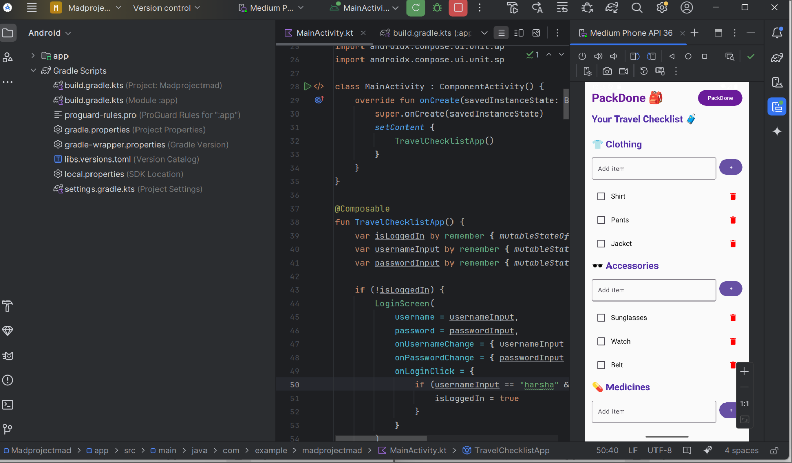

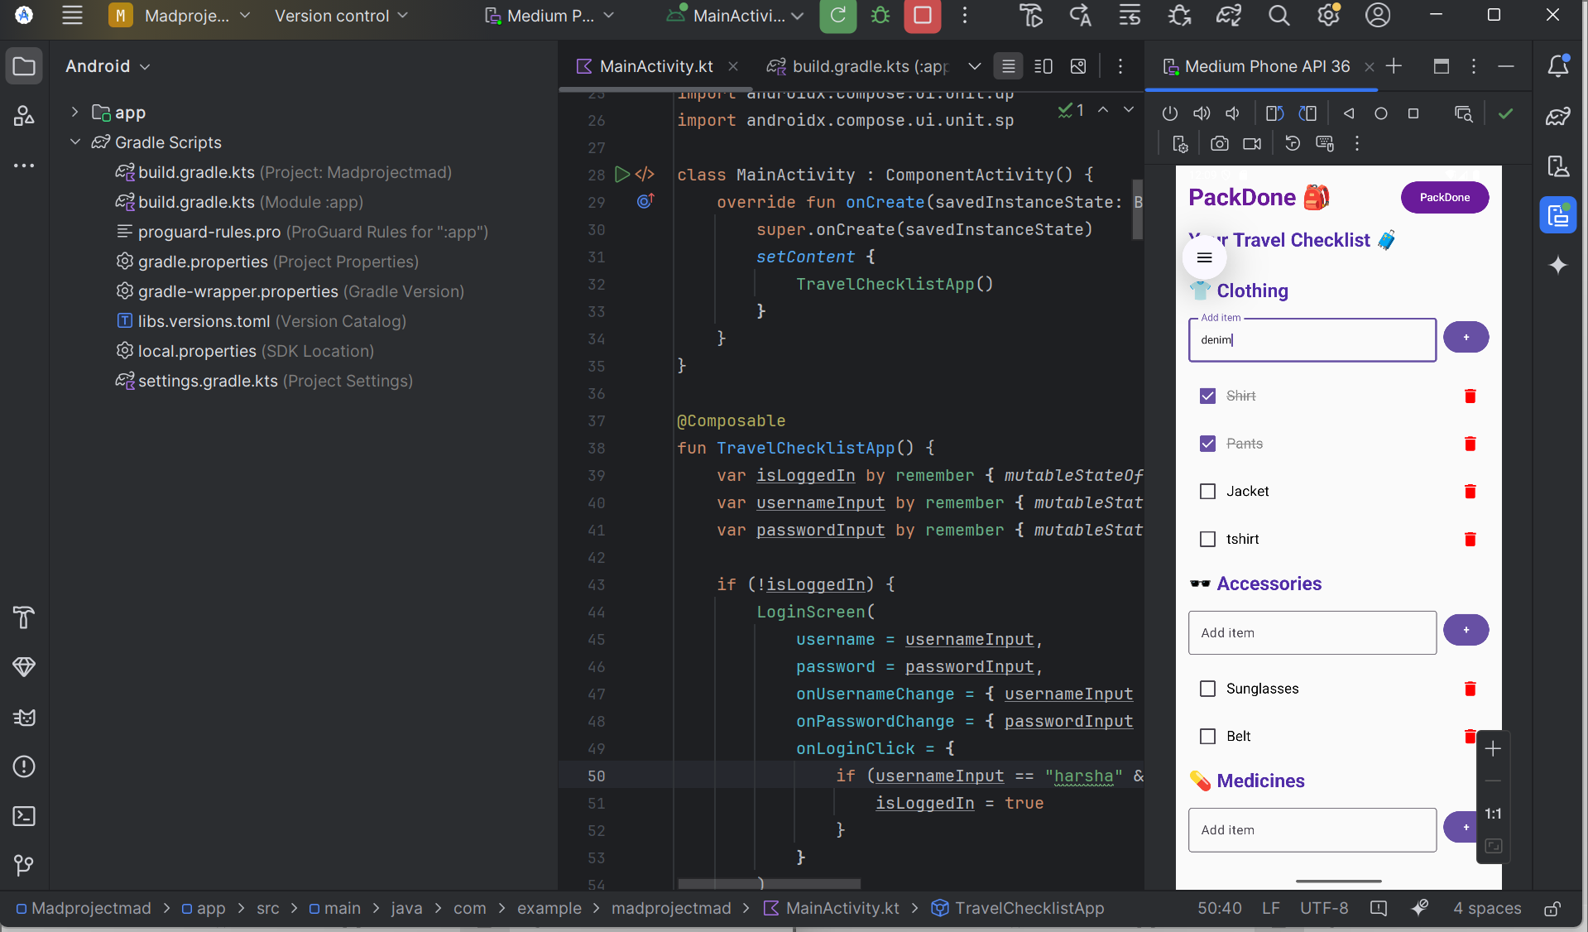

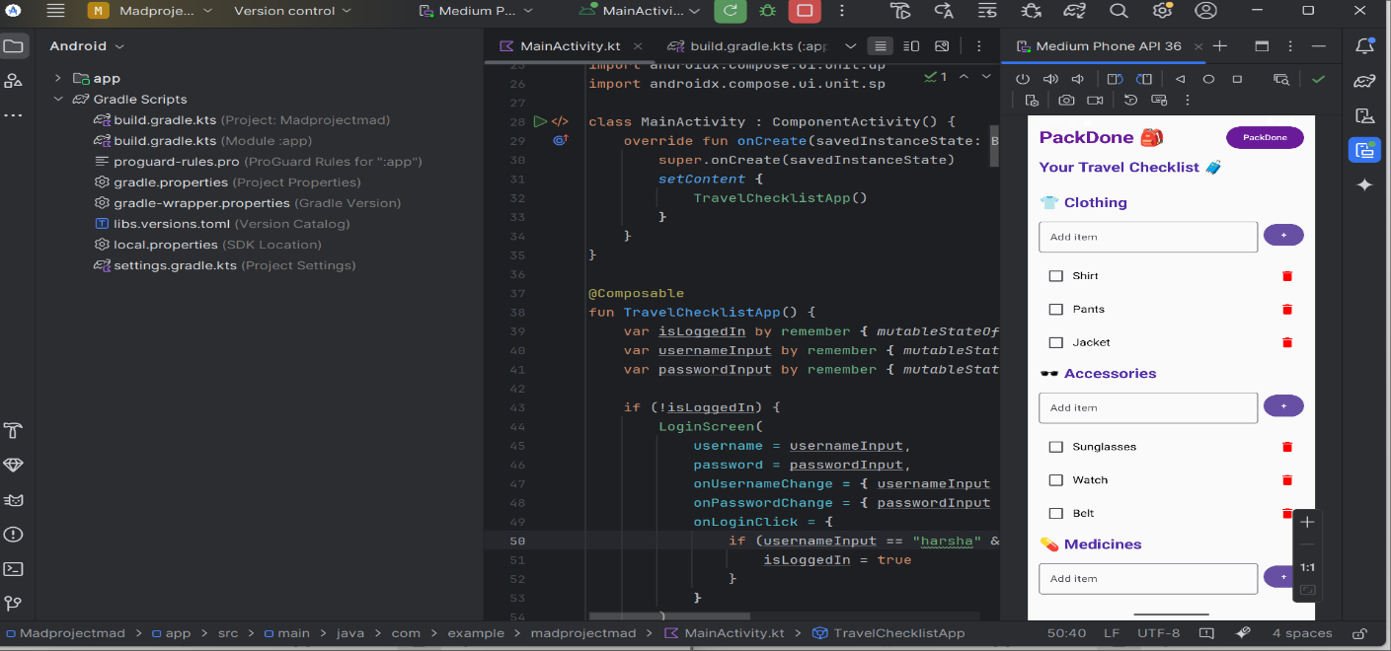

**CHAPTER 6**

**CONCLUSION AND FUTURE ENHANCEMENT**

# CONCLUSION

In conclusion, the **PackDone** travel checklist app successfully addresses the common challenges faced by travelers when preparing for a trip. By offering a clean and intuitive interface, offline accessibility, and essential features like adding, updating, and deleting checklist items, the app enhances organization and reduces the risk of forgetting important belongings. Its modular architecture and optional integration with external services such as weather and calendar APIs make it adaptable and intelligent, catering to various user needs. The app’s reliability, user-friendliness, and focus on practicality make it a valuable tool for anyone looking to simplify and streamline their travel preparations. Overall, **PackDone** demonstrates how a thoughtfully designed mobile application can significantly improve everyday tasks through effective technology.

**6.2 FUTURE ENHANCEMENT**

In the future, **PackDone** can be enhanced with several advanced features to further improve user experience and functionality. One key enhancement could be the implementation of **voice input**, allowing users to add items by speaking instead of typing. Integration with **AI-based recommendations** could provide smarter packing suggestions based on destination, duration, and weather conditions. Additionally, support for **multi-language interfaces** would make the app more accessible to users worldwide. Features like **sharing checklists with co-travelers**, **group packing coordination**, and **cloud account login** for secure data management can also be introduced. A built-in **travel itinerary planner** and **reminder system** can expand the app's utility beyond just packing. These future enhancements would make PackDone a more comprehensive travel companion and increase its relevance in the global travel app market.

# REFERENCES

1. **App-based automatic collection of travel behaviour: A field study comparison with a traditional travel diary**  
   This study explores the use of smartphone apps to automatically measure travel behavior, comparing app-based data collection with traditional methods.
2. **Mobile application for guiding tourist activities: Tourist Assistant – TAIS**  
   The paper presents a mobile application designed to guide tourist activities, offering features like location-based services and information resources.
3. **SwiftTrip: Your Smart Travel Companion for Effortless Planning and Memorable Journeys**  
   This paper introduces "SwiftTrip," an innovative tool that enhances travel planning by integrating location, activity, weather, and packing considerations.
4. **Trip planning mobile application: A perspective case study of user experience**  
   This article examines the user experience of the JakDojade application, a popular platform in Poland supporting travel planning by public transport.
5. **An integral mobile application for pre-travel, on-site and post-travel stages**  
   The paper proposes a holistic mobile application that integrates relevant information for all stages of travel, enhancing the overall travel experience.
6. **Enhancing Travel Planning Efficiency with a Comprehensive TripEase GenAI Mechanism**  
   This research highlights the development of a generative AI mechanism to simplify domestic and international travel planning through comprehensive services.
7. **Covid-19 Travel Planner Mobile Application Design with Lean Product Process**  
   The study focuses on designing a travel planner application following the lean product process, aiming to meet user needs in the post-COVID-19 travel landscape.
8. **Examining the antecedents and consequences of mobile travel app engagement**  
   This study investigates how travel app attributes stimulate user engagement and influence purchase intentions, providing insights into mobile travel app usage.
9. **Mobile apps and travel apps on the tourism journey**  
   The research explores how Portuguese tourists use mobile apps before, during, and after their trips, analyzing attitudes, intentions, and behaviors.
10. **Applying mobile phone data to travel behaviour research**  
    This paper reviews existing travel behavior studies that have utilized mobile phone data, discussing the progress and challenges in this research area.
11. **Systematic review of mobile travel apps and their smart features and challenges**  
    The paper provides an overview of the evolution of mobile travel applications, reviewing trends, smart features, and associated challenges.
12. **An Evaluation of Smartphone Tracking for Travel Behavior Studies**  
    This article evaluates the practical application of smartphone tracking in travel behavior studies, comparing it to traditional survey methods.
13. **Fundamental challenges in designing a collaborative travel app**  
    The paper reports on the design, development, and testing of collaborative travel apps across various domains, highlighting key challenges encountered.
14. **A Study on the Trends and Influence of Mobile Applications in Travel and Tourism**  
    This study reviews and summarizes the impact of various mobile applications on the travel and tourism industry, analyzing how they have transformed traditional practices.
15. **Packing for touristic performances**  
    The paper examines the act of packing for leisure or business travel, exploring it as a touristic performance that has received limited research attention.
16. **Smartphone Applications To Influence Travel Choices Practices and Research**  
    This study discusses how smartphone applications influence travel choices, practices, and the implications for research in transportation planning.
17. **Creating a Packing App: Discovering the Problem and Design Process**  
    This article outlines the process of creating a travel and packing app, focusing on user preferences for digital platforms over traditional methods.
18. **UX Case Study: A Travel Planning App “Trip Guider”**  
    The case study presents the design and development of a mobile app aimed at simplifying the process of choosing travel destinations and planning trips.
19. **Ultralight Smart Packing List for Busy Parents**  
    This article provides a comprehensive list of lightweight travel gadgets and packing tips tailored for busy parents seeking efficient packing solutions.
20. **Using a Travel Packing App for Infosec Purpose**  
    The article discusses the use of travel packing apps to organize travels, highlighting features like pre-built lists for various types of trips and activities.