**Event Driven Architecture**

**Serverless Computing**

**AWS Lambda**

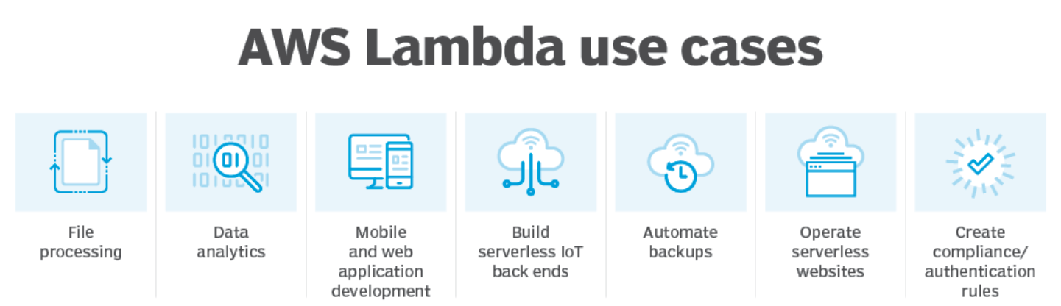

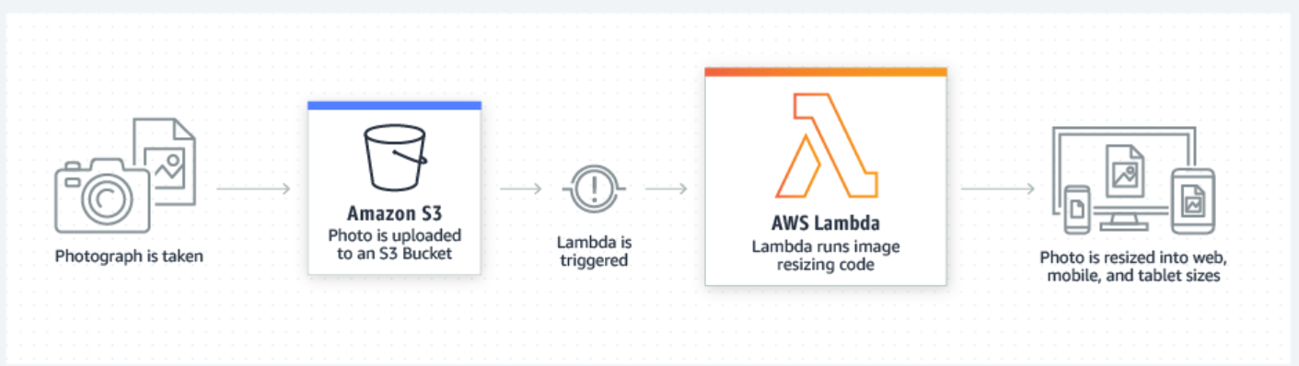

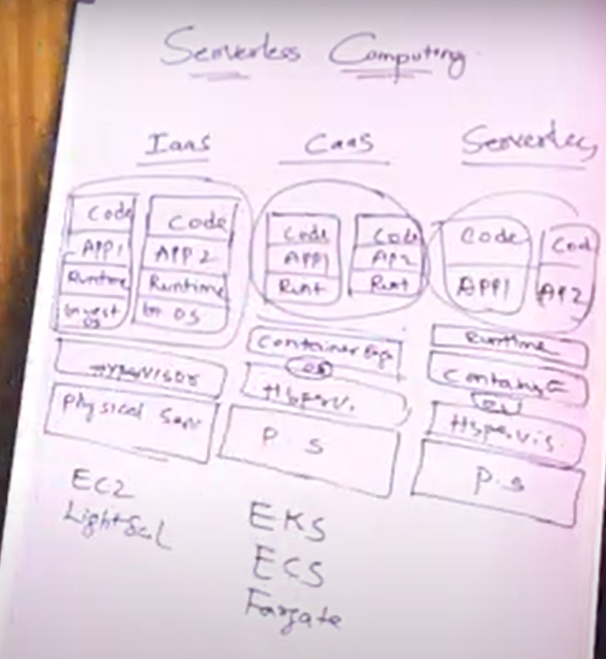 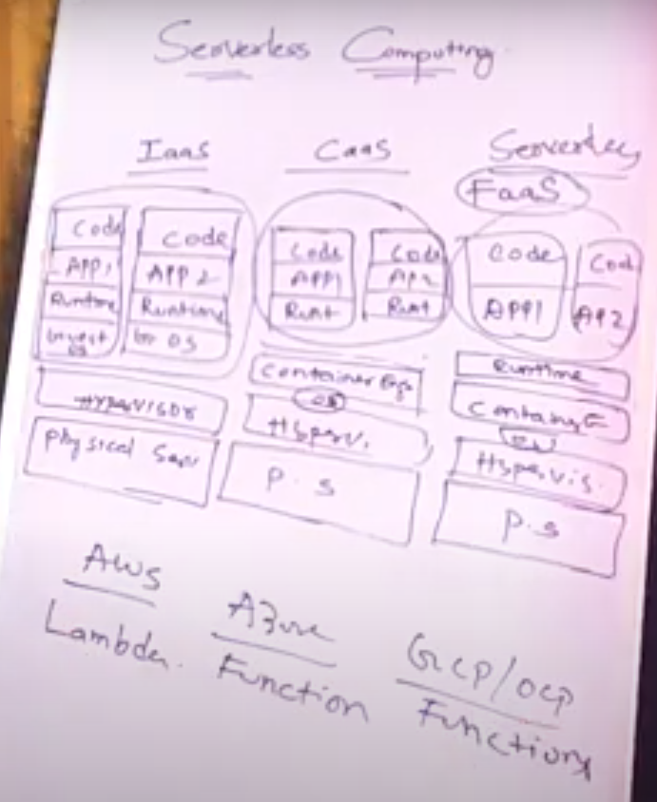

* Serverless is also called Function as a service (Faas)

**Faas services**

* AWS Lambda
* Azure Functions
* GCP/OCP Functions

**# How AWS Lambda Function Works**

* **Users will put Requests 🡪 AWS Cloud Provider will Create Containers for each user request 🡪**

**AWS Lambda code will be triggered and executes it 🡪 Responses will be going back to users 🡪 AWS Cloud Provider will kill the Containers.**

* Benefits of AWS Lambda - Event based trigger.

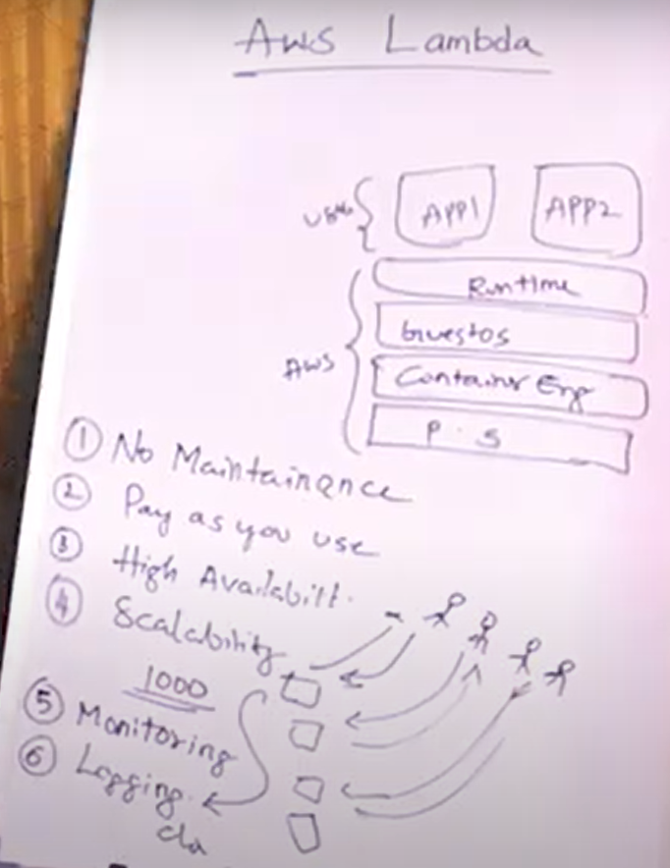 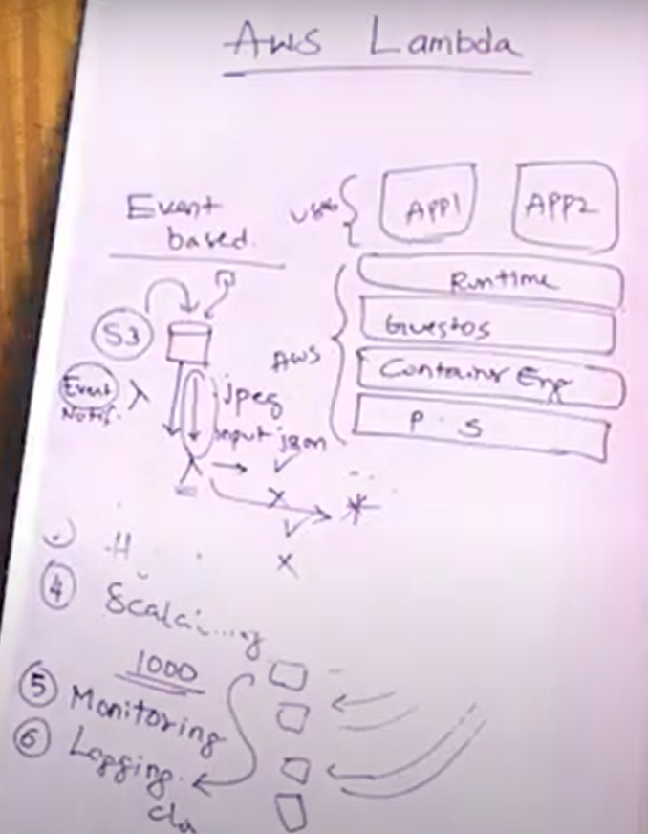

* AWS Snapstart is only applicable for JAVA currently.

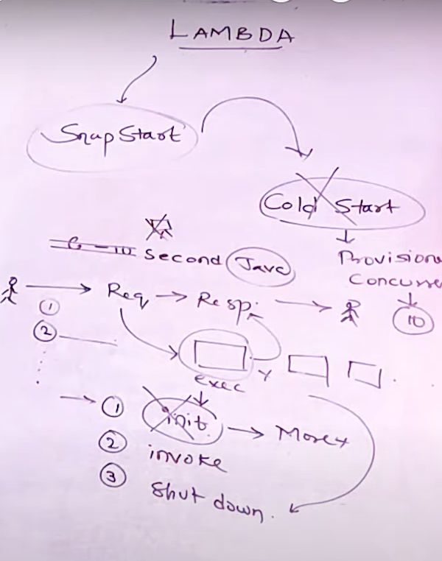 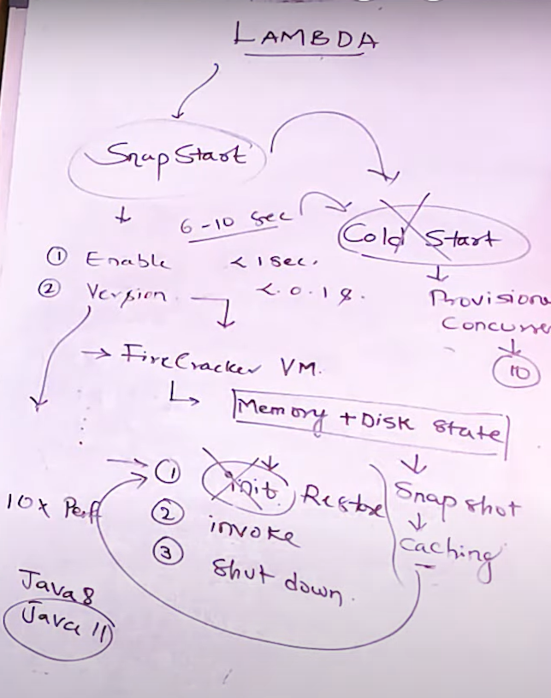

**CloudWatch**

* Event Bus
* Rules

**Event Bridge**

* Event Bus
* Rules

**Cognito**

**API Gateway**

* It is used to provide REST APIs or to expose REST API

**Step Functions**

**SQS**

**SNS**

**Amplify**

