**Git**

**It is a source control system or VCS (Version Control System)**

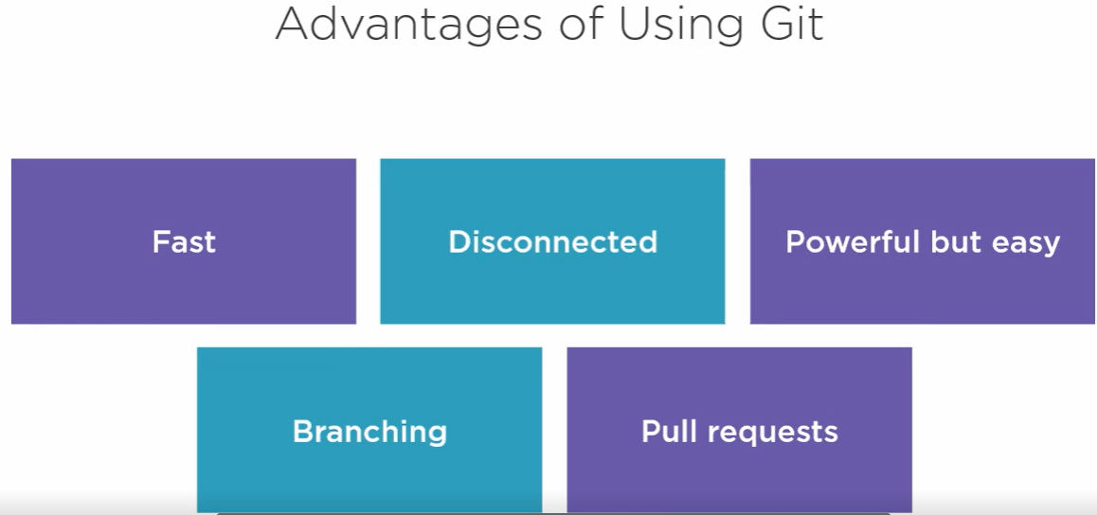

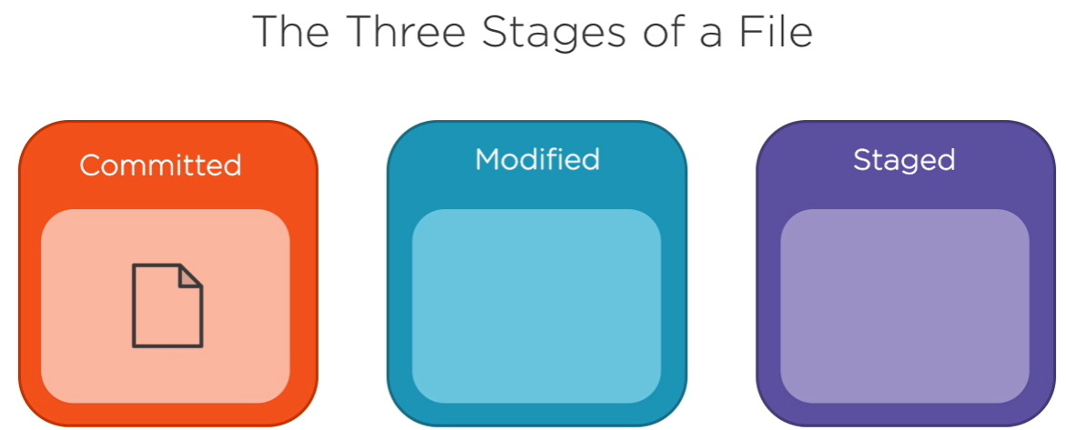

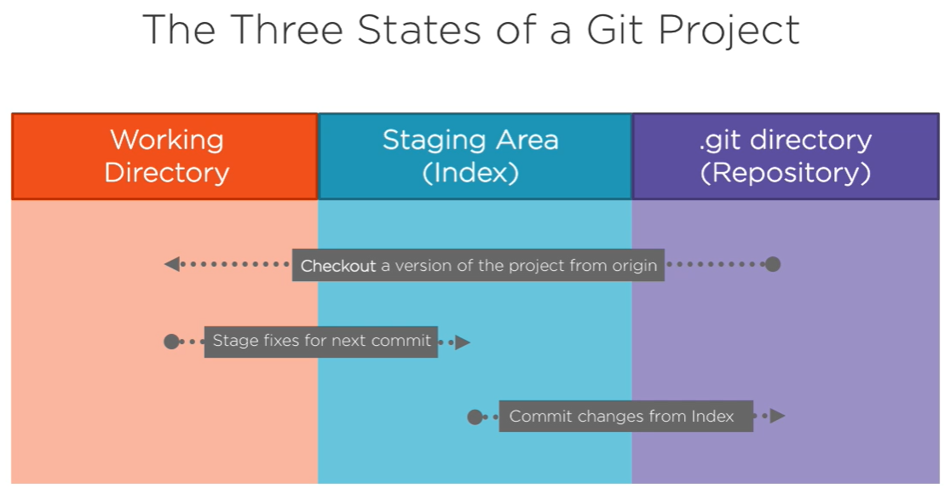

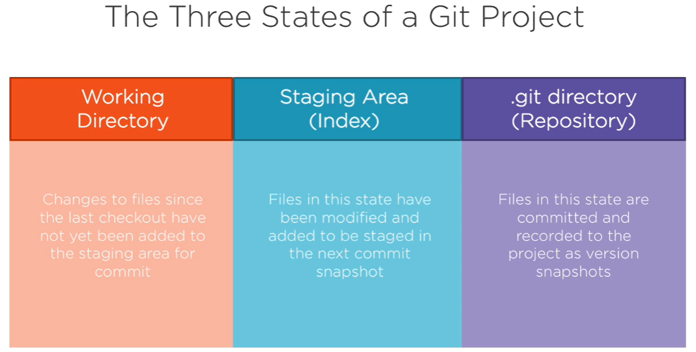

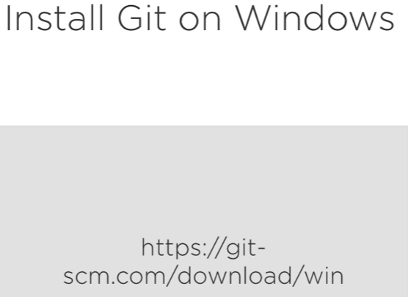

**Code Hosting Providers**

Send your code, to code hosting provider

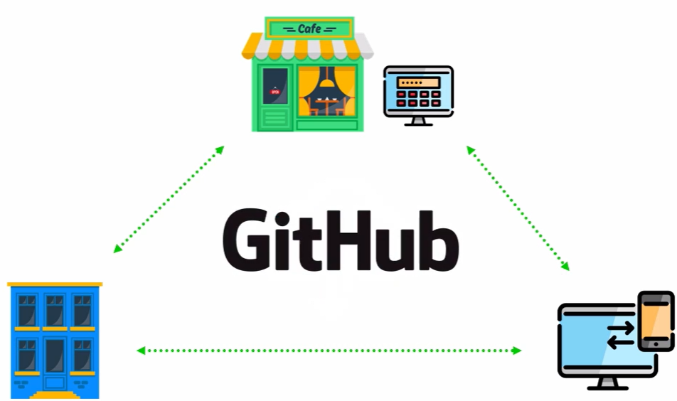

1. GitHub
2. GitLab
3. BitBucket

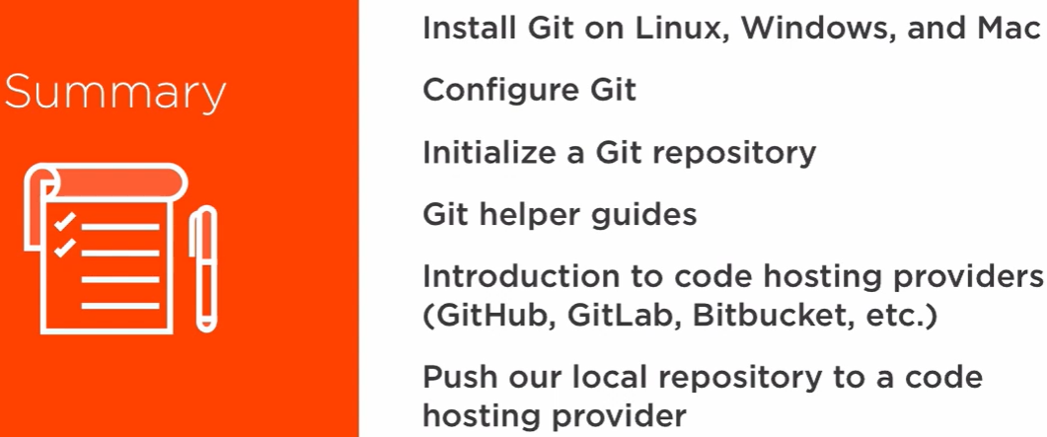

**Git bash commands**

* git --version
* git config --global user.name “ “
* git config --global user.email “ “
* git config –edit --global
* git config --list
* git config --user.name

**#Initialize a new git repository**

(be in the project directory)

* git init

**#(GIT_DIR!)**

* cd .git

#This command will add all of the files to our staging area

* git add .

**#commit**

* git commit -m “message”

**#here -a option automatically stages all changes in working directory that are being tracked by git**

* git commit -a -m ”message”

**#create link between local git repository to GitHub**

* git remote add origin <http link>

**#pushing local git repository to GitHub**

* git push -u origin master (or)
* git push origin master

**#git status**

* git status

**#short status**

* git status -s (or) git status --short

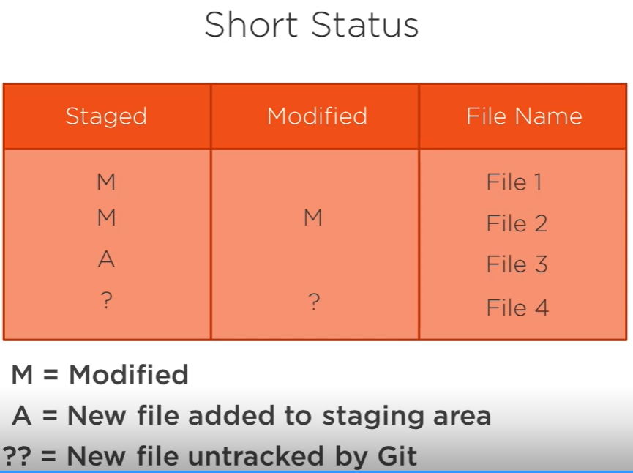

**#open text editor notepad++**

**#For notepad++, set path in environment variables**

* git config core.editor “notepad++ -multiInst -nosession”
* notepad++ <file-name>

**#For default editor**

* start <file-name>

**#File Stages**

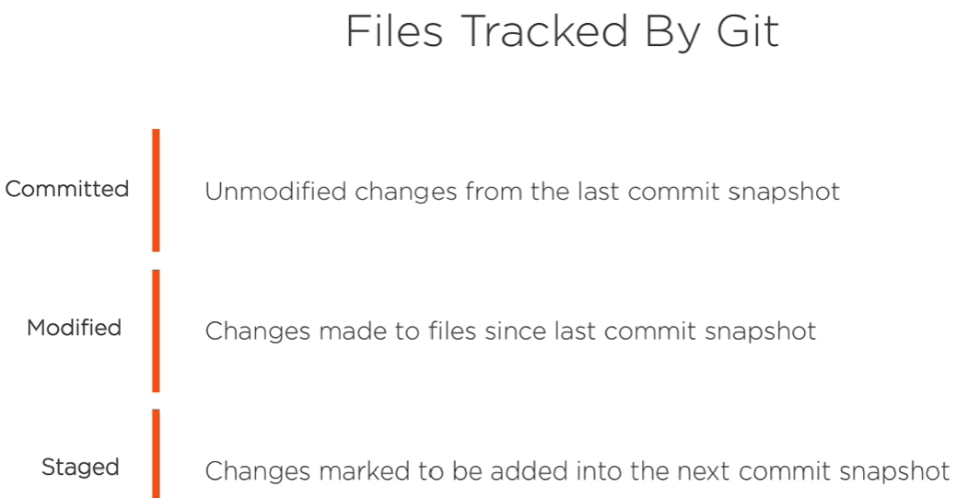

**#Git diff explained**

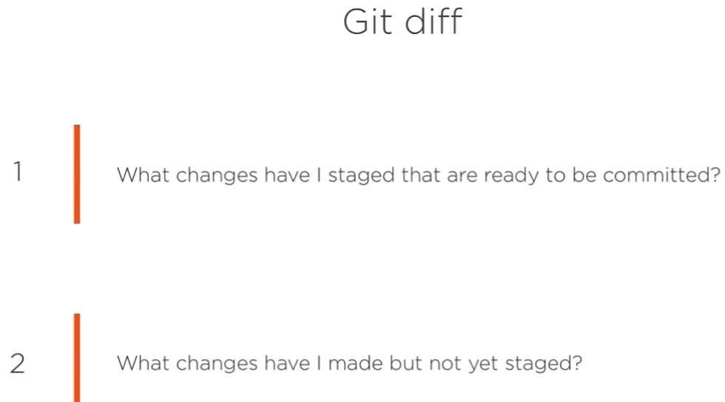

* git diff --staged

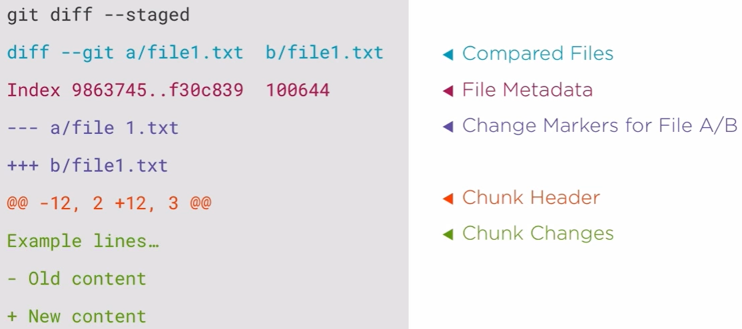

**#Check Commit History**

* git log

**#limited number of history**

* git log -1, got log -2

**#simplified history of list of commits**

* git log --oneline

**#detailed hostory**

* git log --stat

**#more detailed history (similar to git diff)**

* git log –patch

**#Remove and Move Files**

**#Remove files**

* git rm f <file-name>

**#TO delete hidden .git directory in the working directory**

* rm -fr .git

**#To delete sub directory**

* rm -fr <sub directory name>

**#untrack files**

* git rm –cached <file-name>

#Rename files

* git mv filename <new-file-name>

**Introduction to Branches**

open <http://git-school.github.io/visualizing-git>

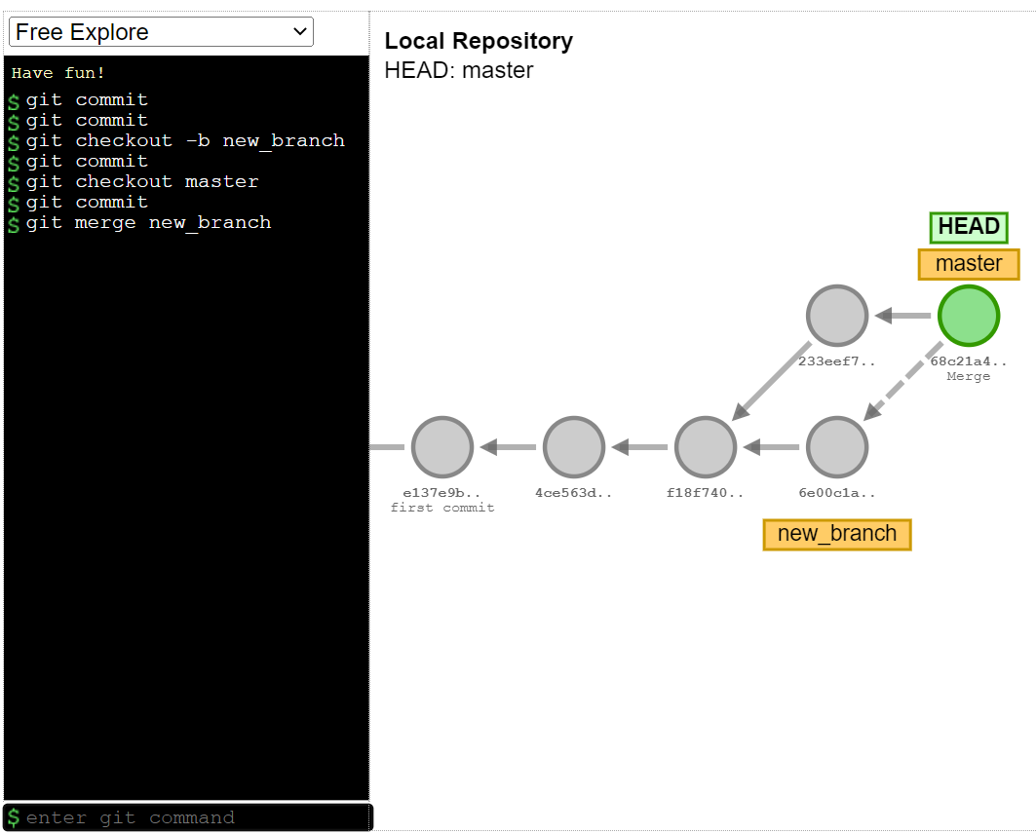

**#Creating new branch**

* git checkout -b <new-branch-name>

**#rolling back to master branch**

* git checkout master

**#without committing we can stash it so that the working directory will be clean**

* git stash

**#provides list of work-in-progress changes that we’ve stashed along with branch and some commit data**

* git stash list

**#to see a better detailed view of what file was stashed in a high-level overview Of the changes**

* git stash show

**#to get this change out of stash**

* git stash pop

**#merge branch**

* git merge <branch name>

#reset

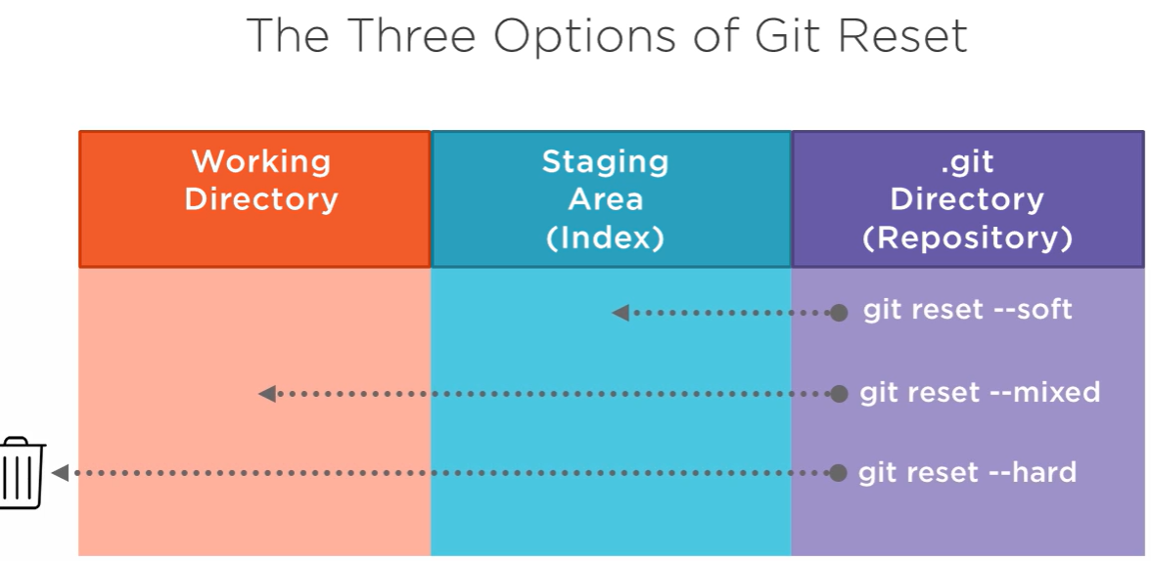

**#Pull from remote Origin**

* git clone <http link>

**#To update the git local repository**

* git pull origin <branch-name>

**GitHub Fundamentals**

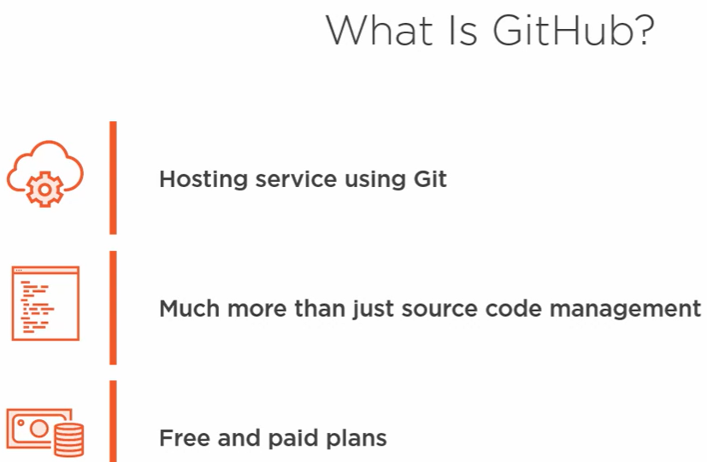

**GitHub Actions**

Automation is key for streamlining your work processes and GitHub Actions is the best way to supercharge your GitHub workflow.

Hello git

I am harsha

Checking !...