**GitHub Actions**

Automation is key for streamlining your work processes and GitHub Actions is the best way to supercharge your GitHub workflow.

**Basic GitHub Flow**



**GitHub Actions Core Concepts Overview**

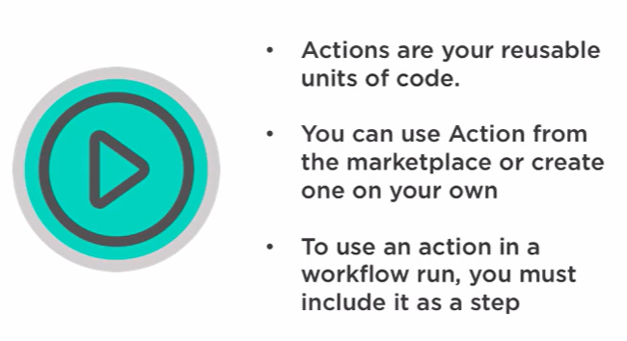

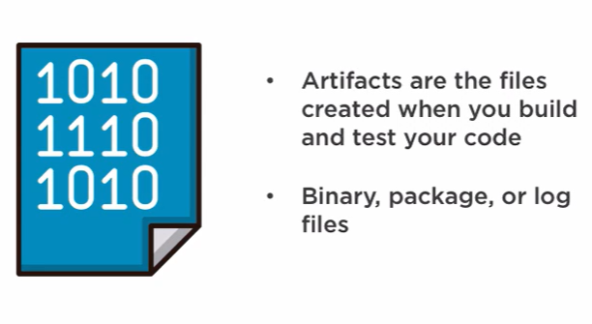

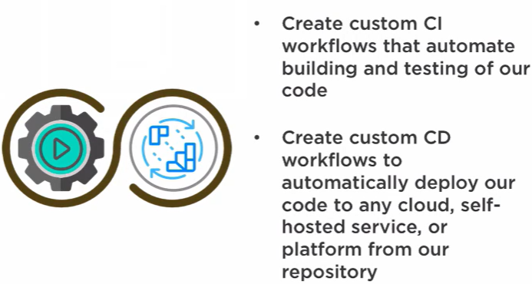

Next is continuous integration and continuous deployment. With GitHub Actions, we can create custom CI workflows that automate building and testing of our code, and we can view the status of our code changes and detailed logs for each action in our workflow. Continuous deployment builds upon continuous integration. When new code is committed and passes any CI tests, the code can be automatically deployed to a production environment. With GitHub Actions, we can create custom CD workflows to automatically deploy our code to any cloud self‑hosted service or platform for our repository. This is an area where GitHub Actions really shines

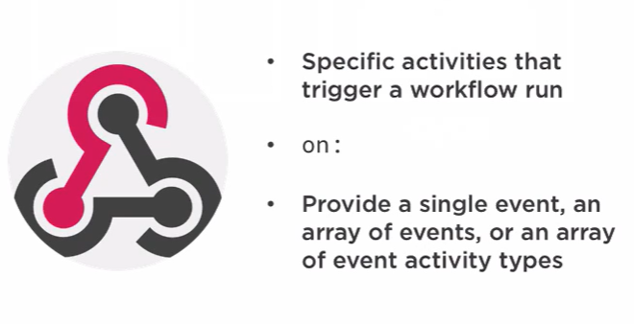

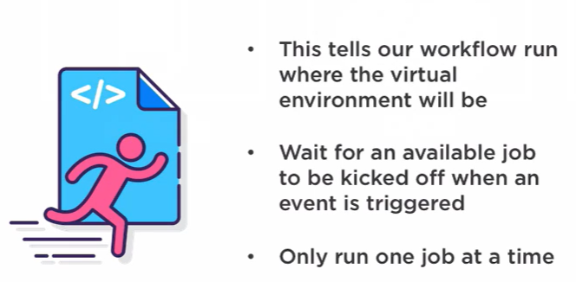



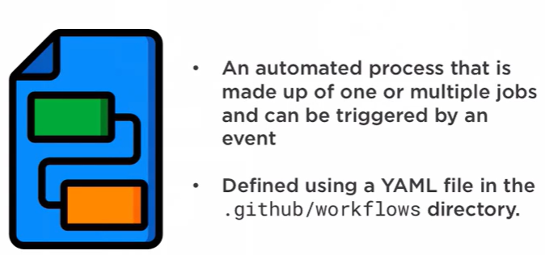

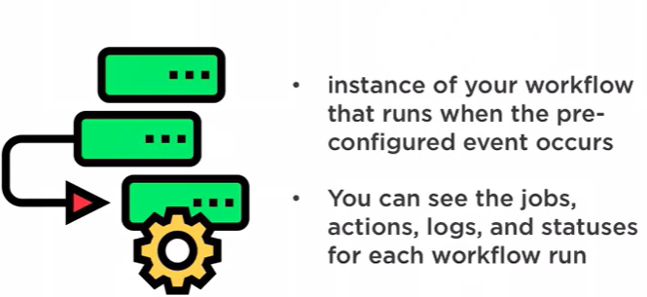

Links

https://github-actions-hero.now.sh

Self Hosted Runners

how to run self hosted runners in gihub actions, give me a yaml file and steps to do

**Copilot said:**

**Copilot**

Running **self-hosted runners** in GitHub Actions allows you to execute workflows on your own infrastructure rather than GitHub's hosted environment. This is useful for custom environments, better performance, or accessing internal resources.

**🛠️ Steps to Set Up a Self-Hosted Runner**

**✅ 1. Prepare the Machine**

* Use any OS: Linux, macOS, or Windows.
* Ensure it has internet access and can run your build tools.

**✅ 2. Register the Runner**

1. Go to your GitHub repository.
2. Navigate to **Settings > Actions > Runners**.
3. Click **"New self-hosted runner"**.
4. Choose your OS and follow the instructions to:
   * Download the runner package.
   * Configure it using the provided token.
   * Start the runner.

Example for Linux:

# Download

curl -o actions-runner-linux-x64-2.308.0.tar.gz -L https://github.com/actions/runner/releases/download/v2.308.0/actions-runner-linux-x64-2.308.0.tar.gz

# Extract

tar xzf actions-runner-linux-x64-2.308.0.tar.gz

# Configure

./config.sh --url https://github.com/your-org/your-repo --token YOUR_TOKEN

# Start

./run.sh

**✅ 3. Add the Runner to a Workflow**

Here’s a sample **GitHub Actions YAML** that uses a self-hosted runner:

name: CI with Self-Hosted Runner

on:

  push:

    branches:

      - main

jobs:

  build:

    runs-on: self-hosted  # This targets your self-hosted runner

    steps:

      - name: Checkout code

        uses: actions/checkout@v3

      - name: Run build

        run: |

          echo "Building on self-hosted runner..."

          make build

You can also specify labels if you added them during runner setup:

* runs-on: [self-hosted, linux, x64]

**🔐 Security Tips**

* Run the runner in a sandboxed environment.
* Use labels to control which jobs run on which runners.
* Keep the runner software updated.

Would you like help setting this up on a specific OS or integrating it with a real project?

You said:

Choose your OS and follow the instructions to: Download the runner package. Configure it using the provided token. Start the runner.  
  
where do I need to perform this 4th step ?

**Copilot said:**

**Copilot**

Great question! The **4th step**—downloading, configuring, and starting the self-hosted runner—needs to be performed **on the machine that you want to use as the runner**.

**🖥️ Where to Perform the Setup**

You should run these commands on a machine that:

* You own or control (e.g., a VM, physical server, cloud instance).
* Has access to the internet and the tools your workflow needs.
* Will stay online and available when GitHub Actions jobs are triggered.

This could be:

* A **Linux server** (e.g., Ubuntu VM on AWS, Azure, or GCP).
* A **Windows desktop or server**.
* A **macOS machine** (for mac-specific builds).

**📦 Example: Setting Up on an Ubuntu VM**

1. **SSH into your VM**:

ssh your-user@your-vm-ip

1. **Download the runner**:

curl -o actions-runner-linux-x64-2.308.0.tar.gz -L https://github.com/actions/runner/releases/download/v2.308.0/actions-runner-linux-x64-2.308.0.tar.gz

1. **Extract and configure**:

tar xzf actions-runner-linux-x64-2.308.0.tar.gz

cd actions-runner

./config.sh --url https://github.com/your-org/your-repo --token YOUR_TOKEN

1. **Start the runner**:

./run.sh

You can also set it up as a **systemd service** so it runs automatically on boot.

Would you like help setting this up on a specific OS or cloud provider like AWS or Azure?

**GitHub Actions Use Case**

