Docker  
  
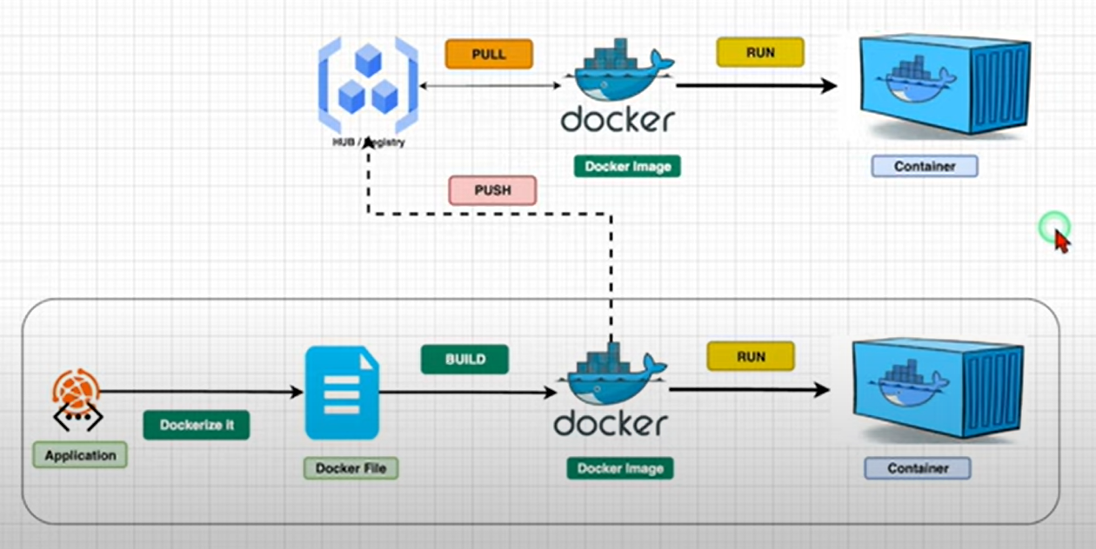  
  
  
K8s

Helm charts

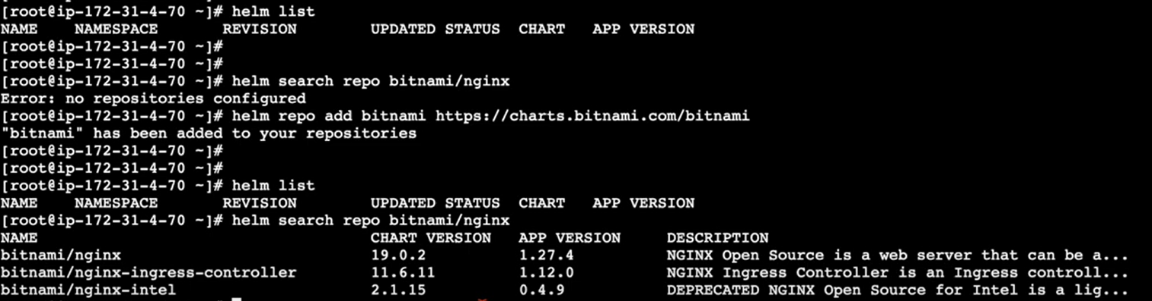

* helm search hub nginx

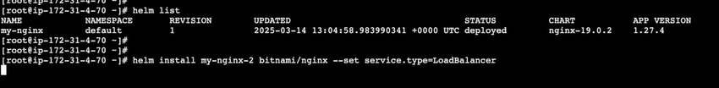

* helm repo update

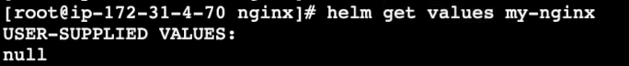





Creating app with helm

Made same changes in deployment.yaml file and upgraded with below commands



