SQL – Structured Query Language

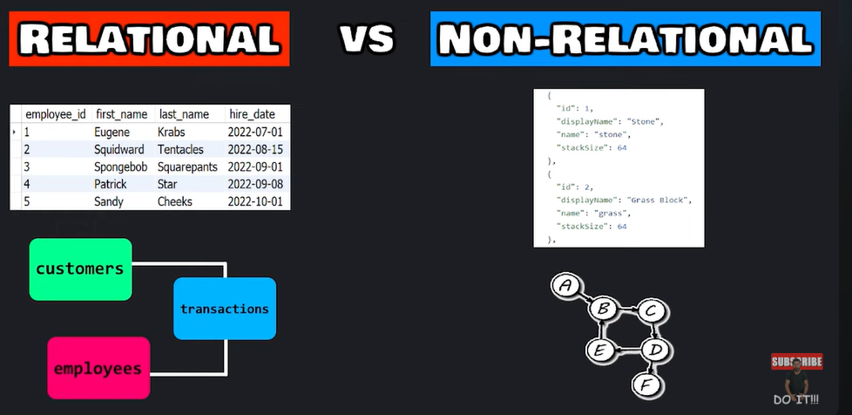

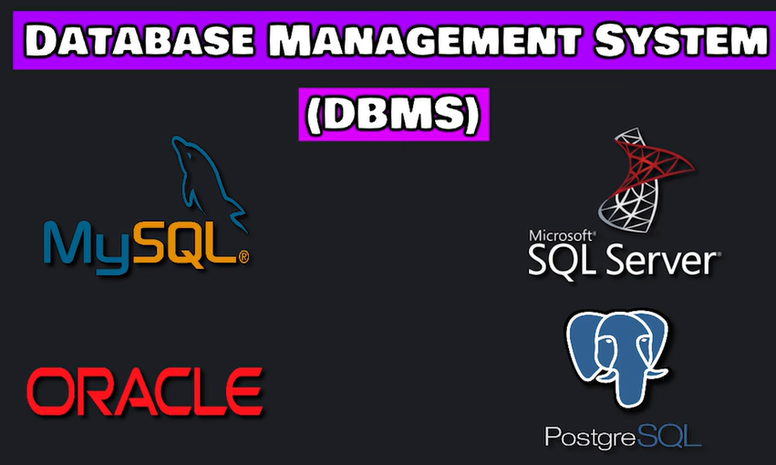

**SQL is Case Insensitive**

* **How to create a DATABASE**

**CREATE**

create database mydb;

**DROP**

Drop database mydb;

**ALTER**

Alter database mydb read only = 1;

* How to create a **TABLE**

**CREATE**

create table employees(

emp_id int,

f_name varchar(25),

l_name varchar(25),

hourly_pay decimal(5,2),

hire_date date

);

select * from employees;

rename table employees to workers;

rename table workers to employees;

**DROP**

drop table employees;

**ALTER**

**# adding column phone_number**  
alter table employees

add phone_number varchar(15);  
  
select * from employees;

**#renaming column name phone_number to email**

alter table employees

rename column phone_number to email;

**# modifying column email datatype**

alter table employees

modify column email varchar(25);

**#modifying column email position just after l_name**

alter table employees

modify column email varchar(25)

after l_name;

select * from employees;

**#modifying column email position at first**

alter table employees

modify column email varchar(25)

first ;

select * from employees;

**# drop column email**

alter table employees

drop column email;

select * from employees;

**INSERT**

**# inserting values into tables**

insert into employees

values (1, ”Bhavitha”, ”Narmeta”, 45.12,”2021-11-23”),

(2, "Sravya", "Vellore", 60.00, "2022-11-07"),

(3, "Janvika", "Appasani", 65.75, "2021-11-07");

select * from employees;

**# inserting values into tables in specified columns**

insert into employees (emp_id, f_name, l_name)

values (4, "Meghana", "Konda");

select * from employees;

**SELECT**

select * from employees;

select f_name, l_name

from employees;

select *

from employees

where emp_id = 2;

select *

from employees

where hourly_pay >= 50;

select *

from employees

where hire_date <= "2022-11-23";

select *

from employees

where emp_id != 1;

select *

from employees

where hire_date is NULL;

select *

from employees

where hire_date is not NULL;

* **How to UPDATE and DELETE data from table**

**UPDATE**

update employees

set hourly_pay = 30.00,

hire_date = "2024-01-07"

where emp_id = 4;

select * from employees;  
  
update employees

set hire_date = "NULL"

where emp_id = 4;

select * from employees;  
  
  
update employees

set hourly_pay = 30.00;

select * from employees;  
  
  
**DELETE**delete from employees

where emp_id = 4;

select * from empolyees;

**AUTOCOMMIT, COMMIT, ROLLBACK**  
  
**CONSTRAINTS**  
**1.) UNIQUE CONSTRAINT**CREATE TABLE products(

p_id INT,

p_id VARCHAR(25) UNIQUE,

P_price DECIMAL(4,2)   
  
);  
CREATE TABLE products(

p_id INT,

p_id VARCHAR(25),

P_price DECIMAL(4,2)   
  
);  
  
INSERT INTO products

VALUES (101, “shirt”, 75.00),

(101, “pant”, 85.00),

(101, “shoes”, 75.00);

**# if table is created and want to add UNIQUE CONSTRAINT to a particular colomn**

ALTER TABLE products

ADD CONSTRAINT

UNIQUE(p_name)

**2.) NOT NULL**

CREATE TABLE products(

product_id INT,

product_id VARCHAR(25),

product_price DECIMAL(4,2) NOT NULL   
  
);

**# if already table is created and want to add NOT NULL to a particular colomn**

ALTER TABLE products

MODIFY price DECIMAL(4,2) NOT NULL

**3.) CHECK**create table employees(

emp_id int,

f_name varchar(25),

l_name varchar(25),

hourly_pay decimal(5,2),

hire_date date

CONSTRAINT chk_hourly_pay CHECK (hourly_pay >= 10.00)

);

**# if already table is created and want to add CHECK CONSTRAINT to particular colomn**

ALTER TABLE employees

ADD CONSTRAINT chk_hourly_pay CHECK(hourly_pay >= 10.00);

**DROP CHECK**ALTER TABLE employees

DROP CHECK chk_hourly_pay;  
  
  
4. ) **DEFAULT CONSTRAINT**CREATE TABLE products(

product_id INT,

product_id VARCHAR(25),

product_price DECIMAL(4,2) DEFAULT 0  
  
);

**# if already table is created and want to set DEFUALT to a particular colomn**  
ALTER TABLE products

ALTER P_price SET DEFAULT 0

INSERT INTO products(p_id,p_name)

VALUES ("106", "COVER")  
  
**example**  
  
CREATE TABLE transactions(

transaction_id INT,

amount DECIMAL (5, 2),

transaction_date DATETIME DEFAULT NOW()

);

INSERT INTO transactions(transaction_id, amount)

VALUES (1, 4.99);  
  
  
**PRIMARY KEY**

* **PRIMARY KEY** in a table is applied to a column where the values in it should be **UNIQUE** and **NOT NULL**
* Also there should be only one **PRIMARY KEY**

**Example**

CREATE TABLE transactions(

transaction_id INT PRIMARY KEY,

amount DECIMAL (5,2)

);

**# if table is already created and want to add PRIMARY KEY to a particular colomn**

ALTER TABLE transaction

ADD CONSTRAINT

PRIMARY KEY (transaction_id)

INSERT INTO transactions

VALUES (1002, 9.55);

SELECT * FROM transactions;

SELECT amount

FROM transactions

WHERE transaction_id = 1002

**AUTO_INCREMENT CONSTRAINT**

CREATE TABLE transactions(

transaction_id INT PRIMARY KEY AUTO_INCREMENT,

amount DECIMAL (5, 2)

);  
  
CREATE TABLE transactions(

transaction_id INT PRIMARY KEY AUTO_INCREMENT,

amount DECIMAL (5, 2)

);

ALTER TABLE transactions

AUTO_INCREMENT = 1000  
  
**FOREIGN KEY CONSTRAINT  
  
**

**  
  
example**CREATE TABLE customers(

customer_id INT PRIMARY KEY AUTO_INCREMENT,

first_name VARCHAR(25),

last_name VARCHAR(25)

);

SELECT * FROM customers;  
  
INSERT INTO CUSTOMERS(first_name, last_name)

VALUES ("Rakesh", "Aduri"),

("James", "Bond"),

("Alan", "Walker"),

("Adam", "Smith");

SELECT * FROM CUSTOMERS;  
  
CREATE TABLE transactions(

transaction_id INT PRIMARY KEY AUTO_INCREMENT,

amount DECIMAL (5, 2),

customer_id INT,

FOREIGN KEY (customer_id) REFERENCES customers(customer_id)

);

SELECT * FROM transactions;  
  
**DROP FOREIGN KEY**

ALTER TABLE transactions

DROP FOREIGN KEY transactions_ibfk_1

ALTER TABLE transactions

ADD CONSTRAINT fk_customer_id

FOREIGN KEY (customer_id) REFERENCES customers(customer_id);

ALTER TABLE transactions

AUTO_INCREMENT = 1000;

INSERT INTO transactions(amount, customer_id)

VALUES (4.99, 3),

(2.89, 2),

(2.28, 3),

(4.99, 1);

SELECT * FROM transactions;

DELETE FROM customers

WHERE customer_id = 3;

**INNER JOIN**

INSERT INTO transactions(amount, customer_id)

VALUES (1.00, NULL);

SELECT * FROM transactions;

INSERT INTO customers(first_name, last_name)

VALUES ("poppy", "puff");

SELECT * FROM customers;

SELECT *

FROM transactions INNER JOIN customers

ON transactions.customer_id = customers.customer_id;

SELECT transaction_id, amount, first_name, last_name

FROM transactions INNER JOIN customers

ON transactions.customer_id = customers.customer_id;

**LEFT JOIN  
  
**

SELECT *

FROM transactions LEFT JOIN customers

ON transactions.customer_id = customers.customer_id;

**RIGHT JOIN**

SELECT *

FROM transactions LEFT JOIN customers

ON transactions.customer_id = customers.customer_id;

**FUNCTIONS in MYSQL**

**COUNT**

SELECT COUNT(amount) AS COUNT

FROM transactions;

**SUM**

SELECT SUM(amount) AS TOTAL

FROM transactions;

**AVERAGE**

SELECT AVERAGE(amount) AS AVG

FROM transactions;

**CONCAT**SELECT CONCAT (first_name, “ ”, last_name) AS full_name  
FROM customers;

**LOGICAL OPERATORS**

**AND**

SELECT *

FROM employees

WHERE hire_date < "2022-11-23" AND job = "Sr Analyst";

**OR**

SELECT *

FROM employees

WHERE job = "PMO" OR job = "Sr Analyst";

**NOT**

SELECT *

FROM employees

WHERE NOT job = "BA" AND NOT job = "PMO";

**BETWEEN**

SELECT *

FROM employees

WHERE hire_date BETWEEN "2022-11-07" AND "2024-12-07"

**IN**

SELECT *

FROM employees

WHERE job IN ("Sr Analyst", "Associate Analyst");