**Terraform**  
  
Naming Conventions

You said:

while working with terraform do we need to create main.tf file mandatorily ?

**Copilot said:**

**Copilot**

No, you **do not need to create a main.tf file mandatorily** when working with Terraform. However, here's why it's commonly used and what your options are:

**✅ Why main.tf is commonly used:**

* It's a **convention**, not a requirement.
* It helps organize your Terraform configuration clearly, especially in larger projects.
* Typically contains the **core resources** and **provider configurations**.

**🧩 What Terraform actually requires:**

Terraform looks for **any .tf files** in the working directory. These files are all loaded and processed together. You can split your configuration across multiple files like:

* providers.tf – for provider blocks
* variables.tf – for input variables
* outputs.tf – for output values
* main.tf – for main resource definitions

Or even name them however you like, such as network.tf, compute.tf, etc.

**🛠️ Minimum requirement:**

You just need at least one .tf file with valid Terraform configuration in your working directory. The name doesn't matter.

Would you like help organizing a Terraform project structure or creating a sample configuration?

You said:

for outputs.tf file can we put any other name ?

**Copilot said:**

**Copilot**

Yes, you **can use any name** for the file that contains your Terraform outputs — it doesn't have to be outputs.tf.

**✅ Key Points:**

* Terraform loads **all .tf files** in the working directory, regardless of their names.
* The naming convention like outputs.tf is just for **organization and readability**.
* You could name it my_outputs.tf, final_results.tf, or anything else meaningful to you or your team.

**🔍 Best Practice:**

Stick to conventional names like:

* main.tf
* variables.tf
* outputs.tf
* providers.tf

This makes it easier for others (and future you!) to understand the structure of your project quickly.

Would you like a sample Terraform project layout or help organizing your current one?

------------------------------------------------------------------------------------------------------------------  
**Question**

You said:  
I am learning terraform  
  
I am creating private subnet genrally   
  
what is   
  
cidr_block = element(var.private_subnet_cidrs, count.index) availability_zone = element(var.availability_zones, count.index)  
  
and what is  
  
cidr_block = var.private_subnet_cidrs[count.index] availability_zone = element(var.availability_zones[count.index]

**Copilot said:**

**Copilot**

Great question, Harsha! You're exploring two different ways of accessing elements from a list variable in Terraform. Let's break them down clearly:

**✅ 1. Using element() function:**

* **element(list, index)** is a Terraform function that safely retrieves an item from a list.
* It **wraps around** if the index is out of bounds. For example, if the list has 2 items and the index is 3, it will return the first item again.
* This is useful when you're creating more resources than the number of items in the list and want to **cycle through** them.

**✅ 2. Using direct indexing:**

* This is **direct list indexing**.
* It will **fail with an error** if count.index exceeds the length of the list.
* Use this when you're sure the number of resources you're creating **matches the list length exactly**.

**🔍 So, which one should you use?**

| **Use Case** | **Recommended Syntax** |
| --- | --- |
| You want to **cycle through** a shorter list | element() |
| You want to **strictly map** one-to-one with list items | Direct indexing (list[index]) |

Would you like a quick example with a count loop to see how both behave in practice?

You said:

Yes, please show me an example.

**Copilot said:**

**Copilot**

Here’s a simple example to demonstrate the difference between element() and direct indexing in Terraform when creating private subnets.

**🧪 Scenario:**

You want to create 3 private subnets across 2 availability zones.

**🧾 Variables:**

**🔁 Using element() (safe cycling):**

* **Result:**
  + Subnet 0 → 10.0.1.0/24, us-east-1a
  + Subnet 1 → 10.0.2.0/24, us-east-1b
  + Subnet 2 → 10.0.1.0/24, us-east-1a (cycled back)

✅ No error, even though there are only 2 CIDRs.

**❌ Using direct indexing (strict):**

* **Result:**
  + Subnet 0 → OK
  + Subnet 1 → OK
  + Subnet 2 → ❌ **Error: index out of range**

**✅ Summary:**

| **Method** | **Safe for cycling?** | **Fails on overflow?** | **Use when...** |
| --- | --- | --- | --- |
| element() | ✅ Yes | ❌ No | You want to loop through a shorter list |
| list[index] | ❌ No | ✅ Yes | You want strict 1:1 mapping |

what is here count.index

**Copilot said:**

**Copilot**

Great follow-up! Let's break down what count.index means in Terraform:

**🔢 What is count.index?**

In Terraform, when you use the count meta-argument to create **multiple instances** of a resource, Terraform automatically provides a special variable called count.index.

* **count.index** is the **current index** of the resource being created in the loop.
* It starts from 0 and increments by 1 for each instance.

**🧱 Example:**

Here’s what happens:

| **count.index** | **cidr_block (from list)** | **availability_zone (from list)** |
| --- | --- | --- |
| 0 | var.private_subnet_cidrs[0] | var.availability_zones[0] |
| 1 | var.private_subnet_cidrs[1] | var.availability_zones[1] |
| 2 | var.private_subnet_cidrs[2] or cycles back if using element() | var.availability_zones[2] or cycles back |

**🧠 Think of it like a loop:**

Let me know if you'd like a visual diagram or a real-world analogy to make it even clearer!  
  
  
Abhishek Veeramalla most common task

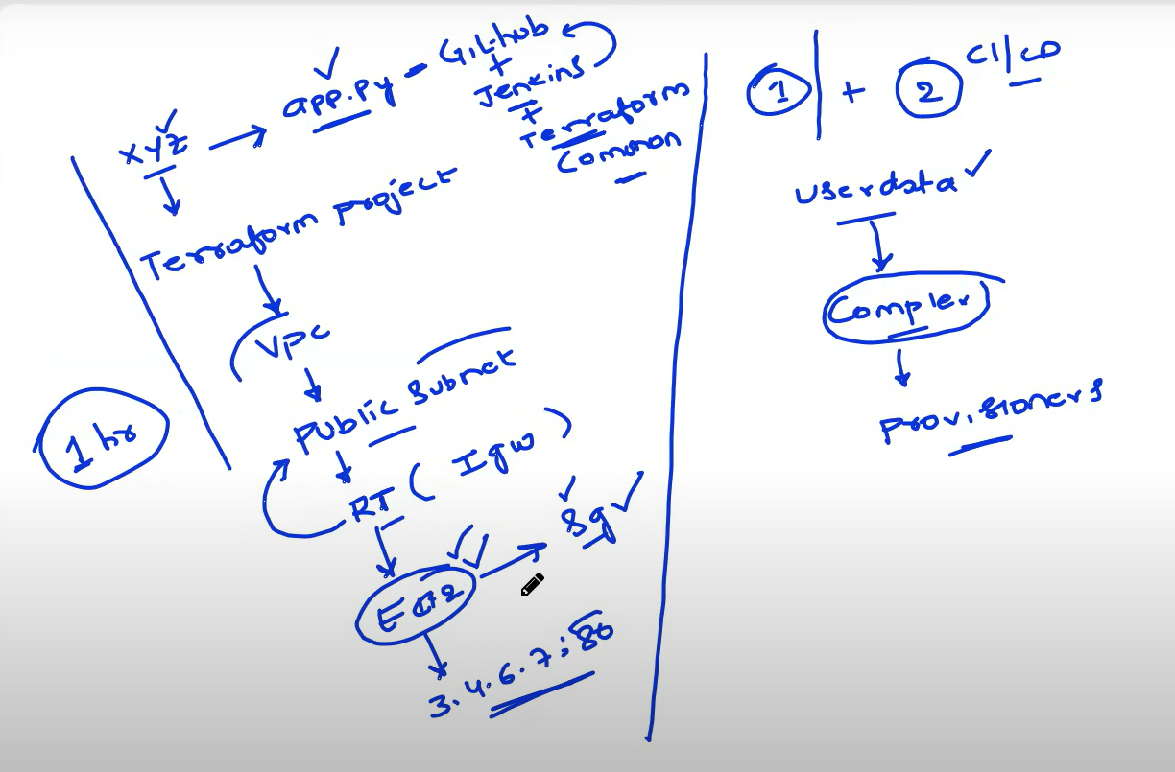

**Managing terraform.tfstate file and locking with s3 backend and dynamodb table**I am working with terraform project where I created a backend folder to to store terraform.tfstate file in s3 bucket and for lock I created a dynamodb table.   
  
now this same s3 and dynamodb table, can I use it for another terraform infrastructure projects also, where I can use to store multiple terraform.tfstate files in one backend s3 bucket only ?

**Copilot said:**

**Copilot**

Yes, you **can absolutely use the same S3 bucket and DynamoDB table** for multiple Terraform infrastructure projects. This is a common and recommended practice for managing Terraform state centrally. However, there are a few important considerations to ensure everything works smoothly:

**✅ How to Use One S3 Bucket for Multiple Projects**

Each Terraform project should have a **unique key** in the backend configuration to avoid overwriting each other's state files.

**Example:**

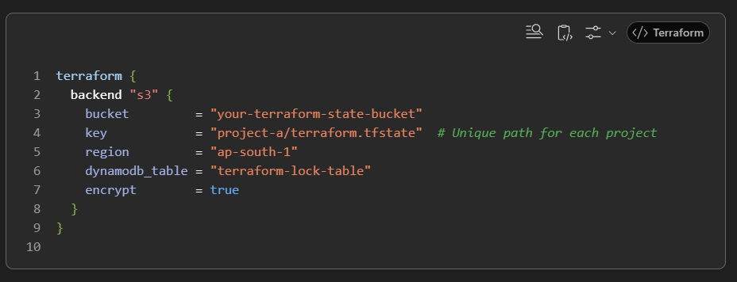

For another project:  
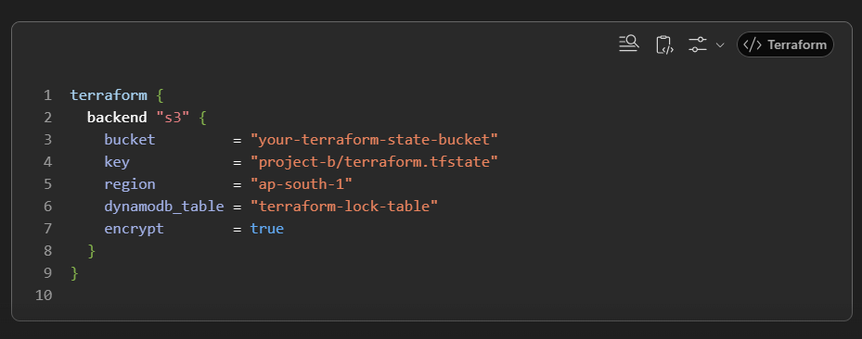

**✅ Benefits of This Setup**

* **Centralized state management**.
* **Reusability** of infrastructure components.
* **Cost-effective** (no need to create multiple buckets or tables).
* **Locking** is still effective because DynamoDB uses the state file key to manage locks.

**⚠️ Things to Watch Out For**

* Ensure **unique key values** for each project.
* Make sure **IAM permissions** allow access to the shared bucket and table.
* Avoid using the same key across environments (e.g., dev, staging, prod) unless intentionally shared.

**Terraform Import**

my backend folder terraform.tfstate file did not stored in s3 bucket actually, its statefile used to be in local, and this got deleted

**Copilot said:**

**Copilot**

Got it — thanks for the clarification!

Since your **Terraform state file was stored locally** and has now been deleted, here's what that means and what you can do next:

**🧨 What Happens When Local terraform.tfstate Is Deleted**

* Terraform **no longer knows** what resources it has created.
* Running terraform plan will show **all resources as new**, even if they already exist in AWS.
* If you run terraform apply, it may try to **recreate resources**, which can lead to errors or duplication.

**🛠️ Recovery Options**

**✅ Option 1: Manually Import Resources**

If the infrastructure still exists in AWS, you can **rebuild the state file** using terraform import.

Example:

Commands:

* terraform import aws_s3_bucket.terraform_state hk-terrform-backend-s3-bucket
* terraform import aws_dynamodb_table.terraform_locks hk-terraform-dynamodb-locks

This will re-associate the existing resources with your Terraform configuration.

**✅ Option 2: Start Fresh (if safe)**

If the resources are disposable or you want to recreate them:

* Run terraform apply again.
* Terraform will treat it as a new deployment and create the resources from scratch.

**🧠 Pro Tip: Move to Remote Backend**

To avoid this issue in the future, consider configuring a **remote backend** (S3 + DynamoDB) so the state file is stored safely in the cloud.

Let me know if you'd like help setting up the remote backend or writing import commands for your existing resources.

**Terraform migrate**

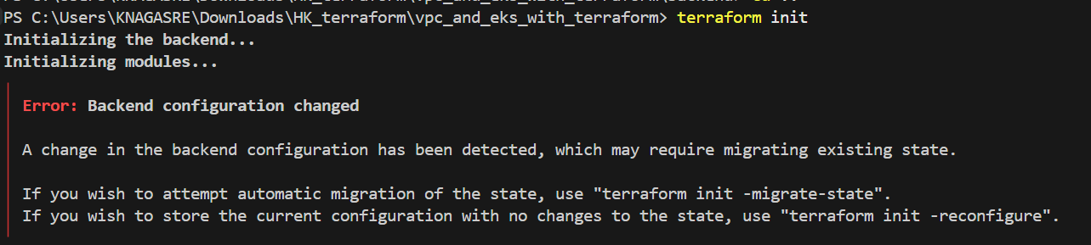

Dynamodb Locking issues (Stale locks)

**🧾 Terraform State Lock Issue – Conversation Summary**

**🟢 User Context**

You are running **two separate Terraform infrastructure projects** using:

* The **same S3 bucket** (hk-terrform-backend-s3-bucket)
* The **same DynamoDB table** for state locking
* **Separate state file paths** for each project

**🧩 Issue Encountered**

When attempting to run terraform destroy on the second project, you received the following error:

Error acquiring the state lock

ConditionalCheckFailedException: The conditional request failed

Lock Info:

ID: 002ecff1-2e42-a86d-35d9-98e3a4b867a8

Path: hk-terrform-backend-s3-bucket/vpc_and_eks_with_terraform/terraform.tfstate

Operation: OperationTypeApply

Who: CORP\knagasre@LIN25007339

**🔍 Diagnosis**

* You confirmed that you **used separate state file paths** for each project.
* You **did not run both projects simultaneously**.
* The error is likely due to a **stale lock** left in the DynamoDB table after destroying the first project.

**🛠️ Solutions Provided**

**✅ Manual Lock Removal via AWS Console**

1. Go to **DynamoDB Console**.
2. Open the table used for Terraform locking.
3. Use **“Explore table items”**.
4. Filter by LockID equal to:

* hk-terrform-backend-s3-bucket/vpc_and_eks_with_terraform/terraform.tfstate

1. Identify the correct item and **delete it**.

**✅ Force Unlock via CLI**

If you're sure no other operation is running:

* terraform force-unlock 002ecff1-2e42-a86d-35d9-98e3a4b867a8

**🛡️ Best Practices Suggested**

* Continue using **unique state file paths** per project.
* Consider using **separate DynamoDB tables** for fully isolated projects.
* Avoid using -lock=false unless performing read-only operations.