Miryala Harshavardhan
Enroll No.15114045

Chart showing the time for execution for
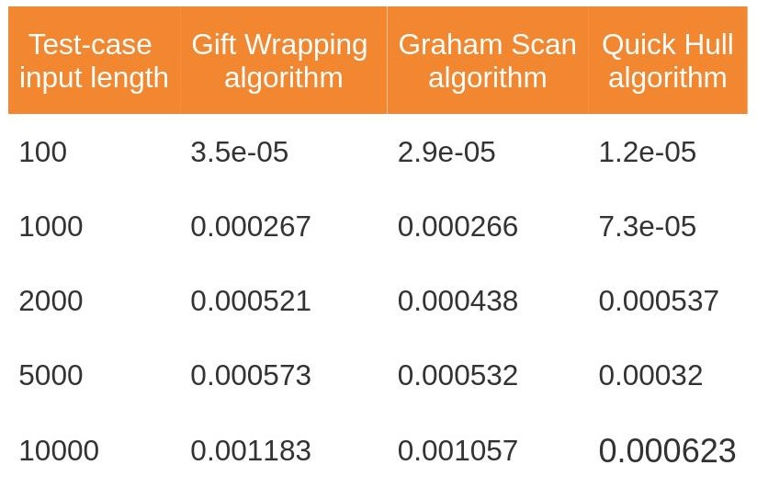
algorithms vs test-cases

These test-cases are generated using “SPOJ Toolkit Test-case generator”.

And the test-cases are uploaded in github repository.

