WEEK 3 TASK REPORT
Data Cleaning and Preprocessing Pipeline Development
A reproducible pipeline for beauty & wellness data
Item | Details
Prepared by | Harshavardhan Reddy
Role | Data Analyst Intern – Beauty & Wellness Analytics
Task | Week 3: Data Cleaning and Preprocessing Pipeline Development
Domain | Beauty & Wellness (skincare, haircare, makeup, supplements, spa services)
Tools | Python 3, pandas, NumPy, scikit-learn, Matplotlib
Date | 2 October 2026
Deliverable | DOC report with methodology, code, flowchart and pilot-run results

1. Executive Summary
The quality of any analysis or model is limited by the quality of the data behind it. Beauty and wellness data is especially messy: product names are typed in many spellings, prices appear in different currencies and formats, skin types are self-reported in free text, and customer reviews often contain gaps, duplicates and impossible values.
This report documents a ten-stage data cleaning and preprocessing pipeline built for that environment. To confirm that the design works in practice and not only on paper, I created a simulated raw dataset of 2,120 records containing realistic, deliberately injected defects, and ran the pipeline on it end-to-end using Python.
Key results of the pilot run:
- 120 duplicate records removed and 20 inconsistent category spellings merged into 5 clean labels.
- Prices stored as text in three styles (“$24.99”, “Rs. 1,999”, “12.5 USD”) converted into one numeric USD column; 732 non-standard dates parsed into one datetime type.
- 34 impossible values (ratings outside 1–5, ages such as 0 or 250, non-positive prices, future dates) detected and neutralised.
- 21 price outliers flagged and capped, reducing the average price from $584 to $43.83 while the median stayed at $35.50.
- Final output: 1,995 analysis-ready rows with zero missing values in key fields, plus a JSON audit log for full traceability.

2. Objective and Scope
The objective of this task is to develop a robust data cleaning and preprocessing pipeline for the beauty and wellness data conceptualised in previous weeks, so that the dataset is ready for accurate analysis and modelling. The scope covers:
- identifying data quality issues likely to appear in publicly available beauty and wellness data;
- defining methods for missing values, outliers, inconsistencies and format standardisation;
- selecting Python libraries and justifying them, with pseudo-code and working code;
- documenting the process for reproducibility; and
- explaining how clean data improves later analysis and modelling.
Because the data collected earlier is conceptual, a simulated raw dataset was used for the practical run. All defect rates in this report therefore illustrate how the pipeline behaves; they are not claims about the prevalence of errors in any real source.

3. Dataset Description
The dataset represents customer reviews and purchases of beauty and wellness products and services. Each row is one review linked to a customer, product and purchase.
Field | Raw type | Description
review_id / customer_id | Integer | Unique review key and customer identifier.
product_name, brand | Text | Product title and brand (e.g. GlowLab Serum).
category | Text | Skincare, Haircare, Makeup, Wellness Supplements, Spa Services.
price | Text (mixed) | Price with symbols or codes: $24.99, Rs. 1,999, 12.5 USD.
rating | Number | Customer rating on a 1–5 scale.
age, skin_type, country | Mixed | Customer demographics (self-reported).
purchase_date | Text (4 formats) | Date of purchase in several formats.
ingredients | Text | Comma-separated list of key ingredients.
review_text | Text | Free-text customer review.
would_recommend | Yes / No | Whether the customer recommends the product.

4. Potential Data Quality Issues in Public Beauty & Wellness Data
Public sources such as e-commerce listings, review sites, open product databases and survey exports share a predictable set of problems. The table lists the main ones, with the impact each would have if left untreated.
Issue | Typical example | Impact if untreated
Inconsistent labels | “Skincare”, “SKINCARE”, “ skincare ” | One category splits into many groups; counts and averages are wrong.
Mixed currencies / price formats | $24.99, Rs. 1,999, 12.5 USD | Prices cannot be averaged or compared; arithmetic fails on text.
Free-text ingredient lists | “Vitamin C” vs “Ascorbic Acid”; different separators | Formulations cannot be compared or counted reliably.
Self-reported skin type | “oily”, “Oily skin”, “OILY” | Label noise weakens segmentation and recommendation models.
Missing demographics | Age or skin type left blank | Biased segment analysis; many models cannot accept NaN.
Impossible or extreme values | Age 250, rating 11, price $250,000 | Distorts means, scaling and model training.
Mixed date formats | 2025-03-04, 04/03/2025, Mar 04, 2025 | Wrong sorting; day/month confusion; broken time-series.
Duplicate records | Same review scraped twice | Inflated review counts and biased ratings.
Spam and incentivised reviews | Repeated text, bursts of 5-star ratings | Overstated satisfaction and unreliable sentiment.
Scale inconsistencies | 5-star vs 10-point vs thumbs up/down | Ratings from different sources are not comparable.
Seasonality and promotions | Festive-season discounts and sales spikes | Misleading price and demand trends.

5. Pipeline Overview and Flowchart
The pipeline has ten stages that run in a fixed order. The order matters: text is standardised before types are converted, validity rules run before outlier detection (so impossible values are not mistaken for outliers), and imputation runs after both (so medians are not contaminated by errors). Each stage is shown below with the rationale for it.
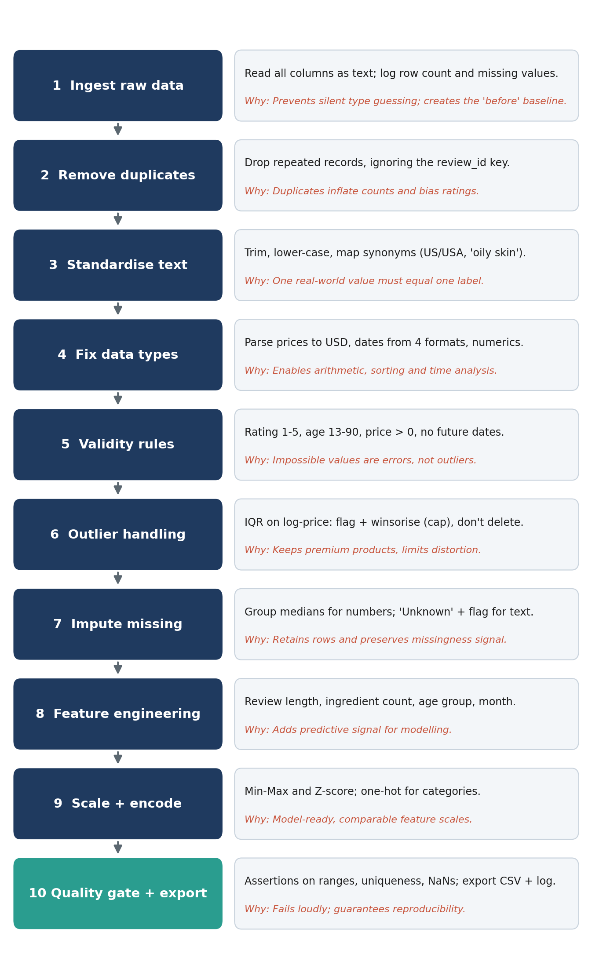
Figure 1: Data preprocessing flowchart with rationale for each stage

6. Step-by-Step Cleaning Methodology

6.1 Load data as text and record a baseline
Every column is read as text first. This prevents pandas from guessing types and silently converting values such as “$24.99” to NaN. The pipeline immediately logs row counts and missing values per column so that every later change can be compared with this baseline. In the pilot data, 784 of 29,680 cells (2.6%) were missing, with review_text (10.8%), age (7.3%) and skin_type (5.6%) the most affected.

6.2 Remove duplicates
Duplicates are identified by comparing all columns except the review ID, because scraped copies often receive a new ID. The first occurrence is kept. The pilot run removed 120 duplicate rows (5.7% of the raw data).
df = df.drop_duplicates(subset=[c for c in df.columns if c != "review_id"], keep="first")

6.3 Standardise text and categories
Text fields are trimmed, lower-cased, and mapped through a synonym dictionary before being converted to a consistent display case. This turned 20 raw category variants into 5, 25 skin-type variants into 5 (plus “Unknown”), 16 brand spellings into 8, and eight country spellings (US, USA, United States, GB, UK, and so on) into four countries plus “Unknown”.
df["skin_type"] = (df["skin_type"].str.strip().str.lower()
.str.replace(r"\s*skin$", "", regex=True).str.title())
df["country"] = df["country"].str.lower().replace(
{"us": "united states", "usa": "united states", "uk": "united kingdom", "in": "india"})

6.4 Fix data types
Prices are parsed with a regular expression that extracts the first numeric token, then converted to USD using a documented, configurable exchange rate (assumed 1 USD = 80 INR). Dates are parsed by trying each known format explicitly rather than letting a library guess. Explicit formats avoid the classic day/month ambiguity in values such as 04/03/2025. In the pilot data, 511 prices were stored as text with symbols or codes and 732 of 2,120 dates (34.5%) were not in ISO format; all were converted.
def parse_price(value):
if pd.isna(value): return np.nan
s = str(value).replace(",", "")
num = float(re.search(r"-?\d+(?:\.\d+)?", s).group()) # first numeric token
return num * USD_PER_INR if ("rs" in s.lower() or "\u20b9" in s) else num

parsed_date = pd.Series(pd.NaT, index=df.index)
for fmt in ["%Y-%m-%d", "%d/%m/%Y", "%b %d, %Y", "%d-%m-%y"]:
attempt = pd.to_datetime(df["purchase_date"], format=fmt, errors="coerce")
parsed_date = parsed_date.fillna(attempt) # keep first successful parse

6.5 Apply validity rules
Some values are not outliers but errors: a rating of 11, an age of 250 or a purchase date in the future cannot be true. These are checked against business rules (rating 1–5, age 13–90, price greater than zero, date not in the future). Violations are counted for the audit log and set to missing so that the imputation step can handle them consistently. The pilot run found 10 invalid ratings, 15 impossible ages, 4 non-positive prices and 5 future dates (34 in total). Rows with an unusable purchase date are dropped because the date is essential for time-based analysis; this accounts for the difference between 2,000 rows after de-duplication and 1,995 in the final output.
df.loc[~df["rating"].between(1, 5), "rating"] = np.nan
df.loc[~df["age"].between(13, 90), "age"] = np.nan
df.loc[df["price_usd"] <= 0, "price_usd"] = np.nan
df.loc[df["purchase_date"] > pd.Timestamp.today(), "purchase_date"] = pd.NaT

6.6 Detect and treat outliers
Beauty prices are strongly right-skewed: a mass-market cleanser may cost $6 while a premium spa package costs several hundred. A plain Z-score assumes a bell-shaped distribution and is itself distorted by extreme values, so it is unsuitable here. Instead, the interquartile range (IQR) rule is applied to the log of the price, with fences at Q1 − 1.5×IQR and Q3 + 1.5×IQR. Values beyond the upper fence are flagged in a separate column and winsorised (capped at the fence) instead of being deleted, so genuine premium products stay in the data with reduced influence. In the pilot run, 21 prices were flagged and the maximum price fell from $250,000 to $176.46.
log_p = np.log1p(df["price_usd"])
q1, q3 = log_p.quantile([.25, .75]); iqr = q3 - q1
hi = q3 + 1.5 * iqr
df["price_outlier_flag"] = (log_p > hi).astype(int) # keep a record
df["price_usd_winsorized"] = df["price_usd"].clip(upper=np.expm1(hi)) # cap, don't delete

6.7 Handle missing values
No single imputation method suits every column. The strategy depends on the data type and on what a missing value means:
Field | Raw missing | Strategy | Rationale
age | 155 (7.3%) | Median by country, then global median | Median is robust to skew; country gives a closer estimate than the overall value.
rating | 106 (5.0%) | Median by category | Ratings are ordinal, so the median respects the 1–5 scale better than the mean.
price | 59 (2.8%) | Median of capped price by category | Prices differ sharply between categories.
skin_type | 118 (5.6%) | “Unknown” + missing flag | A self-reported trait should not be guessed.
country | 43 (2.0%) | “Unknown” + missing flag | Same reasoning; preserves the fact that it was absent.
review_text | 229 (10.8%) | “Unknown” + missing flag | Customers who skip the text may behave differently, so absence is informative.
ingredients | 74 (3.5%) | “Unknown”; ingredient_count = 0 | Avoids inventing formulations.

df["age"] = df["age"].fillna(df.groupby("country")["age"].transform("median"))
df["skin_type_missing"] = df["skin_type"].isna().astype(int)
df["skin_type"] = df["skin_type"].fillna("Unknown")

6.8 Feature engineering, scaling and encoding
Four new features add predictive signal: review_length (words per review), ingredient_count, age_group (13–24, 25–34, 35–44, 45+) and purchase_month. Price and age are scaled in two ways: Min-Max (0 to 1) for algorithms sensitive to range, and Z-score for algorithms that assume centred data. Categorical fields are one-hot encoded so that models do not treat category labels as ordered numbers.
from sklearn.preprocessing import MinMaxScaler, StandardScaler
num_cols = ["price_usd_winsorized", "age"]
df[["price_minmax", "age_minmax"]] = MinMaxScaler().fit_transform(df[num_cols])
df[["price_z", "age_z"]] = StandardScaler().fit_transform(df[num_cols])
df = pd.get_dummies(df, columns=["category", "skin_type"],
prefix=["cat", "skin"], dtype=int)

6.9 Quality gate and export
The final stage asserts that review IDs are unique, ratings are within 1–5, ages within 13–90, prices are positive and no key column contains missing values. If any check fails, the pipeline stops with an error instead of exporting bad data. On success it writes the cleaned CSV and the cleaning_log.json audit file.

7. Pseudo-Code of the Complete Pipeline
The following pseudo-code summarises the logic independently of any language. The full working implementation is in Appendix A.
FUNCTION run_pipeline(raw_csv):
df <- READ raw_csv AS TEXT # no silent type guessing
LOG row_count, missing_per_column # 'before' baseline
df <- DROP DUPLICATES (all columns except ID)
df <- TRIM + LOWERCASE text; MAP synonyms # "USA","US" -> "United States"
df <- PARSE price -> USD, dates (try 4 formats), numerics
FOR each rule IN [rating 1-5, age 13-90, price > 0, date <= today]:
COUNT violations; SET violating cells TO NULL
fence <- (Q1 - 1.5*IQR, Q3 + 1.5*IQR) ON log(price)
FLAG price outliers; WINSORISE price at upper fence
FOR numeric columns: FILL NULL WITH group median
FOR text columns: ADD <col>_missing flag; FILL "Unknown"
df <- ADD features (review_length, ingredient_count, age_group)
df <- SCALE (Min-Max, Z-score) ; ONE-HOT encode categories
ASSERT ranges valid, ID unique, no NULL in key columns
WRITE cleaned csv + cleaning_log.json
RETURN df

8. Tools and Python Libraries
The libraries below were chosen because they are mature, well documented and work together on the same DataFrame structure. The first four were used in the pilot run; the rest are recommended for a production version.
Library | Used for | Why it is suitable
pandas | Loading, grouping, string cleaning, datetime parsing, de-duplication, missing-value handling | Vectorised operations on tabular data; .str, .groupby() and to_datetime() cover most cleaning tasks.
NumPy | log1p / expm1, NaN handling, conditional logic | Fast numerical operations and the standard NaN representation used by pandas.
re (standard library) | Extracting numbers from messy price strings | Precise pattern matching with no extra dependency.
scikit-learn | MinMaxScaler, StandardScaler | Same scaler objects can later be placed inside a model Pipeline, preventing train/test leakage.
Matplotlib / Seaborn | Diagnostic charts (box plots, bar charts) | Visual checks reveal problems that summary statistics hide.
SciPy | Winsorising and statistical tests (optional) | Proven statistical routines such as scipy.stats.mstats.winsorize.
missingno (optional) | Matrix and heatmap of missingness patterns | Shows whether gaps are random or linked across columns.
pandera / Great Expectations (optional) | Declarative data validation | Turns the quality gate into reusable, readable rules with reports.
logging + json | Run logs and audit trail | Zero dependencies; machine-readable record of every run.
Git / GitHub | Version control | Tracks pipeline changes and supports team review.

9. Pilot Run Results
The pipeline was executed on the 2,120-row simulated dataset. The table compares the data before and after cleaning, and Figure 2 summarises the issues treated.
Measure | Raw data | Cleaned data
Rows | 2,120 | 1,995
Duplicate records | 120 | 0
Category labels | 20 variants | 5
Skin-type labels | 25 variants | 6 (incl. Unknown)
Brand labels | 16 variants | 8
Country labels | 8 variants | 5 (incl. Unknown)
Prices stored as text with symbols | 511 | 0 (numeric USD)
Dates not in standard format | 732 | 0 (datetime type)
Missing values in age, rating, price | 320 | 0
Impossible values | 34 | 0
Maximum price | $250,000 | $176.46 (capped)
Mean price (USD) | $584.64 | $43.83
Median price (USD) | $35.50 | $35.50
Columns | 14 | 37 (incl. features and encodings)

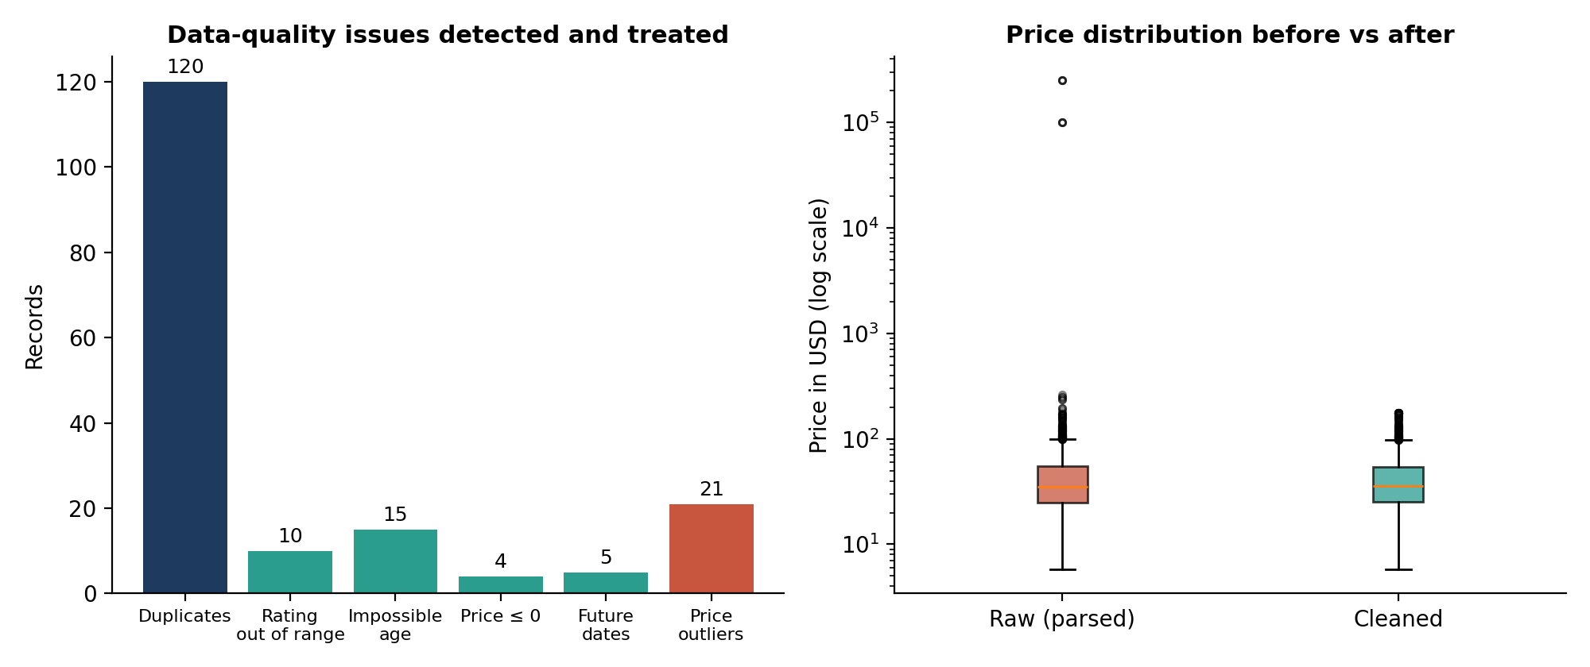
Figure 2: Issues detected and treated (left) and price distribution before and after (right)
The unchanged median ($35.50) alongside a fall in the mean from $584 to $43.83 confirms that the pipeline removed the distortion caused by extreme values without altering the typical product price.

10. Documentation and Reproducibility
A cleaning process is only trustworthy if another analyst can repeat it and get the same result. The following practices are built into the pipeline.
- Raw data is never edited. The original file is read-only; every output goes to a new file.
- One function per step. Each stage takes a DataFrame and returns a DataFrame, so steps can be tested, reordered or reused independently.
- Central configuration. Assumptions such as the exchange rate, valid ranges and the reference date are stated as named constants and documented, not buried in code.
- Audit log. cleaning_log.json records the number of rows affected by each rule, which gives a simple data lineage trail.
- Fixed random seed. The data generator uses seed 42, so the simulated dataset is identical on every run.
- Automated quality gate. Assertions fail loudly if the cleaned data violates any rule.
- Data dictionary. Appendix C lists each engineered column with its definition.
- Pinned environment. Tested with pandas 3.0.2, NumPy 2.4.4, scikit-learn 1.8.0 and Matplotlib 3.10.8, recorded in requirements.txt.
- Unit tests. Small tests protect tricky logic such as price parsing (example below).
def test_parse_price():
assert parse_price("$24.99") == 24.99
assert round(parse_price("Rs. 1,999"), 2) == 24.99 # 1999 / 80
assert parse_price("12.5 USD") == 12.5
assert np.isnan(parse_price(None))

Recommended repository layout:
beauty-wellness-cleaning/
├─ data/
│ ├─ raw/ raw_beauty_wellness.csv (read-only)
│ └─ processed/ cleaned_beauty_wellness.csv
├─ src/
│ ├─ generate_raw_data.py
│ └─ cleaning_pipeline.py
├─ tests/ test_cleaning.py
├─ reports/ cleaning_log.json, figures
├─ requirements.txt
└─ README.md how to run, assumptions, change log

11. How Clean Data Improves Analysis and Modelling
- Correct aggregates. Grouping by category now yields 5 groups instead of 20, so average rating, revenue and review counts per category are accurate.
- Reliable trends. A single datetime type enables correct monthly and seasonal analysis of purchases.
- Representative statistics. With extreme prices capped, the mean reflects typical products ($43.83 rather than $584), which makes price-sensitivity studies meaningful.
- Model-ready inputs. Scaled numeric features suit distance-based methods (K-Means, KNN) and linear models; one-hot columns suit logistic regression and tree-based models.
- Preserved information. Missing-value flags and outlier flags let models learn from the pattern of absence and from premium products instead of losing them.
- Concrete use cases. Predicting would_recommend, segmenting customers by skin type and age group, building product recommendations, studying ingredient-rating relationships, and sentiment analysis of review_text.

12. Domain-Specific Solutions
Solution | Status | Benefit
Missing-value flags alongside imputation | Implemented | Keeps the information that a customer withheld skin type or review text.
Log-scale IQR with flag and winsorising | Implemented | Handles skewed beauty prices; premium items stay in the data.
Cascading explicit date-format parser | Implemented | Avoids day/month guessing errors across mixed sources.
Currency harmonisation inside the parser | Implemented | Combines INR and USD listings into one comparable price.
Synonym maps for skin type and country | Implemented | Merges “oily skin”, “Oily”, “OILY” into one label.
Ingredient normalisation to INCI names | Proposed | Matches “Vitamin C” with “Ascorbic Acid”; enables multi-hot ingredient features.
Review-authenticity heuristics | Proposed | Flags repeated text and 5-star bursts to reduce spam influence.
Price per ml / per gram | Proposed | Fair comparison across pack sizes once size data is available.

13. Limitations and Future Work
- The pilot dataset is simulated, so the defect rates are illustrative. The next step is to run the pipeline on a real public dataset and tune thresholds.
- Imputation assumes values are missing at random within each group. If missingness is systematic (for example, older customers skipping the age field), a model-based method such as KNN or iterative imputation should be tested.
- In this demonstration the scalers are fitted on the whole dataset. Before model training, scaling and imputation statistics should be fitted on the training split only, to avoid data leakage.
- The exchange rate is a fixed assumption; a production version should use dated rates from a trusted source.
- Future work includes a multivariate outlier check (Isolation Forest), text cleaning for multilingual and Hinglish reviews, and automated reports using pandera or Great Expectations.

14. Conclusion
This task produced a complete, documented and tested data cleaning pipeline for beauty and wellness data. It addresses the most common problems of public data – duplicates, inconsistent labels, mixed formats, invalid values, outliers and gaps – using methods matched to the nature of each problem. The pilot run converted 2,120 messy records into 1,995 reliable, model-ready rows and produced an audit trail that makes the process repeatable. The same pipeline can be applied to real data in the coming weeks, giving the later analysis and modelling stages a trustworthy foundation.

Appendix A: Complete Pipeline Code (cleaning_pipeline.py)
The script below runs the complete pipeline. It is also supplied as a separate .py file together with generate_raw_data.py, which creates the simulated input.
"""
Beauty & Wellness Data Cleaning and Preprocessing Pipeline
Author : Harshavardhan Reddy (Data Analyst Intern)
Usage : python cleaning_pipeline.py
Input : raw_beauty_wellness.csv
Output : cleaned_beauty_wellness.csv, cleaning_log.json
"""
import json
import logging
import re

import numpy as np
import pandas as pd
from sklearn.preprocessing import MinMaxScaler, StandardScaler

logging.basicConfig(level=logging.INFO, format="%(asctime)s | %(levelname)s | %(message)s")
log = logging.getLogger("pipeline")

USD_PER_INR = 1 / 80 # documented, configurable FX assumption
REPORT = {} # audit trail written to cleaning_log.json

# ---------------------------------------------------------------- 1. LOAD
def load_data(path: str) -> pd.DataFrame:
# read everything as text first: no silent type guessing
df = pd.read_csv(path, dtype=str)
REPORT["rows_raw"] = len(df)
REPORT["missing_raw"] = df.isna().sum().to_dict()
log.info("Loaded %d rows, %d columns", *df.shape)
return df

# ---------------------------------------------------------------- 2. STRUCTURE
def remove_duplicates(df):
before = len(df)
key_cols = [c for c in df.columns if c != "review_id"]
df = df.drop_duplicates(subset=key_cols, keep="first")
REPORT["duplicates_removed"] = before - len(df)
return df.reset_index(drop=True)

def standardize_text(df):
for col in ["category", "skin_type", "brand", "country", "would_recommend"]:
df[col] = df[col].str.strip().str.lower()
df["skin_type"] = df["skin_type"].str.replace(r"\s*skin$", "", regex=True)
df["country"] = df["country"].replace(
{"us": "united states", "usa": "united states", "in": "india",
"gb": "united kingdom", "uk": "united kingdom", "ae": "uae"})
df["category"] = df["category"].str.title()
df["skin_type"] = df["skin_type"].str.title()
df["country"] = df["country"].str.title()
df["brand"] = df["brand"].str.title()
df["would_recommend"] = df["would_recommend"].map({"yes": 1, "no": 0})
return df

# ---------------------------------------------------------------- 3. TYPE FIXES
def parse_price(value):
"""Convert '$24.99', 'Rs. 1,999', '12.5 USD' -> float in USD."""
if pd.isna(value):
return np.nan
s = str(value).replace(",", "")
match = re.search(r"-?\d+(?:\.\d+)?", s) # first numeric token only
if match is None:
return np.nan
num = float(match.group())
return num * USD_PER_INR if ("rs" in s.lower() or "₹" in s) else num

def fix_types(df):
df["price_usd"] = df["price"].map(parse_price)
df["rating"] = pd.to_numeric(df["rating"], errors="coerce")
df["age"] = pd.to_numeric(df["age"], errors="coerce")
df["customer_id"] = pd.to_numeric(df["customer_id"], errors="coerce").astype("Int64")

d = pd.Series(pd.NaT, index=df.index, dtype="datetime64[ns]")
for fmt in ["%Y-%m-%d", "%d/%m/%Y", "%b %d, %Y", "%d-%m-%y"]: # try each known format
parsed = pd.to_datetime(df["purchase_date"], format=fmt, errors="coerce")
d = d.fillna(parsed)
df["purchase_date"] = d
return df.drop(columns=["price"])

# ---------------------------------------------------------------- 4. VALIDITY RULES
def apply_validity_rules(df):
today = pd.Timestamp("2026-10-02")
bad = {
"rating_out_of_range": ~df["rating"].between(1, 5) & df["rating"].notna(),
"age_impossible": ~df["age"].between(13, 90) & df["age"].notna(),
"price_non_positive": (df["price_usd"] <= 0),
"future_date": df["purchase_date"] > today,
}
for name, mask in bad.items():
REPORT[name] = int(mask.sum())
df.loc[bad["rating_out_of_range"], "rating"] = np.nan
df.loc[bad["age_impossible"], "age"] = np.nan
df.loc[bad["price_non_positive"], "price_usd"] = np.nan
df.loc[bad["future_date"], "purchase_date"] = pd.NaT
return df

# ---------------------------------------------------------------- 5. OUTLIERS
def handle_price_outliers(df):
log_p = np.log1p(df["price_usd"])
q1, q3 = log_p.quantile([.25, .75])
iqr = q3 - q1
lo, hi = q1 - 1.5 * iqr, q3 + 1.5 * iqr
mask = (log_p < lo) | (log_p > hi)
REPORT["price_outliers_flagged"] = int(mask.sum())
df["price_outlier_flag"] = mask.fillna(False).astype(int)
cap_hi = np.expm1(hi)
df["price_usd_winsorized"] = df["price_usd"].clip(upper=cap_hi)
return df

# ---------------------------------------------------------------- 6. MISSING VALUES
def impute_missing(df):
# numeric: median by group (robust to skew)
age_by_country = df.groupby("country")["age"].transform("median")
df["age"] = df["age"].fillna(age_by_country).fillna(df["age"].median())
df["price_usd_winsorized"] = df["price_usd_winsorized"].fillna(
df.groupby("category")["price_usd_winsorized"].transform("median"))
df["rating"] = df["rating"].fillna(df.groupby("category")["rating"].transform("median"))
# categorical: explicit 'Unknown' keeps the signal that data was absent
for col in ["skin_type", "country", "review_text", "ingredients"]:
df[f"{col}_missing"] = df[col].isna().astype(int)
df[col] = df[col].fillna("Unknown")
# a valid date is essential for time analysis, so drop rows without one
df = df.dropna(subset=["purchase_date"]).reset_index(drop=True)
return df

# ---------------------------------------------------------------- 7. FEATURES + SCALING
def engineer_features(df):
df["review_length"] = df["review_text"].str.split().str.len()
known = df["ingredients"].where(df["ingredients"] != "Unknown")
df["ingredient_count"] = known.str.count(",") + 1
df["ingredient_count"] = df["ingredient_count"].fillna(0).astype(int)
df["purchase_month"] = df["purchase_date"].dt.to_period("M").astype(str)
df["age_group"] = pd.cut(df["age"], [12, 24, 34, 44, 90],
labels=["13-24", "25-34", "35-44", "45+"])
return df

def scale_features(df):
num_cols = ["price_usd_winsorized", "age"]
df[["price_minmax", "age_minmax"]] = MinMaxScaler().fit_transform(df[num_cols])
df[["price_z", "age_z"]] = StandardScaler().fit_transform(df[num_cols])
return pd.get_dummies(df, columns=["category", "skin_type"],
prefix=["cat", "skin"], dtype=int)

# ---------------------------------------------------------------- 8. QUALITY GATE
def validate(df):
assert df["review_id"].is_unique, "duplicate review_id"
assert df["rating"].between(1, 5).all(), "rating out of range"
assert df["age"].between(13, 90).all(), "age out of range"
assert (df["price_usd_winsorized"] > 0).all(), "non-positive price"
key = df[["age", "rating", "price_usd_winsorized"]]
assert key.notna().all().all(), "NaN in key columns"
log.info("All data-quality assertions passed")

def run(raw_path="raw_beauty_wellness.csv", out_path="cleaned_beauty_wellness.csv"):
df = load_data(raw_path)
df = remove_duplicates(df)
df = standardize_text(df)
df = fix_types(df)
df = apply_validity_rules(df)
df = handle_price_outliers(df)
df = impute_missing(df)
df = engineer_features(df)
df = scale_features(df)
validate(df)
df.to_csv(out_path, index=False)
REPORT["rows_clean"] = len(df)
REPORT["cols_clean"] = df.shape[1]
key = df[["age", "rating", "price_usd_winsorized"]]
REPORT["missing_clean_key_cols"] = int(key.isna().sum().sum())
with open("cleaning_log.json", "w") as f:
json.dump(REPORT, f, indent=2, default=str)
log.info("Saved %s (%d rows, %d cols)", out_path, *df.shape)
return df

if __name__ == "__main__":
run()

Appendix B: How to Run
pip install pandas==3.0.2 numpy==2.4.4 scikit-learn==1.8.0 matplotlib==3.10.8
python generate_raw_data.py # creates raw_beauty_wellness.csv
python cleaning_pipeline.py # creates cleaned_beauty_wellness.csv and cleaning_log.json

Appendix C: Data Dictionary for Engineered Columns
Column | Definition
price_usd | Price converted to USD (after parsing text and currency); invalid values set to missing.
price_outlier_flag | 1 if the price is above the log-IQR upper fence, otherwise 0.
price_usd_winsorized | price_usd capped at the upper fence; missing values filled with category median.
<field>_missing | 1 if skin_type, country, review_text or ingredients was missing in the source.
review_length | Number of words in review_text; a missing review (“Unknown”) counts as one word.
ingredient_count | Number of comma-separated ingredients; 0 when unknown.
purchase_month | Year-month of purchase (e.g. 2025-07).
age_group | Bucket of age: 13-24, 25-34, 35-44, 45+.
price_minmax, age_minmax | Min-Max scaled price and age (0 to 1).
price_z, age_z | Z-score scaled price and age (mean 0, standard deviation 1).
cat_*, skin_* | One-hot encoded category and skin-type columns.

