WEEK 3 TASK REPORT
Advanced Data Analysis and Visualization in Logistics
Exploring delivery performance, cost drivers and bottlenecks in a simulated logistics network
Item | Details
Prepared by | Harshavardhan Reddy
Role | Data Analyst Intern
Task | Week 3: Advanced Data Analysis and Visualization in Logistics
Dataset | Simulated logistics dataset, 3,000 shipments, January to December 2025
Tools | Python 3, pandas, NumPy, Matplotlib, Seaborn
Date | 2 October 2026
Deliverables | This DOC report, Python script (logistics_analysis.py) and dataset (logistics_dataset.csv)

1. Executive Summary
Logistics is a data-rich business: every shipment produces a record of where it went, how it travelled, how long it took and what it cost. The value lies in turning those records into decisions. This report documents an end-to-end analysis of a simulated logistics dataset of 3,000 shipments, covering data design, exploratory data analysis (EDA), nine visualizations, and recommendations.
Key findings:
- On-time performance is 74.0% overall, but it collapses in the festive peak: 58.9% in October to December versus 80.9% in the rest of the year.
- Carrier choice matters more than transport mode. TransCo delivers on time only 55.8% of the time, against 85.4% for SwiftHaul, while all four transport modes sit within about three points of each other.
- Cost is driven by weight and mode, not by distance alone. Weight correlates with cost at r = 0.55 versus r = 0.26 for distance. Air costs $4.00 per kg, about six times Sea at $0.66.
- Delay causes are concentrated. Warehouse congestion and carrier capacity together explain 56.8% of all delays, so two fixes address more than half the problem.

2. Objective and Scope
The objective is to deepen analytical skills by exploring, analysing and visualizing logistics data in Python, and to present the findings so that they support data-driven decisions. The scope covers:
- defining a hypothetical logistics dataset and its key variables;
- computing central tendencies, distributions and correlations;
- producing multiple visualizations of trends, distributions and relationships, with a justification for each chart type;
- interpreting results in terms of operational efficiency, cost drivers and bottlenecks; and
- documenting the method, code and recommendations.

3. Data Simulation
No real company data was used. A dataset was generated with a fixed random seed (42) so that results are reproducible. Relationships were built in the way a real network behaves: longer distances take longer, faster modes cost more, congestion rises in the festive season, and some carriers are less reliable than others. Because the data is simulated, the findings show how the analysis works, not facts about any real operator.

3.1 Dataset structure
Variable | Type | Description
shipment_id | Text | Unique shipment identifier (SHP100000 onwards)
order_date | Date | Order date, 2025; also split into month and weekday
origin_hub | Category | Dispatch hub: Mumbai, Delhi, Chennai, Kolkata, Hyderabad
destination_region | Category | North, South, East, West, Central
transport_mode | Category | Road, Rail, Air, Sea
carrier | Category | SwiftHaul, BlueLine, TransCo, QuickMove
product_category | Category | Electronics, FMCG, Apparel, Machinery, Pharma
distance_km | Numeric | Route distance, gamma distributed, 80 to 4,500 km
weight_kg / shipment_volume_cbm | Numeric | Shipment size; weight is log-normal, so a few very heavy loads
planned_days / delivery_days | Numeric | Promised and actual delivery time
delay_days / delayed | Numeric | Actual minus planned days; flag = 1 if delay_days > 0
fuel_price_inr | Numeric | Monthly fuel price index with random noise
transport_cost_usd | Numeric | Cost driven by distance, weight, mode, fuel and region
cost_per_kg / cost_per_km | Numeric | Derived unit-cost metrics
delay_cause | Category | Recorded cause for each delayed shipment

3.2 Simulation logic (excerpt)
# delivery time = travel time + warehouse handling + carrier effect + noise
transit = df.distance_km / speed * region_factor
handling = np.random.gamma(2, 0.5, N) + (season - 1) * 2.0 # peak congestion
df["delivery_days"] = np.round(transit + handling + carrier_effect
+ np.random.normal(0, 0.5, N), 1).clip(lower=0.5)
df["delayed"] = (df.delivery_days > df.planned_days).astype(int)

# cost = fixed fee + distance x weight x mode rate, scaled by fuel price
df["transport_cost_usd"] = 30 + df.distance_km * df.weight_kg * mode_rate * (fuel / 90)
Data quality: 60 randomly placed missing values (30 in weight_kg, 30 in fuel_price_inr) were introduced and filled with the column median, which is robust to the skew seen in these variables.

4. Methodology
- Simulate the dataset and save it as a CSV file.
- Treat missing values (median imputation) and derive new metrics: delay_days, cost_per_kg, cost_per_km, season.
- Run descriptive statistics: mean, median, standard deviation, minimum, maximum and skewness.
- Compute the Pearson correlation matrix of numeric variables.
- Group performance by mode, carrier, region and month with groupby aggregations.
- Build nine visualizations with Matplotlib and Seaborn, choosing each chart type for the question it answers.
- Interpret results and convert them into recommendations.

5. Exploratory Data Analysis

5.1 Central tendency and spread
Variable | Mean | Median | Std dev | Min | Max | Skew
Distance (km) | 1053.33 | 973 | 507.51 | 93 | 3743 | 1.01
Weight (kg) | 268.51 | 184.4 | 271.49 | 10 | 2662.6 | 3.05
Delivery days | 4.26 | 3.9 | 2.04 | 0.5 | 17.3 | 1.05
Delay days | -0.48 | -0.5 | 1.01 | -3.3 | 4.7 | 0.54
Cost (USD) | 315.57 | 157.62 | 545.01 | 32.21 | 8260.16 | 6.8
Cost per kg | 1.27 | 0.94 | 1.17 | 0.12 | 10.48 | 3.2
Cost per km | 0.31 | 0.17 | 0.46 | 0.02 | 9.34 | 7.3
Reading the table: delivery time is only mildly right-skewed (mean 4.26 versus median 3.90 days), so the average is a fair summary. Cost is very different. The mean cost of $315.57 is about twice the median of $157.62, and the skewness of 6.80 shows a long tail of expensive shipments. By the 1.5 x IQR rule, 295 shipments (9.8%) are cost outliers, mostly heavy air consignments. For cost, the median and the log scale are therefore more honest than the mean.

5.2 Performance by transport mode
Mode | Shipments | Avg days | Avg cost (USD) | Cost / kg | On-time
Air | 300 | 2.21 | 1077.02 | 4 | 75.7%
Road | 1533 | 3.91 | 284.62 | 1.14 | 74.0%
Rail | 563 | 4.42 | 190.18 | 0.83 | 73.0%
Sea | 604 | 5.98 | 132.79 | 0.66 | 73.8%

5.3 Performance by carrier
Carrier | Shipments | Avg days | Avg delay (days) | On-time
SwiftHaul | 885 | 3.79 | -0.86 | 85.4%
QuickMove | 587 | 4.17 | -0.61 | 80.2%
BlueLine | 809 | 4.38 | -0.44 | 73.0%
TransCo | 719 | 4.75 | 0.05 | 55.8%

5.4 Correlations
Key Pearson correlations: distance and delivery time r = 0.68 (strong); weight and cost r = 0.55 (moderate); distance and cost r = 0.26 (weak); fuel price and cost r = 0.01 (almost none). Weight and volume are nearly the same signal (r = 0.96), so only one is needed in any cost model.

5.5 EDA code
num = ["distance_km", "weight_kg", "delivery_days", "delay_days",
"transport_cost_usd", "cost_per_kg", "cost_per_km", "fuel_price_inr"]
desc = df[num].describe().T
desc["median"] = df[num].median()
desc["skew"] = df[num].skew()
corr = df[num].corr()

on_time = 100 * (1 - df.delayed.mean())
by_mode = df.groupby("transport_mode").agg(days=("delivery_days", "mean"),
cost=("transport_cost_usd", "mean"), cpk=("cost_per_kg", "mean"))
by_carrier = df.groupby("carrier").delayed.apply(lambda s: 100 * (1 - s.mean()))

6. Visualizations and Interpretation
Each figure below follows the same pattern: why this chart type was chosen, the code that produces it, and what it shows.

6.1 Distribution of delivery time
Why this chart: A histogram with a density curve is the standard way to see the shape of one numeric variable. It shows the typical value, the spread and any long tail at once, and the mean and median lines show whether the data is skewed.
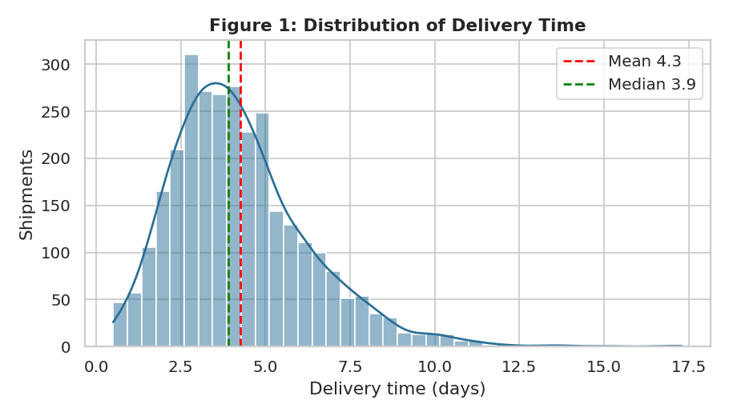
What it shows: Delivery time is single-peaked, centred near 4 days, with a right tail reaching 17 days. The mean (4.26) sits above the median (3.90), confirming mild right skew. The tail is the operational concern: a small number of shipments take several times longer than typical, and these drive complaints.
sns.histplot(df.delivery_days, bins=40, kde=True)
plt.axvline(df.delivery_days.mean(), color="red", ls="--")
plt.axvline(df.delivery_days.median(), color="green", ls="--")

6.2 Delivery time by transport mode
Why this chart: A box plot compares a distribution across categories. It shows the median, quartiles and outliers for every mode in one view, which a table of averages cannot do.
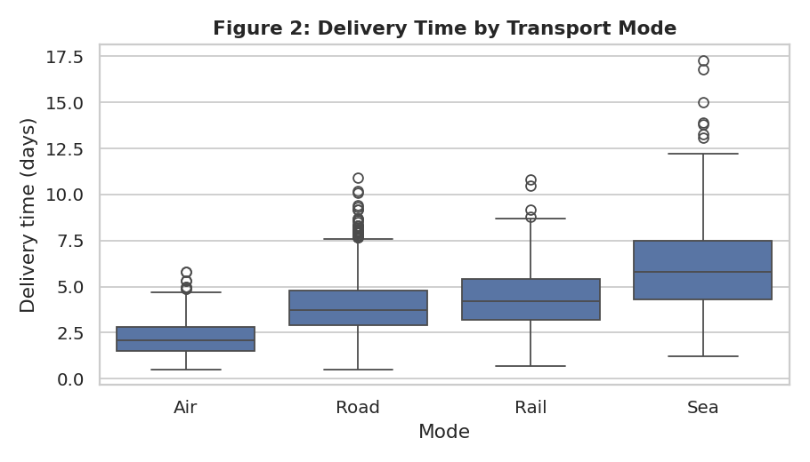
What it shows: Air is fastest (median about 2 days) and Sea slowest (about 6 days), with Road and Rail between. Sea and Rail also show wider boxes, meaning less predictable arrival times, which matters when customers need firm delivery windows.
sns.boxplot(data=df, x="transport_mode", y="delivery_days",
order=["Air", "Road", "Rail", "Sea"])

6.3 Monthly volume and on-time rate (trend)
Why this chart: Time-based questions need a time axis. Bars show volume and a line shows on-time %, on a secondary axis, so the relationship between load and service quality is visible together.
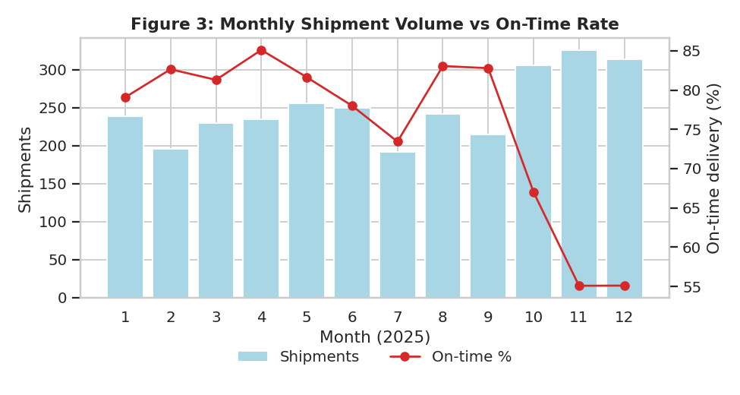
What it shows: Volume jumps from about 240 shipments a month to over 300 from October to December. On-time delivery falls from around 80 to 85% to 55% in November and December. Service quality degrades exactly when demand rises, which points to a capacity and congestion bottleneck.
ax.bar(monthly.index, monthly.n)
ax2 = ax.twinx()
ax2.plot(monthly.index, monthly.ontime, color="#d62828", marker="o")

6.4 Distance versus transport cost
Why this chart: A scatter plot is the right tool for the relationship between two numeric variables. Colouring by mode adds a third dimension, and a log scale on cost handles the heavy skew (6.80) that would otherwise squash most points at the bottom.
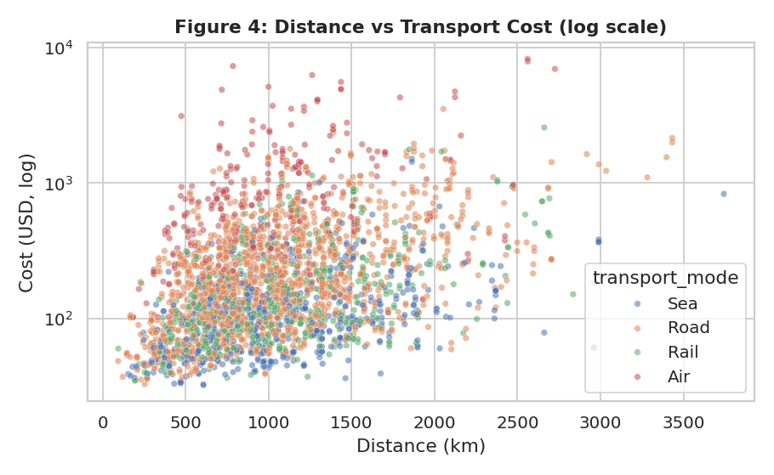
What it shows: The cloud rises with distance but is very wide: at the same distance, cost varies by two orders of magnitude. The colour layers show the reason. Air sits at the top, Road and Rail in the middle, and Sea at the bottom. Mode and weight explain cost better than distance does.
sns.scatterplot(data=df, x="distance_km", y="transport_cost_usd",
hue="transport_mode", alpha=.55)
plt.yscale("log")

6.5 Correlation heatmap
Why this chart: A heatmap summarises every pairwise correlation in one picture, so strong relationships and redundant variables can be spotted quickly before any modelling.
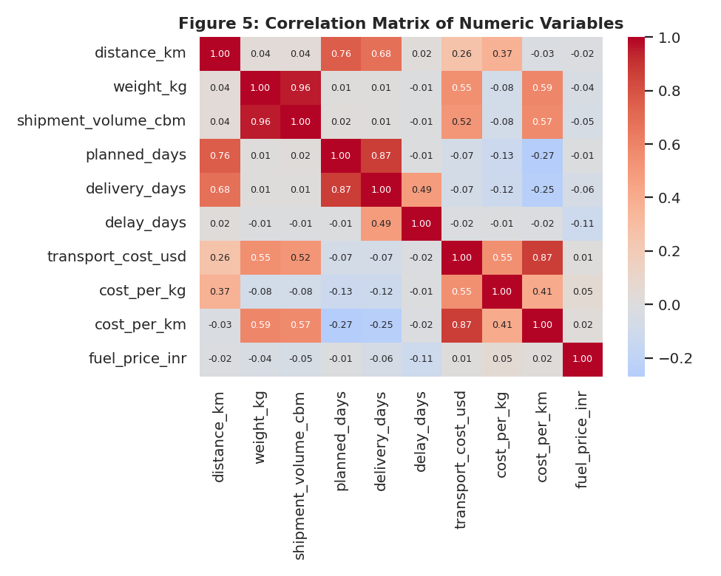
What it shows: Distance drives planned and actual delivery time (r = 0.76 and 0.68). Weight and volume drive cost (r = 0.55 and 0.52) and are almost duplicates of each other (0.96). Fuel price shows no linear link to cost (0.01) because its monthly swings are small compared with other factors. The map also shows that delay_days is unrelated to distance or weight: delays come from process issues, not shipment characteristics.
sns.heatmap(df[num].corr(), annot=True, fmt=".2f",
cmap="coolwarm", center=0)

6.6 Cost per kg by transport mode
Why this chart: A bar chart with error bars compares a summary metric across a few categories. Cost per kg normalises for shipment size, which makes modes comparable.
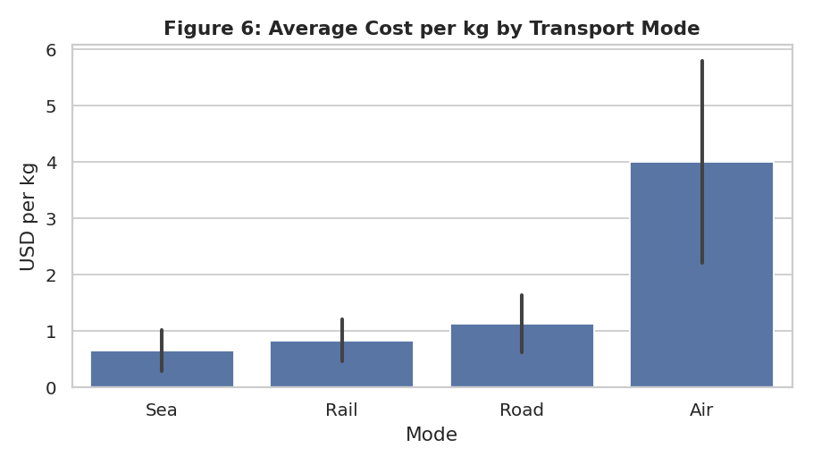
What it shows: Air costs about $4.00 per kg, Road $1.14, Rail $0.83 and Sea $0.66. The error bars show that Road and Air costs vary a lot, while Sea and Rail are steadier. Moving suitable non-urgent freight from Air or Road to Rail would cut unit cost materially.
sns.barplot(data=df, x="transport_mode", y="cost_per_kg",
order=["Sea", "Rail", "Road", "Air"], errorbar="sd")

6.7 On-time rate by carrier
Why this chart: A sorted horizontal bar chart ranks entities clearly and leaves room for readable labels. Ranking is what a carrier review meeting needs.
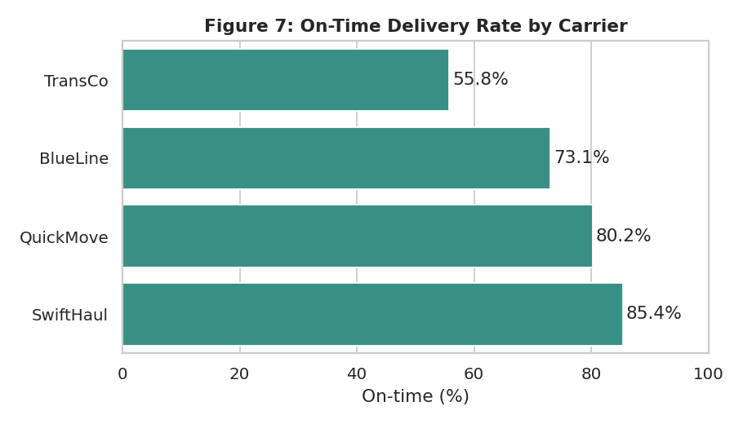
What it shows: SwiftHaul leads at 85.4%, followed by QuickMove (80.2%) and BlueLine (73.1%). TransCo trails at 55.8%, nearly 30 points behind the best. Since TransCo handles about 24% of shipments, it is the single largest source of lateness.
ct = df.groupby("carrier").delayed.apply(lambda s: 100*(1-s.mean())).sort_values()
sns.barplot(x=ct.values, y=ct.index)

6.8 Delay rate by carrier and season (bottleneck view)
Why this chart: A two-way heatmap makes interaction effects visible. Here it tests whether poor performance is caused by the carrier, by the season, or both.
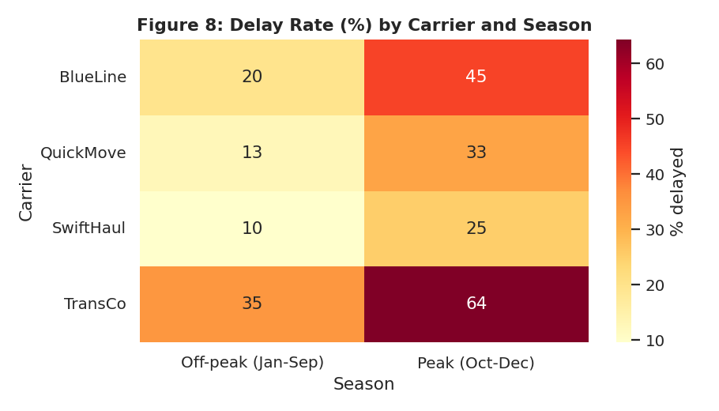
What it shows: Every carrier gets worse in peak season, but not equally. SwiftHaul rises from 10% to 25% delayed, while TransCo rises from 35% to 64%. Season and carrier effects stack: the weakest carrier in the busiest months is the worst combination in the network.
hm = df.pivot_table(index="carrier", columns="season",
values="delayed", aggfunc="mean") * 100
sns.heatmap(hm, annot=True, fmt=".0f", cmap="YlOrRd")

6.9 Pareto chart of delay causes
Why this chart: A Pareto chart combines sorted bars with a cumulative line, following the idea that a few causes produce most of the problem. It tells a manager where to act first.
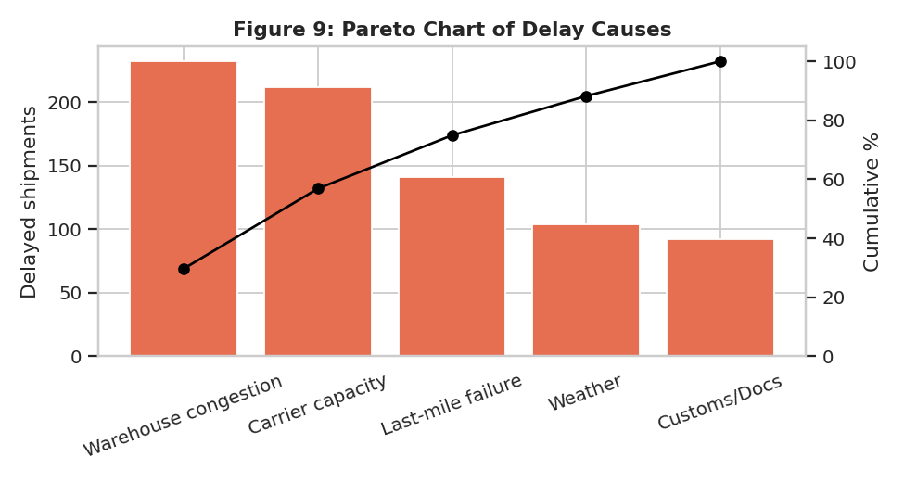
What it shows: Warehouse congestion (29.7%) and carrier capacity (27.1%) account for 56.8% of delays. Adding last-mile failure takes the total to about 75%. Weather and customs, which are harder to control, together make up only about a quarter.
cc = df.loc[df.delayed == 1, "delay_cause"].value_counts()
ax.bar(cc.index, cc.values)
ax2.plot(cc.index, 100 * cc.cumsum() / cc.sum(), marker="o")

7. How the Visualizations Support Logistics Metrics
Metric | Visualization | Decision it supports
Delivery time (lead time) | Histogram, box plot (Figs 1, 2) | Set realistic promised delivery windows; choose mode by urgency
On-time delivery rate | Trend chart, carrier bars (Figs 3, 7) | Carrier scorecards and peak-season capacity planning
Cost per kg / per shipment | Scatter, bar chart (Figs 4, 6) | Mode selection and rate negotiation
Cost drivers | Correlation heatmap (Fig 5) | Decide which variables to include in cost forecasting
Bottlenecks | Two-way heatmap, Pareto (Figs 8, 9) | Prioritise fixes where most delay is concentrated

8. Analytical Insights

8.1 Operational efficiency
Overall, 74.0% of shipments arrive on or before plan, and late shipments are late by only 0.82 days on average. The problem is therefore the frequency of delay, not its size. Shipments are planned with a buffer of about half a day, which hides some inefficiency but also means that small disruptions tip many shipments into lateness. Efficiency is acceptable off-peak (80.9%) and poor in peak season (58.9%).

8.2 Cost drivers
Weight, volume and transport mode explain most of the cost variation. Distance matters, but only through its interaction with mode and weight. Fuel price had almost no visible effect in this dataset, so fuel surcharges deserve scrutiny. Cost is highly skewed, so a small number of heavy or air shipments account for a disproportionate share of spend, and reporting should use the median and cost per kg rather than the simple average.

8.3 Potential bottlenecks
- Peak-season warehouse capacity: delays rise sharply when monthly volume exceeds roughly 300 shipments.
- A single under-performing carrier: TransCo is late on more than one in three off-peak shipments and nearly two in three in peak.
- Process causes, not geography: delay_days shows no correlation with distance or weight, and region differences in on-time rate are small (72.8% to 74.5%), so fixes should target warehouses and carrier contracts rather than specific lanes.

9. Recommendations
- Add warehouse capacity or temporary labour from October. Congestion is the largest single delay cause (29.7%) and the on-time rate falls to 55% in November and December.
- Put TransCo on a performance improvement plan and shift part of its volume to SwiftHaul and QuickMove, especially in peak months. Add service-level penalties to the contract.
- Move non-urgent, heavy freight from Road and Air to Rail or Sea. Rail costs about 27% less per kg than Road, and Sea about 42% less.
- Reserve Air for genuinely urgent shipments, since it costs about six times Sea per kg and is only about two days faster than Road.
- Pre-book carrier capacity before the peak and diversify carriers, which addresses the second largest delay cause (carrier capacity, 27.1%).
- Build a monthly dashboard from Figures 3, 7 and 9, and report the median cost, cost per kg and on-time rate rather than simple averages.

10. Limitations
The data is simulated, so relationships such as the peak-season effect and the weakness of TransCo were built in and then rediscovered by the analysis. That is a useful test of the method, but on real data the same steps should be repeated and the effects tested for statistical significance. Correlation does not prove causation, and the simulation does not model factors such as driver shortages, road closures or customer-side failures.

11. Conclusion
The analysis shows how a structured EDA and well-chosen visualizations convert raw shipment records into operational decisions. Histograms and box plots described delivery time, scatter plots and heatmaps explained cost, and the Pareto chart and carrier-by-season heatmap located the bottlenecks. The main message is that service quality depends on peak-season capacity and carrier selection, and cost depends on weight and mode. Acting on those two points would improve both reliability and spend.

Appendix: Complete Python Script
The same script is supplied as the separate file logistics_analysis.py. Running it regenerates the dataset, summary statistics, correlation matrix and all nine figures.
"""
Week 3: Advanced Data Analysis and Visualization in Logistics
Author: Harshavardhan Reddy
Steps: 1) simulate dataset 2) EDA 3) visualizations 4) export stats
"""
import json
import numpy as np
import pandas as pd
import matplotlib
matplotlib.use("Agg")
import matplotlib.pyplot as plt
import seaborn as sns

np.random.seed(42)
sns.set_theme(style="whitegrid", palette="deep")
plt.rcParams.update({"figure.dpi": 130, "axes.titleweight": "bold", "axes.titlesize": 12})
OUT = "charts/"

# ---------------------------------------------------------------- 1. SIMULATION
N = 3000
regions = {"North": 1.0, "South": 1.05, "East": 1.15, "West": 0.95, "Central": 1.0}
modes = { # base speed km/day, cost per kg-km, reliability
"Road": dict(speed=450, cpk=0.0009, p=0.50),
"Rail": dict(speed=380, cpk=0.0006, p=0.20),
"Air": dict(speed=1500, cpk=0.0040, p=0.10),
"Sea": dict(speed=250, cpk=0.0004, p=0.20),
}
carriers = {"SwiftHaul": 0.0, "BlueLine": 0.4, "TransCo": 0.9, "QuickMove": 0.2}
categories = ["Electronics", "FMCG", "Apparel", "Machinery", "Pharma"]

df = pd.DataFrame({
"shipment_id": [f"SHP{100000+i}" for i in range(N)],
"order_date": pd.to_datetime("2025-01-01") + pd.to_timedelta(np.random.randint(0, 365, N), unit="D"),
"origin_hub": np.random.choice(["Mumbai", "Delhi", "Chennai", "Kolkata", "Hyderabad"], N),
"destination_region": np.random.choice(list(regions), N, p=[.22, .22, .16, .24, .16]),
"transport_mode": np.random.choice(list(modes), N, p=[m["p"] for m in modes.values()]),
"carrier": np.random.choice(list(carriers), N, p=[.30, .25, .25, .20]),
"product_category": np.random.choice(categories, N, p=[.2, .3, .2, .15, .15]),
})
df["distance_km"] = np.clip(np.random.gamma(4, 260, N), 80, 4500).round(0)
df["weight_kg"] = np.clip(np.random.lognormal(5.2, 0.9, N), 10, 8000).round(1)
df["shipment_volume_cbm"] = (df.weight_kg / np.random.uniform(120, 250, N)).round(2)
df["month"] = df.order_date.dt.month
df["weekday"] = df.order_date.dt.day_name()

# monthly seasonality (peak in Oct-Dec festive season)
season = df.month.map({10: 1.25, 11: 1.4, 12: 1.35, 1: 0.95, 2: 0.9, 3: 0.95}).fillna(1.0)
# oversample peak months by resampling to create volume trend
w = season / season.sum()
df = df.sample(N, weights=w, replace=True, random_state=1).reset_index(drop=True)
df["shipment_id"] = [f"SHP{100000+i}" for i in range(N)]
season = df.month.map({10: 1.25, 11: 1.4, 12: 1.35, 1: 0.95, 2: 0.9, 3: 0.95}).fillna(1.0)

speed = df.transport_mode.map(lambda m: modes[m]["speed"])
reg = df.destination_region.map(regions)
car = df.carrier.map(carriers)
transit = df.distance_km / speed * reg
handling = np.random.gamma(2, 0.5, N) + (season - 1) * 2.0 # warehouse dwell, peak congestion
df["planned_days"] = np.ceil(transit + 1.5).astype(int)
df["delivery_days"] = np.round(transit + handling + car + np.random.normal(0, 0.5, N), 1).clip(lower=0.5)
df["delay_days"] = (df.delivery_days - df.planned_days).round(1)
df["delayed"] = (df.delay_days > 0).astype(int)

cpk = df.transport_mode.map(lambda m: modes[m]["cpk"])
fuel = 85 + 10 * np.sin(df.month / 12 * 2 * np.pi) + np.random.normal(0, 2, N) # INR/L index
df["fuel_price_inr"] = fuel.round(1)
df["transport_cost_usd"] = (30 + df.distance_km * df.weight_kg * cpk * (fuel / 90)
* np.random.normal(1, 0.08, N) * (1 + 0.15 * (reg - 1))).round(2)
df["cost_per_kg"] = (df.transport_cost_usd / df.weight_kg).round(3)
df["cost_per_km"] = (df.transport_cost_usd / df.distance_km).round(3)

# delay cause for delayed shipments
causes = ["Warehouse congestion", "Carrier capacity", "Weather", "Customs/Docs", "Last-mile failure"]
pc = np.where(df.month.isin([10, 11, 12]), 0.38, 0.22)
df["delay_cause"] = "None"
idx = df.index[df.delayed == 1]
for i in idx:
p = np.array([pc[i], .25, .15, .12, .0]); p[4] = 1 - p[:4].sum()
df.at[i, "delay_cause"] = np.random.choice(causes, p=p)

# inject a few missing values & save raw
for c in ["weight_kg", "fuel_price_inr"]:
df.loc[np.random.choice(df.index, 30, replace=False), c] = np.nan
df.to_csv("logistics_dataset.csv", index=False)
df["weight_kg"] = df.weight_kg.fillna(df.weight_kg.median())
df["fuel_price_inr"] = df.fuel_price_inr.fillna(df.fuel_price_inr.median())

# ---------------------------------------------------------------- 2. EDA
num = ["distance_km", "weight_kg", "shipment_volume_cbm", "planned_days",
"delivery_days", "delay_days", "transport_cost_usd", "cost_per_kg", "cost_per_km", "fuel_price_inr"]
desc = df[num].describe().T
desc["median"] = df[num].median()
desc["skew"] = df[num].skew()
desc = desc[["mean", "median", "std", "min", "max", "skew"]].round(2)
corr = df[num].corr().round(2)

S = {}
S["n"] = N
S["desc"] = desc.to_dict("index")
S["on_time_rate"] = round(100 * (1 - df.delayed.mean()), 1)
S["avg_delay_when_late"] = round(df.loc[df.delayed == 1, "delay_days"].mean(), 2)
S["corr_dist_cost"] = corr.loc["distance_km", "transport_cost_usd"]
S["corr_weight_cost"] = corr.loc["weight_kg", "transport_cost_usd"]
S["corr_dist_days"] = corr.loc["distance_km", "delivery_days"]
S["corr_fuel_cost"] = corr.loc["fuel_price_inr", "transport_cost_usd"]
S["mode"] = df.groupby("transport_mode").agg(n=("shipment_id", "count"), days=("delivery_days", "mean"),
cost=("transport_cost_usd", "mean"), cpk=("cost_per_kg", "mean"),
ontime=("delayed", lambda s: 100 * (1 - s.mean()))).round(2).to_dict("index")
S["carrier"] = df.groupby("carrier").agg(n=("shipment_id", "count"), days=("delivery_days", "mean"),
ontime=("delayed", lambda s: 100 * (1 - s.mean())), delay=("delay_days", "mean")).round(2).to_dict("index")
S["region"] = df.groupby("destination_region").agg(n=("shipment_id", "count"), days=("delivery_days", "mean"),
ontime=("delayed", lambda s: 100 * (1 - s.mean()))).round(2).to_dict("index")
monthly = df.groupby("month").agg(n=("shipment_id", "count"), cost=("transport_cost_usd", "mean"),
ontime=("delayed", lambda s: 100 * (1 - s.mean()))).round(2)
S["monthly"] = monthly.to_dict("index")
S["cause"] = df.loc[df.delayed == 1, "delay_cause"].value_counts().to_dict()
S["peak_ontime"] = round(100 * (1 - df[df.month.isin([10, 11, 12])].delayed.mean()), 1)
S["offpeak_ontime"] = round(100 * (1 - df[~df.month.isin([10, 11, 12])].delayed.mean()), 1)
q1, q3 = df.transport_cost_usd.quantile([.25, .75]); iqr = q3 - q1
S["cost_outliers"] = int((df.transport_cost_usd > q3 + 1.5 * iqr).sum())
S["missing_filled"] = 60
desc.to_csv("summary_statistics.csv"); corr.to_csv("correlation_matrix.csv")

# ---------------------------------------------------------------- 3. VISUALIZATIONS
# Fig 1 histogram + KDE
fig, ax = plt.subplots(figsize=(7, 4))
sns.histplot(df.delivery_days, bins=40, kde=True, color="#2a6f97", ax=ax)
ax.axvline(df.delivery_days.mean(), color="red", ls="--", label=f"Mean {df.delivery_days.mean():.1f}")
ax.axvline(df.delivery_days.median(), color="green", ls="--", label=f"Median {df.delivery_days.median():.1f}")
ax.set(title="Figure 1: Distribution of Delivery Time", xlabel="Delivery time (days)", ylabel="Shipments"); ax.legend()
plt.tight_layout(); plt.savefig(OUT + "fig1_delivery_hist.png"); plt.close()

# Fig 2 boxplot delivery by mode
fig, ax = plt.subplots(figsize=(7, 4))
order = ["Air", "Road", "Rail", "Sea"]
sns.boxplot(data=df, x="transport_mode", y="delivery_days", order=order, ax=ax)
ax.set(title="Figure 2: Delivery Time by Transport Mode", xlabel="Mode", ylabel="Delivery time (days)")
plt.tight_layout(); plt.savefig(OUT + "fig2_box_mode.png"); plt.close()

# Fig 3 monthly trend dual axis
fig, ax = plt.subplots(figsize=(7.5, 4))
ax.bar(monthly.index, monthly.n, color="#a9d6e5", label="Shipments")
ax.set(xlabel="Month (2025)", ylabel="Shipments", title="Figure 3: Monthly Shipment Volume vs On-Time Rate")
ax.set_xticks(range(1, 13))
ax2 = ax.twinx(); ax2.plot(monthly.index, monthly.ontime, color="#d62828", marker="o", label="On-time %")
ax2.set_ylabel("On-time delivery (%)"); ax2.grid(False)
h1, l1 = ax.get_legend_handles_labels(); h2, l2 = ax2.get_legend_handles_labels()
ax.legend(h1 + h2, l1 + l2, loc="upper center", bbox_to_anchor=(0.5, -0.15), ncol=2, frameon=False)
plt.tight_layout(); plt.savefig(OUT + "fig3_monthly_trend.png"); plt.close()

# Fig 4 scatter distance vs cost
fig, ax = plt.subplots(figsize=(7, 4.3))
sns.scatterplot(data=df, x="distance_km", y="transport_cost_usd", hue="transport_mode", alpha=.55, s=18, ax=ax)
ax.set_yscale("log")
ax.set(title="Figure 4: Distance vs Transport Cost (log scale)", xlabel="Distance (km)", ylabel="Cost (USD, log)")
plt.tight_layout(); plt.savefig(OUT + "fig4_dist_cost.png"); plt.close()

# Fig 5 correlation heatmap
fig, ax = plt.subplots(figsize=(7.5, 6))
sns.heatmap(corr, annot=True, fmt=".2f", cmap="coolwarm", center=0, annot_kws={"size": 7}, ax=ax)
ax.set_title("Figure 5: Correlation Matrix of Numeric Variables")
plt.tight_layout(); plt.savefig(OUT + "fig5_corr.png"); plt.close()

# Fig 6 cost per kg by mode (violin/bar)
fig, ax = plt.subplots(figsize=(7, 4))
sns.barplot(data=df, x="transport_mode", y="cost_per_kg", order=["Sea", "Rail", "Road", "Air"], errorbar="sd", ax=ax)
ax.set(title="Figure 6: Average Cost per kg by Transport Mode", xlabel="Mode", ylabel="USD per kg")
plt.tight_layout(); plt.savefig(OUT + "fig6_cost_kg.png"); plt.close()

# Fig 7 on-time by carrier
fig, ax = plt.subplots(figsize=(7, 4))
ct = df.groupby("carrier").delayed.apply(lambda s: 100 * (1 - s.mean())).sort_values()
sns.barplot(x=ct.values, y=ct.index, color="#2a9d8f", ax=ax)
for i, v in enumerate(ct.values): ax.text(v + .5, i, f"{v:.1f}%", va="center")
ax.set(title="Figure 7: On-Time Delivery Rate by Carrier", xlabel="On-time (%)", ylabel="", xlim=(0, 100))
plt.tight_layout(); plt.savefig(OUT + "fig7_carrier.png"); plt.close()

# Fig 8 heatmap carrier x month-group delay rate
fig, ax = plt.subplots(figsize=(7, 4))
df["season"] = np.where(df.month.isin([10, 11, 12]), "Peak (Oct-Dec)", "Off-peak (Jan-Sep)")
hm = df.pivot_table(index="carrier", columns="season", values="delayed", aggfunc="mean") * 100
sns.heatmap(hm, annot=True, fmt=".0f", cmap="YlOrRd", cbar_kws={"label": "% delayed"}, ax=ax)
ax.set_title("Figure 8: Delay Rate (%) by Carrier and Season"); ax.set(xlabel="Season", ylabel="Carrier")
plt.tight_layout(); plt.savefig(OUT + "fig8_heatmap.png"); plt.close()
S["heat"] = hm.round(1).to_dict("index")

# Fig 9 Pareto of delay causes
fig, ax = plt.subplots(figsize=(7.5, 4))
cc = df.loc[df.delayed == 1, "delay_cause"].value_counts()
ax.bar(cc.index, cc.values, color="#e76f51")
ax.set_ylabel("Delayed shipments"); ax.tick_params(axis="x", rotation=20)
ax2 = ax.twinx(); ax2.plot(cc.index, 100 * cc.cumsum() / cc.sum(), color="black", marker="o")
ax2.set_ylabel("Cumulative %"); ax2.set_ylim(0, 105); ax2.grid(False)
ax.set_title("Figure 9: Pareto Chart of Delay Causes")
plt.tight_layout(); plt.savefig(OUT + "fig9_pareto.png"); plt.close()
S["cause_pct"] = (100 * cc / cc.sum()).round(1).to_dict()

json.dump(S, open("stats.json", "w"), indent=1, default=float)
print(desc); print(corr[["transport_cost_usd", "delivery_days"]])
print(json.dumps({k: S[k] for k in ["on_time_rate", "avg_delay_when_late", "peak_ontime", "offpeak_ontime",
"cost_outliers", "mode", "carrier", "region", "cause_pct", "heat"]}, indent=1, default=float))

