Assignment 10.1

Lab 10 – Code Review and Quality: Using AI to Improve Code Quality and Readability

- Name – harsha
- Date – 15-09-2025
- Subject – AI Assisted Coding
- Hall Ticket Number – 2503a52l04
- Student Mail Id – 2503a52l04@sru.edu.in

Task Description 1 – Syntax and Logic Errors
Task: Use AI to identify and fix syntax and logic errors in a faulty Python script.
Sample Input Code:
# Calculate average score of a student
def calc_average(marks):
total = 0
for m in marks:
total += m
average = total / len(marks)
return avrage # Typo here
marks = [85, 90, 78, 92]
print("Average Score is ", calc_average(marks)
Expected Output:
• Corrected and runnable Python code with explanations of the fixes.
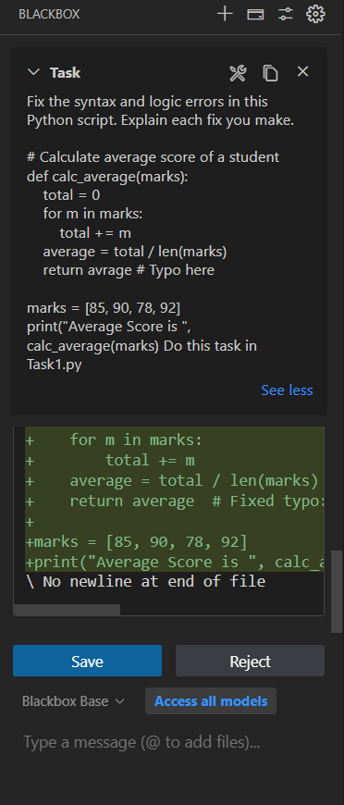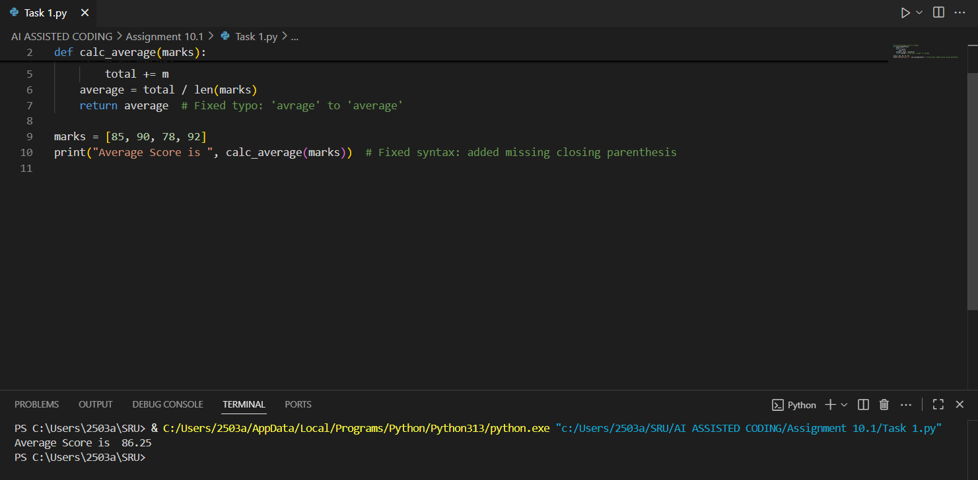

Task Description 2 – PEP 8 Compliance
Task: Use AI to refactor Python code to follow PEP 8 style guidelines.
Sample Input Code:
def area_of_rect(L,B):return L*B
print(area_of_rect(10,20))
Expected Output:
• Well-formatted PEP 8-compliant Python code

Screenshots :
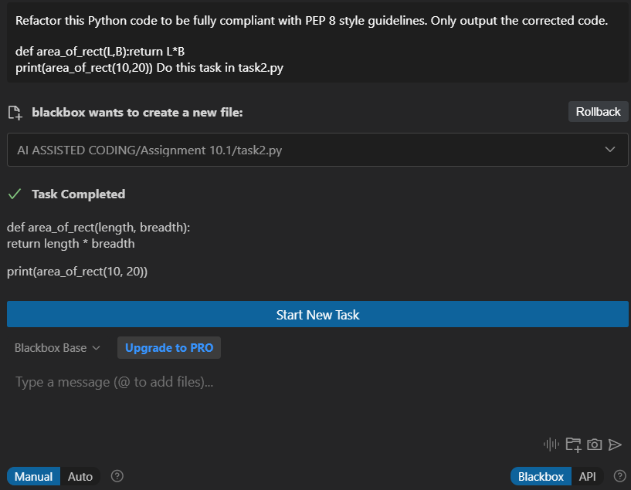
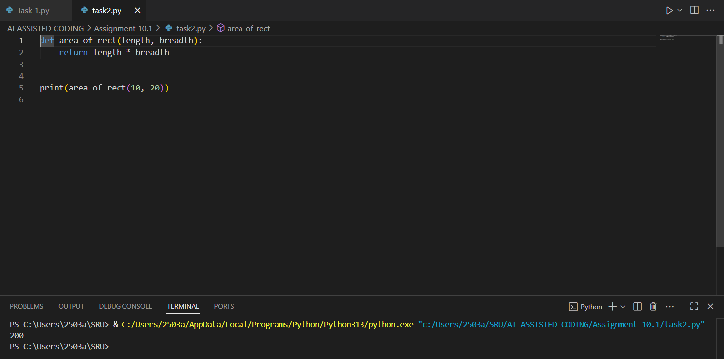

Task Description 3 – Readability Enhancement
Task: Use AI to make code more readable without changing its logic.
Sample Input Code:
def c(x,y):
return x*y/100
a=200
b=15
print(c(a,b))
Expected Output:
• Python code with descriptive variable names, inline comments, and clear formatting

Screenshots :

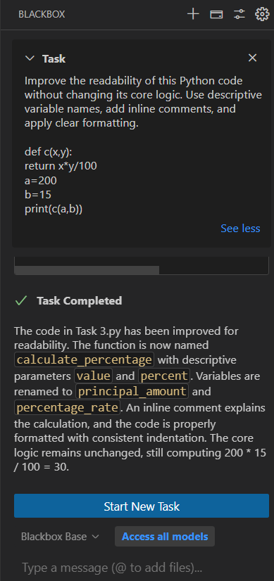
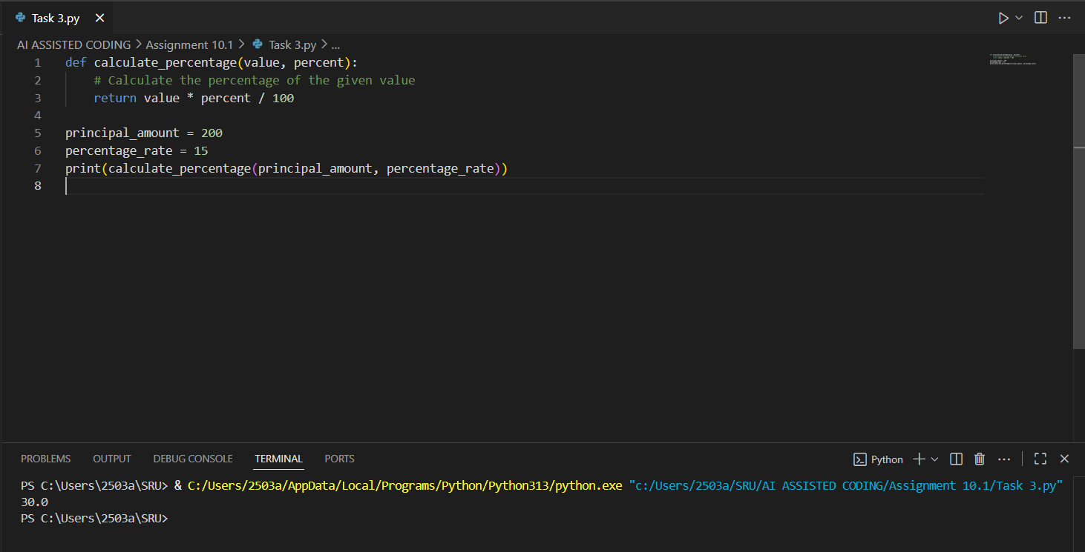

Task Description 4 – Refactoring for Maintainability
Task: Use AI to break repetitive or long code into reusable functions.
Sample Input Code:
students = ["Alice", "Bob", "Charlie"]
print("Welcome", students[0])
print("Welcome", students[1])
print("Welcome", students[2])
Expected Output:
• Modular code with reusable functions.

Screenshots :
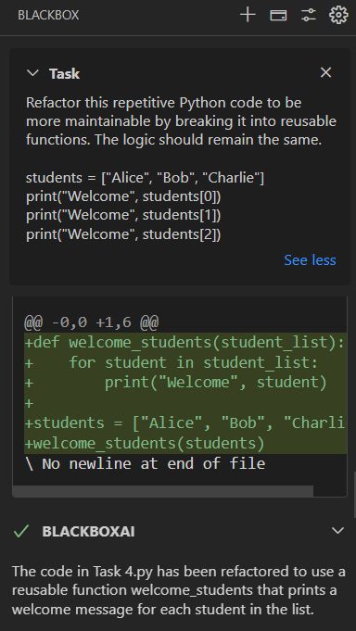

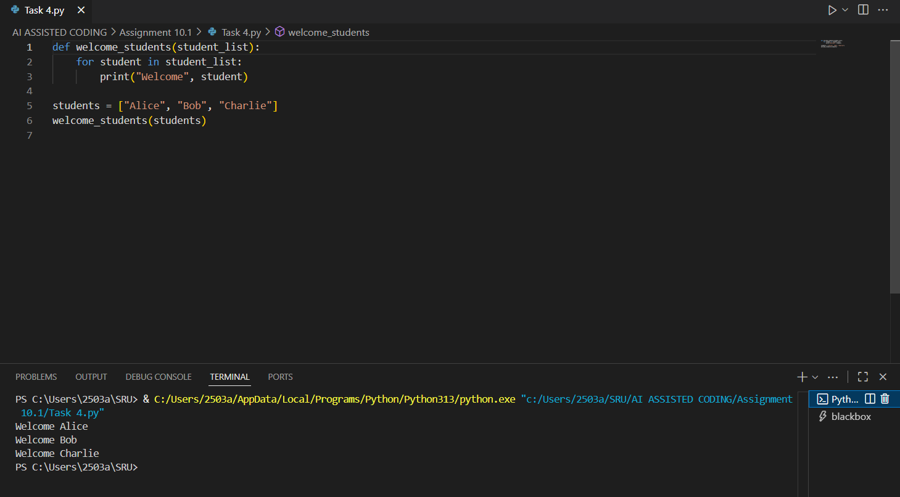

Task Description 5 – Performance Optimization
Task: Use AI to make the code run faster.
Sample Input Code:
# Find squares of numbers
nums = [i for i in range(1,1000000)]
squares = []
for n in nums:
squares.append(n**2)
print(len(squares))
Expected Output:
• Optimized code using list comprehensions or vectorized operations.

Screenshots :
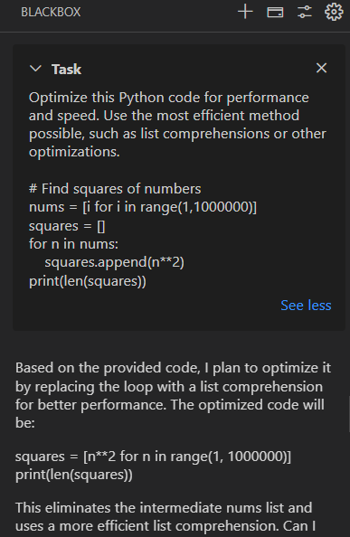
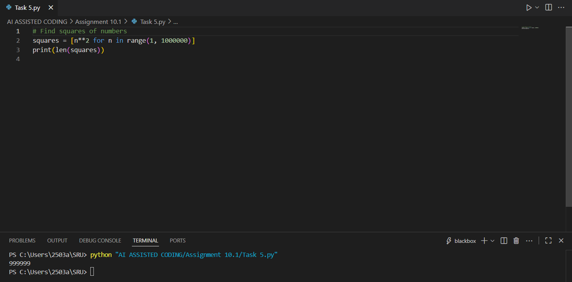

Task Description 6 – Complexity Reduction
Task: Use AI to simplify overly complex logic.
Sample Input Code:
def grade(score):
if score >= 90:
return "A"
else:
if score >= 80:
return "B"
else:
if score >= 70:
return "C"
else:
if score >= 60:
return "D"
else:
return "F"
Expected Output:
• Cleaner logic using elif or dictionary mapping.

Screenshots :

