Assignment-14
Lab 14: Web Design Application – AI-Assisted HTML/CSS/JS Generation
Task1:
Create a personal portfolio website using HTML, CSS, and JavaScript. The website should have four sections — Home, About, Projects, and Contact. Generate the HTML structure, suggest responsive CSS styling using flexbox or grid, and add hover effects on project cards. The design should be clean, responsive, and visually appealing.
Code:
1)Index.html
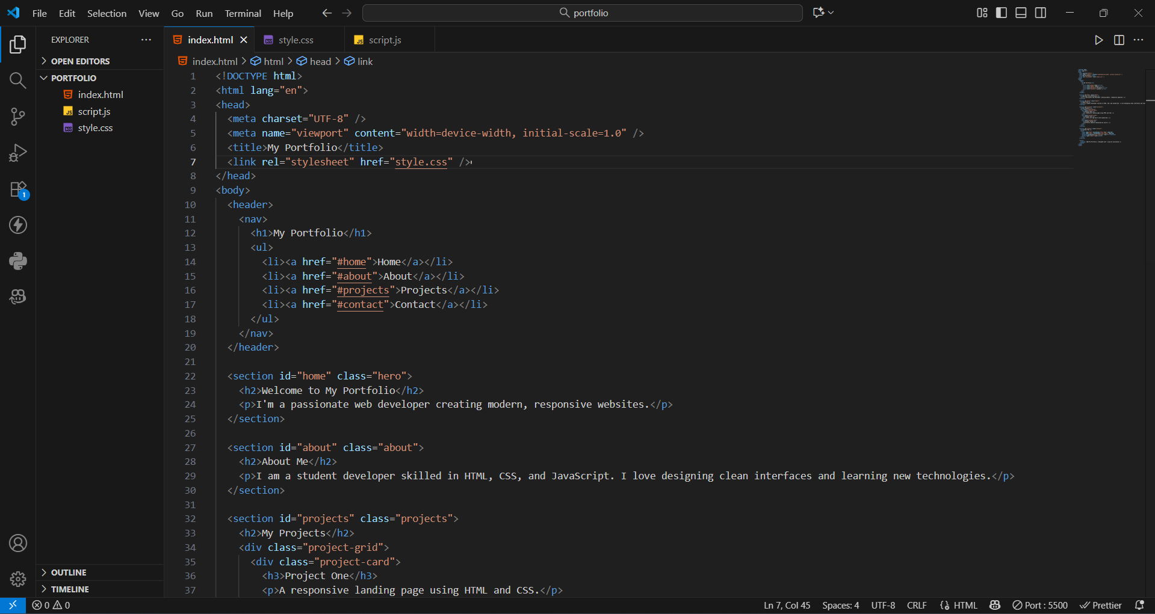
2)style.css
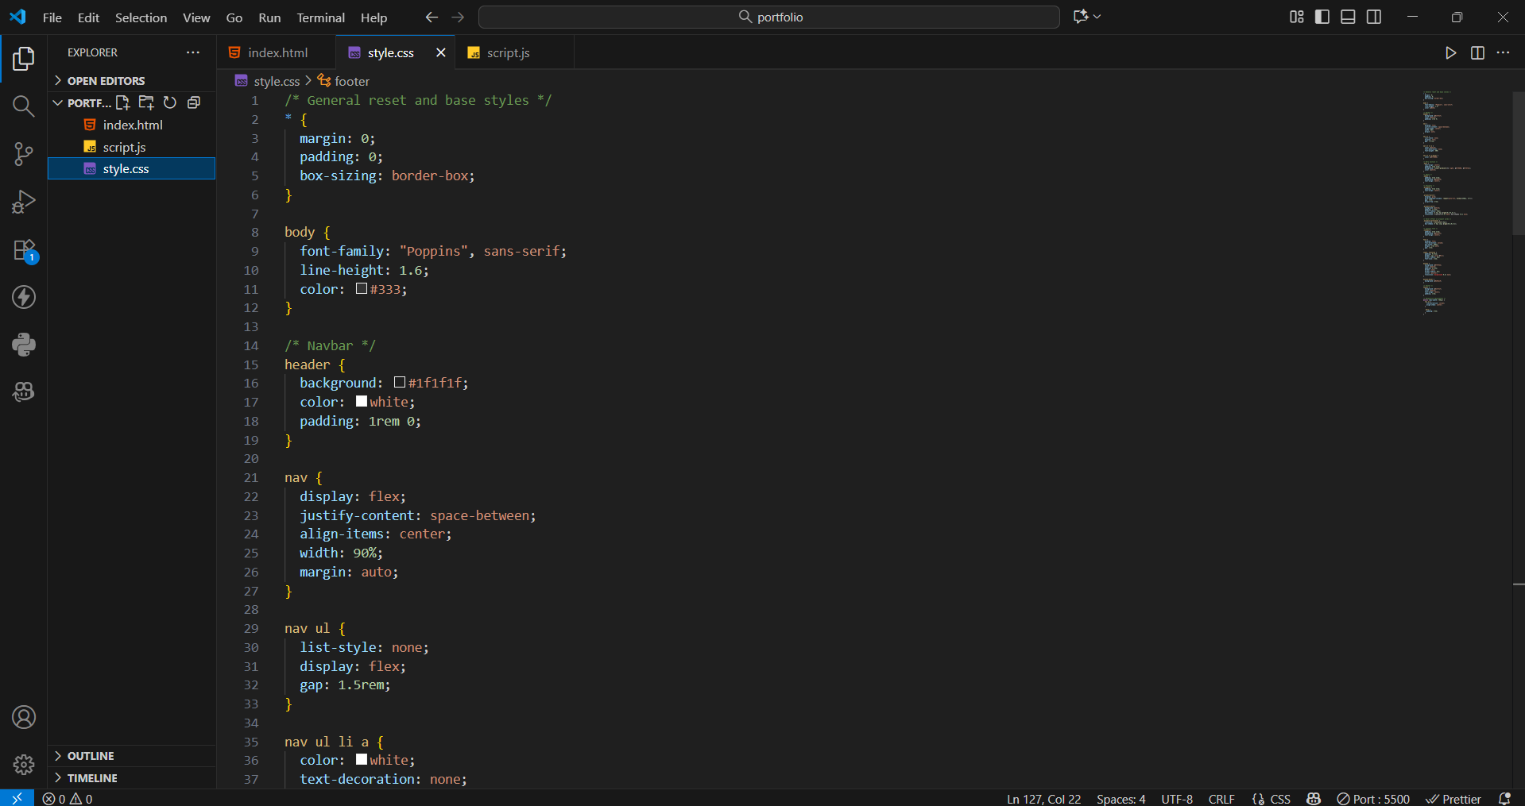
3)script.js
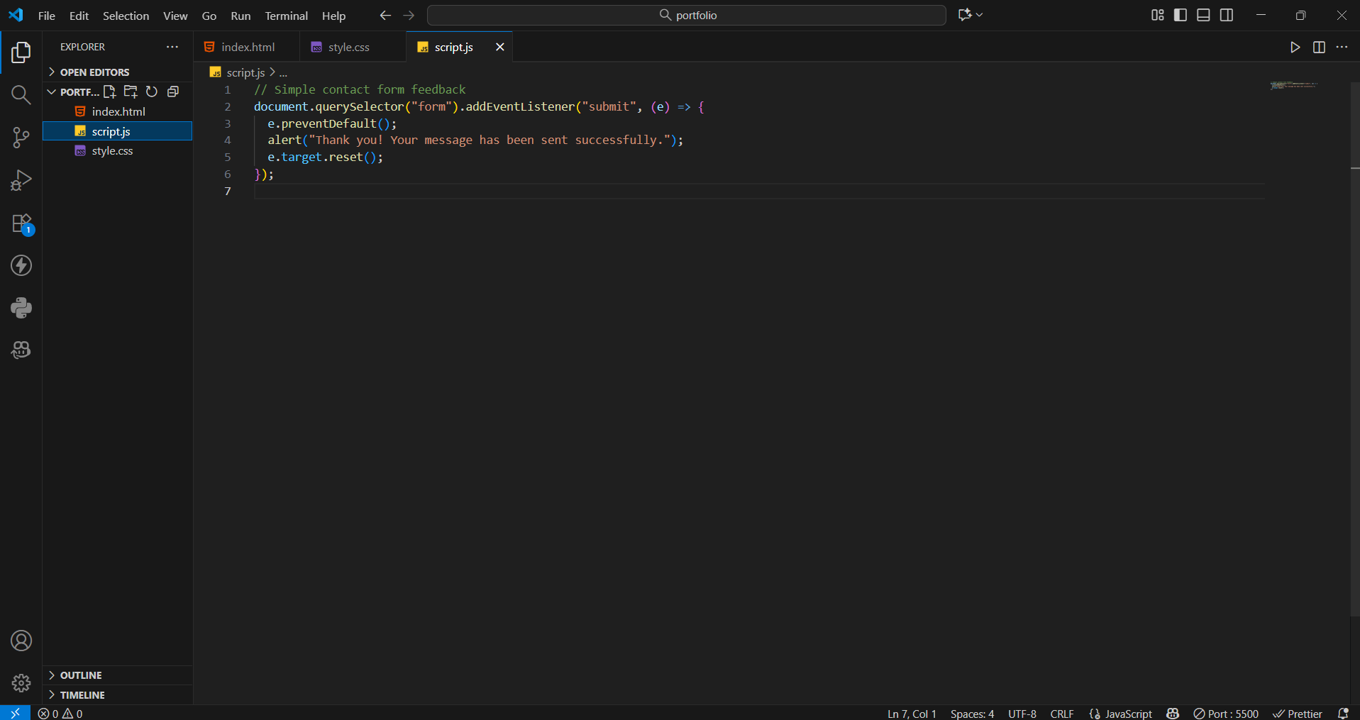
Output:
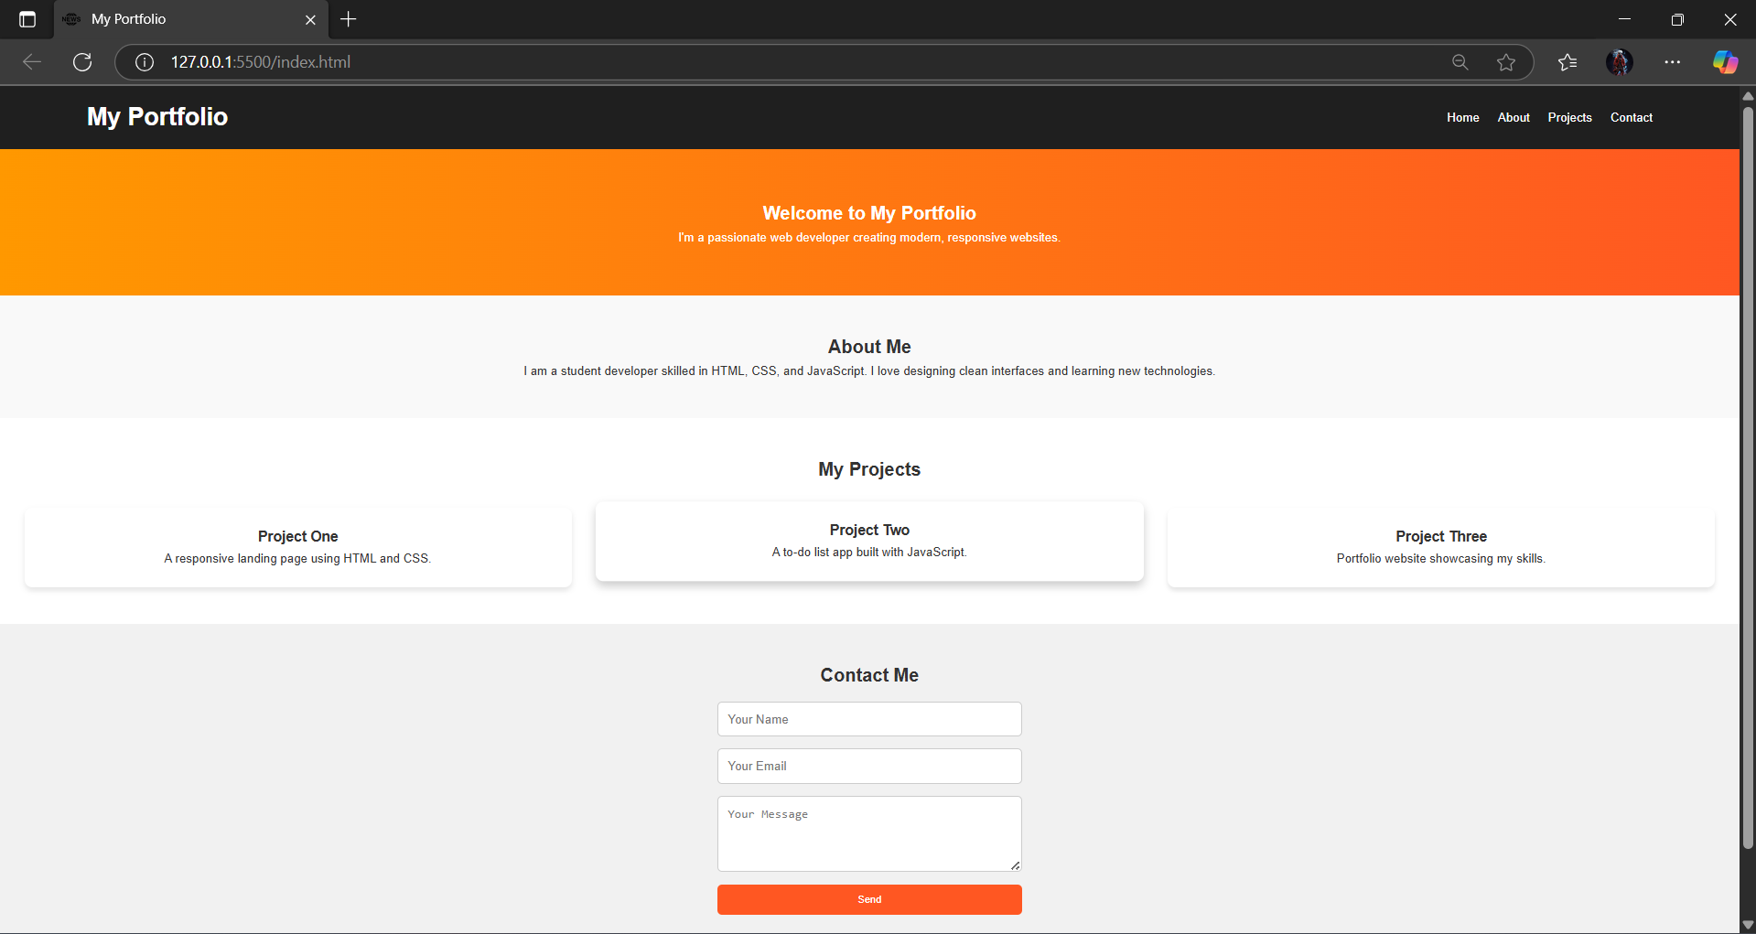
Observation:
Using GitHub Copilot, the portfolio website was quickly created with sections like Home, About, Projects, and Contact. The AI suggested responsive CSS using Flexbox/Grid and hover effects for interactivity, making the site visually appealing and easy to design efficiently.

Task2:
Create a restaurant landing page using HTML, CSS, and JavaScript with AI assistance. Include a navbar (Home, Menu, Gallery, Contact), a CSS-styled menu section, and a JS image slider.
Then, build a tech fest registration form with fields like Name, Email, Phone, Department, and Event. Use Copilot to add styling and real-time input validation.
Code:
1)restaurant.html
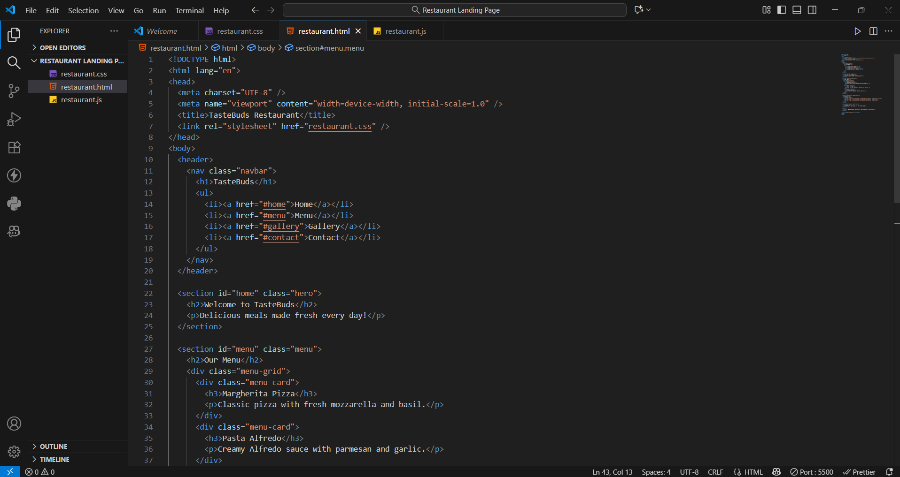
2) restaurant.css
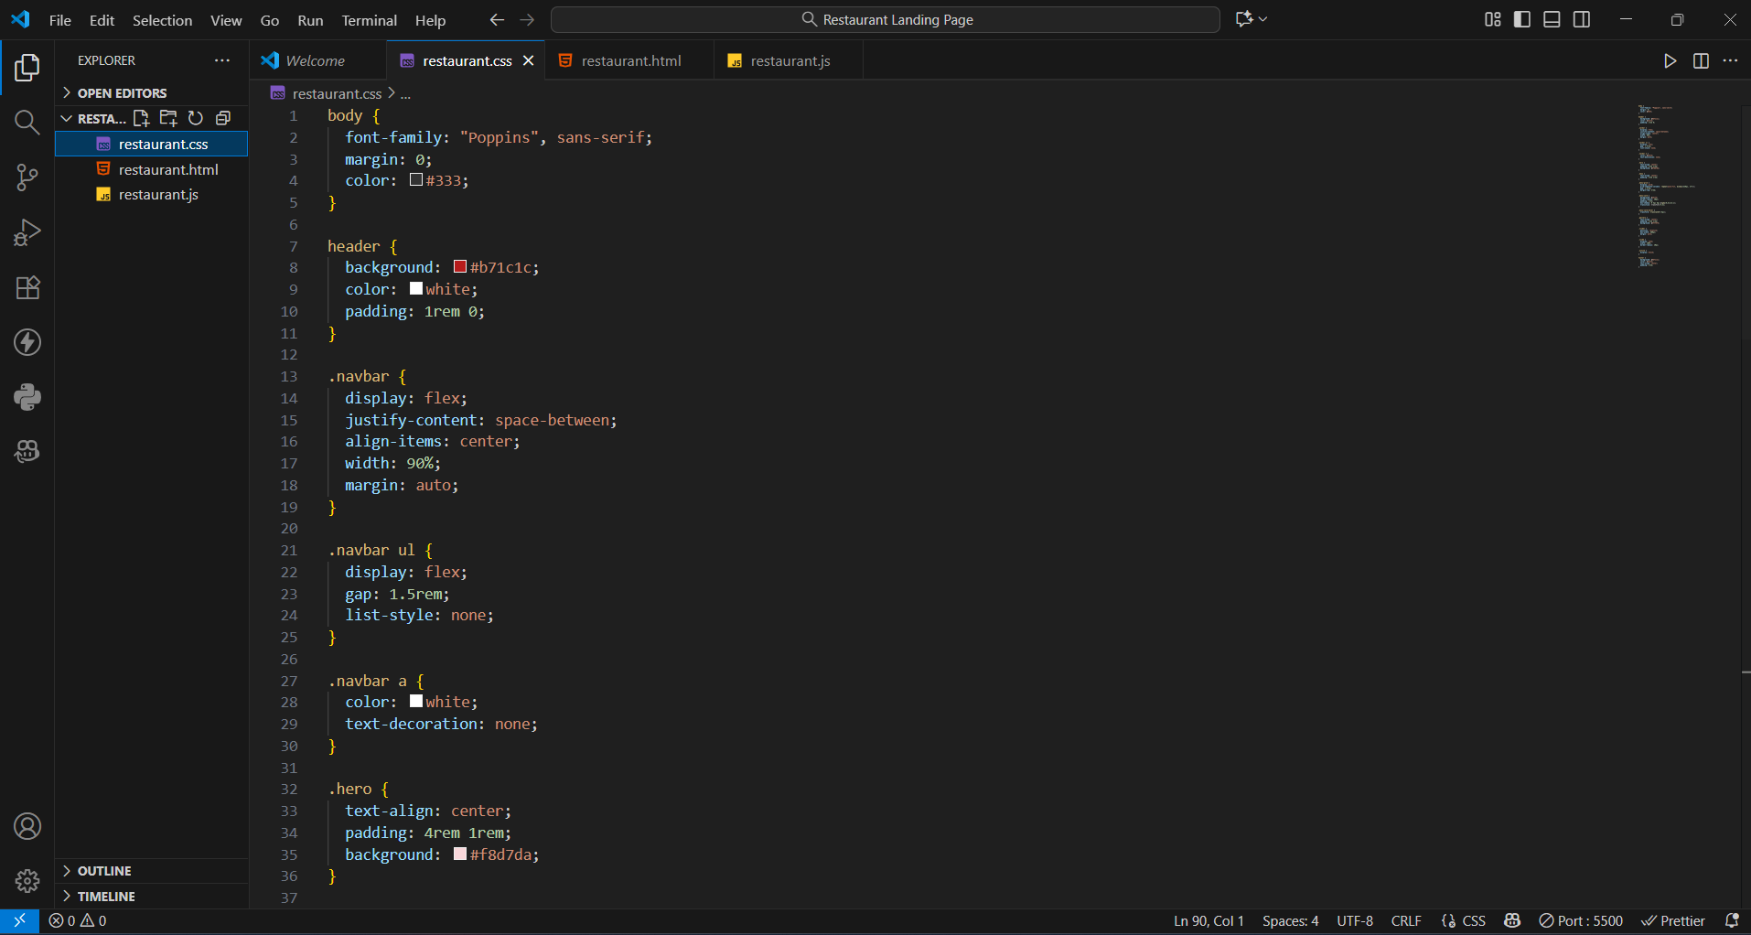

3) restaurant.js
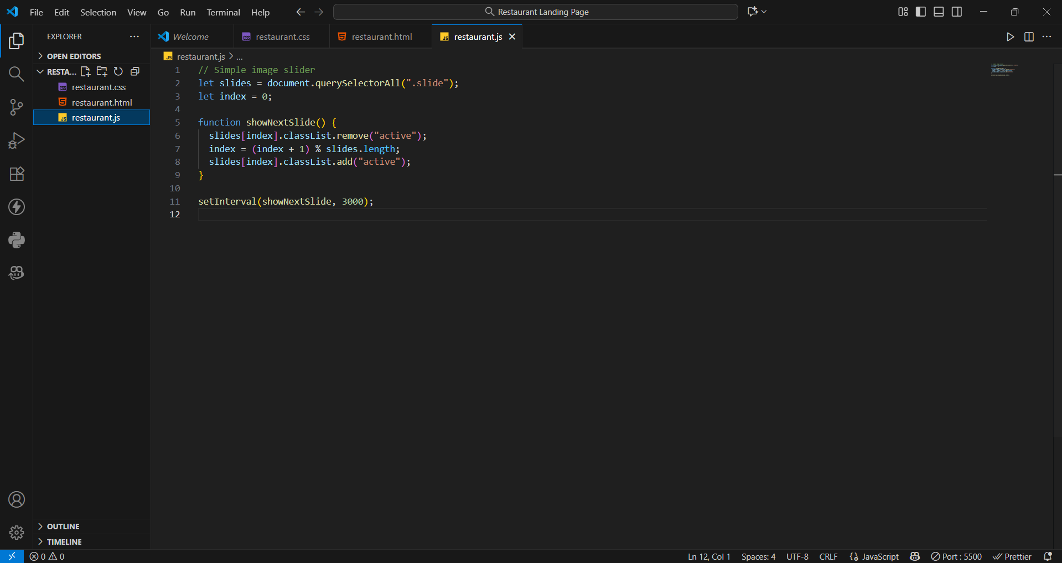
Output:
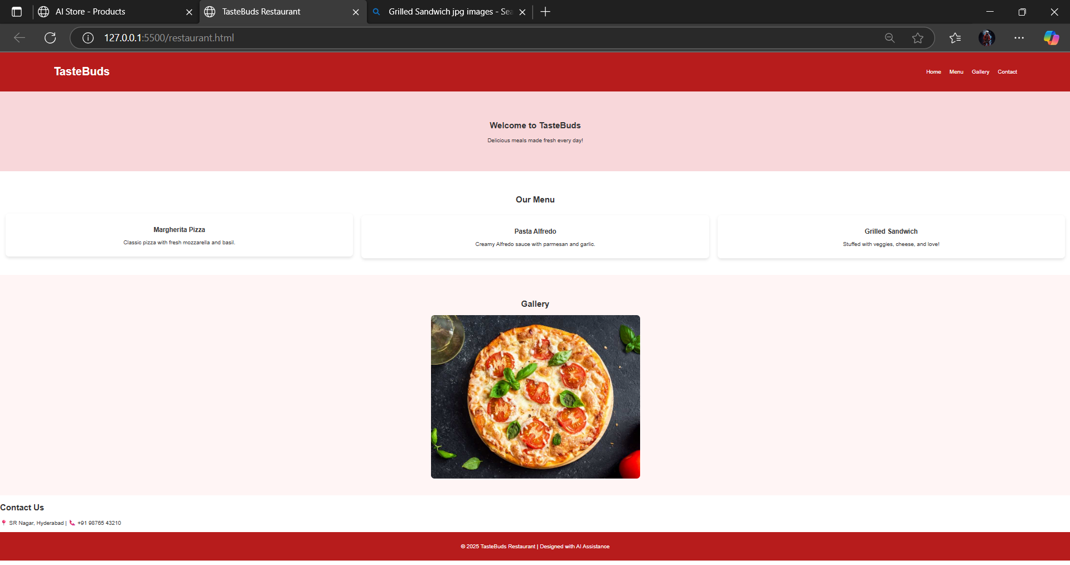
Observation:
Using AI assistance, the restaurant landing page was quickly generated with a navigation bar, menu cards styled in CSS, and an automated JavaScript image slider. The AI suggestions helped make the page responsive, interactive, and visually attractive.

Task3:
Then, create an event registration form for a university tech fest. The form should include fields for Name, Email, Phone, Department, and Event Selection. Use Copilot to help generate the HTML form, apply attractive CSS styling, and implement real-time JavaScript validation for email format and phone number length.
Code:
1)event.html
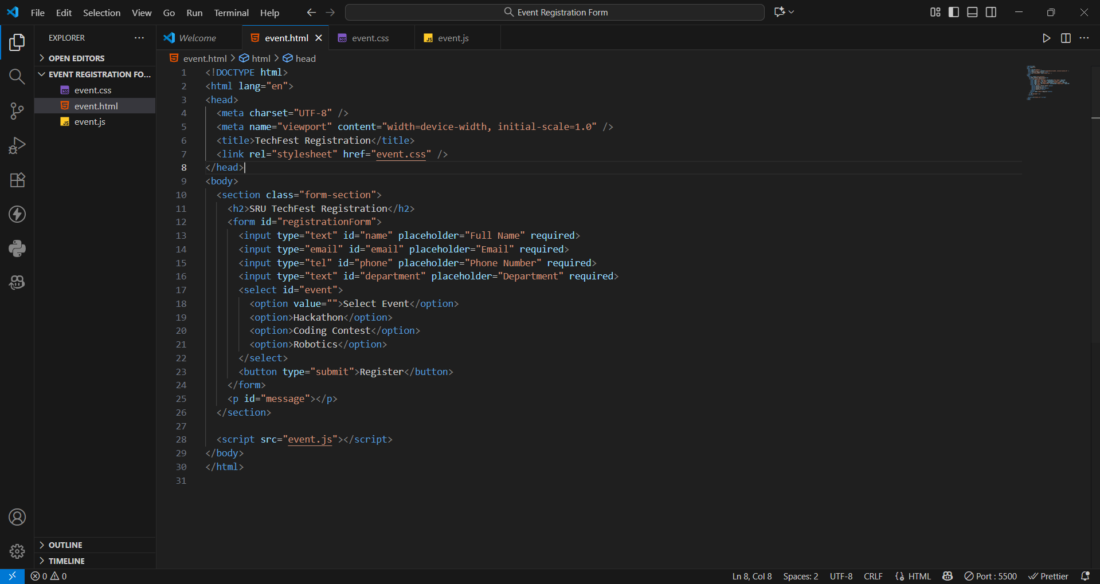
2)event.css
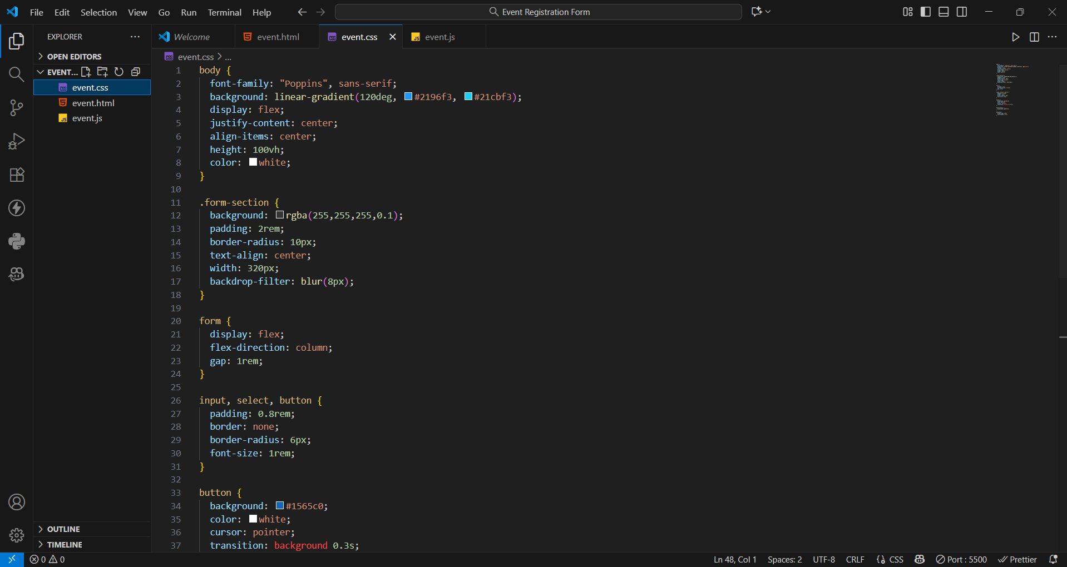

3)event.js
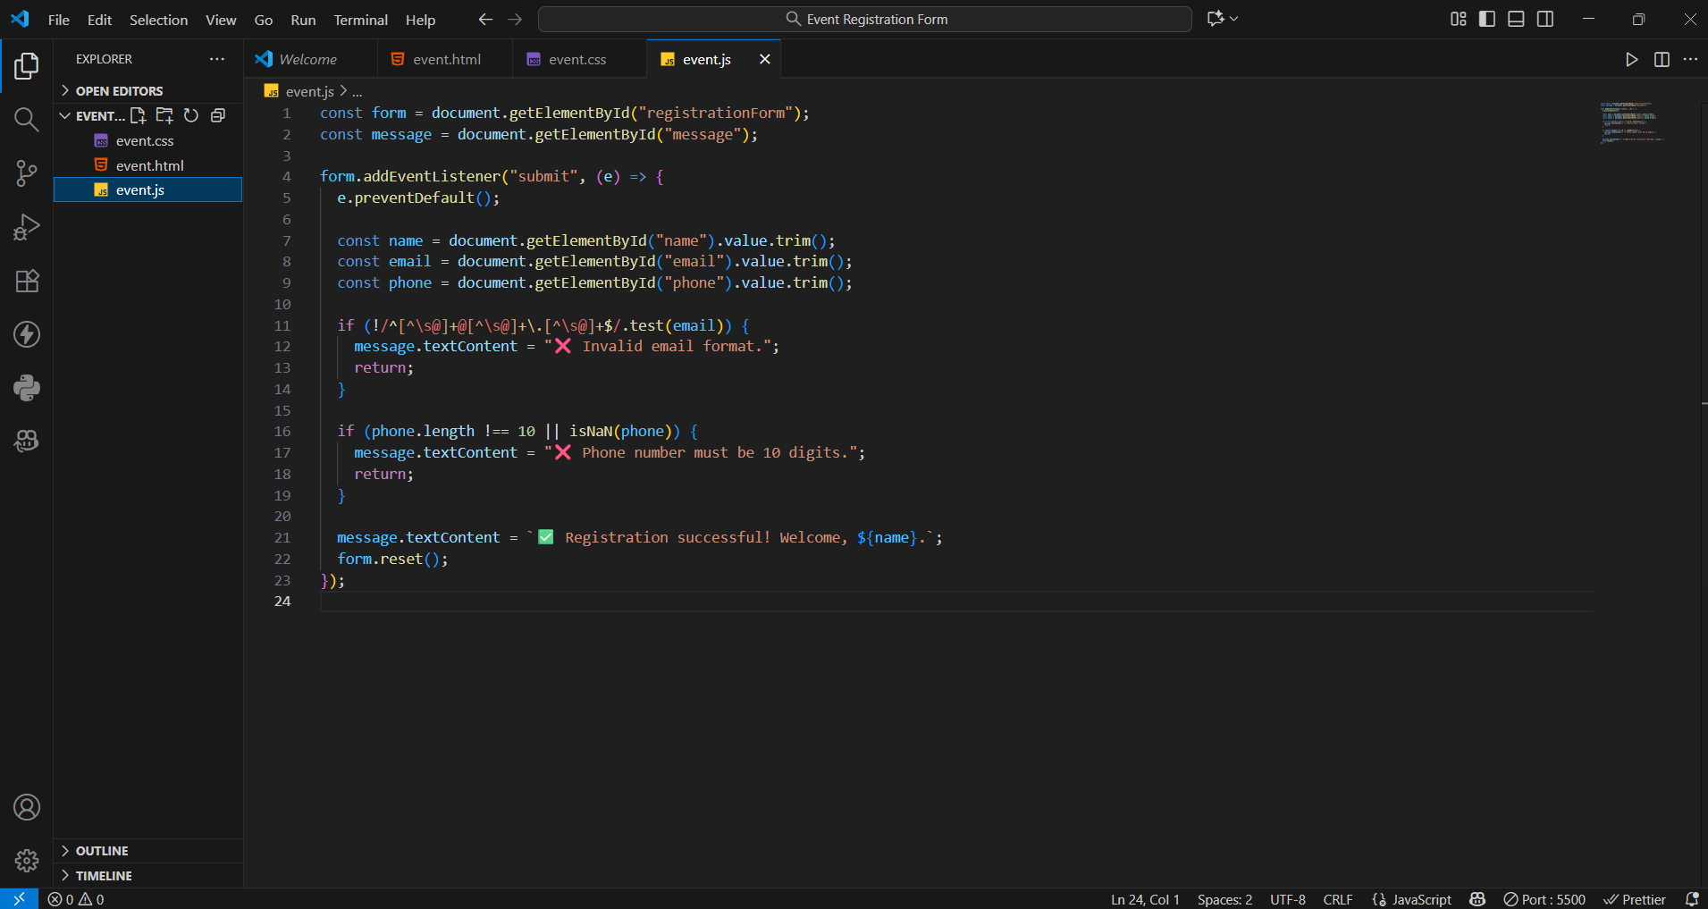
Output:
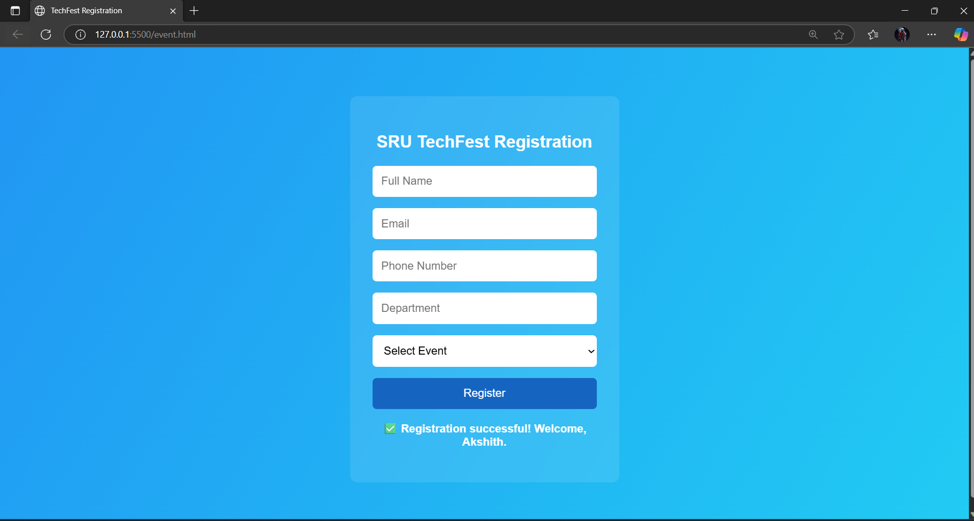
Observation:
With AI-generated suggestions, the registration form was designed with clean styling and real-time JavaScript validation. The AI assistance simplified input handling, improved accuracy, and made the overall development faster and more efficient.

Task4:
Create an e-commerce product page using HTML, CSS, and JavaScript with AI assistance. The page should display products in a responsive grid layout with names, prices, and “Add to Cart” buttons. Use Copilot to implement the JavaScript “Add to Cart” feature and modify it to include a cart counter at the top-right corner of the page
Code:
1)ecommerce.html
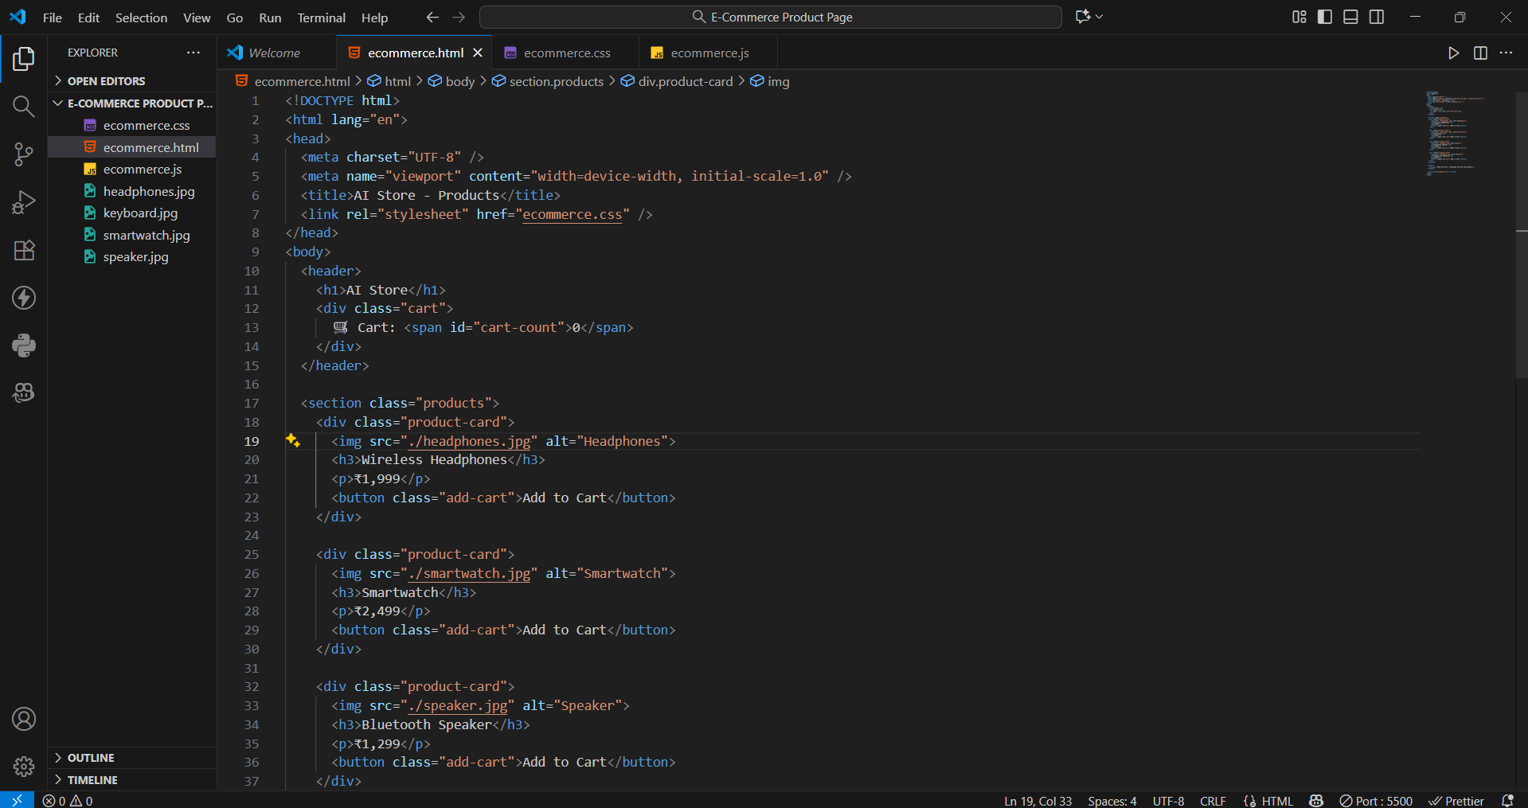
2)ecommerce.css
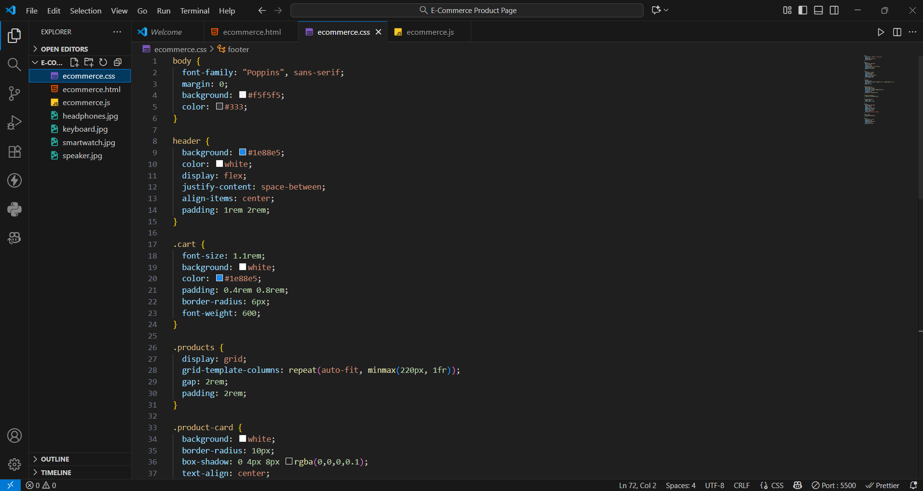

3)ecommerce.js
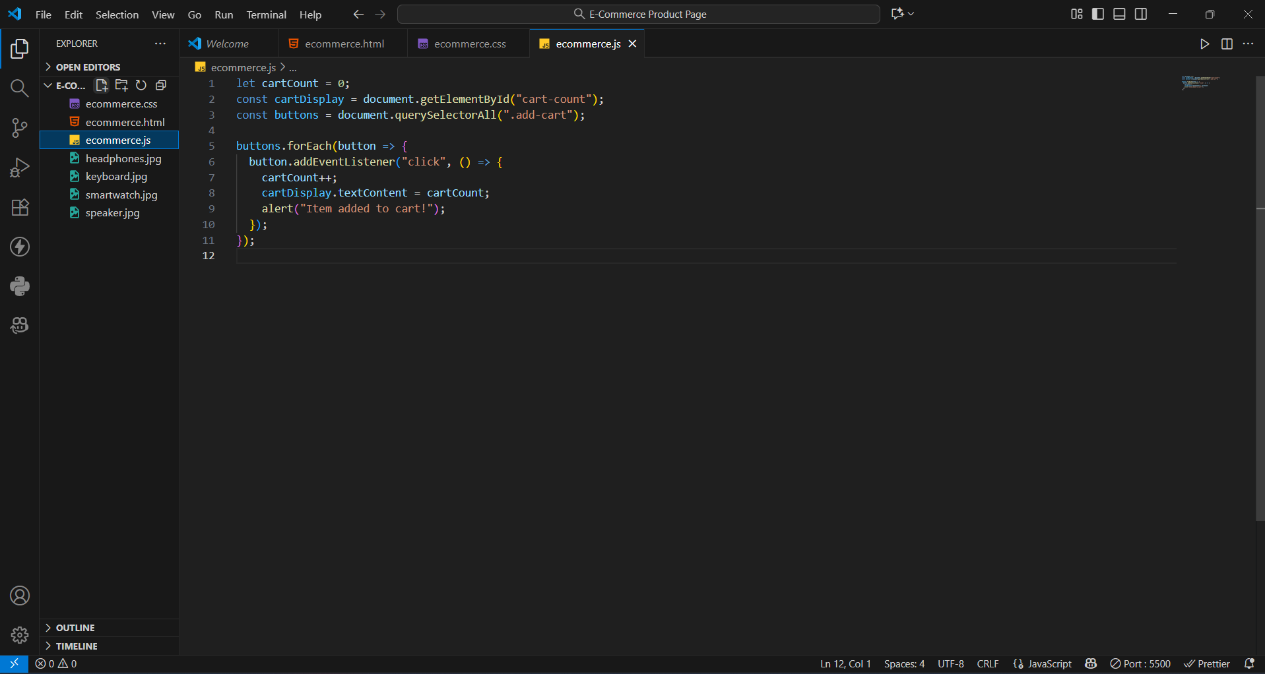
Output:
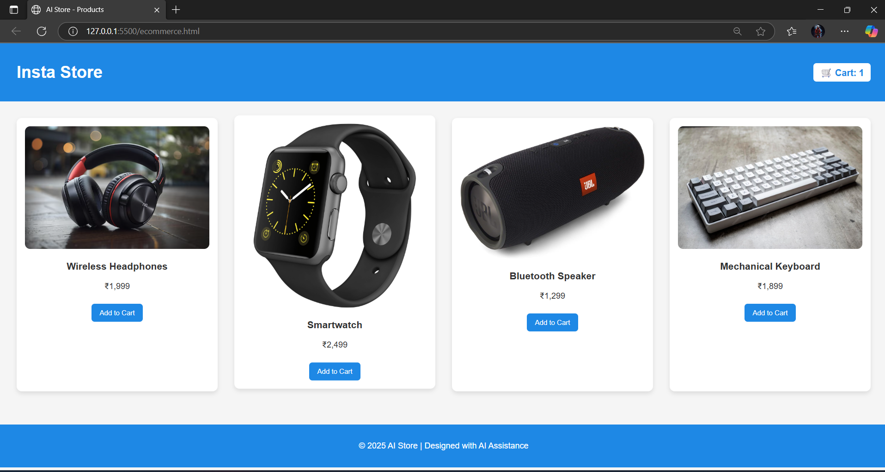
Observation:
Using GitHub Copilot, the e-commerce product page was created efficiently with a grid-based product layout and responsive design. The AI-assisted JavaScript “Add to Cart” feature worked smoothly, updating the cart counter dynamically. This task demonstrated how AI tools can simplify web development by providing instant, optimized code suggestions.

