Assignment 11
Task Description #1 – Stack Implementation
Task: Use AI to generate a Stack class with push, pop, peek, and is_empty
methods.
Sample Input Code:
class Stack:
pass
Expected Output:
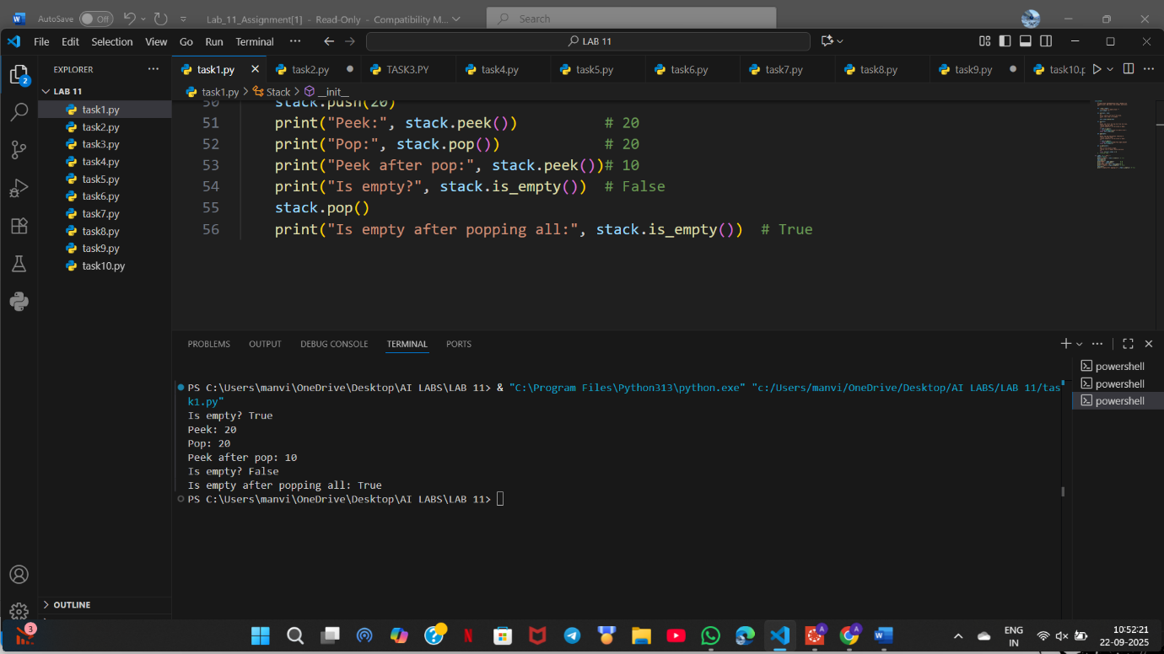
3 assert test cases :
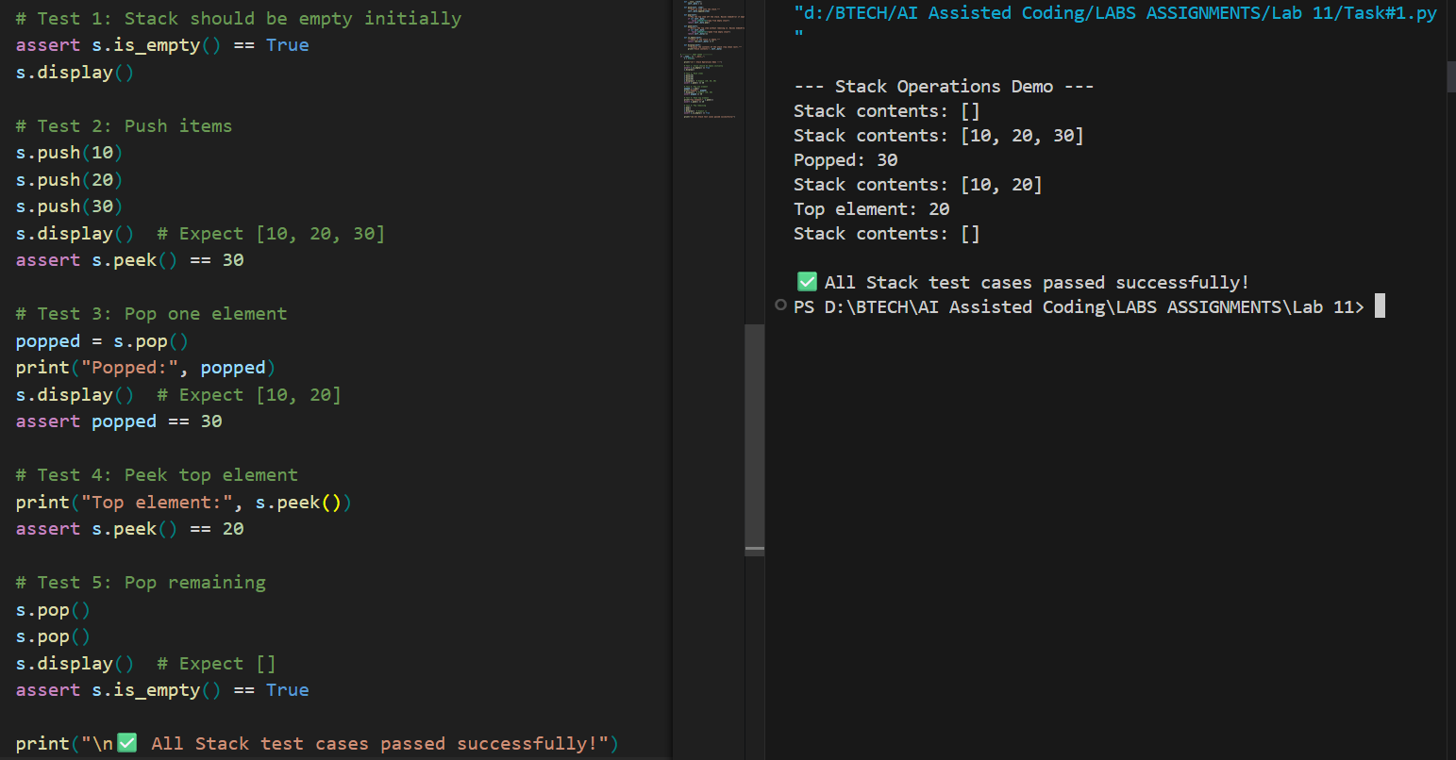
Task Description #2 – Queue Implementation
Task: Use AI to implement a Queue using Python lists.
Sample Input Code:
class Queue:
pass
Expected Output:
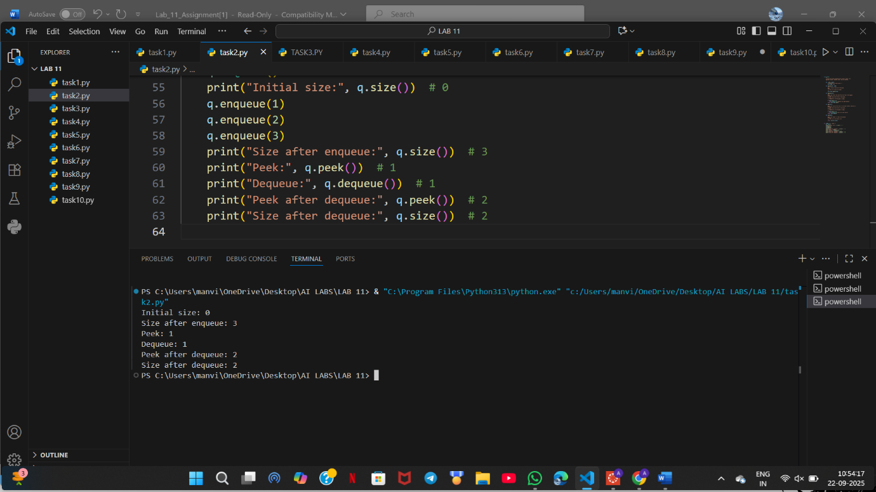
3 assert test cases :
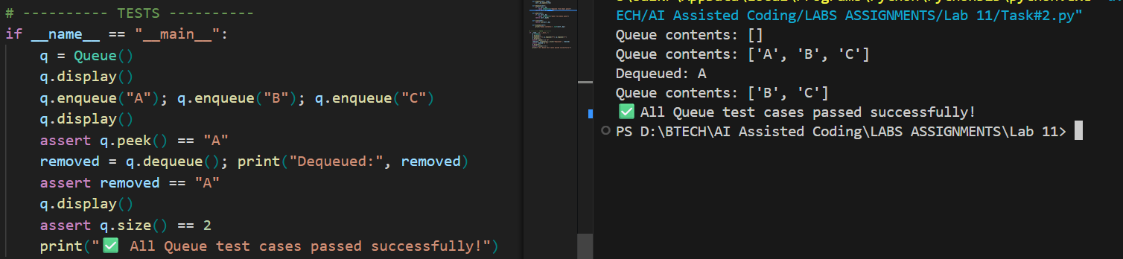

Task Description #3 – Linked List
Task: Use AI to generate a Singly Linked List with insert and display methods.
Sample Input Code:
class Node:
pass
class LinkedList:
pass
Expected Output:
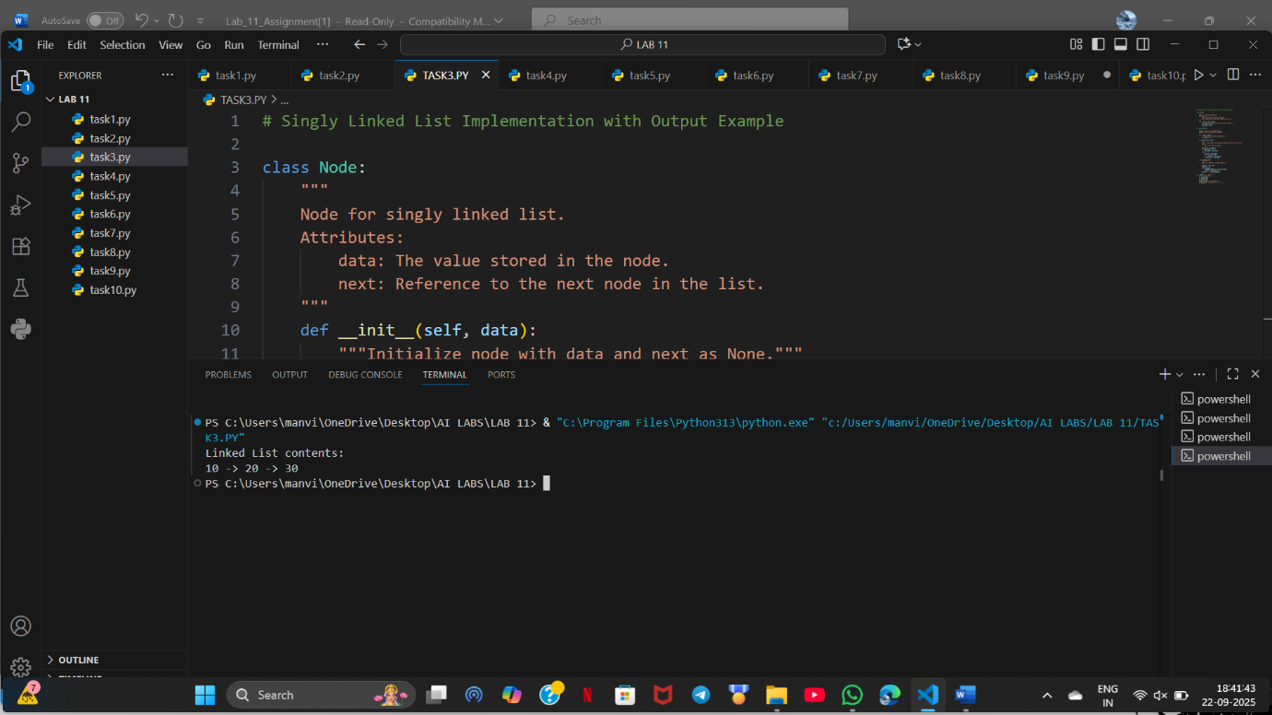
3 assert test cases :
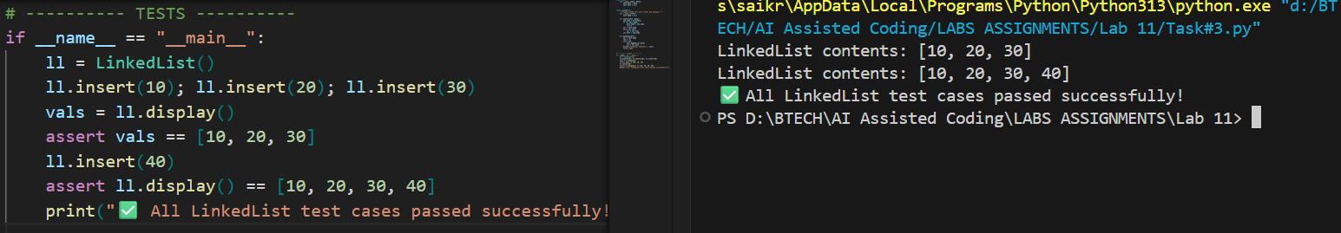

Task Description #4 – Binary Search Tree (BST)
Task: Use AI to create a BST with insert and in-order traversal methods.
Sample Input Code:
class BST:
pass
Expected Output:
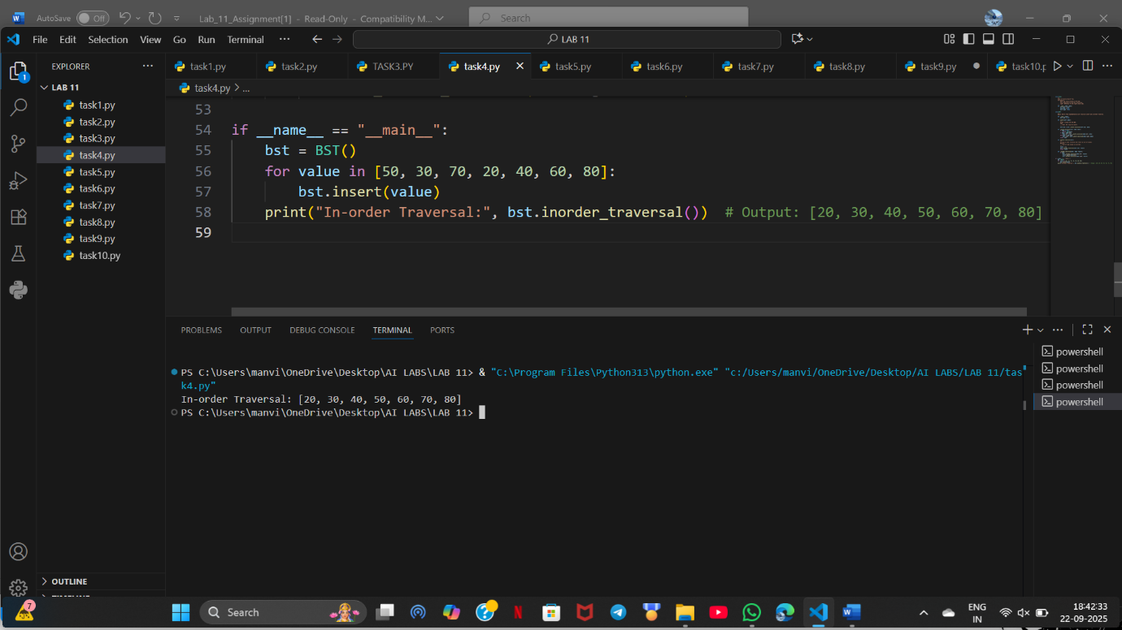
3 assert test cases :
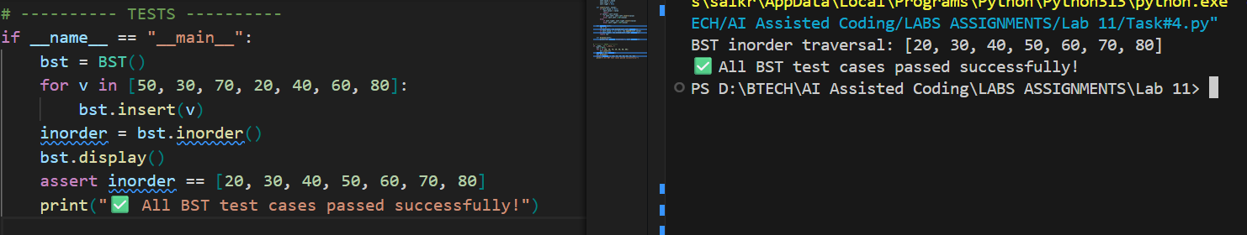

Task Description #5 – Hash Table
Task: Use AI to implement a hash table with basic insert, search, and delete
methods.
Sample Input Code:
class HashTable:
pass
Expected Output:
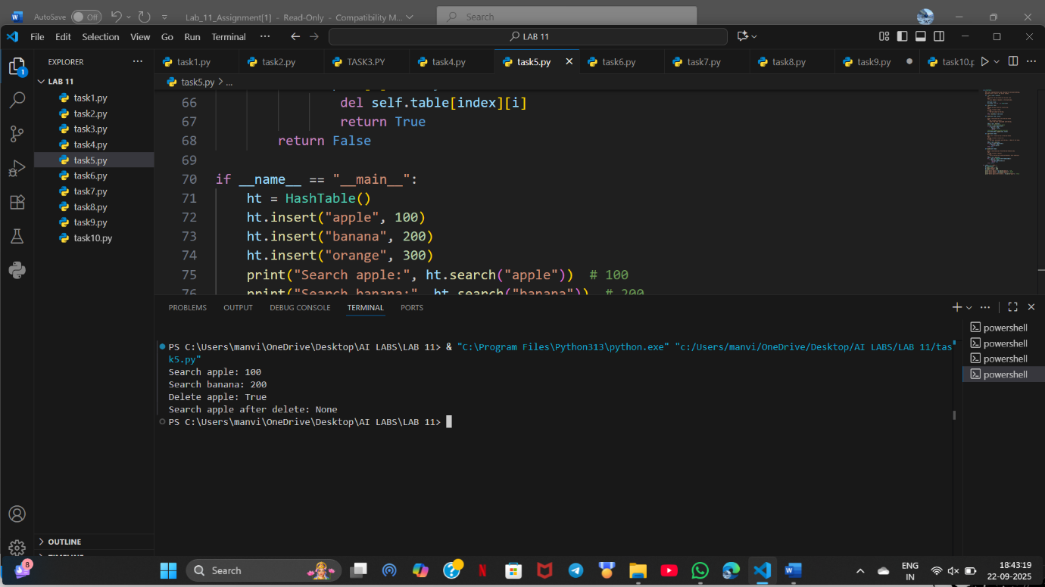
3 assert test cases :
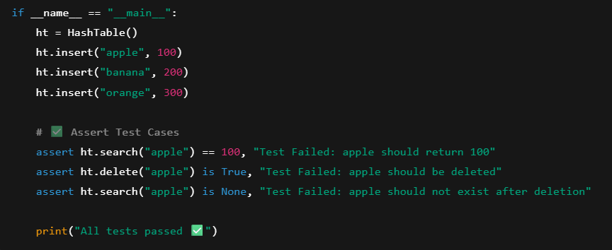

Task Description #6 – Graph Representation
Task: Use AI to implement a graph using an adjacency list.
Sample Input Code:
class Graph:
pass
Expected Output / 3 assert test cases :
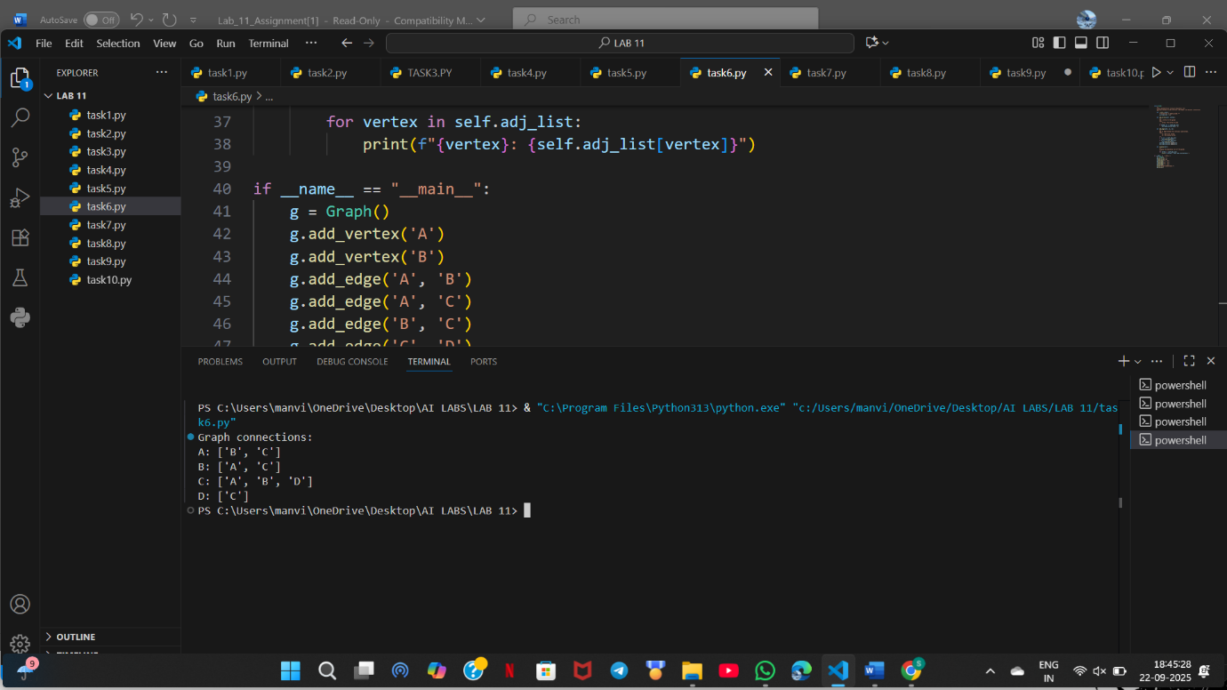

Task Description #7 – Priority Queue
Task: Use AI to implement a priority queue using Python’s heapq module.
Sample Input Code:
class PriorityQueue:
pass
Expected Output / 3 assert test cases :
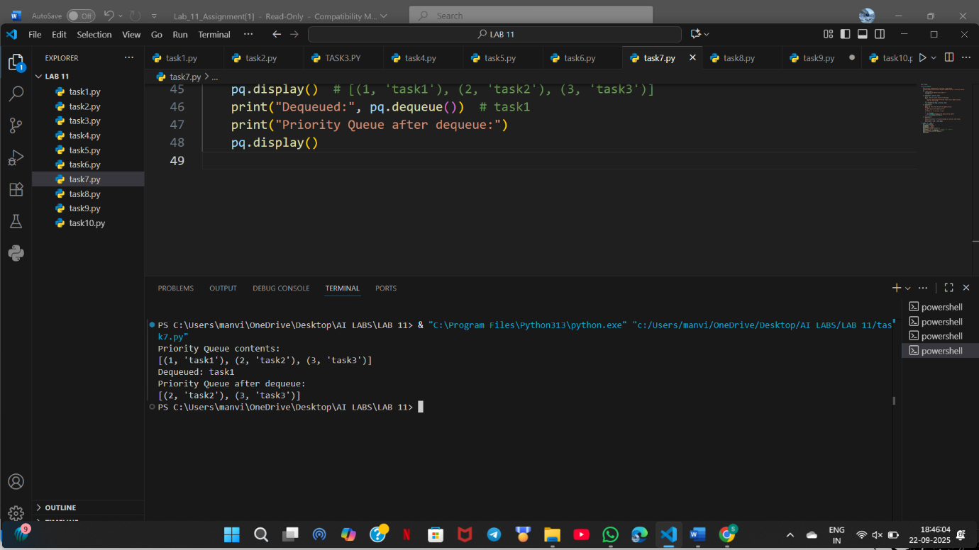

Task Description #8 – Deque
Task: Use AI to implement a double-ended queue using collections.deque.
Sample Input Code:
class DequeDS:
pass
Expected Output / 3 assert test cases :
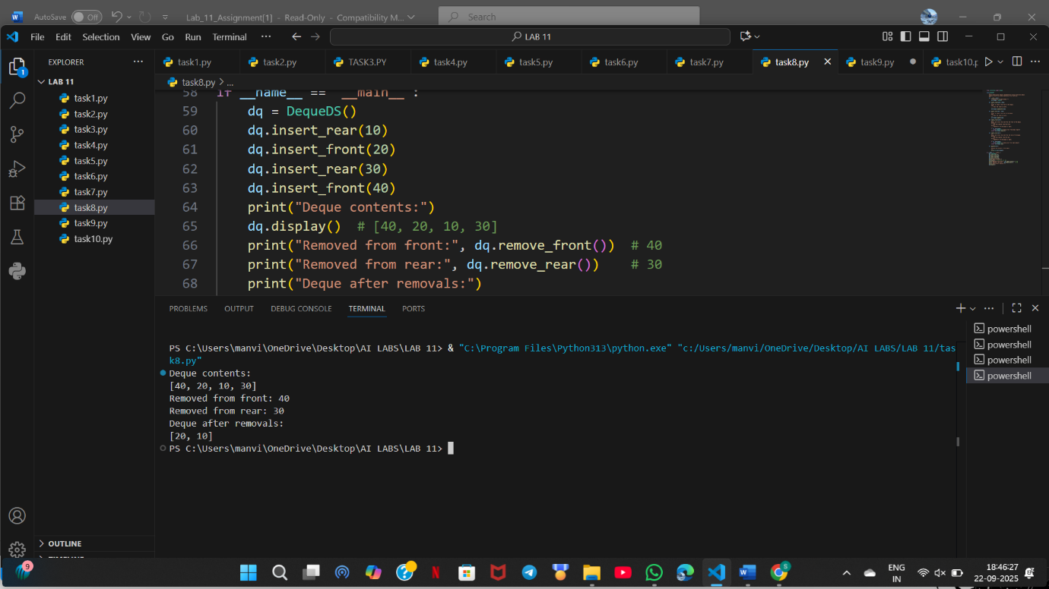

Task Description #9 – AI-Generated Data Structure Comparisons
Task: Use AI to generate a comparison table of different data structures (stack,
queue, linked list, etc.) including time complexities.
Sample Input Code:
# No code, prompt AI for a data structure comparison table
Expected Output:
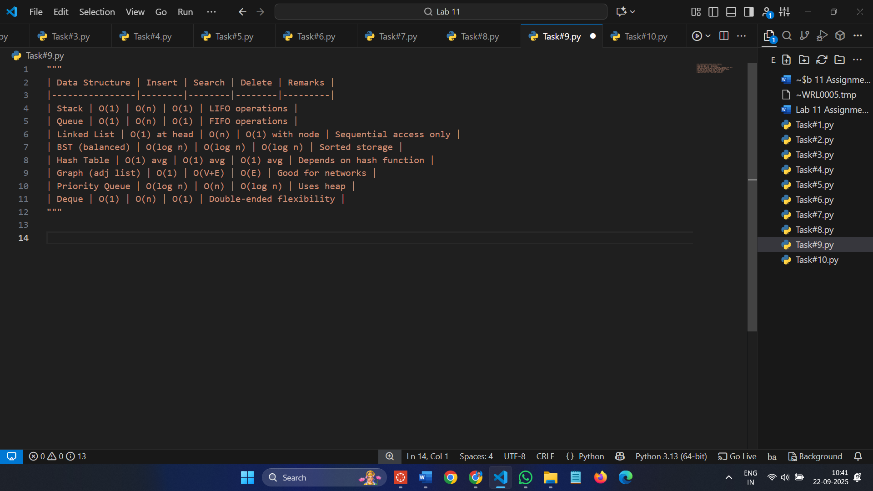
Task Description #10 Real-Time Application Challenge – Choose the
Right Data Structure
Scenario:
Your college wants to develop a Campus Resource Management System that
handles:
1. Student Attendance Tracking – Daily log of students entering/exiting
the campus.
2. Event Registration System – Manage participants in events with quick
search and removal.
3. Library Book Borrowing – Keep track of available books and their due
dates.
4. Bus Scheduling System – Maintain bus routes and stop connections.
5. Cafeteria Order Queue – Serve students in the order they arrive.
Student Task:
• For each feature, select the most appropriate data structure from the list
below:
o Stack
o Queue
o Priority Queue
o Linked List
o Binary Search Tree (BST)
o Graph
o Hash Table
o Deque
• Justify your choice in 2–3 sentences per feature.
• Implement one selected feature as a working Python program with AI-
assisted code generation.
Expected Output:
• A table mapping feature → chosen data structure → justification.
• A functional Python program implementing the chosen feature with
comments and docstrings
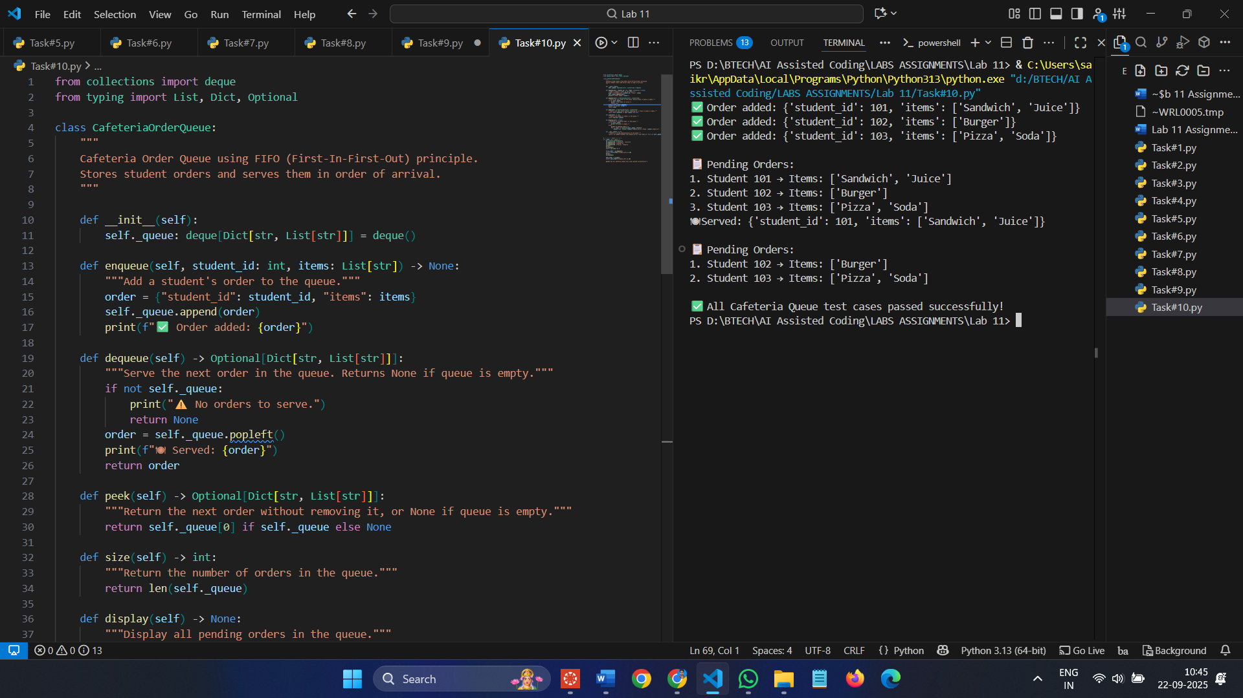
3 assert test cases :
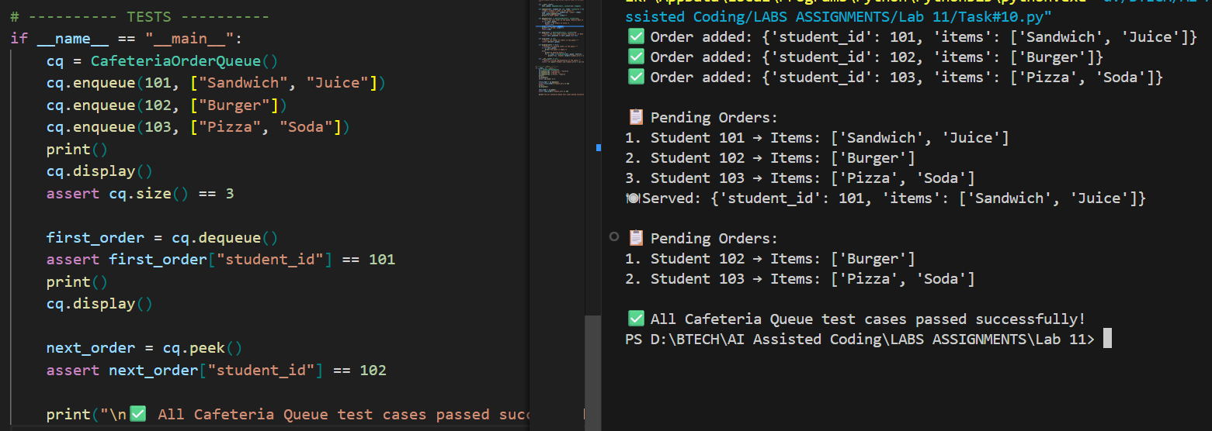

Observation :
Task 1 – Stack : LIFO operations work correctly. push, pop, peek behave as expected. display() shows contents; all tests passed.
Task 2 – Queue : FIFO order maintained. enqueue, dequeue, peek work correctly. display() confirms order; tests passed.
Task 3 – Linked List : Insertion at tail works. display() shows list order. Tests confirm correct node addition.
Task 4 – Binary Search Tree (BST) : Recursive insert and in-order traversal produce sorted output. display() verified; tests passed.
Task 5 – Hash Table : Insert, search, and delete work correctly using chaining. display() shows buckets; all tests passed.
Task 6 – Graph : Adjacency list stores vertices and edges correctly. display() confirms connections; tests passed.
Task 7 – Priority Queue : Min-heap ensures correct priority order. enqueue/dequeue work; display() shows heap.
Task 8 – Deque : Double-ended insertion/removal works as expected. display() shows contents; all tests passed.
Task 9 – Data Structure Comparisons : Comparison table correctly shows time complexities and key differences. Useful reference for choosing structures.
Task 10 – Cafeteria Queue : FIFO order works correctly; enqueue adds orders, dequeue serves them in order.
peek() shows next order, display() visualizes pending orders clearly; tests passed.

