Assignment-13
Lab 13: Code Refactoring – Improving Legacy Code with AI Suggestions
Task 1: Refactoring a Legacy Calculator Script Scenario:
Prompt: Refactor this basic calculator code to make it cleaner and modular.
Use functions for each operation (add, subtract, multiply, divide) and a dictionary to map user choices to these functions.
Make sure it asks the user for two numbers, performs the selected operation, and handles division by zero errors.
Output(Before Refactor):
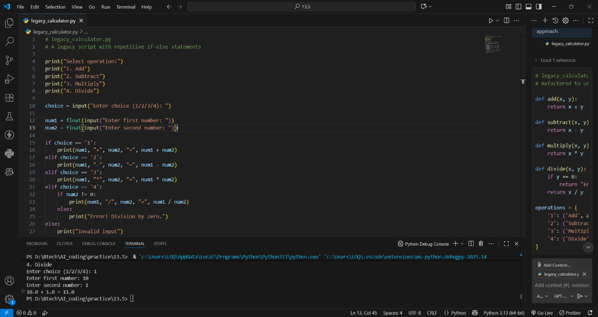
Output(After Refactor):
Prompt: Refactor this calculator to make it modular using functions and a dictionary-based approach
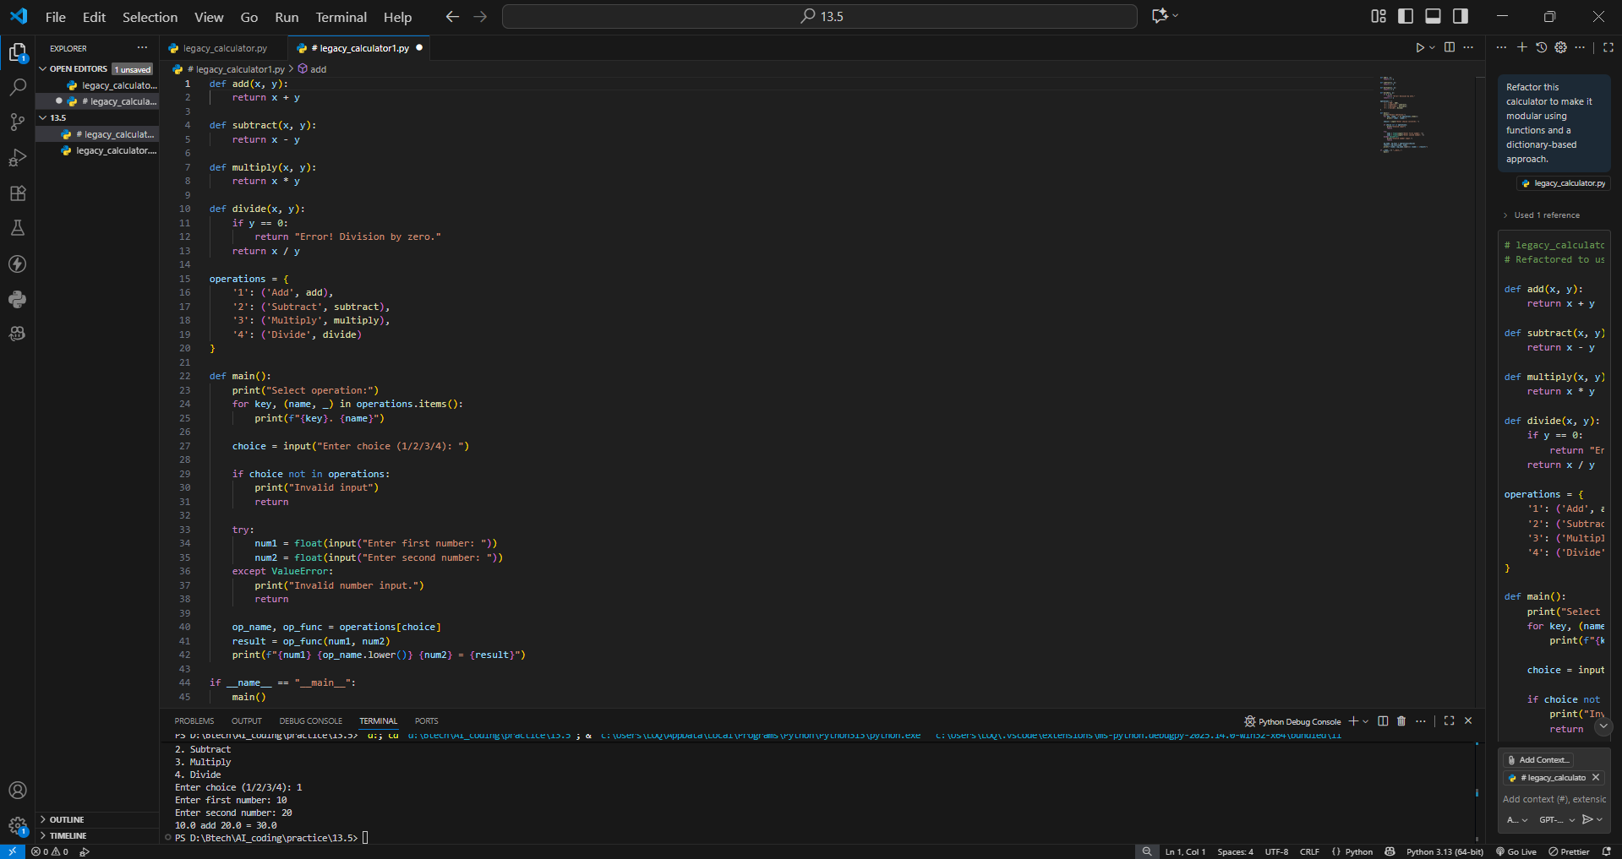
Observation:
Old code had many if-else statements and was hard to maintain.
Copilot made it modular using functions and a dictionary.
Now it’s cleaner, easier to read, and simple to add new operations.
Task 2: Modernizing a Student Database Program Scenario:
Output(Before Refactor):
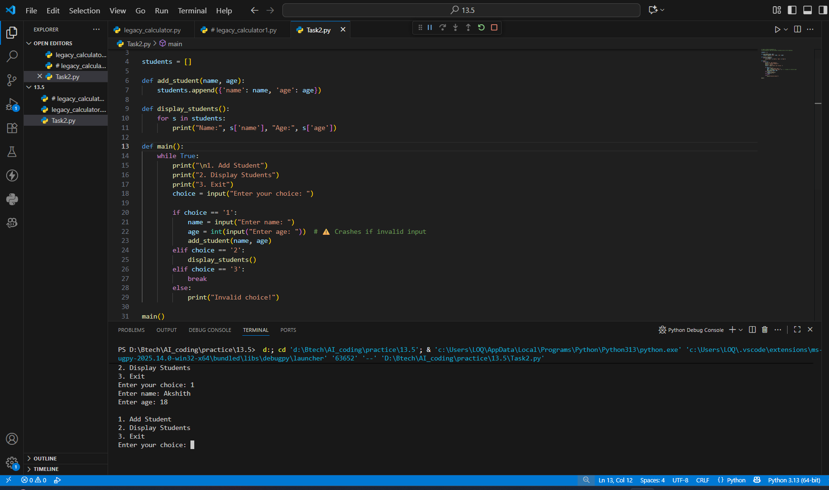
Output(After Refactor):
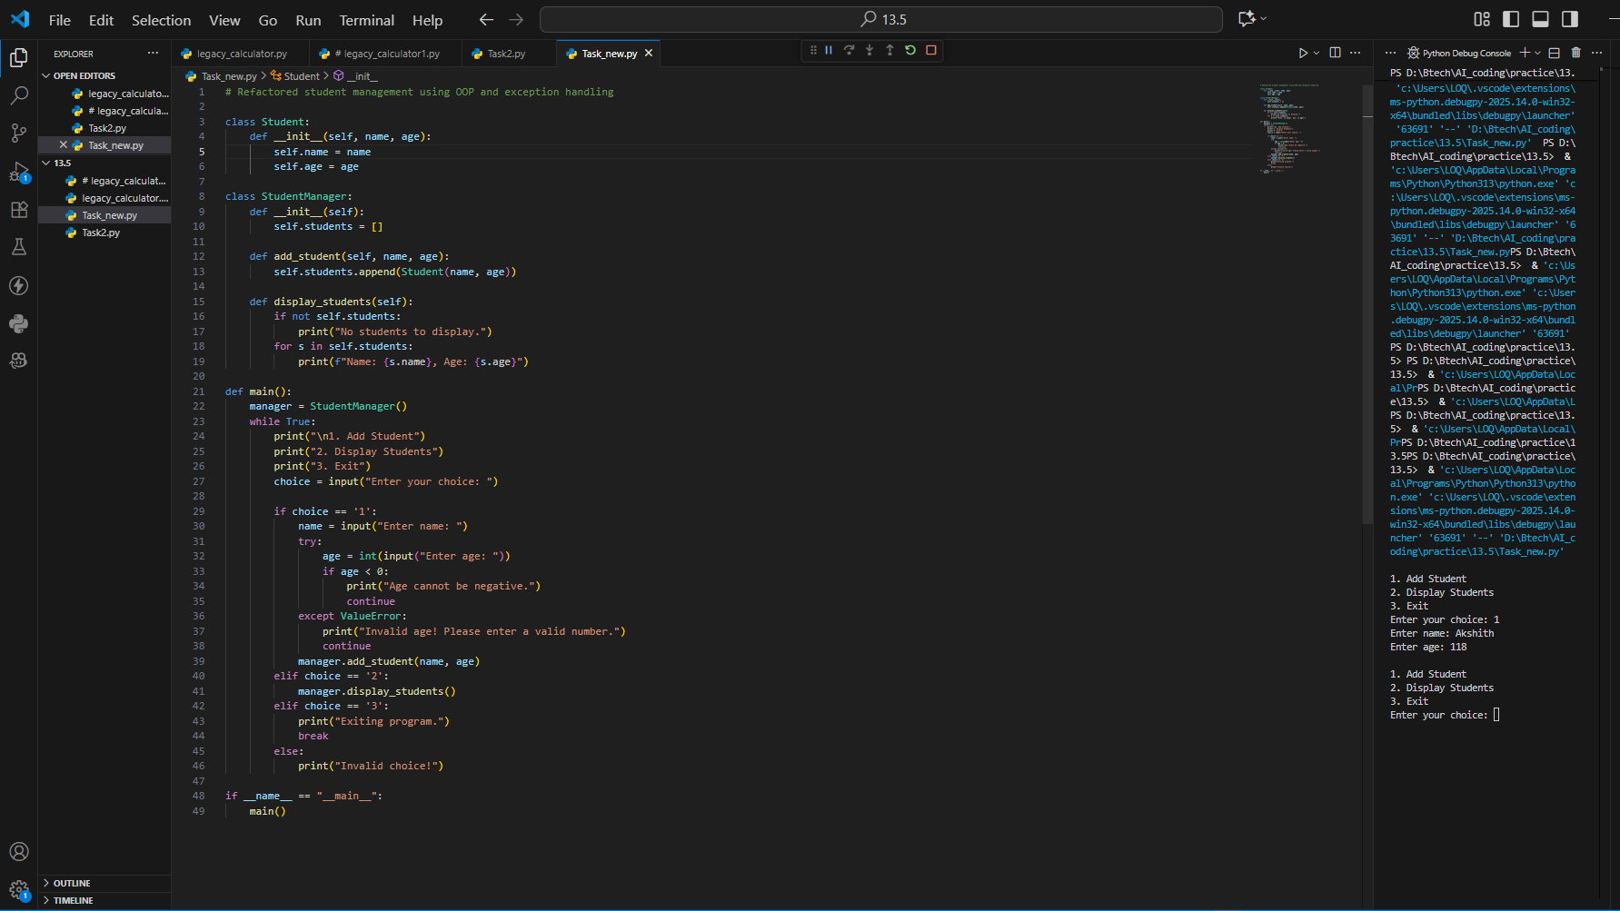
Observation:
Old code used global variables and crashed on wrong input.
Copilot converted it into classes with error handling.
Now it’s stable, organized, and user-friendly.
Task 3: Optimizing Performance in File Processing Scenario:
Output(Before Refactor):
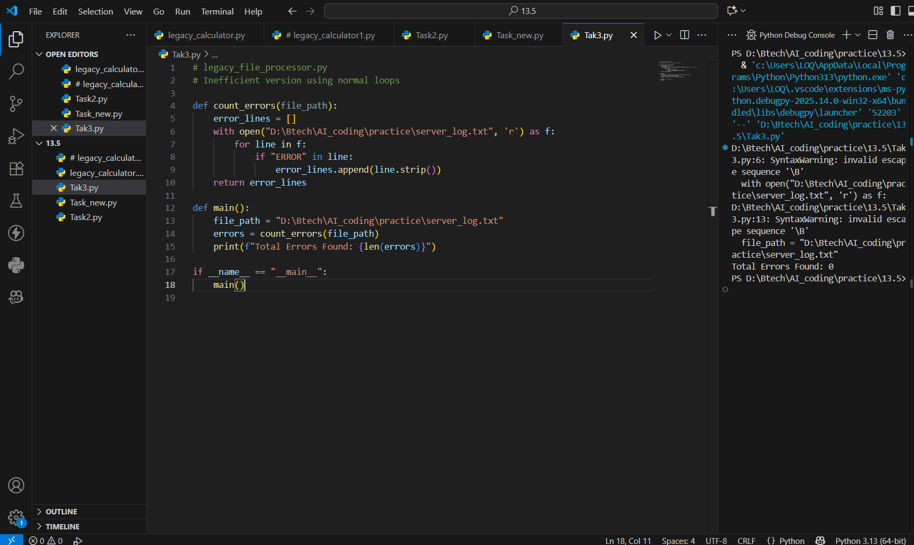
Output(After Refactor):
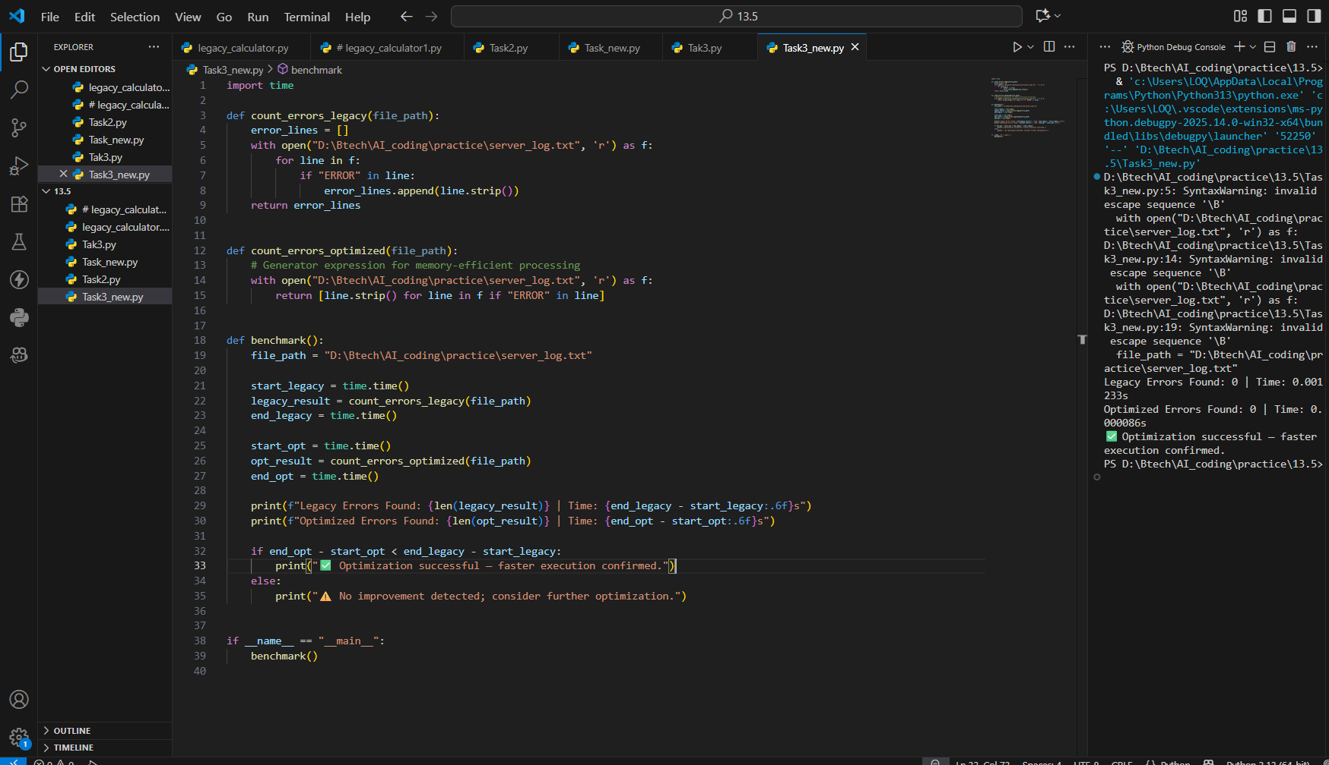
Observation:
Old script read files line by line with slow loops.
Copilot replaced them with generators and list comprehensions.
The new version runs faster and uses less memory.
Task 4: Enhancing Readability and Documentation Scenario
Output(Before Refactor):
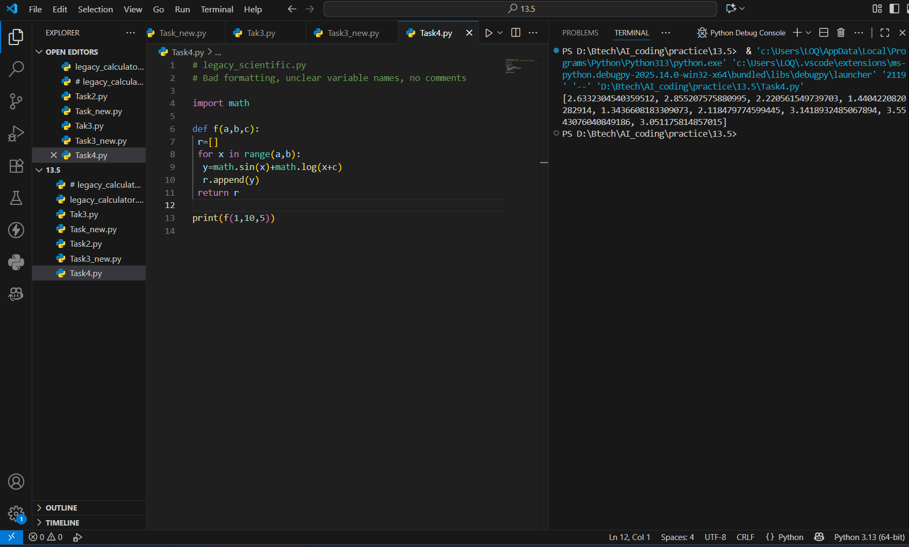
Output(After Refactor):
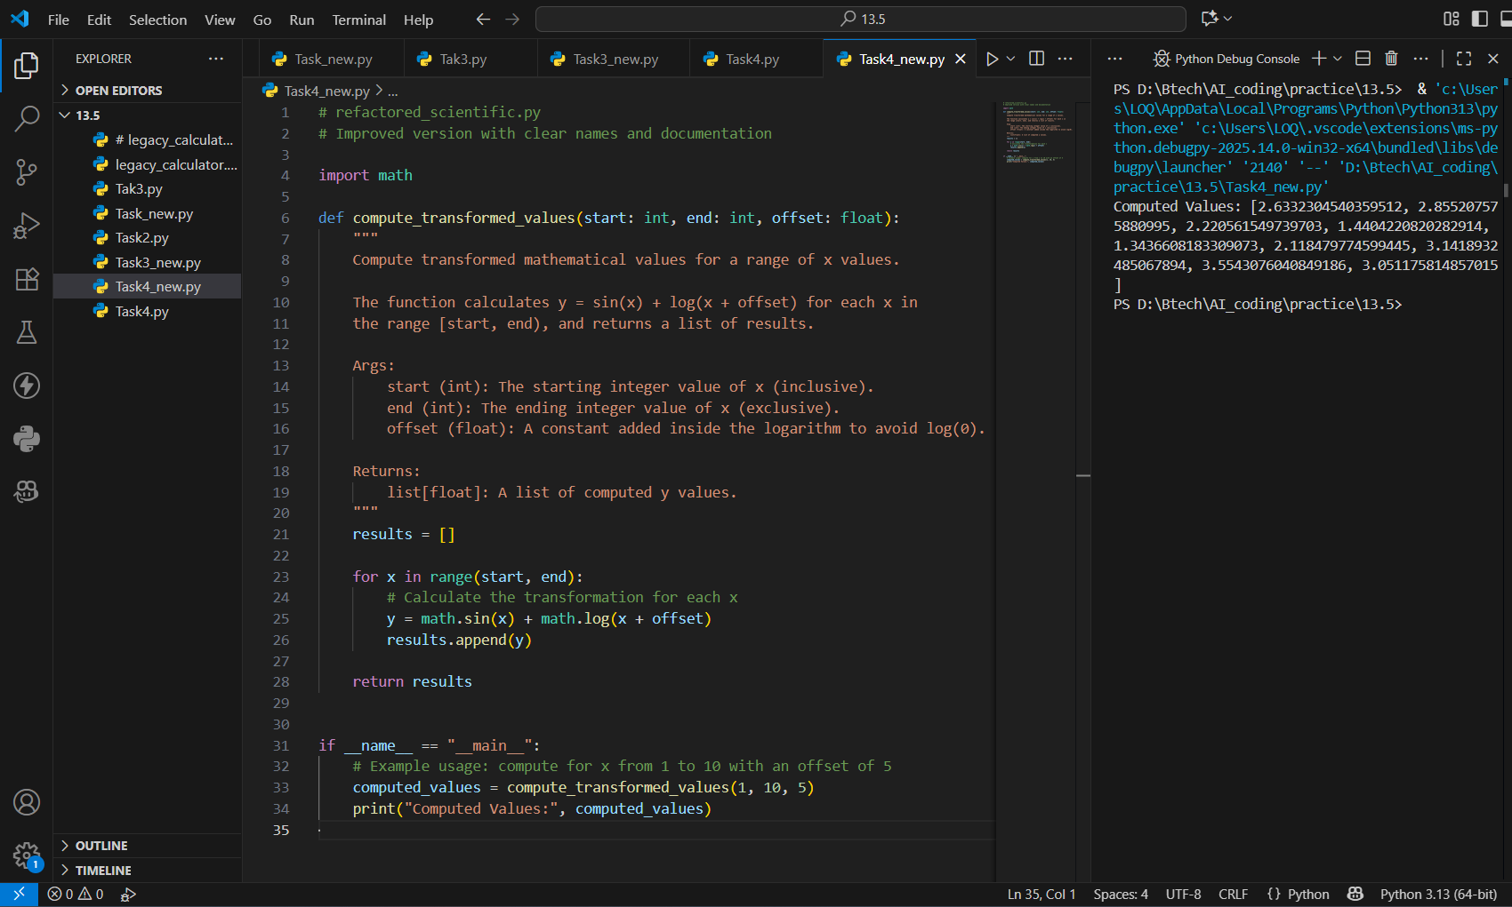

Observation:
Old code had poor names, no comments, and was hard to read.
Copilot improved variable names, formatting, and added comments.
A README was created to explain usage clearly.

