ASSIGNMENT-9.5

Task 1: (Automatic Code Commenting)
Scenario: You have been given a Python function without comments.

def calculate_discount(price, discount_rate): return price - (price * discount_rate / 100)

- Use an AI tool (or manually simulate it) to generate line-by-line comments for the function.
- Modify the function so that it includes a docstring in Google-style or NumPy-style format.
- Compare the auto-generated comments with your manually written version.
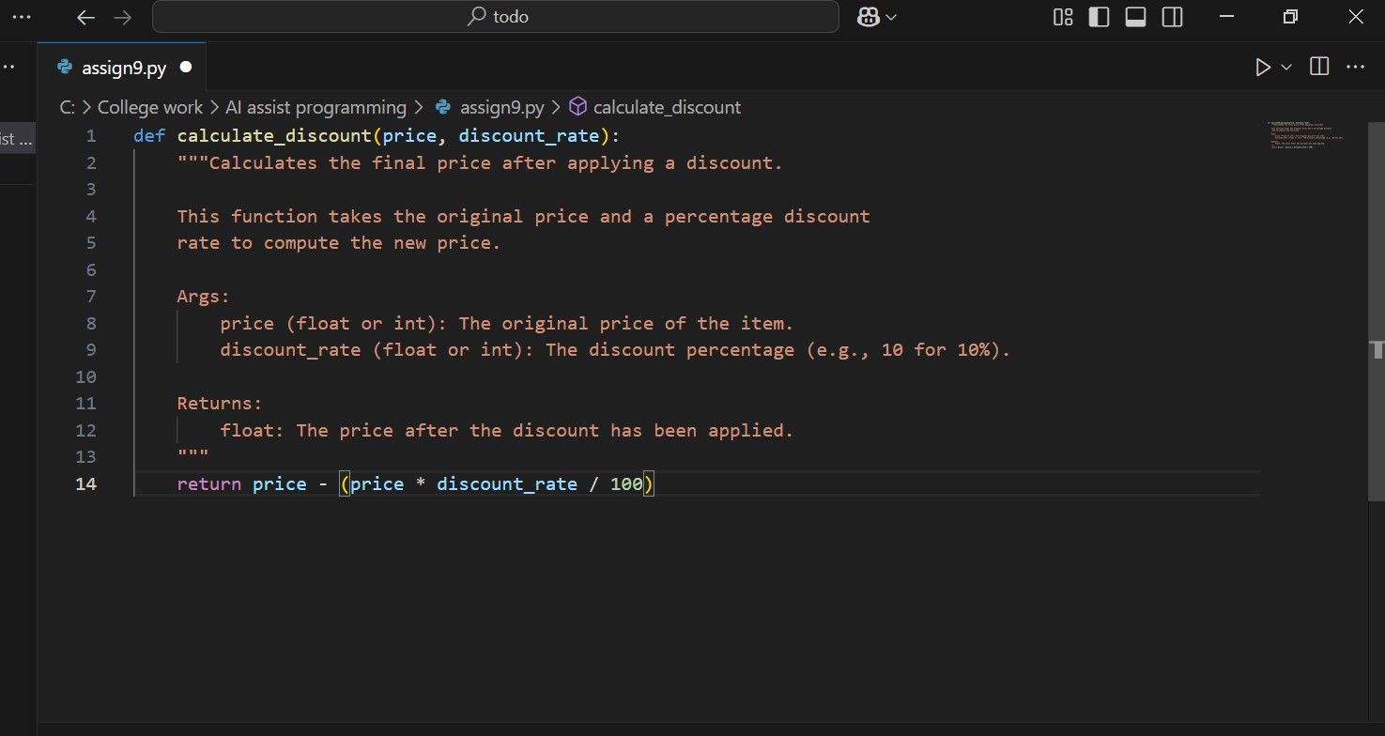

Task 2: (API Documentation Generator)
Scenario: A team is building a Library Management System with multiple functions.

def add_book(title, author, year):
# code to add book pass def issue_book(book_id, user_id):
# code to issue book Pass

- Write a Python script that uses docstrings for each function (with input, output, and description).
- Use a documentation generator tool (like pdoc, Sphinx, or MkDocs) to automatically create HTML documentation.
- Submit both the code and the generated documentation as output.

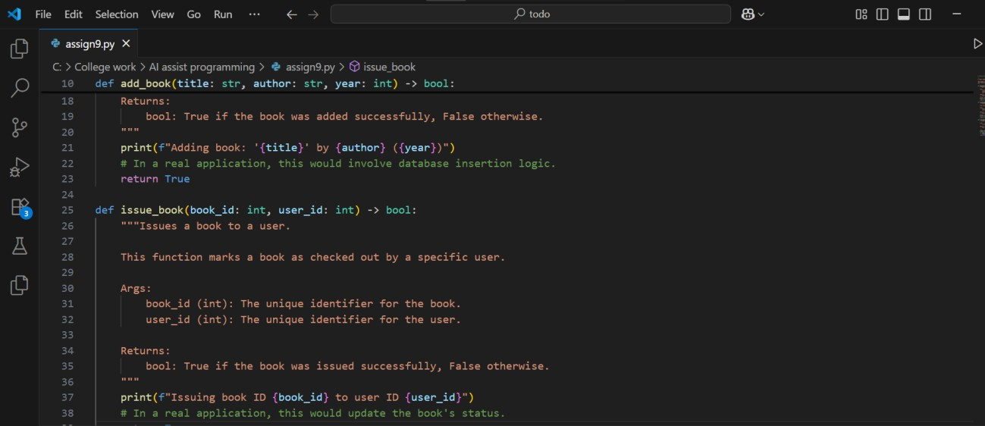
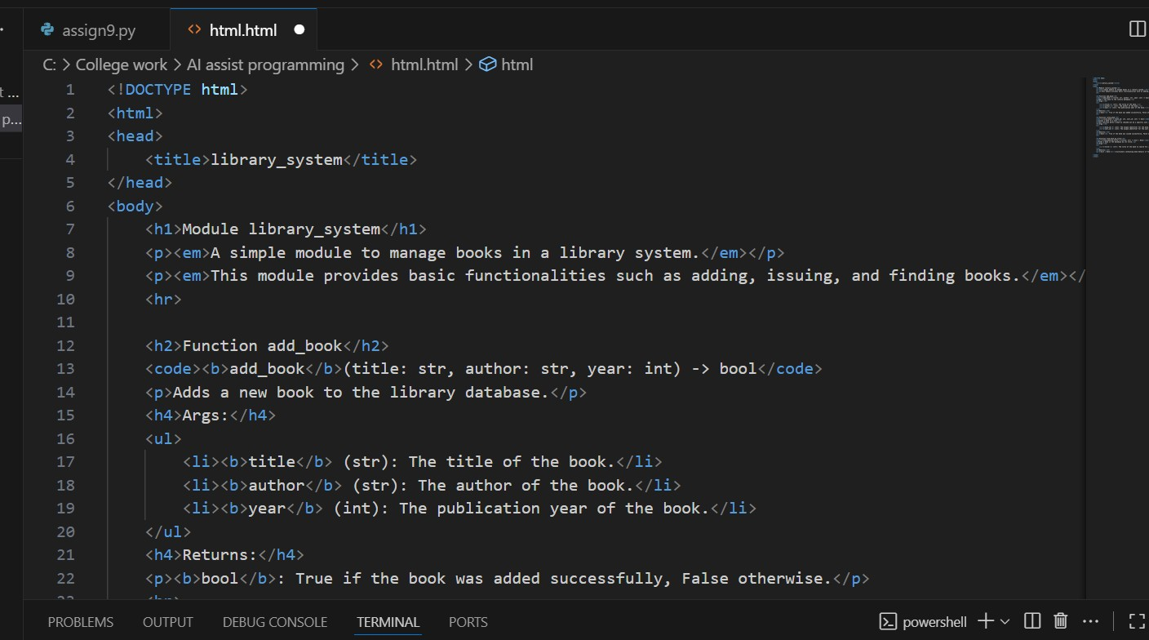
TASK 3: (AI-Assisted Code Summarization)
Scenario: You are reviewing a colleague’s codebase containing long functions def process_sensor_data(data):
cleaned = [x for x in data if x is not None] avg = sum(cleaned)/len(cleaned)
anomalies = [x for x in cleaned if abs(x - avg) > 10] return {"average": avg, "anomalies": anomalies}

- Generate a summary comment explaining the purpose of the function in 2–3 lines.
- Create a flow-style comment (step-by-step explanation).
- Write a short paragraph of documentation describing possible use cases of this function in real-world scenarios

STEP BY STEP EXPLANATION:
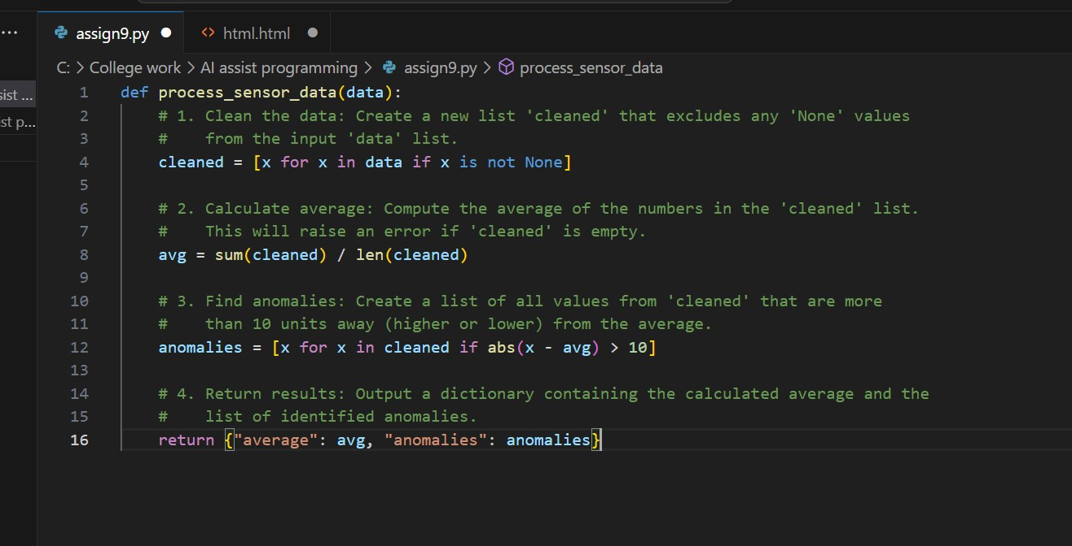
TASK 4 : (Real-Time Project Documentation)
Scenario: You are part of a project team that develops a Chatbot Application. The team needs documentation for maintainability.
- Write a README.md file for the chatbot project (include project description, installation steps, usage, and example).
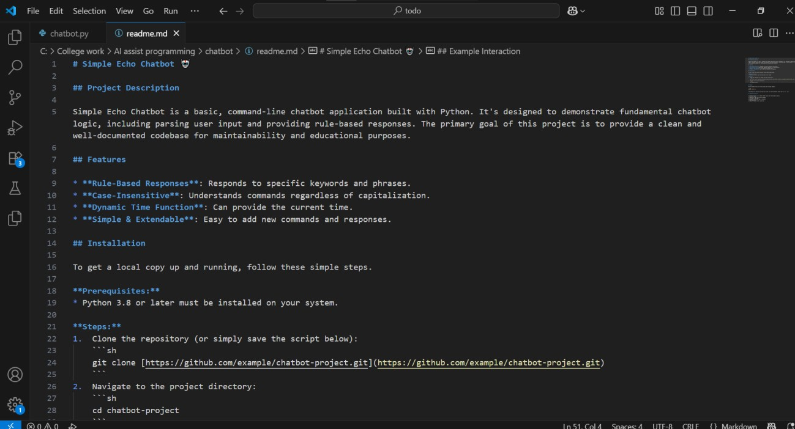

- Add inline comments in the chatbot’s main Python script (focus on explaining logic, not trivial code).
- Use an AI-assisted tool (or simulate it) to generate a usage guide in plain English from your code comments.
- Reflect: How does automated documentation help in real-time projects compared to manual documentation?
