SUMMARY

SYNOPSYS strengthened software security with SYNOPSYS POLARIS, achieving automation,enhancing software security and robust code analysis.

SYNOPSYS POLARIS:Enhancing Software Security and Efficiency

Introduction:
To guard against ever-evolving cyber threats in today's digital world, software security is critical. The Synopsys Polaris Software Integrity Platform was used by SYNOPYS, a renowned software development company, to successfully improve its software security. The selection, implementation, and results of this platform are described in depth to highlight the value of preventative security measures.

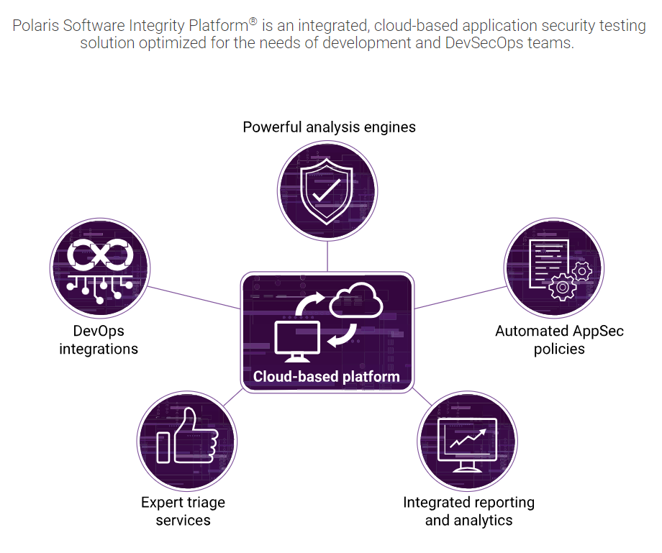

Challenges:
Critical security issues that Synopsys experienced before using Synopsys Polaris included:

Increasing Security Threats: The business has seen a surge in security threats, including flaws in its code that put consumer data and brand reputation at danger.

Resource constraints: Manual security testing required a lot of resources and time, which had an influence on project completion dates and the effectiveness of development.

Relevant Drivers:
In line with Synopsys's objectives to protect their software, the Executive Order on Strengthening the Cybersecurity of Federal Networks and Critical Infrastructure highlighted the need to improve cybersecurity measures across industries.

Solution:
The Synopsys examined a range of security options, including Synopsys Polaris, open-source tools, and manual testing as per tradition. They selected Polaris for a number of reasons:

With its industry-leading security analysis engines, Polaris provided a full security study, assuring accurate code evaluation.

Automation Capability: Polaris made security testing automated, minimizing manual labour and speeding up development.

Integration: Polaris streamlined the security testing process by easily integrating with their current DevOps and development technologies
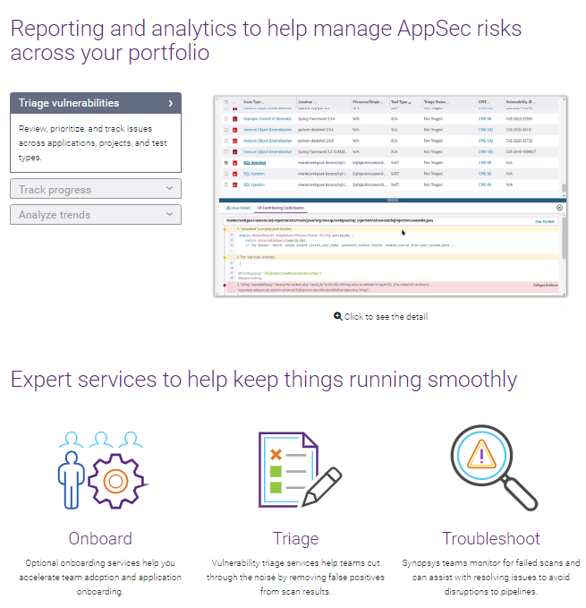

Implementations:
Initial evaluation of current security procedures revealed flaws and need for improvement.

Deployment: Polaris was included into the pipeline for developing new systems, ensuring that it symbiotically interacted with them.

Team Training: Workers got thorough instruction on how to use Polaris in processes.

Lessons Learned:
During the implementation phase, Synopsys discovered some crucial lessons:

User Training: Comprehensive user training is necessary to fully reap the rewards of a new security system.

Integration Planning:Planning for integration is essential to minimizing interruptions and ensuring smooth interaction with current systems.

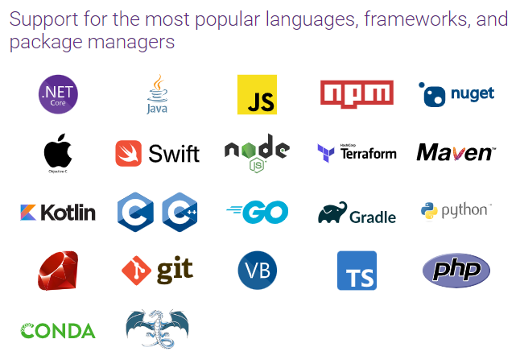

Results achieved:
The expected results would include improvements in software security, such as reduced vulnerabilities, faster development cycles, and enhanced efficiency due to automation.

REFERENCES

For more information about SYNOPSIS POLARIS, please see the SYNOPSYS website at https://www.synopsys.com/software-integrity/polaris.html
https://www.synopsys.com/software-integrity/polaris/demo.html

CONTACT INFORMATION

Harsh Raj(219302137)
+91 7050567661
harsh.219302137@muj.manipal.edu
harshha092@gmail.com

