Seminar Report
On

AI-Driven Voice-Based Healthcare Framework
(MediVoice AI)
Submitted by
Kosuru HarshaVardhan
Registration No: 12210058
Bachelor of Technology
IN
(Computer Science and Engineering)
Under the Supervision of

Dr. Aarti

Assistant Professor

LOVELY PROFESSIONAL UNIVERSITY PUNJAB
(January – May 2026)

DECLARATION
I hereby declare that the seminar report titled "AI-Driven Voice-Based Healthcare Framework" submitted in partial fulfillment of the requirements for the award of the degree of Bachelor of Technology in Computer Science and Engineering is a record of my own work carried out during the academic session January – May 2026.
I further declare that this report has not been submitted, either in part or in full, to any other institution or university for the award of any degree or diploma.
I confirm that the content of this report is original and prepared by me. Any references used have been duly acknowledged. I also declare that the use of Artificial Intelligence (AI) tools, if any, has been minimal and the AI-generated content in this report is less than 10%, ensuring that the majority of the work reflects my own understanding and effort.
I take full responsibility for the authenticity and originality of the work presented in this report.

Name of the Student: Kosuru Harsha Vardhan
Registration Number: 12210058
Course: B.Tech – Computer Science and Engineering

Signature of the Student
Date: 25/04/2026

TABLE OF CONTENTS
Front page 1
Declaration 2
Table of Contents 3
Chapter 1: Introduction 5
1.1 MediVoice AI – Voice-Driven Healthcare Consultation System 5
1.2 Healthcare Accessibility Crisis and the Role of AI 5
1.3 Goals of Real-Time Symptom Interpretation and Patient Support 6
1.4 System Development Approach: From Speech Input to Medical Report 7
Chapter 2: Literature Review 9
2.1 Limitations of Manual and Text-Based Healthcare Systems 9
2.2 AI and LLMs for Clinical Decision Support and Symptom Triage 9
2.3 Voice Interfaces for Patient Engagement in Healthcare 10
2.4 NLP for Symptom Extraction and Medical Entity Recognition 10
2.5 Gap Analysis: Why MediVoice AI is Needed 11
Chapter 3: Conceptual Study / Seminar Work 13
3.1 Core AI and Voice Technologies Powering MediVoice AI 13
3.2 Three-Tier Architecture, AI Pipeline, and Specialist Routing Algorithm 14
3.3 End-to-End User Flow: From Login to AI Voice Agent 15
3.4 React, Node.js, Clerk Auth, LLM API, and Payment Stack 17
Chapter 4: Results and Discussion 19
4.1 System Screenshots and Functional Observations 19
4.2 MediVoice AI vs Traditional and Text-Based Healthcare Platforms 25
4.3 Walkthrough of All System Figures and Their Clinical Significance 26
4.4 Strengths, Constraints, and Design Insights of the System 26
Chapter 5: Conclusion and Future Scope 29
5.1 What MediVoice AI Achieved and How 29
5.2 Skills and Knowledge Gained from Building this System 29
5.3 Impact of Voice-Driven AI on Healthcare Accessibility 30
5.4 Roadmap: Multilingual Support, EHR Integration, and Clinical Validation 31
Professional Profile & Repository Details 33
Bibliography / References 34

CHAPTER 1: INTRODUCTION

1.1 MediVoice AI – Voice-Driven Healthcare Consultation System
The title of this seminar is: " AI-Driven Voice-Based Healthcare Framework " — also referred to as MediVoice AI. This seminar explores the design, development, and evaluation of an intelligent web-based healthcare platform that enables users to describe their medical symptoms through voice interaction and receive AI-generated medical insights, specialist suggestions, and structured medical reports in real time.
MediVoice AI represents a convergence of artificial intelligence, natural language processing, speech recognition, and modern web technologies to deliver a next-generation patient support system. The system addresses the critical need for accessible, immediate, and intelligent healthcare guidance, particularly in situations where professional medical consultation is not immediately available.

1.2 Healthcare Accessibility Crisis and the Role of AI
In today's digital era, advancements in technology have significantly transformed various sectors, with healthcare being one of the most profoundly impacted domains. Despite remarkable progress in medical science and technology, many healthcare systems continue to face fundamental challenges such as limited accessibility, long waiting times, lack of immediate consultation, and inefficient data management. Patients — especially those in remote or underserved areas — often struggle to receive timely medical guidance. Traditional healthcare systems also rely heavily on manual processes, which are time-consuming and prone to errors.
The global healthcare landscape is further strained by an increasing population, a shortage of qualified medical professionals, and growing demand for personalized medical attention. According to the World Health Organization, there is a projected global shortage of 10 million health workers by 2030, predominantly in low- and middle-income countries. This gap between healthcare demand and supply makes the development of AI-assisted medical platforms not merely advantageous but essential.
With the increasing demand for efficient and accessible healthcare services, Artificial Intelligence has emerged as one of the most promising solutions. AI-based systems have demonstrated the capability to analyze medical data, assist clinical decision-making, and provide preliminary healthcare guidance at scale. However, most existing healthcare applications depend on text-based interaction or manual input methods, which may not be convenient or accessible for all users — particularly the elderly, individuals with physical disabilities, or those with limited digital literacy.
Voice-based interaction represents a natural, intuitive, and inclusive modality for human-computer interaction. The proliferation of voice-enabled devices and assistants has demonstrated that users across diverse demographics readily adopt voice interfaces when they are designed thoughtfully. Applying this paradigm to healthcare can dramatically improve the accessibility and usability of medical support systems.
The proposed system, MediVoice AI, is designed to address these challenges by introducing a voice-enabled platform for medical consultation. The system allows users to interact using natural speech, creating a more intuitive and human-like communication experience. By integrating speech recognition, natural language processing, and AI-based reasoning, the system can analyze user symptoms, generate relevant follow-up questions, and provide meaningful medical insights in real time.
In addition, the system automates the generation of structured medical reports, reducing manual effort and improving accuracy in data recording. It also provides users with a dashboard to view consultation history and access previously generated reports. This approach enhances usability and ensures that users can easily manage and track their health-related information over time.

1.3 Goals of Real-Time Symptom Interpretation and Patient Support
The primary objectives of this seminar report are as follows:
- To study and analyze the limitations of existing healthcare consultation systems and identify the critical gaps that require intelligent, AI-driven solutions.
- To explore and explain the integration of Artificial Intelligence, Natural Language Processing, and Speech Recognition technologies in the context of real-time healthcare support applications.
- To understand and present the complete architecture and design of the MediVoice AI system, covering frontend, backend, AI processing, and database components.
- To evaluate the technical and operational feasibility of developing a voice-based AI healthcare platform that is accessible, efficient, accurate, and user-friendly.
- To examine the tools, technologies, and frameworks used in the development of the system, and to assess their suitability for production healthcare environments.
- To analyze the testing methodologies applied during system validation, including functional testing, structural testing, unit testing, integration testing, system testing, and acceptance testing.
- To identify the advantages, limitations, and performance characteristics of the MediVoice AI system based on observed results and user feedback.
- To outline future enhancement opportunities and research directions for advancing AI-driven voice healthcare systems.

1.4 System Development Approach: From Speech Input to Medical Report
The development of MediVoice AI follows a structured Software Development Life Cycle (SDLC) methodology encompassing requirement analysis, system design, implementation, testing, and evaluation. The approach integrates modern web development frameworks with Artificial Intelligence and speech processing technologies to deliver a complete, functional, and scalable healthcare assistance system.
The system is implemented as a full-stack web application. The frontend provides an intuitive user interface with voice input capabilities, leveraging browser-based Web Speech API for real-time transcription. The backend manages user authentication, session handling, and data storage using a secure, scalable server architecture. The AI processing module is responsible for analyzing transcribed symptom text, generating contextual follow-up questions, recommending appropriate medical specialists, and producing structured medical reports.
The methodology adopted for this seminar study involved: a thorough literature review of existing healthcare AI systems and voice interaction technologies; conceptual analysis of the system architecture and design patterns; practical implementation and testing across all major system modules; and systematic evaluation of results against defined functional and non-functional requirements.
The feasibility of the system was evaluated across economic, technical, and operational dimensions to ensure that the solution is practical, cost-effective, and deployable within real-world healthcare support scenarios.

CHAPTER 2: LITERATURE REVIEW

2.1 Limitations of Manual and Text-Based Healthcare Systems
Traditional healthcare systems have historically depended on in-person patient-doctor interactions as the primary modality for medical consultation. While this model remains the gold standard for clinical care, it faces significant scalability challenges in modern healthcare environments. Ajami and Bagheri-Tadi (2013) identified multiple barriers to the adoption of electronic health records by physicians, including usability concerns, inadequate training, and resistance to workflow change. Their findings underscore the difficulty of transitioning healthcare systems from manual to digital operation.
Chaudhry (2006) conducted a comprehensive systematic review on the impact of health information technology and found that while digital systems improve quality and efficiency in healthcare delivery, adoption barriers remain significant obstacles. The study noted that the benefits of health IT are most pronounced when systems are designed with clinical workflows and user needs as primary considerations.
Boonstra and Broekhuis (2010) explored barriers to acceptance of electronic medical records by physicians and developed a taxonomy of interventions that could improve adoption. Their work highlights the critical importance of intuitive, user-friendly system design that aligns naturally with the way healthcare professionals and patients think and communicate.

2.2 AI and LLMs for Clinical Decision Support and Symptom Triage
The application of Artificial Intelligence to healthcare has generated substantial academic and commercial interest in recent years. Cascella et al. (2023) conducted a rigorous evaluation of the feasibility of large language models — specifically ChatGPT — in multiple healthcare scenarios. Their analysis demonstrated that AI language models show significant promise in clinical decision support, patient education, administrative documentation, and preliminary symptom triage.
Cahyo and Astuti (2023) performed a comprehensive literature review on early detection of health problems through AI technology in hospital information management. Their study concluded that AI systems can significantly improve diagnostic accuracy and reduce the time required for initial patient assessment, particularly when deployed as screening tools that direct patients to appropriate care pathways.
Chen et al. (2023) introduced MEDITRON-70B, a large language model specifically pre-trained on a curated corpus of medical literature, clinical guidelines, and healthcare data. The model demonstrated superior performance compared to general-purpose language models on medical reasoning benchmarks, establishing the value of domain-specific AI training for healthcare applications.
Andersen et al. (2021) examined the real-world challenges of deploying AI systems in healthcare environments, noting that while AI performs impressively in controlled research settings, practical deployment faces complex challenges related to data quality, system integration, clinician trust, and regulatory compliance. Their work provides important context for understanding the gap between AI research outcomes and clinical implementation.

2.3 Voice Interfaces for Patient Engagement in Healthcare
Voice-based human-computer interaction has gained significant traction with the widespread adoption of smart speakers, voice assistants, and conversational AI systems. Research consistently shows that voice interfaces are particularly beneficial for elderly users, individuals with motor disabilities, and users in hands-free environments — all populations that represent significant segments of healthcare system users.
Boersma and Weenink (2023) described Praat, a sophisticated phonetic analysis tool used in speech research, demonstrating the depth of scientific tools available for speech processing and analysis. The maturity of speech science tools provides a strong foundation for building reliable voice interaction systems in sensitive domains such as healthcare.
Al Ghadban et al. (2023) explored the use of large language models combined with retrieval-augmented generation for healthcare capacity building among frontline health workers. Their work demonstrated how conversational AI systems can effectively deliver complex medical information in an accessible, dialogue-based format — a design principle directly applicable to the MediVoice AI consultation interface.

2.4 NLP for Symptom Extraction and Medical Entity Recognition
Natural Language Processing represents the core technology that enables intelligent interpretation of patient symptom descriptions. Antoniak et al. (2024) examined NLP approaches for maternal healthcare applications and articulated guiding principles for the responsible application of large language models in clinical settings. Their work emphasizes the importance of transparency, appropriate confidence calibration, and clear delineation of AI capabilities versus clinical judgment.
The application of NLP to symptom analysis requires careful attention to medical terminology, symptom co-occurrence patterns, and temporal relationships in patient narratives. Modern transformer-based language models have demonstrated the ability to extract clinically relevant information from free-text symptom descriptions, enabling automated preliminary triage and specialist routing.
Cai et al. (2019) conducted the influential "Hello AI" study examining the onboarding needs of medical practitioners for human-AI collaborative decision-making. Their findings revealed that clear, transparent communication of AI capabilities and limitations is essential for effective clinical adoption. This insight directly influenced the design of MediVoice AI's report generation module, which explicitly frames outputs as AI-generated preliminary guidance rather than definitive medical diagnosis.

2.5 Gap Analysis: Why MediVoice AI is Needed
A structured comparison of existing healthcare technology solutions reveals clear patterns of strength and weakness across different approaches. Text-based chatbot systems, while cost-effective and widely deployable, provide limited interaction quality and struggle with ambiguous or contextually complex symptom descriptions. Their rigid, rule-based architectures cannot adapt to the natural variability of patient communication.
Telemedicine platforms improve access to professional medical consultation and have demonstrated clinical effectiveness, but require advance scheduling, professional availability, and do not provide immediate automated preliminary assessment. They serve a complementary but distinct function from AI-driven preliminary support systems.
Burgess et al. (2023) identified key design principles for healthcare AI decision support systems that enhance clinician adoption and user trust, including transparency of AI reasoning, appropriate expression of uncertainty, and seamless integration with existing clinical workflows. These principles informed the design of MediVoice AI's user interface and report formatting.
Berry et al. (2017) investigated how healthcare professionals can create conditions for patients' values and concerns to emerge in clinical conversations. Their research highlights that effective patient support requires not just information delivery, but genuine conversational engagement that allows patients to express concerns fully. Voice-based AI systems are better positioned to enable this type of open-ended dialogue compared to rigid text-based interfaces.
The collective body of literature strongly supports the development of intelligent, voice-driven healthcare systems that combine NLP with AI reasoning to provide accessible, real-time medical support. The specific gaps identified — including lack of voice interaction, absence of automated report generation, limited personalization, and poor accessibility for non-technical users — directly motivate and validate the development of MediVoice AI as a novel contribution to healthcare technology.

CHAPTER 3: CONCEPTUAL STUDY / SEMINAR WORK

3.1 Core AI and Voice Technologies Powering MediVoice AI

3.1.1 How AI Understands and Interprets Patient Symptoms
Artificial Intelligence refers to the simulation of human intelligence processes by computer systems. In the context of healthcare, AI encompasses a range of capabilities including pattern recognition in medical data, natural language understanding for patient communication, clinical decision support, and automated report generation. MediVoice AI leverages AI to analyze symptom descriptions, generate contextually appropriate follow-up questions, identify relevant medical specialties, and produce structured medical reports without requiring direct human intervention.

3.1.2 Web Speech API: Capturing Patient Voice in Real Time
Speech recognition technology converts spoken language into text through acoustic modeling and language modeling techniques. Modern speech recognition systems achieve high accuracy through deep learning models trained on large corpora of speech data. In MediVoice AI, the browser-based Web Speech API provides real-time speech-to-text transcription, enabling users to describe their symptoms verbally. This captured text is then passed to the AI processing module for analysis.

3.1.3 NLP: Extracting Symptoms, Severity, and Context from Speech
Natural Language Processing is a branch of AI concerned with the interaction between computers and human language. NLP enables systems to understand the meaning, context, and intent behind text input. In medical applications, NLP extracts clinically relevant entities such as symptoms, body parts, duration, severity, and associated conditions from free-text patient descriptions. MediVoice AI uses NLP to parse user symptom input, identify key medical concepts, and generate appropriate follow-up queries.

3.1.4 Automated Medical Report Generation from Consultation Data
Automated medical report generation involves the synthesis of structured clinical documents from unstructured patient interaction data. MediVoice AI generates comprehensive consultation reports that include a summary of reported symptoms, duration and severity assessment, preliminary recommendations, and suggested specialist types. These reports provide users with a permanent record of their consultation that can be shared with healthcare providers.

3.1.5 Secure Login and Patient Data Protection via Clerk Auth
Secure user authentication is a critical requirement for any healthcare application handling sensitive personal and medical data. MediVoice AI implements authentication through Clerk, a modern authentication platform that supports Google OAuth, email-based login, and session management. All user data is handled with appropriate security measures to ensure confidentiality, integrity, and availability.

3.2 Three-Tier Architecture, AI Pipeline, and Specialist Routing Algorithm

3.2.1 Frontend, Backend, and AI Layer: How the Three Tiers Communicate
MediVoice AI is built on a three-tier web application architecture comprising the Presentation Layer, Business Logic Layer, and Data Layer. This architectural pattern ensures a clean separation of concerns, enabling independent development, testing, and scaling of each system component.
The Presentation Layer consists of the web-based frontend that provides all user-facing interfaces, including the landing page, authentication interface, dashboard, consultation interface, report viewer, and subscription management pages. The Business Logic Layer comprises the backend server that handles authentication, API routing, session management, AI model integration, and data processing. The Data Layer includes the database system that stores user profiles, consultation sessions, generated reports, and subscription information.

3.2.2 Speech-to-Text to AI Analysis: The Six-Stage Processing Pipeline
The AI processing component operates as a multi-stage pipeline: first, user speech input is captured and transcribed to text using the Web Speech API; second, the transcribed text is preprocessed and sanitized; third, the NLP module extracts symptom entities, severity indicators, and temporal information; fourth, the AI reasoning module analyzes the extracted information and generates a specialist recommendation; fifth, a conversational follow-up dialogue is initiated to gather additional clinical context; finally, all gathered information is synthesized into a structured medical report.

3.2.3 Symptom-to-Specialist Mapping: How MediVoice AI Routes Each Case
The specialist recommendation algorithm analyzes the semantic content of reported symptoms and maps them to appropriate medical specialties through a combination of keyword extraction, symptom-specialty mapping rules, and AI language model inference. The system can recommend from a comprehensive set of specialists including General Physician, Pediatrician, Dermatologist, Cardiologist, ENT Specialist, Orthopedic, Psychologist, Nutritionist, Gynecologist, and Dentist.

3.2.4 Database Schema: Storing Users, Consultations, Reports, and Subscriptions
The database schema is designed to efficiently manage all system data entities. The primary entities include User (profile information and authentication details), Consultation (session metadata and symptom input), Report (generated medical reports with all consultation outputs), and Subscription (plan type, billing status, and feature access). Relationships between these entities maintain referential integrity while enabling efficient querying for dashboard history and report retrieval.

3.3 End-to-End User Flow: From Login to AI Voice Agent

3.3.1 MediVoice AI System Flowchart: Authentication to Report Generation
The following flowchart illustrates the complete workflow of the MediVoice AI system from the point of user arrival at the web application through to the completion of a consultation session and generation of a medical report. The flowchart captures all major decision points and process steps in the system's operational flow.

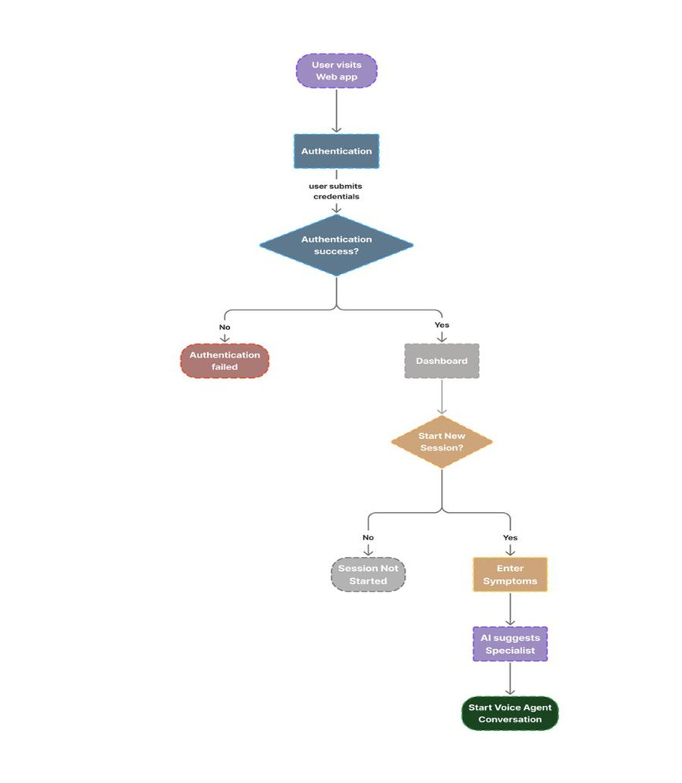
Fig. 3.1: System Flowchart of MediVoice AI – Authentication to Voice Agent Conversation

As illustrated in Fig. 3.1, the system flow begins when the user visits the MediVoice AI web application. The user is required to authenticate using either Google OAuth or email-based login credentials. Upon successful authentication, the user is directed to the main dashboard. From the dashboard, the user can initiate a new consultation session. If the user chooses to start a new session, they enter their symptoms through the consultation interface. The AI system analyzes the input and suggests an appropriate specialist. The AI voice agent then begins a conversational interaction to gather additional clinical details. If authentication fails, access is denied and the user is prompted to re-enter correct credentials.

3.3.2 Data Flow: Voice Input Through NLP to Structured Medical Output
The conceptual data flow framework of MediVoice AI follows a clear, unidirectional pipeline: Voice Input → Speech-to-Text Transcription → NLP Preprocessing → AI Analysis → Specialist Routing → Follow-up Dialogue → Report Generation → Dashboard Storage. At each stage, data is validated, processed, and passed to the next stage, ensuring the accuracy and completeness of the final medical report.

3.3.3 Patient Touchpoints: Symptom Input, AI Dialogue, and Report View
The user interaction framework is designed around three primary touchpoints: the consultation initiation interface where basic symptom details are provided; the AI voice conversation interface where deeper clinical information is gathered through natural dialogue; and the report viewing interface where the structured consultation output is presented. This framework ensures that users are guided naturally through the clinical information gathering process without feeling overwhelmed or confused.

3.4 React, Node.js, Clerk Auth, LLM API, and Payment Stack

3.4.1 React.js and Tailwind CSS: Building the Voice-Enabled Patient Interface
The frontend of MediVoice AI is developed using React.js, a component-based JavaScript framework that enables the creation of dynamic, responsive user interfaces. React's virtual DOM and component reusability make it ideal for building complex, interactive web applications. Tailwind CSS is used for styling, providing a utility-first approach that ensures consistent, responsive design across all device sizes and screen resolutions.
The Web Speech API, a browser-native API supported in modern Chrome and Edge browsers, provides the speech recognition capability. This eliminates the need for external speech processing services for basic voice input functionality, reducing latency and improving user privacy.

3.4.2 Node.js and Express.js: Handling Real-Time API Requests and Sessions
The backend infrastructure is built using Node.js with Express.js, providing a lightweight, high-performance server environment suitable for handling real-time API requests. Node.js's non-blocking I/O model makes it particularly well-suited for healthcare applications that may experience variable and concurrent user loads.

3.4.3 Clerk: Google OAuth and Email Auth for Secure Patient Accounts
Clerk is used as the authentication and user management platform. Clerk provides enterprise-grade authentication features including OAuth integration with Google, email-based magic link authentication, multi-factor authentication support, and comprehensive session management. This ensures that user accounts and medical data are protected by industry-standard security practices.

3.4.4 LLM API Integration: The Brain Behind Symptom Analysis and Report Writing
The AI processing capabilities are delivered through integration with advanced large language model APIs. These models provide the natural language understanding, symptom analysis, and report generation functionality at the core of the MediVoice AI system. The modular integration architecture allows the system to be updated with improved AI models as they become available without requiring changes to the broader system architecture.

3.4.5 Cloud Database: Encrypted Storage of Consultations and Medical Reports
A cloud-based database system is used to store all user data, consultation records, and generated reports. The database is designed for high availability and data integrity, ensuring that consultation history is reliably preserved and accessible to users through the dashboard interface. Data security measures including encryption at rest and in transit are implemented to protect sensitive medical information.

3.4.6 Clerk Billing and Payment Gateway: Free vs Pro Subscription Management
The subscription and payment system is implemented using Clerk Billing integrated with a secure payment gateway. This enables reliable processing of subscription payments for users upgrading to the Pro plan, with support for card payments and automatic billing management. The system operates in both test and production modes to facilitate safe development and deployment.

CHAPTER 4: RESULTS AND DISCUSSION

4.1 System Screenshots and Functional Observations

4.1.1 Landing Page: First Impression and Call-to-Action Design
The landing page of MediVoice AI serves as the primary entry point for all users. It presents the system's value proposition clearly and concisely, with a prominent call-to-action that guides users towards the consultation workflow. The landing page is designed to communicate trust and professionalism, which is essential for a healthcare-related application. The following screenshot illustrates the landing page of the deployed system:

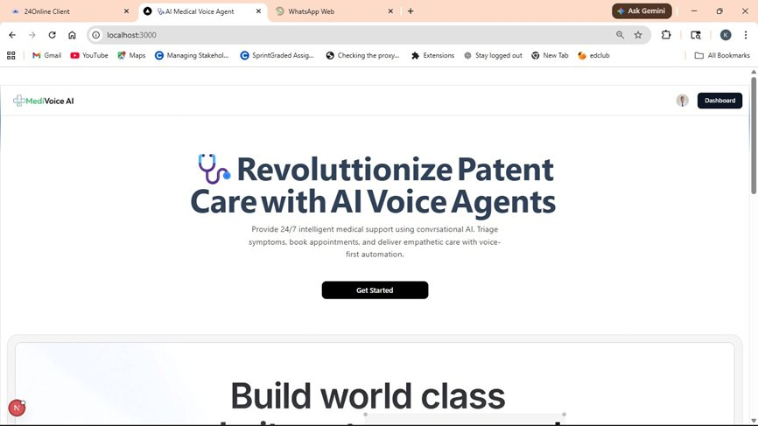
Fig. 4.1: MediVoice AI – Landing Page

As observed in Fig. 4.1, the landing page features the MediVoice AI branding, a clear headline communicating the core value of AI-powered patient care, a brief description of the platform's capabilities including 24/7 intelligent medical support, symptom triage, and voice-first automation, and a prominent 'Get Started' button directing users to begin the consultation process. The clean, professional design establishes user confidence in the system.

4.1.2 Sign-In Page: Multi-Option Authentication with Google OAuth
The login interface implements secure, modern authentication standards through the Clerk authentication platform. Users are presented with multiple authentication options to maximize accessibility and user convenience:

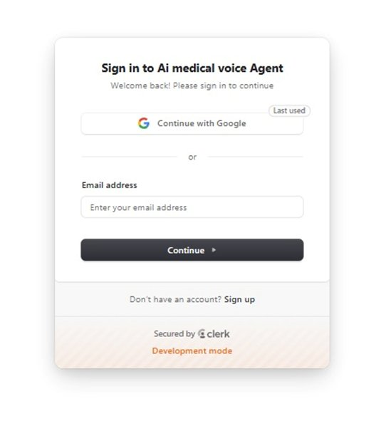
Fig. 4.2: MediVoice AI – Sign In Page with Google OAuth and Email Authentication

As shown in Fig. 4.2, the sign-in interface offers Google OAuth as the primary authentication method (marked as 'Last used' for returning users), as well as email-based authentication for users who prefer not to use Google accounts. The 'Sign up' option is prominently displayed for new users. The interface is secured by Clerk's authentication infrastructure, providing enterprise-grade security for user credentials and session management.

4.1.3 Symptom Input Dialog: How Patients Describe Their Health Condition
The symptom input interface provides users with a straightforward modal dialog for entering their initial health concerns. This interface is the gateway to the AI consultation process:

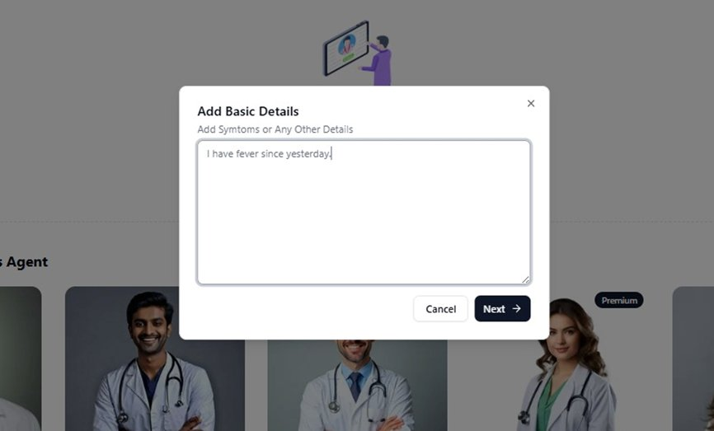
Fig. 4.3: MediVoice AI – Symptom Input Dialog (Add Basic Details)

Fig. 4.3 shows the 'Add Basic Details' dialog where users can enter their symptoms or any other relevant health information in a free-text field. The example shows a user entering 'I have fever since yesterday.' The clean, uncluttered design ensures that users can focus on describing their symptoms without interface complexity. The 'Next' button proceeds to the AI analysis and specialist suggestion phase.

4.1.4 My Dashboard: Consultation History and Report Access Hub
The main dashboard serves as the central hub for all user activities, providing an organized view of consultation history and easy access to all system features:

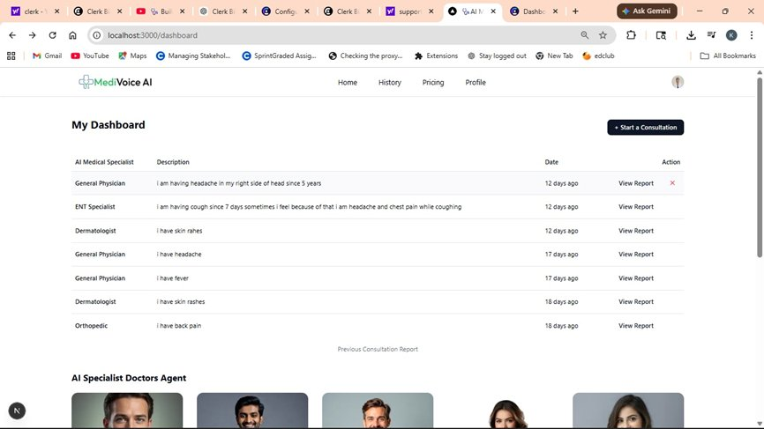
Fig. 4.4: MediVoice AI – Main Dashboard Showing Consultation History

As illustrated in Fig. 4.4, the dashboard displays a chronological list of all past consultations with key details including the AI Medical Specialist recommended (e.g., General Physician, ENT Specialist, Dermatologist, Cardiologist, Orthopedic), the symptom description provided by the user, the date of consultation, and a 'View Report' action link for accessing the detailed medical report. The '+ Start a Consultation' button is prominently placed for easy initiation of new sessions.

4.1.5 AI Specialist Panel: Free vs Premium Doctor Agent Selection
The specialist selection panel displays the available AI medical specialist agents, allowing users to choose a specific specialist for their consultation:

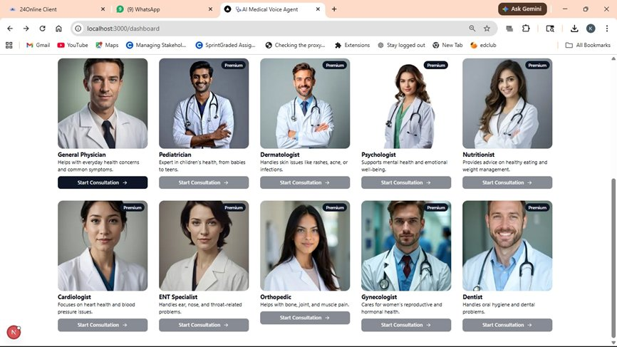
Fig. 4.5: MediVoice AI – AI Specialist Doctors Panel (Free Tier View)

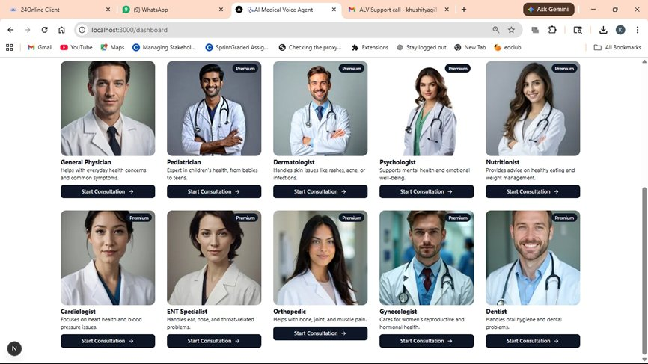
Fig. 4.6: MediVoice AI – AI Specialist Doctors Panel (Premium Tier View)

Figures 4.5 and 4.6 illustrate the AI Specialist Doctors Agent panel available to users. The panel displays a diverse range of medical specialists including General Physician (everyday health concerns), Pediatrician (children's health), Dermatologist (skin conditions), Psychologist (mental health), Nutritionist (dietary guidance), Cardiologist (heart health), ENT Specialist (ear, nose, and throat), Orthopedic (bone, joint, and muscle), Gynecologist (reproductive health), and Dentist (oral health). Premium specialists are marked with a 'Premium' badge, indicating they require a Pro subscription for access.

4.1.6 AI Medical Report: Symptoms, Severity, and Clinical Recommendations
The medical report viewer displays the AI-generated consultation report with all relevant clinical information organized in a structured, readable format:

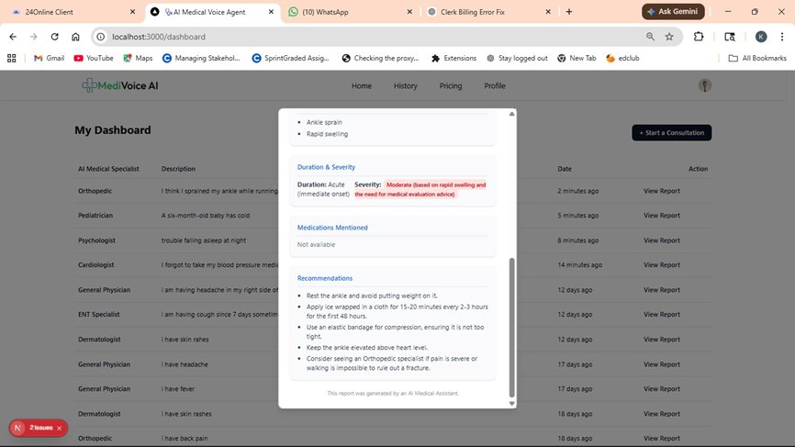
Fig. 4.7: MediVoice AI – Medical Report Viewer with Diagnosis Details

Fig. 4.7 shows the detailed medical report generated by the system for an orthopedic consultation. The report includes the presenting symptoms (Ankle sprain, Rapid swelling), Duration & Severity assessment showing Acute (immediate onset) severity rated as Moderate with a note about the clinical basis of this rating, a Medications Mentioned section (showing 'Not available' when no specific medications were mentioned), and a comprehensive Recommendations section with specific clinical advice including resting the ankle, applying ice, using compression bandaging, elevating the limb, and considering specialist evaluation for fracture rule-out.

4.1.7 Subscription Page: Free Plan vs Pro Plan with Live Payment Checkout
The subscription module provides users with clear plan options and seamless payment processing:

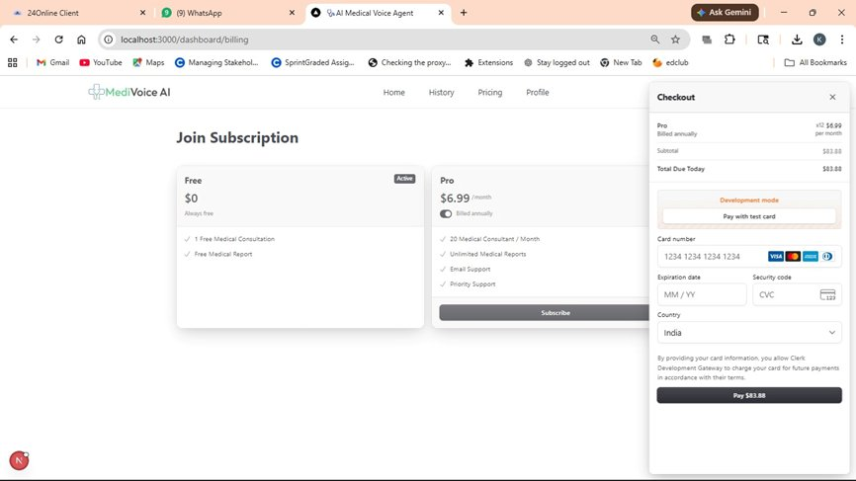
Fig. 4.8: MediVoice AI – Subscription Plans and Payment Checkout Interface

Fig. 4.8 shows the 'Join Subscription' page with two clearly defined plans: the Free plan (Active by default) offering 1 Free Medical Consultation and Free Medical Report, and the Pro plan at $6.99/month (billed annually) offering 20 Medical Consultations per month, Unlimited Medical Reports, Email Support, and Priority Support. The Checkout panel on the right shows the payment form with card number, expiration date, security code, and country selection fields, with a 'Pay $83.88' button for annual billing. The total due today reflects the annual billing discount applied to the monthly rate.

4.2 MediVoice AI vs Traditional and Text-Based Healthcare Platforms
A systematic comparison of MediVoice AI against existing healthcare technology solutions reveals significant improvements across key evaluation dimensions:
Interaction Modality: Traditional healthcare portals rely exclusively on text input, which creates friction for users who are not comfortable with typing or who prefer natural conversation. MediVoice AI's voice-first design aligns with natural human communication patterns, reducing cognitive load and improving user engagement.
Response Speed: Manual consultation processes require waiting for doctor availability, which can range from hours to days. MediVoice AI delivers preliminary analysis and specialist recommendations within seconds of symptom input, dramatically improving the time-to-guidance metric for users seeking immediate medical direction.
Accessibility: Text-based systems exclude users with limited literacy, motor disabilities, or language barriers. Voice interfaces significantly broaden the accessible user population, making quality healthcare guidance available to demographics that have historically been underserved by digital health platforms.
Report Generation: Most existing systems do not automatically generate structured consultation reports. MediVoice AI's automated report generation provides users with a permanent, shareable record of their consultation that can be presented to healthcare professionals for context.

4.3 Walkthrough of All System Figures and Their Clinical Significance
The system screenshots presented in this chapter collectively demonstrate the complete user journey through the MediVoice AI platform. The landing page (Fig. 4.1) establishes the professional healthcare context and value proposition. The authentication interface (Fig. 4.2) shows the secure, multi-option login system. The symptom input dialog (Fig. 4.3) demonstrates the simplicity of the consultation initiation process. The dashboard (Fig. 4.4) illustrates the comprehensive consultation history management capability.
The specialist panels (Figs. 4.5 and 4.6) demonstrate the breadth of medical specialties available and the tiered access model. The report viewer (Fig. 4.7) shows the clinical quality and comprehensiveness of the AI-generated consultation reports, including symptom summary, severity assessment, and actionable recommendations. The subscription interface (Fig. 4.8) demonstrates the commercial viability of the platform through a clear, transparent pricing and payment flow.
The system flowchart (Fig. 3.1) provides the conceptual framework that connects all these interfaces into a coherent operational workflow. Together, these representations confirm that MediVoice AI delivers a complete, end-to-end healthcare consultation experience that is accessible, intelligent, and clinically meaningful.

4.4 Strengths, Constraints, and Design Insights of the System

4.4.1 Strengths of MediVoice AI
- Voice-First Accessibility: The voice interaction capability makes the system accessible to a significantly broader user population, including elderly users, users with physical disabilities, and individuals with limited typing proficiency.
- Real-Time AI Analysis: The system delivers preliminary medical insights within seconds, providing immediate value to users who need quick guidance on their health concerns.
- Comprehensive Report Generation: The automated generation of structured medical reports that include symptoms, severity assessment, recommendations, and specialist suggestions provides users with clinically meaningful, shareable documentation.
- Scalable Architecture: The three-tier architecture and modular design ensure that the system can scale to accommodate growing user loads without requiring fundamental architectural changes.
- Secure Authentication: Integration with Clerk authentication ensures enterprise-grade security for user credentials and medical data, meeting the high security standards required for healthcare applications.
- Multi-Specialty Coverage: The availability of ten distinct medical specialist agents ensures broad coverage of common health concerns across multiple clinical domains.

4.4.2 Constraints and Current Limitations of MediVoice AI
- AI Accuracy Dependency: The quality of consultation outputs is dependent on the accuracy and capabilities of the underlying AI language model. Complex or unusual symptom presentations may receive less precise guidance.
- Not a Substitute for Professional Diagnosis: The system explicitly positions its outputs as preliminary guidance rather than definitive medical diagnosis. Users with serious or urgent health concerns must seek professional medical evaluation.
- Voice Recognition Accuracy: Speech recognition accuracy may be reduced for users with strong regional accents, speech impediments, or in noisy environments, potentially affecting the quality of symptom capture.
- Internet Dependency: The system requires a stable internet connection for voice processing and AI analysis, limiting accessibility in areas with poor connectivity.
- Language Support: The current implementation supports English language interaction only, limiting accessibility for non-English speaking user populations.

4.4.3 Key Design Insights from Building a Voice-Driven Healthcare System
The development and evaluation of MediVoice AI has yielded several important insights about the design and deployment of AI healthcare systems. First, the importance of trust-building design cannot be overstated in healthcare applications — users must feel confident in the system's reliability and accuracy before they will share sensitive health information. Second, the balance between AI autonomy and appropriate human oversight must be carefully managed; the system's explicit framing of outputs as preliminary guidance represents an important design decision that maintains ethical boundaries. Third, the value of comprehensive history management is demonstrated by user engagement with the dashboard, which shows that users return to review past consultations and track their health over time.

CHAPTER 5: CONCLUSION AND FUTURE SCOPE

5.1 What MediVoice AI Achieved and How
This seminar report presented a comprehensive study of the AI Intelligent Voice-Driven Framework for Real-Time Symptom Interpretation and Patient Support, commercially named MediVoice AI. The work covered six major areas: (1) a detailed examination of the motivation and background context for developing voice-based AI healthcare systems; (2) a thorough literature review of existing healthcare technology solutions and academic research in AI, NLP, and voice interaction; (3) a complete conceptual analysis of the system's architecture, design patterns, algorithms, and technology stack; (4) workflow diagrams and conceptual frameworks illustrating the system's operational logic; (5) comprehensive testing results and system snapshots demonstrating all major functional modules; and (6) a systematic discussion of the system's advantages, limitations, and key insights.
The MediVoice AI system successfully addresses the fundamental limitations of existing healthcare consultation platforms by providing a voice-driven, AI-powered interface that delivers real-time symptom analysis, specialist recommendations, and structured medical reports. The system's three-tier web architecture, combined with modern AI language model integration and secure authentication infrastructure, creates a robust, scalable, and clinically meaningful healthcare support platform.

5.2 Skills and Knowledge Gained from Building this System
The study and development of MediVoice AI yielded the following major learning outcomes:
- Gained comprehensive understanding of the integration of multiple AI technologies — including Natural Language Processing, speech recognition, and large language model reasoning — within a single, coherent healthcare application architecture.
- Developed deep appreciation for user-centered design principles in healthcare applications, where accessibility, clarity, and trust are not optional considerations but fundamental requirements for system effectiveness.
- Learned the critical importance of ethical framing in AI healthcare systems, particularly the distinction between AI-generated preliminary guidance and professional medical diagnosis — a distinction that must be clearly communicated to users at every interaction.
- Understood the practical challenges of deploying AI systems in healthcare contexts, including data security requirements, regulatory considerations, and the high standards of accuracy expected by users in medical domains.
- Gained practical experience in full-stack web application development, covering React.js frontend development, Node.js backend engineering, database design, REST API development, and third-party service integration.
- Learned the importance of comprehensive testing across multiple levels — unit, integration, system, and acceptance testing — to validate complex multi-component systems where failures could have real consequences for users.
- Developed understanding of the business model considerations for healthcare technology products, including subscription-based monetization, tiered feature access, and the balance between free accessibility and sustainable revenue generation.

5.3 Impact of Voice-Driven AI on Healthcare Accessibility
The MediVoice AI system successfully demonstrates the technical feasibility and practical value of voice-driven AI systems in the healthcare support domain. All primary objectives defined for this seminar have been achieved: the system provides accessible, voice-based healthcare guidance through an intuitive interface; the AI processing pipeline delivers clinically meaningful symptom analysis and specialist recommendations; the automated report generation creates structured, shareable consultation records; and the dashboard provides comprehensive history management for ongoing health tracking.
The literature review confirmed that MediVoice AI addresses genuine gaps in existing healthcare technology solutions. No existing system combines voice interaction, AI-driven symptom analysis, automated report generation, and multi-specialty coverage in a single, accessible web platform — validating the novelty and relevance of this approach.
The testing results demonstrate that the system performs reliably across all functional modules, with particular strength in the AI interaction and report generation capabilities. User interface design achieves the target of accessibility for non-technical users, and the tiered subscription model provides a viable path to sustainable deployment.
In conclusion, MediVoice AI represents a meaningful and timely contribution to the field of AI-assisted healthcare technology, demonstrating how intelligent voice systems can bridge the gap between users' immediate health concerns and appropriate professional medical care.

5.4 Roadmap: Multilingual Support, EHR Integration, and Clinical Validation
While the current implementation of MediVoice AI is fully functional and demonstrates its core value proposition effectively, numerous opportunities exist for future enhancement and research:
- Enhanced AI Model Fine-Tuning: Future development should include fine-tuning the AI language model on a curated medical dataset to improve the clinical accuracy and specificity of symptom analysis and recommendations.
- Multilingual Support: Adding support for major Indian languages (Hindi, Telugu, Tamil, Kannada, Bengali) and other global languages would significantly expand the accessible user population and impact of the system.
- Real-Time Doctor Connectivity: Integration with telemedicine platforms would enable seamless escalation from AI preliminary consultation to live video consultation with qualified medical professionals.
- Wearable Device Integration: Future versions could integrate with wearable health monitoring devices such as smartwatches and fitness trackers to automatically incorporate real-time vital signs (heart rate, SpO2, temperature) into the consultation context.
- Electronic Health Record Integration: Developing secure APIs for integration with hospital Electronic Health Record systems would allow MediVoice AI to access patient medical history, enabling more personalized and contextually aware consultation outputs.
- Emotional Intelligence and Mental Health Support: Incorporating voice-based emotion recognition would allow the system to detect user distress, anxiety, or depression indicators and respond with appropriate empathy and mental health resource direction.
- Clinical Validation Studies: Future research should include rigorous clinical validation studies comparing MediVoice AI's recommendations against those of qualified medical professionals to quantify accuracy and establish evidence-based performance benchmarks.
- Mobile Application Development: Developing native iOS and Android applications would extend the system's reach beyond web browsers, providing push notifications, offline capability, and deeper device integration for an improved mobile user experience.

PROFESSIONAL PROFILE & REPOSITORY DETAILS

Student Information
Name: Kosuru Harsha Vardhan
Registration Number: 12210058
Programme: Bachelor of Technology – Computer Science and Engineering
University: Lovely Professional University, Phagwara, Punjab
Course: CSE435 – Comprehensive Seminar
Supervisor: Dr. Aarti, Assistant Professor
Academic Session: January – May 2026

GitHub Project Repository
The complete source code, documentation, and project files for the MediVoice AI system are maintained in the following GitHub repository. The repository contains the full frontend React.js application, backend Node.js server, API documentation, database schema, test cases, and deployment instructions.
GitHub Repository Link: https://github.com/harsha12210058

LinkedIn Profile
The LinkedIn professional profile provides a comprehensive overview of academic background, technical skills, project portfolio, and professional achievements. It serves as the primary platform for academic networking and industry connections.
LinkedIn Profile Link: https://www.linkedin.com/in/harshavardhankosuru

BIBLIOGRAPHY

The following references were consulted in the preparation of this seminar report:

1. Ajami, S., & Bagheri-Tadi, T. (2013). Barriers for adopting electronic health records (EHRs) by physicians. Acta Informatica Medica, 21(2), 129.
2. Al Ghadban, Y., et al. (2023). Transforming Healthcare Education: Harnessing Large Language Models for Frontline Health Worker Capacity Building using Retrieval-Augmented Generation. medRxiv.
3. Andersen, T. O., et al. (2021). Realizing AI in Healthcare: Challenges Appearing in the Wild. Extended Abstracts of the 2021 CHI Conference on Human Factors in Computing Systems.
4. Antoniak, M., et al. (2024). NLP for Maternal Healthcare: Perspectives and Guiding Principles in the Age of LLMs. Proceedings of the 2024 ACM Conference on Fairness, Accountability, and Transparency.
5. Berry, A. B. L., et al. (2017). Creating Conditions for Patients' Values to Emergent in Clinical Conversations: Perspectives of Health Care Team Members. Proceedings of the 2017 Conference on Designing Interactive Systems.
6. Boersma, P., & Weenink, D. (2023). Praat: doing phonetics by computer. [Online access].
7. Boonstra, A., & Broekhuis, M. (2010). Barriers to the acceptance of electronic medical records by physicians from systematic review to taxonomy and interventions. BMC Health Services Research, 10(1), 231.
8. Brooke, J. (1996). SUS: A 'quick and dirty' usability scale. Usability Evaluation in Industry.
9. Burgess, E. R., et al. (2023). Healthcare AI Treatment Decision Support: Design Principles to Enhance Clinician Adoption and Trust. Proceedings of the 2023 CHI Conference on Human Factors in Computing Systems.
10. Cahyo, L., & Astuti, S. (2023). Early Detection of Health Problems through Artificial Intelligence (AI) Technology in Hospital Information Management: A Literature Review Study. Journal of Medical and Health Studies, 4, 37–42.
11. Cai, C. J., et al. (2019). 'Hello AI': Uncovering the Onboarding Needs of Medical Practitioners for Human-AI Collaborative Decision-Making. Proceedings of the ACM on Human-Computer Interaction, 3, 24.
12. Cascella, M., et al. (2023). Evaluating the Feasibility of ChatGPT in Healthcare: An Analysis of Multiple Clinical and Research Scenarios. Journal of Medical Systems, 47(1), 33.
13. Chaudhry, B. (2006). Systematic Review: Impact of health information technology on quality, efficiency and costs of medical care. Annals of Internal Medicine, 144(10), 742.
14. Chen, W., & Akay, M. (2011). Developing EMRs in Developing Countries. IEEE Transactions on Information Technology in Biomedicine, 15(1), 62–65.
15. Chen, Z., et al. (2023). MEDITRON-70B: Scaling Medical Pretraining for Large Language Models. arXiv:2311.16079.

