15). Create a Cloning of a VM and Test it by loading the Previous Version/Cloned VM.

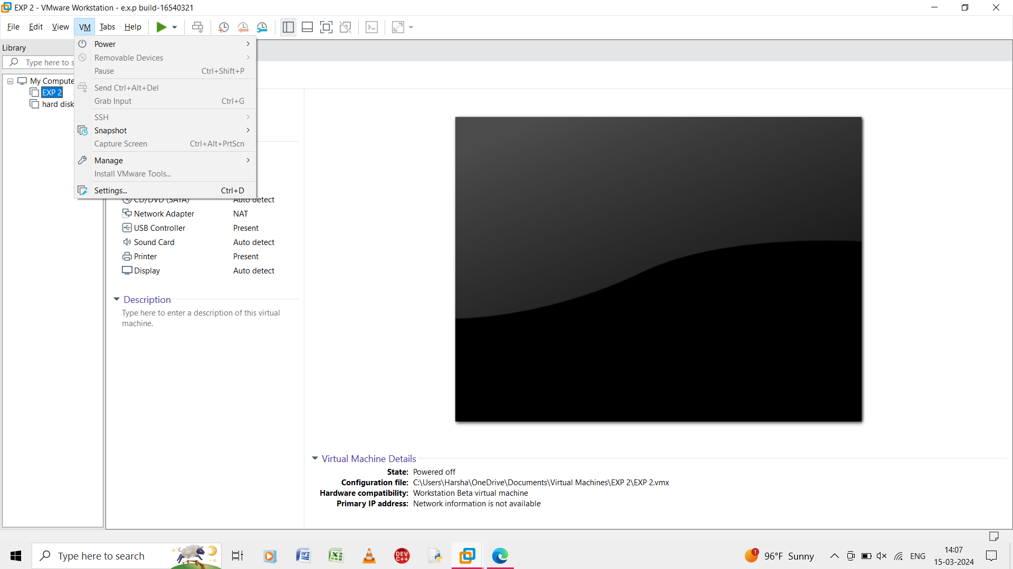

Step 1: open the created virtual machine and go to manage.

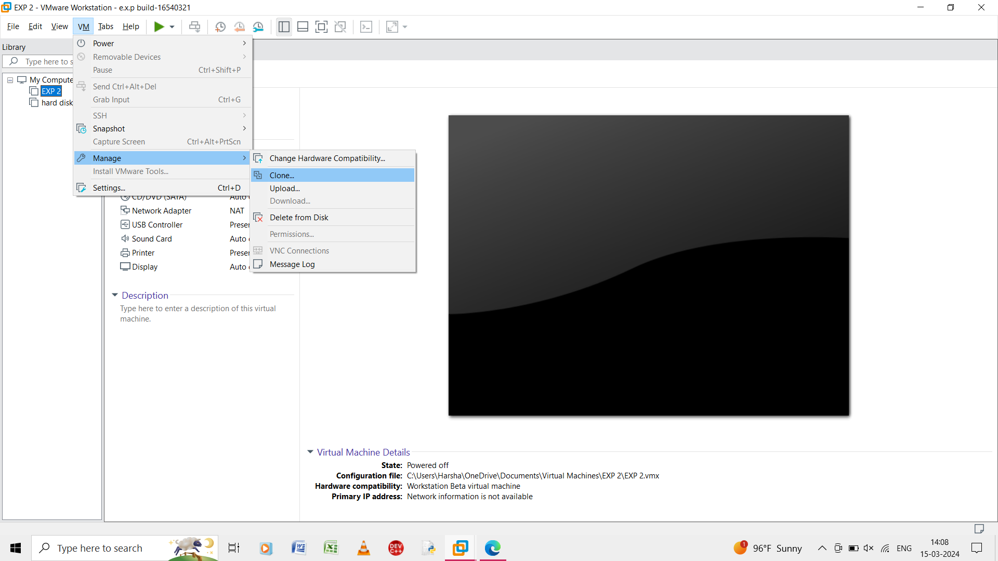

Step 2: in the manage open the clone.

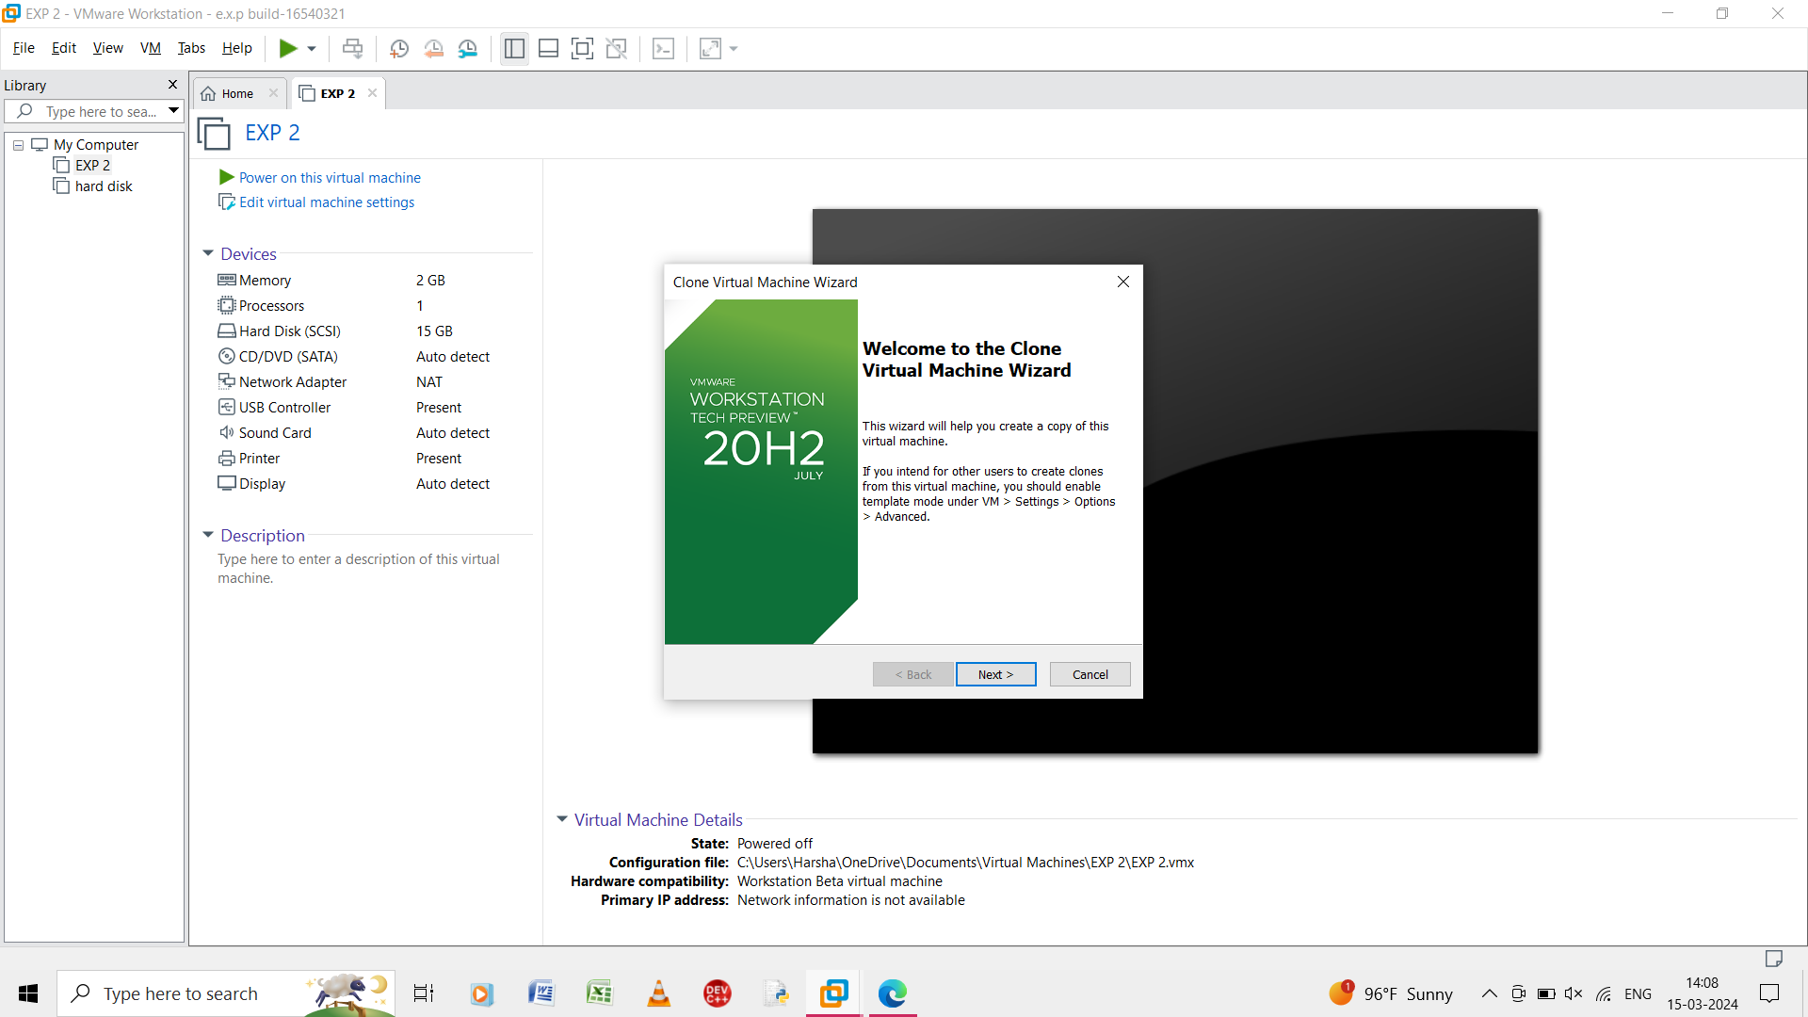

Step 3: in the clone virtual machine click on the next.

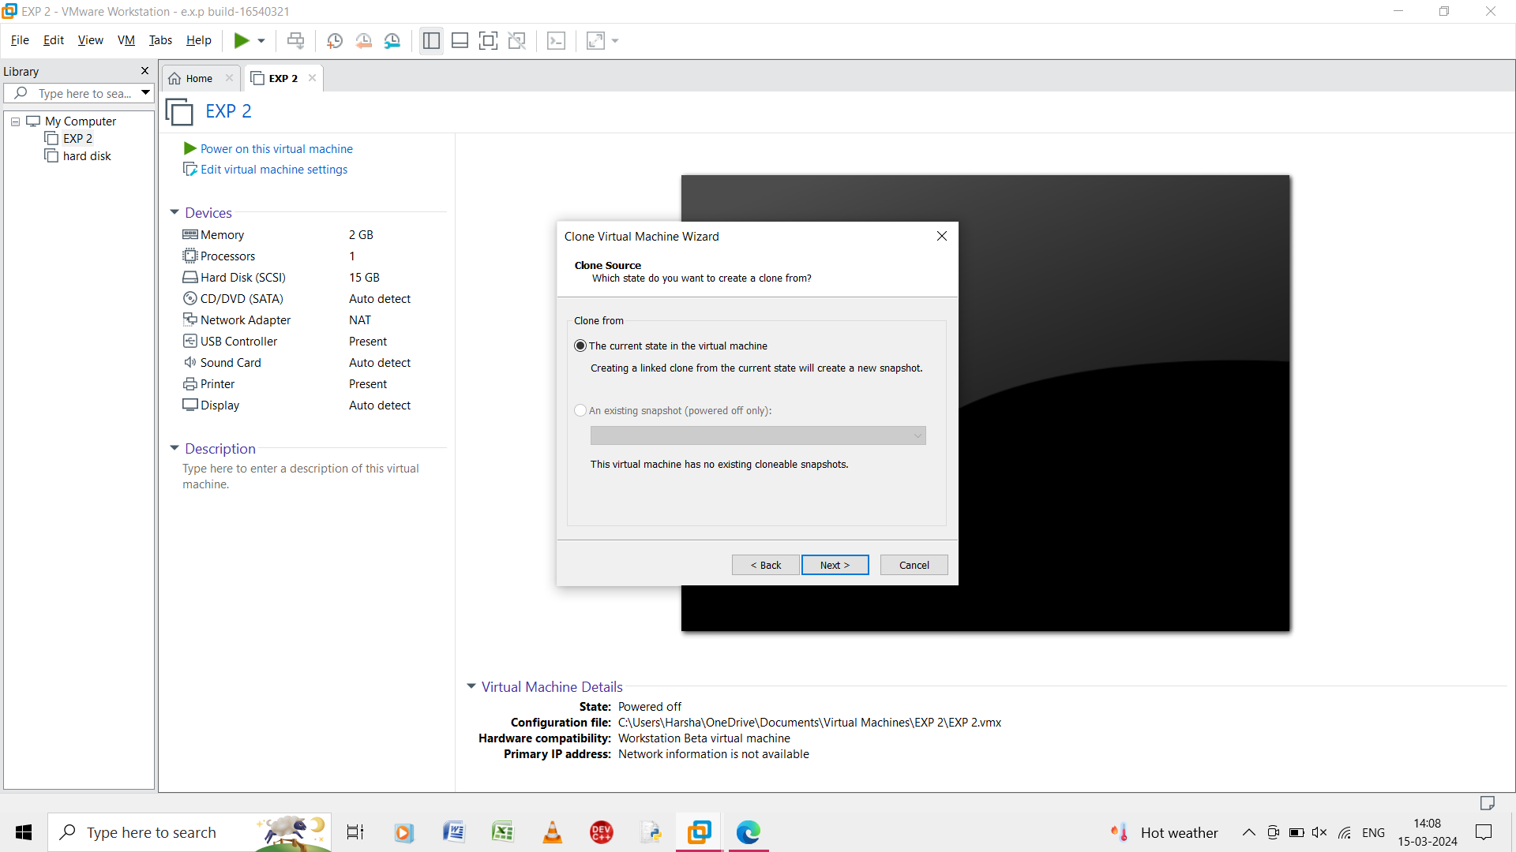

Step 4: in the clone source give the clone from the current state in the virtual machine and creating a linked done from the current state will create a new snapshot.

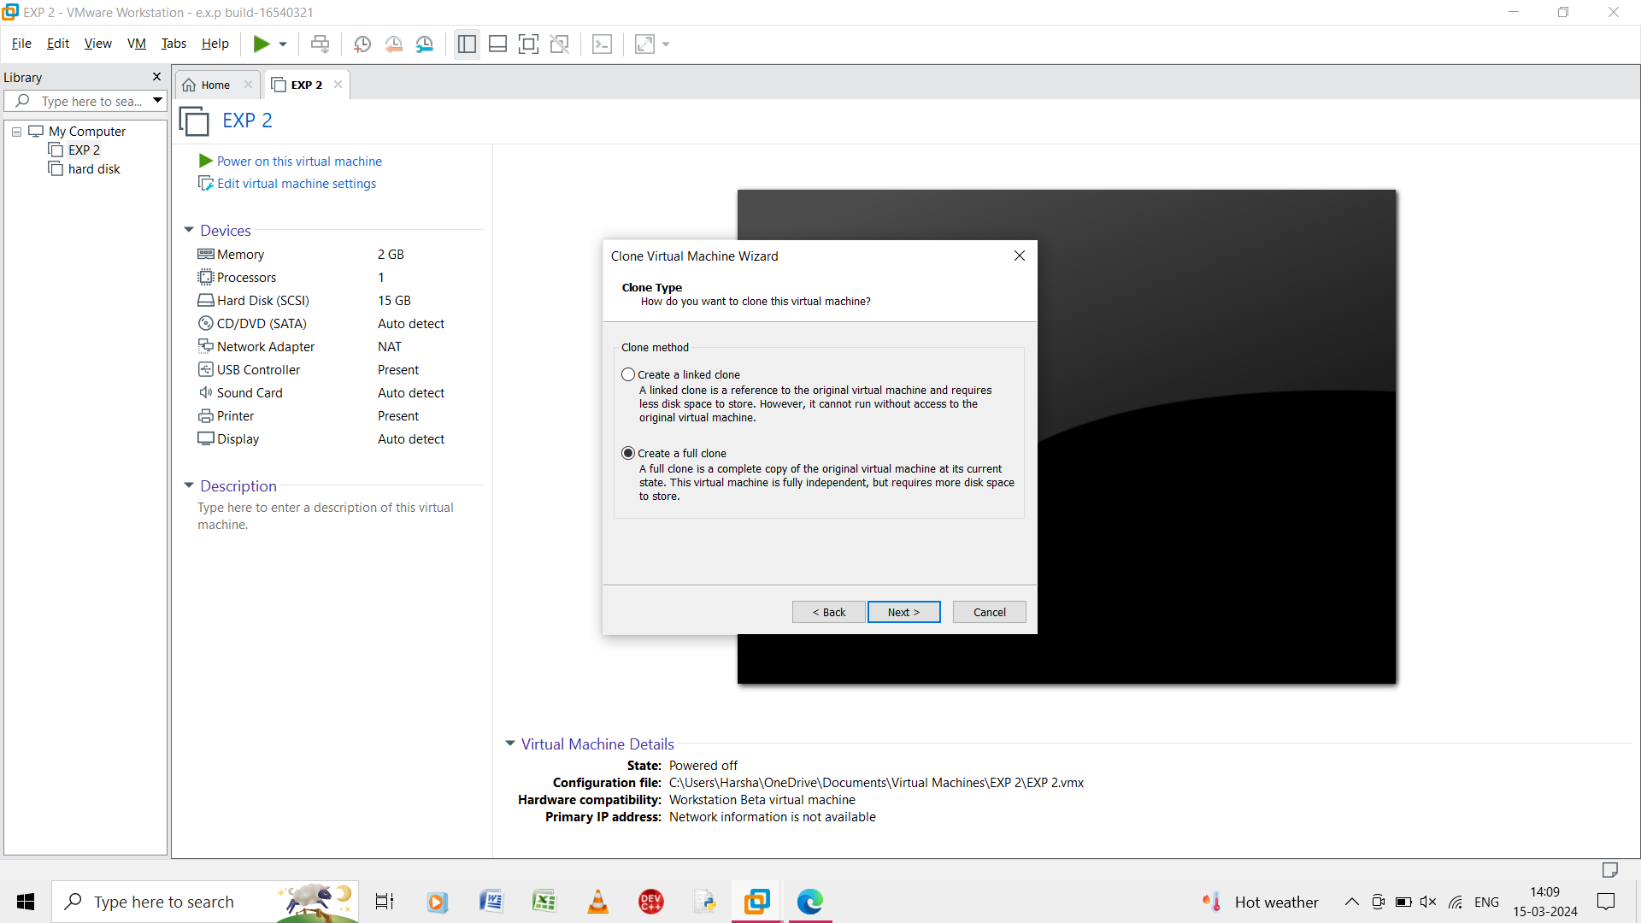

Step 5: in the clone virtual machine wizard and create a full clone.

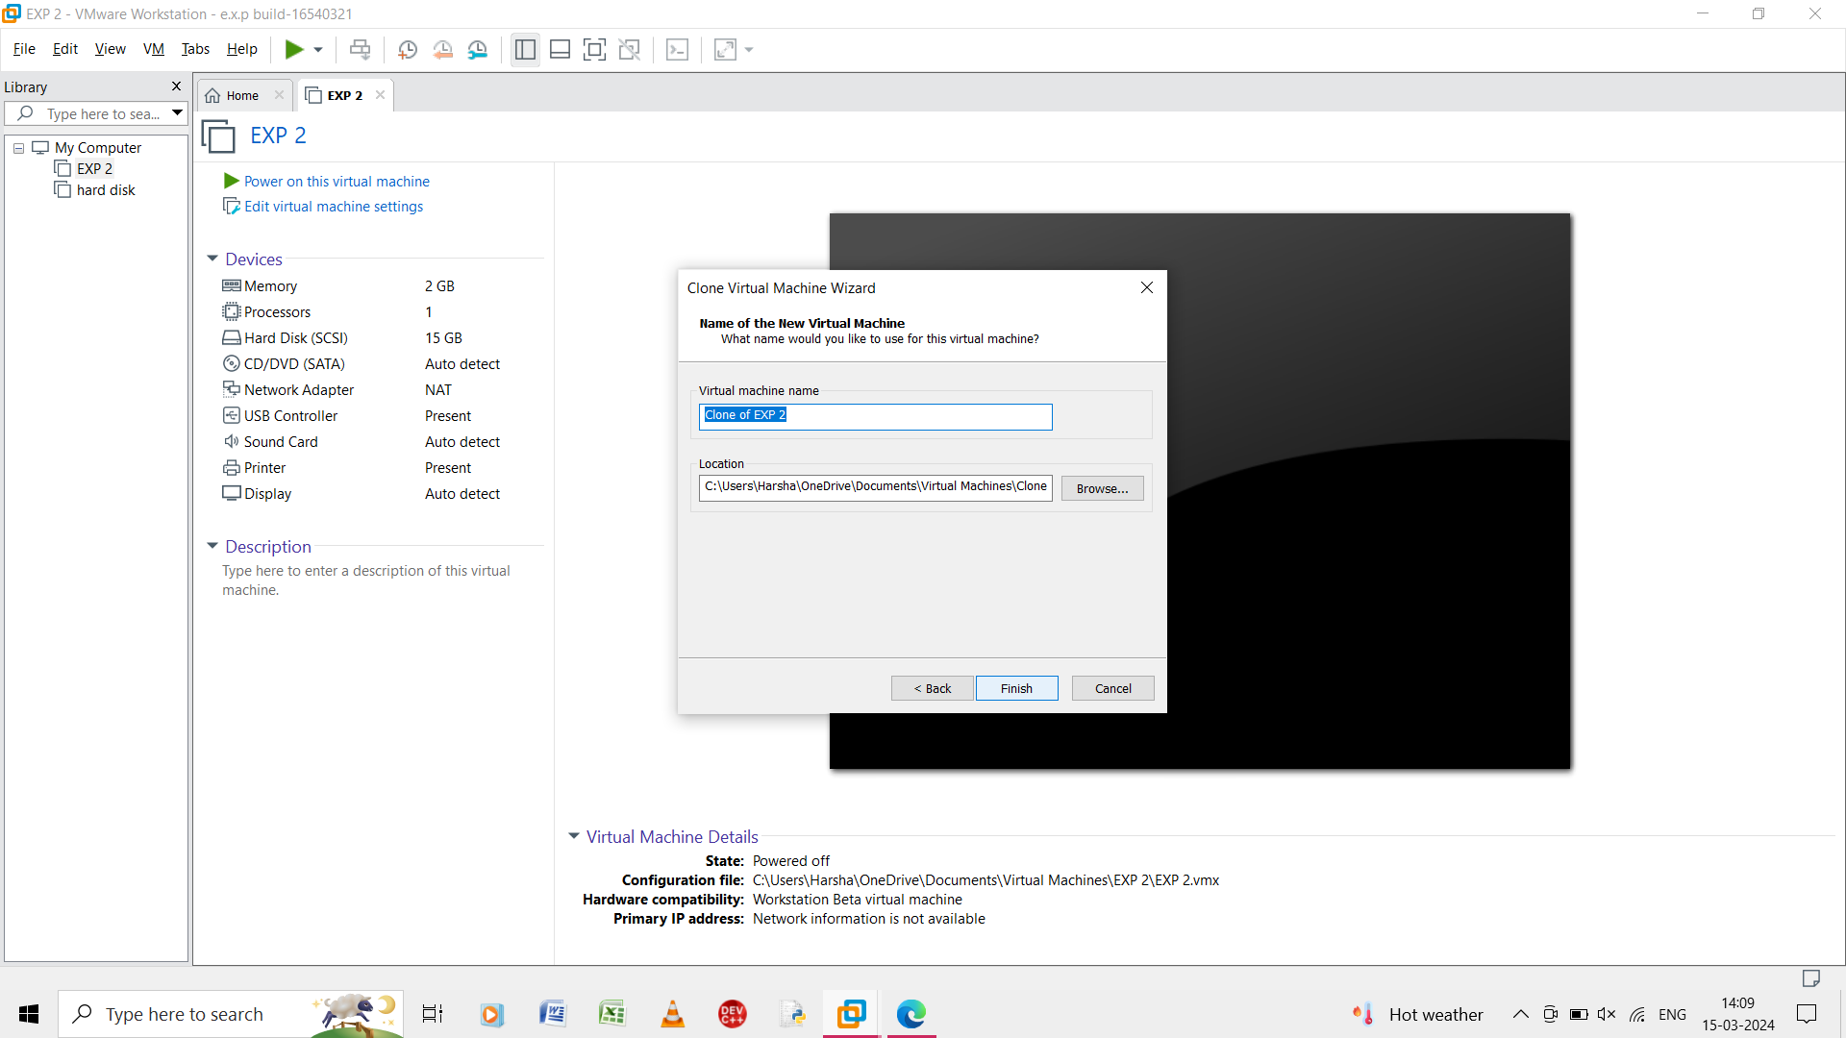

Step 6: in the clone virtual machine and give the name as clone of exp 2.

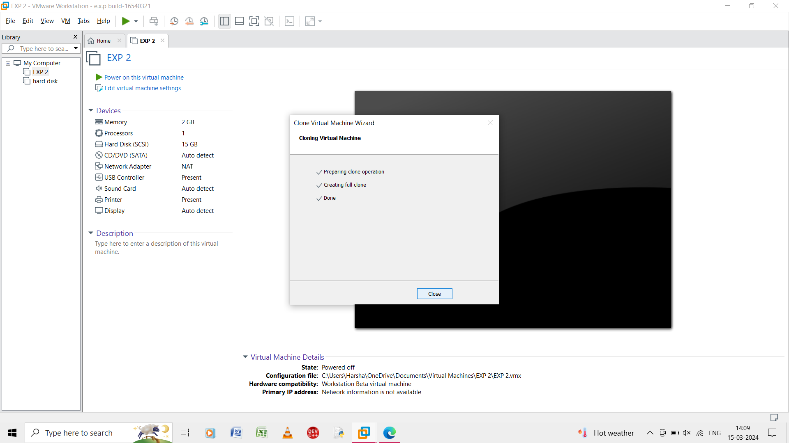

Step 7: the clone virtual machine is created and close it.

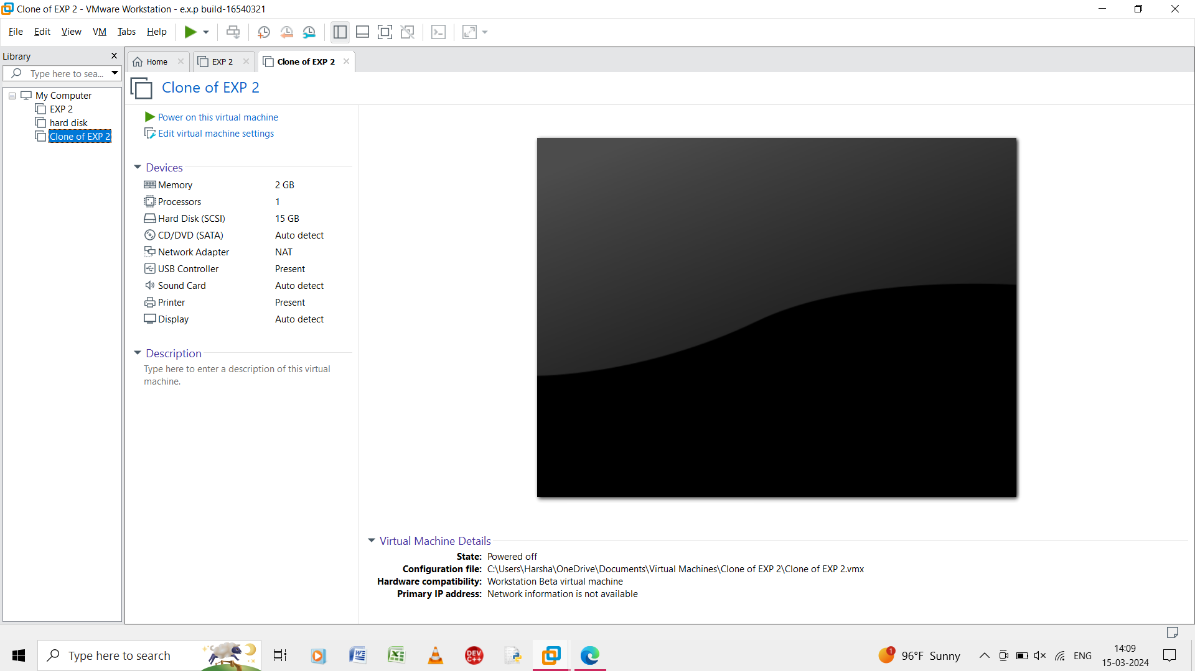

Step 8: the clone of the virtual machine is created named as clone of exp 2.