14). Create a Snapshot of a VM and Test it by loading the Previous Version/Cloned VM

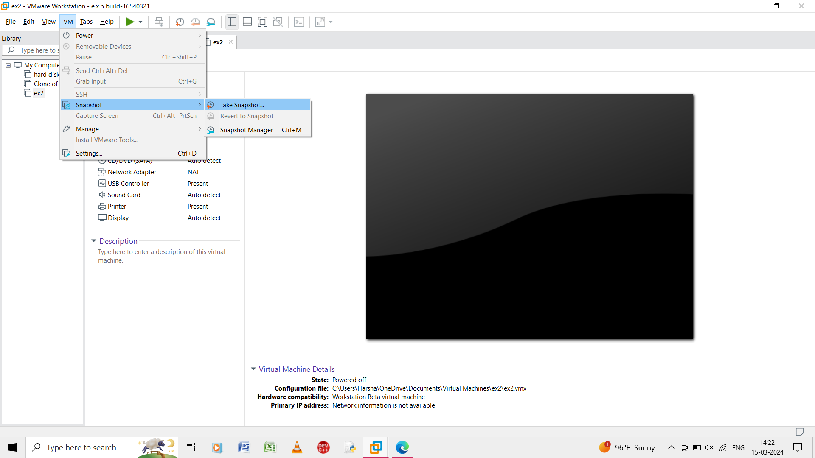

Step 1: vitual machine should be created and click and select the snapshot , take snapshot.

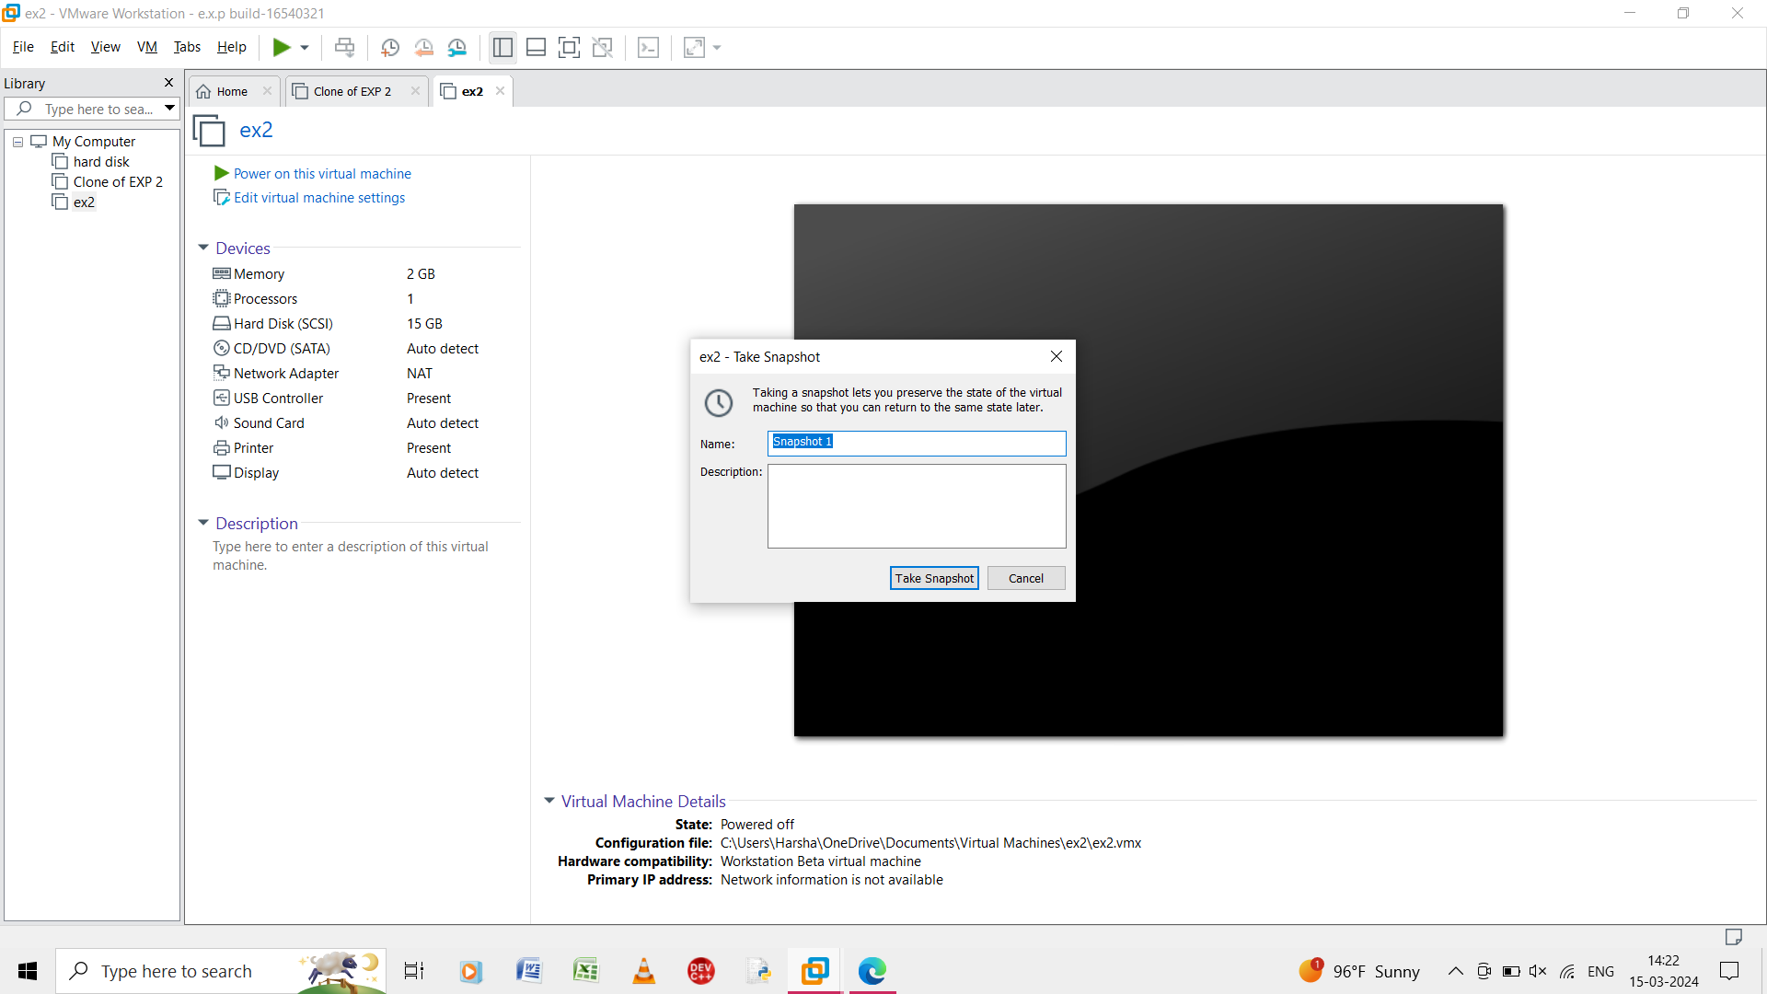

Step 2: the details of the virtual machine is showed and take snapshot.

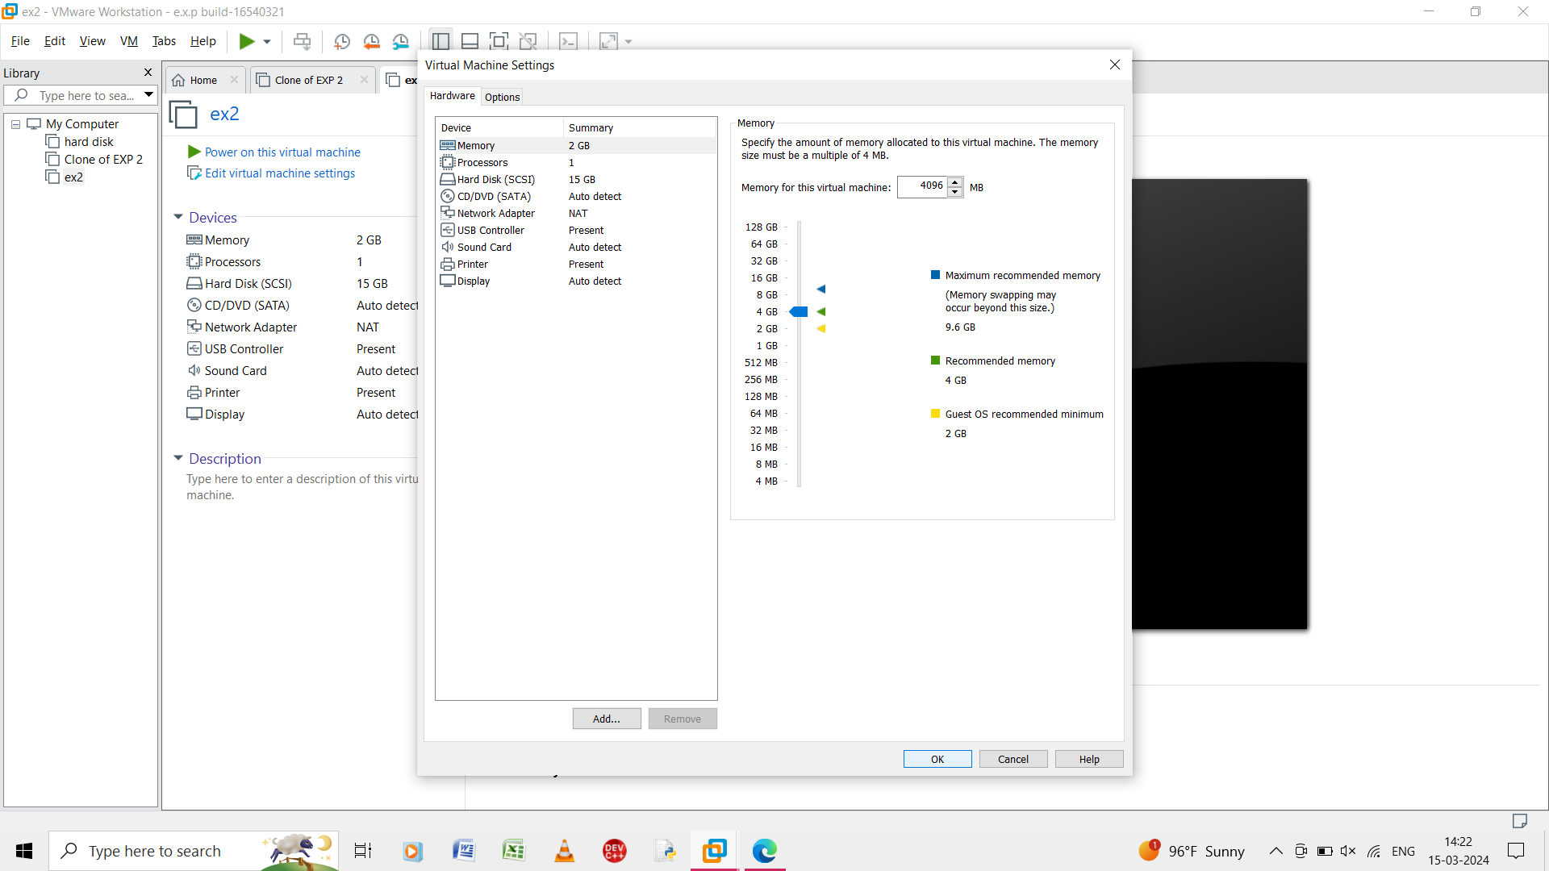

Step 3: in the virtual machine change the number of processor and memory.

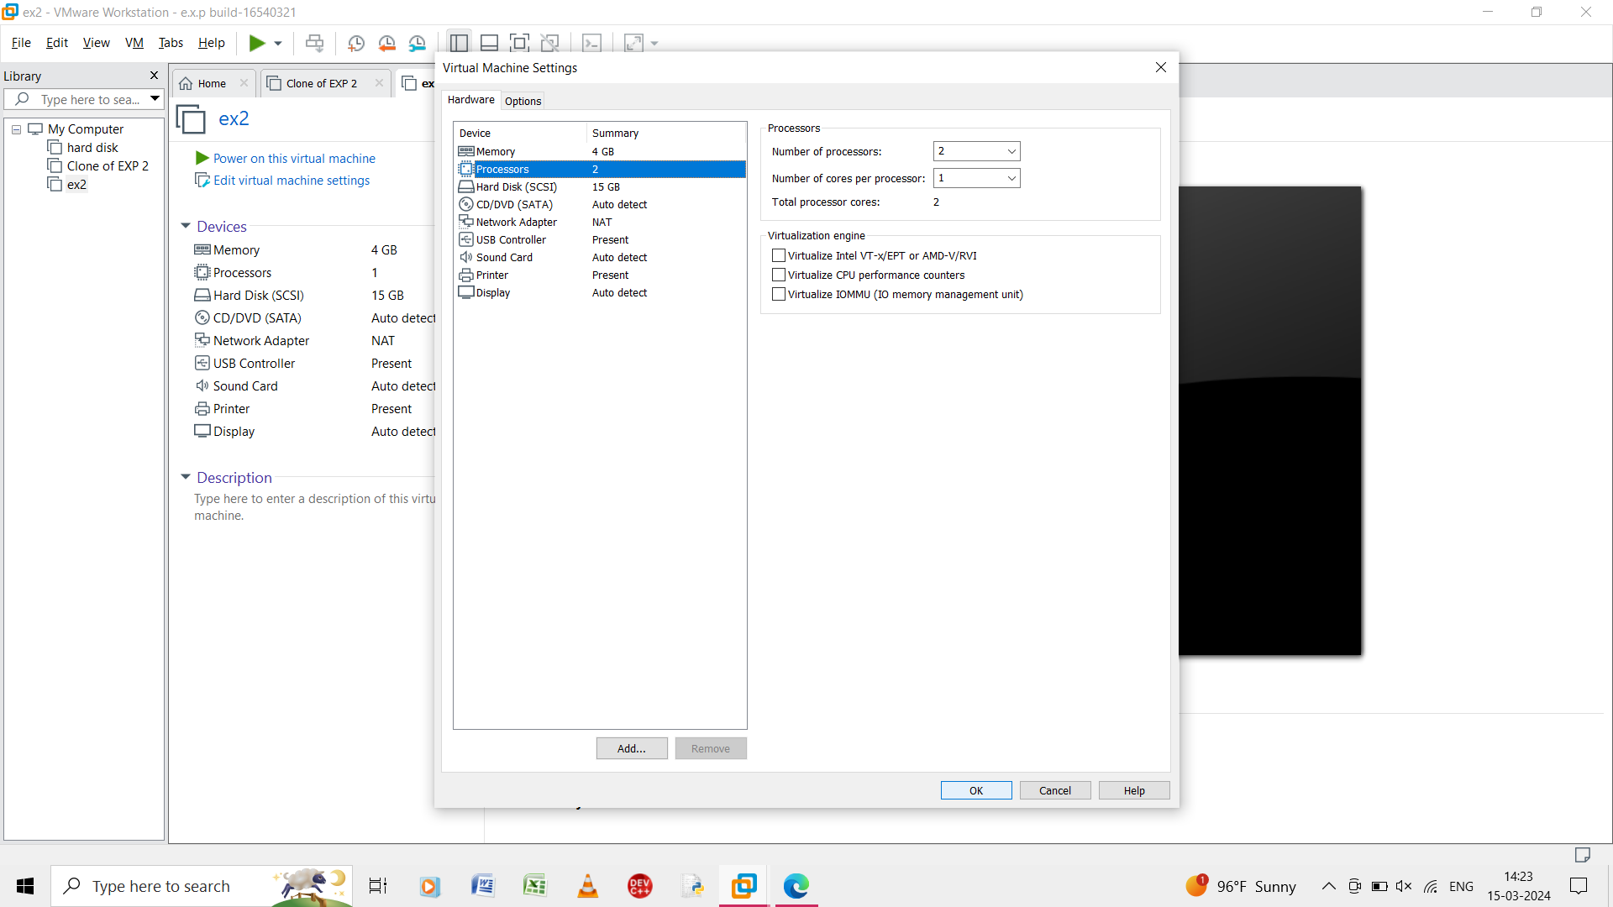

Step 4: change the processors of 2GB and memory for 4GB.

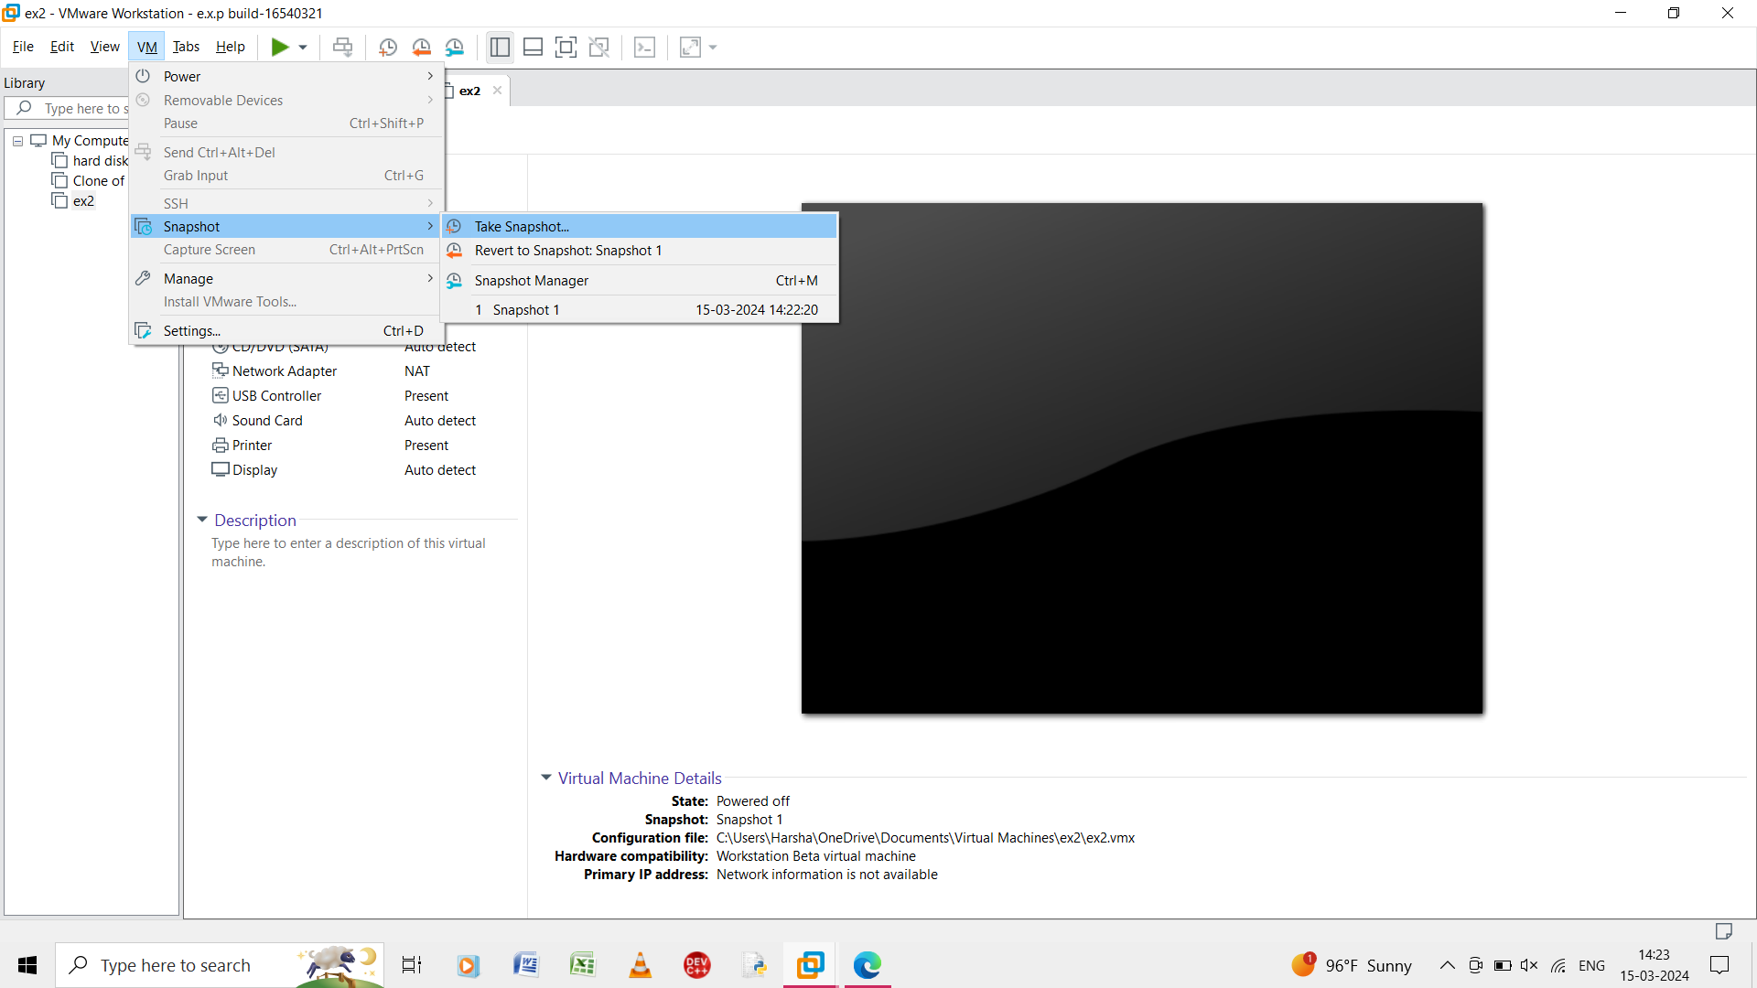

Step 5: in the virtual machine select the snapshot .

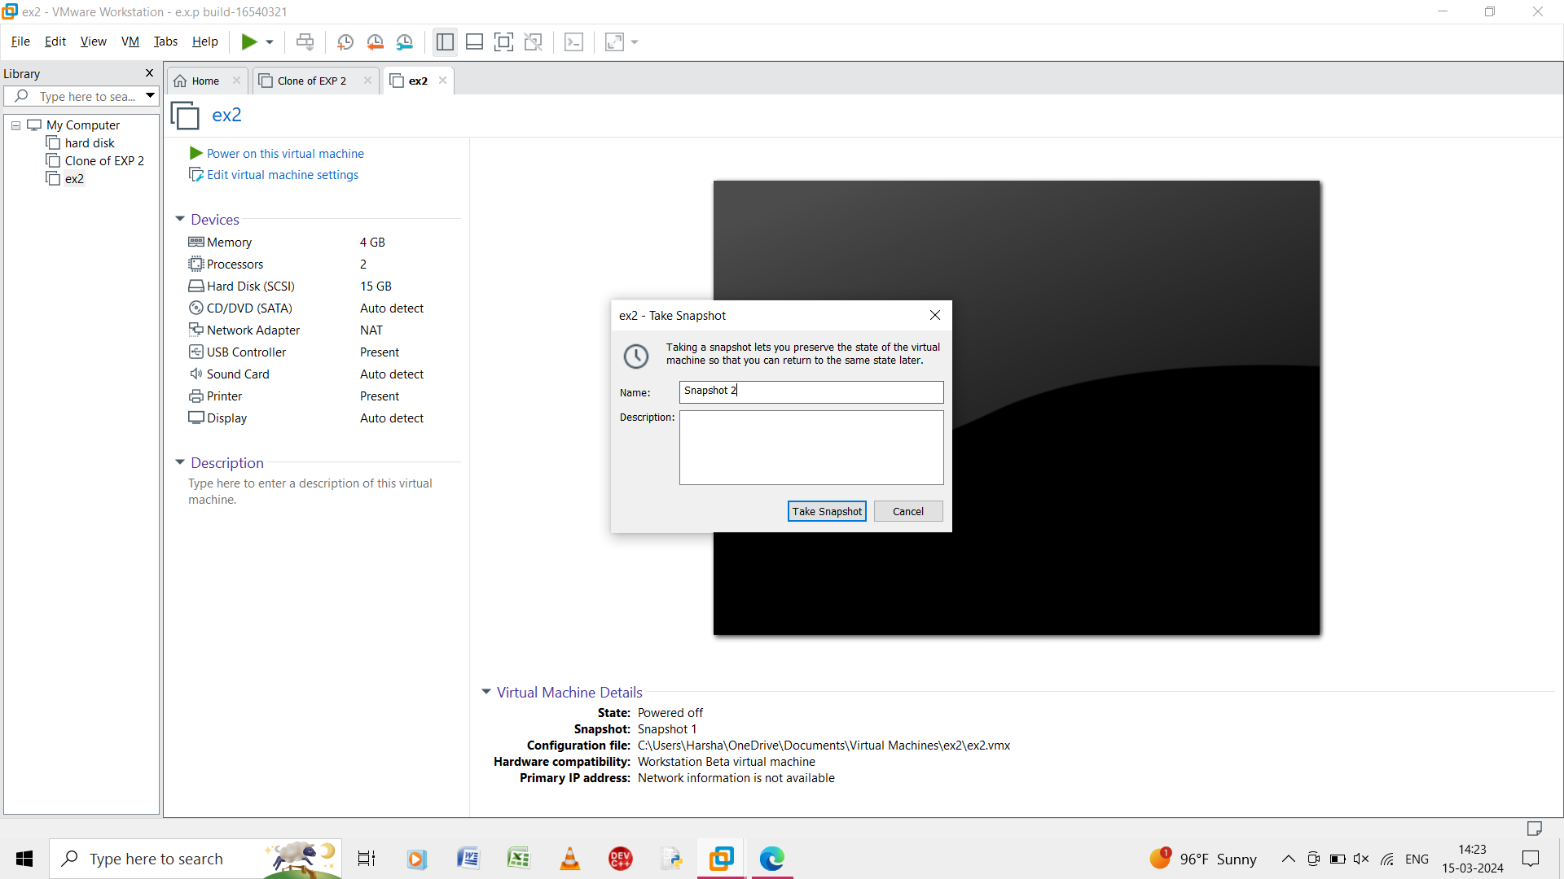

Step 6: take the snap shot of the changes made in the virtual machine.

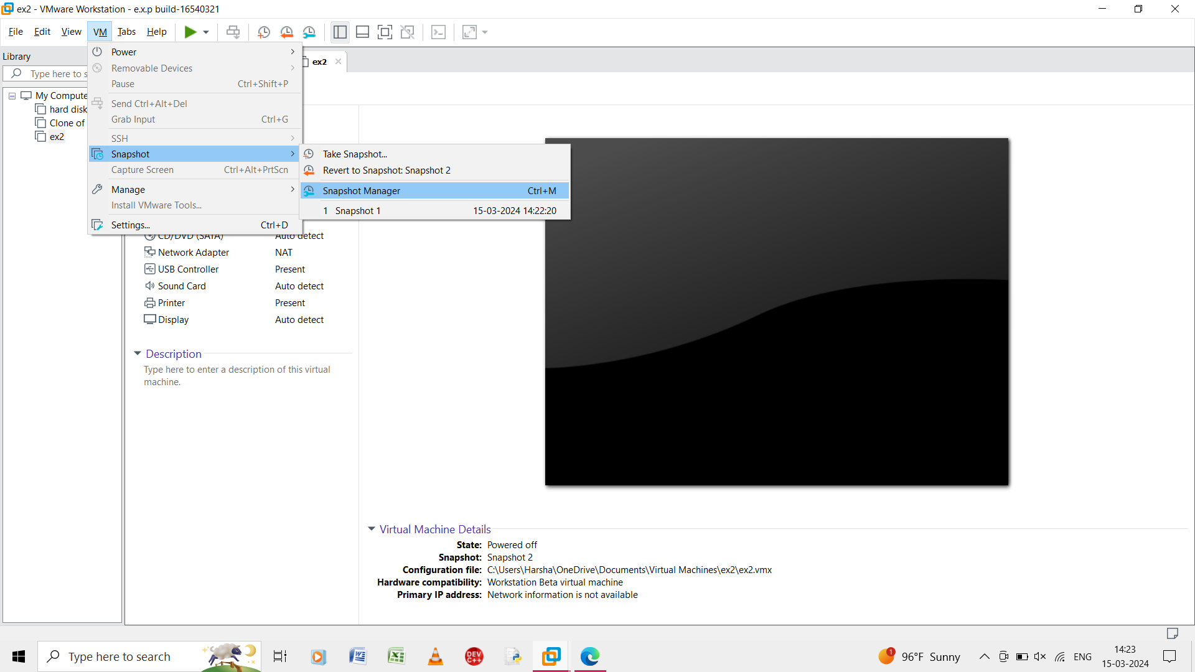

Step 7: in the virtual machine from the snapshot go to snapshot manager.

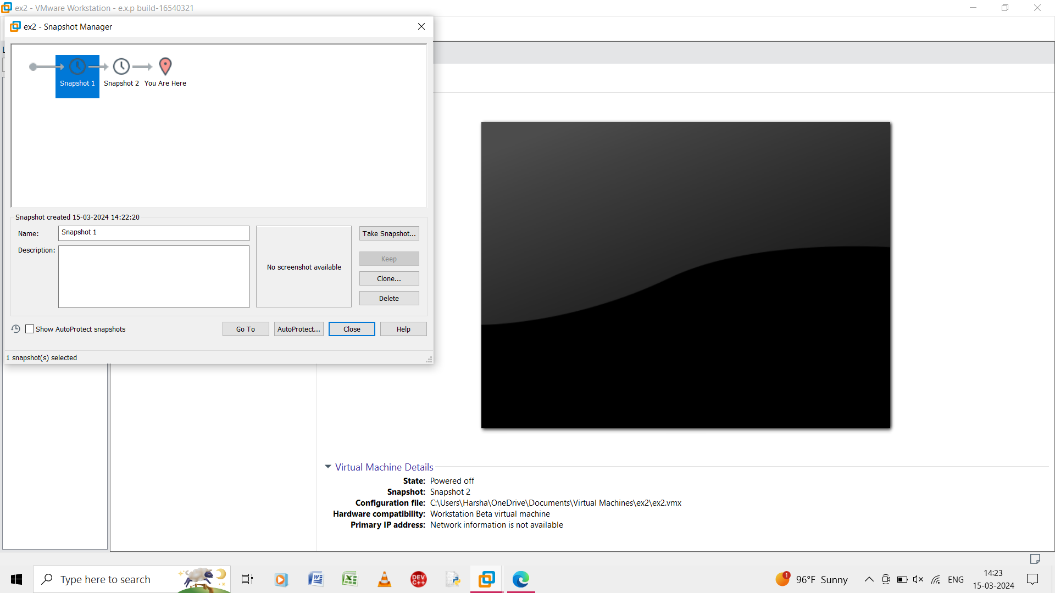

Step 8: select the snapshot 1 in shown snapshot manager.

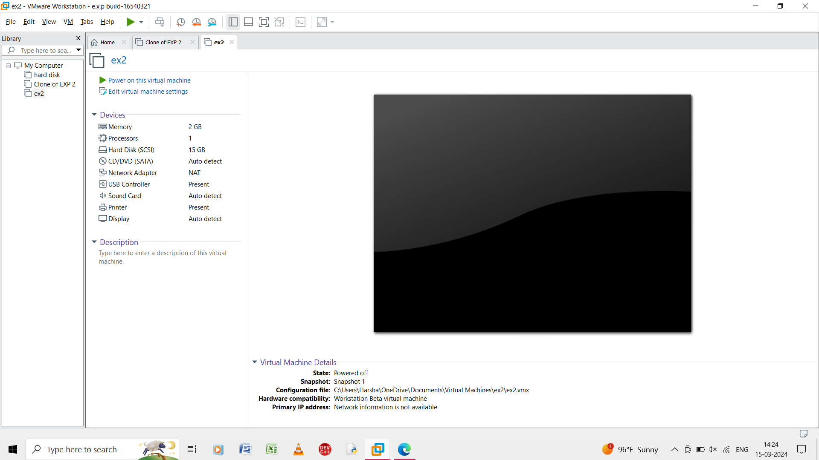

Step 9: it shows the report of the snapshot 1.

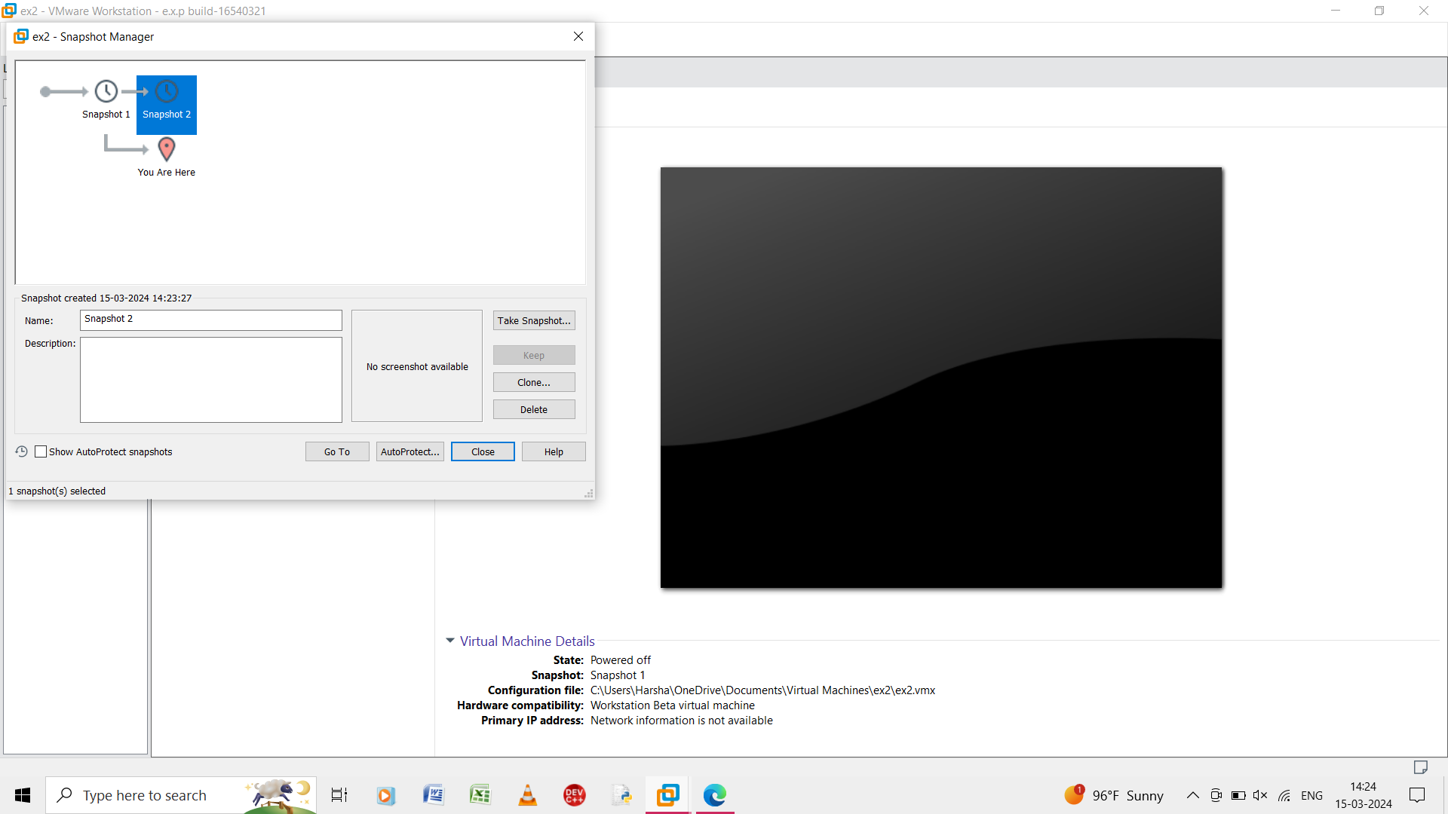

Step 10: select the snapshot 2 in shown snapshot manager.

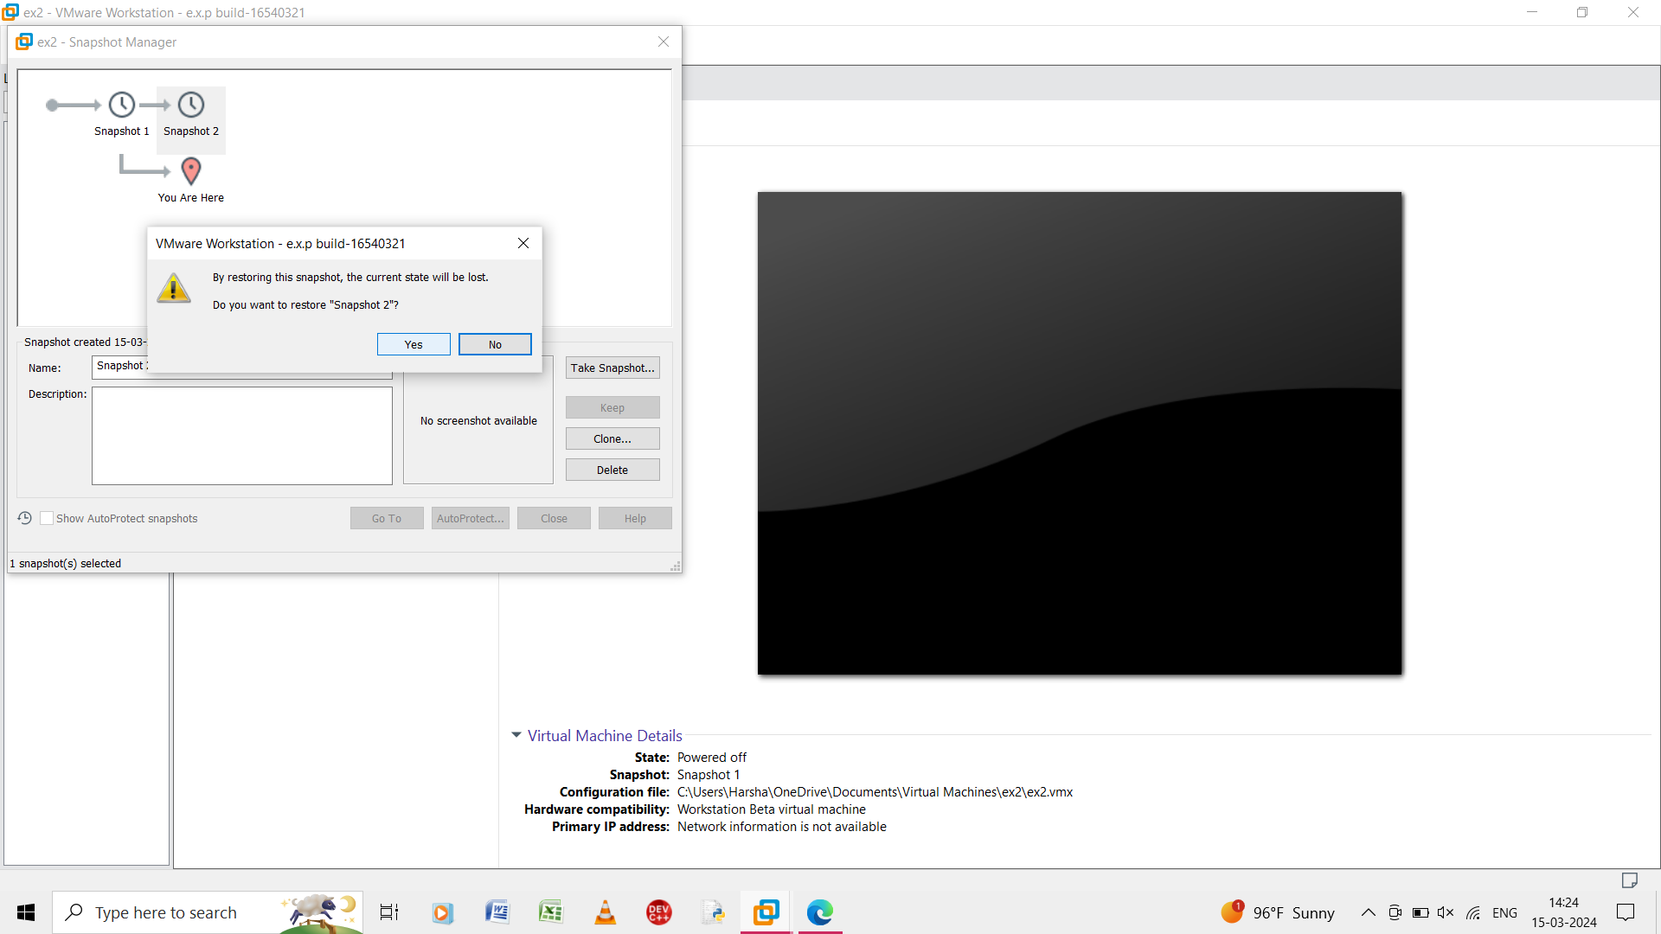

Step 11: we change the snapshot of 1 and 2.

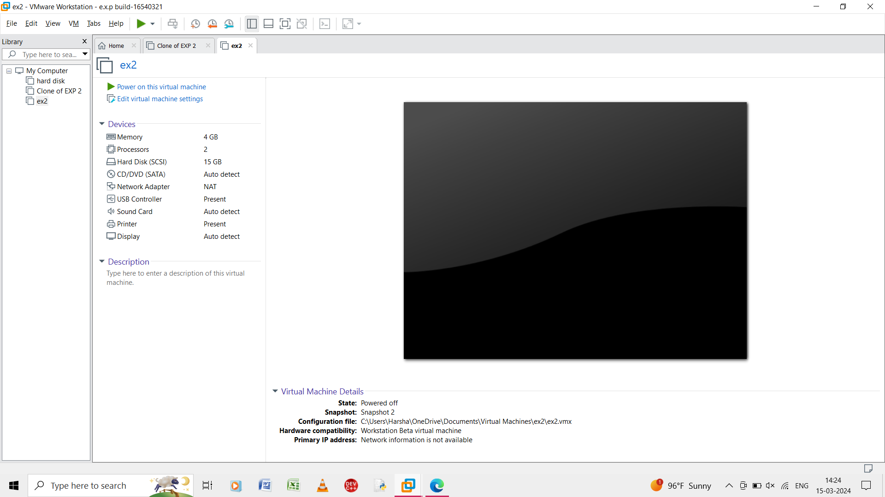

Step 12: the output of the virtual machine is shown.