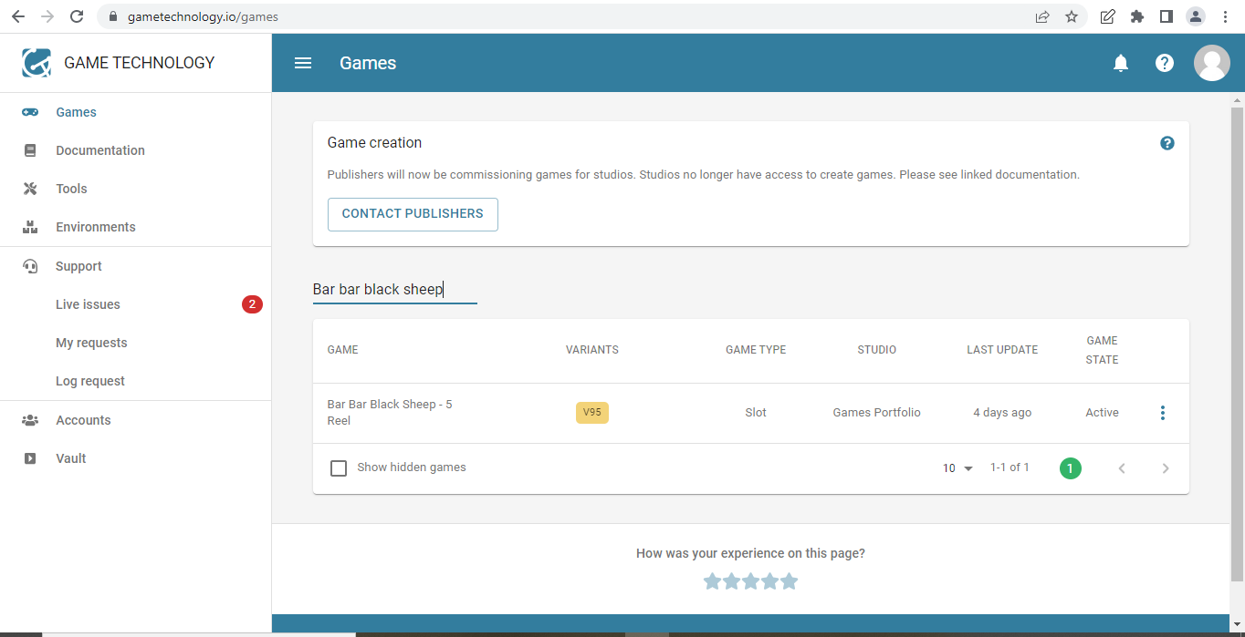
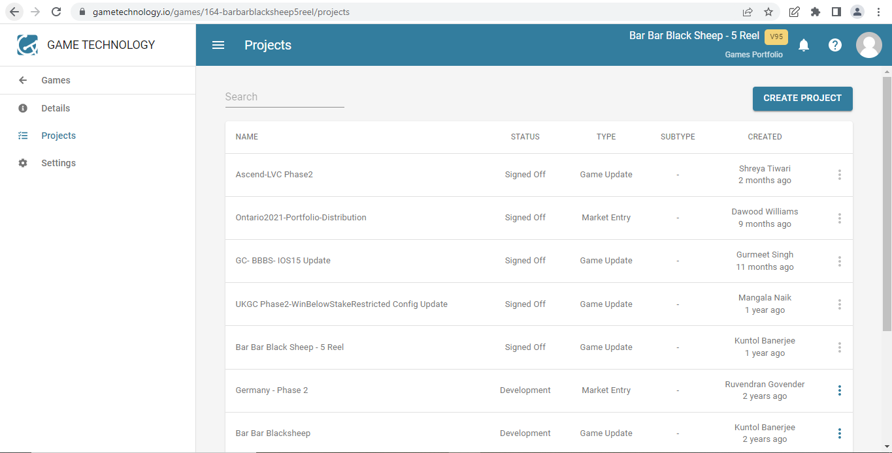
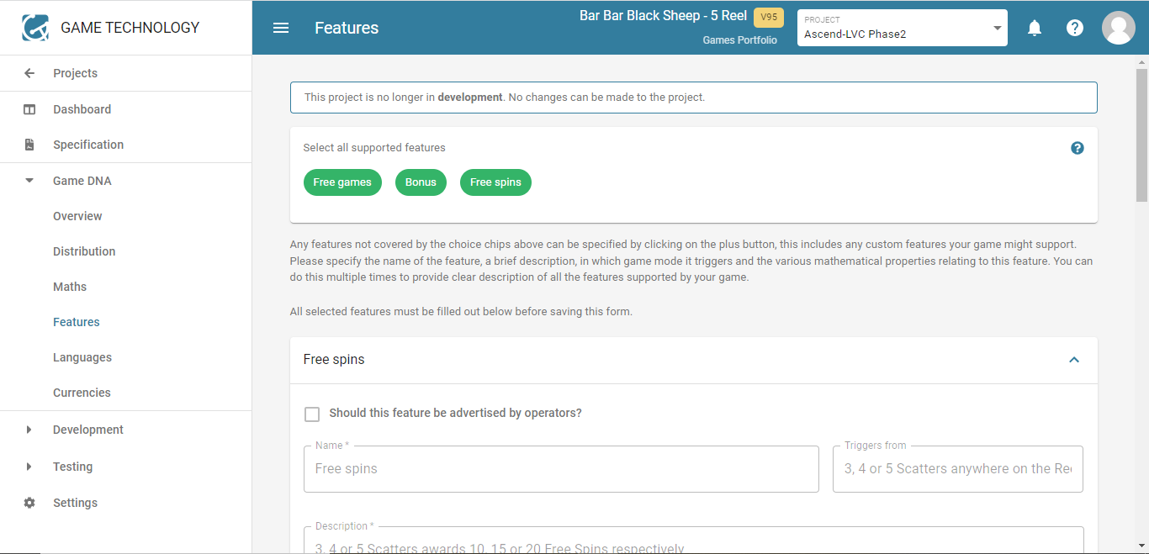
GAME TECHNOLOGY

Finding supported game features
- Go to https://www.gametechnology.io/games
- Enter the game name
- Click on the respective game
- Click on Project on left hand side and select the latest signed off or updated one in that

- Click on Game DNA on left hand side and select features, you will be able to find all the features available for the respective game

