Train Ticket Booking Management System

In this phase, we design and configure the data model for the Train Ticket Booking System. This involves creating custom objects, fields, relationships, record types, layouts, and schema visualization.

🔹 1. Standard & Custom Objects
- Standard Objects Used: User (for Agent assignment), Contact (optional alternative to Passenger).

Custom Objects Created:
  - Train c → Stores train details.
  - Passenger c → Stores passenger/customer details.
  - Ticket c → Stores ticket information (PNR, journey, status).
  - Booking c (optional junction) → Groups passenger & ticket if many-to-many is required.
  - Route c → Stores source, destination, and station details.

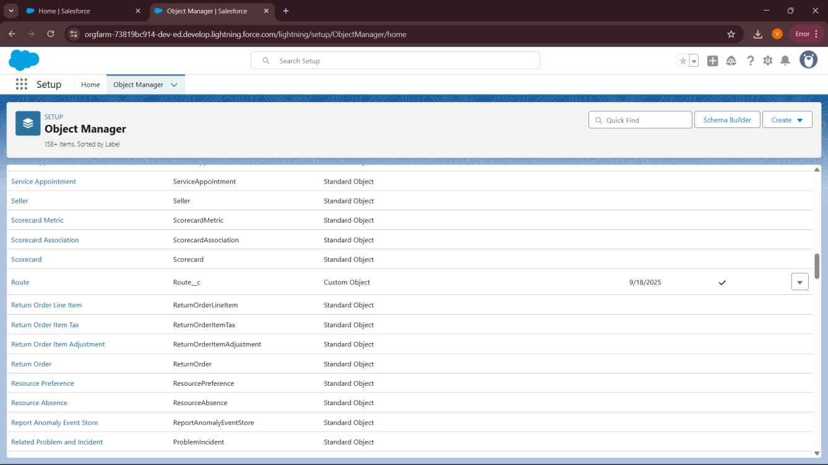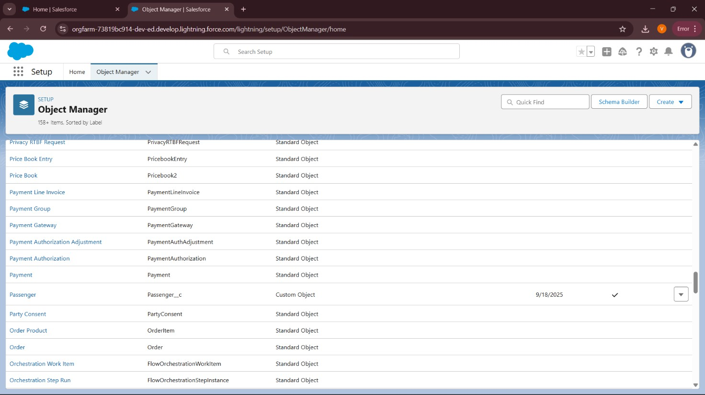

🔹 2. Fields
Example Fields Created:
- Train c → Train_No, Train_Name, Source, Destination, Class_Type, Total_Seats, Available_Seats.
- Passenger c → Name, Age, Gender, Email, Phone, Wallet_Balance, ID_Proof, ID_Number.
- Ticket c → PNR (Auto Number), Journey_Date, Status, Seat_No, Price, Booking_Date, Passenger (Lookup), Train (Lookup), Assigned Agent (Lookup to User), Payment_Status, Refund_Status.
- Route c → Route_Name, Source_Station, Destination_Station, Station_List, Departure_Time, Arrival_Time.

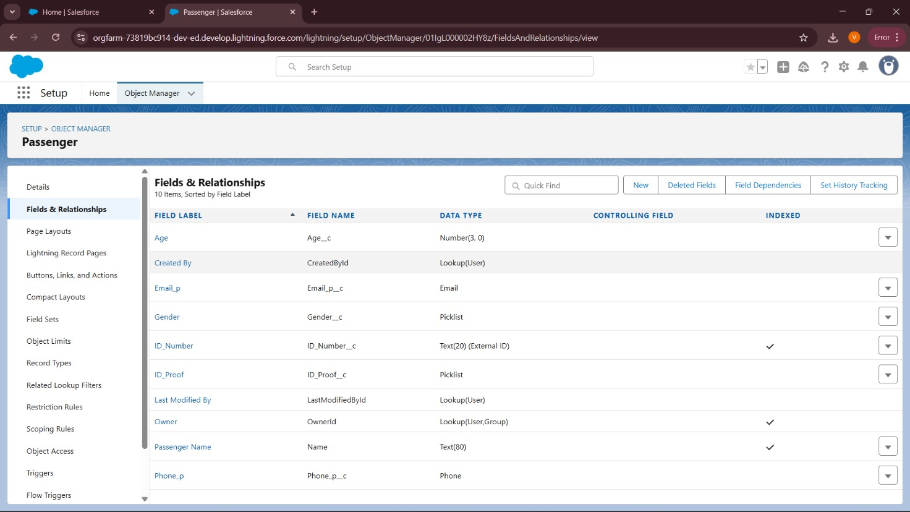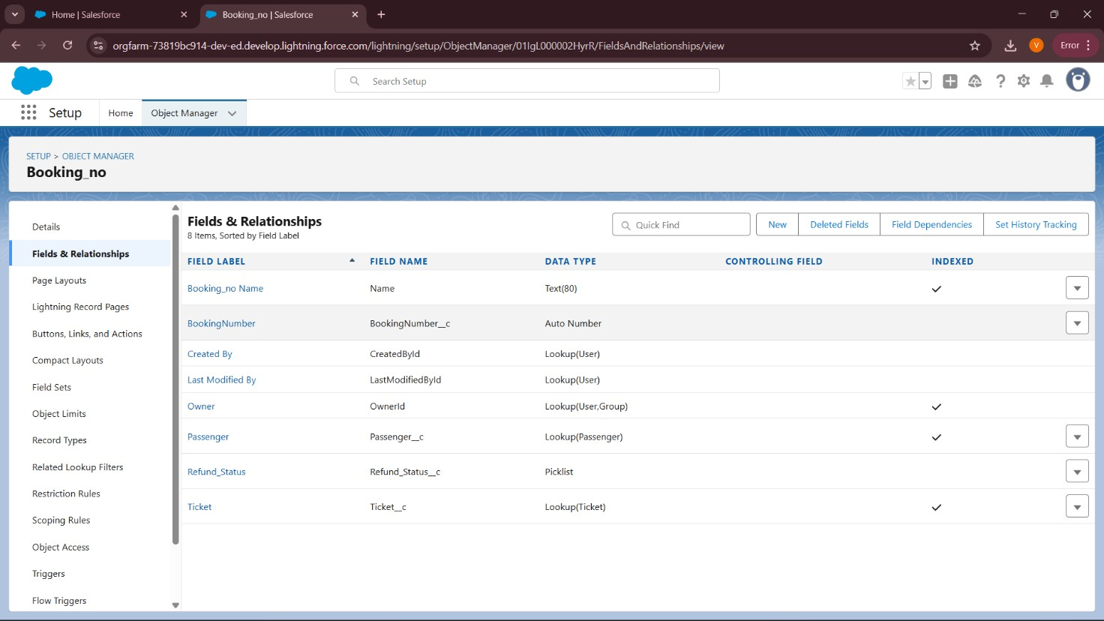

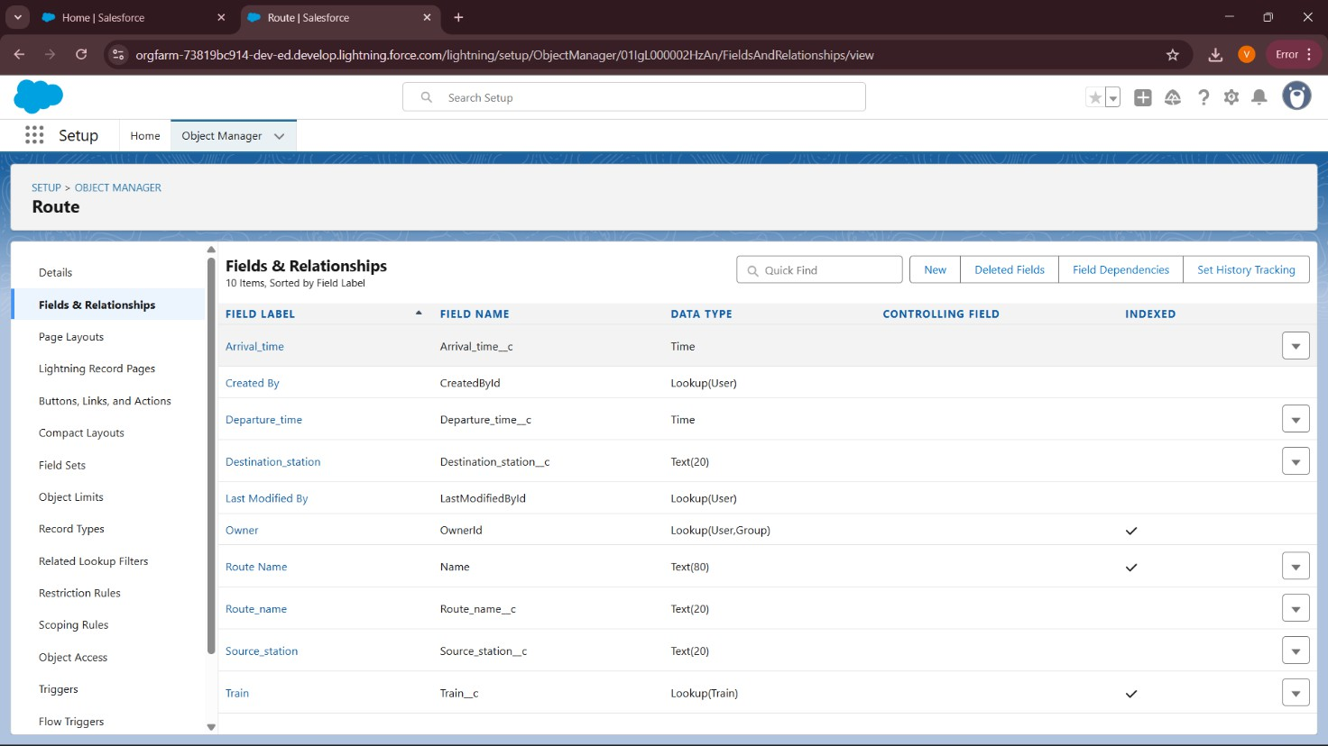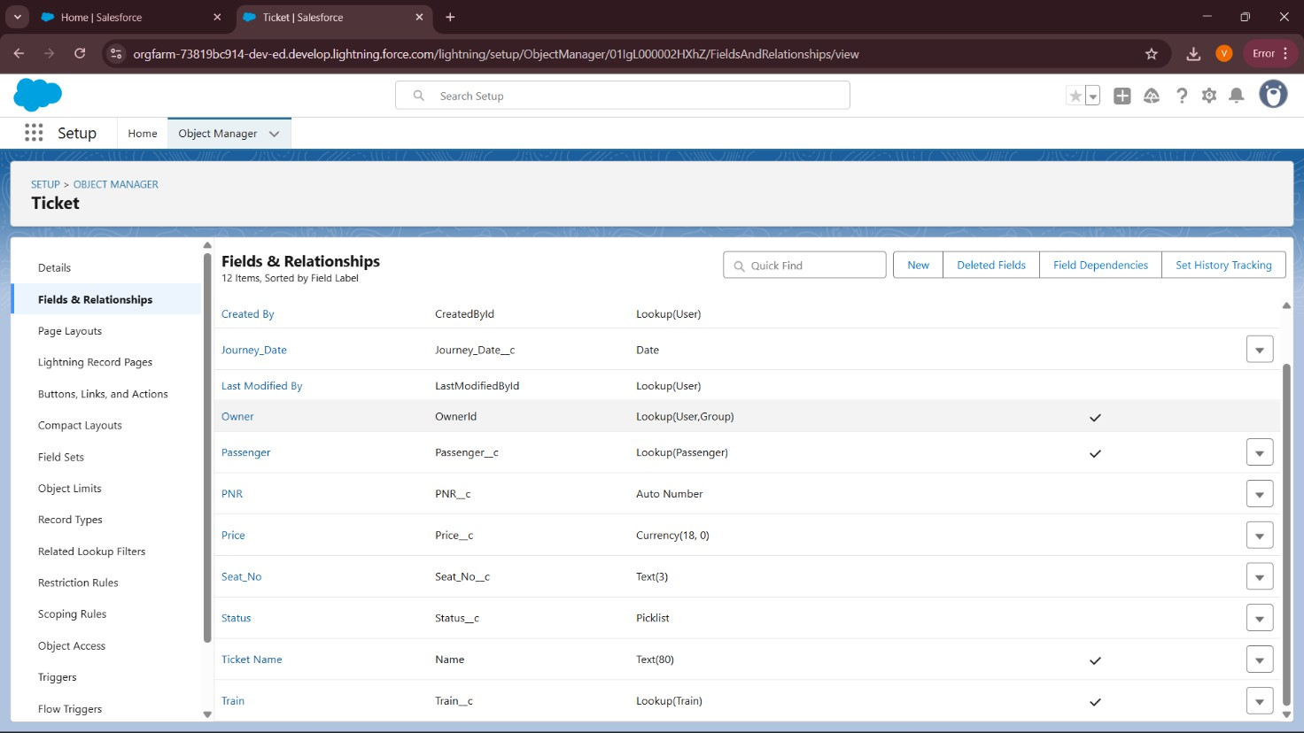

🔹 3. Record Types
Created record types on Ticket c to manage business processes:
- Booked
- Cancelled
- Waitlisted
- Pending Payment

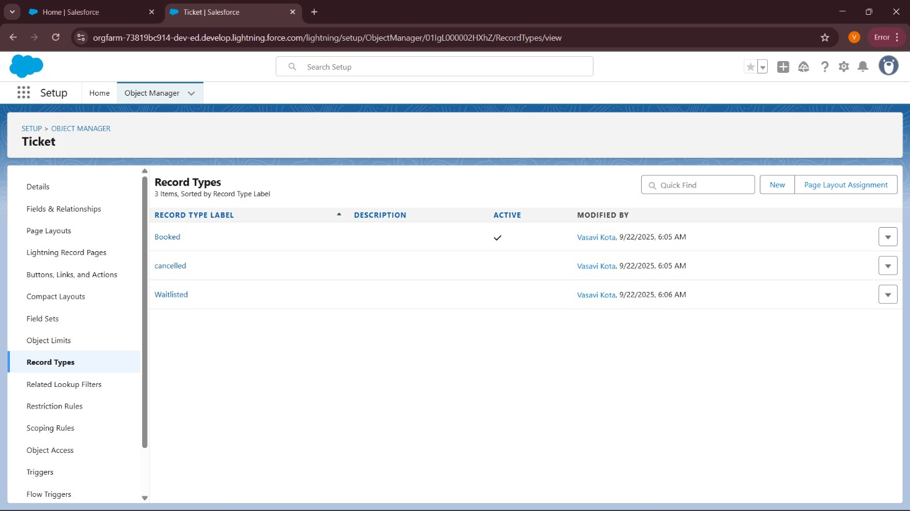

🔹 4. Page Layouts
- Ticket — Passenger Layout: Only booking details, no refund or agent fields.
- Ticket — Agent Layout: Includes Assigned Agent, Refund Status, Payment Status.
- Ticket — Admin Layout: Full access to all fields. Layouts are assigned to profiles based on record type.

🔹 5. Compact Layouts
Compact layouts were configured for quick view in Lightning header & mobile:
- Train c → Train Name, Train No, Available Seats.
- Ticket c → PNR, Status, Journey Date, Train.

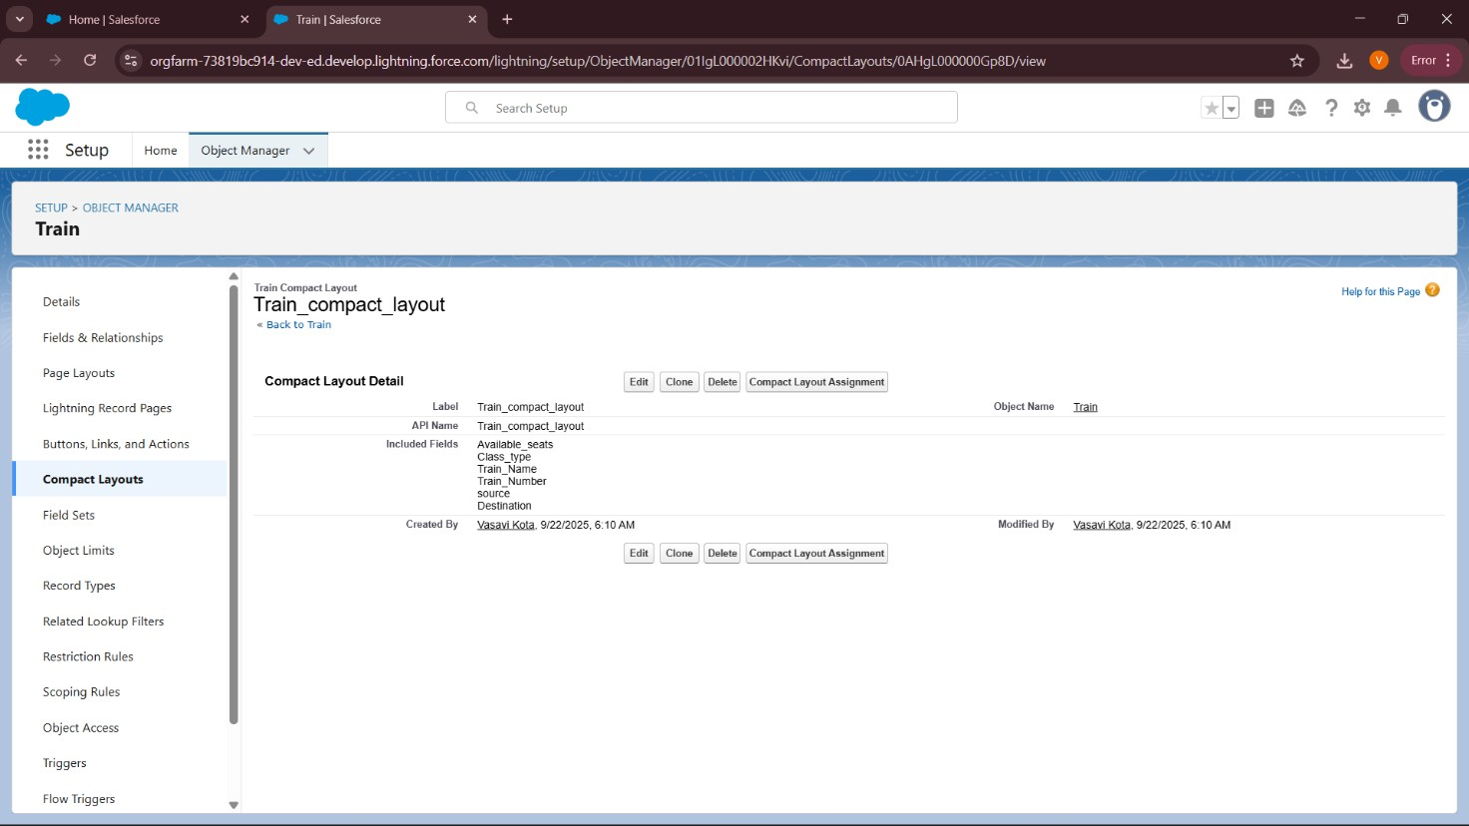
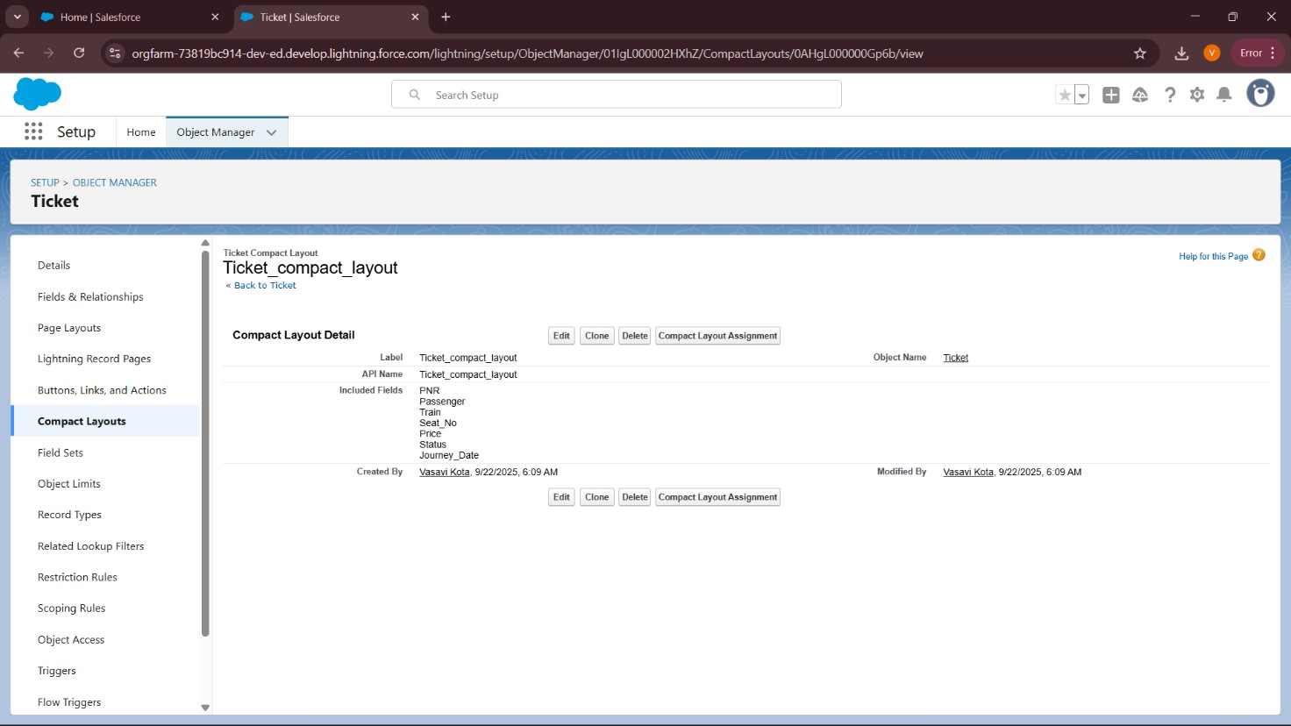

🔹 6. Schema Builder
- Verified relationships using Schema Builder.
- Relationships configured:
  - Ticket → Train = Lookup (1 Train : Many Tickets).
  - Ticket → Passenger = Lookup (1 Passenger : Many Tickets).
  - Ticket → Assigned Agent = Lookup(User).
  - Booking → Ticket & Passenger = optional Master-Detail (junction).

  - Route → Train = Lookup.
- Schema Builder used to visualize and confirm links between objects.
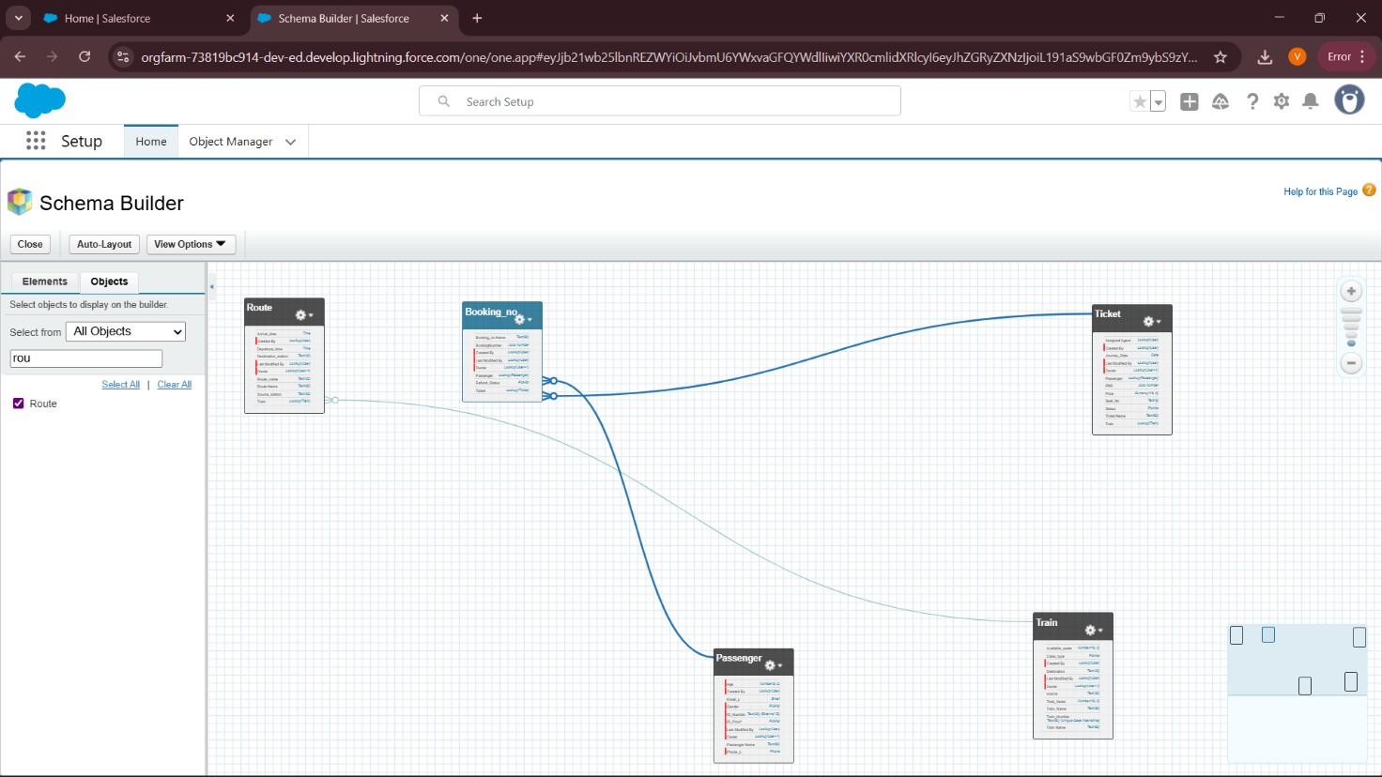

🔹 7. Relationship Choices
- Lookup used where we want flexibility (Train ↔ Ticket, Passenger ↔ Ticket).
- Master-Detail used in junction (Booking ↔ Ticket, Booking ↔ Passenger) if grouping is required.
- Hierarchical Relationship is only for User object (not applied here).
- This design ensures data safety (Tickets not auto-deleted if Train is deleted)

