Train Ticket Booking System

Phase 4: Process Automation (Admin)
- Validation Rules
- Workflow Rules
- Process Builder
- Approval Process
- Flow Builder (Screen, Record-Triggered, Scheduled, Auto-launched)
- Email Alerts
- Field Updates
- Tasks
- Custom Notifications

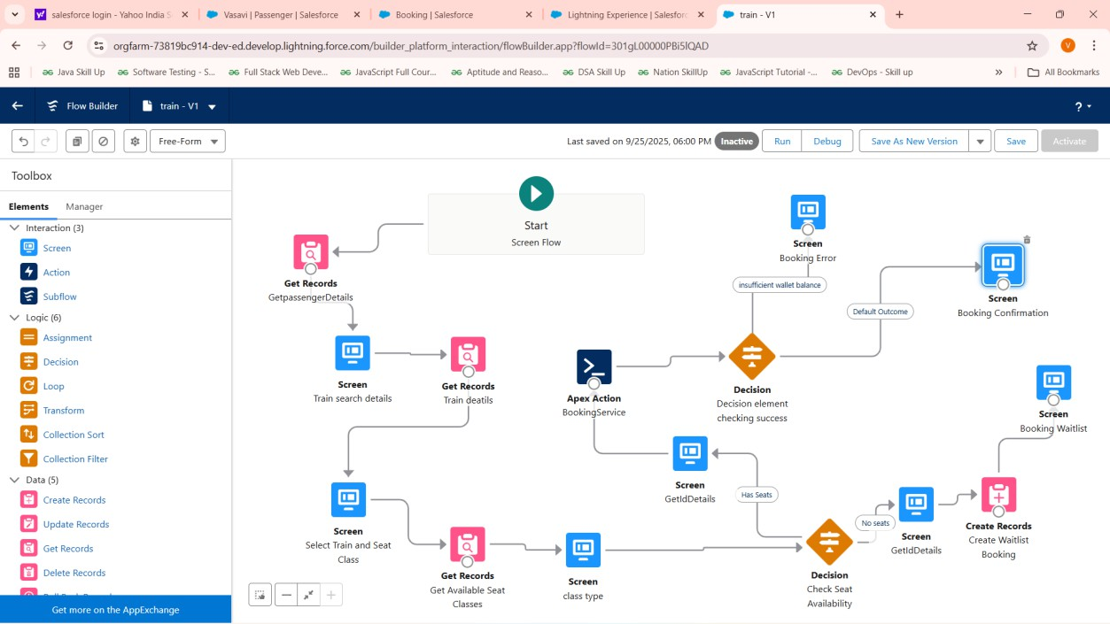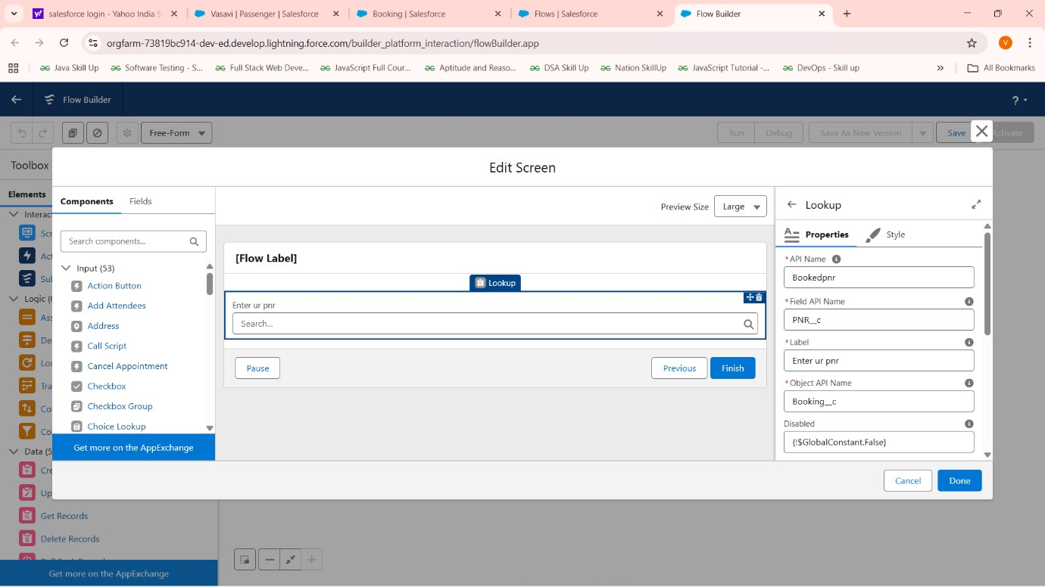

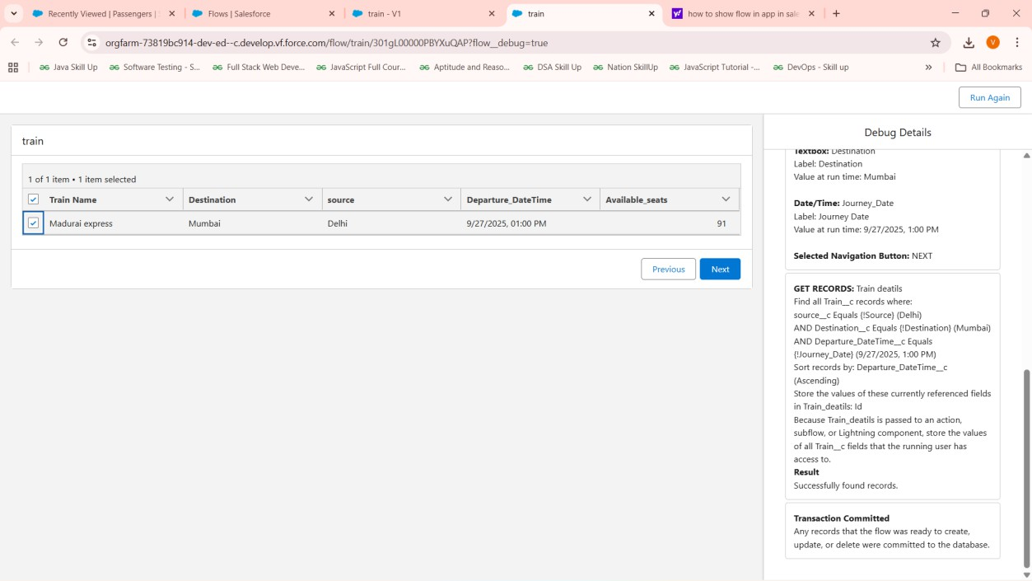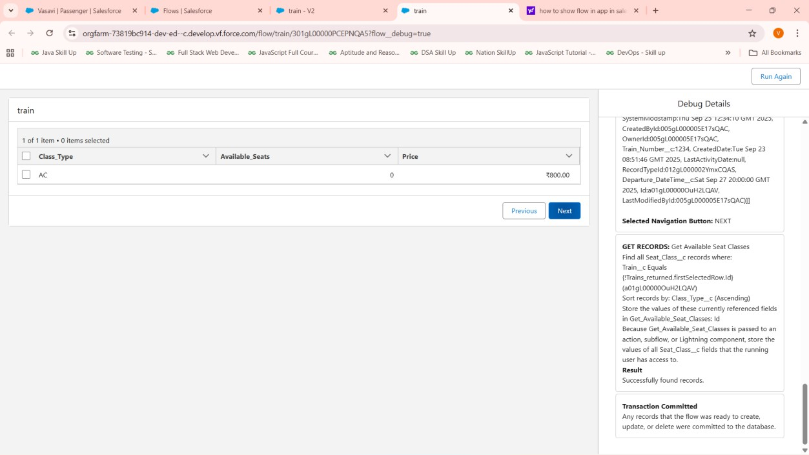

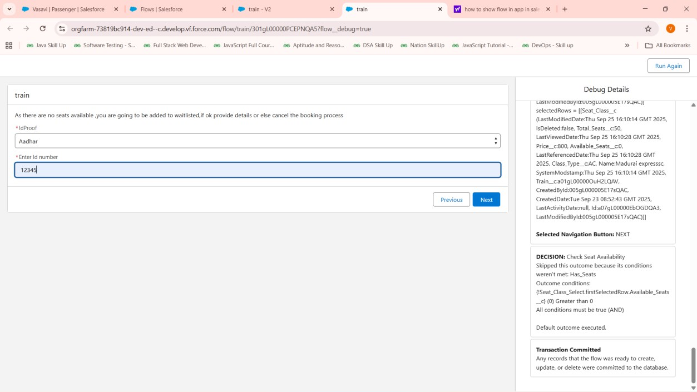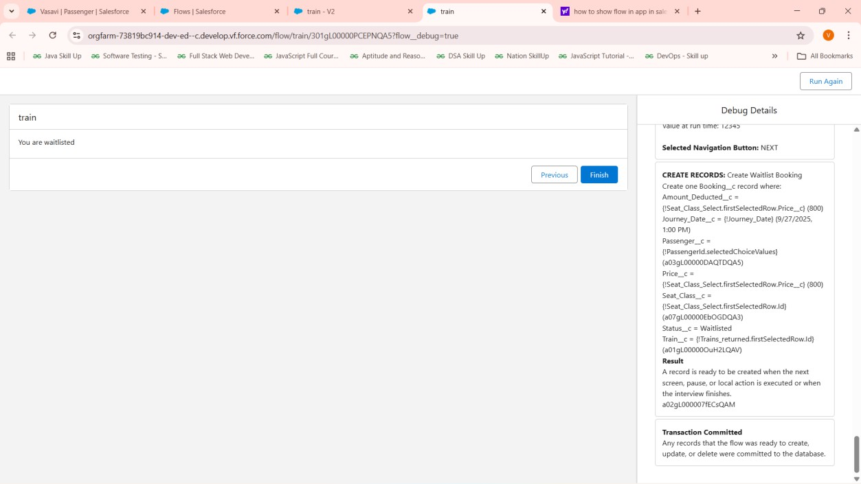

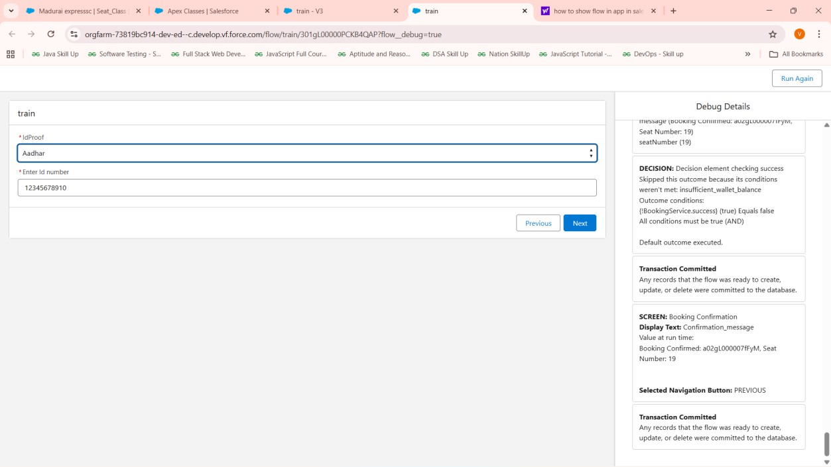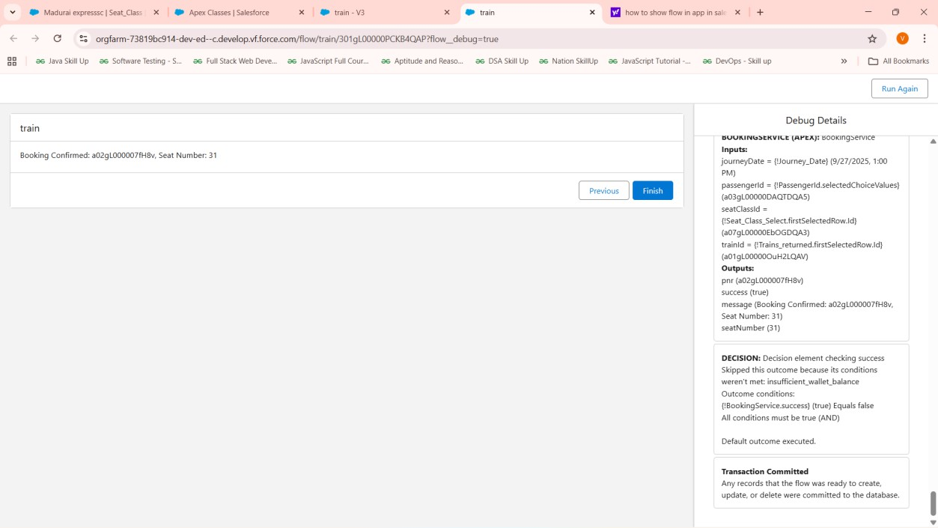

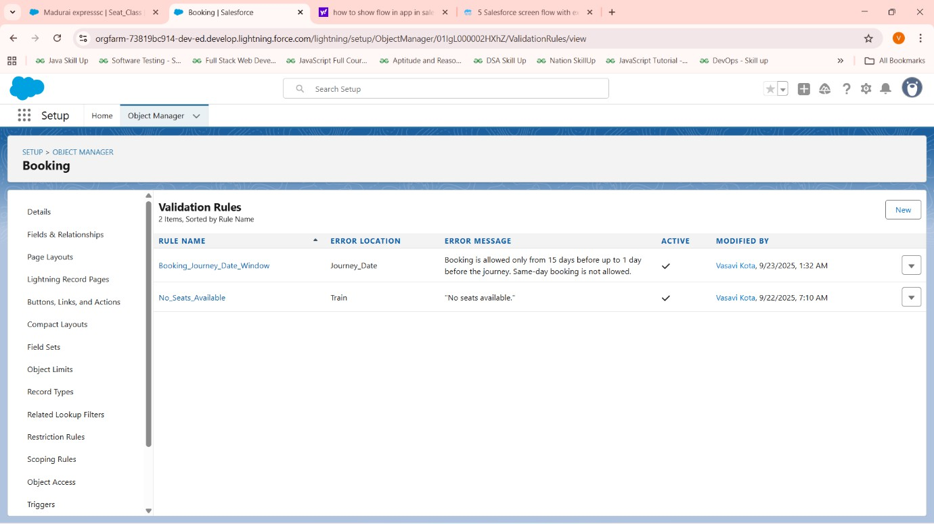

Phase 5: Apex Programming (Developer)
- Classes & Objects
- Apex Triggers (before/after insert/update/delete)
- Trigger Design Pattern
- SOQL & SOSL
- Collections: List, Set, Map
- Control Statements
- Batch Apex
- Queueable Apex
- Scheduled Apex
- Future Methods
- Exception Handling
- Test Classes
- Asynchronous Processing

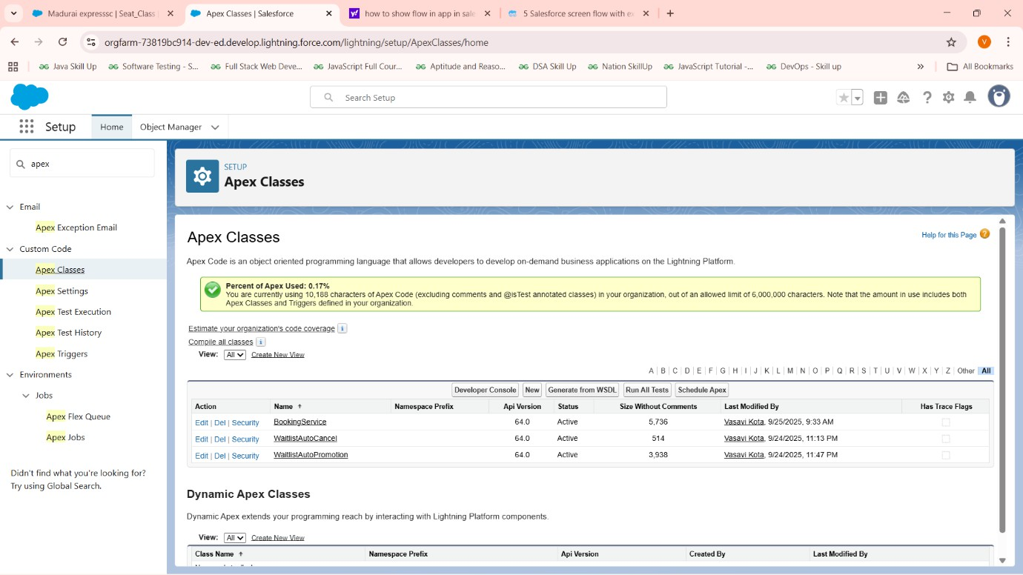
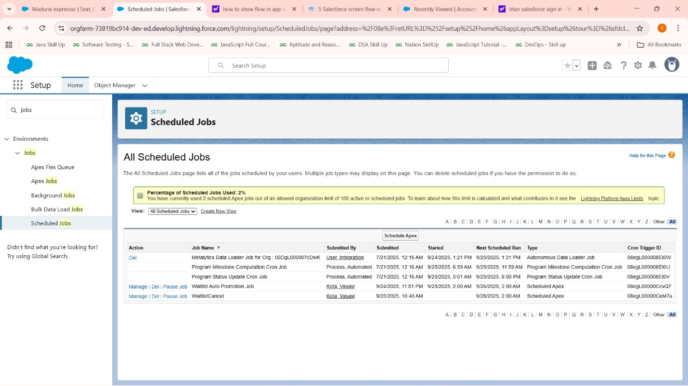
- ​

public class BookingService { @AuraEnabled
public static String cancelBooking(Id bookingId) {
Booking c b = [SELECT Id, Passenger c, Amount_Deducted c, Status c, Journey_Date c F ROM Booking c WHERE Id = :bookingId FOR UPDATE];
if (b.Status c == 'Cancelled') { return 'Booking already cancelled.';
}

Date today = Date.today();
Integer daysToJourney = b.Journey_Date c.daysBetween(today);

if (daysToJourney < 2) {
return 'Cannot cancel booking less than 2 days before journey.';
}

b.Status c = 'Cancelled';

Passenger c p = [SELECT Id, Wallet_Balance c FROM Passenger c WHERE Id = :b.Passenger_
_c FOR UPDATE];

if (b.Amount_Deducted c != null && b.Amount_Deducted c > 0) { p.Wallet_Balance c += b.Amount_Deducted c;

Wallet_Transaction c wt = new Wallet_Transaction c( Passenger c = p.Id,
Amount c = b.Amount_Deducted c, Transaction_Type c = 'Refund', Transaction_Date c = Datetime.now(), Balance_After c = p.Wallet_Balance c, Reference c = b.Name
);
update p; insert wt;
}

update b;
return 'Booking cancelled successfully.';
}

public class BookingResult { @InvocableVariable public Boolean success; @InvocableVariable public String message; @InvocableVariable public String pnr;
@InvocableVariable public String seatNumber;
}

@InvocableMethod(label='Create Booking')
public static List<BookingResult> createBooking(List<Request> requests){ List<BookingResult> results = new List<BookingResult>();
for(Request req : requests){
BookingResult br = new BookingResult(); br.success = false;
Passenger c p = [SELECT Id, Wallet_Balance c FROM Passenger c WHERE Id = :req.passen gerId FOR UPDATE];
Seat_Class c sc = [SELECT Id, Available_Seats c, Price c, Train c, Total_Seats c FROM S eat_Class c WHERE Id = :req.seatClassId FOR UPDATE];

Train c t = [SELECT Id, Available_Seats c, Price c FROM Train c WHERE Id = :sc.Train c FOR UPDATE];
Decimal fare = sc.Price c != null ? sc.Price c : t.Price c; if(sc.Available_Seats c > 0 && t.Available_Seats c > 0){
if(p.Wallet_Balance c >= fare){
// Assign seat number randomly
Set<Integer> bookedSeats = new Set<Integer>();
for(Booking c prev : [SELECT Seat_Number c FROM Booking c WHERE Seat_Class c
= :sc.Id AND Journey_Date c = :req.journeyDate]) {
if(prev.Seat_Number c != null) bookedSeats.add(Integer.valueOf(prev.Seat_Number_

_c));

}
List<Integer> availableSeats = new List<Integer>(); for(Integer i = 1; i <= sc.Total_Seats c; i++) {
if(!bookedSeats.contains(i)) availableSeats.add(i);

}
Integer seatNumber = availableSeats.size() > 0 ? availableSeats[Math.mod(Math.abs(Cryp to.getRandomInteger()), availableSeats.size())] : null;

p.Wallet_Balance c -= fare;
Wallet_Transaction c wt = new Wallet_Transaction c( Passenger c = p.Id,
Amount c = -fare, Transaction_Type c = 'Deduction',
Transaction_Date c = Datetime.now(), Balance_After c = p.Wallet_Balance c, Reference c = 'Booking'
);
Booking c b = new Booking c( Passenger c = p.Id,
Train c = t.Id, Seat_Class c = sc.Id, Status c = 'Confirmed',
Journey_Date c = req.journeyDate, Price c = fare,
Amount_Deducted c = fare,
Seat_Number c = String.valueOf(seatNumber)
);
sc.Available_Seats c -= 1;
t.Available_Seats c -= 1; update p;
insert wt; insert b;
// Query inserted booking to get generated PNR (Name)
Booking c booked = [SELECT Name FROM Booking c WHERE Id = :b.Id];

update sc; update t;

br.pnr = booked.Name;
br.seatNumber = String.valueOf(seatNumber); br.success = true;
br.message = 'Booking Confirmed: ' + booked.Name + ', Seat Number: ' + seatNumber;
} else {
br.message = 'Insufficient wallet balance.';
}
} else {
Booking c wb = new Booking c( Passenger c = p.Id,
Train c = t.Id, Seat_Class c = sc.Id, Status c = 'Waitlist',
Journey_Date c = req.journeyDate, Price c = fare,
Amount_Deducted c = 0
);
insert wb; br.success = true;
br.message = 'Added to waitlist. PNR: ' + wb.Name; br.pnr = wb.Name;
}
results.add(br);
}
return results;
}

public class Request {
@InvocableVariable public Id passengerId; @InvocableVariable public Id trainId; @InvocableVariable public Id seatClassId; @InvocableVariable public Date journeyDate;
}
}

global class WaitlistAutoCancel implements Schedulable { global void execute(SchedulableContext sc) {
Date checkDate = Date.today().addDays(1);
List<Booking c> waitlist = [SELECT Id, Passenger c, Price c FROM Booking c WHERE Status c = 'Waitlist' AND Journey_Date c = :checkDate];
List<Booking c> toCancel = new List<Booking c>(); for(Booking c b : waitlist){
b.Status c = 'Cancelled';

toCancel.add(b);
// Optionally, call an email utility here to notify the passenger and create refund Wallet_Transacti on c if needed.
}
if(!toCancel.isEmpty()) { update toCancel;
// Optionally, send notification emails or process further logic.
}
}
}

global class WaitlistAutoPromotion implements Schedulable { global void execute(SchedulableContext sc) {
Date checkDate = Date.today().addDays(1); // day before journey

// Query all cancelled bookings freeing seats List<Booking c> cancelledBookings = [
SELECT Train c, Seat_Class c, Journey_Date c FROM Booking c
WHERE Status c = 'Cancelled' AND Journey_Date c = :checkDate
];

// Map to count freed seats by train + seat class
Map<String, Integer> freedSeatsCount = new Map<String, Integer>(); for (Booking c b : cancelledBookings) {
String key = b.Train c + ':' + b.Seat_Class c;
Integer currentCount = freedSeatsCount.containsKey(key) ? freedSeatsCount.get(key) : 0; freedSeatsCount.put(key, currentCount + 1);

}

// Process each train + seat class combination for (String key : freedSeatsCount.keySet()) { String[] parts = key.split(':');
Id trainId = parts[0];
Id seatClassId = parts[1];
Integer seatsToPromote = freedSeatsCount.get(key);

// Query waitlist bookings FIFO order
List<Booking c> waitlistBookings = [SELECT Id, Passenger c, Journey_Date c FROM Booking_
_c
WHERE Status c = 'Waitlist' AND Train c = :trainId AND Seat_Class c = :se
atClassId
AND Journey_Date c = :checkDate ORDER BY CreatedDate ASC LIMIT :seats

ToPromote];

// Bulk query passengers and seat class/train details for efficiency Set<Id> passengerIds = new Set<Id>();
for(Booking c wb : waitlistBookings) passengerIds.add(wb.Passenger c); Map<Id, Passenger c> passengers = new Map<Id, Passenger c>([
SELECT Id, Wallet_Balance c FROM Passenger c WHERE Id IN :passengerIds FOR UPDATE
]);
Seat_Class c scs = [SELECT Id, Available_Seats c, Train c, Total_Seats c, Price c FROM Sea t_Class c WHERE Id = :seatClassId FOR UPDATE];
Train c train = [SELECT Id, Available_Seats c, Price c FROM Train c WHERE Id = :trainId FOR UPDATE];

Decimal fare = scs.Price c != null ? scs.Price c : train.Price c; List<Booking c> toUpdateBookings = new List<Booking c>();
List<Wallet_Transaction c> walletTransactions = new List<Wallet_Transaction c>();

Integer seatsPromoted = 0;
for (Booking c waitlist : waitlistBookings) {
Passenger c p = passengers.get(waitlist.Passenger c);
if (p != null && p.Wallet_Balance c >= fare && seatsPromoted < seatsToPromote) {

// Find and assign next available seat number Set<Integer> bookedSeats = new Set<Integer>();
for(Booking c b : [SELECT Seat_Number c FROM Booking c WHERE Seat_Class c = :scs.Id AND Journey_Date c = :waitlist.Journey_Date c AND Status c='Confirmed']) {
if (b.Seat_Number c != null) bookedSeats.add(Integer.valueOf(b.Seat_Number c));
}
List<Integer> availableSeats = new List<Integer>(); for (Integer i = 1; i <= scs.Total_Seats c; i++) {
if (!bookedSeats.contains(i)) availableSeats.add(i);
}
if (availableSeats.isEmpty()) break; // no seats to assign, break

Integer seatNumber = availableSeats[Math.mod(Math.abs(Crypto.getRandomInteger()), availa bleSeats.size())];

// Deduct fare from wallet p.Wallet_Balance c -= fare;

// Update booking to confirmed waitlist.Status c = 'Confirmed'; waitlist.Amount_Deducted c = fare; waitlist.Price c = fare;
waitlist.Seat_Number c = String.valueOf(seatNumber);

// Track records for update/insert toUpdateBookings.add(waitlist);

walletTransactions.add(new Wallet_Transaction c( Passenger c = p.Id,
Amount c = -fare, Transaction_Type c = 'Deduction',
Transaction_Date c = Datetime.now(), Balance_After c = p.Wallet_Balance c, Reference c = 'Booking Promotion'
));

seatsPromoted++; scs.Available_Seats c -= 1;
train.Available_Seats c -= 1;
} else {
// Optionally notify passenger for insufficient balance or handle per policy
}
}

if (!toUpdateBookings.isEmpty()) { update toUpdateBookings;
update new List<Passenger c>(passengers.values()); insert walletTransactions;
update scs; update train;
}
}
}
}

Phase 6: User Interface Development
- Lightning App Builder
- Record Pages
- Tabs
- Home Page Layouts
- Utility Bar
- LWC (Lightning Web Components)
- Apex with LWC
- Events in LWC
- Wire Adapters
- Imperative Apex Calls
- Navigation Service

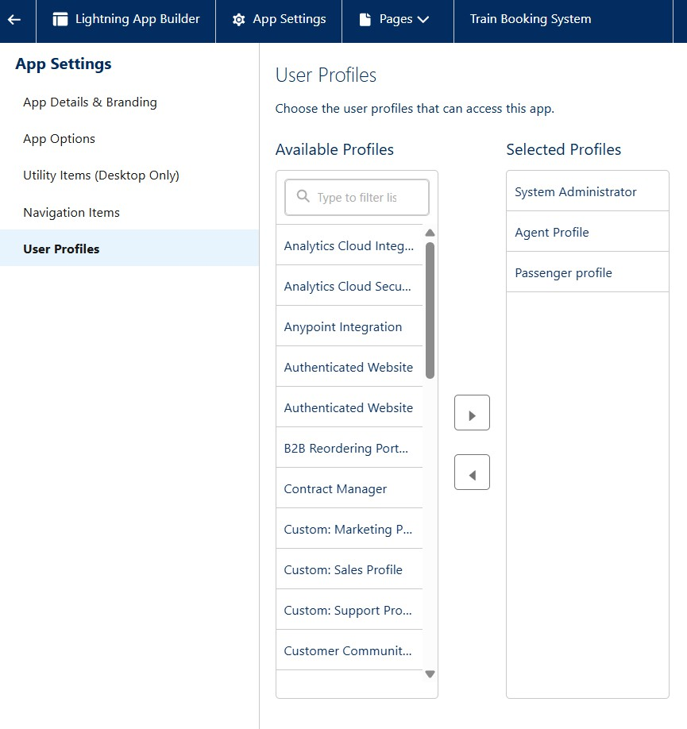

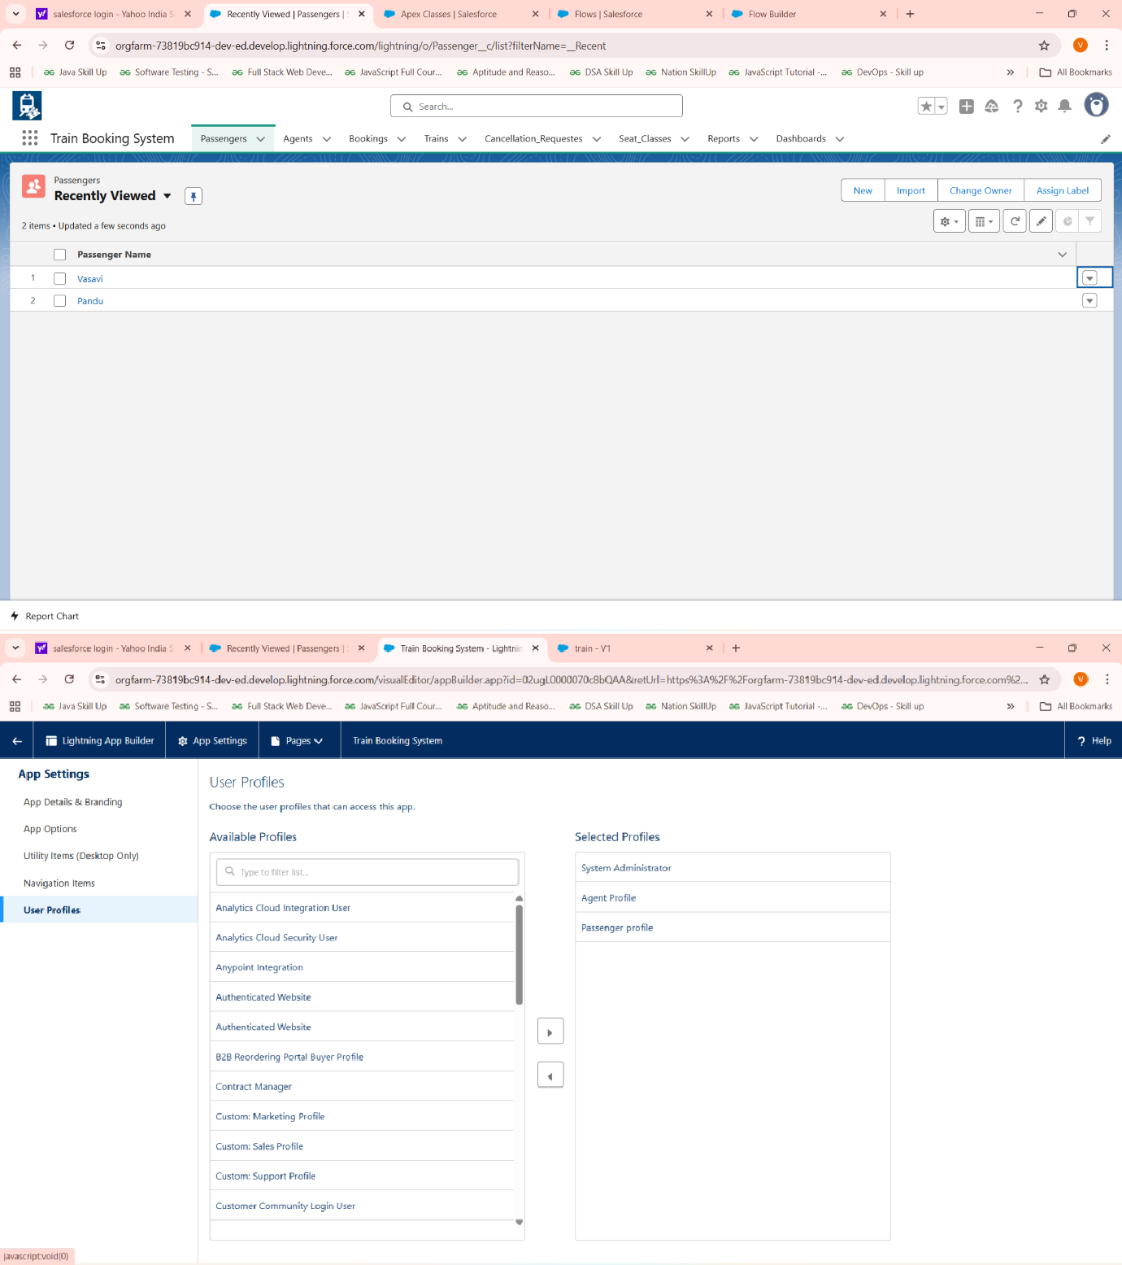

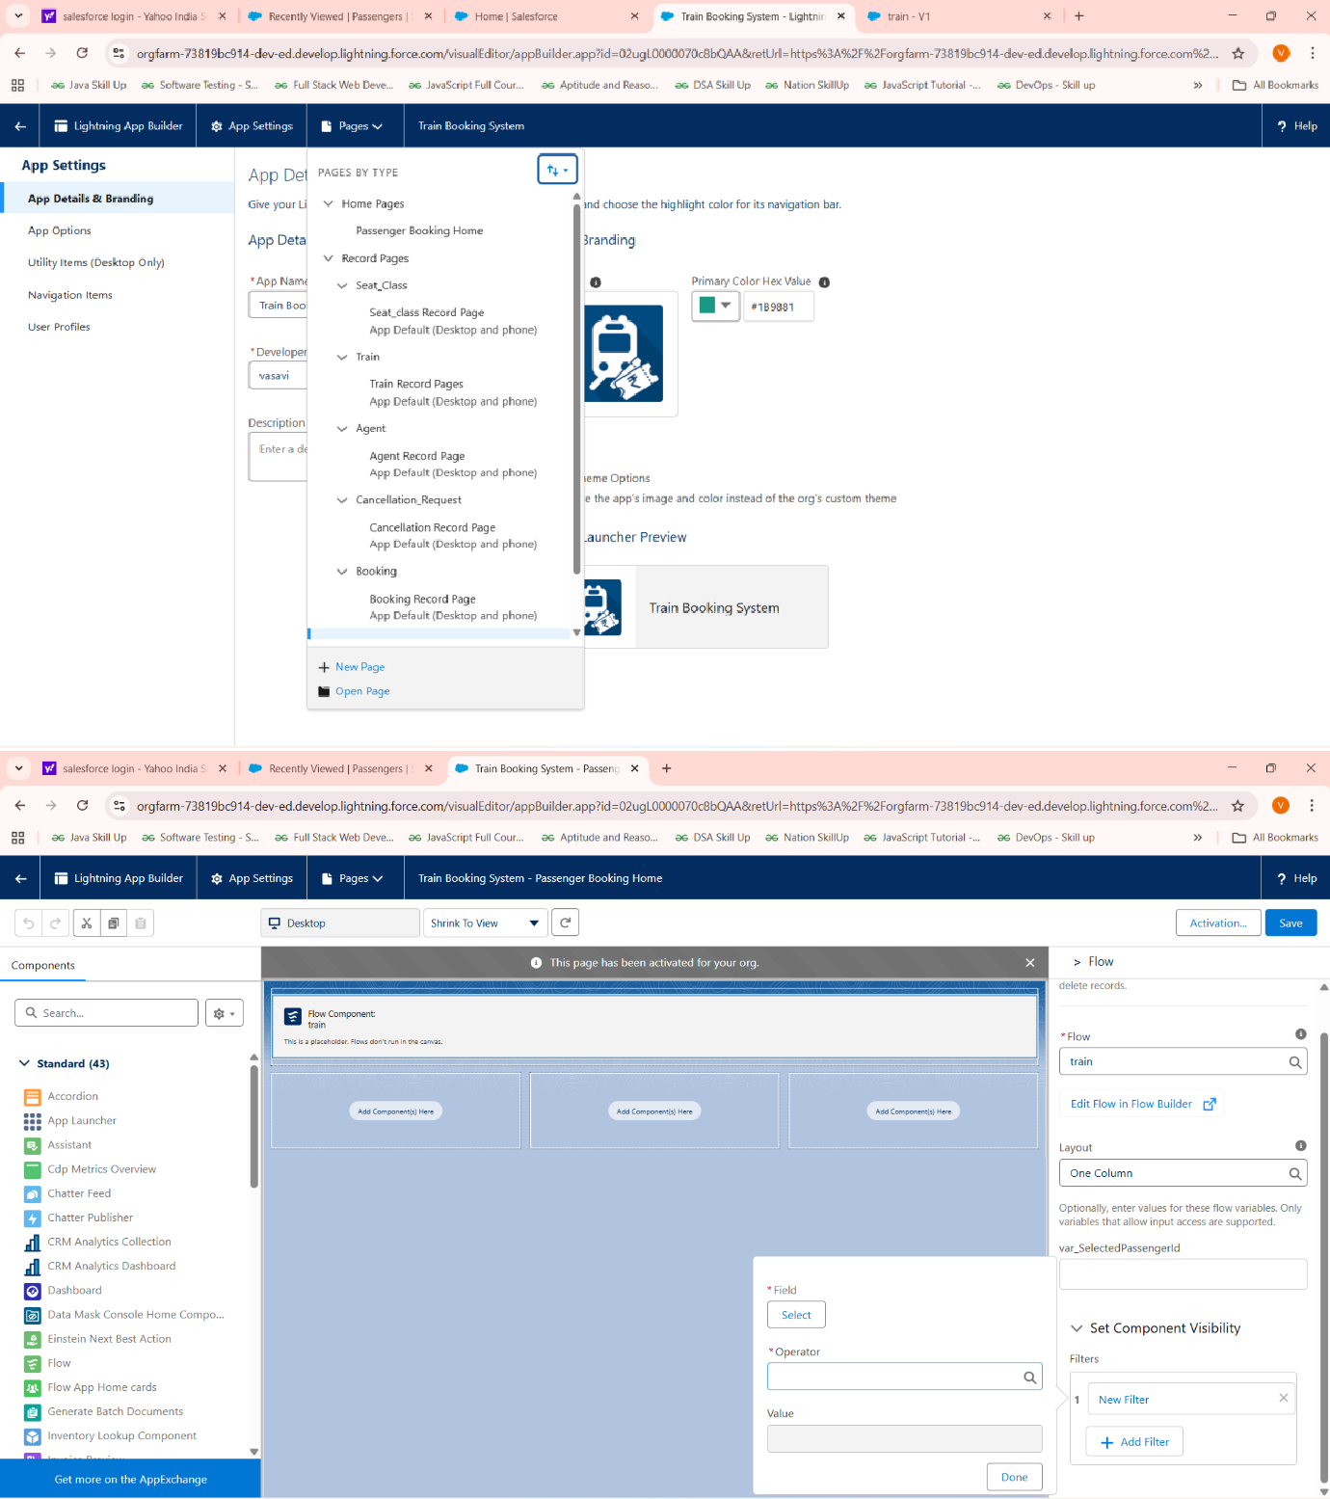

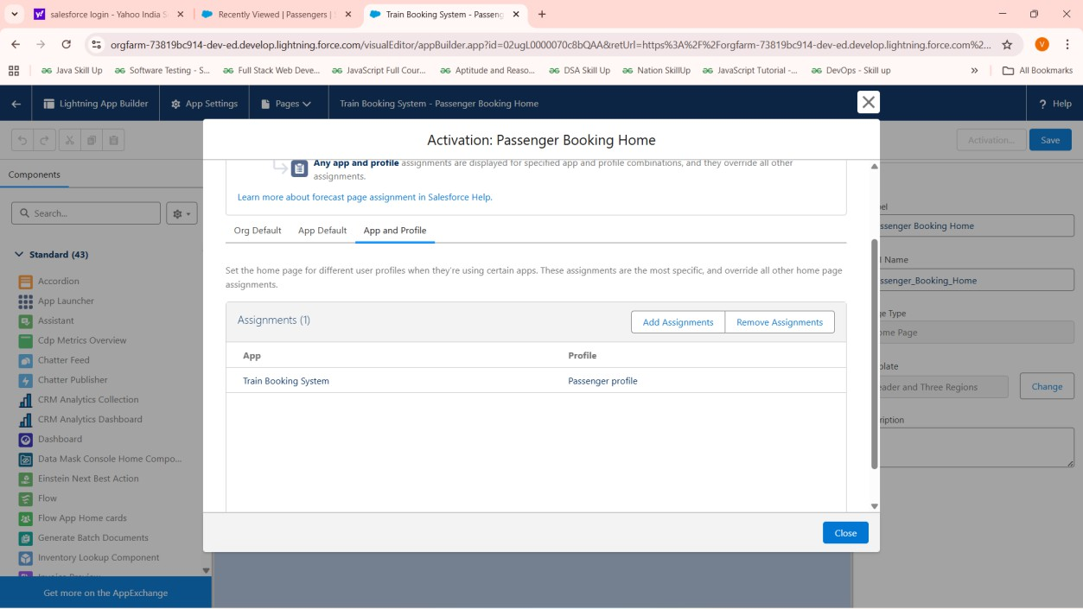

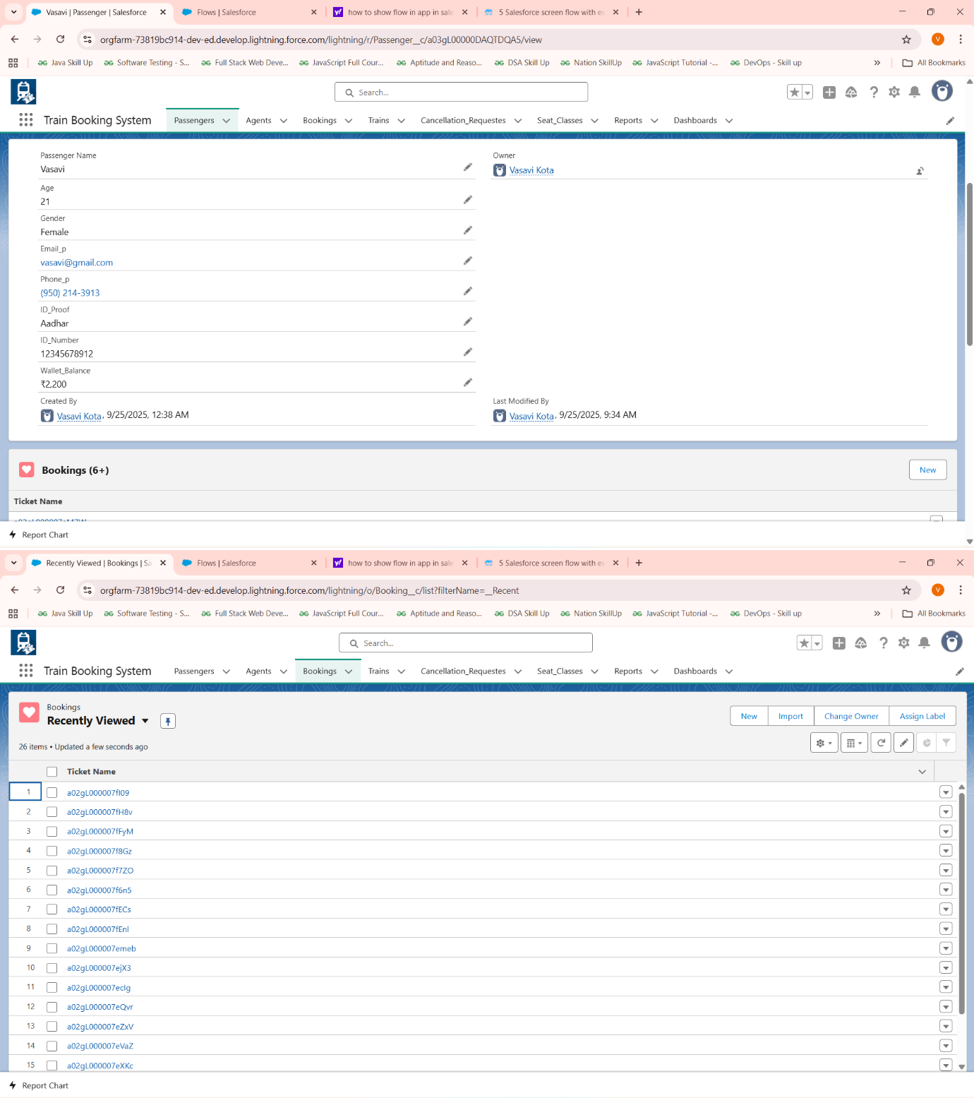

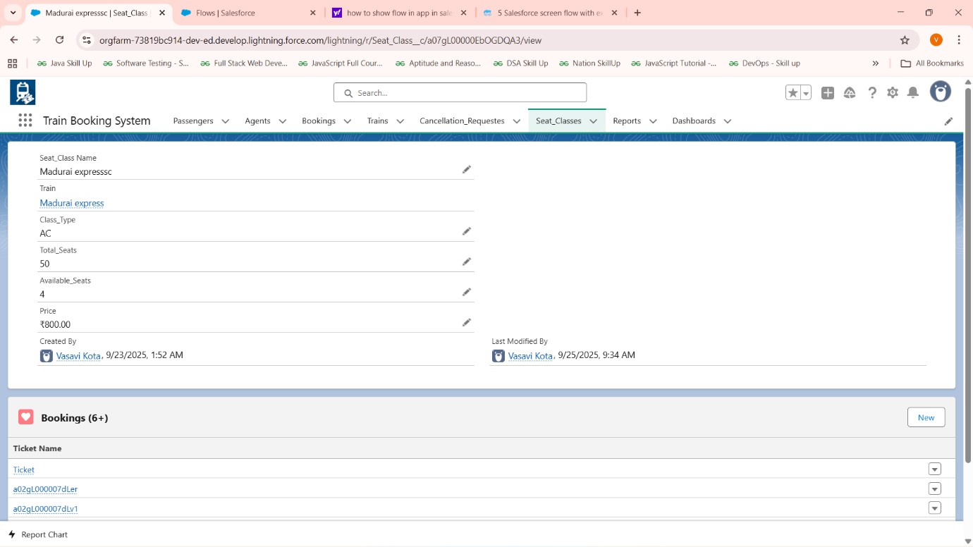

Overall summary:

Phase 4: Process Automation (Admin)
- Validation Rules: Implemented to enforce business rules like cancellation timing policies.
- Workflow Rules & Process Builder: Limited use; moved towards Flow Builder for UI and automation.
- Approval Process: Not implemented in current scope; can be added if needed.
- Flow Builder:
  - Created Screen Flows for Booking and Cancellation processes.
  - Used Record-Triggered and Scheduled Flows via Apex scheduled jobs for waitlist management.
- Email Alerts: Setup for booking confirmation, cancellation notifications (integration with Apex or Flow).
- Field Updates & Tasks: Integrated as part of Apex logic and Flow outcomes.
- Custom Notifications: Configured or considered for alerting users on booking statuses.

Phase 5: Apex Programming (Developer)
- Classes & Objects: Built core BookingService and Waitlist management Apex classes.
- Apex Triggers: Not extensively implemented; Apex classes handle logic.
- Trigger Design Patterns: Not covered but can be adopted for scale.

- SOQL & SOSL: Used for querying bookings, passengers, trains, seat classes efficiently.
- Collections: Utilized Lists, Sets, and Maps for data processing.
- Control Statements: Implemented complex booking logic and validations.
- Scheduled Apex: Developed WaitlistAutoCancel to cancel waitlisted tickets before 1 day from journeydate and WaitlistAutoPromotion for freed seats from cancellation to confirmed booking schedulable classes
- Exception Handling & Test Classes: Recommendations to enhance for production readiness.
- Asynchronous Processing: Scheduled Apex for batch/scheduled jobs.

Phase 6: User Interface Development
- Lightning App Builder: Used for building flow containers and app pages.
- Record Pages & Tabs: Setup for quick access to Booking and related objects.
- Home Page Layouts & Utility Bar: Customized for better UX.
- Lightning Web Components (LWC): Not implemented; but working on it will complete soon
- Apex with LWC Integration: Considered for complex UI functionality.
- Events, Wire Adapters, Imperative Apex Calls: Planned for advanced interaction.
- Navigation Service: Used for smooth UI transitions in Lightning apps.

