Train Ticket Booking System- PHASE_2

Presented By:
Vasavi Kota CMRCET,Hyderabad

Phase 2: Org Setup & Configuration

🔹 1. Company Profile Setup

Go to Setup → Company Information → Edit.
- I Set Company Name = Railway Ticketing System.
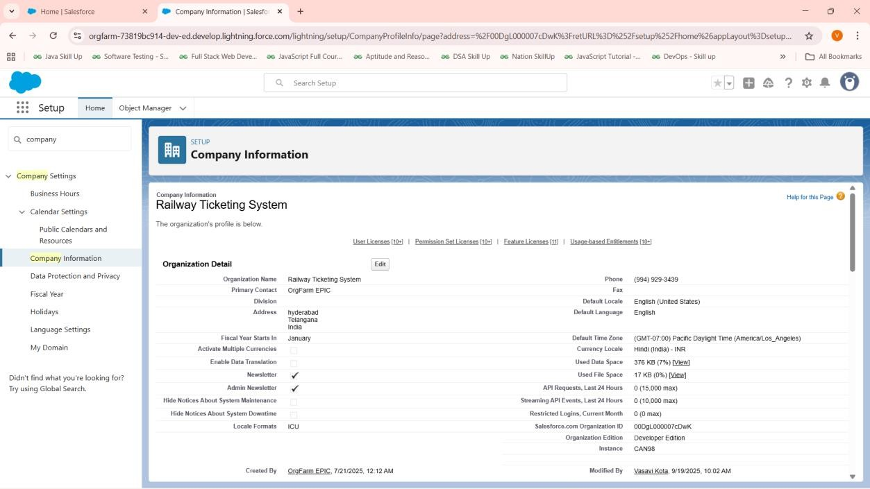

🔹 2. Business Hours & Holidays
- Setup → Business Hours → Defining as 24/7 as they can book tickets anytime.
- Holidays → Not adding any sample holidays because agents can manage the bookings .
- If needed we can add for approval processes and flows (like refunds not processed on holidays).

🔹 3. Fiscal Year Settings
- Setup → Fiscal Year → Use Standard Fiscal Year.
- Defines reporting cycles for dashboards and revenue tracking.

🔹 4. User Setup & Licenses
- Created users for Admin, Agent, Passenger.
- Admin → System Administrator license (My own account).
- Agent → Salesforce Platform license.
- Passenger → Simulated as a Contact (Standard User) and salesforce licence.
- This allows testing from different perspectives.
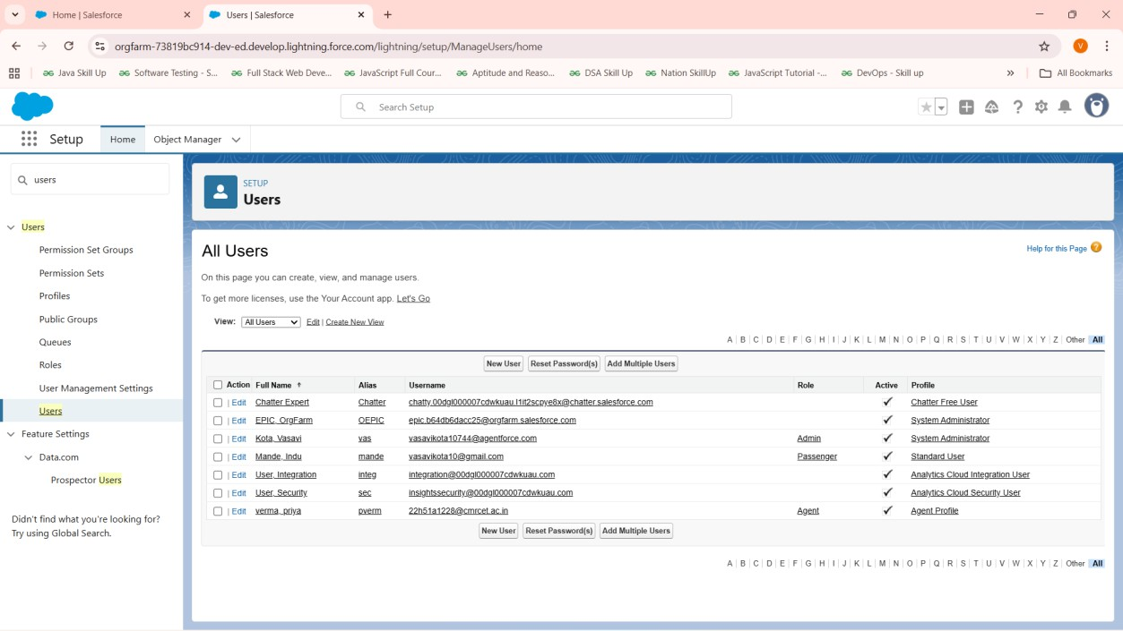

🔹 5. Profiles
Profiles control object and field-level access.

Passenger Profile:
  - Access only to their own Tickets/Bookings.
  - Read-Only access to Trains & Routes.

Agent Profile:
  - Create/Edit Tickets for passengers.
  - Manage Passenger records.
  - Read access to Trains & Routes.

Admin Profile:

  - Full access (System Administrator).
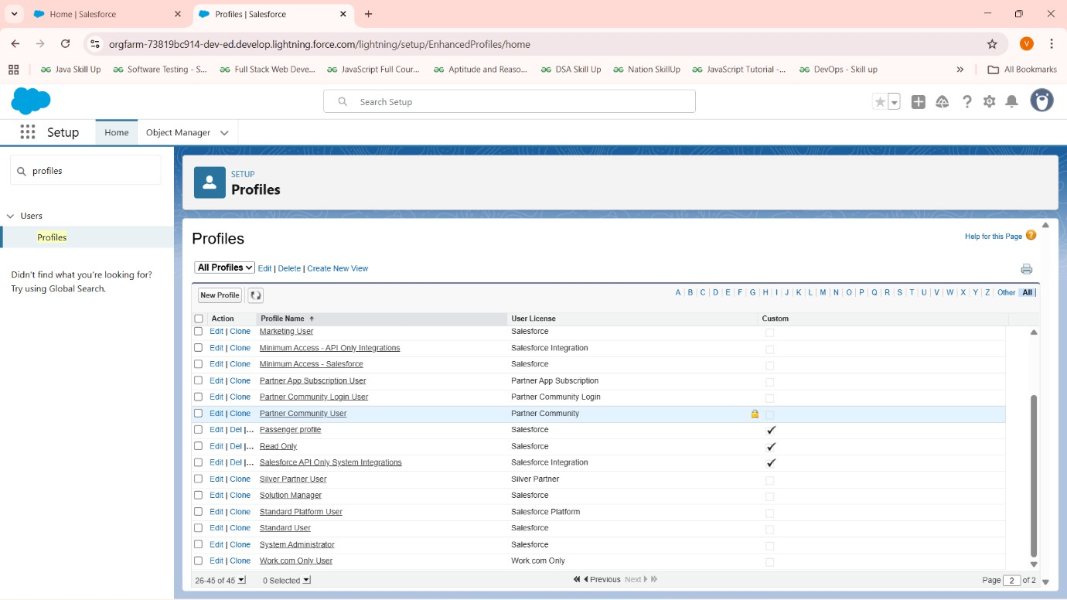

🔹 6. Roles
Roles control data visibility in the hierarchy.

- Created hierarchy: Admin → Agent → Passenger.
- Assigned users to each role.
- Ensures Agents can see their customers’ Tickets, while Passengers can only see their own.

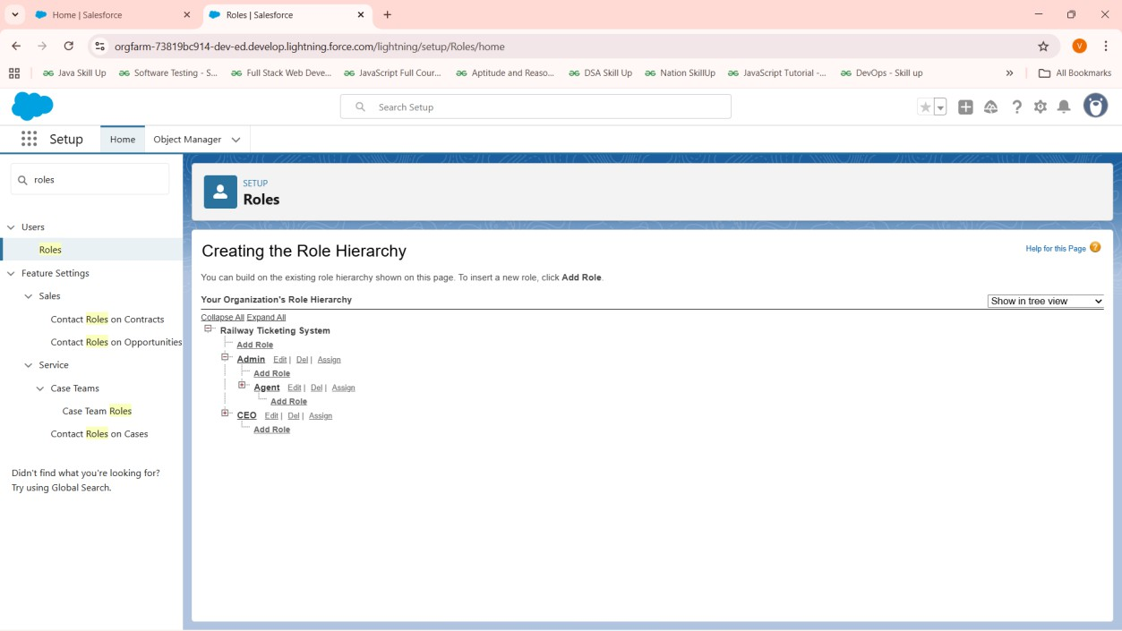

🔹 7. Permission Sets
Permission sets give additional access beyond profiles.

- Manage Refunds Permission Set:
  - Grants edit access to Refund_Status c field on Ticket.
  - Assigned to Agents & Admins only.
  - Ensures passengers cannot manipulate refunds.
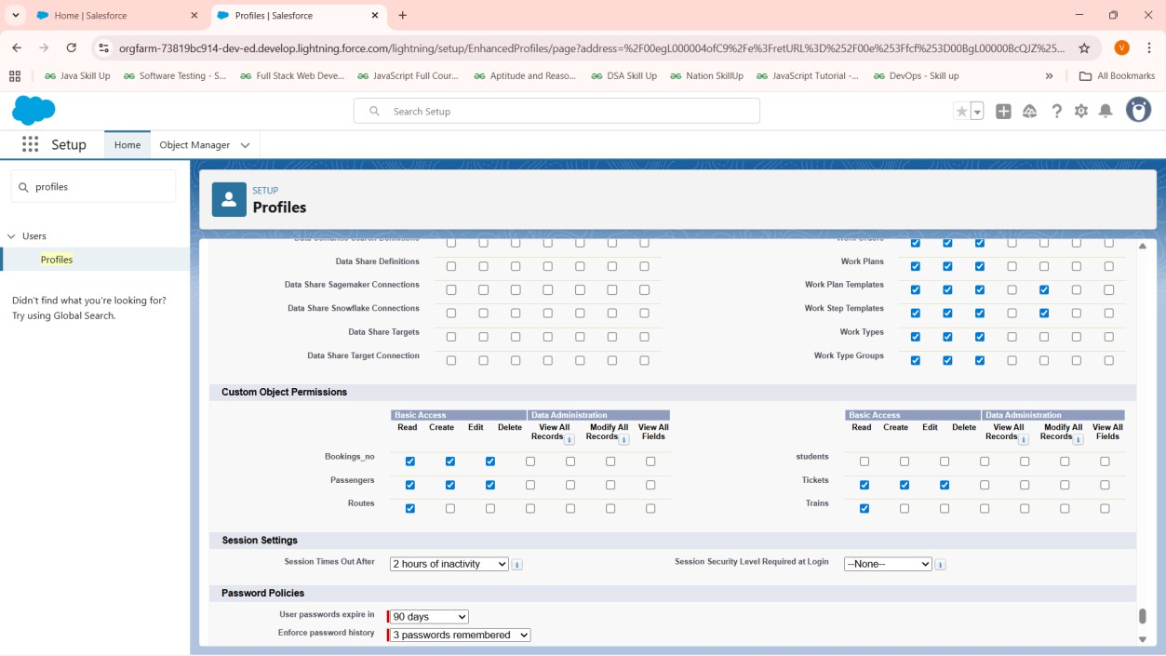

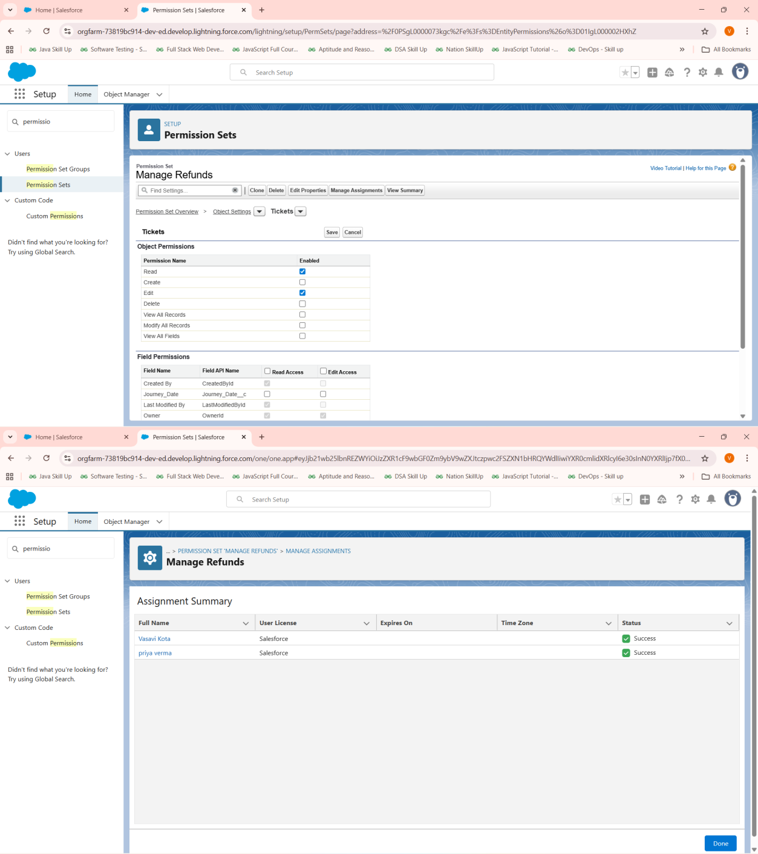

🔹 8. Organization-Wide Defaults (OWD)
Defines the baseline sharing level for all records.

- Ticket = Private (only owner/Admin sees by default).
- Booking = Private.
- Passenger = Private.
- Train = Public Read Only.

- Route = Public Read Only.

This ensures data privacy by default.
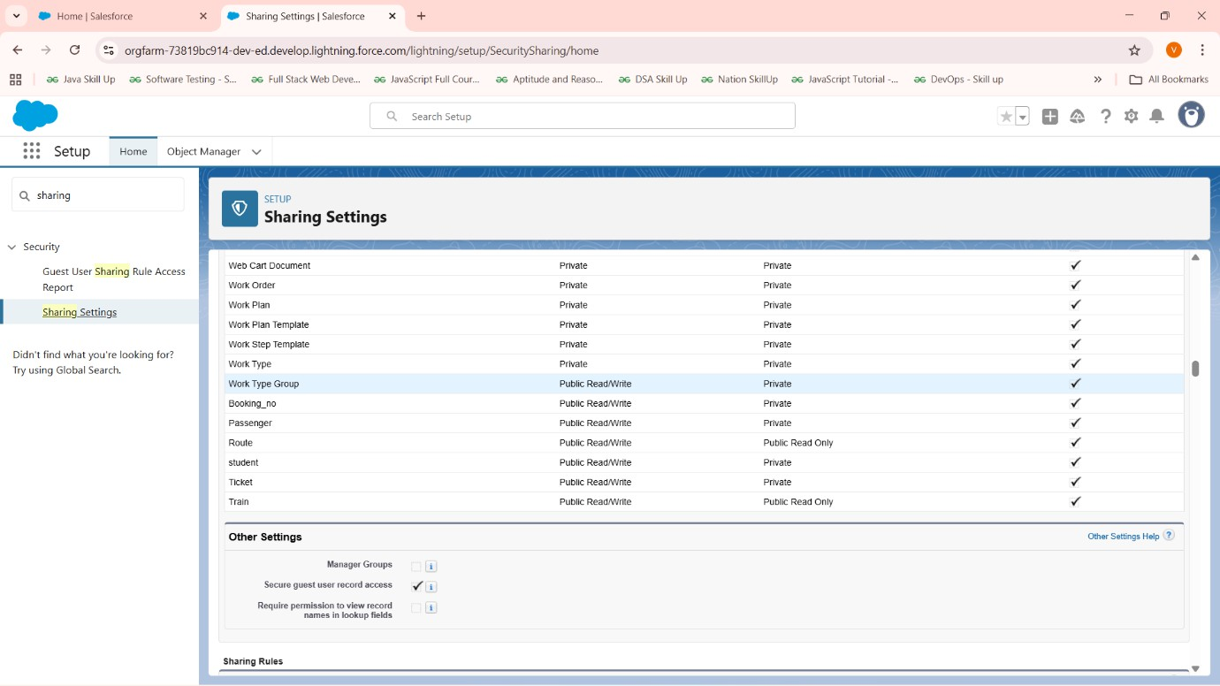

🔹 9. Sharing Rules
Used to open access where needed.

- Created a Sharing Rule on Ticket:
  - Criteria: Assigned Agent is not blank.
  - Shared with Role: Agent.
  - Access: Read/Write.
- This allows Agents to see Tickets assigned to them while Passengers remain restricted.

🔹 10. Login Access Policies
- Setup → Login Access Policies → Enabled “Administrators Can Log in as Any User.”
- Allows Admin to test flows by logging in as Passenger or Agent without needing passwords.

✅ Phase-2 Outcome

At the end of Phase 2, the Salesforce org is fully prepared with:

- Company information and working hours.
- Users, roles, profiles, and permission sets.
- Data access secured through OWD and Sharing Rules.
- Admin can impersonate users for testing.

