**DATA STRUCTURES**

**DAY-1**

**1.EVEN OR ODD NUMBER**

#include<stdio.h>

int main()

{

int n;

printf("enter n value");

scanf("%d",&n);

if(n%2==0)

printf("even number");

else

printf("odd number");

}

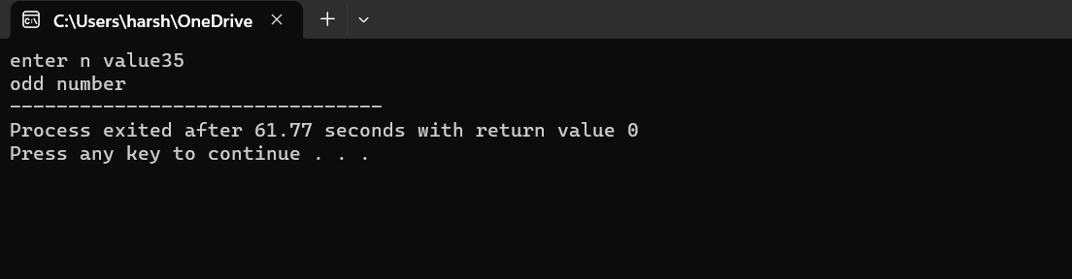

**2. SUM OF FIRST N NUMBERS**

#include<stdio.h>

int main()

{

int n,i,s=0;

printf("enter n value");

scanf("%d",&n);

for(i=1;i<=n;i++)

s=s+i;

printf("sum=%d",s);

}

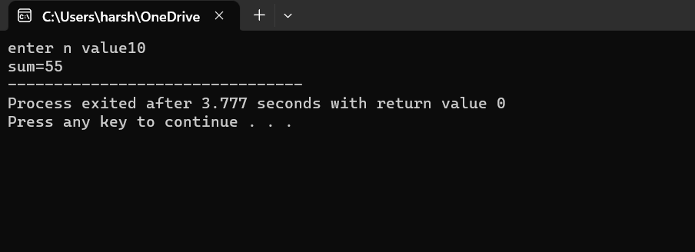

**3.EVEN NUMBERS SUM IN FIRST N NATURAL NUMBERS**

#include<stdio.h>

int main()

{

int n,i,s=0;

printf("enter n value");

scanf("%d",&n);

for(i=1;i<=n;i++)

{

if(i%2==0)

s=s+i;

}

printf("sum=%d",s);

}

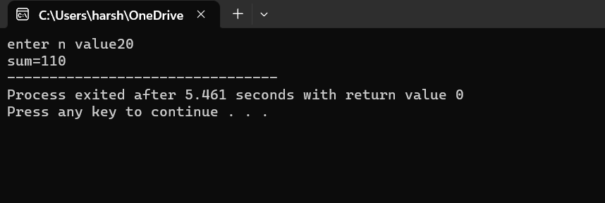

**4.ODD NUMBERS SUM IN FIRST N NUMBERS**

#include<stdio.h>

int main()

{

int n,i,s=0;

printf("enter n value");

scanf("%d",&n);

for(i=1;i<=n;i++)

{

if(i%2==1)

s=s+i;

}

printf("sum=%d",s);

}

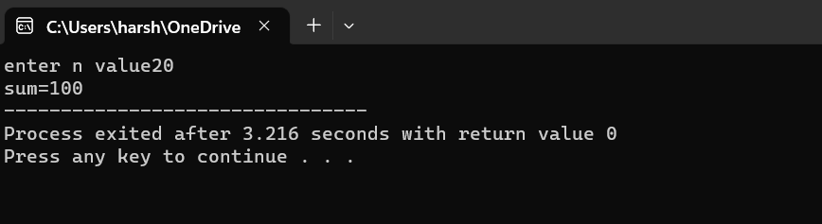

**5.FACTORIAL WITHOUT USING RECURSION**

#include<stdio.h>

int main()

{

int n,i,f=1;

printf("enter n value");

scanf("%d",&n);

for(i=1;i<=n;i++)

{

f=f*i;

}

printf("factorial=%d",f);

}

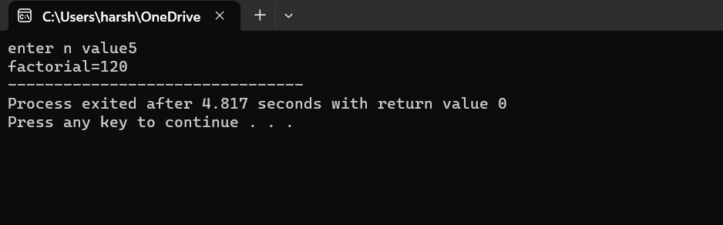

**6.FACTORIAL USING RECURSIONS**

#include<stdio.h>

int fact(int);

int main()

{

int f,n;

printf("enter n value");

scanf("%d",&n);

f=fact(n);

printf("factorial=%d",f);

return 0;

}

int fact(int n)

{

if(n==1)

return 1;

else

return n*fact(n-1);

}

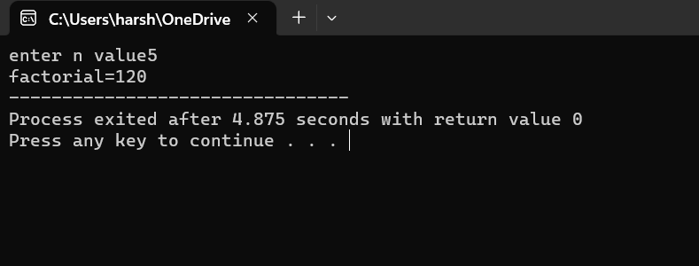

**7.FIBONACCI SERIES**

#include<stdio.h>

int fact(int);

int main()

{

int a=0,b=1,c,n,t;

printf("enter no of terms");

scanf("%d",&n);

printf("%d\n%d\n",a,b);

t=3;

while(t<=n)

{

c=a+b;

printf("%d\n",c);

a=b;

b=c;

t++;

}

}

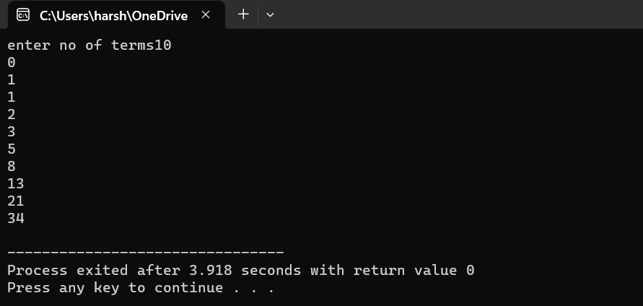

**8. FIBONACCI SERIES USING RECURSIONS**

#include<stdio.h>

int fib(int);

int main()

{

int n,f,i;

printf("enter no of terms ");

scanf("%d",&n);

for(i=0;i<n;i++)

{

f=fib(i);

printf("\n%d",f);

}

}

int fib(int n)

{

if(n==0)

return 0;

if(n==1)

return 1;

else

return (fib(n-1)+fib(n-2));

}



**9.ARMSTRONG NUMBER**

#include<stdio.h>

int main()

{

int n,r,s=0,x;

printf("enter a number ");

scanf("%d",&n);

x=n;

while(n>0)

{

r=n%10;

s=s+r*r*r;

n=n/10;

}

if(s==x)

printf("armstrong number ");

else

printf("not armstrong number");

return 0;

}

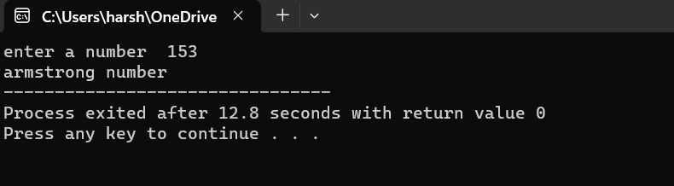

**10.REVERSE A NUMBER**

#include<stdio.h>

int main()

{

int n,r,s=0,x;

printf("enter a number ");

scanf("%d",&n);

x=n;

while(n>0)

{

r=n%10;

s=s*10+r;

n=n/10;

}

printf("reverse number =%d",s);

return 0;

}

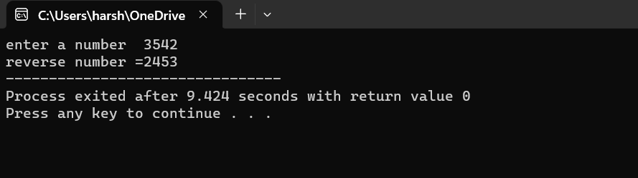

**11.PALINDROME NUMBER**

#include<stdio.h>

int main()

{

int n,r,s=0,x;

printf("enter a number ");

scanf("%d",&n);

x=n;

while(n>0)

{

r=n%10;

s=s*10+r;

n=n/10;

}

if(x==s)

printf("palindrome number");

else

printf("not palindrome number");

return 0;

}

