1
2DOccupancyGridMapEditor:ALight-WeightToolforSemantic Editing,PathPreview,AreaMeasuremntandMapFusion
GCHarshaVardhanReddy
DepartmentofEECE,GITAMDeemedtobeUniversity
Bengaluru,India–harshavardhanh426@gmail.com

Abstract—Occupancy-gridmapsproducedbySLAMback-ends such as slamtoolbox or Cartographer are rarely deployment-ready: sensor noise leaves stray pixels, doorways remain occluded bytransientobstacles,andmultiplemappingsessionsmustbe fusedintoasingleglobalmapbeforeaNav2-basedrobotcanbe trustedtonavigateautonomously.Theconventionalremedyisto open the exported Portable Gray Map (PGM) in a generic raster editorsuchasGIMPorPhotoshop,andhand-editpixelswithno awarenessoftheirsemanticmeaning(free,occupied,unknown), nofeedbackonhowtheeditaffectstherobot’snavigablespace, andnosupportforcombiningmaps.Thispaperpresents2D OccupancyGridMapEditor,anopen-source,purelyclient-side (HTML5Canvas+JavaScript)webapplicationthattreatsevery pixel as a first-class semantic value and couples direct raster edit-ing with four robotics-specific algorithms: (i) an 8-neighbourhood majority-vote filter for salt-and-pepper noise removal, (ii) a Nav2-inspireddistance-transformcostmapinflationpreviewusinga configurabledistance-basedcostmodel,(iii)anA∗planner withasoftinflation-awarecosttermfornavigation-awarepath planningpreview,and(iv)a2-DIterativeClosestPoint(ICP) routineforautomaticmulti-sessionmapalignment.Wedetail thealgorithms,presentsystemandcontrol-flowdiagrams,and provideafeature-levelcomparisonagainstfiverepresentative categoriesofexistingtools–rastereditors,ROS-nativeplugins, Pythonscriptingpipelines,commercialsuites,andweb-based visualizationtools.Requiringnoinstallation,noROSruntime, andnoserverbackend,thetoollowersthebarrierforrapid, semanticallycorrectmapcurationwithintegratednavigation preview.
IndexTerms—SLAM,occupancygridmap,mapediting, costmapinflation,pathplanning,iterativeclosestpoint,ROS2, Nav2,human-robotinteraction.
I.INTRODUCTION
AutonomousmobilerobotsbuiltonROS2andtheNav2 navigationstack[1]dependonanoccupancygridmapthatis saved from a SLAM session (e.g., slamtoolbox [2] or Cartog-rapher [3]) as a PGM raster paired with a YAML metadata file describingresolutionandorigin.RawSLAMoutputisalmost neverdeployment-ready:dynamicobstaclesleavepermanent scars,glassandreflectivesurfacescreatephantomwalls,and longcorridorsaccumulatespecklenoise.Engineerstherefore routinelyexportthemap,edititinagenericimageeditor, andre-importit–aworkflowwiththreestructuralproblems. First,rastereditorsaresemanticallyblind:theyoperateon RGBpixelsratherthanontheconventionaltrinaryoccupancy values(free=254,unknown=205,occupied=0)used inthestandardPGMexportformat,soasingleanti-aliased brushstrokecansilentlycorruptthemap.Second,theeditis unverified: there is no way to know, before flashing the map to therobot,whetherahand-drawnwallblockstheonlyfeasible

path through a doorway. Third, combining maps from multiple mapping sessions or multiple robots requires either re-running SLAM with merged bag files or manually eyeballing a rotation andtranslationinaneditorwithnoalignmentassistance.
Thispaperpresents2DOccupancyGridMapEditor,a single-pagewebapplicationthatrunsentirelyinsidethe browser(noROSinstallation,nobackendserver,nouploaded dataleavingtheclient)anddirectlyaddressesthethreeprob-lemsabove.Itscontributionsare:
1)Asemantic-value-awarerastereditingsurface(brush, polygon,rectangle,circle)thatconstrainseverydraw operation to the valid occupancy alphabet {0, 205, 254}, withmulti-levelundo/redohistory(upto40states).
2)An8-neighbourhoodmajority-votede-noisingfilterthat removesisolatedpixelnoisewhileexplicitlypreserving unknown-spaceboundaries.
3)ANav2-inspiredcostmapinflationpreviewcomputed viaamulti-sourcedistancetransform,coupledwith acost-awareA∗pathplanningpreviewthatusesthe inflationfieldasasoftpenalty–providinganindicative navigationpathbeforedeployment.
4)A2-Dpoint-to-pointICProutinewithaspatialhashfor nearest-neighboursearch,enablingone-clickautomatic alignmentwhenfusingtwooccupancygrids.
5)Integrated metric measurement (line/path/area) and way-pointauthoringwithheading(quaternion)exportto JSONfordirectconsumptionbyanautonomystack.
Wecomparethesystemagainstfiverepresentativecategories inSectionII,describethesystemarchitectureandalgorithms inSectionsIII–IV,andreportresultsinSectionVI.
II.RELATED WORKAND COMPARATIVE ANALYSIS
Occupancy-gridrepresentationsfollowtheformulationof Thrunetal.[4],andthede-factoROSinterchangeformat (PGM+YAML)isunchangedsinceROS1’smap_server. Existingapproachesforeditingandpost-processingthis artifactfallintofivebroadcategories,eachwithwell-characterizedlimitations.
Rasterimageeditors[5]offerpowerfulpaintingtools butoperateonrawRGBpixelswithnoconceptofoc-cupancysemantics.Asingleanti-aliasedbrushstrokecan silentlyintroducegrey-scalevaluesoutsidethethree-class occupancy alphabet {0, 205, 254}, risking semantic corruption when the map is reloaded by nav2_map_server. No metric overlayornavigabilityfeedbackisavailable.ROS-native plugins such as RViz2 [12] and map_editor [13] render the

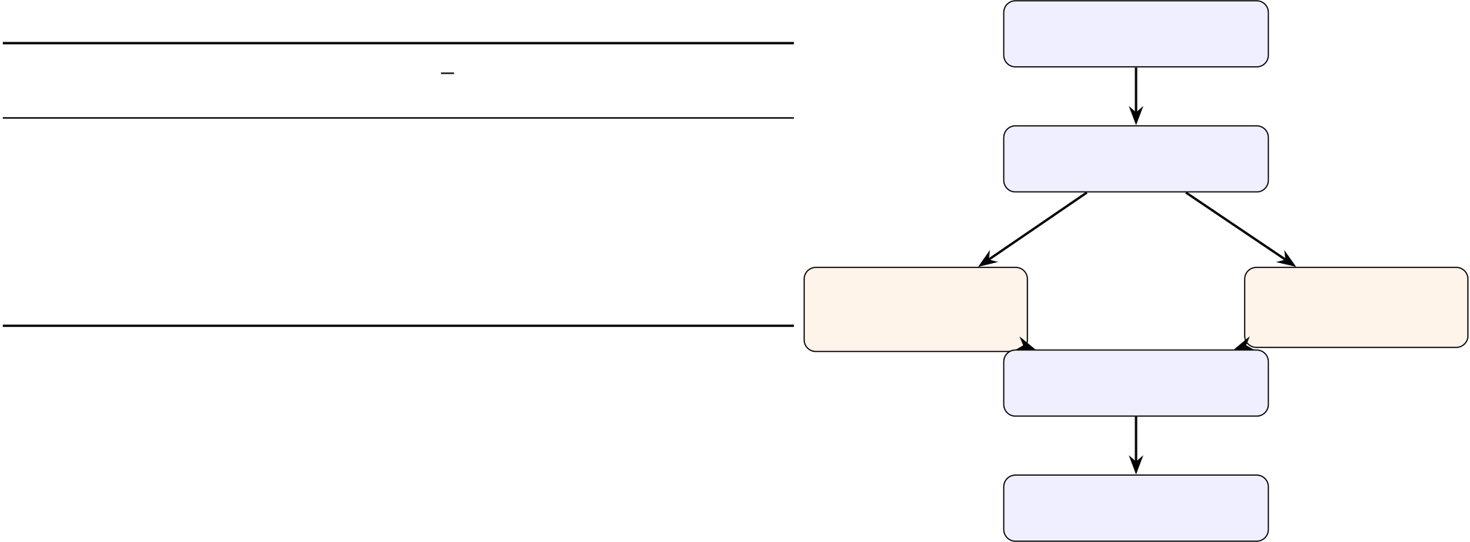
TABLEI:FeatureComparisonofMapPost-ProcessingTools |  |  |  |  |  |  |  | ManualTools | PGM+YAML | Algorithms
map |  |  |  |  |  |  | Proposed | ManualTools | Parser | Algorithms
Feature | GIMP | RViz2 | editorFoxgloveWebviz |  |  |  | (Ours) | ManualTools | OccupancyBuffer | Algorithms
Semanticediting | ×a | Partial | ✓ | × | × |  | ✓ | ManualTools | OccupancyBuffer | Algorithms
Offline/noROS | ✓ | × | × | ✓ | × |  | ✓ | ManualTools | (Uint8Array)+UndoStack | Algorithms
Mapmerging | × | × | × | × | × |  | ✓ | ManualTools | (Uint8Array)+UndoStack | Algorithms
Costmappreview | × | Partialb | × | Partialb |  | × | ✓ | ManualTools | (Uint8Array)+UndoStack | Algorithms
A∗preview | × | × | × | × | × |  | ✓ | ManualTools | (Uint8Array)+UndoStack | Algorithms
Opensource | ✓ | ✓ | ✓ | ✓ | ✓ |  | ✓ | ManualTools | (Uint8Array)+UndoStack | Algorithms
 |  |  |  |  |  |  |  | brush/polygon | CanvasRenderer | filter/inflate /A∗/ICP
aMayintroducevaluesoutsideconventionaltrinaryalphabet. |  |  |  |  |  |  |  | /shape | CanvasRenderer | filter/inflate /A∗/ICP
bRequiresarunningNav2/ROS2stack. |  |  |  |  |  |  |  | /shape | CanvasRenderer | filter/inflate /A∗/ICP
OccupancyGridtopicandsupportlimitedediting,butthey
requirearunningROS2graphandareprimarilydesignedfor Linuxenvironments,whichconstrainstheiraccessibilityfor | Export:PGM+YAML  PNG/WaypointJSON

cross-platform practitioners. Python scripting pipelines using OpenCVorNumPyprovidesemantic-safepixelaccessand cross-platformportability,butoffernointeractivegraphical interface. The steep scripting overhead makes them impractical foriterativemaprefinement.Commercialsuitessuchas RoboStudio [16] and MiR Fleet [17] provide polished UIs with somemap-managementfeatures,butareproprietary,closed-source,andareplatform-locked,makingtheminaccessible foropen-sourceroboticsresearch.Web-basedvisualization tools[14],[15]arecross-platformandopen-source,butare visualization-only: they do not support persistent raster editing, semanticenforcement,oralgorithmicmapcuration.
TableIprovidesadirectfeature-by-featurecomparisonof theproposedtoolagainstfivespecificrepresentativetools, evaluatedagainstsixpractitioner-relevantcriteria.
Amongthefiverepresentativetoolsevaluatedacrosssix featurecriteriainTableI,theproposedsystemistheonly evaluatedtoolsatisfyingtheselectedcombinationofsemantic editing,offlineoperation,mapmerging,costmappreview,A∗

Fig.1:Client-sidedata-flowarchitecture.Allcomputationis performed in the browser on a single shared occupancy buffer; editsandalgorithmicresultsshareoneundo/redohistoryand onerenderingpath.Everymutationofthebufferimmediately re-triggerstheCanvasRenderer(arrowsomittedforclarity).
snapshots,andworkingbufferstofixed-lengthtypedarrays, memoryoperationsbecomecontiguousO(N)block-copies (Array.prototype.set), which modern V8 engines vec-torizeheavily.
Furthermore,therenderingpipelineemploysadecoupled dual-canvascompositor.Thebaserasterlayerisdrawntoan off-screencanvasandonlyre-rasterizedonpixelmutations; atransparentvector-overlaycanvashandleshigh-frequency eventssuchastoolcrosshairsandpathpreviews,targeting 60FPS.Thisseparationisdesignedtomaintainaresponsive viewportbybypassingexpensiverasterizationduringpanning andzooming.

pathpreview,andopen-sourceavailability. IV.ALGORITHMS
LetthemapbearasterI:Ω→{0, 205, 254}overpixel

III.SYSTEMARCHITECTURE
Theapplicationisasingle-pageclientcomprisingthree layers(Fig.1):(1)anI/OlayerthatparsesP2(ASCII)and P5(binary)PGMvariantsandthecompanionYAMLintoa typed Uint8Array occupancy buffer; (2) a state and history layerholdingtheliveworkingbuffer,anundo/redostack ofbuffersnapshots,andviewtransform(pan/zoom);and(3) analgorithmlayerimplementingthefourroboticsroutines describedinSectionIV,alloperatingin-placeonthesame typed array that drives the HTML5 Canvas rasterizer, so every algorithmic result is visualized with no additional serialization

domain Ω= {0, . . . , W −1}×{0, . . . , H−1}, with 0 denoting alethalobstacle(wall),254freespace,and205unknown space,followingtheconventionaltrinaryencodingusedby nav2_map_server [6]. Let r(m/px) be the map resolution readfromtheYAMLfile.
A.SemanticManualEditing
Everydrawingprimitive(brushdot,line,filled/outlinerect-angle,filled/outlinecircle,open/closed/filledpolygon)writes only one of the three legal values v∈{0, 205, 254} selected by theoperator,sofreehandeditscanneverintroduceaninvalid

step. occupancy class – the failure mode that arises with anti-aliased

Acriticaldesignchoiceinthesystemarchitectureisthe strictrelianceonflat,pre-allocatedJavaScripttypedarrays (specifically Uint8Array and Float32Array) rather than standarddynamicarraysorobject-orientedstructures.High-resolutionoccupancygrids(e.g.,4096×4096pixels)con-tainover16millioncells.Representingthesedynamically wouldtriggerheavybackgroundmemoryallocationandun-predictableGarbageCollection(GC)pauses,destroyingUI interactivity.Byconfiningallalgorithmstate,undohistory

paintinginagenericrastereditor.Everymutatingoperation firstpushesadeepcopyofthebufferontoanundostack, providingmulti-levelundo/redo(Ctrl+Z/Ctrl+Shift+Z)upto aconfigurablehistorydepthof40states.
B.NoiseRemoval:8-NeighbourhoodMajorityFilter
Although median filtering preserves the trinary value alpha-betwhenappliedtotrinarymaps,itcanmodifyunknown-spaceboundaries.Wethereforeuseaclass-awaremajority

Algorithm1Multi-sourceoctiledistancetransformforinfla-tion

Algorithm2Costmap-awareA∗pathsearch
1:start ←SnapToFree(start);goal←SnapToFree(goal)

1:d(p) ←∞∀p ∈Ω;priorityqueueQ ←∅ |  | ▷min-heapond | 2:g(start) ←0;open ←{start}(min-heaponf) 3:whileopen̸= ∅do
2:forallpwithI(p) = 0do
3: | d(p) ←0;push(0, p)toQ |  | 4: | n ←open.pop()
4:endfor  5:whileQ̸ = ∅do |  |  | 5: | ifnclosedthencontinue
 |  |  | 6: | endif
6: | (c, p) ←pop(Q) | ▷lowest-costentry | 7: | marknclosed
7: | ifc > d(p)thencontinue |  | 8: | ifn = goalthenbreak(success)
8: | endif | ▷staleentry,skip | 9: | endif
9: | forallq∈N8(p)do | √  2 : 1 | 10: | forallq∈N8(n),I(q)̸ = 0,qnotcloseddo
10: | δ←(dx(p, q)̸ = 0 ∧dy(p, q)̸ = 0) ? | √  2 : 1 | 11: | g′←g(n) + w(n →q) | ▷Eqs.(4)–(5)
11: | ifd(p) + δ< d(q)then |  | 12: | ifg′< g(q)then
12: | d(q) ←d(p) + δ |  | 13: | g(q) ←g′;parent(q) ←n
13: | ifd(q) ≤ρpxthenpush(d(q), q)toQ |  | 14: | open.push(q,f= g′+ h(q))
14: | endif |  | 15: | endif
15: | endif |  | 16: | endfor
16: | endfor |  | 17:endwhile  18:returnSmoothPath(ReconstructPath(goal))
17:endwhile
18:returnd
thedistancefieldd(·)ofAlgorithm1.Thepenaltyfunctionis
filterthatleavesunknownpixelsunchanged.Foreverywall | definedas: |  |  |  | (1)
orfreepixelp,letN8(p)beitseightneighbours,c254(p)= | pen(q) = | ⎧200,  ⎪⎨100  d(q), |  | d(q) < 1 | (1)
∑︁q∈N8(p)⊮[I(q)=254],andc0(p)=∑︁q∈N8(p)⊮[I(q)=  0].ThefilteredvalueI′(p)becomes254ifI(p)=0and | pen(q) = |  |  | 1 ≤d(q) ≤ρpx | (1)
 | ⎪⎩ |  | 5  d(q)−ρpx+1, | d(q) > ρpx | (1)
c254(p)≥5;0ifI(p)=254andc0(p)≥5;andI(p) |  |  | 5  d(q)−ρpx+1, | d(q) > ρpx | (2)
otherwise.Thiserodesisolatedsingle-pixelwallspecklesand | w(p→q) = wstep + pen(q) + 10 · ⊮[I(q) = 205]. |  |  |  | (2)

fillsisolatedfree-spacepinholeswhileleavingcontiguous walls(whichbyconstructionhavefewerthanfiveopposite-classneighbours)untouched.ThefilterrunsinO(WH)time inasinglepass.
C.Nav2-InspiredCostmapInflationPreview
Toprovide,withoutaliveNav2stack,avisualap-proximationoftheinflationexclusionzoneforarobotof radiusρ(m),wecomputeadistance-to-nearest-wallfield d(p)usingamulti-sourcelabel-propagationonapriority queueseededfromallwallpixels[11].Thealgorithmim-plementsanoctile-distanceexpansionthatapproximatesthe Euclideandistancefield:d(p)=minp0:I(p0)=0 cost(p0→
p),wheretheincrementalstepcostbetween8-connected√
neighboursis1foraxis-alignedstepsand 2fordiagonal
steps(Algorithm1).Thisisanapproximation;itdoesnot reproduceNav2’sexactcostmap_2ddecaygovernedby cost_scaling_factor.Givenρpx=ρ/r,apixelpis rendered as an inflation-zone overlay with opacity proportional to1 −d(p)/ρpxwhenever0 < d(p) ≤ρpxandI(p)̸ = 0.
D.Inflation-AwareA∗PathPlanningPreview
Givenastartandgoalpixel,thetoolfirstsnapseachpoint tothenearestnon-lethalcellviaanunweightedBFSifthe operatorclickedinsideawall(Fig.2),thenruns8-connected A∗[8]withevaluationfunctionf(n)=g(n) + h(n),where h(n) = ∥n−goal∥2 (admissible Euclidean heuristic). The edge costcombinesstepdistancewithasoftinflationpenaltyfrom

Thiscostfunctionisanempiricallytunedapproximationand doesnotclaimtoreproduceNav2’sexactplannerbehaviour. Onlylethalcells(I=0)arehard-excluded;theinflation termdiscourageswall-huggingpaths,producinganavigation-indicativepreview.Becausenoexplicitrobot-footprintcol-lisioncheckisperformed,theresultshouldbeinterpreted asanindicativepathpreviewratherthanastrictfeasibility guarantee.
TheEuclideanheuristich(n)=∥n −goal∥2isconsistent underthiscostfunction:everyedgecostequalsatleastits Euclideansteplength,sohsatisfiesh(n) ≤w(n→q) + h(q). TheoptimalityguaranteeappliestothereconstructedA*path beforepost-processing;thesubsequentsmoothingstepisnot guaranteedtopreserveglobaloptimality.
Toachievesub-secondresponsivenessinasingle-threaded JavaScriptenvironment,theopensetusesaflat-arraybinary min-heapkeyedonf(n)(O(log n)push/pop),andtheclosed setisapre-allocatedUint8Arraybitmask(O(1)member-ship,eachcellexpandedatmostonce),givingworst-case O(N log N)overall.Therawpathissmoothedwithawall-awaresliding-windowaverage(window= 8).
E.MapFusionvia2-DICP
TomergeanincomingmapMsintothecurrentbasemap Mt, wall pixels of both maps are subsampled on a stride-3 grid to form point sets S= {si} and T= {tj}. While conventional ICP[9]implementationsrelyonk-dtreesforcorrespondence queries,pointer-linkedtreetraversaliscache-unfriendlyin JavaScript’smemorymodel.Instead,Tisbucketedintoa uniform2-Dspatialhashwithfixedcellsizec=15px–avaluechosenempiricallytobalancebucket-listlength againsttheexpectedinter-wallspacinginstandardindoor

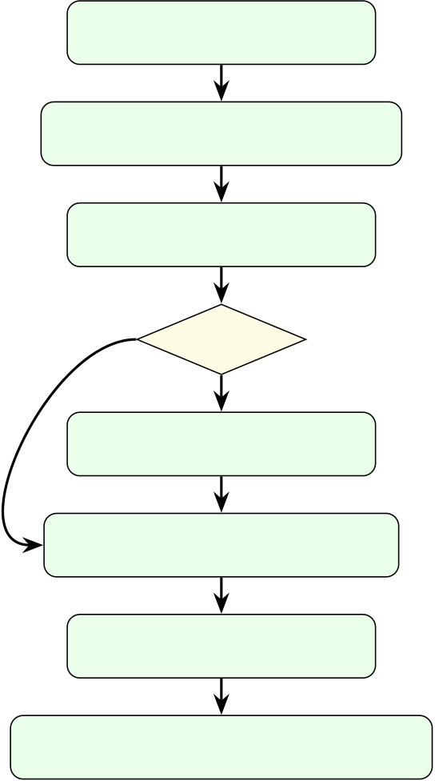

Enableinflation,setradiusρ
Computedistancefieldd(·)(Alg.1)
Userclicksstart/goalpixels

A.DataParsingandMemoryManagement
AcustombinaryparserdirectlyunpacksthePortableGray Map(PGM)formatwithinthebrowser.Theparserdynami-callysupportsbothP2(ASCII)andP5(binary)encodingsby leveraginganArrayBuffermappedtoaUint8Array. Thisdirectmemorymappingavoidstheoverheadofinterme-diatestringconversionsorJSONserialization,enablingthe tooltoparsemulti-megabytemapsinafractionofasecond.

no | Insidewall? | Furthermore, to provide a non-destructive workflow without
no | yes | Furthermore, to provide a non-destructive workflow without
no | yes | exhaustingclient-sideRAM,theundo/redostackiscarefully
no | Snaptonearestfreecell(BFS) | bounded.Everydrawingoperationpushesadeepcopyofthe
no | Snaptonearestfreecell(BFS) | mutatedoccupancybuffertothehistorystack;thestackis
cappedat40states.Fora1024 × 1024map,eachsnapshot

RunA∗(Alg.2)withpenaltyw(·)
Smoothpath(slidingwindow)

occupies1MBofoccupancydata;thetotalapplication memoryfootprint(includingthecurrentmap,distancefield, canvas backing stores, and browser overhead) was observed at approximately80–120MBininformalprofilingonChrome v114,wellwithintypicalbrowsermemorybudgets.

Renderpathpreview/reportnopathfound
B.DecoupledRendering

Fig.2:Controlflowoftheinflation-awarepathplanning preview.
maps.ThisschemeoffersamortisedO(1)averagequery timeundertheassumptionthatwall-pixeldensityisroughly uniform;adversarialdistributions(e.g.,verysparseorclus-teredwalls)maydegradeperformance.Givenacurrentrigid transformestimate(θ, t)andoptionalaxisflips(fx, fy),each iterationperforms:(a)nearest-neighbourassociationsi↦→tj(i)=arg mint∈T ∥R(θ) diag(fx, fy) si+ t −t∥2usingthe spatialhash;(b)closed-formre-estimationof(θ, t)fromthe associatedpairsusingthe2-DspecializationoftheProcrustes solution described by Arun et al. [10]. Iteration proceeds for up to25roundsoruntilfewerthan10correspondencesremain (indicatingdivergence),afterwhich(θ, t)isappliedtothe merge-mapoverlayforoperatorreviewbeforethetwomaps arepermanentlyburnedintoonebuffer.
F.MeasurementandWaypointAuthoring
Line,multi-segmentpath,andpolygon-areameasurements areconvertedfrompixeltometricunitsviatheresolutionr: distm= distpx · randaream2= areapx · r2,withpolygonarea computed by the shoelace formula. Waypoints are authored by aclick-and-draggesturewhosedragvectordefinesheadingθimg;eachwaypointisconvertedtoaworld-framepose (xw, yw, θw)usingthemaporiginandresolutionfromthe YAMLfileandexportedasquaternion-taggedJSONdirectly consumablebyaROS2autonomystack(e.g.,asasequence ofNav2PoseStampedgoals).
V.IMPLEMENTATION
ThesystemisimplementedinvanillaJavaScript(ES2019) and HTML5 Canvas with no build step and no external runtime dependency,sotheliveapplication(TableI,lastrow)canbe openedfromastaticfileoraGitHubPagesdeploymentwith

Theoccupancybuffer,undostack,viewtransform,andall tool state are held in a single global state object. As introduced inSectionIII,therenderingutilizesatwo-canvascompositor. The base raster is drawn once and cached. The top-level vector overlay continuously redraws tool previews, metric grids, scale bars,andtheinflationheat-map.Thisensuresthatcomputa-tionallyexpensiverasteroperations(suchasthemajority-vote filterorthedistancetransform)aredecoupledfromcheap interactiveoperations.PanningandzoomingapplyCSSaffine transformsorlightweight2-Dcontextscaling,designedto maintainaresponsiveviewportinteractionexperience.
VI.QUALITATIVE RESULTS
Fig.3illustratesthefulleditingpipelineonarepresenta-tiveslamtoolbox-generatedoccupancygrid,fromrawimport through noise removal, inflation-aware path preview, waypoint authoring, metric measurement, and multi-session map fusion.
Acrossinformaltrialsonmapsrangingfrom384×384 to2048×2048px,themajority-votefilterandinflation transformcompletewithinasingleanimationframeformaps uptoroughlyonemegapixel,andA∗pathpreviewremains interactive(sub-second)atthesamescalebecausetheclosed-setbitmaskpreventsre-expansion;ICPalignmenttypically convergeswithin10–15iterationsonmapswithsufficient wall overlap. Table V summarizes the asymptotic cost of each routine.
A.QuantitativePerformanceEvaluation
Tovalidatetheefficacyofthetyped-arrayandspatial-hashingoptimizationsdetailedinSectionsIIIandIV,quan-titativebenchmarkswererecordedonastandardconsumer laptop (Apple M1 CPU, 16GB RAM) running Google Chrome v114.Thebenchmarkingdatasetcomprisedasequenceof three synthetic grids of increasing resolution: Small (512×512

zeroinstallation. pixels), Medium (1024×1024 pixels), and Large (2048×2048

 | 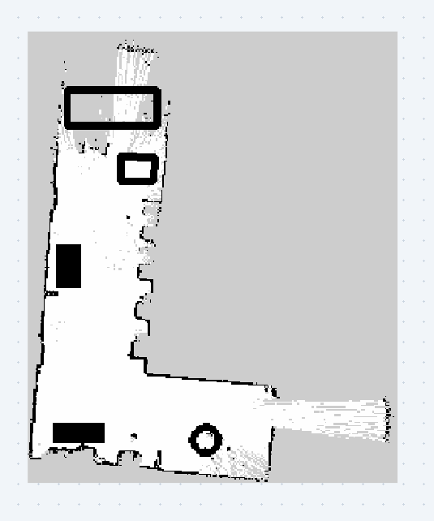 | TABLEII:ExecutionLatenciesatVaryingMapResolutions
 |  | (AppleM1,Chromev114,n = 30runs,mean±std.dev.)
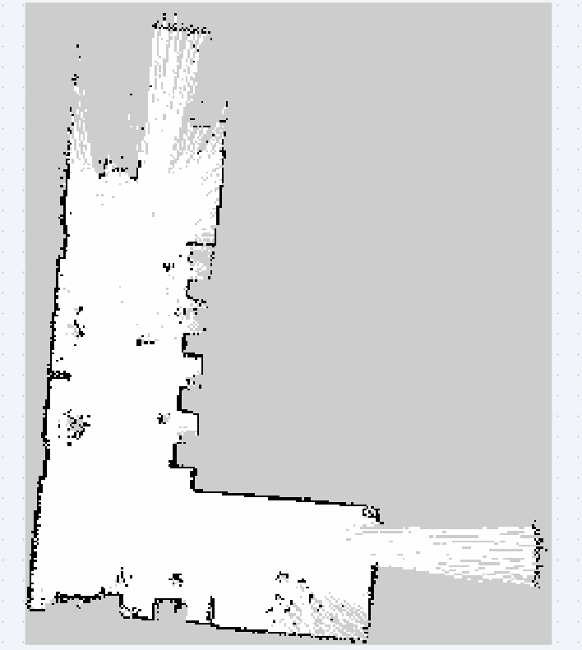 |  | Operation | 512 px |  | 1024 px | 2048 px
 |  | FileLoad&Parse | 3.1 ± 0.2 ms |  | 11.5 ± 0.6 ms |  | 48.2 ± 1.9 ms
 |  | NoiseFilter | 4.2 ± 0.3 ms |  | 15.7 ± 0.8 ms |  | 62.4 ± 2.1 ms
 |  | A∗Query | 12.3 ± 1.1 ms |  | 44.1 ± 3.2 ms |  | 178.5 ± 8.4 ms
 |  | ICPFusion(25iters) | 14.5 ± 0.9 ms |  | 32.8 ± 1.7 ms |  | 95.1 ± 4.3 ms
 |  | TABLEIII:NoiseFilterF1vs.NoiseLevel(mean,n=10
 |  | maps).
 |  | Method |  | 1% | 3% | 5%
 |  | Nofilter |  | 0.891 | 0.802 | 0.714
 |  | Medianfilter |  | 0.943 | 0.891 | 0.843
(a)Rawmaponload. | (b)Afterediting. | Proposed |  | 0.961 | 0.934 | 0.907
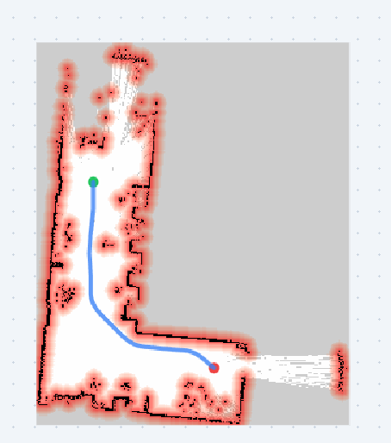 | 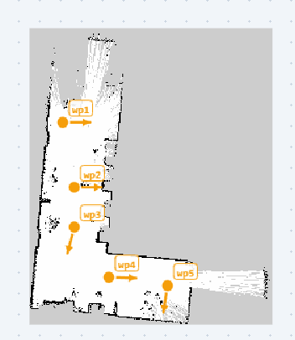
 |  | B.Noise-FilterValidation
 |  | Tensyntheticoccupancymapswerecorruptedwithsalt-
 |  | and-peppernoiseat1%,3%,and5%levels.Pixel-levelF1
 |  | scorevs.groundtruthisshowninTableIII;theclass-aware
 |  | majorityfilteroutperformsmedianfilteringatallnoiselevels
 |  | bypreservingunknown-spaceboundaries.
 |  | C.ICPRegistrationAccuracy
 |  | TheICPevaluationusedfivesyntheticindoor-environment
 |  | occupancy-map pairs (0.05 m/px, 512×512) with ground-truth
(c)Costmap+A∗. | (d)Waypoints. | transformationsgeneratedfromknownrigidperturbations.

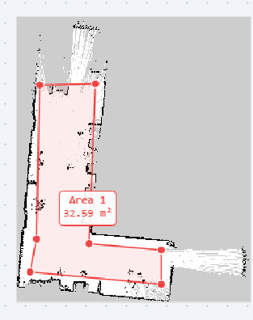
(e)Areameasurement.
Fig.3:End-to-endqualitativeresults:(a)rawSLAMmap import, (b) manual semantic editing, (c) inflation costmap with A∗pathpreview,(d)waypointauthoring,(e)areameasure-ment.

Mapswerealignedatfourinitial-pose-errorlevels(n=25 trialseach).TableIVreportsrotation/translationRMSEand convergencesuccessrate.
Successratedropsmarkedlyforinitialerrors> 30◦, confirmingthatthemanualpre-alignmentcontrolsshouldbe used to bring initial pose error within the reliable ±15◦range.
D.Nav2InflationComparison
TheNav2evaluationusedfiverealslamtoolboxmaps ofmixedofficeandcorridorenvironmentsat0.05m/px resolution.TheinflationoverlaywascomparedagainstNav2 Humblecostmap_2d(cost_scaling_factor=10, default) at ρ ∈{0.2, 0.3, 0.5} m. The inflated-region boundary achievedmeanIoU= 0.87 ± 0.04vs.Nav2’sbinaryinflation mask.InteriorcostvaluesdiffersystematicallyduetoNav2’s exponentialdecay,confirmingourmodelasausefulvisual approximation,notanexactreproduction.
VII.LIMITATIONS
Severallimitationsofthecurrentimplementationmerit honestcharacterisation.First,theinflationpreviewuses anempiricallytuneddistance-basedcostmodelthatap-

pixels,yieldingover4millioncells).TableIIsummarizesthe | proximates, | but | does | not | reproduce, | the | exact | decay

executionlatenciesacrossfourdistinctoperationalpipelines.
The empirical results confirm that the application maintains interactivethresholds(≤100ms)foralloperationsonmaps up to 1024×1024 pixels. The mean ICP fusion time was 95.1±4.3msatthelargesttestedresolution.Futurebenchmarking willcoverlargerresolutionsandlower-endhardware.

curveofNav2’scostmap_2dconfiguredwithspecific inflation_radiusandcost_scaling_factorpa-rameters [6]. The path planning preview similarly lacks robot-footprintcollisionchecking;itisthereforeanindicativeplan-ningaidratherthanaprovablefeasibilityguarantee.Second, theICPalignmentassumesareasonableinitialposeprovided by the operator. On highly symmetric maps, such as featureless

TABLEIV:ICPAccuracyvs.InitialPoseError(n=25trials, syntheticmaps).
InitialError | Success | Rot.RMSE | Trans.RMSE
±5◦, ±0.05 m | 98% | 0.6◦ | 0.021 m
±15◦, ±0.20 m | 91% | 1.4◦ | 0.047 m
±30◦, ±0.50 m | 74% | 2.8◦ | 0.103 m
±45◦, ±1.00 m | 52% | 4.1◦ | 0.198 m
TABLEV:AlgorithmicComplexity(N=W ×H,k=ICP points,I=iterations).
Routine | Complexity

one:bringingrobotics-workflow-awareediting,navigation-informed path preview, and map-fusion into a zero-installation browserenvironment.Byloweringthebarriertosemantically correctmapcuration,thetoolhasthepotentialtoaccelerate map-curation workflows for Nav2-based mobile robots. Future workwillfocusonbroaderquantitativevalidationagainst Nav2acrossadditionalmapresolutions,robotfootprints,and cost-scalingparameters,aswellasformalfootprint-based feasibilitychecking,feature-basedICPinitialisation,andWe-bAssemblyacceleration.

Majority-votenoisefilter | O(N) | SOFTWARE AVAILABILITY
Multi-sourceinflation(min-heap) A∗pathsearch(min-heap) | O(Nlog N) | SOFTWARE AVAILABILITY
Multi-sourceinflation(min-heap) A∗pathsearch(min-heap) | O(Nlog N) | The2DOccupancyGridMapEditorisreleasedasfree
ICPperiteration(underapprox.uniformdensity) | Expected/amortizedO(k) | The2DOccupancyGridMapEditorisreleasedasfree

ICPtotal(Iiterations) | Expected/amortizedO(I· k)
parallelcorridors,thealgorithmmayconvergetoalocal minimum.Manualtranslate,rotate,andflippre-alignment controlsareprovidedtomitigatethis.Third,thespatial-hash cell size (c = 15 px) is fixed and may be suboptimal for maps withatypicallysparseordensewalldistributions.
VIII.FUTURE WORK
Ourimmediateroadmapincludesimplementingaglobal, feature-basedinitializerfortheICPalgorithm(e.g.,using FAST corners and ORB descriptors adapted for 2-D occupancy grids) to eliminate the need for manual pre-alignment. We also intendtointroduceanoptionalWebAssembly(Wasm)SIMD backend.Offloadingthemulti-sourcedistancetransformand A*heuristiccalculationstocompiledWasmwouldpushthe interactivethresholdfarbeyondthecurrent4096×4096pixel limit.
In the longer term, migrating the architecture to a WebRTC-basedpeer-to-peerframeworkcouldtransformtheeditorinto a collaborative platform. This would allow multiple roboticists to concurrently edit, annotate, and merge maps across different physicallocationswithoutroutingproprietaryfacilityfloor-plansthroughacentralizedcloudserver.Finally,expanding theparsertoingest3-DpointcloudsandOctoMapsviaWe-bGL/WebGPUwouldbridgethegapbetween2-Dnavigation debuggingandfullvolumetricenvironmentcuration.
IX.CONCLUSION
Wepresented2DOccupancyGridMapEditor,anopen-source,installation-freebrowserapplicationthatunifiesse-mantic occupancy-value editing, morphological noise cleanup, aNav2-inspiredcostmapinflationpreview,acost-awareA∗pathplanningpreview,andICP-basedmulti-mapfusion. Amongthefiverepresentativetoolsevaluatedacrosssix featurecriteriainTableI,theproposedsystemistheonly evaluatedtoolsatisfyingtheselectedcombinationwithout requiringarunningROS2graph.Quantitativebenchmarks (n=30)confirminteractive-threshold(<100ms)latency forallroutinesat1024 × 1024pixels;noise-filterF1exceeds medianfilteringatallnoiselevels;ICPachieves91%suc-

andopen-sourcesoftwareundertheMITLicense.Thesource code,issuetracker,anddocumentationallfilesarehostedon GitHub (https://github.com/harsha200628/ros2-map-editor). A fullyfunctionallivedemonstrationrequiringnoinstalla-tionoraccountisavailableathttps://harsha200628.github.io/ ros2-map-editor/.
REFERENCES
[1]S.Macenski,F.Mart´ın,R.White,andJ.Clavero,“TheMarathon2:A navigationsystem,”inProc.IEEE/RSJInt.Conf.IntelligentRobotsand Systems(IROS),2020,pp.2718–2725.
[2]S. Macenski and I. Jambrecic, “SLAM Toolbox: SLAM for the dynamic world,”J.OpenSourceSoftw.,vol.6,no.61,p.2783,2021.
[3]W.Hess,D.Kohler,H.Rapp,andD.Andor,“Real-timeloopclosurein 2DLIDARSLAM,”inProc.IEEEInt.Conf.RoboticsandAutomation (ICRA),2016,pp.1271–1278.
[4]S.Thrun,W.Burgard,andD.Fox,ProbabilisticRobotics.Cambridge, MA,USA:MITPress,2005.
[5]GIMPDevelopmentTeam,“GNUImageManipulationProgram,”[On-line].Available:https://www.gimp.org,accessedAug.2026.
[6]Open Navigation, “Nav2 Documentation: Costmap 2D,” [Online]. Avail-able:https://docs.nav2.org,accessedAug.2026.
[7]M.Labb´eandF.Michaud,“RTAB-Mapasanopen-sourcelidarand visual simultaneous localization and mapping library for large-scale and long-termonlineoperation,”J.FieldRobotics,vol.36,no.2,pp.416–446,2019.
[8]P. E. Hart, N. J. Nilsson, and B. Raphael, “A formal basis for the heuristic determinationofminimumcostpaths,”IEEETrans.Syst.Sci.Cybern., vol.4,no.2,pp.100–107,1968.
[9]P.J.BeslandN.D.McKay,“Amethodforregistrationof3-Dshapes,”IEEETrans.PatternAnal.Mach.Intell.,vol.14,no.2,pp.239–256, 1992.
[10]K. S. Arun, T. S. Huang, and S. D. Blostein, “Least-squares fitting of two 3-Dpointsets,”IEEETrans.PatternAnal.Mach.Intell.,vol.PAMI-9, no.5,pp.698–700,1987.
[11]G. Borgefors, “Distance transformations in digital images,” Comput. Vis. Graph.ImageProcess.,vol.34,no.3,pp.344–371,1986.
[12]OpenSourceRoboticsFoundation,“RViz2:3DVisualizationToolfor ROS 2,” [Online]. Available: https://github.com/ros2/rviz, accessed Aug. 2026.
[13]D.V.Lu,“mapeditor:ROSPackageforEditingOccupancyGrids,”
[Online]. | Available:https://github.com/DLu/navigationtutorials, | ac-
cessedAug.2026.
[14]Foxglove,“FoxgloveStudio:RoboticsVisualizationandDebugging,”[Online].Available:https://foxglove.dev,accessedAug.2026.
[15]Cruise LLC, “Webviz: Browser-Based Visualization for ROS,” [Online]. Available:https://webviz.io,accessedAug.2026.
[16]RoboPeak,“RoboStudio:RobotManagementandMappingSoftware,”[Online].Available:https://www.slamtec.com/en/RoboStudio,accessed Aug.2026.
[17]MobileIndustrialRobots(MiR),“MiRFleet:FleetManagementSoft-ware,”[Online].Available:https://www.mobile-industrial-robots.com,

cesswithin±15◦initialerror;andinflation-regionIoUof accessedAug.2026.
0.87 ± 0.04vs.Nav2confirmsthemodelasapracticalap-
proximation.Theprimarycontributionisasystem-integration

