AP Computer Science Principles
1.1.9 – Art and Algorithms: Turtle Race Game
Harsha Malipeddi

Purpose: Simulate a race between multiple turtles with randomness and competition
The start of the race
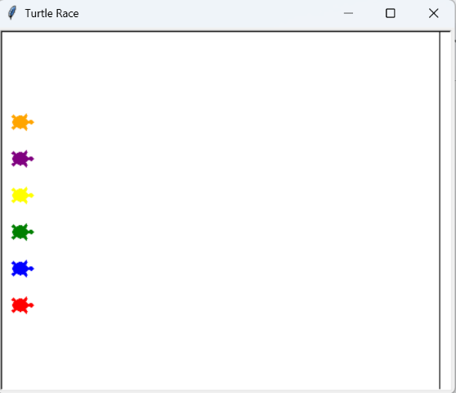
The six turtles (orange, purple, yellow, green, blue, red) are lined up at the starting position facing right.

Middle of the Race
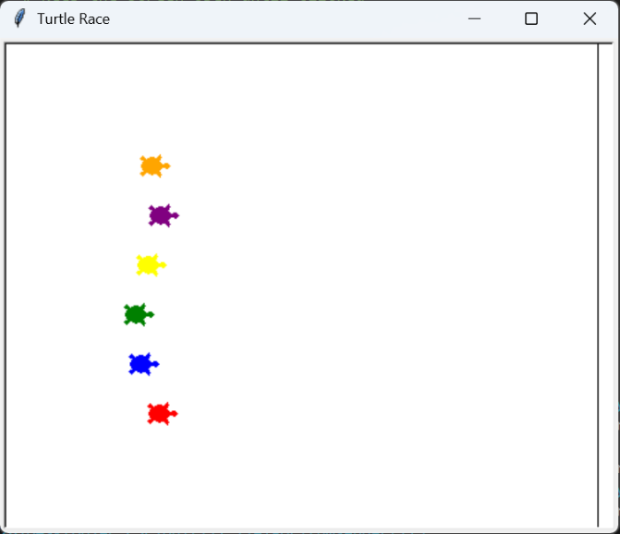
The turtles are racing at different speeds and positions, and they are competing to the finish line.

End of the race
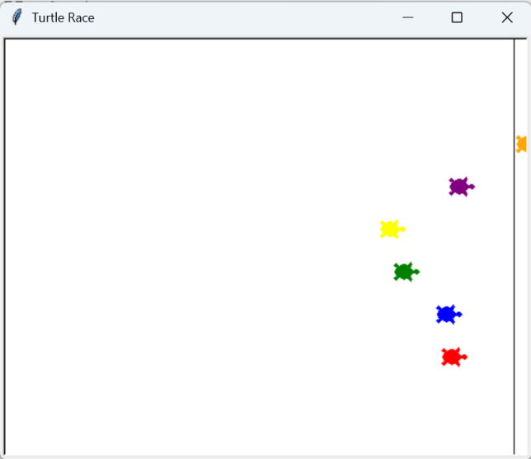
One turtle has won the race, and other turtles lost the race.

# List of colors for the turtles
colors = ["red", "blue", "green", "yellow", "purple", "orange"]
The colors list stores the initial data with the available colors for the turtles.

# List to store all the created turtle objects
all_turtles = []

# Create, position, and color turtles
for index in range(6):
new_turtle = turtle.Turtle(shape="turtle")
new_turtle.color(colors[index])
new_turtle.penup()
new_turtle.goto(x=-230, y=y_positions[index])
all_turtles.append(new_turtle)

The all_turtles list stores the created turtle objects themselves. A for loop is used to iterate through the colors list, create each turtle object, set its attributes, and append it to the all_turtles list.

while is_race_on:
for turtle in all_turtles:
# Check if any turtle has crossed the finish line
if turtle.xcor() >= 230:
is_race_on = False
winning_color = turtle.pencolor()
print(f"The winner is the {winning_color} turtle!")

# Move each turtle forward by a random distance
rand_distance = random.randint(0, 10)
turtle.forward(rand_distance)
The if statement checks a turtle’s current x coordinate against the finish line position (230). If the condition is true, then the loop breaks, a winner is declared and a program is altered.

