1. Log into the laptop
2. Click the Windows button
3. Type in “Python”
4. If you do not see this or something similar: 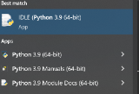 let Mr. Peggs know. We need to install python on your computer. If the python version is something different than 3.9 i think we will be ok! We are going to give it a try and if doesnt work, we will get the tech guy in here to fix it.
5. Click the Windows Button again
6. Type in “visual studio”
7. Click on the icon for Visual Studio Code 
8. Click the Extension Button in VS Code 
9. In the search bar, type in “python”
10. Click install on this one: 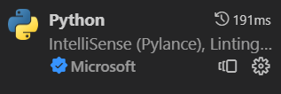
11. May take a few minutes to install
12. You may need to make adjustments to setting like Dark Mode or something along those lines. Make whatever adjustments or setting preferences you like, it doesnt matter to me. You can also click “mark as done” on a lot of the stuff that pops up and it wont have a big affect on everything.
13. Minimize the VS Code Window

CS2, follow the same directions below but change the name of the folder to CSP, create a Unit 1 folder, etc. Instead of Hello World, create a file and code called Hello Liberty!

1. On the Desktop of the Laptop, create a CSE Folder
   1. Right click anywhere on the desktop
   2. Click New Folder
   3. Name it CSE
2. Go into this new folder called CSE and create a new folder called Unit 3
3. Inside of your Unit 3 folder create a folder called 3.1
   1. This should be inside of a Unit 3 Folder
   2. So on your desktop make sure you have a CSE Folder, inside of that folder have a Unit 3 Folder, inside of that folder have a 3.1 Folder
4. In Visual Studio Code, click the following
   1. File>Open Folder>Desktop>CSE>Unit 3>3.1>Select Folder
      1. This will make sure anything you create will save inside of your 3.1 folder….this is called file management and it is essential to VS Code
5. Your VS Code Screen should now look like this:
   1. 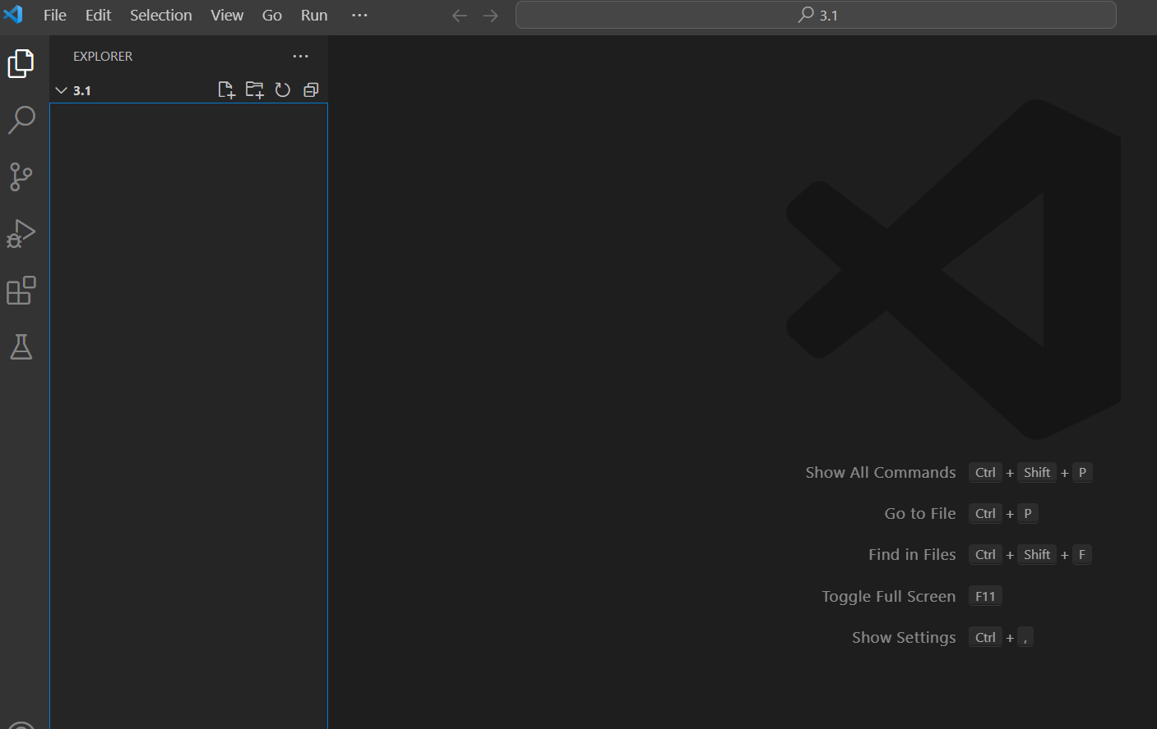
6. Click File>New File>Select Python (you may have to type in python)
7. On line 1 type in print(“hello world”)
   1. 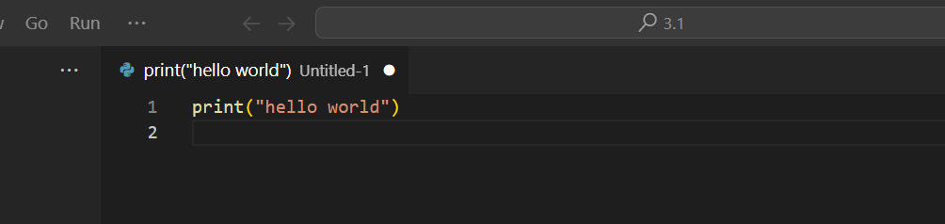
8. Notice the white dot next to the Untitled-1, this means the file is not saved. To save it Click File>Save As
9. Name the file hello
10. Click Save
    1. Your save window should look like this exactly:
       1. 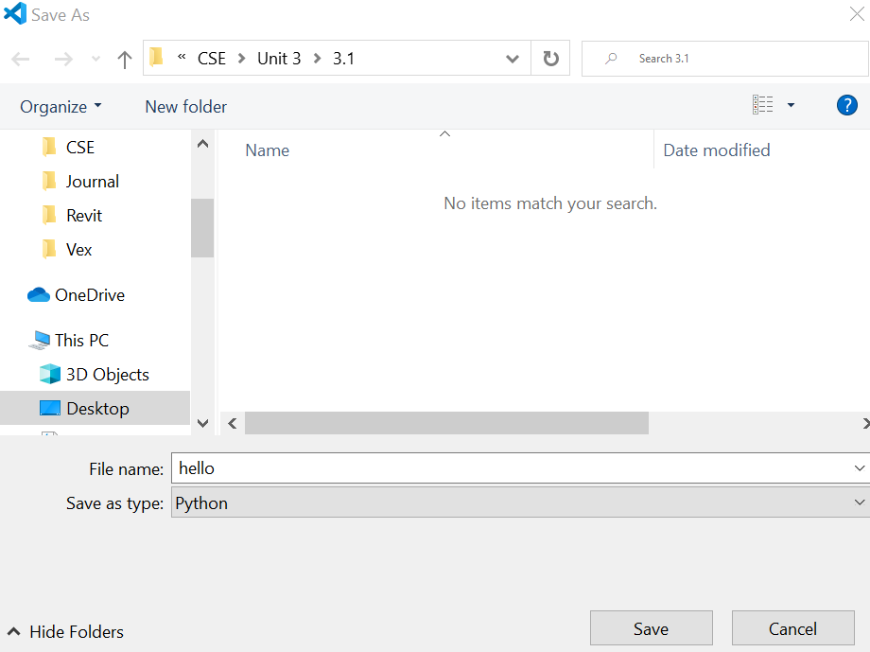
11. Click the Run Button in the top right corner: 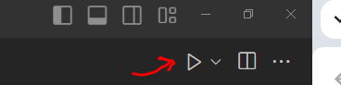
12. The bottom screen/output screen should pop up if it wasnt already visible and look like this:
    1. 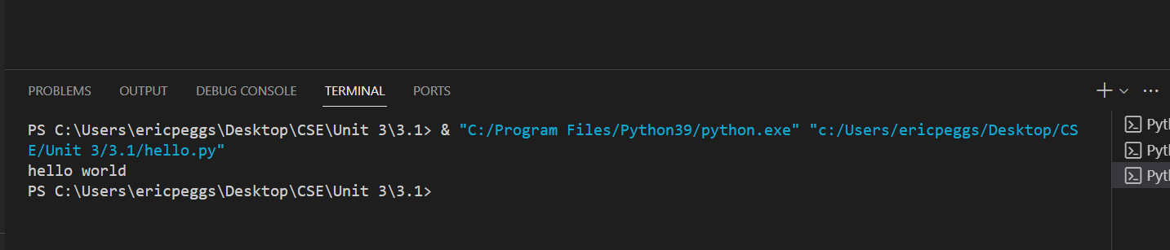
13. If the bottom screen/output screen/terminal isnt displayed simply click the Terminal Tab at the top of the window and click New Terminal. You may need to Run the program again.
14. Take a screenshot that looks like the one in number 23. Put it on a google doc and submit it to the module for setting up VS Code. Here is what I am looking for:
    1. C:\Users\YOURNAME\Desktop\CSE\Unit 3\3.1
    2. Hello world

