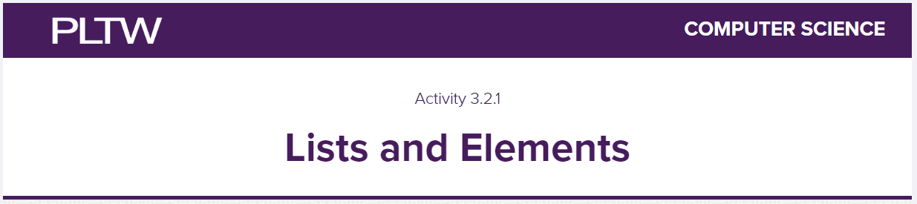

| List Object | A collection of data values that do not have to be the same type |
| --- | --- |
| Element | A single entry of a list. It can be different datatypes |
| 0 | ←–where does indexing start in python….what value |
| [] | ←—what syntax or punctuation to create a list |

FYI, beginning through #14 can all be done using the “trinkets” or code platform provided on MYPLTW. Just take screenshots of it with your name as a #firstnamelastname

# Accessing Elements of a List

1. How many elements are in each list?

| string_list | 4 |
| --- | --- |
| int_list | 6 |
| float_list | 3 |
| boolean_list | 5 |
| mixed_list | 4 |
| empty_list | 0 |

2. Add Print Statements to the code so you can see the list contents that will be returned. Also in your code, put in a #firstnamelastname so i know it is your work

| Screenshot here: |
| --- |

| How many of each type of data are in mixed_list = [ ] | 4 elements - 2 string, 1 list, 1 integer |
| --- | --- |

| index | A specific location by order for an individual element in a list |
| --- | --- |

1. Simply hit Run, then read through the code to understand it. This is indexing at its best! VERY VERY Important! Now read through the other parts where it asks you how to access the second and third elements of the list. This is great quiz material
2. And 7) What is one reason programmers use lists?

| 6. |
| --- |
| 7. Give me a screenshot of the code + #firstnamelastname in the code    Reason: to put values in a string, integer, float, boolean, or a list inside the square brackets in a category |

8) Can you access an element that is not on the list?

| No, It will show an IndexError which says index out of range. |
| --- |

9) Why do you think a negative index value works, but a number greater than the or equal to the size of the list does not?

| A negative index can access the last elements inside the list but a number greater than or equal to the size of the list does not because It shows an IndexError. |
| --- |

# 

# Boolean Operators and Lists

Still using code from number 7-9

10) Look at the code and add it to program from 7-9 to make it print off that the business does not carry sundaes. Show me that code here:

|  |
| --- |

10 again and thru 13)

Add #firstnamelastname so i know the code is yours

|  |
| --- |

# Lists Have Behaviors

| classes | A template for creating objects |
| --- | --- |
| methods | Functions that belong to a specific class |
| append(x) | Add item x to the end of the list |
| remove(x) | Remove the first occurrence of item x from the list |

14) In the code provided in #14, which line of code (give me a number) is appending something to customer_order list?

| customer_order.append(item) - line 3 |
| --- |

Which line of code is removing an item from the customer_order list?

| customer_order.remove(item) - line 11 |
| --- |

15) Time to make a copy of your code from 3.1.3.

Open your combomenu.py document inside of VSC. Now, click File>Save As>rename it to 3.2.1 Combo Menu.

16-19) you will now modify your code to incorporate lists! I want you to use OPTION 2 that is explained inside of MYPLTW.

Give me screenshots below with #comments to tell me what changes you made

|  |
| --- |