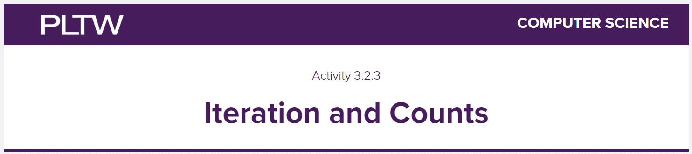

## For Loops and Practicing Syntax

| iteration | A process of repeating a set of instructions until a condition is met or a specific number of times. |
| --- | --- |
| For loops | A control flow statement that allows a set of instructions to be executed repeatedly. |
| While loops | A control flow statement that is a repeating if statement. |

The first line contains:

* The keyword for
* A variable identifier post to use for referencing elements
* The keyword in
* A variable containing a list
* The : character showing the rest of the loop will be on the next indented line

1. Prediction:

| 0  1  2 |
| --- |

1. Were you correct?

| Yes |
| --- |

1. Prediction

| 3 |
| --- |

1. Were you correct?

| Yes |
| --- |

Use # comments to explain what is happening on each line of code in Number 3, give me a screenshot of it here. Also, give me a #firstnamelastname in there as well

|  |
| --- |

## Range and List Functions

| Range function | A function that identifies a starting number, ending number, and how much to change by each time when the program executes the loop. |
| --- | --- |

7. Replace the argument replace_with_numbers with the arguments listed below. Try these examples one at a time, or by commenting out previous range functions after you have run them:

| range(7) | [0,1,2,3,4,5,6] |
| --- | --- |
| range(1,8) | [1,2,3,4,5,6,7] |
| range(0,40,5) | [0,5,10,15,20,25,30,35] |
| range(0,16,3) | [0,3,6,9,12,15] |
| range(0,-10,-2) | [0,-2,-4,-6,-8] |
| range(0) | [ ] |
| range(1,0) | [ ] |

8.Review the ranges in the code block and record your expectations for the outputs along with a brief explanation of why you think it will produce the lists you predict.

| range | expectation | why |
| --- | --- | --- |
| range(5) | Output will be [0,1,2,3,4] | In python the list starts at an index 0 so it will print the values in a list from 0 to 4. |
| range(2, 5) | Output will be [2,3,4] | The values will print in a list starting from 2 to 4. |
| range(5, 1,-1) | Output will be [5,4,3,2] | The list will count backwards from 5 to 2. |
| range(1, 5, -1) | Output will be [ ] | The list will be blank. |

## Combining the For Loop and the Range Function

10. What does inclusive mean?

| It should print all the numbers |
| --- |

| Outcome | Code(screenshots are fine here) |
| --- | --- |
| 1 to 19 inclusive |  |
| 20 to 1 inclusive |  |
| Evens 2 to 10 inclusive |  |
| Odds 9 to 1 inclusive |  |

## While Loops

| While loops | A control flow statement that checks for a condition and continues the loop as long as the condition is true. |
| --- | --- |

Record information about a while loop, what is it? What the syntax is, when it might be used, etc.

| Syntax:  while (conditional expression with a variable):  # what you want to happen  # change the variable for the condition |
| --- |

Run the code provided for while(x<11): in this section so you can understand what is happening in the While Loop.

## 

## Modulo Operator in Loops

| modulo | A math operation that performs division but returns a remainder |
| --- | --- |

11) What would this code section do and how do you know?

| While the variable x is less than 11, it prints the initial x value first then it adds up by 1 each time x is printed in the output.  Here is the output:  0  1  2  3  4  5  6  7  8  9  10 |
| --- |

12) Create and test while loops that print each of the following:

* Numbers from 1 up to 5 inclusive
* Numbers from 10 down to 1 inclusive
* Even numbers from 2 to 10 inclusive
* Odd numbers from 9 down to 1 inclusive; use the modulo operator and a conditional

| Screenshot of your code and it working here. Please include #firstnamelastname somewhere |
| --- |

## Combo Menu with Loops

13-14 Give me a screenshot of where you changed things with your code here, I do not need to check this off, just show me where you made changes:

|  |
| --- |