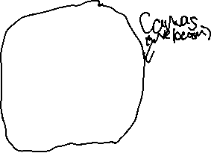

The webcam which is the canvas element is made by a teachable machine model. In the teachable machine model, we collected our datasets from Kaggle (a source where you search for datasets) then fed the datasets for each feature then trained the model and while training the model the weights get adjusted. After that we exported the model and after exporting the model, the model is embedded with HTML and JavaScript code. The first dropdown is for changing the pose to show a different picture. The second dropdown is for changing the language to display the feedback subtitles. The progress bars will show you the score the pose whether you’re doing the pose correctly or not. That’s how the app works. You can share your website or app on Facebook or twitter for people who are interested in learning Bharatanatyam classical dance, or you can connect with other dancers.