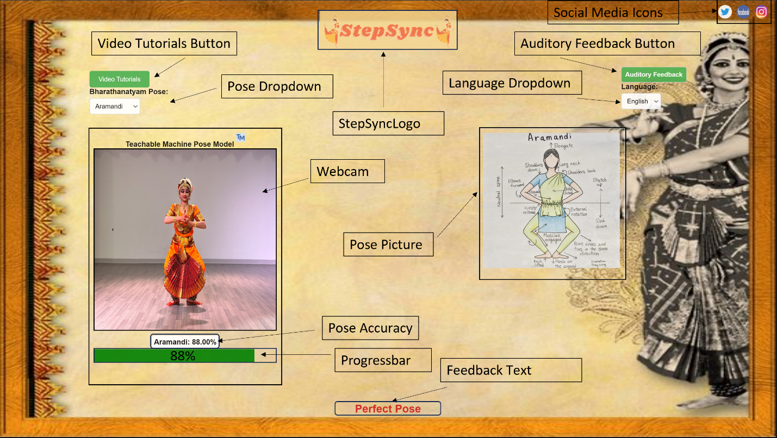

The webcam which is the canvas element is sourced from the teachable machine model.

Teachable Machine Model Steps–

1. Collected datasets from Kaggle or captured datasets from our team members.
2. Fed datasets into each feature by categorizing them.
3. Training the model! While the model is training the weights get adjusted
4. Exported the model into a google teachable machine model (Next Slide ⏭️)

The progress bar is for whether the user is doing the pose accurately or not. The first dropdown menu is for changing the posture. The second dropdown menu is to change the language of the feedback subtitles. Auditory feedback is for the user to listen to the feedback instead of reading the feedback subtitles. The video tutorials are for the user to learn dance postures and dance steps. The social media links are for the user to share their application with other dancers.

Teachable Machine Pose Model ----

* **Teachable Machine Pose Model**

Application File --- [demo\StepSyncHome.html](demo/StepSyncHome.html)