**RELAY**

A relay is an [electrically](http://en.wikipedia.org/wiki/Electric) operated [switch](http://en.wikipedia.org/wiki/Switch). Many relays use an electromagnet to operate a switching mechanism mechanically, but other operating principles are also used. Relays are used where it is necessary to control a circuit by a low-power signal (with complete electrical isolation between control and controlled circuits), or where several circuits must be controlled by one signal.

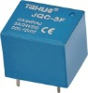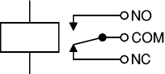 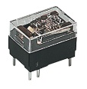 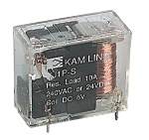

A relay is an electrically operated switch. Current flowing through the coil of the relay creates a magnetic field which attracts a lever and changes the switch contacts. The coil current can be on or off so relays have two switch positions and most have double throw (changeover) switch contacts as shown in the diagram.



Fig 4.8 Relay showing coil and switch contacts

Relays allow one circuit to switch a second circuit which can be completely separate from the first. For example a low voltage battery circuit can use a relay to switch a 230V AC mains circuit. There is no electrical connection inside the relay between the two circuits; the link is magnetic and mechanical.

The coil of a relay passes a relatively large current, typically 30mA for a 12V relay, but it can be as much as 100mA for relays designed to operate from lower voltages. Most ICs (chips) cannot provide this current and a [transistor](http://www.kpsec.freeuk.com/trancirc.htm#ic) is usually used to amplify the small IC current to the larger value required for the relay coil. The maximum output current for the popular 555 timer IC is 200mA so these devices can supply relay coils directly without amplification.

Relays are usually SPDT or DPDT but they can have many more sets of switch contacts, for example relays with 4 sets of changeover contacts are readily available. For further information about switch contacts and the terms used to describe them please see the page on [switches](http://www.kpsec.freeuk.com/components/switch.htm).

Most relays are designed for PCB mounting but you can solder wires directly to the pins providing you take care to avoid melting the plastic case of the relay.

The supplier's catalogue should show you the relay's connections. The coil will be obvious and it may be connected either way round. Relay coils produce brief high voltage 'spikes' when they are switched off and this can destroy transistors and ICs in the circuit. To prevent damage you must connect a [protection diode](http://www.kpsec.freeuk.com/components/relay.htm#protect) across the relay coil.

The figure shows a relay with its coil and switch contacts. You can see a lever on the left being attracted by magnetism when the coil is switched on. This lever moves the switch contacts.

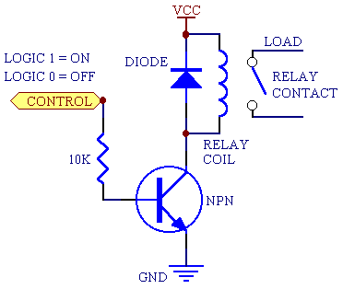

There is one set of contacts (SPDT) in the foreground and another behind them, making the relay DPDT.

The relay's switch connections are usually labelled COM, NC and NO:

* COM = Common, always connect to this; it is the moving part of the switch.
* NC = Normally Closed, COM is connected to this when the relay coil is off.
* NO = Normally Open, COM is connected to this when the relay coil is on.

**Applications of relays**

Relays are used to and for:

* Control a high-voltage circuit with a low-voltage signal, as in some types of modems or audio amplifiers.
* Control a high-current circuit with a low-current signal, as in the starter solenoid of an automobile.
* Detect and isolate faults on transmission and distribution lines by opening and closing circuit breakers.
* Time delay functions. Relays can be modified to delay opening or delay closing a set of contacts. A very short (a fraction of a second) delay would use a copper disk between the armature and moving blade assembly. Current flowing in the disk maintains magnetic field for a short time, lengthening release time. For a slightly longer (up to a minute) delay, a dashpot is used. A dashpot is a piston filled with fluid that is allowed to escape slowly. The time period can be varied by increasing or decreasing the flow rate. For longer time periods, a mechanical clockwork timer is installed.