Transformer
A transformer makes use of Faraday's law and the ferromagnetic properties of an iron core to efficiently raise or lower AC voltages. It of course cannot increase power so that if the voltage is raised, the current is proportionally lowered and vice versa.
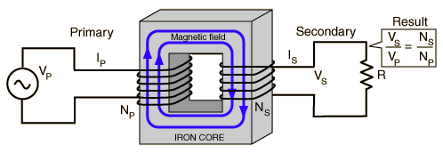

Transformer and Faraday's Law
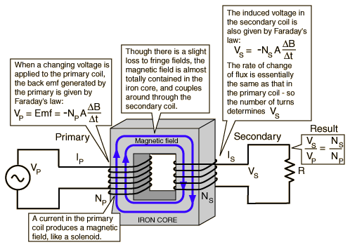

TRANSFORMER CONCEPTS
