S R K R CODING CLUB

HACKOVERFLOW-2k23

Date(s): 19-10-2023 & 20-10-2023
Venue: Technology Center, SRKR Engineering College
Guests: Dr.M.Jagapathi Raju (DIRECTOR ,SRKREC),
Dr.K.V.Murali Krishnam Raju (PRINCIPAL ,SRKREC), Dr.V.ChandraSekhar (HOD CSE, SRKREC),
Dr.Bh.V.S.R.K.Raju (HOD IT, SRKREC)
Anchor(s): Mr. S Siva Gopal Varma

No. of Participants: 132
Description:
HackOverflow-2K23, a college-level hackathon conducted by SRKR Coding Club under the Training and Placement Cell of SRKR Engineering College, in association with the Department of CSE, transcends traditional coding competitions.
Students from diverse disciplines showcased their coding skills, collaborated with like-minded individuals, and contributed to innovative solutions. The event witnessed an impressive turnout, with enthusiastic participation from 1st-year students who added a vibrant energy to the hackathon.
All participants, regardless of the branch or year, received well-deserved participation certificates in acknowledgment of their dedication and valuable contributions. In a special effort to encourage 1st-year participants, consolidation prizes were awarded. Additionally, the top-performing teams, those securing the first, second, and third places, were recognized with prizes, celebrating their outstanding achievements and innovative solutions.
HackOverflow-2K23 exemplifies the commitment of SRKR Coding Club to providing a diverse and inclusive platform that not only challenges participants but also celebrates their accomplishments across disciplines.

S R K R CODING CLUB
Glimpse of the Gallery

Title Announcement:
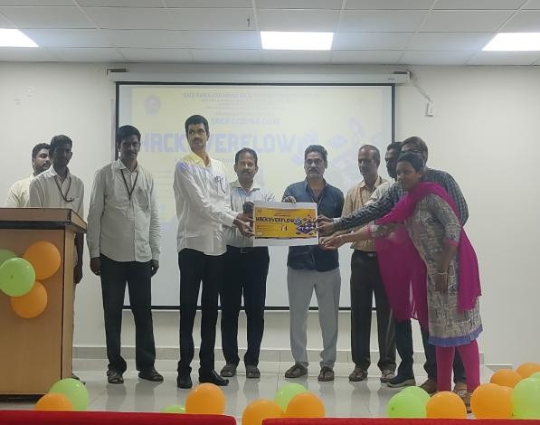
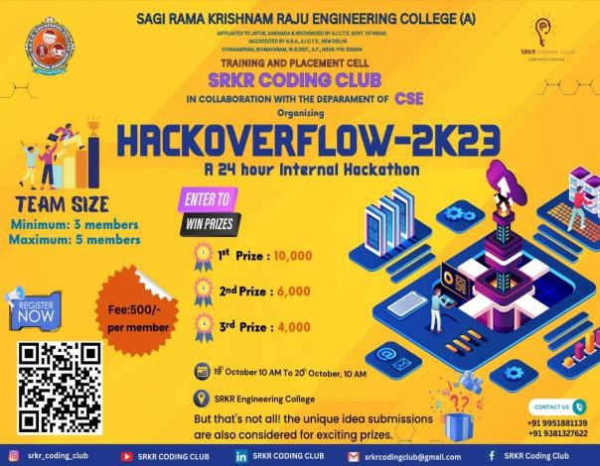

In our inauguration event, our esteemed guests and Principal Dr.K.V.Murali Krishnam Raju unveil the poster for our very first event, "HackOverflow." Their support and enthusiasm for this upcoming hackathon are a testament to our commitment to fostering innovation and problem-solving within our Coding Club.

HackOverflow Unveiled: Flashmob Magic with Cine Club:
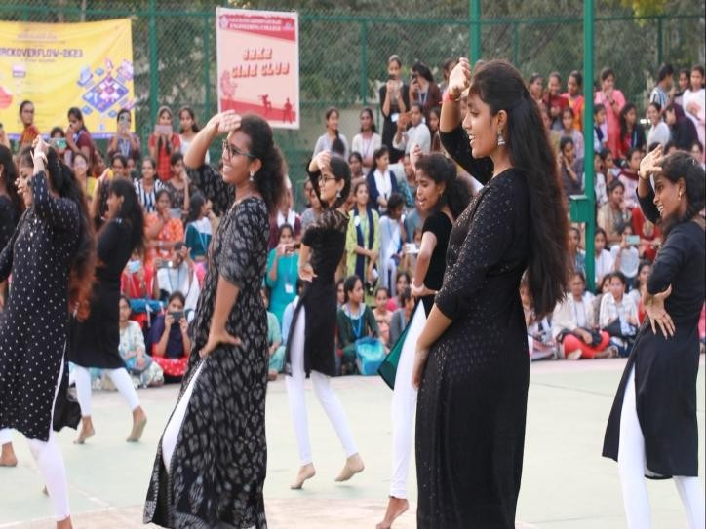

Creating a storm of excitement and awareness, we organized a dynamic flashmob to promote HackOverflow. Collaborating with the Cine Club and garnering support from the CSE Department, our hackathon's buzz reached new heights. The fusion of creativity, cinematic flair, and technological enthusiasm set the stage for an unforgettable promotion, igniting curiosity among students about the coding adventure that awaits at HackOverflow!

S R K R CODING CLUB

Participants Registering for HackOverflow-2K23:
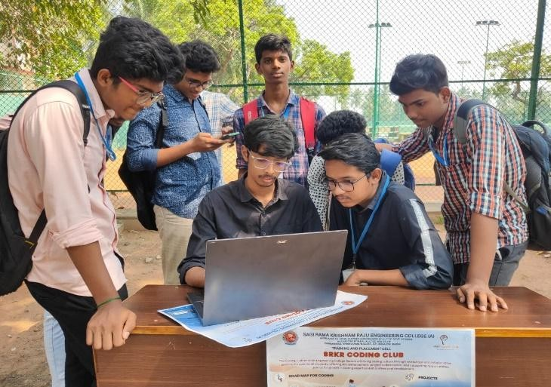
- Jyothi Prajwalan:
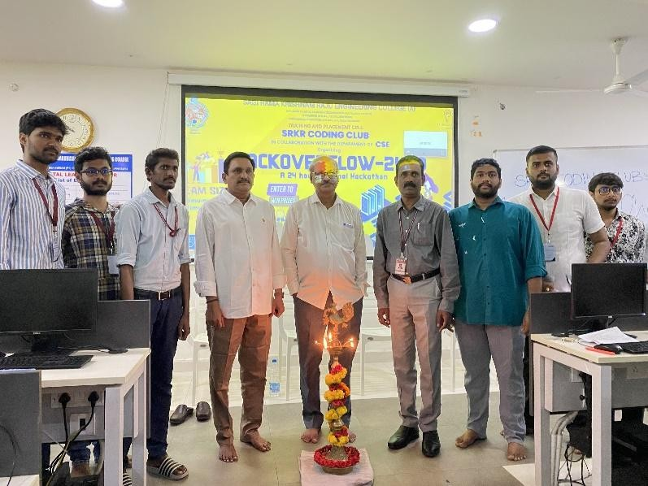

Witnessing a moment of grace and inspiration as Director Dr.M.Jagapathi Raju ignites Jyothi Prajwalan, symbolizing the dawn of knowledge and innovation at HackOverflow- 2K23. His participation adds a touch of wisdom to the event, guiding our journey towards coding excellence.

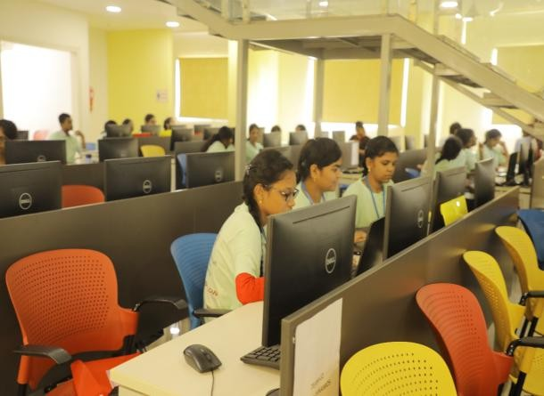
Participants Immersed in Coding at HackOverflow-2K23:

S R K R CODING CLUB
Behold the concentration and dedication as participants immerse themselves in the coding arena at HackOverflow-2K23. The event is alive with the hum of keyboards and the glow of screens, portraying a collective pursuit of excellence in every line of code.

Judges Engaging with Teams at HackOverflow-2K23:
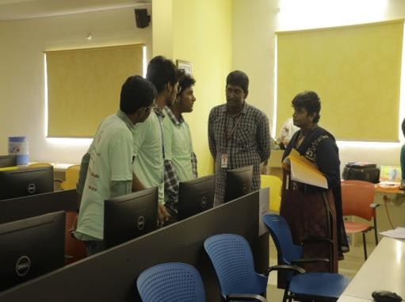
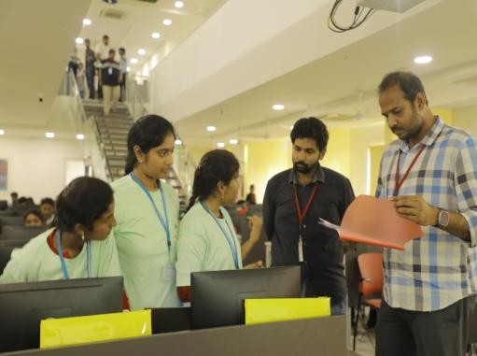

Witness the meticulous evaluation process as judges attentively assess the progress of teams at multiple intervals during HackOverflow-2K23. The exchange of insights and feedback contributes to the refinement of innovative solutions, reflecting the commitment to excellence ingrained in the coding journey.

Lunch:
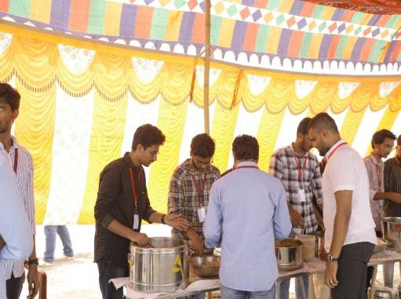
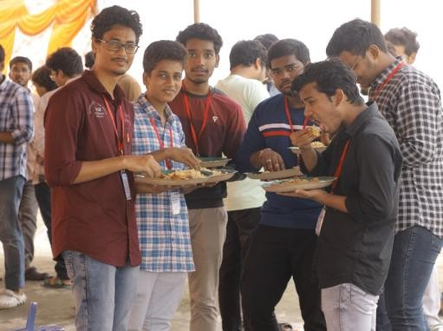

Participants recharge with a hearty lunch from SRKR Coding Club during HackOverflow- 2K23

2nd phase of evaluation:
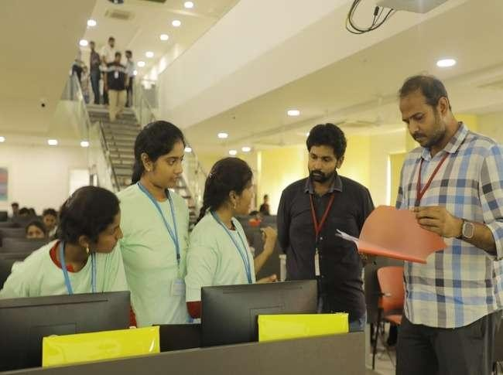

Witness the unveiling of innovation in the second phase of evaluation at HackOverflow- 2K23. Our participants, fuelled by a hearty lunch, showcase their progress and solutions to judges, marking another pivotal moment in this coding journey. The exchange of ideas and insights continues, shaping the path toward coding excellence.

Dinner:
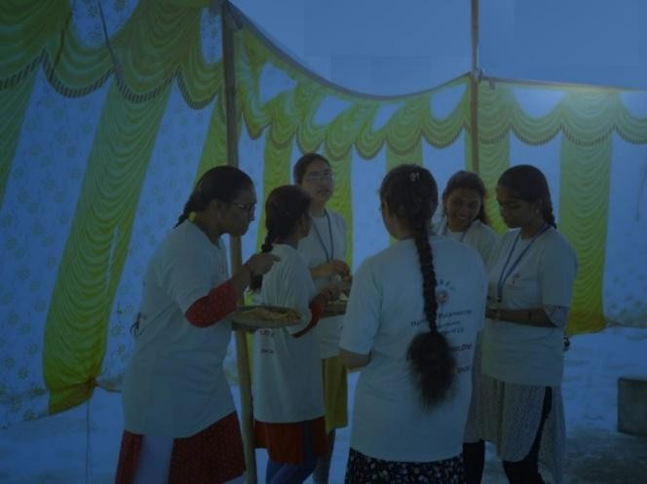

Participants refuel with a delicious dinner provided by SRKR Coding Club at HackOverflow-2K23, fostering warmth and community spirit throughout the coding journey.

Musical Night:
Participants take a break from coding to enjoy soulful tunes, adding a touch of joy and unity to the event's atmosphere. This snapshot captures the relaxed and melodic vibe of our musical night.

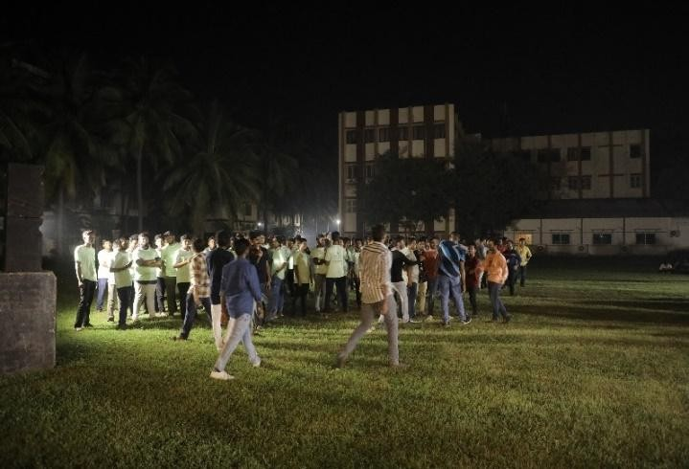

Post-Event Gathering at I Block:
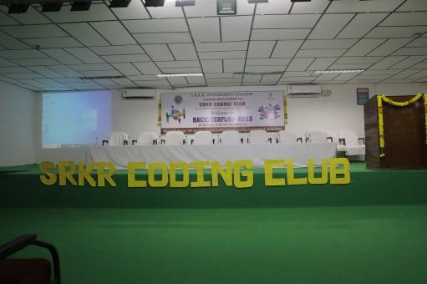
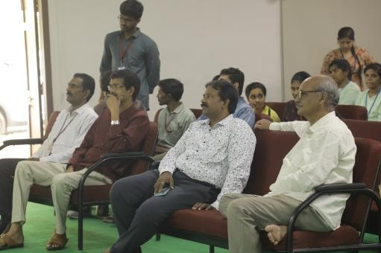

Gathering at I Block for a post-event meetup following HackOverflow-2K23, we embraced the casual setting to share experiences, celebrate achievements, and fondly reminisce about the memories forged during the event.

Inspiring Speeches at I Block:
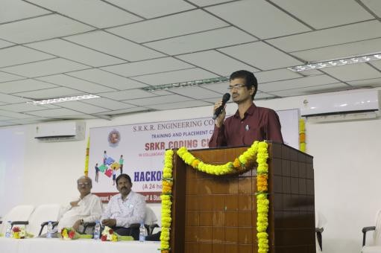
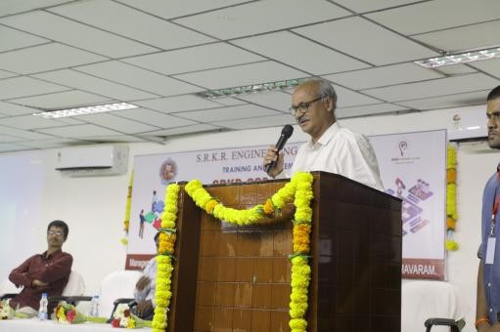

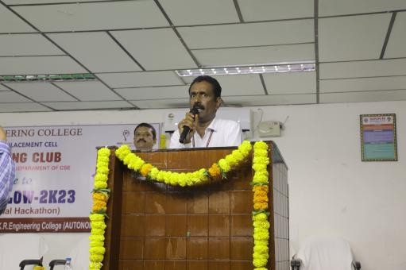

In a gathering at I Block, esteemed guests shared priceless insights and wisdom with the students. Their impactful speeches infused a dose of inspiration, bringing a meaningful conclusion to the enriching journey of HackOverflow-2K23.

Recognition and Appreciation at I Block:
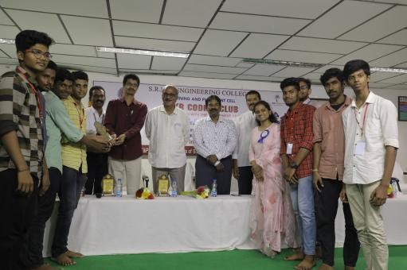
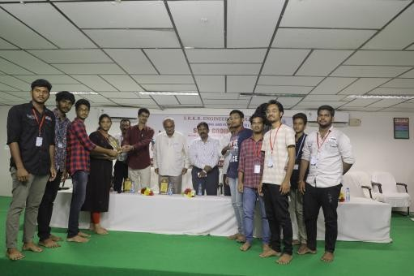
Heartfelt Appreciation: A warm gathering at I Block was the perfect setting to express our gratitude to not only our dedicated club members but also to the fellow club members from other organizations, particularly the esteemed members of the Student Council and EOC. Their collaborative efforts played a pivotal role in the resounding success of HackOverflow- 2K23.

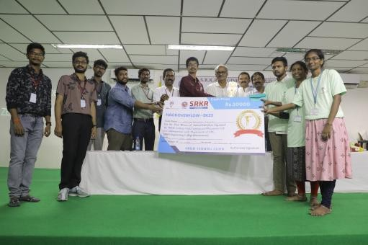
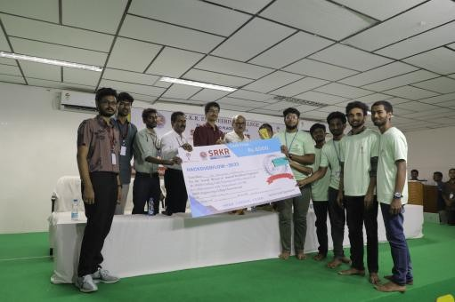
Crowning Achievements: Winners Revealed:

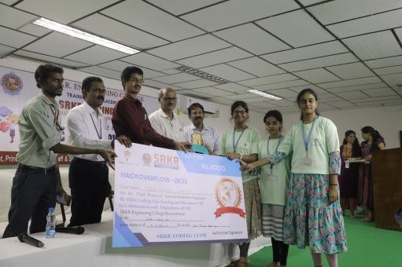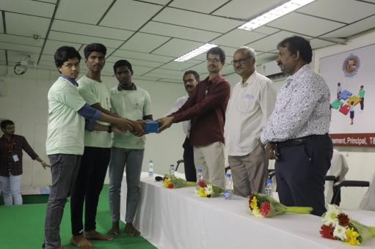
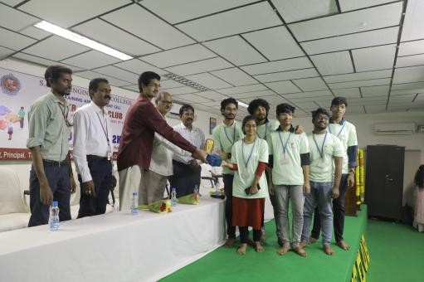

The moment arrived to applaud excellence! The prestigious 1st prize, a substantial 10K, crowned unparalleled innovation. Following closely, the 2nd prize of 6K celebrated outstanding achievements, and the 3rd prize, a commendable 3K, acknowledged remarkable efforts. These prizes are more than rewards; they symbolize the exceptional talent showcased at HackOverflow-2K23.

Our Strength : Management
On our Coding Club's successful inauguration, I would like to extend my heartfelt gratitude to you and the entire management team for your invaluable support and guidance. Your dedication to providing opportunities for professional development is truly commendable, and the establishment of the Coding Club is a testament to your forward-thinking leadership. Thank you for your unwavering support and commitment to empowering our team.

CONVENR

