PES UNIVERSITY
Department of Computer Science and Engineering
Software Engineering — Lab 1
Problem Statement #35: Customizable Subscription Box Scheduler
Submitted by
G.V.N.SREEHARSHA
SRN: PES1UG24CS163
Section: C
This document contains: the Requirements Table, the UML Use-Case Diagram, and the Use-Case Flow Specification.

1. Requirements Table
Problem Statement #35 — Customizable Subscription Box Scheduler

Req ID | Type | Description | Priority | Acceptance Criteria | Rationale | Comments (Peer Critique)
FR-001 | Functional | The system shall allow subscribers to swap monthly box items or pause deliveries at least 48 hours before the billing renewal date. | High | Pass (swap): The subscriber swaps an item at least 48 hours before renewal, the selection updates immediately, and the fulfillment manifest reflects the new item. Pass (pause): The subscriber pauses a delivery at least 48 hours before renewal, the cycle is marked “Paused,” and no charge or box is generated for that cycle. Fail: Either action is accepted within 48 hours of renewal, or a paused cycle still generates a charge or box. | Core value proposition of the product — subscriber control over box contents directly reduces churn from mismatched deliveries. (Given in problem statement.) | Reviewer noted the original criterion only verified the swap path — revised to test swap and pause separately.
FR-002 | Functional | The system shall allow a subscriber to select one or more preference tags (e.g., “coffee”, “fiction”, “vegan”) that filter the products offered for that month's box. | High | Pass: When a subscriber selects a preference tag, the displayed product list updates to show only matching items within 2 seconds. Fail: Unrelated products remain visible, or the list does not refresh within 2 seconds. | Preference-tag filtering is the primary personalization mechanism described in the problem statement and is what differentiates the box from a generic subscription. | Reviewer asked for a numeric response-time bound instead of “quickly” — added the 2-second criterion.
FR-003 | Functional | The system shall allow a subscriber to skip a single upcoming billing cycle without cancelling the underlying subscription. | High | Pass: After the subscriber confirms “Skip This Month,” no charge is generated for that cycle and the subscription status reads “Skipped – resumes <next month>.” Fail: A charge is still generated, or the subscription is cancelled instead of skipped. | The scenario explicitly calls out pausing/skipping billing cycles as required flexibility for subscribers. | Reviewer confirmed this is directly relevant and unambiguous.
FR-004 | Functional | The system shall generate a fulfillment manifest listing all confirmed box selections for the current billing cycle and make it available to the Fulfillment Lead by 06:00 the day after the customization window closes. | Medium | Pass: The manifest contains exactly one row per subscriber with a confirmed box selection for the current billing cycle, with product SKUs and a generation timestamp before 06:00. Fail: The manifest is missing subscribers, contains duplicate rows, or is generated late. | The Fulfillment Lead needs accurate, timely data to pick, pack, and ship boxes on schedule. | Reviewer asked “available when, to whom?” — added the explicit 06:00 deadline and named recipient.
FR-005 | Functional | The system shall allow a subscriber to view the delivery status of their current box (e.g., Processing, Shipped, Delivered) in near real time. | Medium | Pass: The status shown to the subscriber matches the most recent carrier/fulfillment update within 15 minutes. Fail: The displayed status is stale by more than 15 minutes or is not shown at all. | Delivery visibility reduces support inquiries and builds subscriber trust in the service. | Reviewer flagged “real time” as untestable — revised to a measurable 15-minute sync window.
NFR-001 | Nonfunctional – Performance & Security | The fulfillment manifest generator must export shipping labels for 10,000 monthly boxes in under 1 minute. | High | Pass: A benchmark run exporting shipping labels for 10,000 monthly boxes completes in under 1 minute (wall-clock, measured from export start to last label written). Fail: The 10,000-box export takes 1 minute or longer. | Peak-season fulfillment runs must scale without delaying shipment of thousands of boxes at month-end. (Given in problem statement.) | Reviewer noted the criterion described the test but not the pass/fail threshold directly — revised to state the < 1 minute bound explicitly, and moved the NFR type out of the description into the Type column.
NFR-002 | Nonfunctional – Security & Privacy | The system shall encrypt all stored subscriber payment and personal data using AES-256 at rest and TLS 1.2+ in transit. | High | Pass: A security audit confirms every payment/PII field is encrypted at rest and all API traffic is served over TLS 1.2+. Fail: Any payment or PII field is found stored in plaintext, or any endpoint accepts unencrypted traffic. | Subscriber payment data must be protected and the billing feature (skip/pause, recurring charge) implies PCI-DSS-adjacent compliance obligations. | Reviewer suggested naming a concrete standard rather than “secure storage” — added AES-256 / TLS 1.2+, and moved the NFR type out of the description into the Type column.

2. UML Use-Case Diagram
Use-case diagram for the Subscription Box Portal, showing the Subscriber and Fulfillment Lead actors, the Payment Gateway external system, and the five core use cases.
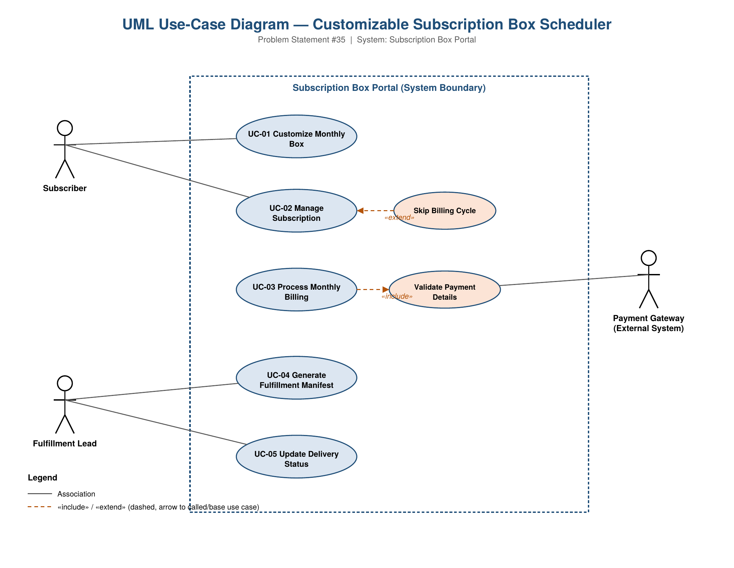

3. Use-Case Flow Specification
Lab 1 — Problem Statement #35: Customizable Subscription Box Scheduler

Use Case ID / Name | UC-01: Customize Monthly Box
Primary Actor | Subscriber

Preconditions
- The subscriber has an active subscription in good standing.
- The subscriber is authenticated and logged in to the portal.
- The monthly customization window is currently open (i.e., at least 48 hours remain before the billing renewal date, per FR-001).

Postconditions
- The subscriber's monthly box selection is saved and reflects the chosen products and preference tags.
- The updated selection is available to the fulfillment system for inclusion in the next fulfillment manifest (FR-004).
- The subscriber receives on-screen confirmation of the updated box.

Main Success Scenario
1. Subscriber opens the current month's box from their account dashboard.
2. System retrieves and displays the products available for the subscriber's selected preference tags (FR-002).
3. Subscriber selects or swaps products in the box, optionally adjusting preference tags to refine the list.
4. System validates the selection (e.g., quantity limits, product availability, customization window still open).
5. Subscriber reviews and confirms the customized box.
6. System saves the updated selection and timestamps the change.
7. System displays a confirmation message summarizing the finalized box contents.

Alternate Flows
A1. Customization Window Has Closed (branches at step 3)
- 3a1. System detects that fewer than 48 hours remain before the billing renewal date, or the window has already closed.
- 3a2. System prevents further changes to the current cycle’s box.
- 3a3. System displays a message: “Customization is closed for this cycle — changes will apply to next month’s box.”
- 3a4. Subscriber may choose to edit next month’s box instead, or exit the use case.
A2. Selected Product Out of Stock (branches at step 4)
- 4a1. System validation detects that a selected product is unavailable.
- 4a2. System flags the item and suggests an in-stock alternative with a matching preference tag.
- 4a3. Subscriber picks the alternative or removes the item, then resumes at step 4.

