Software Requirements Specification for
Hostel Management System (HMS)
Part-1 Submission
Prepared by Team 3
Name | SRN
G.V.N. Sreeharsha | PES1UG24CS163
Chennamraju Vaishnavi | PES1UG24CS129
Devansh Gupta | PES1UG24CS145
Date: 07-10-2026
1

Table of Contents
Revision History
1. Introduction
1.1 Purpose
1.2 Intended Audience
1.3 Product Scope
1.4 References
2. Overall Description
2.1 Product Perspective
2.2 Product Functions
2.3 User Classes and Characteristics
2.4 Operating Environment
2.5 Design and Implementation Constraints
2.6 Assumptions and Dependencies
3. External Interface Requirements
3.1 User Interfaces
3.2 Software Interfaces
3.3 Communications Interfaces
4. Analysis Models
5. System Features
6. Other Nonfunctional Requirements
6.1 Performance Requirements
6.2 Safety Requirements
6.3 Security Requirements
6.4 Software Quality Attributes
6.5 Business Rules
7. Other Requirements
Appendix A: Glossary
Appendix B: Field Layouts
Appendix C: Requirement Traceability Matrix
2

Revision History
Contributor | Date | Revision / Contribution | Version
G.V.N. Sreeharsha | 05-10-2026 | Initial SRS baseline: scope, purpose, user classes, functional requirements and non-functional requirements. | 1.0
Chennamraju Vaishnavi | 07-10-2026 | Reviewed requirements from the testing perspective; defined the fee amount (Room Fee) used by REQ-22, added the payment status report to REQ-23 and clarified the hostel search in REQ-7. | 1.1
Devansh Gupta | 07-10-2026 | Reviewed functional and security requirements against the architecture; checked cross-document references and added team number and team member details. | 1.2
1. Introduction
1.1 Purpose
This document specifies the software requirements for the Hostel Management System
(HMS). HMS is a web based application built using Python and Django for
managing student details and the allocation of hostel rooms and beds. This SRS covers the
complete system.
1.2 Intended Audience
This document is for:
• Developers - to know what has to be built
• Testers - to write test cases from the requirements
• Faculty evaluator - to review the project
• Hostel office staff - who will be the actual users of the system
Section 2 gives the overall description, Section 3 the interface requirements, Section 4 the
use case diagram, Section 5 the functional requirements and Section 6 the non functional
requirements.
1.3 Product Scope
Currently the hostel office keeps student details, room allocations and fee payments in paper
registers and spreadsheets. Finding a vacant bed takes time, and mistakes such as giving
the same bed to two students can happen. Students also cannot check their own allocation
or payment status without visiting the office.
HMS solves this by:
• keeping all student, hostel, room and bed details in one place
• showing available beds instantly and blocking double allocation
• recording allocations, transfers and releases with full history
• recording fee payments and generating receipts
• letting students check their allocation and payment status anytime
1.4 References
• IEEE Std 830-1998, Recommended Practice for Software Requirements Specifications
• Django Documentation - https://docs.djangoproject.com
• MySQL 8.0 Reference Manual - https://dev.mysql.com/doc
• OWASP Application Security Verification Standard (ASVS) 4.0
• SE Mini Project Guidelines and Problem Statements, Section C
3

2. Overall Description
2.1 Product Perspective
HMS is a new, standalone system that replaces the manual hostel registers and
spreadsheets. It is not part of any existing system. It has three tiers:
Tier | Technology
Front end | HTML, CSS, Bootstrap (Django templates)
Back end | Python, Django
Database | MySQL
HMS does not connect to any external system in this version.
2.2 Product Functions
• Login and logout for Admin, Warden and Student
• Manage staff user accounts
• Manage students (add, search, update, deactivate)
• Manage hostels, rooms and beds
• Allocate, transfer and release beds
• Record fee payments and generate receipts
• Generate occupancy report
• View own allocation and payment status (Student)
2.3 User Classes and Characteristics
User Class | Description | Usage
Admin | Hostel office head / IT staff. Manages staff accounts, hostels, rooms and beds. Full access. | Daily
Warden | Hostel staff. Registers students, allocates beds, records payments and views reports. Most important user class. | Daily
Student | Views own profile, allocation and payment status only. Mostly uses mobile. | Occasional
2.4 Operating Environment
Component | Requirement
Server OS | Windows 10+ or Ubuntu 20.04+
Runtime | Python 3.11+, Django 5.x
Database | MySQL 8.0
Client | Any modern browser (Chrome, Firefox, Edge) on laptop or mobile
2.5 Design and Implementation Constraints
• Must be developed in Python using Django (as per problem statement)
• MySQL must be used as the database
• Web application only, no mobile app
4

• Must be completed within the semester by the project team
• All database access through Django ORM or parameterised queries
• Code on GitHub and follows PEP 8
2.6 Assumptions and Dependencies
• Every student has a unique student ID (SRN)
• Each hostel is either Boys or Girls only
• A bed belongs to exactly one room and a room to exactly one hostel
• Fees are collected offline (cash / UPI / bank transfer) and recorded by staff
• Hostel office has a device with internet access
• Depends on third party libraries: mysqlclient and reportlab (PDF receipts)
3. External Interface Requirements
3.1 User Interfaces
• Web interface built with HTML, CSS and Bootstrap
• Role based dashboard shown after login
• Navigation bar with only the options allowed for that role
• Forms show error messages next to the invalid field; mandatory fields marked with *
• Error messages never show stack traces, SQL or file paths
• Pages work on both laptop and mobile screens
3.2 Software Interfaces
Software | Purpose
MySQL 8.0 | Stores all data, accessed through Django ORM
Django 5.x | Web framework, authentication, sessions and CSRF protection
reportlab | Generating PDF receipts
3.3 Communications Interfaces
• HTTPS (TLS 1.2 or higher) between browser and server
• MySQL connection between application server and database on a private network
4. Analysis Models
Figure 1 shows the use case diagram with the three actors - Admin, Warden and Student.
5

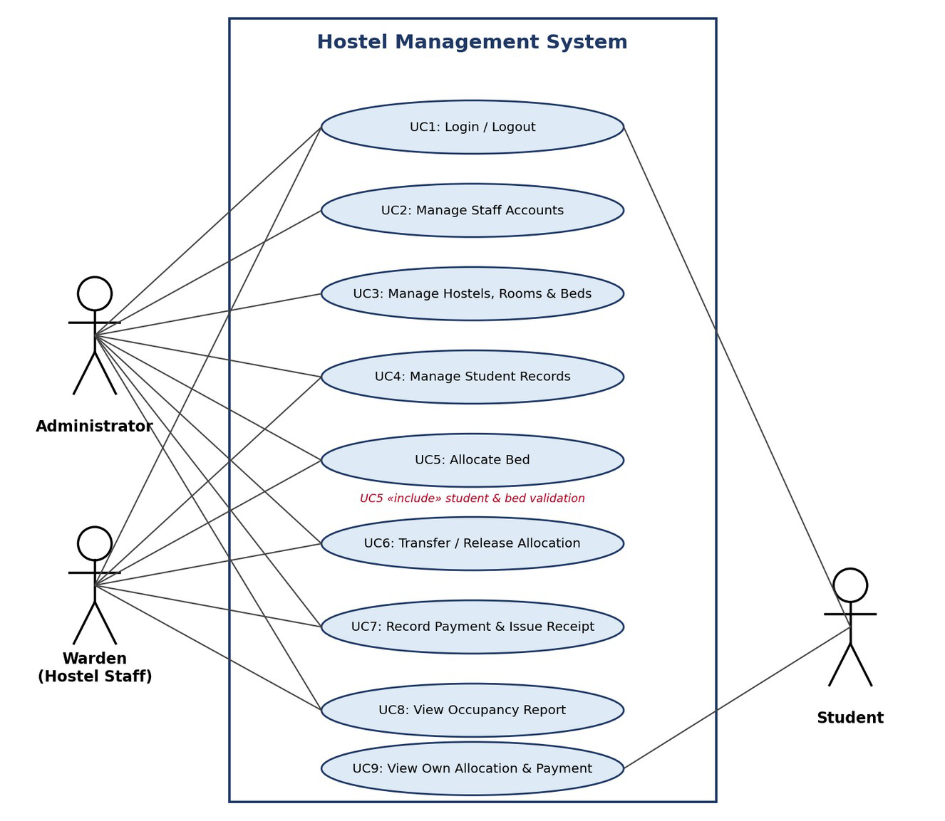
Figure 1: Use case diagram
5. System Features
5.1 User Login and Management
Description and Priority: Lets users login and lets admin manage user accounts. Priority - High.
Stimulus / Response:
User Action (Stimulus) | System Response
User enters correct ID and password | Dashboard for that role is shown
User enters wrong password | "Invalid username or password" shown
Admin submits add user form | User account saved, success message shown
Functional Requirements:
ID | Requirement
REQ-1 | The system shall allow Admin, Warden and Student to login using their username and password and shall show the dashboard of their role within 2 seconds.
REQ-2 | The system shall show "Invalid username or password" for wrong credentials without telling which one was wrong, and shall lock the account for 15 minutes after 5 consecutive failed attempts.
REQ-3 | The system shall end the session when the user clicks Logout or after 15 minutes of inactivity.
REQ-4 | The Admin shall be able to create and deactivate user accounts and assign a role (Admin / Warden / Student), with a unique username for each account.
6

5.2 Student Management
Description and Priority: Lets staff maintain student details needed for hostel admission. Priority - High.
Stimulus / Response:
User Action (Stimulus) | System Response
Staff submits add student form | Student saved, success message shown
Staff submits a Student ID that already exists | "Student ID already registered" shown
Staff searches by ID or name | Matching students listed
Functional Requirements:
ID | Requirement
REQ-5 | The Admin or Warden shall be able to register a student by entering all mandatory fields given in Appendix B, and the system shall save the record only if all fields are valid.
REQ-6 | The system shall not allow two students with the same Student ID and shall show "Student ID already registered".
REQ-7 | The Admin or Warden shall be able to search students by Student ID, name (partial match) or hostel (the hostel of the student's current allocation), with results shown within 2 seconds for up to 5,000 records.
REQ-8 | The Admin or Warden shall be able to update a student's contact details, course and year, but not the Student ID.
REQ-9 | The system shall deactivate (not delete) a student record only if the student has no active allocation; otherwise it shall refuse and show the allocated bed.
5.3 Hostel, Room and Bed Management
Description and Priority: Lets admin set up hostels, rooms and beds so that allocation can be done. Priority - High.
Stimulus / Response:
User Action (Stimulus) | System Response
Admin adds hostel | Hostel saved and shown in hostel list
Admin adds room with capacity | Room saved and beds created automatically
Staff opens Available Beds | List of free beds shown
Functional Requirements:
ID | Requirement
REQ-10 | The Admin shall be able to add and edit a hostel with a unique name and a type (Boys / Girls).
REQ-11 | The Admin shall be able to add a room to a hostel with a room number unique within that hostel, floor, room type (single / double / triple) and capacity from 1 to 4.
REQ-12 | The system shall automatically create one bed for each unit of room capacity (for example 101-A, 101-B) with status "Available".
REQ-13 | The system shall show available beds filtered by hostel, floor and room type, and shall not show occupied or under-maintenance beds.
7

5.4 Allocation Management
Description and Priority: Lets staff allocate, transfer and release beds without conflicts. Priority - High.
Stimulus / Response:
User Action (Stimulus) | System Response
Staff selects student and an available bed and confirms | Allocation saved, bed marked Occupied, confirmation shown
Staff selects an already occupied bed | Request rejected with reason shown
Staff releases an allocation | Bed becomes Available, vacate date saved
Functional Requirements:
ID | Requirement
REQ-14 | The Admin or Warden shall be able to allocate an available bed to an active student, and the system shall save the allocation date and mark the bed Occupied in one atomic transaction.
REQ-15 | The system shall not allow allocation of an occupied bed, or allocation to a student who already has an active allocation, and shall show the reason.
REQ-16 | The system shall allow allocation only if the student's gender matches the hostel type.
REQ-17 | The Admin or Warden shall be able to transfer a student to another available bed, and the old bed shall be released and the new bed occupied in one atomic transaction.
REQ-18 | The Admin or Warden shall be able to release an allocation by entering a vacate date, and the bed shall become "Available".
REQ-19 | The system shall keep all past allocations and show a student's allocation history in date order.
5.5 Fee Payment and Receipt
Description and Priority: Records hostel fees paid offline and gives receipts. Priority - Medium.
Stimulus / Response:
User Action (Stimulus) | System Response
Staff enters amount, mode and date for a student | Payment saved and receipt generated
Staff opens student payment status | Paid / Partial / Pending shown
Functional Requirements:
ID | Requirement
REQ-20 | The Admin or Warden shall be able to record a payment for a student with amount greater than zero, payment date, mode (Cash / UPI / Bank Transfer) and optional reference number.
REQ-21 | The system shall generate a receipt with a unique sequential receipt number for every payment, which can be viewed and downloaded as PDF.
REQ-22 | The system shall show the payment status of each student as Paid, Partial or Pending based on the payments recorded against the fee amount for the student's room type (Room Fee, Appendix B).
8

5.6 Reports and Student View
Description and Priority: Lets staff see occupancy and lets students see their own details. Priority - Medium.
Stimulus / Response:
User Action (Stimulus) | System Response
Staff selects a hostel and clicks Occupancy Report | Total, occupied and available beds shown
Student opens My Allocation | Own bed and payment status shown
Functional Requirements:
ID | Requirement
REQ-23 | The system shall generate an occupancy report for each hostel showing total beds, occupied beds, available beds and occupancy %, and a payment status report listing each student's fee amount, amount paid and status (Appendix B); both downloadable as CSV.
REQ-24 | The Student shall be able to view only their own profile, current allocation and payment status.
6. Other Nonfunctional Requirements
6.1 Performance Requirements
ID | Requirement
NFR-1 | At least 95% of page requests shall complete within 2 seconds with up to 50 users at the same time.
NFR-2 | Allocating a bed (REQ-14) shall take less than 3 seconds including saving to the database.
NFR-3 | The system shall support 5,000 student records and 2,000 beds without exceeding the response time in NFR-1.
6.2 Safety Requirements
ID | Requirement
NFR-4 | The database shall be backed up once every day and shall be restorable with at most 24 hours of data loss.
NFR-5 | Allocation and payment records shall never be permanently deleted, only updated or marked inactive.
6.3 Security Requirements
Security Objectives:
ID | Requirement
SO-1 | Only authorised users can access the system and each user can only do what their role allows.
SO-2 | Allocation and payment records can only be created or changed through valid operations by authorised staff, and every change can be traced to a user.
SO-3 | Personal details of students (contact, guardian and payment details) are kept confidential.
9

ID | Requirement
SO-4 | The system stays usable for staff during office hours and resists simple attacks such as repeated password guessing.
Security Requirements:
ID | Requirement | Objective
NFR-6 | Passwords shall be stored hashed using Django PBKDF2, never in plain text, and shall be at least 8 characters with a letter and a digit. | SO-1
NFR-7 | The system shall check the user role on every request and block (HTTP 403) pages and actions not allowed for that role. | SO-1
NFR-8 | A student shall only be able to view their own data. | SO-3
NFR-9 | User session shall expire after 15 minutes of no activity, and session cookies shall be HttpOnly and Secure. | SO-1
NFR-10 | All input shall be validated on the server and all forms shall be protected against CSRF and SQL injection. | SO-2
NFR-11 | Every login, failed login, create, update, deactivate, allocate, release and payment action shall be logged with user, action, record and date-time, and kept for at least 1 year. | SO-2
NFR-12 | All traffic shall use HTTPS (TLS 1.2 or higher), and an account shall be locked for 15 minutes after 5 failed logins. | SO-4
6.4 Software Quality Attributes
Attribute | Requirement
Usability | A new warden can register a student and allocate a bed within 5 minutes using a one page user guide.
Reliability | System available at least 99% of the time during office hours (8 AM - 8 PM) on working days.
Data Integrity | The database itself shall make sure a bed has at most one active allocation and a student has at most one active allocation.
Portability | Runs on both Windows and Linux servers; works on the latest two versions of Chrome, Firefox and Edge.
Maintainability | Code follows PEP 8 and is split into separate Django apps per module; unit tests cover at least 70% of the application logic.
6.5 Business Rules
ID | Rule
BR-1 | A bed can have only one active allocation at a time.
BR-2 | A student can have only one active allocation at a time.
BR-3 | Boys can be allocated only to Boys hostels and girls only to Girls hostels (domain requirement).
BR-4 | Only Admin can add or change hostels, rooms, beds and user accounts.
BR-5 | A recorded payment cannot be edited or deleted; corrections are made by a new adjusting entry (domain requirement).
BR-6 | A student can access only their own data.
10

7. Other Requirements
• All tables shall use primary and foreign keys with referential integrity (MySQL InnoDB).
• Student data must be handled as per university data rules.
• Only English language is supported in this version. Dates are shown as DD-MM-YYYY
and amounts in INR.
11

Appendix A: Glossary
Term | Meaning
HMS | Hostel Management System
SRN | Student Registration Number
Warden | Hostel staff member who handles day to day hostel work
Allocation | Assigning a student to a bed for a period of time
Active allocation | An allocation with no vacate date
RBAC | Role Based Access Control
ORM | Object Relational Mapping
CSRF | Cross Site Request Forgery
TLS | Transport Layer Security
Soft delete | Marking a record inactive instead of removing it
Appendix B: Field Layouts
Student Registration Fields
Field | Length | Data Type | Description | Mandatory
Student ID (SRN) | 13 | Alphanumeric | Student registration number | Y
Name | 60 | Text | Full name | Y
Date of Birth | 10 | Date | DD-MM-YYYY | Y
Gender | 6 | Text | Male / Female | Y
Course | 30 | Text | e.g. B.Tech CSE | Y
Year | 1 | Numeric | 1 to 5 | Y
Mobile | 10 | Numeric | Student mobile number | Y
Email | 80 | Alphanumeric | Valid email ID | Y
Guardian Name | 60 | Text | Parent / guardian | Y
Guardian Mobile | 10 | Numeric | Emergency contact | Y
Address | 200 | Text | Permanent address | N
Status | 10 | Text | Active / Inactive | Y
Hostel, Room and Bed Fields
Field | Length | Data Type | Description | Mandatory
Hostel Name | 40 | Text | Unique hostel name | Y
Hostel Type | 5 | Text | Boys / Girls | Y
Room Number | 6 | Alphanumeric | Unique within hostel | Y
Floor | 2 | Numeric | Floor number | Y
Room Type | 10 | Text | Single / Double / Triple | Y
Capacity | 1 | Numeric | 1 to 4 | Y
Room Fee | 10 | Numeric | Fee amount in INR for the room type; used for payment status | Y
Bed Number | 8 | Alphanumeric | Generated, e.g. 101-A | Y
12

Field | Length | Data Type | Description | Mandatory
Bed Status | 15 | Text | Available / Occupied / Maintenance | Y
Allocation and Payment Fields
Field | Length | Data Type | Description | Mandatory
Allocation Date | 10 | Date | Date bed was assigned | Y
Vacate Date | 10 | Date | Date bed was released | N
Receipt Number | 12 | Alphanumeric | Unique, sequential | Y
Amount | 10 | Numeric | Amount paid in INR, greater than 0 | Y
Payment Date | 10 | Date | Date of payment | Y
Payment Mode | 15 | Text | Cash / UPI / Bank Transfer | Y
Reference Number | 30 | Alphanumeric | Transaction reference | N
Report Fields
Occupancy Report | Payment Status Report
Hostel Name | Student ID
Total Beds | Student Name
Occupied Beds | Hostel / Room / Bed
Available Beds | Fee Amount
Beds Under Maintenance | Amount Paid
Occupancy % | Payment Status
Generated On | Generated On
13

Appendix C: Requirement Traceability Matrix
Sl. No | Req ID | Brief Description | Architectu re Ref | Design Ref | Code File Ref | Test Case ID | System Test Case ID
1 | REQ-1 | Login using ID and  password, role dashboard | C1,C2 | API-A1  4.1 | TBD | TC-AUTH-01 | Planned
2 | REQ-2 | Invalid login message and account lockout | C2 | API-A1  4.4 | TBD | TC-  AUTH-02,03 | Planned
3 | REQ-3 | Logout and session timeout | C2 | API-A2  3.9 | TBD | TC-AUTH-04 | Planned
4 | REQ-4 | Admin creates / deactivates users and assigns roles | C2 | API-A3 | TBD |  | Planned
5 | REQ-5 | Register student with mandatory fields | C3 | SD-1  API-S1 | TBD | TC-STU-01,02 | Planned
6 | REQ-6 | Reject duplicate Student ID | C3,C9 | SD-1  API-S1 | TBD | TC-STU-02 | Planned
7 | REQ-7 | Search students | C3,C9 | API-S2 | TBD | TC-STU-03 | Planned
8 | REQ-8 | Update student details | C3 | API-S3 | TBD | TC-STU-04 | Planned
9 | REQ-9 | Deactivate student only if no active allocation | C3,C5 | API-S4 | TBD | TC-STU-05 | Planned
10 | REQ-10 | Admin adds / edits hostel | C4 | API-H1 | TBD | TC-HST-01 | Planned
11 | REQ-11 | Admin adds room with capacity | C4 | API-H2 | TBD | TC-HST-01 | Planned
12 | REQ-12 | Auto-create beds for a room | C4,C9 | API-H2 | TBD | TC-HST-02 | Planned
13 | REQ-13 | Show available beds with filters | C4 | API-H3 | TBD | TC-HST-02 | Planned
14 | REQ-14 | Allocate available bed to student | C5,C9 | SD-2  API-L1 | TBD | TC-ALC-01 | Planned
15 | REQ-15 | Block allocation of occupied bed / student with active  allocation | C5,C9 | SD-2  API-L1 | TBD | TC-ALC-02,03 | Planned
16 | REQ-16 | Gender and hostel type must match | C5 | SD-2  API-L1 | TBD | TC-ALC-04 | Planned
17 | REQ-17 | Transfer student to another bed | C5,C9 | API-L2 | TBD | TC-ALC-05 | Planned
18 | REQ-18 | Release allocation | C5 | API-L3 | TBD | TC-ALC-06 | Planned
19 | REQ-19 | Allocation history | C5 | API-L4 | TBD | TC-ALC-06 | Planned
20 | REQ-20 | Record payment | C6 | API-P1 | TBD | TC-PAY-01 | Planned
21 | REQ-21 | Generate receipt with unique number | C6 | API-P2 | TBD | TC-PAY-01 | Planned
22 | REQ-22 | Show payment status | C6 | API-P3 | TBD | TC-PAY-02 | Planned
23 | REQ-23 | Occupancy report | C7 | API-R1 | TBD | TC-RPT-01 | Planned
24 | REQ-24 | Student views own data | C2,C3 | API-M1 | TBD | TC-SEC-02 | Planned
25 | NFR-1 | 95% of pages within 2 seconds for 50 users | C1,C9,C10 | 4.1  indexes | TBD | TC-PERF-01 | Planned
26 | NFR-2 | Allocation within 3 seconds | C5,C9 | SD-2  txn | TBD | TC-PERF-02 | Planned
27 | NFR-3 | Support 5,000 students and 2,000 beds | C9,C10 | 4.1  indexes | TBD | TC-PERF-03 | Planned
28 | NFR-4 | Daily database backup | C10 | 4.4 backup | TBD | TC-OPS-01 | Planned
14

Sl. No | Req ID | Brief Description | Architectu re Ref | Design Ref | Code File Ref | Test Case ID | System Test Case ID
29 | NFR-5 | No permanent deletion of records | C9 | 4.1 soft  delete | TBD | TC-STU-05 | Planned
30 | NFR-6 | Password hashing and policy | C2 | 3.9 | TBD | TC-SEC-04 | Planned
31 | NFR-7 | Role check on every request | C2 | 3.9  4.3 | TBD | TC-SEC-01 | Planned
32 | NFR-8 | Student sees only own data | C2,C3 | API-M1  3.9 | TBD | TC-SEC-02 | Planned
33 | NFR-9 | Session expiry and secure cookies | C2 | API-A2  3.9 | TBD | TC-AUTH-  04,SEC-06 | Planned
34 | NFR-10 | Input validation, CSRF and SQL injection protection | C1,C9 | 3.9  4.4 | TBD | TC-SEC-03,05 | Planned
35 | NFR-11 | Audit logging | C8 | 4.4 | TBD | TC-SEC-07 | Planned
36 | NFR-12 | HTTPS and brute-force lockout | C2,C1 | API-A1  3.9 | TBD | TC-AUTH-  03,SEC-06 | Planned
15

