Software Architecture and Design Specification
Project: Hostel Management System (HMS)
Authors: Team 3 - G.V.N. Sreeharsha (PES1UG24CS163), Chennamraju Vaishnavi (PES1UG24CS129), Devansh Gupta (PES1UG24CS145)
Date: 07-10-2026
Status: Submitted for Part-1
Revision History
Version | Date | Contributor | Revision / Contribution
1.0 | 05-10-2026 | G.V.N. Sreeharsha | Initial architecture and design baseline: components, layered pattern, data model, API design and security architecture.
1.1 | 07-10-2026 | Chennamraju Vaishnavi | Reviewed design from the testing perspective; checked API, error handling and sequence diagrams against test cases; added the payment status report endpoint to API-R1.
1.2 | 07-10-2026 | Devansh Gupta | Reviewed architecture and security design against the SRS; added the fee_amount field to the Room entity and API-H2, updated document cross-references and added team number and team member details.
Approvals
Role | Name | Signature/Date
Project Guide
Team Lead | G.V.N. Sreeharsha
Architect | Devansh Gupta
1. Introduction
1.1 Purpose
This document specifies the architecture and design of the Hostel Management System (HMS). It explains how the requirements in the HMS SRS are realised by components, interfaces and data structures.
1.2 Scope
Covers all HMS features: authentication, student management, hostel/room/bed
management, bed allocation (allocate, transfer, release), fee payment and receipts, occupancy report, student self-view, audit logging and the security architecture. Hardware, network and hosting set-up are outside the scope.
1.3 Audience
Developers, QA engineers (Test Plan authors), security reviewers, the project guide and future maintainers.
1.4 Definitions
HMS (Hostel Management System), SRS (Software Requirements Specification), STP (Software Test Plan), MVT (Model-View-Template), ORM (Object Relational Mapping), RBAC (Role Based Access Control), CSRF (Cross Site Request Forgery), TLS (Transport Layer Security), STRIDE (Spoofing, Tampering, Repudiation, Information disclosure, Denial of service, Elevation of privilege), ADR (Architecture Decision Record), API (Application Programming Interface).
1

2. Document Overview
2.1 How to use this document
Section 3 describes the architecture (components, pattern, technology, risks, traceability and security). Section 4 describes the design (data model, sequence diagrams, API, error handling, UX). Component IDs (C1 to C10), sequence diagram IDs (SD-1, SD-2) and API IDs (API-xx) defined here are used in the traceability tables and in Appendix C of the SRS.
2.2 Related Documents
HMS Software Requirements Specification, HMS Software Test Plan (which holds the test cases and the RTM).
3. Architecture
3.1 Goals & Constraints
Goals: correct allocation (a bed is never given to two students), secure handling of student data, responses within 2 seconds for 50 concurrent users, simple modular code that a student team can build and test within one semester.
Constraints: Python with Django and MySQL 8.0 (course requirement); web application only; completion within the semester; PEP 8 coding standard; no external system integration in v1.0.
3.2 Stakeholders & Concerns
Stakeholder | Concerns
Admin | Control over hostels, rooms, beds and user accounts; reliability
Warden | Fast student registration and allocation; no double allocation; easy payment entry
Student | Privacy of personal data; simple view of own allocation and payment status
Developers | Modularity, clear interfaces, testability
QA / Testers | Every requirement traceable to a component and testable
Project guide / evaluators | Completeness against IEEE format, security design, traceability
2

3.3 Component (UML) Diagram
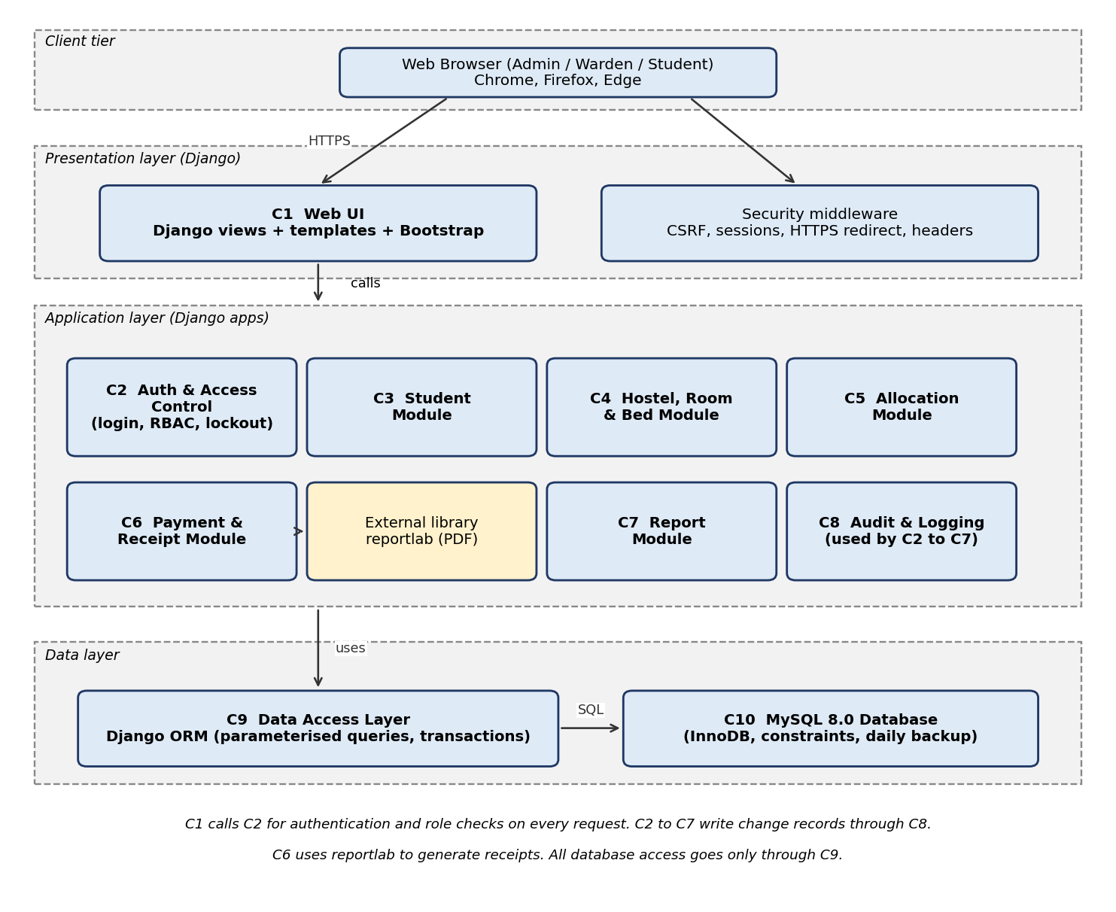
Figure 1: Component diagram of HMS
3.4 Component Descriptions
ID | Component | Responsibility | Django app (planned)
C1 | Web UI | Renders pages and forms, handles user input and output messages, role-based navigation menu | templates, views
C2 | Auth & Access Control | Login/logout, password hashing, account  lockout, session timeout, role checks  (Admin/Warden/Student) on every request, user account administration | accounts
C3 | Student Module | Register, search, update and deactivate students; student self-view | students
C4 | Hostel, Room & Bed Module | Add/edit hostels and rooms, auto-create beds, list available beds | hostels
C5 | Allocation Module | Allocate, transfer and release beds in atomic transactions; enforce business rules BR-1 to BR-3; allocation history | allocations
C6 | Payment & Receipt Module | Record payments, generate unique receipts (PDF), compute payment status | payments
C7 | Report Module | Occupancy report and CSV export | reports
C8 | Audit & Logging | Write audit entries (user, action, record, time) for logins and data changes; application error  logging without sensitive data | audit
C9 | Data Access Layer | Django ORM models, parameterised queries, transactions, soft delete | models
3

ID | Component | Responsibility | Django app (planned)
C10 | MySQL Database | Persistent storage (InnoDB), integrity constraints, daily backup | MySQL 8.0
3.5 Chosen Architecture Pattern and Rationale
A layered architecture (presentation, application, data) implemented with Django's Model-View-Template (MVT) pattern is chosen. Each feature is a separate Django app, so teammates can own modules independently (product ownership) and test them separately.
Rationale: clear separation of concerns; all database access goes through one layer (C9), which makes SQL-injection prevention and transaction control easy to verify; Django's built-in authentication, CSRF protection and ORM directly support the security requirements.
Rejected alternatives: Microservices were rejected as too complex to build, deploy and test for a single-hostel system with a small team. A single-file monolith without modules was rejected because it would not support independent ownership or unit testing.
3.6 Technology Stack & Data Stores
Item | Choice
Language / framework | Python 3.11+, Django 5.x
Front end | Django templates, HTML, CSS, Bootstrap 5
Database | MySQL 8.0 (InnoDB) accessed through Django ORM (mysqlclient driver)
PDF receipts | reportlab
Security | Django auth (PBKDF2), CSRF middleware, session framework, TLS 1.2+ at the web server
Testing / tools | Django test runner, Selenium, Postman, JMeter, OWASP ZAP, GitHub, GitHub Issues
Documentation / diagrams | draw.io / PlantUML style UML, Swagger/OpenAPI style API tables
3.7 Risks & Mitigations
Risk | Mitigation
Two wardens allocate the same bed at the same time | Single transaction with row lock (SELECT ... FOR UPDATE) and a database unique constraint on active allocation per bed
Slow search with 5,000 students | Indexes on Student ID, name and hostel; pagination of lists
Data loss | Daily database backup; restore tested (TC-OPS-01)
Security flaws in custom code | Use Django's built-in security features; run OWASP ZAP scan; review against Section 3.9
Team members' modules do not integrate | Fixed interfaces in Section 4.3; shared models in C9; integration tests each sprint
3.8 Traceability to Requirements
Every requirement of the SRS is allocated to at least one component (Architecture Ref) and to a design element (Design Ref). This table is repeated in Appendix C of the SRS.
4

Req ID | Component(s) | Design reference
REQ-1 | C1, C2 | API-A1; Sec 4.1
REQ-2 | C2 | API-A1; Sec 4.4
REQ-3 | C2 | API-A2; Sec 3.9
REQ-4 | C2 | API-A3
REQ-5 | C3 | SD-1; API-S1
REQ-6 | C3, C9 | SD-1; API-S1
REQ-7 | C3, C9 | API-S2
REQ-8 | C3 | API-S3
REQ-9 | C3, C5 | API-S4
REQ-10 | C4 | API-H1
REQ-11 | C4 | API-H2
REQ-12 | C4, C9 | API-H2
REQ-13 | C4 | API-H3
REQ-14 | C5, C9 | SD-2; API-L1
REQ-15 | C5, C9 | SD-2; API-L1
REQ-16 | C5 | SD-2; API-L1
REQ-17 | C5, C9 | API-L2
REQ-18 | C5 | API-L3
REQ-19 | C5 | API-L4
REQ-20 | C6 | API-P1
REQ-21 | C6 | API-P2
REQ-22 | C6 | API-P3
REQ-23 | C7 | API-R1
REQ-24 | C2, C3 | API-M1
NFR-1 | C1, C9, C10 | Sec 4.1 (indexes, pagination)
NFR-2 | C5, C9 | SD-2 (single transaction)
NFR-3 | C9, C10 | Sec 4.1 (indexes)
NFR-4 | C10 | Sec 4.4 (backup job)
NFR-5 | C9 | Sec 4.1 (soft delete)
NFR-6 | C2 | Sec 3.9
NFR-7 | C2 | Sec 3.9; Sec 4.3
NFR-8 | C2, C3 | API-M1; Sec 3.9
NFR-9 | C2 | API-A2; Sec 3.9
NFR-10 | C1, C9 | Sec 3.9; Sec 4.4
NFR-11 | C8 | Sec 4.4
NFR-12 | C2, C1 | API-A1; Sec 3.9
5

3.9 Security Architecture
Trust boundaries: (1) Browser to web server (untrusted network, protected by HTTPS); (2) Web server to application (every request is authenticated and authorised in C2); (3) Application to database (only C9 connects, using a least-privilege database account).
Threat modelling (STRIDE):
Threat | Example in HMS | Control (component) / requirement
Spoofing | Attacker guesses a warden's password | PBKDF2 hashed passwords, password policy, lockout after 5 failures (C2) - NFR-6, NFR-12
Tampering | Altering allocation or payment data, forged form submission | CSRF tokens, server-side validation, role checks, atomic transactions, payments not editable (C1, C2, C5, C6) - NFR-7, NFR-10
Repudiation | Warden denies releasing a bed | Audit log with user, action, record, timestamp (C8) - NFR-11
Information disclosure | Student reads another student's data; data sniffed on network | Own-data checks, RBAC, HTTPS TLS 1.2+, no sensitive data in logs or errors (C2, C3) - NFR-7, NFR-8, NFR-12
Denial of service | Repeated login attempts, heavy searches | Lockout, pagination and indexed queries (C2, C9) - NFR-1, NFR-12
Elevation of privilege | Warden opens admin URLs directly | Role check on every request, HTTP 403 (C2); only Admin manages users and hostels -  NFR-7, BR-4
Security controls summary:
• Authentication: Django auth with PBKDF2 salted hashes; session timeout 15 minutes; HttpOnly and Secure cookies.
• Authorisation: a role decorator / middleware in C2 is applied to every view; default is deny.
• Input handling: Django forms for validation; ORM only (no string-built SQL); templates auto-escape output.
• Transport: HTTPS only; HTTP redirects to HTTPS.
• Accountability: all changes recorded in the audit table by C8.
• Database: least-privilege account; backups stored separately from the server.
Security objectives SO-1 to SO-4 of the SRS are met by the controls above: SO-1 (authentication, RBAC), SO-2 (validation, transactions, audit), SO-3 (own-data checks, HTTPS), SO-4 (lockout, backups).
4. Design
4.1 Design Overview
HMS is designed as layered Django apps. Views call service functions in the module apps; the service functions use ORM models and enclose multi-step changes in database transactions. Business rules BR-1 to BR-6 are enforced both in code and by database constraints.
Main data entities:
Entity | Key attributes | Relationships
User | username, password hash, role, is_active, failed_attempts, locked_until | A Student user links to one Student
6

Entity | Key attributes | Relationships
Student | student_id (unique), name, dob, gender, course, year, mobile, email, guardian details, status | Has many Allocations and Payments
Hostel | name (unique), type (Boys/Girls) | Has many Rooms
Room | hostel, room_number (unique per hostel), floor, room_type, capacity (1-4), fee_amount (INR) | Has many Beds
Bed | room, bed_number, status  (Available/Occupied/Maintenance) | Has many Allocations over time
Allocation | student, bed, allocated_on, vacated_on (null = active) | Unique constraint: one active allocation per bed and per  student
Payment | student, receipt_no (unique), amount, date, mode, reference | Belongs to Student; never edited
AuditLog | user, action, record, timestamp | Written by C8
Performance design: indexes on student_id, name, hostel and bed status; paginated lists (25 rows per page); allocation done in one short transaction.
Soft delete: students and users are marked inactive, never removed (NFR-5).
4.2 UML Sequence Diagrams
Two flows specific to HMS are modelled: SD-1 student registration and SD-2 bed allocation.
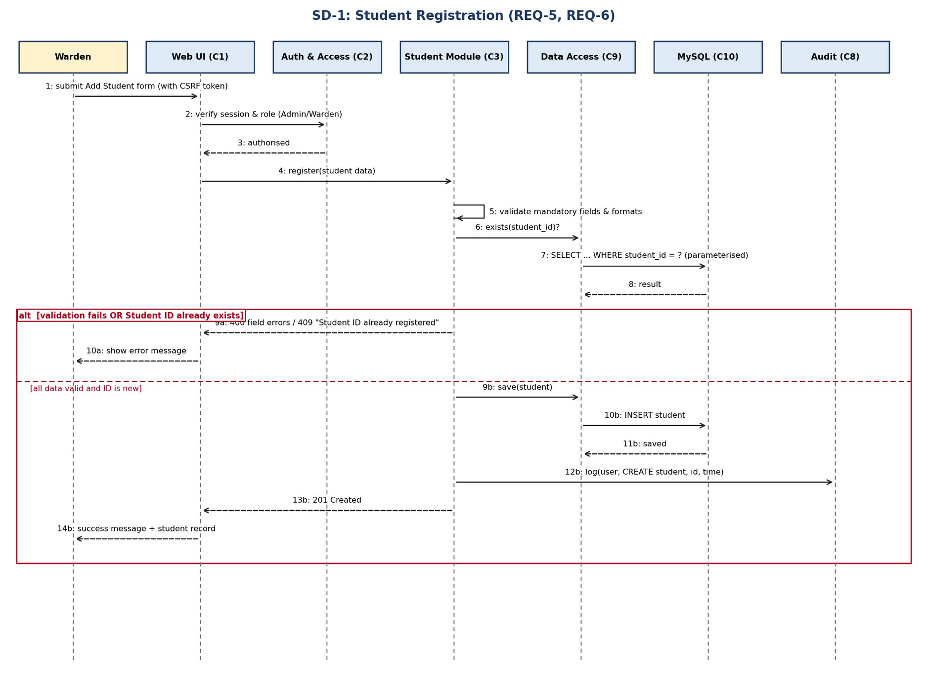
Figure 2: SD-1 Student Registration
7

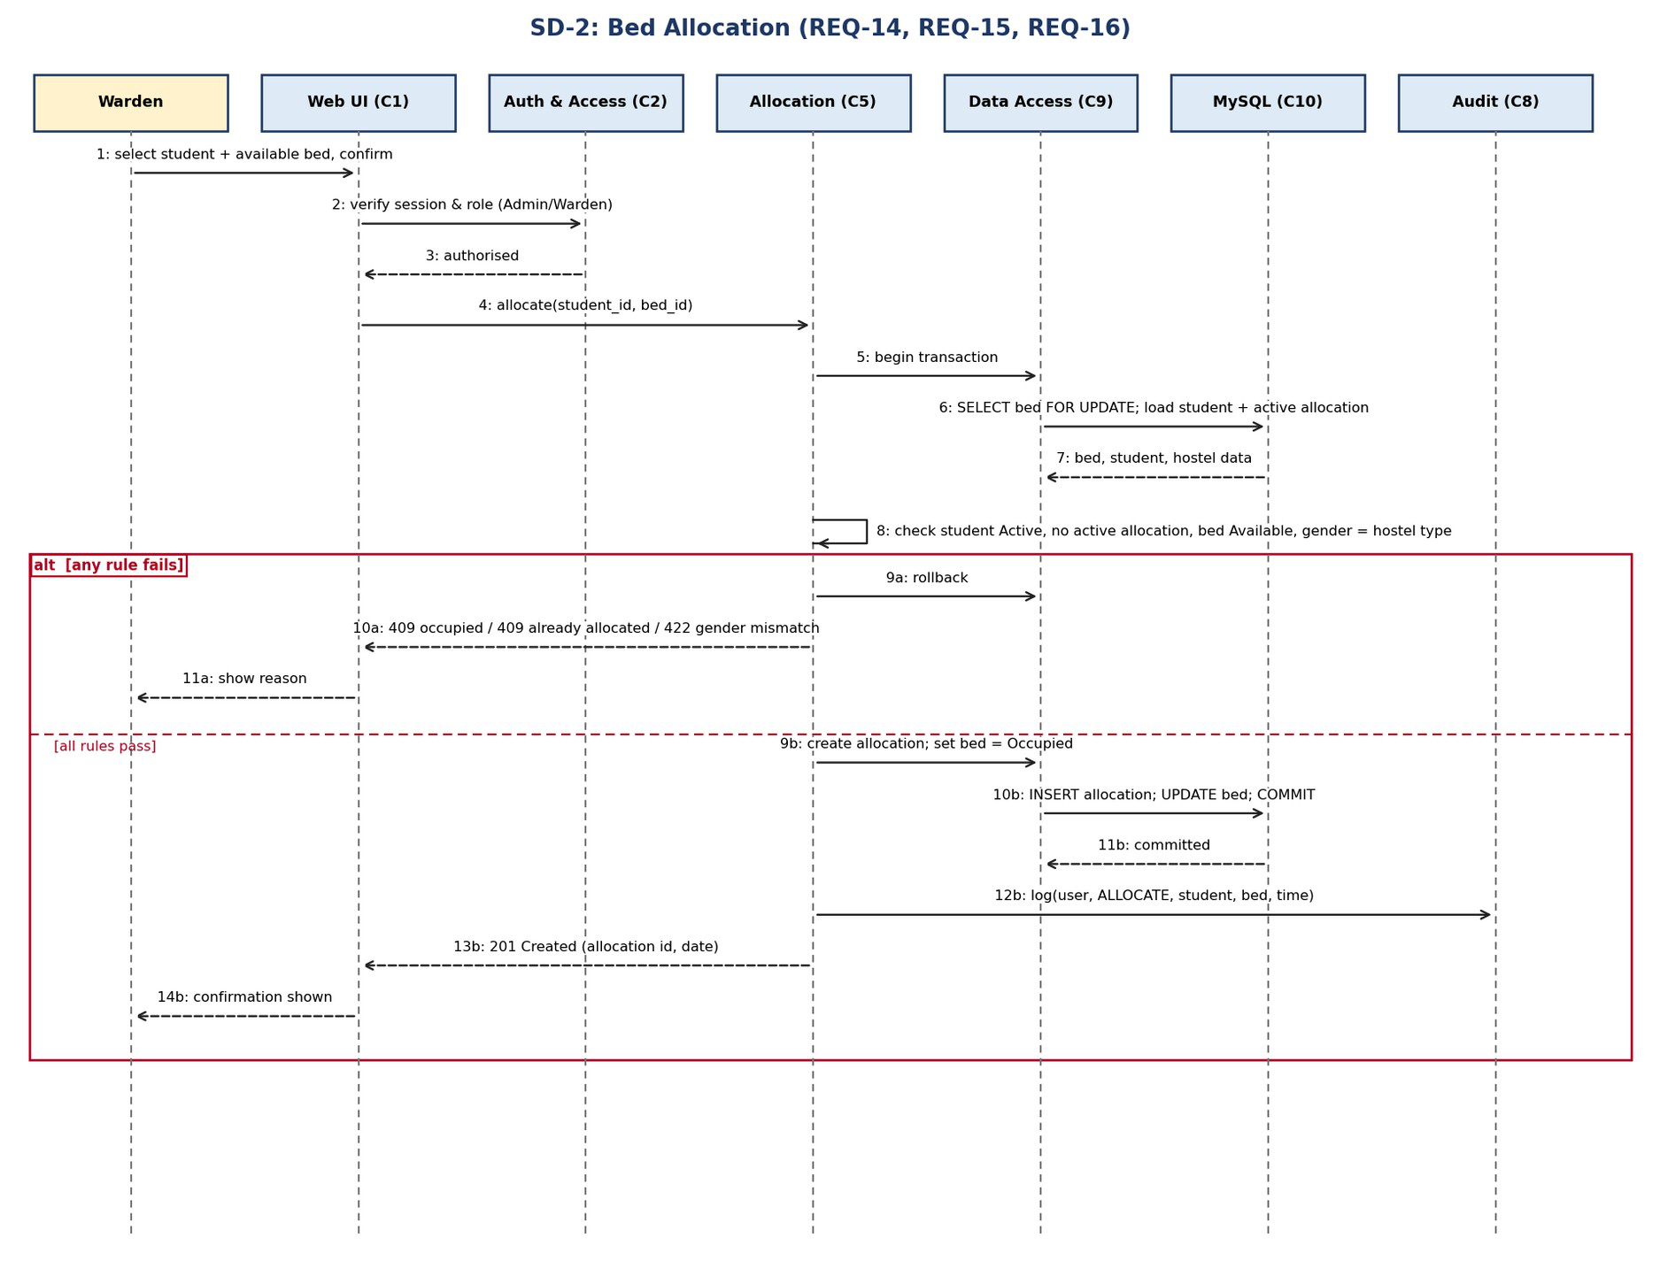
Figure 3: SD-2 Bed Allocation
4.3 API Design
Interfaces are defined for all components. Each module exposes its operations as HTTP endpoints (rendered pages for the browser, and JSON responses that can be exercised with Postman). All endpoints except login require an authenticated session, a CSRF token for state-changing methods, and the roles listed. Common error format is given in Section 4.4.
4.3.1 Auth & Access Control (C2) - roles: all
ID | Method | Endpoint | Request | Success response | Errors
API-A1 | POST | /auth/login/ | {username, password} | 200 {role, redirect} | 401 invalid  credentials; 423 account locked
API-A2 | POST | /auth/logout/ | - | 204 No Content | 401 not logged in
API-A3 | POST / PATCH | /users/ and /users/{id}/ | {username, password, role} / {is_active, role} | 201 {id, role} / 200 | 400 invalid; 403 not Admin; 409  duplicate username
4.3.2 Student Module (C3) - roles: Admin, Warden (API-M1: Student)
ID | Method | Endpoint | Request | Success response | Errors
API-S1 | POST | /students/ | {student_id, name, dob,  gender, course, year, mobile, email, guardian_name,  guardian_mobile, address?} | 201 {id, student_id, name} | 400 field errors; 403; 409 Student ID already  registered
API-S2 | GET | /students/?  q=&hostel=&page= | query parameters | 200 {results[], page, total} | 403
8

ID | Method | Endpoint | Request | Success response | Errors
API-S3 | PATCH | /students/{id}/ | {mobile, email, course, year, guardian..., address} | 200 {student} | 400; 403; 404; 422 student_id cannot be changed
API-S4 | POST | /students/{id}/deactivate/ | - | 200 {status: Inactive} | 403; 404; 409  student has active allocation
API-M1 | GET | /me/ | - | 200 {profile, allocation, payment_status} | 401; 403 (only own data returned)
4.3.3 Hostel, Room & Bed Module (C4) - roles: Admin (write), Warden (read)
ID | Method | Endpoint | Request | Success response | Errors
API-H1 | POST | /hostels/ | {name, type} | 201 {id} | 400; 403; 409  duplicate name
API-H2 | POST | /hostels/{id}/rooms/ | {room_number, floor, room_type, capacity, fee_amount} | 201 {room_id, beds[]} | 400 capacity not 1-4; 403; 404; 409  duplicate room
API-H3 | GET | /beds/available/?  hostel=&floor=&room_ty pe= | query parameters | 200 {beds[]} | 403
4.3.4 Allocation Module (C5) - roles: Admin, Warden
ID | Method | Endpoint | Request | Success response | Errors
API-L1 | POST | /allocations/ | {student_id, bed_id} | 201 {allocation_id, allocated_on} | 403; 404  student/bed; 409 bed occupied or student already allocated; 422  gender mismatch
API-L2 | POST | /allocations/{id}/transfer/ | {new_bed_id} | 200 {allocation_id, bed} | 403; 404; 409 new bed occupied; 422 gender mismatch
API-L3 | POST | /allocations/{id}/release/ | {vacate_date} | 200 {status: Released} | 400 invalid date; 403; 404; 409  already released
API-L4 | GET | /students/{id}/allocations/ | - | 200 {allocations[]} | 403; 404
4.3.5 Payment (C6) and Report (C7) Modules - roles: Admin, Warden
ID | Method | Endpoint | Request | Success response | Errors
API-P1 | POST | /payments/ | {student_id, amount, date, mode, reference?} | 201 {receipt_no} | 400 amount not > 0 / bad mode; 403;  404
API-P2 | GET | /payments/{receipt_no}/ receipt.pdf | - | 200 PDF file | 403; 404
API-P3 | GET | /students/{id}/payment-status/ | - | 200 {status: Paid|  Partial|Pending, paid, due} | 403; 404
API-R1 | GET | /reports/occupancy/?hostel=&format=csv and /reports/payment-status/?hostel=&format=csv | query parameters | 200 {rows[]} or CSV file | 403; 404
Example - POST /allocations/ (API-L1)
9

Request | Response
POST /allocations/  Content-Type: application/json X-CSRFToken: <token>  { "student_id": "PES1UG24CS163", "bed_id": 42 } | 201 Created  { "allocation_id": 311, "allocated_on": "2026-10-05", "bed": "101-A" }  Error example:  409 { "error": { "code": "BED_OCCUPIED", "message": "Bed 101-A is already occupied" } }
4.4 Error Handling, Logging & Monitoring
Standard error format: { "error": { "code": "<MACHINE_CODE>", "message": "<plain-
language text>", "fields": {optional field errors} } }. Browser pages show the same message
next to the form field or at the top of the page.
HTTP | Code | When | User message / behaviour
400 | VALIDATION_ERROR | Missing or invalid input | Field-level messages; nothing is saved
401 | AUTH_REQUIRED /  INVALID_CREDENTIALS | Not logged in or wrong login | "Invalid username or password" (does not say which was wrong); redirect to login
403 | ACCESS_DENIED | Role not allowed, CSRF failure | "Access denied"; no data changed; event logged
404 | NOT_FOUND | Record does not exist | "Record not found"
409 | DUPLICATE /  BED_OCCUPIED /  ALREADY_ALLOCATED / HAS_ACTIVE_ALLOCATIO N | Business rule conflict | Message names the conflict, for example "Student ID already registered"
422 | GENDER_MISMATCH / IMMUTABLE_FIELD | Rule violation on valid input | Message explains the rule
423 | ACCOUNT_LOCKED | 5 failed logins | "Account locked for 15 minutes"
500 | SERVER_ERROR | Unexpected failure | Generic message "Something went wrong"; transaction rolled back; details only in server log

• | Transactions: allocation, transfer and release run in one database transaction; any
failure rolls back so data is never half-updated.
• Logging: application log (errors, with a request ID) and audit log (who did what and
when). Passwords, session IDs and full personal details are never written to logs.
• Error pages never show stack traces, SQL or file paths (Django DEBUG is off in
deployment).
• Monitoring: track login failure count, HTTP 4xx/5xx rate, average response time,
backup job success, and database free space; review weekly during the project.
4.5 UX Design
• Role-based dashboard and navigation menu showing only permitted options.
• Forms with required-field markers (*), inline validation messages, and confirmation
dialogs for release, transfer and deactivate actions.
• Bootstrap responsive layout, usable on laptop and mobile screens; readable font sizes
and sufficient colour contrast.
• Allocation screen: select student, view filtered list of available beds, confirm - designed
so a new warden completes it in under 5 minutes (quality attribute: Usability).
• Screens: Login, Dashboard, Student List/Form, Hostel/Room/Bed List, Allocation,
Payment, Receipt, Reports, Staff Accounts, My Allocation (Student).
10

4.6 Open Issues & Next Steps
• Module ownership will be assigned in the sprint plan before implementation; the
architecture supports independent ownership of C2 to C7.
• For v1.0, the fee amount will be maintained as a configurable value per room type and
used by the Payment & Receipt Module to calculate Paid, Partial or Pending status.
• For v1.0, account lockout will be implemented in C2 using the existing failed_attempts
and locked_until fields, with a 15-minute lockout after 5 consecutive failed attempts.
• Fill the Code File Ref column of SRS Appendix C as modules are implemented.
• Future enhancements: online payment gateway, e-mail notifications, mess
management, visitor log.
5. Appendices
5.1 Glossary: HMS, SRS, STP, MVT, ORM, RBAC, CSRF, TLS, STRIDE, ADR, API, SD
(Sequence Diagram), C1-C10 (components).
5.2 References: IEEE 42010 (Architecture description), IEEE Std 830 (SRS), OWASP
ASVS 4.0, Django documentation 5.x, MySQL 8.0 Reference Manual, HMS SRS, HMS
Software Test Plan.
5.3 Tools: draw.io / PlantUML style diagrams, Swagger/OpenAPI style tables, Postman,
GitHub.
11

