**JUnit Testing Exercises**

**Exercise 1: Setting Up Junit**

Step 1: Created a new Java project named JUnitDemo in Eclipse.

Step 2: Adding JUnit 5 in Eclipse:

1. Right-click on the project → Build Path → Add Libraries…

2. Select JUnit → Click Next

3. Select JUnit 5 → Click Finish

Step 3: Creating 2 packages com.example.calculator contains business logic (Calculator), com.example.calculator.test contains test class (CalculatorTest).

**Calculator.java**

package com.example.calculator;

public class Calculator {

public int add(int a, int b) {

return a + b;

}

public int multiply(int a, int b) {

return a * b;

}

}

**CalculatorTest.java**

package com.example.calculator.test;

import com.example.calculator.Calculator;

import static org.junit.jupiter.api.Assertions.*assertEquals*;

import org.junit.jupiter.api.Test;

public class CalculatorTest {

@Test

void testAdd() {

Calculator calc = new Calculator();

*assertEquals*(7, calc.add(3, 4));

*assertEquals*(-1, calc.add(2, -3));

*assertEquals*(0, calc.add(0, 0));

}

@Test

void testMultiply() {

Calculator calc = new Calculator();

*assertEquals*(15, calc.multiply(3, 5));

*assertEquals*(0, calc.multiply(0, 5));

*assertEquals*(-6, calc.multiply(2, -3));

}

}

Step 4: Configure module-info.java or Delete It

module JUnitDemo {

requires org.junit.jupiter.api;

exports com.example.calculator;

}

Step5: Running Junit Tests:

1. Open NumberUtilsTest.java

2. Right-click inside the file → Choose Run As → JUnit Test.

3. Eclipse runs the test and shows the JUnit panel with a green bar if all tests pass.

**Output:**

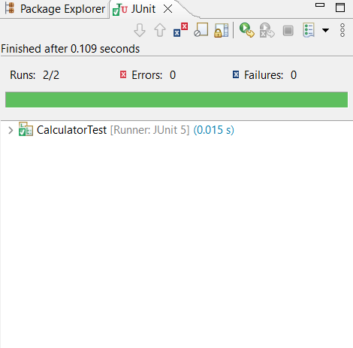

**Exercise 3: Assertions in Junit**

Step1: Creating a class AssertionsTest in com.example.calculator.test package.

**AssertionsTest.java**

package com.example.calculator.test;

import static org.junit.jupiter.api.Assertions.*;

import org.junit.jupiter.api.Test;

public class AssertionsTest {

@Test

public void testAssertions() {

*assertEquals*(5, 2 + 3);

*assertTrue*(5 > 3);

*assertFalse*(5 < 3);

*assertNull*(null);

*assertNotNull*(new Object());

}

}

Step2: Ensure that JUnit5 library and requirements in module-info.java are added.

Step3: Running Junit Tests:

1. Open AssertionsTest.java.

2. Right-click inside the file → Choose Run As → JUnit Test.

3. Eclipse runs the test and shows the JUnit panel with a green bar if all tests pass.

**Output:**

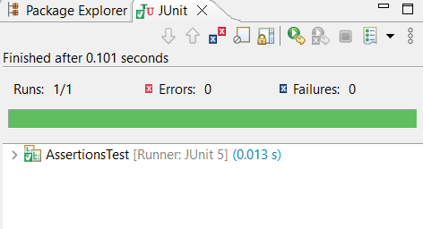

**Exercise 4: Arrange-Act-Assert (AAA) Pattern, Test Fixtures, Setup and Teardown Methods in Junit**

Step1: Created a new package com.example.cart and added a simple class ShoppingCart.java.

**ShoppingCart.java:**

package com.example.cart;

import java.util.ArrayList;

import java.util.List;

public class ShoppingCart {

private List<String> items = new ArrayList<>();

public void addItem(String itemName) {

items.add(itemName);

}

public void removeItem(String itemName) {

items.remove(itemName);

}

public int getItemCount() {

return items.size();

}

public void clear() {

items.clear();

}

}

Step2: Created a separate test package com.example.cart.test and added ShoppingCartTest.java.

**ShoppingCartTest.java:**

package com.example.cart.test;

import com.example.cart.ShoppingCart;

import static org.junit.jupiter.api.Assertions.*;

import org.junit.jupiter.api.BeforeEach;

import org.junit.jupiter.api.AfterEach;

import org.junit.jupiter.api.Test;

public class ShoppingCartTest {

private ShoppingCart cart;

@BeforeEach

void setUp() {

cart = new ShoppingCart();

System.*out*.println("Setup: New shopping cart created.");

}

@AfterEach

void tearDown() {

cart = null;

System.*out*.println("Teardown: Shopping cart reference cleared.");

}

@Test

void testAddItem() {

cart.addItem("Laptop");

System.*out*.println("Item added: Laptop");

*assertEquals*(1, cart.getItemCount());

}

@Test

void testRemoveItem() {

cart.addItem("Mouse");

System.*out*.println("Item added: Mouse");

cart.removeItem("Mouse");

System.*out*.println("Item removed: Mouse");

*assertEquals*(0, cart.getItemCount());

}

@Test

void testClearCart() {

cart.addItem("Book");

cart.addItem("Pen");

System.*out*.println("Items added: Book, Pen");

cart.clear();

System.*out*.println("Cart cleared");

*assertEquals*(0, cart.getItemCount());

}

}

Step3: Ensure that JUnit5 library and requirements in module-info.java are added.

Step4: Running JUnit Tests

1. Right-click on ShoppingCartTest.java.

2. Select Run As > JUnit Test.

3. Check the JUnit result tab and console for output.

**Output:**

**Console:**

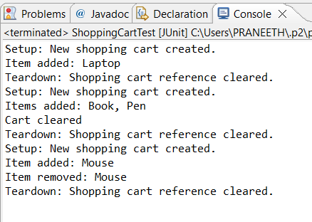

**JUnit result tab:**

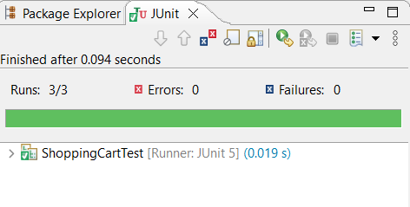

**Mockito Hands-On Exercises**

**Exercise 1: Mocking and Stubbing**

Step1: Create a New Maven Project in Eclipse:

Go to File → New → Project…

Select Maven Project → Click Next

Choose Create a simple project (skip archetype selection) → Next

Fill:

* Group Id: com.example
* Artifact Id: MockitoTestExample

Click Finish

Step2: Add Dependencies to pom.xml:

<project xmlns="http://maven.apache.org/POM/4.0.0"

xmlns:xsi="http://www.w3.org/2001/XMLSchema-instance"

xsi:schemaLocation="http://maven.apache.org/POM/4.0.0

http://maven.apache.org/xsd/maven-4.0.0.xsd">

<modelVersion>4.0.0</modelVersion>

<groupId>com.example</groupId>

<artifactId>MockitoTestExample</artifactId>

<version>1.0-SNAPSHOT</version>

<packaging>jar</packaging>

<name>MockitoTestExample</name>

<properties>

<project.build.sourceEncoding>UTF-8</project.build.sourceEncoding>

<maven.compiler.source>17</maven.compiler.source>

<maven.compiler.target>17</maven.compiler.target>

</properties>

<dependencies>

<dependency>

<groupId>org.junit.jupiter</groupId>

<artifactId>junit-jupiter</artifactId>

<version>5.11.0</version>

<scope>test</scope>

</dependency>

<dependency>

<groupId>org.mockito</groupId>

<artifactId>mockito-core</artifactId>

<version>5.11.0</version>

<scope>test</scope>

</dependency>

</dependencies>

<build>

<plugins>

<plugin>

<groupId>org.apache.maven.plugins</groupId>

<artifactId>maven-surefire-plugin</artifactId>

<version>3.2.5</version>

</plugin>

</plugins>

</build>

</project>

Step3: Create a package com.example in src/main/java and create the core classes:

**ExternalApi.java:**

package com.example;

public interface ExternalApi {

String getData();

}

**MyService.java:**

package com.example;

public class MyService {

private ExternalApi api;

public MyService(ExternalApi api) {

this.api = api;

}

public String fetchData() {

return api.getData();

}

}

Step4: Create a package com.example in src/test/java and create the test class:

**MyServiceTest.java:**

package com.example;

import static org.junit.jupiter.api.Assertions.*assertEquals*;

import static org.mockito.Mockito.*;

import org.junit.jupiter.api.Test;

import org.mockito.Mockito;

public class MyServiceTest {

@Test

public void testExternalApi() {

ExternalApi mockApi = Mockito.*mock*(ExternalApi.class);

*when*(mockApi.getData()).thenReturn("Mock Data");

MyService service = new MyService(mockApi);

String result = service.fetchData();

*assertEquals*("Mock Data", result);

}

}

Step5: Run the Test

1. Open MyServiceTest.java.

2. Right-click inside the file → Choose Run As → JUnit Test.

3. Eclipse runs the test and shows the JUnit panel with a green bar if all tests pass.

**Output:**

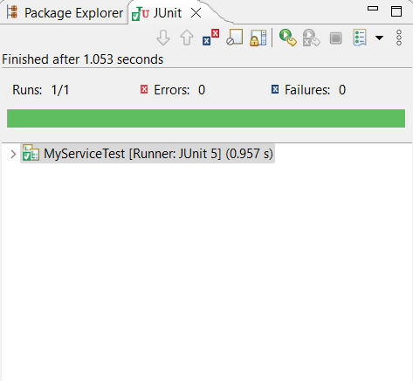

**Exercise 2: Verifying Interactions**

Step1: Create a New Maven Project in Eclipse:

Go to File → New → Project…

Select Maven Project → Click Next

Choose Create a simple project (skip archetype selection) → Next

Fill:

* Group Id: com.example
* Artifact Id: MockitoVerifyExample

Click Finish

Step2: Add JUnit and Mockito Dependencies to pom.xml.

Step3: Create a package com.example in src/main/java and create the core classes:

**ExternalApi.java:**

package com.example;

public interface ExternalApi {

String getData();

}

**MyService.java:**

package com.example;

public class MyService {

private ExternalApi api;

public MyService(ExternalApi api) {

this.api = api;

}

public String fetchData() {

return api.getData();

}

}

Step4: Create a package com.example in src/test/java and create the test class:

package com.example;

import static org.mockito.Mockito.*;

import org.junit.jupiter.api.Test;

public class MyServiceTest {

@Test

public void testVerifyInteraction() {

ExternalApi mockApi = *mock*(ExternalApi.class);

MyService service = new MyService(mockApi);

service.fetchData();

*verify*(mockApi).getData();

}

}

Step5: Run the Test

1. Open MyServiceTest.java.

2. Right-click inside the file → Choose Run As → JUnit Test.

3. Eclipse runs the test and shows the JUnit panel with a green bar if all tests pass.

**Output:**

