TRACEOUT

STEP1:- open windows command prompt and Type tracert command.

STEP2:- Type [www.saveetha.com](http://www.saveetha.com) in that.

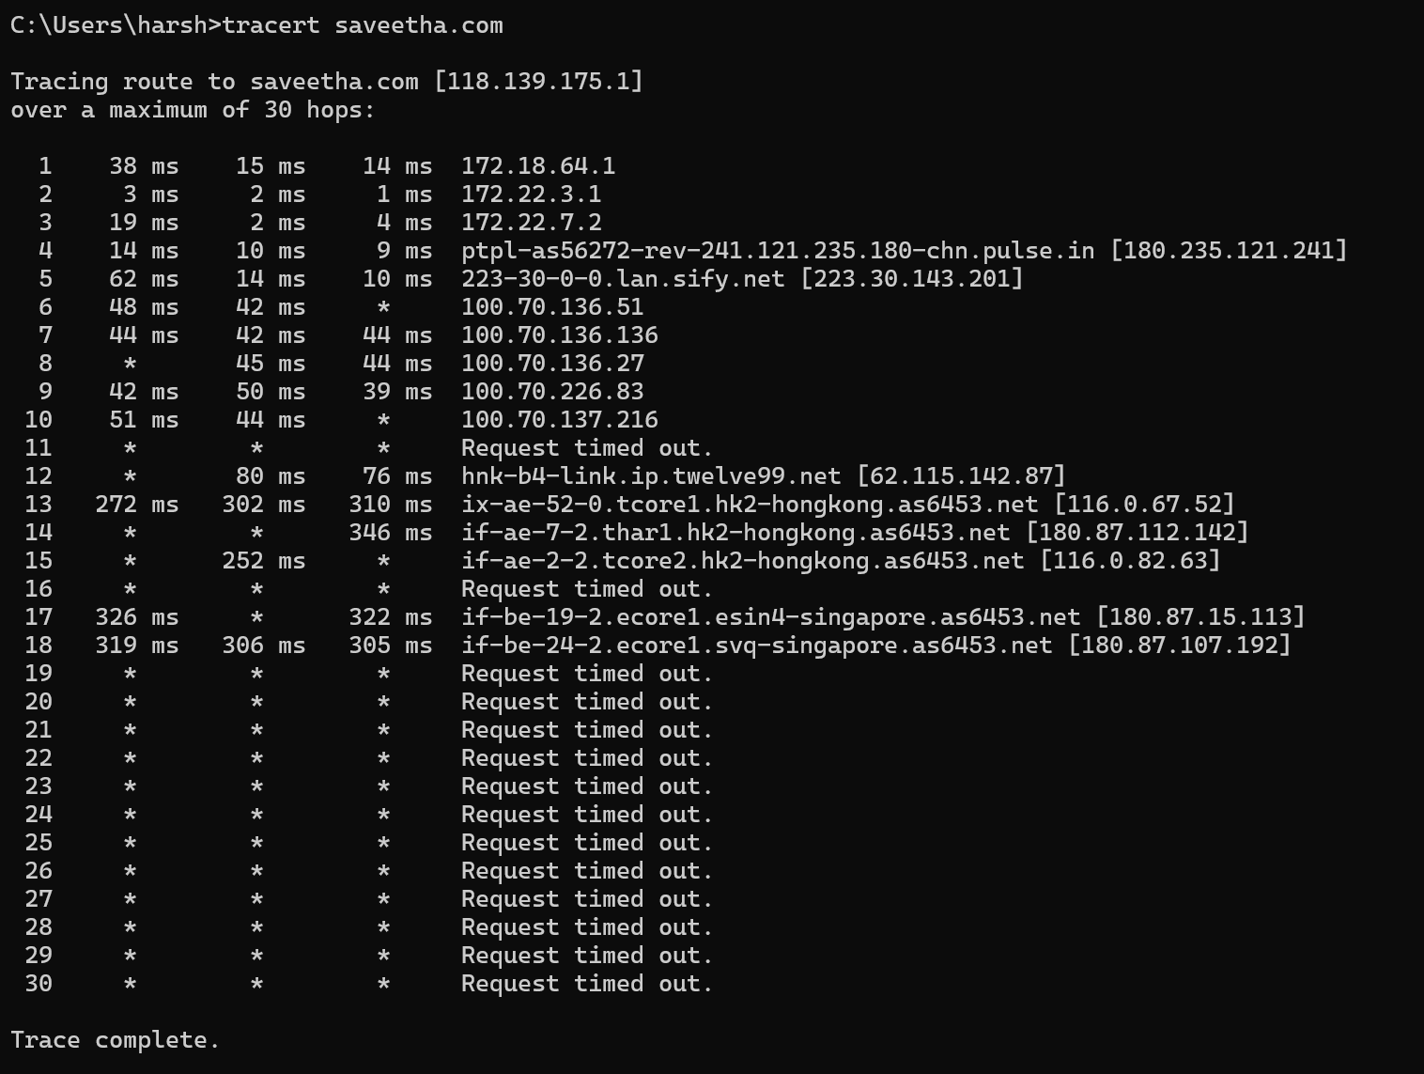

STEP3:-Enter ping IP Address

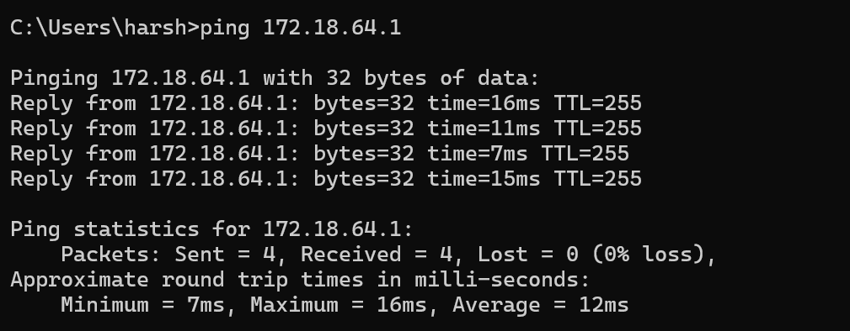

STEP4:- ENTER netstat

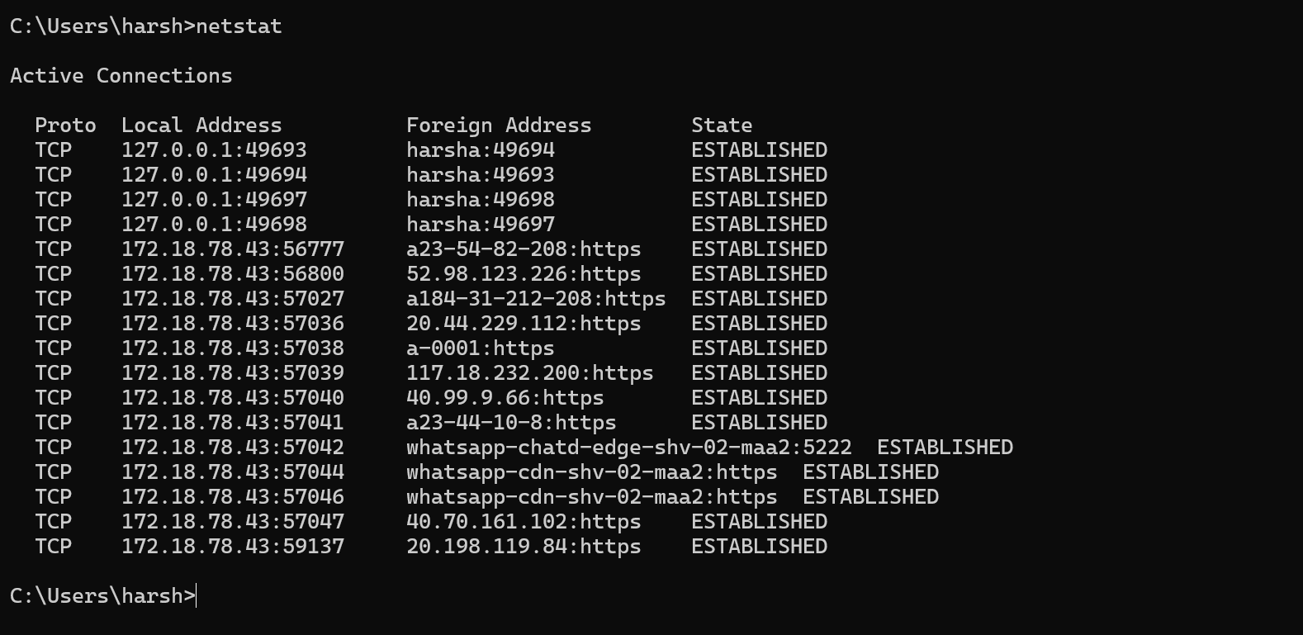

STEP5:- Type ipconfig

