**CHAPTER-I**

**INTRODUCTION**

* 1. **Description of Wireless Sensor Networks**

Wireless sensor networks (WSNs) have become an important field of research from past several years. WSNs usually comprise of large number of disseminated, self-directed, tiny, low cost, low power multifunctional sensor nodes that are deployed in a region of interest. Apart from sensing capability, sensor nodes are capable of processing data and communicating, as they are equipped with embedded microprocessors and radio transceivers. The contemporary developments in microelectronic mechanical systems (MEMS); wireless communication technologies; the smart sensors deployed in a physical area networked through wireless links*i.e*., the internet provide unprecedented opportunities for a variety of civilian and military applications (environmental monitoring, battle field surveillance and industry process control etc.).

Sensor nodes offer a powerful combination of distributed sensing, computing and communication. The exceptional capabilities of these tiny sensor nodes enable the realization of WSNs based on the collaborative effort of the sensor nodes [1]. Wireless sensor networks incorporate knowledge and technologies from three different fields; wireless communications, networking and control theory. In order to realize the existing and potential applications for WSN; sophisticated and extremely efficient communication protocols are required.

In many real time applications, the sensor nodes are performing different tasks like neighbor node discovery [2,3], smart sensing [4], data storage [5,6], processing data aggregation [7], target tracking [8], control and monitoring node localization [9,10], synchronization and efficient routing between nodes and base stations [11]. Sensor networks may consist of many different types [12] of sensors such as seismic, low sampling rate magnetic, thermal, visual, inferred, acoustic, and radar, which are able to monitor a wide variety of ambient conditions (temperature, humidity, vehicular movement, lightning condition, pressure, soil makeup, noise levels, object tracking, mechanical stress on subjected object, current characteristics such as speed, direction, and size of an object). Unlike traditional wireless communication networks (cellular, mobile ad hoc networks (MANET)); the WSNs have unique characteristics such as denser level of node deployment, higher unreliability of sensor nodes, and severe energy, computation and storage constraints *etc*.

* 1. **Characteristics**

A WSN can be defined as a network of sensor devices, which can communicate the information gathered from a monitored field through wireless links. These networks are vastly used for assessing numerous parameters (temperature, pressure, humidity *etc*.) of real-world unattended physical environment. The unique characteristics of the WSNs must be taken into consideration for efficient deployment of the network [13]. The significant characteristics of the WSNs are represented in Fig.1.

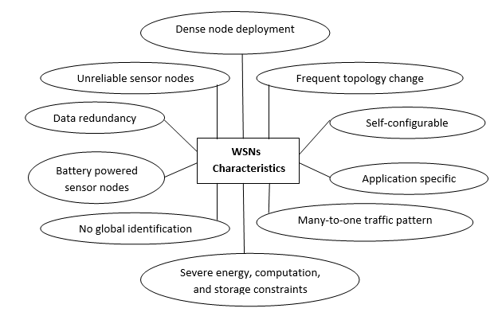

Fig.1: WSNs characteristics

***Dense node deployment*:**Sensor networks are typically deployed in harsh environments (military, submarines, and battlefield). The influence of physical parameters (temperature pressure, wave speed, wind speed, pollution *etc*.) of such environments on sensor nodes introduces the performance degradation and failure of nodes. If a node fails in a network, then it is impossible to repair or reconfigure. Hence, densely deployed sensor nodes are required to improvise the performance of WSNs [14].

***Battery powered sensor nodes*:**The sensor nodes are typically driven by batteries. Majority of WSNs applications are deployed in the harsh environments, where it is impossible to recharge or change the batteries.

***Severe energy, computation, and storage constraints*:**Sensor nodes are usually operated at extremely hostile environmental conditions (high & low temperatures, underground, and underwater) such that, they require high energy to operate for long time. The applications (habitat health monitoring, target tracking) of sensor networks require long term monitoring of data and hence should offer large storage and computational capability [15, 16].

***Self-configurable*:**The sensor nodes having the ability to configure themselves into a communication network and are deployed randomly in a region of interest without careful planning and infrastructure. The self-configure nature and mobility of sensor nodes enforces the change in topology and inconsistence of network topology.

***Application specific*:**The sensor nodes have different type of characteristics depending upon the environment. The sensor networks [17] designed for military, navigation, and surveillance systems offers different specifications (range, cost, storage, power, processor *etc*.) of sensors and environmental parameters (temperature, pressure, PH, salinity, humidity *etc.*). For example, the sensors used for environmental monitoring are not suitable for underwater habitat monitoring.

***Unreliable sensor nodes*:**The nature of the environment and physical parameters of the medium makes the sensor nodes unreliable. The nodes in the sensor networks which are deployed to monitor underwater explorations, disasters are highly influenced by the underwater environment conditions. Hence, the nodes in the sensor networks are prone to failure or physical damage.

***Frequent topology change*:** The mobility of sensor nodes introduces frequent change in topology of the sensor networks. In addition to mobility, the presence of unreliable sensor nodes, multipath, and channel fading also played foremost role in topology variations. The scenario metrics like; network size, node density, transmission range of sensor networks also causes changes in topology [18].

***No global identification*:** The presence of large number of sensor nodes in sensor networks would introduce a high overhead for the identification maintenance. Hence, it is impossible to build a global addressing scheme for a sensor network.

***Many-to-one traffic pattern*:** In WSNs the sensed data from various sensor sources is transmitted to a particular sink, thereby exhibiting many-to-one traffic pattern.

***Data redundancy*:** Redundancy is the provision of additional or duplicate resources, which can produce similar results. The sensors nodes are densely deployed in a particular region for specific application. The data sensed by these sensor nodes in a specific application have a certain level of correlation or redundancy [19].

* 1. **Design Objectives**

The sensor nodes capabilities and performance are influenced by the characteristics of the sensor networks and different application requirements (power, storage, range, processor, cleaning elements, hardware structure, cost, size *etc*.). These requirements of the sensor nodes make the design and implementation of WSNs a challenging task and provide specified design objectives for network developers. The significant design objectives of WSNs are outlined in Fig.2.

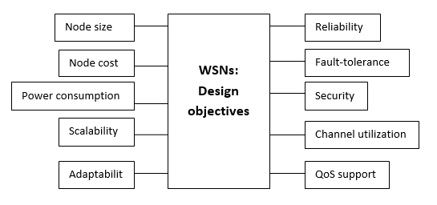

Fig.2: Design Objectives of WSNs

***Node size*:** The primary design objective of sensor networks is reducing node size. Sensor nodes are frequently installed (densely) in harsh or antagonistic environments. The power consumption, cost, and deployment of sensor nodes are facilitated with reduction in the node size.

***Node cost*:** The unique characteristics of the sensor nodes used for military, underwater applications having high cost. Reducing node cost is another primary design objective of sensor networks. Since sensor nodes are usually deployed in a harsh or hostile environment in large numbers and cannot be reused, it is important to reduce the cost of sensor nodes, which in turns reduce the network cost.

***Power consumption*:** The sensor nodes in the network are driven by batteries. Usually, the sensor networks are implemented in harsh environments (battle field, military, underwater *etc.*); hence it is very tough and even unbearable to recharge or replace the batteries. The power requirement of sensor nodes in the harsh environments is very high. Therefore, power consumption is also an important parameter to be considered as one of the major design objectives of wireless sensor network, as it is very crucial to reduce the power consumption and hence, that the nodes life time can be prolonged [20].

***Scalability*:** In WSN the number of sensor nodes deployed in studying a phenomenon may be in the order of hundreds or thousands. This value may change depending up on application. For example, machine diagnosis analysis the node density is around 300 sensor nodes and the density for the vehicle tracking application is around 10 sensor nodes per region [21]. The algorithms and schemes developed to deploy networks should be compatible with this number of nodes. The proposed algorithms must also utilize the high-density nature of the sensor networks.

***Adaptability*:** Mobility, failure of nodes in WSNs results in changes in node density and network topology. Thus, network protocols designed for sensor networks should be adaptive to such density and topology changes.

***Reliability*:** It is essential that the data should be reliably delivered over noisy, error - prone, and time varying wireless channels in many sensor network applications. The node failures [22], link failures [23], power, and environmental conditions will affect the reliable data transmission. The algorithms designed for sensor networks must provide error control and correction mechanisms to ensure reliable data delivery in order to meet these requirements.

***Fault tolerance*:** Sensor nodes are prone to failures due to harsh deployment environments, lack of power, and unattended operations. The failure of sensor nodes should not affect the overall task of the sensor network. Fault tolerance is the ability to sustain sensor network functionalities without any interruption due to node failures [24, 25]. Thus, sensor nodes should be fault tolerant and have the abilities of self-testing, self-calibrating, self-repairing, and self-recovering.

***Security*:**The sensor nodes are vulnerable to adversaries in many military applications. In such circumstances, a sensor network should introduce effective security mechanisms to prevent the data information in the network or a sensor node from unauthorized access or malicious attacks [26].

***Channel utilization*:** Sensor networks have limited bandwidth resources and hence, the communication protocols designed for sensor networks should efficiently make use of bandwidth to improve channel utilization.

***QoS support*:** In sensor networks, different applications may have different quality of service (QoS) requirements in terms of delivery latency and packet loss. For example, fire monitoring (delay sensitive) requires timely data delivery; data collection for scientific exploration is delay tolerant but cannot stand packet loss [27].

Majority of the sensor networks are application specific and have different application requirements. The implementation of all the design objectives in a single network is impractical. In order to meet the requirements of a specific application, only part of the design objectives is implemented in the network design. The unique network characteristics introduce major challenges in the design of sensor network, which involves the following main aspects: limited energy capacity, limited hardware resources, massive and random deployment, dynamic and unreliable environment, diverse applications.

* 1. **Classification**

Wireless sensor networks are deployed in various environments to accomplish different kind of application requirements. These networks are classified depending up on the nature of the environment, where the sensor networks are deployed. The broad classification of WSNs is represented in Fig.3

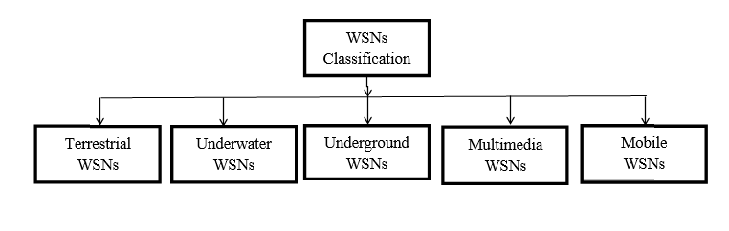

**Fig.3: Classification of WSNs [28]**

* + 1. **Terrestrial WSNs:**

These networks consist of hundreds to thousands of wireless sensor nodes organized either in amorphous (Ad Hoc) or precise (preplanned) manner. Terrestrial WSNs can efficiently communicate with base stations. In an amorphous mode, the sensor nodes are randomly distributed within the largest area that is dropped from a fixed plane. The precise mode considers the optimal placement, grid placement, 2D, and 3D placement models [29]. The battery power is limited (battery is equipped with solar cells as a secondary power source) and the energy conservation of these networks is achieved by using low duty cycle operations, minimizing delays, and optimal routing *etc*.

* + 1. **Underwater WSNs:**

These networks consist of large number of sensor nodes and vehicles deployed underwater. Autonomous underwater vehicles are used for gathering information from these sensor nodes. The long propagation delay, bandwidth, and sensor failures are challenges for underwater sensor communications. These sensors nodes are also having limited battery capacity (cannot be replaced). A typical arrangement (see Fig.4) of the underwater wireless sensor network architecture has been illustrated, where the sensor nodes are clustered together for data transmission.

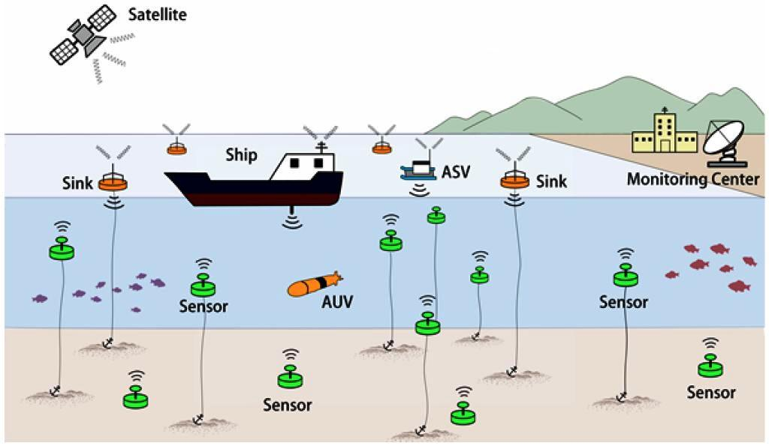

**Fig.4: Typical Architecture of UWSNs [30].**

Each sensor node independently collects the information and transmitted to cluster head. The cluster head is responsible for transmitting the sensed data to surface station. Each cluster node communicates with cluster head using horizontal multi-hop links, whereas the cluster head communicates via vertical links with surface stations [31, 32].

* + 1. **Underground WSNs**

In terms of deployment, maintenance, equipment cost consideration, and proper planning the underground sensor networks are extremely inflated, when compared to terrestrial sensor networks. These networks have number of sensor nodes that are hidden in the ground (see Fig.5) to monitor underground conditions. An additional sink node is deployed above the ground in order to relay information from sensor nodes to the base station. The underground sensors having the limited battery power and are very difficult to recharge. A high level of attenuation and signal loss happens in the underground environment which makes the wireless communication is a challenging task. Fig.5 shows the typical arrangements of the underground sensor network. It consists of a control center at the surface of the earth, where the monitored or sensed data will be processed. The sensor nodes deployed in underground are designed in such a way that, they are susceptible to work at very high temperature and pressure [33].

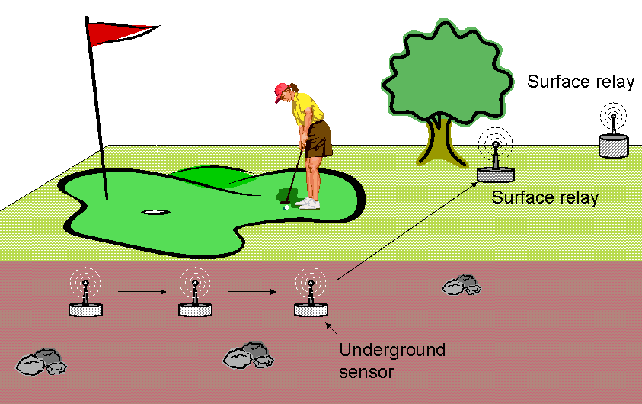

**Fig.5: Underground Wireless Sensor Networks [33]**

* + 1. **Multimedia WSNs:**

Multimedia wireless sensor networks have been proposed to enable tracking and monitoring of events in the form of multimedia, such as imaging, video, audio. These networks consist of low cost sensor nodes equipped with microphones and cameras. These nodes are interconnected with each other over a wireless connection for data compression, retrieval, and correlation. The challenges with the multimedia WSNs include high energy consumption, high bandwidth requirements, and data processing and compression techniques [34, 35]. The architecture for MWSNs is represented in Fig.6, where three sensor networks with different characteristics are shown, possibly deployed in different physical locations. The single-tier network of homogeneous video sensors contain has a subset of sensors having higher processing capabilities called processing hubs.

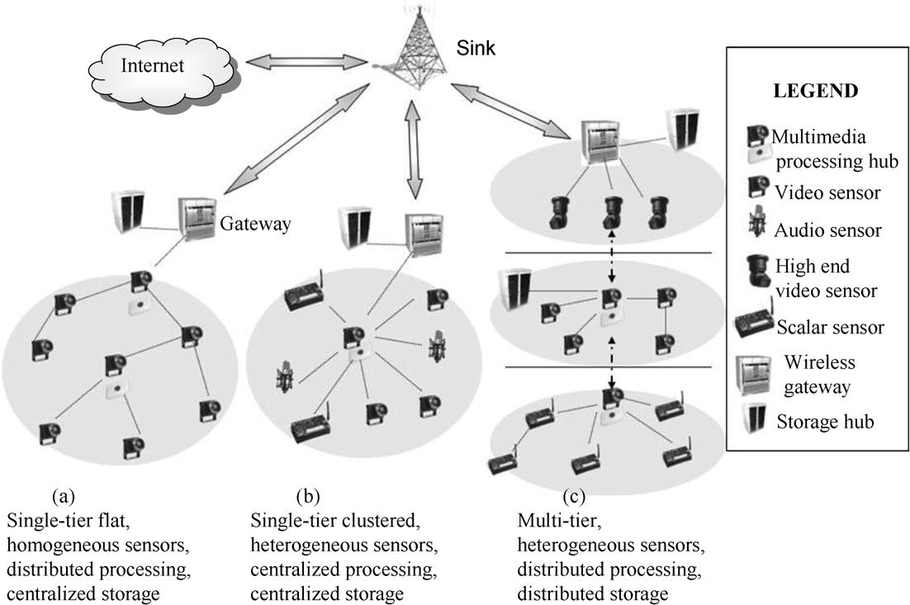

**Fig.6: General Architecture of Multimedia WSNs [34]**

The union of the processing hubs constitutes a distributed processing architecture. The multimedia content gathered is relayed to a wireless gateway through a multi hop path. Similarly, a single-tier network of heterogeneous sensors, where video, audio, and scalar sensors relay data to a central cluster head, which is also in charge of performing intensive multimedia processing on the data (processing hub). The cluster head relays the gathered data to the wireless gateway and to the storage hub. Data processing and storage can be performed in distributed manner at each different tier. A multi-tier, heterogeneous sensor has a multimedia storage hub which store the data collected from each cluster in the network. Scalar sensors are distributed in a clustered manner to collect data from different aspects of underwater environment. A group of single tire clusters will form a multi-tire clustered wireless multimedia sensor network.

* + 1. **Mobile WSNs:**

These networks consist of wireless sensor nodes that can be moved on their own and can be interacted with the physical environment. The mobile nodes have the ability to compute sense and communicate. The mobile wireless sensor networks are much more versatile than static sensor networks. The higher energy efficiency, improved coverage, and superior channel capacity are the advantages of mobile WSNs over static wireless sensor networks [36-38].

**CHAPTER-II**

**UNDERWATER WIRELESS SENSOR NETWORS**

* 1. **Introduction**

Underwater wireless sensor networks (UWSN) are intended to facilitate applications for a wide variety of applications such as; tsunami warnings [39], off-shore explorations [40], tactical survey lines [41], monitoring of oil and gas spills [42], assisted navigation [43], pollution monitoring [44], and for many commercial applications [45]. It is essential to enable a reliable communication among the underwater devices for making those applications viable in real time. The UWSNs are differing from terrestrial networks in terms of network size, cost, deployment, power, memory [46]. The fundamental difference among communication parameters of UWSNs and terrestrial sensor networks are described in Table3.

Table 3: Comparisons among communication parameters of underwater and terrestrial sensor networks [46]

|  |  |  |
| --- | --- | --- |
| **Parameter** | **Underwater** | **Terrestrial** |
| Wave type | Acoustic | Electromagnetic |
| Velocity | 1500 m/s | 3*108 m/s |
| Propagation delay | Large | Small |
| Bandwidth | 0-400KHz | 20K-300GHz |
| Power required | High | Low |
| Receiver complexity | High | Low |
| Transducer | Piezoelectric | Electromagnetic |

The sensor nodes are transceivers usually scattered in a sensor field where each of them has the capability to collect data, route data back to the sink/gateway and end users by a multi-hop infrastructureless architecture through the sink. They use their processing capabilities to locally carry out simple computations and transmit only the required and partially processed data. The sink may communicate with the task manager/end user via the internet/satellite/any type of wireless network. However, in many cases the sink can be directly connected to the end users. There may be multiple sinks/gateways and multiple end users in the architecture.

Each sensor node primary role is to gather data from the environment through various sensors. The data generated from sensing the environment need to be processed and transmitted to nearby sensor nodes for multi hop delivery to the sink. In addition to the original data, each sensor node is responsible for relaying the information transmitted by its neighbors. The low power communication technique in UWSNs limits the communication range of sensor node. In a large network, multi-hop communication is required so that nodes relay the information sent by their neighbors to the data collector. Accordingly, the sensor node is responsible for receiving the data sent by its neighbors for the routing discussions. When the transmission range of the all sensors nodes is large enough and the sensors can transmit their data directly to the centralized base station, they form a star topology. However, the sensor networks often cover large geographic areas and radio transmission power should be kept at a minimum in order to conserve energy; consequently, multi hop communication is the more common case for sensor networks [47].

The major challenges associated with the underwater sensor network applications as follows:

1. A high propagation delay which is five orders of magnitude higher than that in the terrestrial networks.
2. The channel is dynamic in nature.
3. Multipath fading problem has experienced.
4. High bit error rates and temporary losses of connectivity can be experienced.
5. Battery power is limited, usually it is non-rechargeable, and even solar energy is also do not work in underwater conditions. [48].
   1. **UWSNs Features:**

Underwater sensors are prone to failure because of pollution and corrosion. UWSN is a promising new field from past several years and helps in exploring the unfathomed world that lies underwater. The important features of UWSNs are listed as follows:

***Irregular underwater environment*:** The design and deployment of UWSN is highly challenging due to unpredictable underwater environment conditions. The unspecified high-water pressure, unsystematic underwater activities, and uneven depths of the underwater surface also influence the design of UWSNs [49].

***Sophisticated network design and deployment*:** The unpredictable underwater environment (uneven water pressure, salinity, PH, wave speed *etc*.) makes the design and deployment of underwater network difficult, which works reliably and wirelessly. The current tethered technology allows constrained communication but it invites significant cost of deployment, maintenance, and device recovery to survive with volatile undersea conditions [50, 51].

***Unscalability*:** The exploration of the underwater environment strongly relies on either a single high-cost underwater device or a small-scale underwater network. The current existing technologies are not suitable for applications covering large areas of underwater [52]. Hence, it is essential to enable a scalable underwater sensor network technology for exploring a huge underwater space [53].

***Unreliable Information*:** The nodes in UWSNs are in continuous motion due to mobility and water currents. Hence, it is very crucial to identify the exact locations of the sensor nodes. Traditional positioning and localization systems [54, 55] do not work in underwater. Therefore, the continuous changes in the location of the mobile nodes introduce frequent topology changes in the networks, which eventually make the information transmission unreliable.

***Unique protocol necessity for UWSNs*:** The medium of communication in underwater is water, unlike free space as in terrestrial sensor networks. Therefore, the protocols required for UWSNs are not compatible with the terrestrial sensor network protocols. Acoustic signals are widely used for underwater communication over large distances, while radios are considered for short-distance and water surface communications. At extra low frequencies, the radio signals require large antenna size and high transmission power in order to transmit for long distance. These requirements of radio signals decrease the whole network lifetime of UWSNs [56].The propagation delay of the RF communication is very low when compared to acoustic communication; hence many algorithms and protocols for terrestrial WSN cannot be adapted directly to UWSNs [57-59].

***Low data rates*:** The harsh environmental conditions of underwater medium affect the communication of RF signals in underwater. In underwater medium, very short-range communication is possible using RF signals because much of RF energy is absorbed by water. As an alternative for RF, acoustic communication is being used to transmit pulse signals and low fidelity information underwater due to its low bandwidth [60]. The applications of UWSNs like; measuring the amount of pollution from a fishing format the seabed requires transmitting lots of data. However, with such low frequencies, it requires a lot of time to send such dynamic data.

***Physical Damage to Equipment*:** The sensors used in underwater devices are susceptible to repetitive underwater challenges, for example, algae collection on camera lens and salt accumulation, decreasing the effectiveness of sensors and so forth. In addition, nodes are also affected by corrosion and fouling in underwater [61].

* 1. **Research challenges:**
* Today’s necessity is that, the researchers have to develop less expensive, robust, nano sensors, in order to reduce the power consumption, cost of the sensor nodes.
* The periodical cleaning of devise mechanisms is necessary to avoid corrosion and fouling, which may impact the lifetime of underwater devices.
* There is a need for robust, stable sensors on a high range of temperatures since sensor drift of underwater devices may be a concern.
* There is a need for new integrated sensors for synoptic sampling of physical, chemical, and biological parameters to improve the understanding of processes in marine systems.
* The available bandwidth is severely limited [62].
* The underwater channel is impaired because of multi path and fading.
* Propagation delay in underwater is five orders of magnitude higher than in Radio Frequency (RF) terrestrial channels.
* High bit error rates and temporary losses of connectivity (shadow zones) can be experienced [63].
* Underwater sensors are characterized by high cost because of extra protective sheaths needed for sensors and also relatively small numbers of suppliers (*i.e*., not much economy of scale) are available.
* Battery power is limited and usually batteries cannot be recharged in underwater environments [64-65].
  1. **Architectures of UWSNs:**

**1D-UWSNArchitecture:**

The sensor nodes, which are deployed autonomously in a network is referred as One-Dimensional Underwater Sensor Network (1D-UWSN) architecture. Every sensor node is a detached network itself and responsible for sensing, processing, and transmitting the information to the remote station. Every node in 1D-UWSN architecture can sense underwater properties (floating buoy) or it can be deployed underwater for a particular period of time to sense information and then float towards the surface to transmit the sensed information to the remote station[66]. Sometimes the node can be an autonomous underwater vehicle (AUV) which dives inside the water, sense or collect the underwater properties, and relay the information to the remote station [67]. Sensor nodes in 1D-UWSN architecture compatible with all the basic communication carriers such as; acoustic, radio frequency (RF), and optical signals. The nature of the topology in 1D-UWSN is star and the transmission among source and destination is takes place via single hop.

**2D-UWSN Architecture:**

The sensor nodes, which are clustered together (see Fig.7) to form a network is referred as Two-Dimensional Underwater Sensor Networks (2D-UWSN) architecture. Each cluster contains a cluster head (anchor node). The clusters are fixed as they are fastened at the underwater surface. Each one of the cluster member sense the underwater data and communicates it to the anchor node [68].

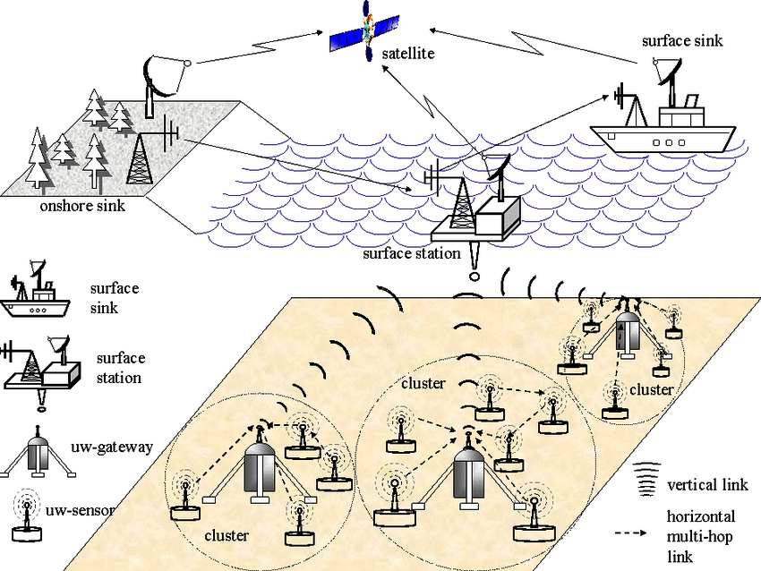

Fig.7: Architecture of 2D Underwater Sensor Network[69]

The anchor node receives the information/data from all its member nodes and dispatches to the surface buoyant nodes. Every member of the cluster communicates with its anchor node with horizontal communication link and every anchor node communicates with the surface buoyant node with vertical communication link. Acoustic, optical, and RF communication carriers can be used in 2D-UWSN deployment depending on the type of application and nature of underwater environment. Typically, the distance among anchor node and surface buoyant node is very high in majority of applications. Underwater communication based on acoustic waves is preferred for underwater anchor node and the surface buoyant node because it offers long range communication in underwater. The network arrangement can be star, mesh, or ring depending on the application requirement. These types of deployments can be used for both time-critical and delay tolerant applications [70].

**3D-UWSN Architecture:**

3D-UWSN architecture refers to a network where the sensor nodes are deployed in the form of clusters and are anchored at different depths. The communication scenario among the sensor nodes in 3D-UWSN goes beyond 2D due to variable heights of the sensor nodes. The typical deployment architecture of the 3D-UWSNs is represented in Fig.8.

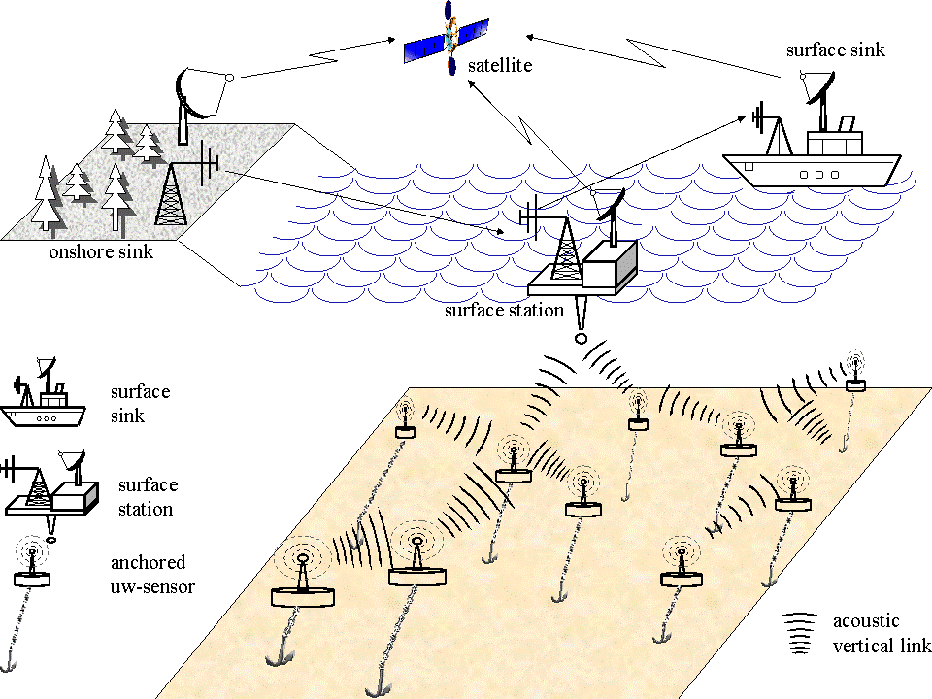

Fig.8: Architecture of 3D underwater Sensor Network [71]

The variable heights of the sensor nodes make the communication scenario among the sensor nodes are in 3D. As the nodes are deployed at variable heights, the communication between the sensors goes beyond the two dimensions. There are three communication scenarios available in this architecture such as; intercluster communication of nodes at different depths, intracluster (sensor-anchor node) communication, and anchor-buoyant node communication. Acoustic, optical, and RF signals can be used in all three types of communication scenarios. While 3D architecture provides more complete images of a surveyed area, the challenge is to position all nodes in a structure that can ensure uninterrupted communication and full area coverage at all times. This is difficult to achieve because ocean currents, animals, passing ships and submarines might destroy some of the placed nodes, which can ultimately cause communication breakdowns.

**4D-UWSN Architecture:**

The 4D-UWSN architecture is formed, where the combination of 3D-UWSN and mobile UWSN are deployed underwater. Mobile UWSN comprises of remotely operative underwater vehicles (ROV), which collects the data from anchor nodes and relay the data to the remote station. The ROV can be autonomous submersible robots, or vehicles, ships, and even submarines. Each underwater sensor node can be autonomous in relaying the data directly to ROV depending on how close that particular sensor node is to the ROV. The communication scenario between ROV and underwater sensor node depends on the distance and data between them and either acoustic or radio can be used. As the transmission is to be directly related to ROV, the sensors which have large data and are close to ROV can use radio links while the sensors which have small data to transmit or are far from ROV can use acoustics links [72, 73].

**CHAPTER-III**

**LITERATURE REVIEW**

The advances in communication wireless technology, the understanding of the mobile ad hoc network applications and the need for reliable systems has motivated to improve the network reliability of underwater mobile ad hoc networks. The special features (dynamic topology, mobility, self-configure etc.) of underwater ad hoc networks introduce major research challenges in underwater communication. The applications of underwater sensing range from oil industry to aquaculture, and include instrument monitoring, pollution control, climate recording, and prediction of natural disturbances, search and survey mission, and study of marine life.

Wireless information through the ocean is one of the enabling technologies for the development of future ocean observation systems and sensor networks. The transmission of information in underwater systems currently uses acoustic, electromagnetic (EM) wave, optical transmission techniques. Acoustic communicationis the most versatile and widely used technique in underwater environments due to the low attenuation (signal reduction) of sound in water and achieving high range (kilometers) of communication. The underwater communication is highly influenced by the physical factors such as temperature, pressure (depth), salinity, and wave speed and chemical compositions (boric acids, magnesium sulphate).

The propagation characteristics (absorption, scattering, propagation velocity, multipath, geometrical spreading, ambient noise) of basic waves also influence the underwater communication. The acoustic communication provides long range communication in underwater (20km). The EM wave propagation is suitable for underwater at shorter depth, it involves high attenuation of the signals in underwater. The optical wave propagation is also suitable at shorter depths, it involves in high scattering of the signals in underwater. The optical waves provide high bandwidth but at the same time it achieves poor range. The research in the field of underwater communication is predominant from last two decades. The current research in underwater environment focused on communication between various remote instruments within a network environment with the help of advances in acoustic modem technology which enables the high-rate reliable communications. Majority of the applications required long term monitoring of the deployment area; the battery powered nodes limit the life time of underwater acoustic networks. The shallow water acoustic characteristics such as, low available bandwidth, highly variable multipath and large propagation delays restrict the efficiency of underwater acoustic networks.

The design of an underwater sensor network that maximizes the throughput and reliability while minimizing the power consumption in this environment is highly challenging task. The literature review provided various aspects (fundamentals, issues, and research opportunities [74-80]; challenges, architectures, advantages, and applications [81-84]; deployment strategies [85]; localization [86]; protocol [87]; clustering [88]; connectivity [89-94] *etc*.,) of Underwater Wireless Sensor Networks (UWSNs).

Liu *et al*., (2008) presented and discussed the fundamental physics of basic wave propagations and then compared the problems and consequences for adopting different communication carriers (acoustic, EM, optical) based on the fundamental first principles of physics and engineering practice. Garcia *et al*., (2011) presents an overview about the main issues and presently used technologies in UWSNs. Jaiang (2008) provided a survey on the recent developments in underwater acoustic communications ranging from energy saving to deployment at different layers. A survey of existing network topologies and their applicability to underwater acoustic channels is presented by Sozer *et al.,* (2000).

Preisig (2006) described some relevant propagation phenomenon and the impact on development and performance of underwater acoustic communication networks. The effect of propagation characteristics (speed of sound, channel latency, absorption, scattering, multipath, waveguide effects, ambient noise etc.) on underwater communication has been discussed. Parton *et al.,* (2006) summarizes all main features, limitations, and practical issues differentiating underwater acoustic networks from terrestrial radio based networks.

The concept of the sensor networks which has been made viable by the convergence of micro electro-mechanical system technology, wireless communication, digital electronics has been described by Akyildiz *et al.,* (2002). The same authors (2004) also investigated the fundamental key aspects of underwater sensor networks. Hidemann*et al.,* (2006) explores the applications and challenges for the underwater sensor networks.

Prasan *et al*., (2012) identified the research directions in short range acoustic communication, MAC, time synchronization, localization protocols for high-latency acoustic networks, long duration network sleeping, and application level data scheduling. Ahmad *et al.,* (2004) presented the propagation of EM waves at GHz frequencies and demonstrate the propagation capabilities of EM waves. The author conducted the experiment for the full range of frequencies in salt water with salinity 4 S/m. The analysis of the path loss in the underwater acoustic channel was conducted by Chaitanya *et al.,* (2011). Umair *et al.,* (2016) highlighted the characteristics of the underwater channel and possible effects over the EM frequencies, specifically over the 2.4 GHz ISM frequency band.

Che *et al.,* (2010) presented the advantages of RF-EM technology by considering the limitations of current and established underwater techniques, as well as the potential that electromagnetic waves can offer to underwater applications. Chitre *et al.,* (2008) provided an overview of the key developments, both theoretical and practical in the underwater sensor networks. Chhagan*et al.,* (2016) address the future aspects of how to improve the security of the underwater sensor networks. Stojanovic (1996) presents a review of recent results and research problems in high speed underwater acoustic communications, focusing on the bandwidth-efficient phase-coherent methods. The same author (2007) also preset the relationship among the capacity and distance in underwater communication networks.

The dependency of the channel capacity up on depth and temperature by taking into account enhanced propagation loss and ambient noise models developed for the underwater communication channel has been analyzed by schgal*et al.,* (2009). Pompili *et al.,* (2006) suggested different deployments strategies for two-dimensional and three-dimensional architectures for underwater acoustic sensor networks and provided the statistical deployment analysis for both architectures. Han *et al*., (2001) provide an overview of the most recent advances of deployment algorithms and classifications in underwater acoustics sensor networks (UASNs). Relevant methods and models are examined by Wei *et al*., (2013) for deployment of sensor nodes in underwater. Prokis*et al.,* (2001) considers several aspects in the design of shallow water acoustic networks which maximize the throughput and reliability while maintaining minimum power consumption.

Riksfjord*et al.,* (2009) explains various modulation techniques, multiple access methods used for underwater acoustic communications. Moore (1967) describes the fundamentals, prospects and problems of radio wave communication in the sea. Cella *et al.,* (2009) explains the benefits of lateral wave EM propagation in shallow water environment and conducted a theoretical analysis, where the maximum distance coverable for a given transmitted power is calculated. Lu *et al.,* (2010) introduced redundancy design for underwater sensor networks based on reliability theory.

Nimbalkar *et al*., (2008) proposed three versions of unicast protocols, which integrate medium access control (MAC) and routing functionalities and leverage different levels of neighbor knowledge for making optimum decisions for reliable data delivery. Kong *et al.,* (2005) presents a new practical application scenario that cannot be addressed by the existing technology and hence demands the advent of the UASNs and UWSNs. The authors presented the research challenges at each layer by go down the top application layer to the bottom physical layer.

Isik *et al.,* (2009) introduced a three-dimensional underwater localization algorithm (3DUL), which achieve network wide robust 3D localization by using a distributed and iterative algorithm. Ling *et al.,* (2009) addressed the two key issues (channel estimation and symbol detection) regarding the design of multi-input multi-output (MIMO) communication systems. Zohu*et al*., (2011) proposes a new multipath power-control transmission scheme (MTP), which can guarantee certain end-to-end packet error rate while achieving a good balance between the overall energy efficiency and end-to-end packet delay.

Min *et al.,* (2012) presented a checkpoint scheme for the head nodes to quickly recover from a head node failure. Fox *et al.,* (2007) discuss the methodology for predicting underwater acoustic communication performance using high fidelity acoustic time series simulation and acoustic modem process emulation. Scalable Localization Scheme with Mobility Prediction (SLMP) was proposed for underwater sensor networks by utilizing the predictable mobility patterns of underwater objects by Zohu*et al.,* (2011).

Naik *et al.,* (2012) proposed a distributed self-organizing localization algorithm for localization in 3D UWSNs.

Gao *et al.,* (2012), proposed an analytical model to investigate the tradeoff between the energy efficiency and network connectivity based on selection of transmission range. Jha *et al.,* (2012) explored various QoS challenges and perspectives for WSNs and UWSNs. Lloret (2013) focused on collecting recent advances on underwater sensors and underwater sensor networks in order to measure, monitor, survey lines and control of underwater environment. Llor*et al.,* (2013) developed a statistical propagation model to facilitate large-scale system design in which the transmission loss is treated as a random variable.

Domingo (2008) presented a detailed survey on ray-theory-based multipath Rayleigh underwater channel models for underwater wireless communication and the research challenges for efficient communication in this environment are outlined. Quadri *et al.,* (2010) analyze the ad hoc network routing protocols in underwater acoustic environment.

A novel algorithm for self-deployment of nodes in underwater acoustic sensor networks was proposed by Senel (2102). The basic idea behind the algorithm is to calculate the optimized depth for each node in the network in such a way that the possible coverage overlaps are minimized and connectivity of the final topology is guaranteed. This algorithm has three phases; first the nodes are organized in a tree structure that is rooted at surface station. Whereas, the depth for all nodes is computed iteratively at surface station during the second phase. In the final phase, the calculated depth is distributed to each node so that each node starts sinking.

Transmission range plays a dominant role in the deployment of practical underwater acoustic sensor networks, where the sensor nodes are deployed at random locations with no particular geometrical arrangements. The selection of transmission range directly influences the energy efficiency and connectivity of such random networks.

An analytical modeling was provided by Gao *et al.,* (2012) which identifies the tradeoff between energy efficiency and connectivity through the selection of transmission range. The limited availability and non-reachability of energy resources along with the relative inaccessibility of deployed sensor nodes for energy replenishments necessitated the evaluation of energy optimization techniques in underwater acoustic sensor networks. Clustering is the technique, which increase the system scalability and reduce the energy consumption. In addition to clustering, coverage and connectivity are two significant properties that decide the proper detection and communication of events of interest in UWSNs due to unstable environment. A detailed survey of clustering, coverage, and connectivity issues in UASNs was outlined by Sandeep and Kumar (2017).

The significant attenuation degree attained due to high absorption and scattering of optical transmission in the water confines the achievable range of optical links to only few meters. One way to achieve transmission at long distances is to employ a dense network configuration where information can be transferred through a series of intermediate nodes acting as relays. Vavoulas*et al*., (2014) consider optical wireless network arrangements where nodes are floating at different depths into a service aquatic medium and deployed an effective path loss model which incorporates the key factors that deteriorate the optical power, and we derive the achievable transmission range to satisfy connectivity criteria assuming intensity-modulation direct detection (IM/DD) with ON–OFF keying (OOK).

The algorithms for coverage improvement in UWSNs were proposed by Liu *et al*., (2008). The authors identify the uncovered regions and deploy additional sensors for covering such regions. Then, they relocate some existing sensors to eliminate coverage overlaps and cover blind regions. The similar algorithm has been implemented by akkaya *et al*., (2009) in order to assumed that the sensors are uniform, randomly distributed on the water surface, and to eliminate coverage overlaps in 3D, closer sensors in 2D are deployed at different depths. To identify possible coverage overlaps, nodes are clustered in 2D, and a graph coloring algorithm is applied to determine which nodes should be placed far from each other.

Alam*et al*., (2006) assumed sensors are placed one by one manually and studied the coverage maximization problem while ensuring the connectivity with the least number of nodes. In the conventional 2D scenario, sensor coverage is modeled as a circle, and the maximal coverage problem is mapped to a circle packing formulation that has a polynomial time solution. The design challenges for underwater sensor networks have been subjected to numerous studies. Among those works, node deployment in underwater acoustic sensor networks has been received significant attention from research communities and studied in the literature assuming both manual and remote deployment. A detailed survey about node deployment in underwater acoustic sensor networks is presented by pompili*et al*., (2009).

The effects of transmission range and sensing range on connectivity, coverage in 3D sensor networks was provided by Ravelomanana (2004). The author focused on the two main problems include: What must be the optimal sensing range for ensuring a certain degree of coverage, what is the minimum and maximum node degree for a given transmission range, assuming that n nodes are uniform, randomly placed in 3D volume. The author provided the optimal value of sensing range for maximum coverage and connectivity.

**CHAPTER-IV**

**BASIC PHYSICS OF UWSNs**

Wireless sensor networks for underwater communication basically uses three basic approaches for transmitting information based on acoustic, Electro Magnetic (EM), and optical signals. Each one of these approaches has advantages and disadvantages mainly due to their physical constraints. The signal propagation in underwater can be described by considering the physicochemical properties of the water and the physical properties of the light. The physicochemical factors which influence light properties are; transparency, absorption, and turbidity. The physical properties of the light are: reflection, refraction and extinction, which measure the degree of the light that can penetrate into the marine environment. The two most important factors in seawater are the temperature and salinity (which determine the density of the water) [95].

Most of the underwater communication systems preferred acoustic technology for transmitting the information. Complementary communication techniques, such as optical and EM signals have been proposed for short-range links (typically 1–10 m), where their very high bandwidth (MHz or more) can be exploited. These signals attenuate very rapidly, within a few meters (radio) or tens of meters (optical), requiring either high-power or large antennas. Acoustic communications offer longer ranges, but are constrained by three factors: limited and distance-dependent bandwidth, time-varying multi-path propagation and low speed of sound [96].

* 1. **Underwater communication based on EM waves:**

The transmission of EM signals in underwater is considered to be a fast and efficient communication among network nodes. The high permittivity and electrical conductivity of the water differentiates the propagation of EM waves through water and through air. The conducting nature of the medium (sea water) restricts the usage of EM waves in radio frequencies. Moreover, the use of EM waves in the radio frequency band has several advantages over the acoustic waves, mainly is faster and can be used in higher work frequencies (which results in a higher bandwidth).The RF-EM technology crosses air/water/seabed boundaries easily, and unaffected by turbidity, salinity, and pressure gradients. Acoustic wave’s yields poor performance in shallow water where the transmission can be affected by turbidity, ambient noise, and salinity and also pressure gradients; in addition, acoustic technology can have an adverse impact on marine life. Even though RF-EM can suffer from limited transmission range and electromagnetic interference (EMI), it also has some valuable features that can enable flexible deployment of UWSNs in coastal regions. The acoustic and optical waves cannot perform smooth transitions through the air/water interface [97]. EM waves can cross water-to-air or water-to-earth boundaries easily by following the path of least resistance. EM transmissions are tolerant to turbulence caused by tidal waves or human activities, as opposed to acoustic and optical waves. EM waves can work in dirty water conditions while optical waves are susceptible to particles and marine fouling. This gives EM an advantage when working in a water column with a high level of sediment and aeration. The advantages of RF-EM technology in various aspects (performance, reliability, and implementation) are summarized in Table 6.

Table 6: Advantages of RF-EM Technology [97]

|  |  |
| --- | --- |
|  | **Advantages** |
| **Performance** | Crosses water to air boundary easily |
| Multipath less of an issue |
| Frequency-agile capability |
| Covert, localized communications |
| High joules per bit efficiency |
| Potential for high data rates over small distance |
| High propagation speed |
| **Reliability** | Unaffected by pressure gradients |
| Immune to acoustic noise |
| Unaffected by low visibility |
| Immune to aerated water |
| **Implementation** | No need for surface repeater |
| Distributed transducers |
| Dense, portable units |
| No effect on marine environment |

Thewave propagation through underwater using EM waves, produce the successive cycles of energy, which ultimately lead to strong attenuation. Thewave propagation continuously cycle energy between electric and magnetic fields, which results in high conduction and leads to strong attenuation. Furthermore, there are several factors that limit the use of EM waves in the water. EM waves are propagated in very different ways depending on the type of water where the system is implemented. EM waves propagate at longer distances through conductive sea water at very low frequencies (*i.e.*, 30 to 300Hz). This phenomenon needs large antenna and high power for transmission. Hence it is not ideal for underwater communication [97].

The properties of EM waves such as; magnetic permeability, dielectric permittivity, and electrical conductivity should be considered in order to describe the propagation of EM waves underwater. The ability of the medium to store the magnetic fields is referred as magnetic permeability. Both the water and air are non-magnetic in nature and their relative permeability is same. Hence, the permeability of the water has no significant effect on the EM wave propagation. The ability of the medium to transmit an electric field is referred as relative permittivity (*μ*) of the medium. Generally, the typical value for relative permeability is considered as 81. But, in reality the relative permittivity is a complex valued and is a function of carrier frequency, salinity, and temperature.

The value of dielectric permittivity is approximately 81 for the Arabian and Indian Ocean costal lines [98]. The EM waves are reflected when they are propagated through conductive medium. The conductivity of the medium is calculated in Siemens per meter (S/m). The conductivity of the any medium depends on number of ions present. Water is conductive in nature; hence it will reflect EM waves. The water medium is characterized into three types based on conductivity values (see Table.7). The conductivity () of the water lies between 0 and 1 then the water medium is referred as fresh water, if lies between 1 and 2 then the water medium is referred as river water, and if the is greater than or equal to 2 then it is treated as a sea water.

Table.7: Conductivity ranges of different water mediums [98]

|  |  |
| --- | --- |
| Water | Conductivity value |
| Fresh water |  |
| River water |  |
| Sea water |  |

The conductivity of the sea water is typically around 4S/m, while nominally fresh water conductivity is quite variable but typically in the m S/m range. Attenuation of EM signals is much lower in freshwater than in sea water, but fresh water has a similar permittivity. Relative permeability is approximately 1, so there is a little direct effect on the magnetic field component. The fundamental behavior of the EM waves changes in underwater environment because of their physical properties. At the frequencies, higher than 10 KHz the propagation speed of EM waves is more than 100 times faster than acoustic signals (see Table.8). Meanwhile, at very high frequencies the attenuation of EM waves is very high, when compared to acoustic signals. Hence, the use of EM signals at very low frequencies will produce much better performance than at very high frequencies. The amount of attenuation produced at very low frequencies is also less, when compared to the attenuation produced at ultra-high frequencies (see Fig.10 & 11). EM wave propagation is more than hundred times faster than acoustics at the frequencies higher than 10 KHz and it has a significant advantage for command latency and networking protocols, where many signals have to be exchanged.

***EM waves in fresh water:***

The fresh water has a low conductivity (see Table.7) and hence, it is considered as a low loss medium. The negligible value of turbidity enables the propagation of EM waves through fresh water. The propagation speed can be expressed as

(1)

The constants, is dielectric permittivity and is magnetic permeability. The values of dielectric permeability and magnetic permittivity have no significant changes for most non-magnetic mediums. The dielectric permittivity is further expressed as the product of the permittivity in air and the dimensionless relative permittivity. The relative permittivity () is dimension less quantity, which in the case of fresh water is about 81. The propagation speed characteristics of EM waves in fresh and sea water are depicted in Fig.10. The absorption coefficient for EM propagation in fresh water can be expressed as

(2)

The term, *σ* is the electric conductivity. It may be noticed that, the absorptive loss is essentially frequency-independent, and EM waves can literally propagate through freshwater body. For example, ground penetrating radar (GPR) has been successfully operated on the lake surface to map lake-bottom sediments. As such, using EM waves as the communication carrier in freshwater environments appears very attractive. However, the key problem in using EM waves for communication in freshwater UWSNs is the antenna size. The big antenna size of an EM transmitter (*e.g*., a couple of meters for a 50MHz antenna) is unpractical for the dense deployment of UWSNs [99].

***EM waves in sea water:***

Sea water is considered a high-loss medium due to the fact that it is highly conductive. The conductivity of the sea water is high when compared to fresh water. The higher conductivity in sea water is mainly due to the cumulative increase of total dissolved solid (TDS) concentration in oceans, shown as the great salinity; the average salinity in sea water is about 34 parts per thousand (PPT) [100]. In highly conducting media, both the propagation velocity and absorption of EM waves are functions of carrier frequency. The propagation speed of EM waves in sea water is expressed as (3).

**Fig.10: Propagation speed characteristics of EM waves in sea water & fresh water**

**Fig.11: Absorption coefficient characteristics of EM waves in sea water & fresh water**

(3)

Where, the magnetic permittivity of the material, f is the frequency of the carrier signal and represents the material conductivity. Moreover, the absorption losses in sea water can be approximated by using (4).

(4)

It is observed form the (3), and (4) the increase in absorption loss would results decrees in propagation speed of EM waves velocity of propagation decreases with increase in absorption losses as EM waves propagate in sea water. The absorption loss characteristics of EM waves in fresh and sea water are represented in Fig.11.It is observed from the (1), (2), (3) and (4) that, at the high frequencies there is a greater coefficient of absorption would result. Therefore, it would be better to work at low frequencies while using EM waves as carriers for transmission in underwater. Hence, the EM waves are suitable for fresh water scenarios and short-range communication in sea water conditions (see Table.8).

**Table.8: Data rates for potential ranges of underwater EM [101]**

|  |  |  |  |  |
| --- | --- | --- | --- | --- |
| Range | <10m | 50m | 200m | >1km |
| Sea water | >8kb/s | 300b/s | 25b/s | <1b/s |
| Fresh water | >3mb/s | 150kb/s | 9kb/s | <350b/s |
| Applications | AUV docking; divers personal network | Networks; diver conservation | AUV control; networking; diver conversation | Deep water telemetry |

**Table.9: Effect of frequency on EM wave performance in underwater [102]**

|  |  |  |  |  |  |  |  |
| --- | --- | --- | --- | --- | --- | --- | --- |
| Parameter | Medium | Frequency | | | | | |
| Propagation velocity | 100Hz | 1KHz | 10KHz | 1MHz | 10MHz | 1GHz |
| Sea water | 1.77*1014 | 4.88*104 | 1.52*105 | 4.82*105 | 1.52*106 | 4.30*106 |
| Fresh water | 3.16*105 | 1.00*106 | 3.16*106 | 1.00*107 | 3.16*107 | 1.00*108 |
| Free space | 3*108 | 3*108 | 3*108 | 3*108 | 3*108 | 3*108 |
| Acoustic | 1.50*103 | 1.50*103 | 1.50*103 | 1.50*103 | 1.50*103 | 1.50*103 |
| Wavelength (m) | Sea water | 1.76*102 | 4.88*101 | 1.52*101 | 4.82*100 | 1.52*100 | 4.30*10-1 |
| Fresh water | 3.16*103 | 1.00*103 | 3.16*103 | 1.00*103 | 3.16*103 | 1.00*103 |
| Free space | 3.00*106 | 3.00*105 | 3.00*104 | 3.00*103 | 3.00*102 | 3.00*101 |
| Propagation distance (m) | Sea water | 3.23*102 | 8.92*101 | 2.79*101 | 8.81*100 | 2.79*100 | 7.87*10-1 |
| Fresh water | 5.78*103 | 1.83*103 | 5.78*102 | 1.83*102 | 5.78*101 | 1.83*101 |

* 1. **Underwater communication based on optical waves:**

The characteristics of the underwater medium makes the wireless information transfer through underwater is of great interest to the military, industry, and the scientific community. The transmission of wireless information through underwater played an important role in the applications like; tactical surveillance, underwater pollution control, underwater pipeline monitoring, oil control and maintenance, offshore explorations, and underwater environment monitoring *etc*. In order to facilitate all these activities, there is an increase in the number of unmanned vehicles or devices deployed underwater, which require high bandwidth and high capacity for information transfer underwater. Although tremendous progress has been made in the field of acoustic communication underwater, however it is limited by bandwidth.

The low bandwidth of acoustic communication has led to the proliferation of underwater optical wireless communication (UOWC), as it provides higher data rates than the traditional acoustic communication systems with significantly lower power consumption and simpler computational complexities for short range wireless links. The RF signals require huge antenna size, large transmitter power in fresh water and suffer from high attenuation in sea water. The acoustic signals are also suffered from low propagation velocity, high absorption, and severe bandwidth problem. Both EM and acoustic signals offers small data rates in underwater communication. Hence, the perfect choice for underwater communication to support high data rate is using optical signal. UOWC is capable of exceeding Gbps at a distance of few hundreds of meters due to high frequency of optical carrier. Although optical signals in underwater environment face several extreme challenges due to water absorption, scattering caused by suspended particles or due to strong disturbances caused by the underwater environment, and essential requirement of LOS for transmission [103].

The fundamental characteristic of the different water conditions (shallow water to deep oceans) are quite different and require detailed understanding about physio-chemical underwater environment. The properties of the different water conditions are vary with geographical location and with concentrations of dissolved substances and also influences the propagation of optical beam through underwater. In general, four different water types are considered to describe the optical beam transmission through underwater such as; pure sea water, clear ocean water, coastal ocean water, turbid harbor.

**Pure sea water:**

The absorption in pure sea water is considered as a sum of absorption in pure water and absorption by salts in pure salt water. The absorption is the main limiting factor here which increases with the increase in wavelength. The water absorption coefficient in pure sea water () [104] given as (5), where is the operating wavelength, K is the diffuse coefficient, and b is the scattering coefficient.

(5)

**Clear ocean water:**

Ocean water have higher concentration of dissolved particles like dissolved salts, mineral components, colored dissolved organic matter, *etc*. Based on the concentrations of the suspended particles and their geographical locations, the clear ocean water has further classified based on Jerlov water type [105].

**Coastal ocean water:**

They have much higher concentration of dissolved particles and thus increase the turbidity level. The effect of absorption and scattering is more in this water type.

**Turbid harbor:**

This water type has the highest concentration of dissolved and suspended particles and hence, limits the propagation of optical beam due to absorption and scattering. The typical values of absorption and scattering coefficients for different water conditions are represented in Table.10.

**Table.10: Typical values of absorption and scattering coefficient values [106]**

|  |  |  |
| --- | --- | --- |
| Water type | Absorption a (m-1) | Scattering b (m-1) |
| Clear ocean | 0.114 | 0.037 |
| Coastal ocean | 0.179 | 0.220 |
| Turbid harbor | 0.366 | 1.829 |

The optical signal transmission through underwater has two main disadvantages such as; the suspended particles causes light dispersion and the optical signals are absorbed quickly due to physical properties of the water. The propagation of the light depends on the medium traversed. Hence, the light does not travel with the same speed in water and air. The intensity of the light decreases exponentially when it propagates through an aqueous medium. This phenomenon is occurred mainly due to the absorption and scattering. The important factors which affect the underwater optical communications are; absorption; scattering; turbulence; alignment; multipath interference; physical obstructions and background noise.

**Absorption & Scattering**:

The two main phenomenons’s which occurs due to the loss of intensity or change in direction of the optical signal is absorption and scattering respectively. The conversion of optical energy into another type of energy, usually heat or chemical energy is called absorption. The main sources of absorption are; algae, which use light as an energy source, organic and inorganic particulate matter in suspension, dissolved inorganic compounds, and the water itself. The scattering is a phenomenon which is the result of collision of beam with particles in suspension, causing multiple reflections. Scattering effect is a function of turbidity. More the turbidity in water causes higher scattering effect, and introduces difficulties for light penetration [107].

**Turbulence:**

Variation in the refraction index along the propagation path caused due to fluctuations in the density, salinity, and temperature of the underwater environment leads to large fluctuations in the intensity of the signal at the receiver. This phenomenon is called scintillation and degrades the performance of UOWC [108]. There is as such no specific model for underwater turbulence like in the case of free space optical (FSO) communication, due to dynamic nature of the underwater environment.

**Pointing and alignment:**

Due to the very narrow optical beam, maintaining the LoS for reliable optical link is very critical in UOWC. The constant tracking between transverses is very essential to maintain uninterrupted reliable link because of the movement caused by underwater vehicles, ocean current or other turbulent sources. The pointing errors in UOWC consist of two components: bore-sight and jitter. Bore-sight is a fixed displacement between the beam center and the center of detector whereas jitter is the random displacement of the beam center at the detector plane.

**Background noise:**

Background noise must be taken into consideration while designing the UOWC link. Noise is strongly depending upon operating wavelength and geographical location. In general Deep Ocean is less noisy than harbor side due to manmade noise. Most of the noise sources in underwater environment are described as continuous spectrum and Gaussian profile. The main sources of background noise are: diffused extended background noise, background noise from the sun or other stellar objects, and scattered light collected by the receiver.

**Multipath interference and dispersion:**

Multipath interference is produced in optical underwater channel when an optical signal reaches the detector after encountering multiple scattering objects or multiple reflections from other underwater bodies. This phenomenon eventually leads to waveform time dispersion (time spreading) and decreases the data rate due to inter symbol interference (ISI). The multipath interference in UOWC is high when compared to acoustic communications due to the variation of light speed in acoustic and optical communication scenarios [109]. The amount of multipath interference depends up on the system specifications and the propagation environment.

For shallow water environment, optical waves reflected from surface or bottom generates multiple signals at the detector. For deep oceans, these surface and bottom reflections can be ignored. Advanced signal processing techniques such as channel equalization and adaptive optics are used at the receiver to suppress interference. Although channel equalization for fast varying underwater channel seems to be a big challenge, however careful characterization of underwater optical channel can help to choose appropriate system design parameters for reliable and high-quality optical link.

* 1. **Underwater communication based on acoustic waves:**

The underwater communication based on acoustic signals has become an important, versatile, and widely used technology. Acoustic communication is the most versatile and widely used technique in underwater environments due to the low attenuation (signal reduction) of sound in water. This is especially true in thermally stable, deep-water settings. On the other hand, the use of acoustic waves in shallow water can be adversely affected by temperature gradients, surface ambient noise, and multipath propagation due to reflection and refraction.

The much slower speed of acoustic propagation in water, about 1500 m/s (meters per second), compared with that of electromagnetic and optical waves, and is another limiting factor for efficient communication and networking. Nevertheless, the currently favorable technology for underwater communication is upon acoustics. Moreover, there are certain challenges experienced by the underwater acoustic channel in physicals layer due to path loss, shadowing, fading, ISI, Doppler effects etc. the reasons for those challenges in physical layer based on the acoustic channel are summarized in Table.11. An acoustic wave has a number of propagation characteristics that are unique from other waves. The typical physical characteristics of the acoustics waves include propagation velocity, absorption, multipath, and ambient noise [110].

**Table 11: challenges in physical layer based on the acoustic channel [111]**

|  |  |  |
| --- | --- | --- |
| Challenges | Reasons | Effects |
| Path loss | Geometric speeding/energy loss | Low bandwidth/low data rate |
| Shadowing | Random distribution of objects in 3D |
| Noise channel | Human made noise/ambient noise | Low data rate (Hard detection) |
| Fading | Multipath |
| Inter symbol interference | High communication rate in low bandwidth |
| Non-fixed delay | Non fixed speed of carrier wave |
| Doppler shift | Non fixed frequency of carrier wave | Low data rate (Hard detection) |

**Table.12: Available bandwidth in underwater acoustic channel [112]**

|  |  |  |
| --- | --- | --- |
| Communication Link | Range (km) | Bandwidth(KHz) |
| Very long | 1000 | <1 |
| Long | 10-100 | 2-5 |
| Medium | 1-10 | 10 |
| Short | 0.1-1 | 20-50 |
| Very short | <0.1 | >100 |

**CHAPTER-V**

**METHODOLOGY**

**5.1. Propagation velocity*:***

The extremely slow propagation speed of sound through water is an important factor that differentiates acoustic waves from EM propagation. The speed of the sound in water depends on the water properties such as; temperature, salinity, and pressure. The typical speed of sound in water near the ocean surface is about 1520 m/s, which is four times faster than speed of sound in air, but five orders of magnitude smaller than speed of light. The sound speed in water is directly related to change in environmental conditions (temperature, salinity, and depth). The majority of changes in sound speed have occurred due to temperature changes [113]. The sound speed in underwater by taking into the account of temperature, salinity, and depth is defined in following equation (5).

(5)

Where, T, S, Z are temperature, salinity, and depth. to be constants and the values are represented in Table. 14.

Table.14: Sound speed calculation coefficients [114]

|  |  |  |
| --- | --- | --- |
| =1.444.96 | =2.374*10^-4 | =1.675*10^-7 |
| =4.591 | =1.340 | =-1.025*10^-2 |
| =-5.304*10^-2 | =1.630*10^-2 | =-7.139*10^-13 |

The effect of salinity on sound speed is small and also salinity changes in the open ocean are small. The salinity can have significant effect on the speed of sound at the near shore and in estuaries, where the salinity varies greatly. As the depth increases the pressure of water has the largest effect on the speed of sound (see Fig.12). Under most conditions the speed of sound in water is simple to understand. Sound will travel faster in warmer water and slower in colder water. The temperature is increased by 1 degree centigrade for every 4m/s increment in the speed. Approximately, the sound speed increases 4 m/s for water temperature arising 1 degree centigrade. When salinity increases 1 particle salinity unit (PSU), then the sound speed in water increases by 1.4 m/s. As the depth of the water has an increase of 1km, the sound speed increases roughly by 17 m/s [115].

Fig.12: Sound speed characteristics through underwater

There are several factors that influence the distance that sound can travel underwater. Whereas, the particles of sea water can reflect, scatter and absorb certain wavelengths of light. Sea water absorbs 30 times the amount of sound absorbed by distilled water, attenuating certain frequencies of sound in underwater. Low frequency sounds, and pass over tiny particles tend to travel farther without causing any loss by absorption or scattering. Generally, the ocean is divided into horizontal layers, in which the sound speed depends greatly on the temperature in the upper regions and the pressure in the lower regions. The top layer of the sea is heated by the sun whose temperature varies according to the season. In the mid-latitudes, the water is perfectly mixed by the action of waves and currents. But there is a transitional layer called thermocline, where the temperature drops continuously with depth, as the temperature drops, and the speed of the sound is also drops. However, there is a point, which ranges from 4000 meters to 1 Km below the surface, from which the temperature changes are slight. At this stage the main factor influencing the speed of sound is increasing pressure causes the sound speed increases. [116-118].

**5.2. Absorption:**

The acoustic wave energy may be converted to other forms and absorbed by the medium during propagation. During propagation, wave energy may be converted to other forms and absorbed by the medium. The absorptive energy loss is directly controlled by the material imperfection for the type of physical wave propagation through it. For acoustic waves, this material imperfection is the inelasticity, which converts the wave energy into heat. The absorptive loss for acoustic wave propagation is frequency dependent [118].

The ocean sound is attenuated by two main mechanisms named viscous absorption (viscosity can be described as the resistance of a fluid to flow) and ionic relaxation effects due to the presence of minute concentrations of boric acid and magnesium sulfate salts in seawater [118]. The effect of viscous absorption is significant at high frequency (above 100 kHz), whereas the ionic relaxation effects due to boric acid affect at low frequency (say up to few kHz), and due to magnesium sulfate affect at intermediate frequencies (up to a few 100 kHz). The total absorption coefficient is represented as follows in (6).

(6)

Where, , are the boric acid, magnesium sulphate components of sea water and , are the depth pressure components for boric acid, magnesium sulphate, and pure water respectively. (in kHz) stands for the relaxation frequency for boric acid and is given by (7):

(7)

Where, S is salinity (in parts/1000) and T is temperature in centigrade. (KHz) stands for the relaxation frequency for magnesium sulfate and is given by (8):

(8)

**5.3. Transmission Loss**

The sonar parameter transmission loss (TL) is defined as the accumulated decrease in acoustic intensity when an acoustic pressure wave propagates outwards from a source. This magnitude can be estimated by adding the effects of geometrical spreading, absorption and scattering. Spreading loss refers to the energy distributed over an increasingly larger area due to the regular weakening of a sound signal as it spreads outwards from the source. Absorption is a process that involves the conversion of acoustic energy into heat due to the internal friction at a molecular scale within the fluid. At certain frequencies, absorption is increased due to ionic relaxation of certain dissolved salts. Scattering occurs when sound waves are redirected when they interact with a body. The scattering of energy by bodies and bubbles in the underwater medium cause’s propagation loss at sea. Acoustic signals in deep water propagate within a cylinder bounded by the surface and the sea floor; as a result, cylindrical spreading appears. The transmission loss caused by cylindrical spreading and absorption can be expressed as follows;

(9)

where α represents the absorption coefficient with the unit dB/km and r is the range expressed in meters. The ocean sound is attenuated by two main mechanisms named viscous absorption (viscosity can be described as the resistance of a fluid to flow) and ionic relaxation effects due to the presence of minute concentrations of boric acid (B(OH)3) and magnesium sulfate salts (MgSO4) in sea water. The effect of viscous absorption is significant at high frequency (above 100 kHz), whereas the ionic relaxation effects due to boric acid affect at low frequency (up to a few kHz), and due to magnesium sulfate affect at intermediate frequencies (up to a few 100 kHz).

Transmission Loss (Direct Path)

(10)

Transmission Loss (Multi-Path) Due to Surface Reflections:

(11)

(12)

Due to Convergence zone:

(13)

**CHAPTER-VI**

**SIMULATION RESULTS**

The main factors which are venerable in underwater environment are temperature, salinity, and sound speed with respect to depth. In addition, numerous parameters such as; wave height; turbid currents; water pressure; chemical compositions of water; and wave speed causes underwater environment unpredictable in nature. It is necessary that, the proposed channel model should identify the changes in underwater medium characteristics, and network properties in order to deploy a reliable network. Generally, the performance of an acoustic channel model depends on the speed of the sound in underwater and operating frequency. The sound speed in underwater is a function of temperature, salinity, depth, and pH. As the temperature and salinity varying with respect to depth in underwater, the sound speed alters accordingly.

The acoustic medium is the primary means of wireless data communication in marine environment, and the speed of sound is the most fundamental characteristic that influences the data rates that can be achieved, as well as the quality of service, latency, and other crucial network parameters in this channel. The sound speed has unpredictable variations in underwater due to abnormal changes in temperature, salinity, depth and pH with respect to the season, time and location of the ocean. In addition, the sound speed also influenced by numerous factors, including wave height, turbid currents, water pressure, chemical compositions of the water, and wave speed. Whereas, the variation in aforementioned parameters has different profiles in shallow and deep-water divisions of the ocean. The sound speed profile exhibits abnormal variations in shallow water because of drastic change in temperature gradients of the water column across the water depth. Whereas, the temperature is almost constant (4 0C) at the deep-water scenarios, where the sound speed profile has minimal variations.

It is clearly depicted in Fig.1, that the sound speed is varying with temperature and depth. When the depth is extended to 7000m and the temperature is lowered to 4 0C, the sound speed increases to 1650m/s (see Fig.13) from the initial value of 1450m/s at a certain temperature and depth (*T*=30 0C, *D*=100m). Similarly, salinity of the ocean water increases along the depth, which also influences the sound speed in deep water. This is clearly depicted in Fig.14, that the sound speed increases with increase in depth as well as salinity. At a particular salinity (S=33ppt), the sound speed attained different profiles (varying from 1540m/s to 1650m/s) along the depth (see Fig.14).

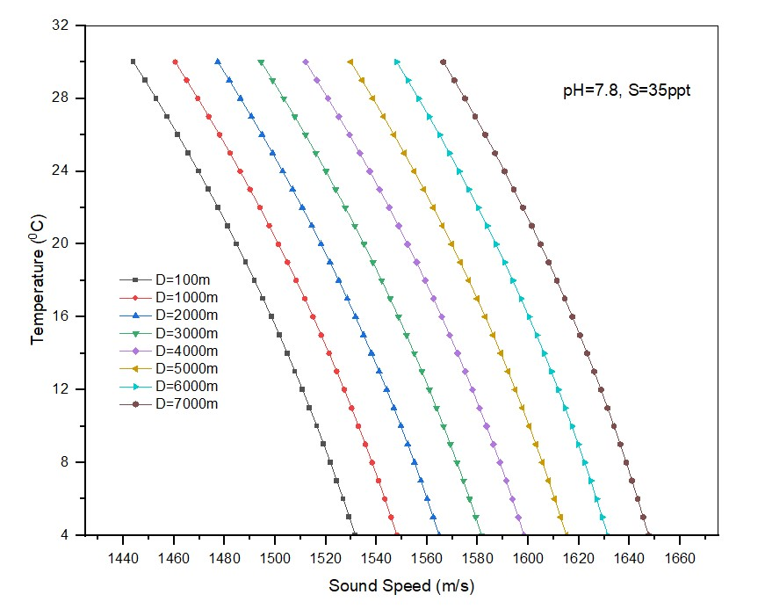

Fig. 13: Effect of Temperature variations on sound speed in deep-water

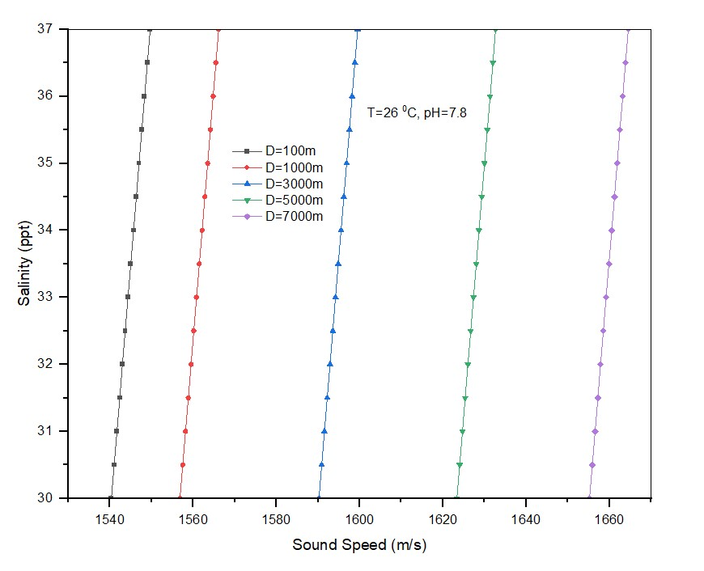

Fig.14: Effect of salinity variations on sound speed in deep-water

Absorption, which results from the transformation of acoustic energy into heat, is the principal cause of attenuation. As the distance and frequency rise, the attenuation grows. The influence of different absorption due to various chemical compositions of the underwater medium has been depicted in Fig. 16. It is clear that boric acid (H3BO3), magnesium sulphate (MgSO4), and pure water are the main contributors to attenuation at frequencies below 1 kHz, between 1 kHz and 100 kHz, and above 100 kHz, respectively (see Fig.16). It is also obvious that the orders of magnitude vary widely and that attenuation rises sharply with frequency. For frequencies of 1 kHz and below, attenuation is less than a few hundredths of a dB/km; hence, it is not a limiting factor. Approximately 1 dB/km of attenuation occurs at 10 kHz, restricting ranges of more than a few tens of kilometres. The transmission losses are frequency and range dependent. According to Fig.15, transmission losses increase as frequency increases, while transmission losses decrease as depth increases.

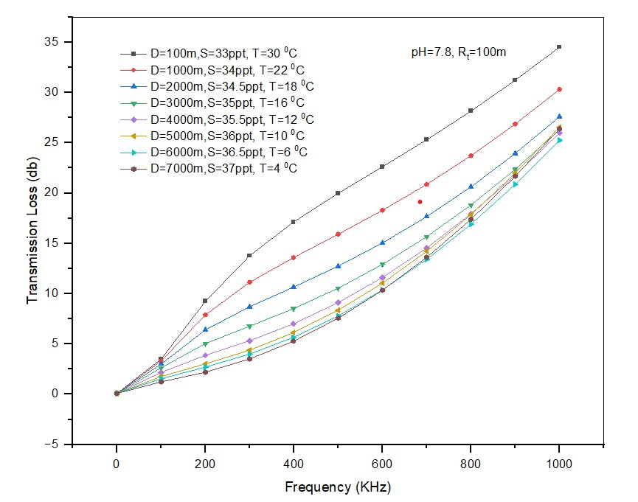

Fig.15: Transmission losses with respect to frequency in deep-water

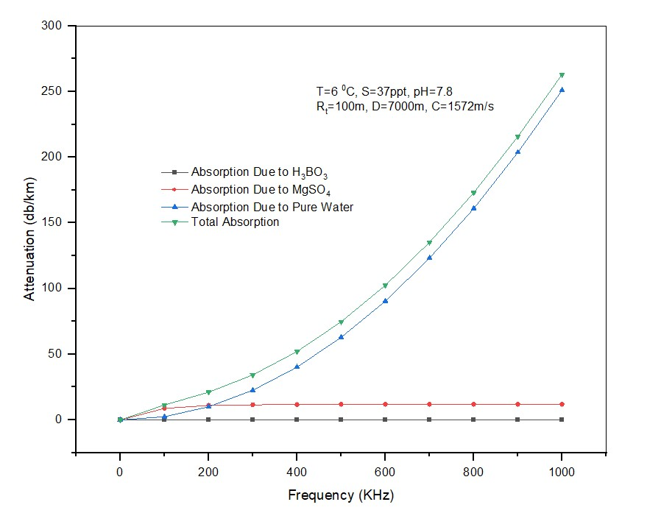

Fig.16: Attenuation in deep water due to absorption

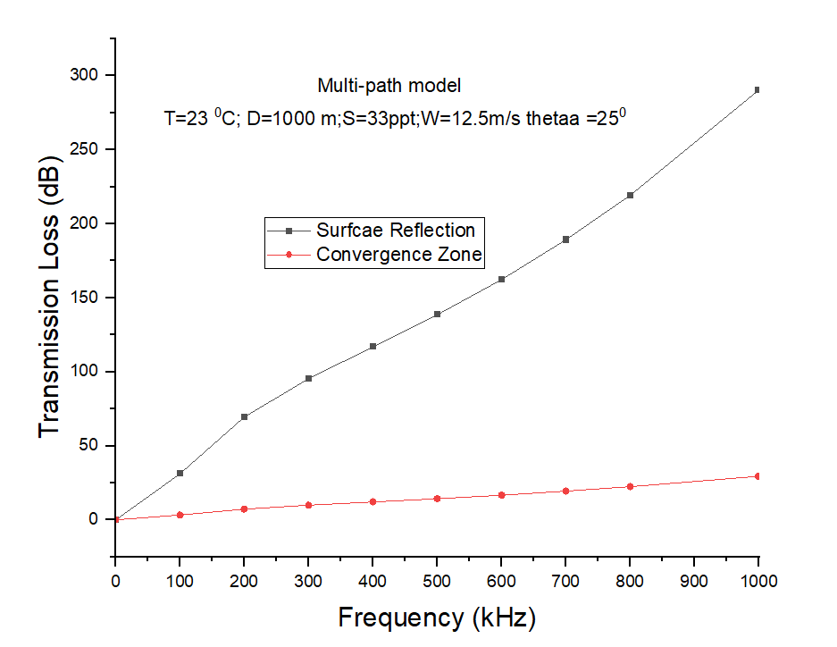

Fig.17: Transmission Losses in deep water for multipath model with D=1000m

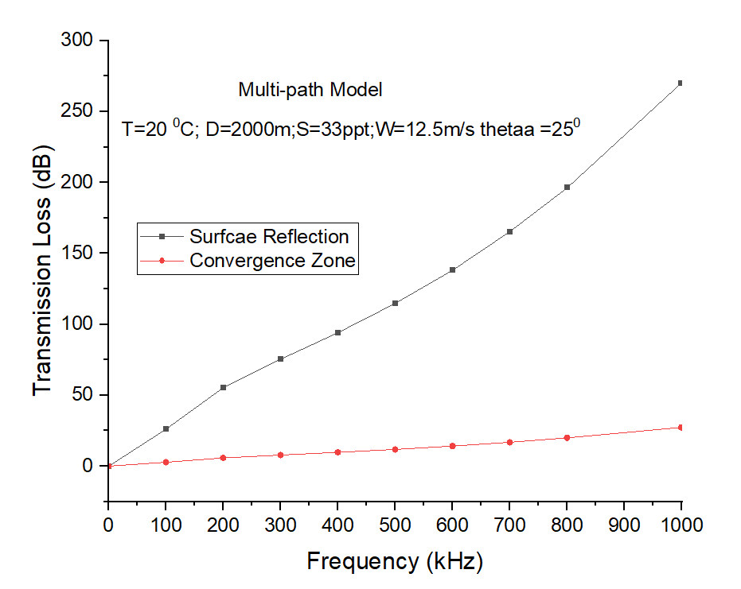

Fig.18: Transmission Losses in deep water for multipath model with D=2000m

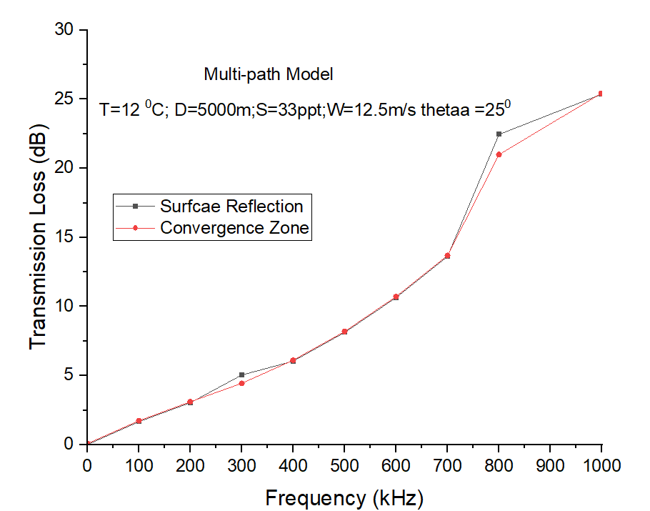

Fig.19: Transmission Losses in deep water for multipath model with D=5000m

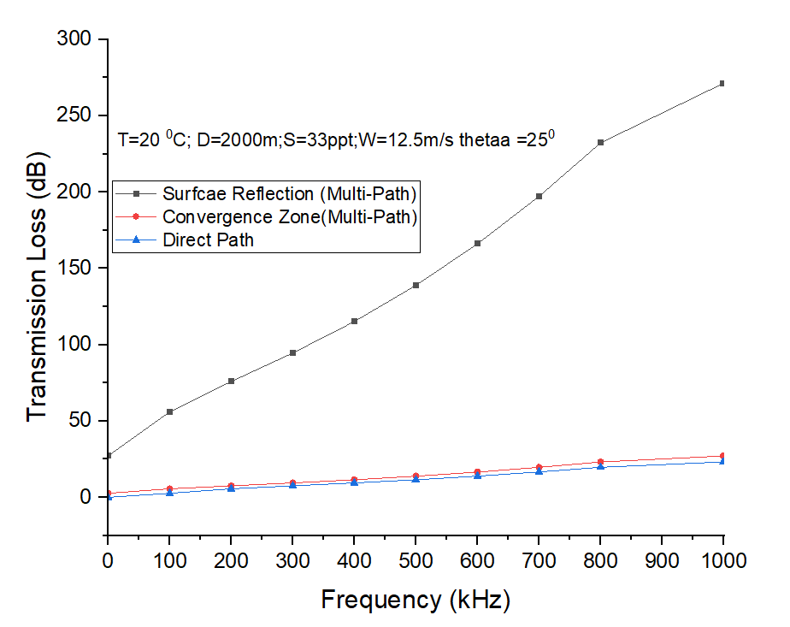

Fig.20: Comparison of Transmission Losses in deep water for multipath and direct path model with D=2000m

**CHAPTER VII**

**CONCLUSION**

* An acoustic channel model that examines the impact of underwater medium factors including temperature, salinity, and pH on sound speed has been suggested in this work. The proposed channel model investigates the effect of salinity and temperature at a fixed pH by varying different depths in shallow water scenario. The proposed channel model also investigates the effect of absorption due to various chemical compositions of water and transmission losses with respect to frequency. The simulation results demonstrated that the transmission losses and absorption losses are frequency dependent. As the frequency increase, these two losses have been increased. The sound speed increases with depth as the temperature and salinity decreases gradually and along the depth. The losses due to surface reflection is more when compared to convergence zone. But at deep water, (5000m) the losses due surface reflection and convergence zone are almost equal.

**REFERENCES**

1. C-Y. Chong and S.P. Kumar, Sensor networks: evaluation, opportunities, challenges, *Proceedings of the IEEE*, 91(8), PP. 1247-1256, 2003.
2. R. Madan and S. Lall, .An energy-optimal algorithm for neighbor discovery in wireless sensor networks, *Mobile Networks and Applications*, 11(3),pp. 317.326, 2006.
3. P. SriChandhana, R. Suguna, A. C.Jiji, Neighbor node discovery in asynchronous sensor networks, *International Journal of Engineering Research and Applications*, 3(4), pp.186-189, 2013.
4. B.F. Spencer jr, Manuel E. Ruiz-Sandoval, NKurata, Smart sensing technology: opportunities and challenges, *Structural Control and Health Monitoring*, 11(4), pp. 349-368, 2004.
5. W-H Liao, H-C Yang, A power-saving data storage scheme for wireless sensor networks, *Journal of Network and Computer Applications*, 35(2), pp. 818-825, 2012.
6. W. Gao and Zhu L, Distributed data storage in wireless sensor networks, *International Journal of Database Theory and Application*, 8(4), pp. 179-182, 2015.
7. D. Geetika, S.S. Tyagi, Data aggregation techniques in wsn: survey, *2nd International Conference on Intelligent Computing, Communication & Convergence*, 92, pp. 378-384, 2016.
8. L.Ѐfren, Nakamura E, Richard P, Target tracking for sensor networks: a survey, *ACM Computing Surveys*, 49(2), pp. 1-31, 2016.
9. P.K Singh, B. Tripathi, N.P.Singh, Node localization in wireless sensor networks, *International Journal of Computer Science and Information Technology*, 2(6), pp. 2568-2572, 2011.
10. N. A. Alrajeh, M. Bashir, B. Shams, Localization techniques in wireless sensor networks, *International Journal of Distributed Sensor Networks*, 2013, pp. 1-9, 2013.
11. N. N. Datta, K. Gopinath, A survey of routing algorithms for wireless sensor networks, *Journal of Indian institute of science*, 86, pp. 569-598, 2006.
12. D. Estrin, R. Govindan, J. Hidemann, S. Kumar, Next century challenges: scalable coordination in sensor networks, *IEEE International Conference on Mobile Computing and Networking*, pp. 263-270, 1999.
13. L. Yong-Min, W. Shu-Ci and N. Xiao-Hong, The architecture and characteristics of wireless sensor network, *International Conference on Computer Technology and Development*, pp. 561-565, 2009.
14. M. R. Ahmed, Xu H, D.Shrma, and H.Cui, Wireless sensor networks: characteristics and architectures, *International Journal of Information and Communication Engineering*, 6(12), pp. 1398-1401.
15. J.Zheng, A.Jamalipour, Introduction to wireless sensor networks, Stefan-Dulman publication, pp. 1-18, 2018.
16. D. Estrin, D. Culler, K. Pister, and G. Sukhatme, Connecting the physical world with pervasive networks, *IEEE Pervasive Computing*, pp. 59 – 69, 2002.
17. I. F. Akyildiz, W. Su, Y. Sankarasubramaniam, and E. Cayirci,Wireless sensor networks: a survey,*Computer Networks*, 38(4), pp. 393 – 422, 2002.
18. N. Padmavathy, SK Chaturvedi, Evaluation of mobile ad hoc network reliability using propagation-based link reliability model, *Reliability Engineering and System Safety*, 115, pp. 1-9, 2013.
19. D. Curiae, C. Volosencu, Redundancy and its applications in wireless sensor networks: a survey, *WSEAS Transaction on Computer*, 8(4), pp. 705-714, 2009.
20. S. Aslam, F, Farooq, S. Sarwar, Power consumption in wireless sensor networks, *Proceedings of the 7th International Conference on Frontiers of Information Technology*, pp.1-9, 2009.
21. E. Shih, S. Cho, N. Ickes, R. Min, A. Sinha, A. Wang, A.Chandrakasan, Physical layer driven protocol and algorithmdesign for energy-efficient wireless sensor networks, *Proceedings of the 7th annual International Conference on Mobile Computing and Networking*, pp. 272-287, 2001.
22. N. Padmavathy, J. R. C. Teja, and S. K. Chaturvedi, Performance evaluation of mobile ad hoc network using montecarlo simulation with failed nodes, *Second International Conference on Electrical, Computer and Communication Technologies*, 2, pp. 1-6, 2017.
23. C. V. Rao, N. Padmavathy, and S. K. Chaturvedi, Reliability evaluation of mobile ad hoc networks: with and without interference, *IEEE 7th International Advance Computing Conference*, pp. 233-238, 2017.
24. G. Hoblos, M. Staroswiecki, A. Aitouche, Optimal designof fault tolerant sensor networks, *IEEE International Conference on Control Applications*, pp. 467–472, 2000.
25. F. Koushanfar, M. Potkonjak, and A. Sangiovanni-Vincentelli, Fault-tolerance Techniques for Ad Hoc Sensor Networks, Proceedings of IEEE Sensors, 2, pp. 1491 – 1496, 2002.
26. X. Du and H. h. Chen, Security in wireless sensor networks, *IEEE Wireless Communications*, 15(4), pp. 60-66, 2008.
27. J.Balen, D. Zagar, and G.Martinovic, Quality of service in wireless sensor networks: a survey and related patents, *Recent Patents on Computer Science*, 4, pp.188-202, 2011.
28. A. Ali, Yu Ming, S.k.Chakraborty, S.Iram, A comprehensive survey on real-time Applications of WSN, *Future Internet*, 9(4), 77, 2017.
29. A. Davis and H. Chang, Underwater wireless sensor networks, *Oceans*, pp. 1-5, 2012.
30. Kao, C.-C. Lin, Y.-S.; Wu, G.-D.; Huang, C.-J. A Comprehensive Study on the Internet of Underwater Things: Applications, Challenges, and Channel Models, Sensors, 17, 1477, 2017.
31. D. Pompili, T. Melodia, I. F. Akyildiz, Deployment Analysis in Underwater Acoustic Wireless Sensor Networks, *Proceedings of the 1st ACM International Workshop on Underwater networks*, pp.48-55, 2006.
32. I. F. Akyildiz, W. Su, Y. Sankarasubramaniam, and E. Cayirci,A Survey on Sensor Networks, *IEEE Communications Magazine*, 40(8), pp. 102-114, 2002.
33. I. F. Akyildiz, E. P. Stunt beck, Wireless underground sensor networks: Research challenges, *Ad Hoc Networks*, 4(6), pp. 669-686, 2006.
34. I. F. Akyildiz, T. Melodia, K. R. Chowdhury, A Survey on Wireless Multimedia Sensor Networks, *Computer Networks*, 51(4), pp. 921-960, 2007.
35. I. T. Almalkawi, M. G. Zapata, J. N. Al-Karaki, andJ. Morillo-Pozo, Wireless multimedia sensor networks: current trends and future directions, *Sensors*, 10, pp. 6662-6717, 2010.
36. S. A. Munir, B. Ren, W. Jiao, B. Wang, D. Xie, and J. Ma, Mobile wireless sensor networks: architecture and enabling technologies for ubiquitous computing, *21st International Conference on Advanced Information Networking and Application Workshops*, pp.113-120, 2007.
37. S. M. Mohamed, H. S. Hamza, I. A. Saroit, Coverage in mobile wireless sensor networks (M-WSN): a survey, *Computer Communications*, 110(15), pp. 133-150, 2017.
38. J. Rezazadeh, M.Movadi, A. S. Ismail, Mobile wireless sensor networks overview, *International Journal of Computer Communication and Networks*, 2(1), pp. 17-22, 2012.
39. S. K. Chaturvedi, P.K.Srivastava, U.Guven, A brief review on tsunami early warning detection using BPR approach and post analysis by SAR satellite dataset, *Journal of Ocean Engineering andScience*, 2(2), pp. 83-89, 2017.
40. X. Huang, Z. Zhu and H. Li, Remote sensing applications for petroleum resource exploration in offshore basins of China, *IEEE International Geoscience and Remote Sensing Symposium*, pp. 4511-4513, 2010.
41. S. H. Lee, S. Lee, H. Song and H. S. Lee, Wireless sensor network design for tactical military applications: Remote large-scale environments, *IEEE Military Communications Conference*, pp. 1-7, 2009.
42. Amitshukla, H.Karki, Application of robotics in onshore oil and gas industry- A review part 1, *Robotics and Autonomous systems*, 75, pp. 490-507, 2016.
43. S. Bhattacharya, N.Atay, G. Alankus, C. Lu, O. B.Bayazit, G-C Roman, Roadmap query for sensor network assisted navigation in dynamic environments, *International Conference on Distributed Computing in Sensor Systems*, pp. 17-36, 2006.
44. M. Pavani and P. T. Rao, Real time pollution monitoring using Wireless Sensor Networks, *IEEE 7thAnnual Information Technology, Electronics and Mobile Communication Conference*, pp. 1-6, 2016.
45. A. Wheeler, Commercial applications of wireless sensor networks using ZigBee, *IEEE Communications Magazine*, 45(4), pp. 70-77, 2007.
46. D. E. Chaitanya, C. V. Sridevi, G.S.B. Rao, Path loss analysis for underwater communication systems, *Proceedings of IEEE TechnologySymposium*, pp. 65-70, 2011.
47. C.Buratti, Andrea Conti,DavideDardari, and Roberto Verdone, An overview on wireless sensor network technology and evaluation, *Sensors*, 9, pp. 6869-6896, 2009.
48. V. Potdar, A. Sharif and E. Chang, Wireless sensor networks: a survey, *International Conference on Advanced Information Networking and Applications Workshops*, pp. 636-641, 2009.
49. S. Salagare, P.N.Sudha, Karthik P, A survey on applications and challenges of underwater wireless sensor nodes, *International Journal of Engineering Trends and Technology*, 41(4), pp. 201-204, 2016.
50. Y. Mahmutoglu, A. Yazgan, E. Tugcu and I. H.Cavdar, The effects of sea environmental conditions on the underwater acoustic communication systems, *36thInternational Conference on Telecommunications and Signal Processing (TSP)*, pp. 133-137, 2013.
51. R. Jurdak, A. G.Ruzzelli and G. M. P. O'Hare, Design Considerations for Deploying Underwater Sensor Networks, *International Conference on Sensor Technologies and Applications (SENSORCOMM 2007)*, pp. 227-232, 2007.
52. Z. Iqbal and H. N. Lee, Deployment strategy analysis for underwater cooperative wireless sensor networks, *International Conference on Information and Communication Technology Convergence (ICTC)*, pp. 699-703, 2015.
53. Z. Zhou, Z. Peng, J. H. Cui, Z. Shi and A. Bagtzoglou, Scalable Localization with Mobility Prediction for Underwater Sensor Networks, *IEEE Transactions on Mobile Computing*, 10(3), pp. 335-348, 2011.
54. D.Prasan. U, Murugappan. S, Scalable and distributed mobile underwater wireless sensor networks for oceanographic applications, *International Journal of Engineering Trends and Technology*, 3(2), pp. 38-143, 2012.
55. P. T. V. Bhuvaneswari, S. Karthikeyan, B. Jeeva and M. A. Prasath, An Efficient Mobility Based Localization in Underwater Sensor Networks, *4thInternational Conference on Computational Intelligence and Communication Networks*, pp. 90-94, 2012.
56. S. S. Shahapur and R. Khanai, Localization, routing and its security in uwsn-a survey, *International Conference on Electrical, Electronics, and Optimization Techniques (ICEEOT)*, pp. 1001-1006, 2016.
57. K. P. Hunt, J. J. Niemeier and A. Kruger, RF communications in underwater wireless sensor networks, *IEEE International Conference on Electro/Information Technology*, pp. 1-6, 2010.
58. D. Makhija, P. Kumaraswamy and R. Roy, Challenges and design of MAC protocol for underwater acoustic sensor networks, *4thInternational Symposium on Modeling and Optimization in Mobile, Ad Hoc and Wireless Networks*, pp. 1-6, 2006.
59. G. Han, J. Jiang, N. Bao, L. Wan and M. Guizani, Routing protocols for underwater wireless sensor networks,  *IEEE Communications Magazine*, 53(11), pp. 72-78, 2015.
60. H. Wang, S.Wang, R. Bu, E. Zhang, A novel cross-layer routing protocol based on network coding for underwater sensor networks, *Sensors*, 17(8), pp. 1-25, 2017.
61. Qureshi, Umair M.; Shaikh, Faisal K.; Aziz, Zuneera; Shah, Syed M.Z.S.; Sheikh, Adil A.; Felemban, Emad; Qaisar, Saad B, RF path and absorption loss estimation for underwater wireless sensor networks in different water environments. *Sensors*, 16(6), pp. 1-15, 2016.
62. I.F. Akyildiz, Pompili D, and Melodia T, Underwater acoustic sensornetworks: research challenges,*Ad Hoc Networks*, 2005; 3(3):257–279.
63. J. Heidemann, Wei Ye, J. Wills, A. Syed and Yuan Li, Research challenges and applications for underwater sensor networking,*IEEE Wireless Communications and Networking Conference*, pp. 228-235, 2006.
64. U.DeveePrasan, S. Murugappan, Underwater sensor networks: architecture, research challenges and potential applications, *International Journal of Engineering Research and Applications*, 2(2), pp. 251-256, 2012.
65. J. Partan, Kurose J, Levine BN, A survey of practical issues in underwater networks, *In Proceedings of ACM Wireless Underwater WNet'06*, pp. 17-24, 2006.
66. G. A. Hollinger *et al*, Underwater data collection using robotic sensor networks, *IEEE Journal on selected areas in communications*, 30(5), pp. 899-911, 2012.
67. S. Verama, Prachi, Communication architectures for underwater wireless sensor network, *International Journal of Computer Network and Information Security*, 6, pp. 67-74, 2015.
68. I. F. Akyildiz, W. Su, Y. Sankarasubramaniam, and E. Cayirci,A survey on sensor networks, *IEEE Communications Magazine*, 40(8), pp. 102-114, 2002.
69. M. Chitre, L. Freitag, E. Sozer, S. Shahabudeen, M. Stojanovic and J. Potter, An architecture for underwater networks, *Oceans,p*p. 1-5, 2006.
70. S.Guptha, R.Guptha, V.Chauhan, A survey on underwater wireless communication, *International Journal of Engineering Applied Science and Technology*, 1(6), pp. 205-208, 2016.
71. T. Singh, M.Singh, UW-Hybrid architecture of underwater acoustic sensor networks, *International Journal of Engineering and Computer Science*, 3(9), pp. 8336-8340, 2014.
72. M. C. Domingo and R. Prior, Energy analysis of routingprotocols for underwater wireless sensor networks,*Computer Communications*, 31(6), pp. 1227–1238, 2008.
73. S. Yoon, A. K. Azad, H. Oh, and S. Kim, AURP: an AUV-aided underwater routing protocol for underwater acoustic sensornetworks, *Sensors*, 12(2),pp. 1827–1845, 2012.
74. Lanbo Liu, Shengli Zhou and Jun-Hong Cui, “Prospects and Problems of Wireless Communication for Underwater Sensor Networks” Wireless Communications and Mobile Computing, 8, pp. 977–994, 2008.
75. Garcia, M., Sendra, S., Atenas, M., & Lloret, J., “Underwater wireless ad-hoc networks: A survey”, Mobile ad hoc networks: Current status and future trends, pp. 379-411, 2011.
76. ZaihanJiang, “Underwater Acoustic Networks – Issues and Solutions”, International Journal of Intelligent Control and Systems, 13(3), pp.152-161, 2008.
77. Ethem M. Sozer, Milica Stojanovic, and John G. Proakis, “Underwater Acoustic Networks”, IEEE Journal of Ocean Engineering, 25(1), pp.72-83, 2000.
78. James Preisig, “Acoustic Propagation Considerations for Underwater Acoustic Communications Network Development”, Mobile Computing and Communications Review, 11(4), pp. 2-10, 2006.
79. Partan J, Kurose J, Levine BN, “A survey of practical issues in underwater networks”, In Proceedings of ACM WUWNet'06, pp. 17-24, 2006.
80. I.F. Akyildiz, W. Su, Y. Sankarasubramaniam, E. Cayirci, “Wireless sensor networks: a survey”, Computer Networks, 38(4), pp.393-422, 2002.
81. Ian F. Akyildiz, Dario Pompili, Tommaso Melodia, “Challenges for Efficient Communication in Underwater Acoustic Sensor Networks”, ACM SIGBED Review- Special issue on embedded sensor networks and wireless computing, 1(2), PP.3-8, 2004.
82. J. Heidemann, Wei Ye, J. Wills, A. Syed and Yuan Li, "Research challenges and applications for underwater sensor networking," IEEE Wireless Communications and Networking Conference, pp. 228-235, 2006.
83. J. Heidemann, M. Stojanovic, and M. Zorzi. Underwater Sensor Networks: Applications, Advances, and Challenges. Phil. Trans. R. Soc. A, 370(1958):158–175, January 2012.
84. U.Devee Prasan, Dr. S. Murugappan, “Underwater Sensor Networks: Architecture, Research Challenges and Potential Applications”, International Journal of Engineering Research and Applications, 2(2), pp. 251-256, 2012.
85. Dario Pompili, Tommaso Melodia, Ian F. Akyildiz, “Deployment Analysis in Underwater Acoustic Wireless Sensor Networks”, Proceedings of the 1st ACM International Workshop on Underwater networks, Los Angeles, CA, USA, pp.48-55, 2006.
86. M. T. Isik and O. B. Akan, "A three dimensional localization algorithm for underwater acoustic sensor networks," IEEE Transactions on Wireless Communications, 8(9), pp. 4457-4463, September 2009.
87. N. B. Qadri and G. A. Shah, "Performance evaluation of ad-hoc routing protocols in underwater acoustic sensor networks," The 19th Annual Wireless and Optical Communications Conference (WOCC 2010), Shanghai, pp. 1-6, 2010.
88. D. N. Sandeep and Vinay Kumar Review on Clustering, Coverage and Connectivity in Underwater Wireless Sensor Networks: A Communication Techniques Perspective, IEEE Access, 5, pp. 11176-11199, 2107.
89. Alexander Vavoulas, Harilaos G. Sandalidis, and Dimitris Varoutas, Underwater Optical Wireless Networks: A – k Connectivity Analysis, IEEE Journal Of Oceanic Engineering, 39(4), pp. 801-809, 2014.
90. Liu B, Ren F, Lin C, Yang Y, Zeng R, Wen H. Theredeployment issue in underwater sensor networks, IEEE Global Telecommunications Conference, PP. 1-6, 2008.
91. Akkaya K, Newell A. Self-deployment of sensors formaximized coverage in underwater acoustic sensor networks.Computer Communications, 32,PP. 1233–1244, 2009.
92. Alam SN, Haas Z. Coverage and connectivity in threedimensionalnetworks. In Proceeding of ACM InternationalConference on Mobile Computing and Networking (MOBICOM’06), pp. 346–357, 2006.
93. Pompili D, Melodia T, Akyildiz IF, Three-Dimensional and Two-Dimensional Deployment Analysis for Underwater Acoustic Sensor Networks, Ad Hoc Networks, 7(4), pp. 778–790, 2009.
94. Garcia, M., Sendra, S., Atenas, M., & Lloret, J, Underwater wireless ad-hoc networks: A survey, Mobile ad hoc networks: Current status and future trends, pp. 379-411, 2011.
95. A. I. Al-Shamma'a, A. Shaw and S. Saman, Propagation of electromagnetic waves at MHz frequencies through seawater,  *IEEE Transactions on Antennas and Propagation*, 52(11), pp. 2843-2849, 2004.
96. X. Che, I. Wells, G. Dickers, P. Kear and X. Gong, Re-evaluation of RF electromagnetic communication in underwater sensor networks,  *IEEE Communications Magazine*, 48(12), pp. 143-151, 2010.
97. X. Che, I. Wells, P. Kear, G. Dickers, X. Gong and M. Rhodes, A Static Multi-hop Underwater Wireless Sensor Network Using  RF Electromagnetic Communications,29th IEEE International Conference on Distributed Computing Systems Workshops, pp. 460-463, 2009.
98. UmairMujtabaQureshi, Faisal Karim, Zuneera Aziz, Syed M. Zafi, AdilAmjad Sheikh, Emad A. Felemban, Saad B. Qaisar, RF Path and Absorption Loss Estimation for Underwater Wireless Sensor Networks in Different Water Environments,*International Conference on Advances in Engineering, Science and Management*, pp. 366-371, 2012.
99. ZaihanJiang, Underwater Acoustic Networks – Issues and Solutions, International Journal of Intelligent Control and Systems, 13(3), pp.152-161, 2008.
100. NeelamSrivastava, Challenges of Next-Generation Wireless Sensor Networks and its Impact on Society, Journal of Telecommunications, 1(1), pp. 128- 133, 2010.
101. A. A. Abdou, A. Shaw, A. Mason, A. Al-shammaa, J. Cullen and S. Wylie, Electromagnetic (EM) Wave Propagation for the Development of an Underwater Wireless Sensor Network, IEEE Sensors Proceedings, pp. 1571-1574, 2011.
102. Z. Zeng, S. Fu, H. Zhang, Y. Dong, and J. Cheng, A Survey of Underwater Optical Wireless Communications, IEEE Communications Survey & Tutorials, 19(1), pp. 204-238, 2017.
103. R.C.Smith and K.S. Baker, Optical properties for the clearest natural waters (200-800nm), Applied Optic, 20(2), pp. 177-184, 1981.
104. J.R.Apel, Principles of ocean physics (International geographic series), Academic Press, 38, pp. 509-584, 1987.
105. H. Kaushal, G. Kaddoum, Underwater optical wireless communication, IEEE Access, 4, pp. 1518-1547, 2016.
106. N. Saeed, A. Celik, T.Y.Al-Naffouri, M-S Alouini, Underwater Optical Wireless Communications, networking, and localization: a survey,IEEE Communication surveys and tutorials, 3(2), pp.1-40, 2016.
107. Xiang chi, Melodia T, Underwater Wireless Communication using Acoustic Signals, International Conference on communications, computing, pp. 232-237, 2014.
108. Lanbo Liu, Shengli Zhou and Jun-Hong Cui, Prospects and Problems of Wireless Communication for Underwater Sensor Networks, Wireless Communications and Mobile Computing, 8, pp. 977–994, 2008.
109. Carlo Fischione, An introduction to wireless sensor networks, Royal institute of technology, pp. 15-24, 2014.
110. Ethem M. Sozer, Milica Stojanovic, and John G. Proakis, Underwater Acoustic Networks, IEEE Journal of Ocean Engineering, 25(1), pp.72-83, 2000.
111. James Preisig, Acoustic Propagation Considerations for Underwater Acoustic Communications Network Development, Mobile Computing and Communications Review, 11(4), pp. 2-10, 2006.
112. C. Lal, R. Petroccia, M. Conti and J. Alves, Secure Underwater Acoustic Networks: Current and Future Research Directions,IEEE Third Underwater Communications and Networking Conference, pp. 1-5, 2016.
113. Mari Carmen Domingo, Overview of channel models for underwater wireless communication networks, Physical Communication, 1, pp. 163-182, 2008.
114. M. Stojanovic, Recent Advances in High-Speed Underwater Acoustic Communication, IEEE Journal of Ocean Engineering, 21(2), pp.125-136, 1996.
115. Indu, Sunita Dixit, Wireless Sensor Networks: Issues and Challenges, International Journal of Computer Science and Mobile Computing, 3(6), pp. 681-685, 2014.
116. Krishnaswamy and S.S. Manvi, Analysis of Acoustic Channel in Underwater Acoustic Sensor Network, IEEE International Advance Computing Conference, pp. 233-236, 2015.
117. E. M. Sozer, M. Stojanovic, and J. G. Proakis, Underwater Acoustic Networks, IEEE Journal of Ocean Engineering, 25(1), pp. 72-83, 2000.
118. H. Riksfjord, O. T Haug and J. M. Hovem, Underwater Acoustic Networks-Survey on Communication Challenges with Transmission Simulations, Third International Conference on Sensor Technologies and Applications, pp. 300-305, 2009.