# SQL Workshop by Harsha

Following are some of tools or resources that you might need in learning SQL.

## Presentation Link

* [Link](https://slides.com/sannareddyharshavardhan/deck/live?context=editing#/)

## Resources or Reference Library

* It happens with everybody to forget syntax for functions, when that happens to you, please refer [W3 Schools](https://www.w3schools.com/)
* Ask for help in [Stackoverflow](https://stackoverflow.com/) programming community. for, most of the questions you will already find answers here..**Explore it**

## IDE or Code Editor

* You don't need to install any software in your laptop to learn basic sql. use, [SQL Fiddle](http://sqlfiddle.com/) web application.
* 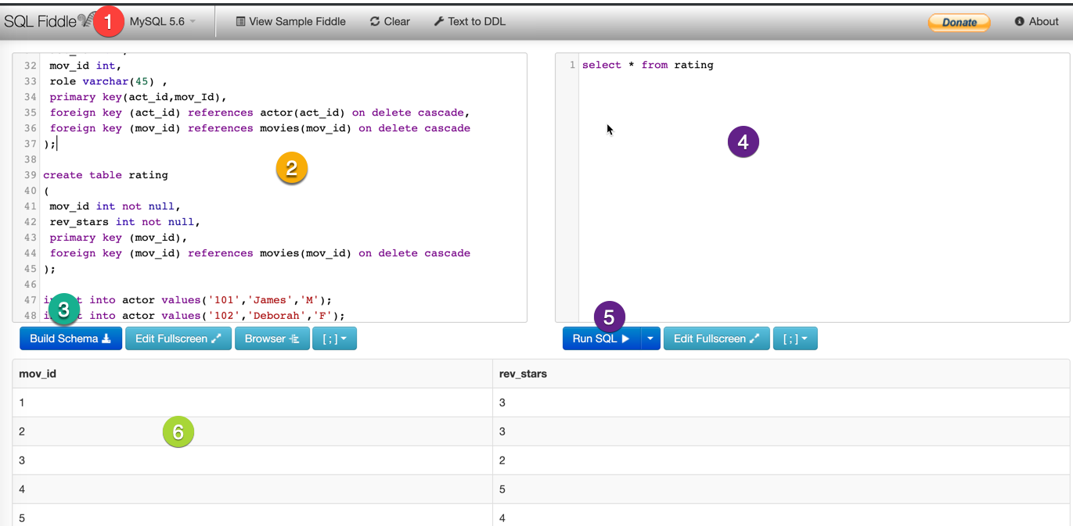
* images

1. Select MySQL from dropdown.
2. Copy contents from script.sql file in Database_Script folder, and paste into left side window.
3. click on Build schema, it will create database.
4. write your sql query
5. click on Run SQL
6. query output window

## Practice Challenges

* [Hackerrank](https://www.hackerrank.com/)
* [LeetCode](https://leetcode.com/)

## SQL Formatter

* We read more code then we write in our life time. Always [format](http://www.dpriver.com/pp/sqlformat.htm) sql code for better readbility

## Regarding Notes

* Prefer always taking notes use any mobile or desktop application. I prefer using [bear](https://bear.app/) application.

## Sample database

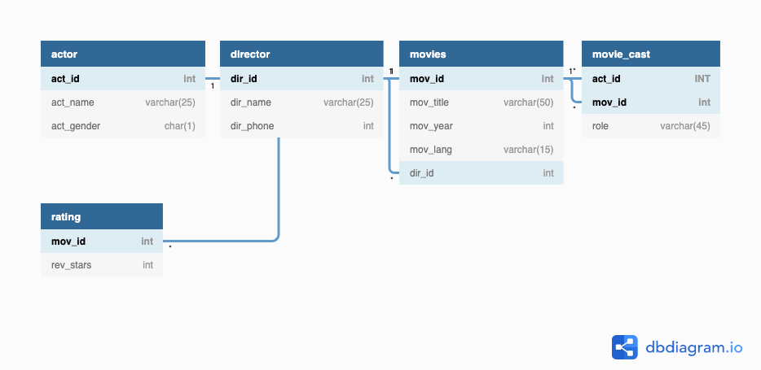

Sample

## Practice Queries

* [Queries](queries.md)