‘ General points to remember:
make sure to know the version of angular
AARYAN MITTAL
SQL: The language used to manage databases.
MySQL: A software system (RDBMS) that uses SQL to manage database operations.
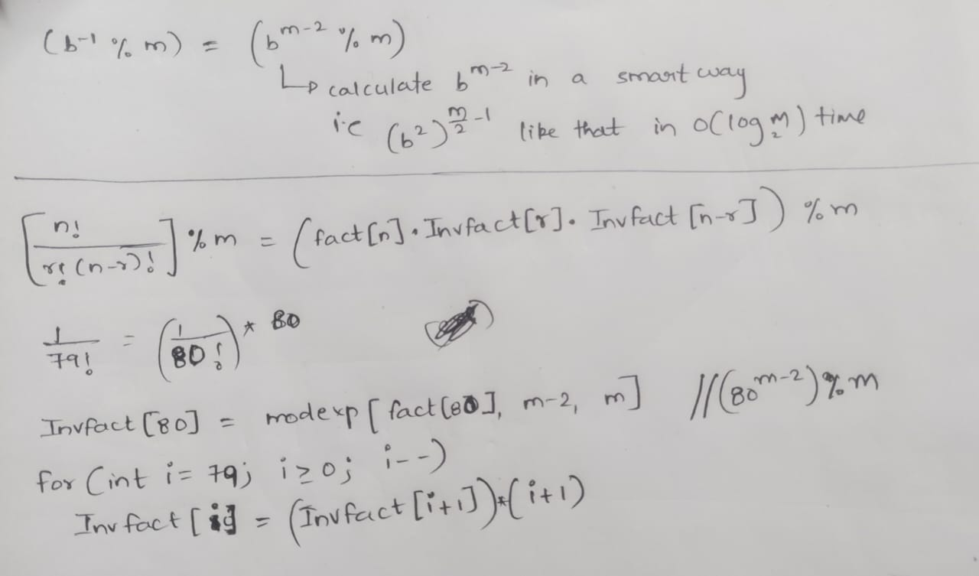
learn to take string with spaces as input
string str;
getline(cin, str);
(all small letters)
A stringstream is a stream in which you can insert data in it and extract data from it like extracting from cin.
A stringstream lets you:
insert data into the stream
Extract data from the stream
//inserting data into the stream s
string data = “kjkhg,khgcvhj*kjhgv,KJHG”
stringstream s(data);

//extract data from the stream
string str;
getline(s, str); //extract data upto first “\n”

string str;
getline(s, str, ','); //extract data that is there upto first comma

SUBSET SUM = check whether the sum is possible or not dp[i][sum]
PERFECT SUM = no of ways to get that subset sum dp[i][sum]
COIN CHANGE = min no of coins to make that sum (we can take a coin any no of times) dp[i][sum]
0-1 KNAPSACK = maximum profit by selecting a particular subset dp[i][w]
DP graphs trees heaps
stacksqueues searching and sorting
arrays strings
linkedlists
Bitmanipulation greedy

In Myprojecs:
In all implementations make use of size variable
Implement stack using array
initially top is at -1 and no edge cases involved
Implement queue using array
initially front=-1, back=-1 and take care when size=0 i.e updating front and back to -1
Implement stack using LL (single)
newly created node will be pointed to last node and update the top
Implement queue using LL (single)
take front, back pointers and at each push last node will be pointing to newly created node
Implement stack using queue
Implement queue using stack
Implement LRU cache:
Do proper initialization of LRUCache you usually forget (head->next = tail) and (tail->prev = next)
Don’t forget to update the size
Heapsort:
BinaryHeap implementation:

While explaining an intuition, try to take example like below(Eg: d1, d2, d3, d4) instead of explaining broadly.
https://leetcode.com/problems/sum-of-two-integers/discuss/84278/A-summary%3A-how-to-use-bit-manipulation-to-solve-problems-easily-and-efficiently
When any undirected graph with no cycle is given we can calculate the shortest path using toposort stack…
(toposort and then relaxing edges)
And its time complexity is O(V+E) (V elements inside the stack and sum of degrees of each element is E)
Never ever think of this process for undirected graph because in it an edge itself is a cycle
So in order to deal with the graphs containing cycles(that too +ve cycles and for -ve cycles shortest path itself is not defined) Dijkstra algorithm is invented.
Dijkstra:
In it we simply traverse all the possible paths in the graph, using BFS traversal(without any visited array becoz a node has to be visited for multiple times as it involves in multiple paths)
So so lets consider our graph contains a cycle, by following the above process ie generating all the paths… the traversal never terminates.
So we will keep a constraint here i.e if(path_value + edgeweight < dist[adj_node]) then only we will add this new path inside the queue. By this, cycle traversal will terminate after one cycle becoz path involving second cycle is obviously large.
By doing upto this, shortest paths can be calculated. But we want to still optimize the time, so we replace queue with a priority queue.
Dijkstra:
The basic method to find the shortest distance is:
1.Initialize a distance array with each element as infinity, where each element corresponds to a node
2.From the source node apply BFS(without a visited array becoz that particular node will be part of multiple paths so there is a need of visiting it multiple times) we and generate all possible paths staring from the source node.
3.In the above process, we will consider and add a path into the queue, only when the distance of the path obtained is less than the dist[node](current minimum distance of the node from the source). Becoz becoz already some path upto this node is existing with some lesser distance value so why to consider this….

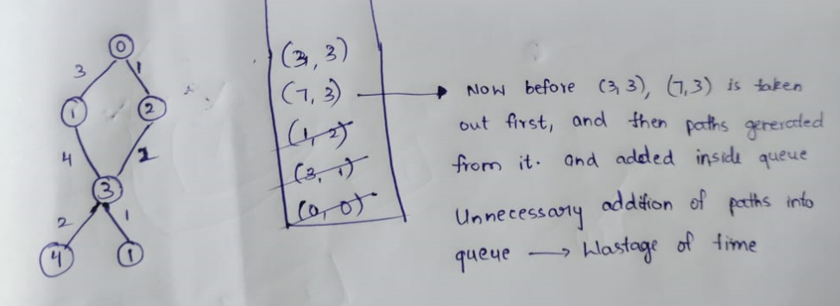
So if we use priority queue, then we can neglet generation of unnecessary paths up to some extent.
There we will first generate children of (3,3) first and then they are added into the priority queue.
After that immediate children of (7,3) are also generated but not added inside priority queue.
Kind of greedy….
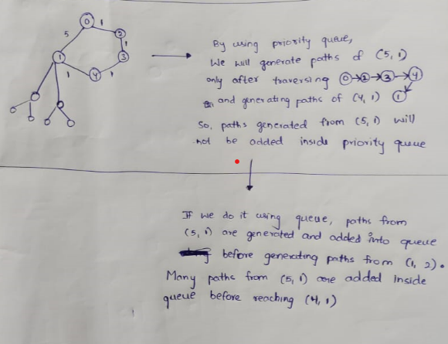
Lets consider our source node is 0 and its one of the neighbours is 1 at a distance of 5units.
There is also another path from 0 to 1 with a distance less than 5units.
If we don’t use priority queue, before traversing the another optimal path, many paths generated from 0->1(5units) are already added inside queue which are unnecessary
For actual dijkstra algorithm having O(V^2) time complexity, for graph with negative edges also we will get wrong outputs
You may get doubt that why Dijkstra time complexity(ElogV) greater than normal BFS(V+E) becoz in normal BFS we maintain a visited array so that we will never visit a node twice. But in Dijkstra, in the process of generating paths we should not maintain visited array becoz here a node may be visited for multiple times
Another tip is that, the shortest path for a particular node from the source node will be popped first from the pq. After this only longer paths for that node will pop out. You can sense it right?? As all edges are +ve, elements popping out are in increasing order.
Consider a question like shortest path in a binary maze…. There we wont use a priority queue, just using a queue is enough and that’s ok becoz the main use of pq is to pop minimum element each time and here we are sure that minimum will always be at front.. Its completely fine but how can its time complexity is O(V+E)??? How are you so sure that a node cannot be added twice which is generally done sometimes in Dijkstra…
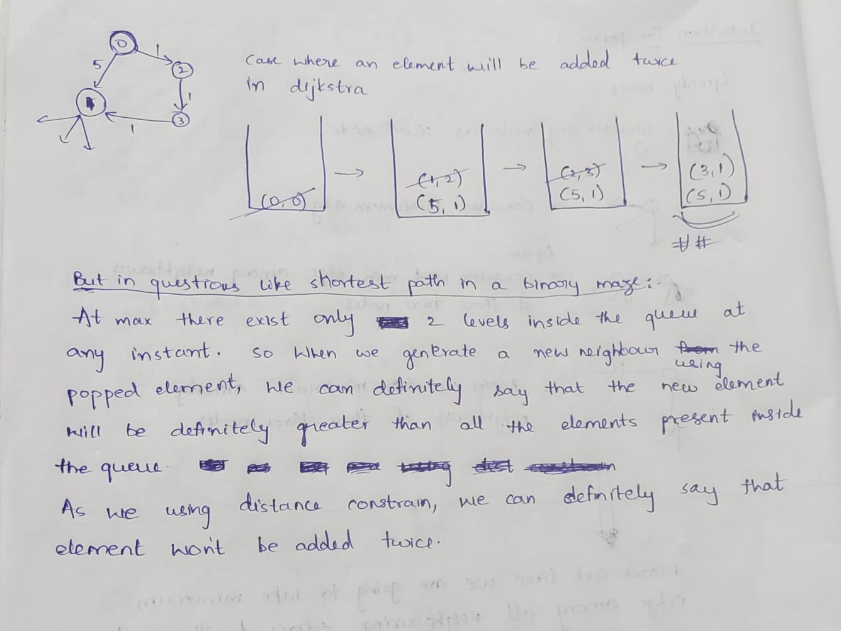

TimeComplexity of Dijkstra and Prims:
For prims algorithm its around ElogE

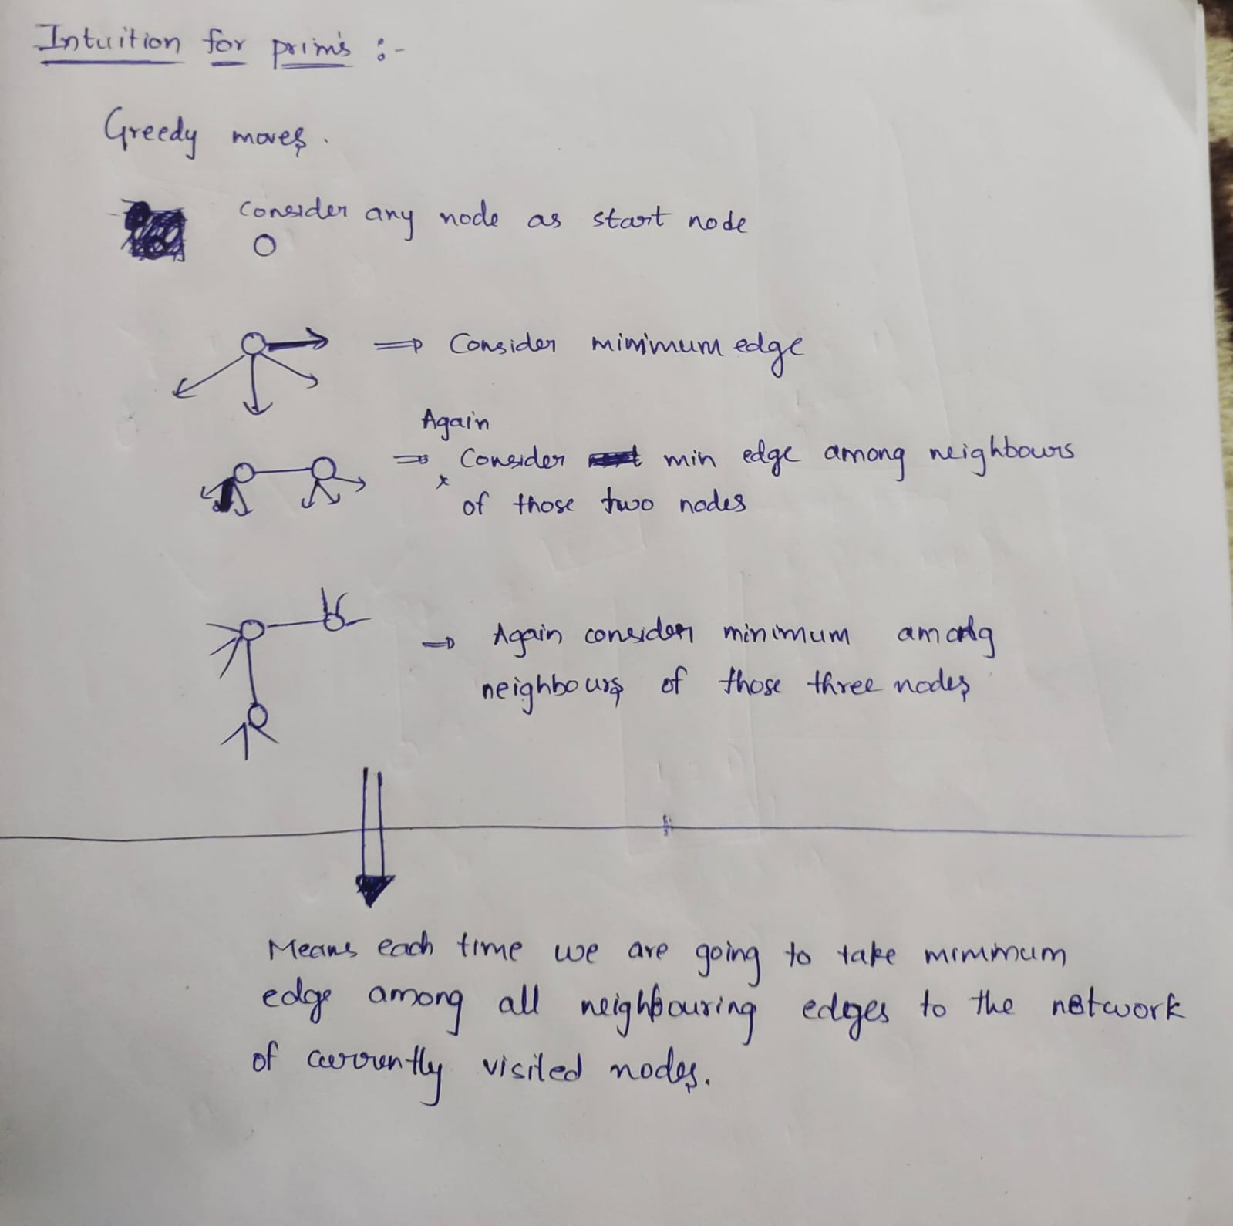
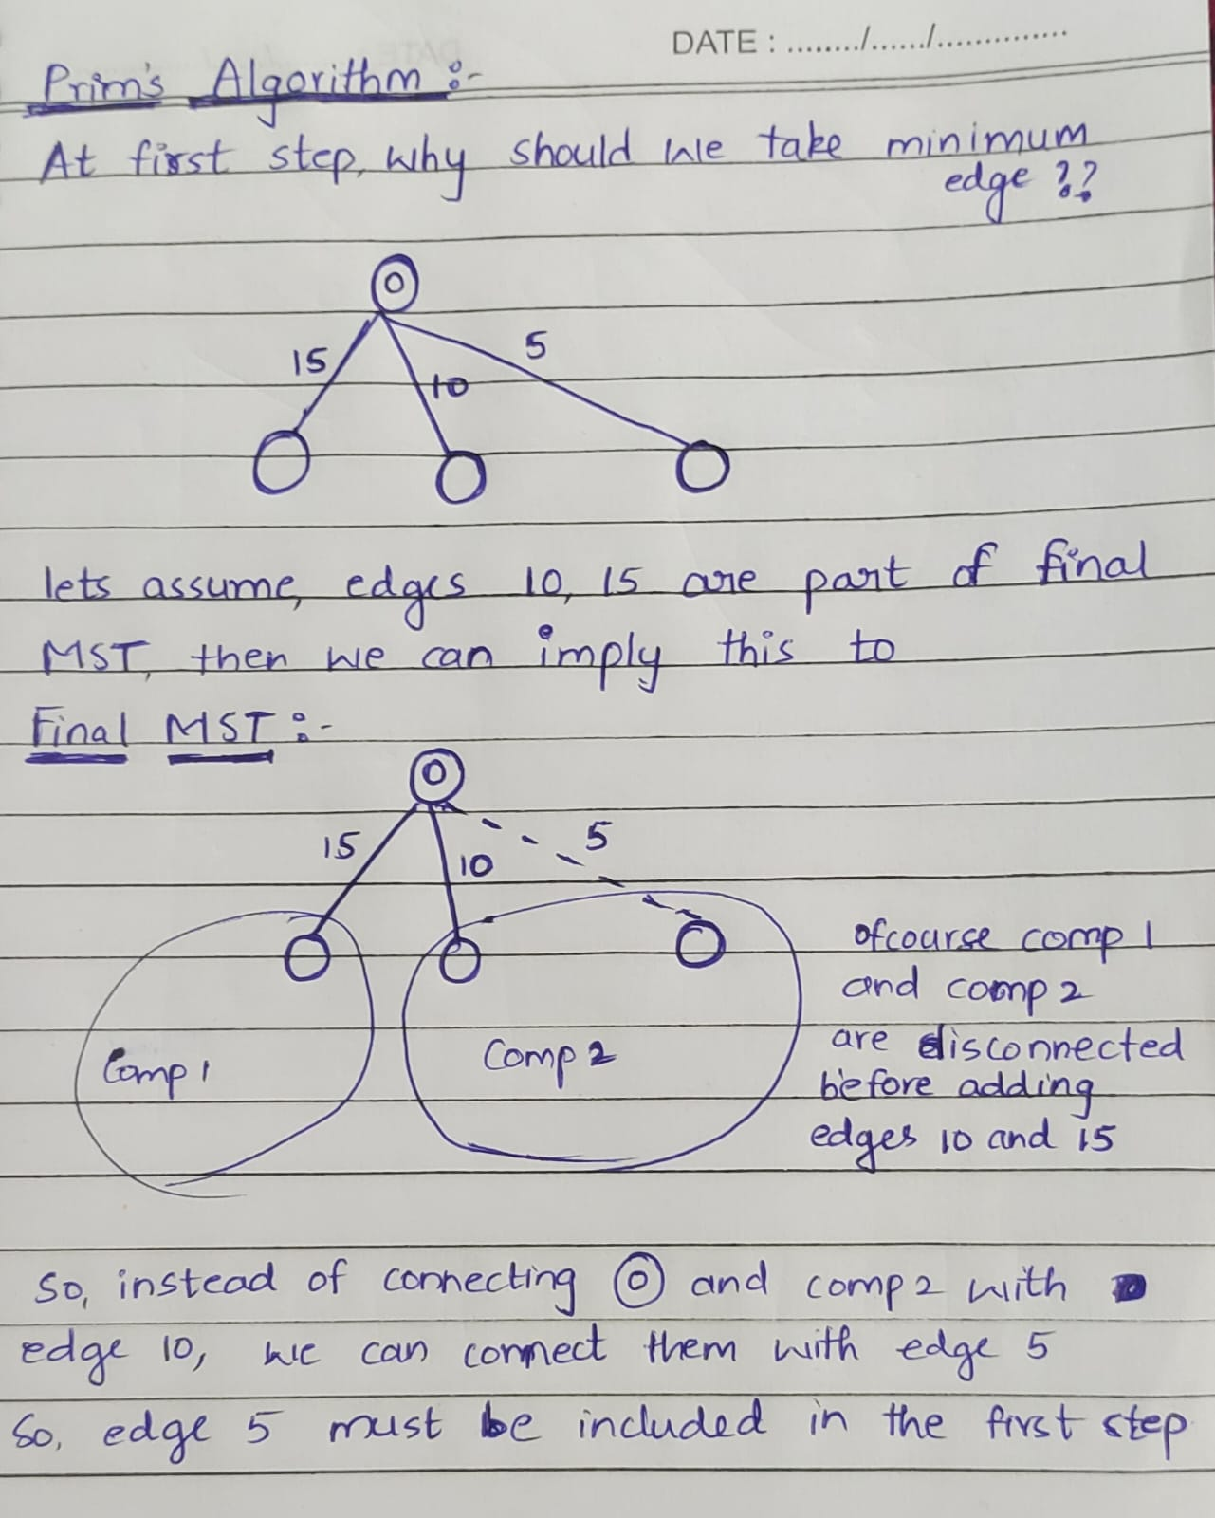

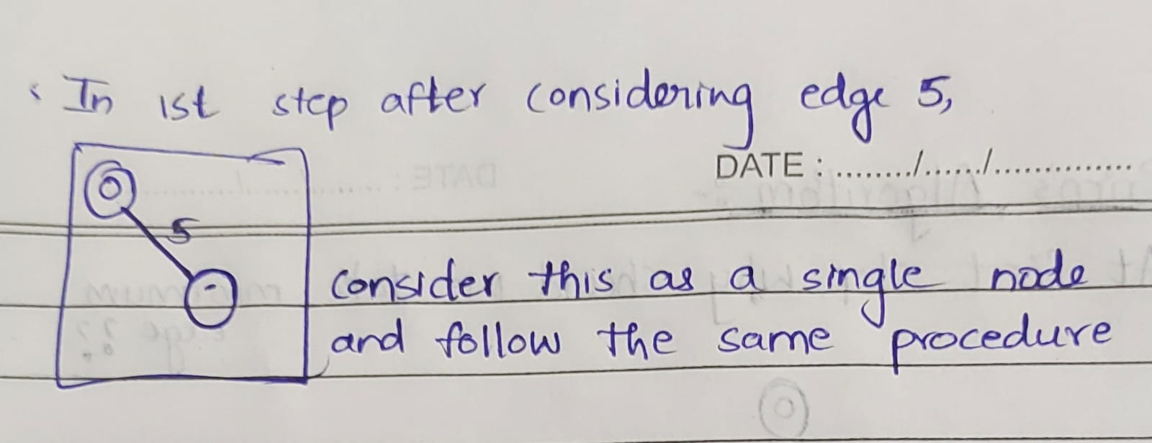
DSU:
Generally used for dynamic graphs
By using this, we can say given 2 nodes belongs to same component or not in O(constant) time.
Union(u,v) = Combines the component containing u and component containing v by joining their ultimate parents
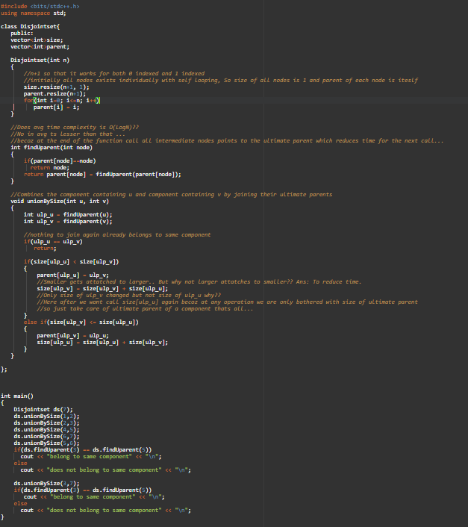
Output:
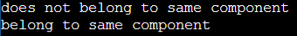

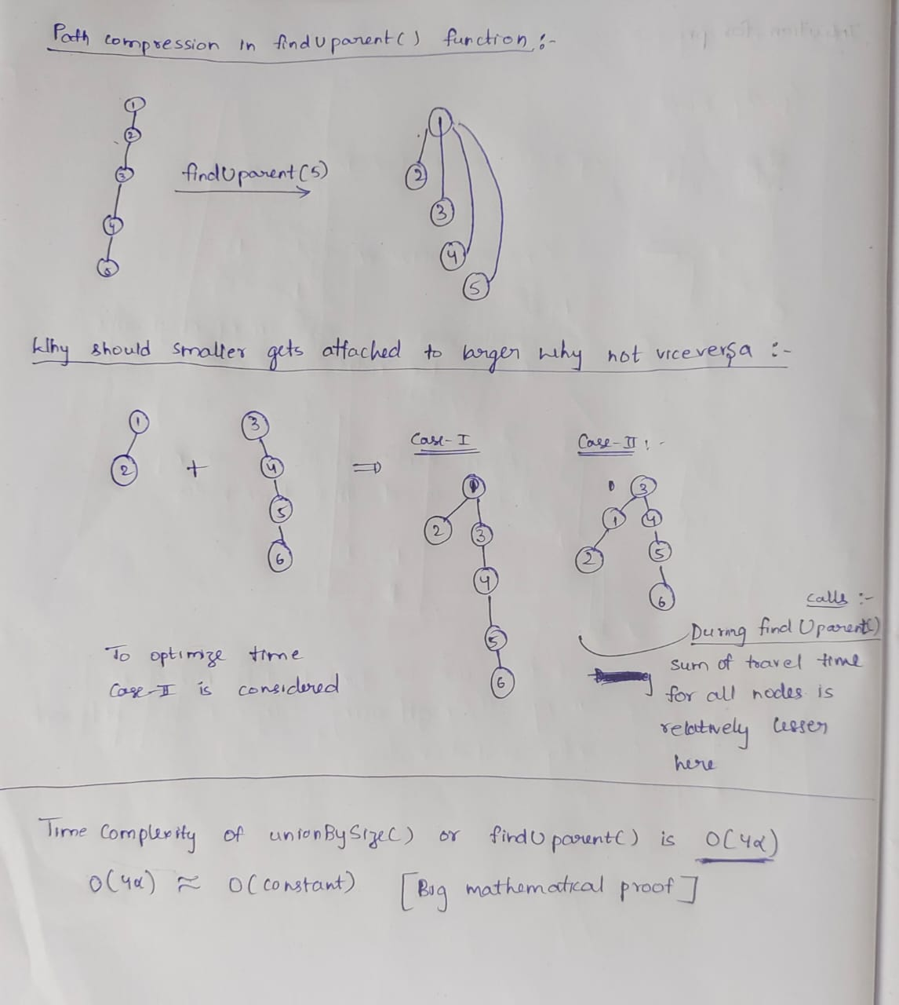

Implementation of a map:
hashmap is array of linked lists …..
elements in each linked list is nodes i.e {key, value}
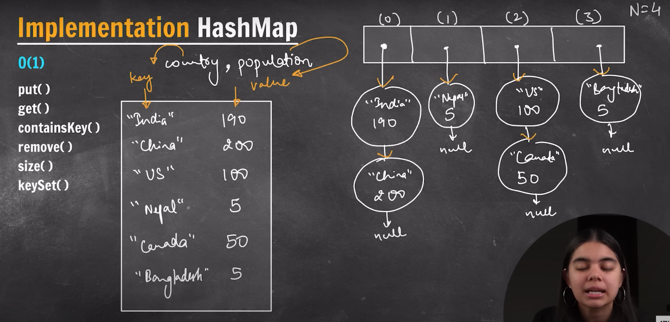
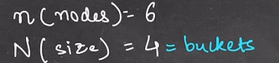

hash function convert key to bucket_index :
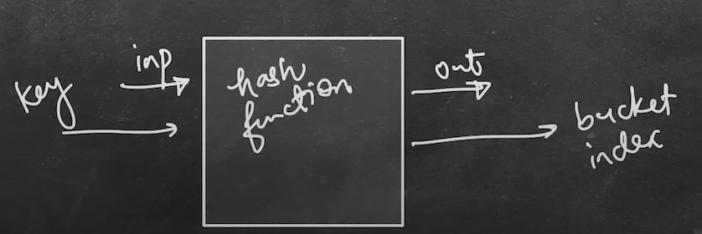

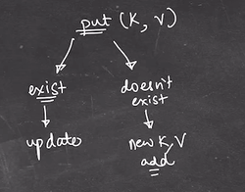
So when we want to add a new element inside the map, firstly
a) Hash function will give the bucket index
b)There is a linked list present inside the bucket. We have to search whether this key present in that LL or not.
c)If present, then its value is updated otherwise new node is added in that LL
Rehashing:
Time Complexity of put() is O(size of LL) = O(n/N) where n = totalnodes , N = no of buckets if we assume that hash Hash function works in such a way that nodes are spread evenly inside buckets
Worst case time complexity is O(n) where all nodes stored in single ll
Lamda = n/N
We will define a threshold value for Lamda such that time complexity O(Lamda) wont become more
Lets say when we add a new node so that n value increased thereby Lamda value crosses its threshold value.
Then rehashing takes place.
In rehashing, N becomes 2*N ie no of buckets are doubled
ie our array is resized as 2*N and elements inside the older array added inside the new array using hash function.
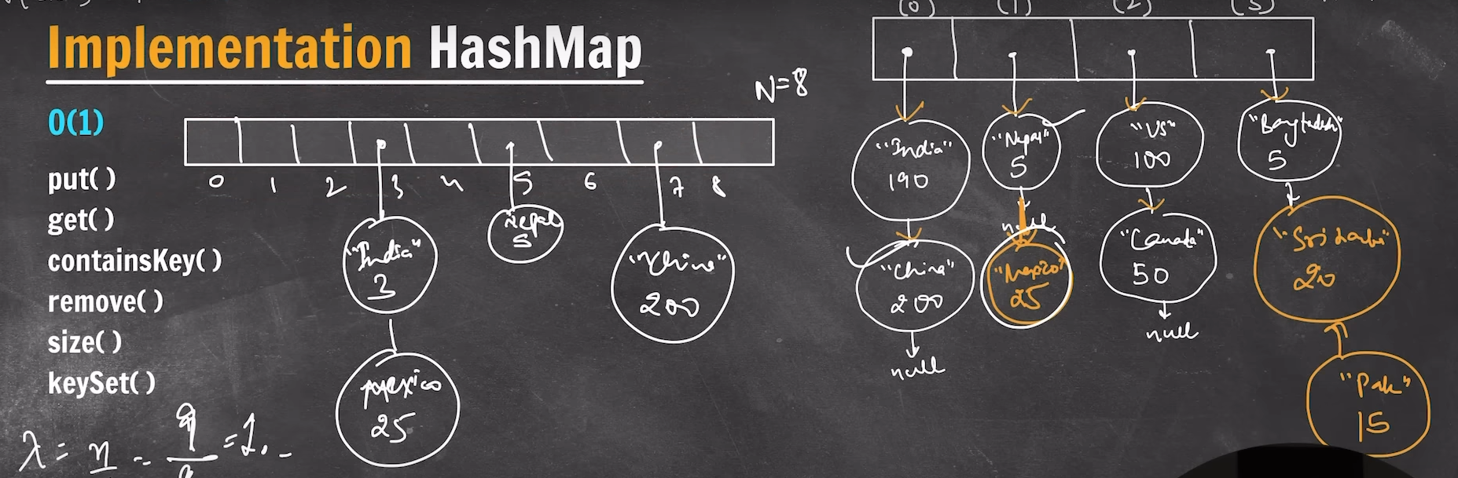
in unordered map, acceptable datatypes of key is limited i.e int, char, double, string etc…
but no pair, vector
Whenever you wanna declare a hash array for characters, make its size as 256 for safe i.e
int hash[256];

Refer the code in MyProjects of online C++ compiler

Char = 1
short = 2
int = 4
long = 4
long long = 8

float = 4
double = 8
long double = 16

Mode = 3median - 2mean

Selection sort – all cases O(n^2)
bubble sort – best case O(n) in sorted array i.e in a particular iteration if there are no swaps occurred then flag says that we can stop the process now
Insertion sort – best case O(n) in sorted array
Merge sort – O(nlogn) in all cases
Quick sort worst case - sorted, reverse sorted, equal
Best case : 1326574

How numbers stored in bits?
if positive – sign bit 0, remaining is its normal binary format
if negative – sign bit 1, remaining is its binary 2’s complement.
sign bit is always MSB(32nd bit)
Array vs ll:
Array - fixed size and contiguous
ll - variable size and non continuous
So memory usage - array best, to increase the size ll best
Update or random access - array best
Add node or delete node - ll best

ls -l = distinguishes files and directories in a long listing format
ls -a = shows all files including hidden files(those start with a . )

ls
cd
pwd
mkdir
rmdir
cp - copy information from file to file
mv - rename files
rm - remove file in the directory
ps - check active process in the terminal
man - user manual of any command
grep

Learn some linux commands

Working inside a map

