This week I learned: what an IP is, how ping works, how DNS resolves domains
Below is the result:
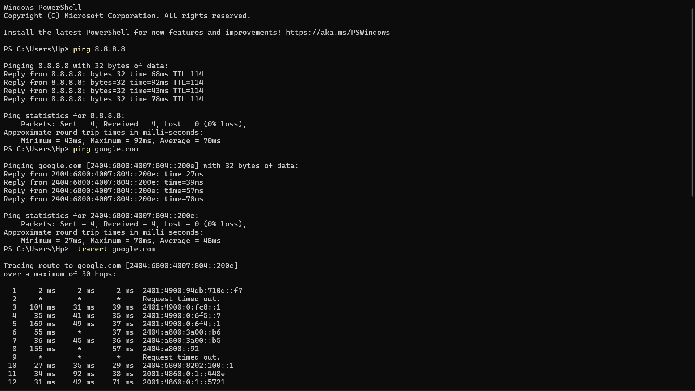
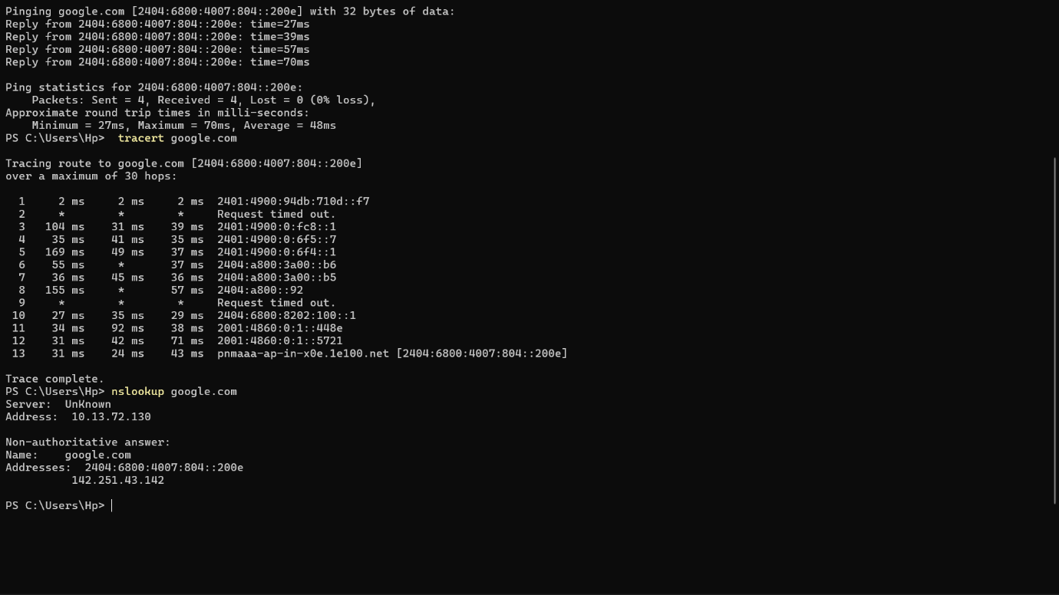

Example command outputs:
1. ping google.com
2.tracert google.com
3.nslookup google.com

