# Week 03 – Linux filesystem and basic commands

## 1. Goal

By the end of Week 3 my goal was to be comfortable moving around a Linux system from the terminal and to understand what the core commands do. This is important for future SOC/DFIR work where almost everything happens on the command line.

## 2. What I worked on (technical)

- Learned the basic Linux filesystem layout: `/`, `/home`, `/var`, `/etc`, `/tmp` etc.
- Practiced navigation and file operations with: `ls`, `cd`, `pwd`, `mkdir`, `rm`, `cp`, `mv`.
- Practiced viewing and searching inside files with: `cat`, `less`, `grep`, `find`.
- Built my own Linux Command Cheat Sheet with name, syntax, example and use‑case for each command.

## 3. Labs and exercises I did

### 3.1 Navigation and directories

- Used `whoami` to check the current user.
- Used `cd ~` to go to my home directory and `ls` to list contents.
- Navigated into `Desktop` with `cd Desktop` and confirmed my path with `pwd` (`/home/kali/Desktop`).
- Ran `ls -la` to see detailed listing, including permissions and hidden files.
- Created a new directory called `test` on Desktop using `mkdir test`, then moved into it with `cd test`.

### 3.2 Creating and removing files

- On the Desktop, created an empty file with:
- `touch text.txt`
- Opened and edited the file with `nano text.txt` and added some sample text like “hi” and “hello”.
- Removed the file with:
- `rm text.txt`

### 3.3 Searching inside files with grep

- Re‑created `text.txt` using `touch text.txt`.
- Added test content (e.g., containing "hi" and "hello") using `nano`.
- Searched for specific words in the file:
- `grep "hi" text.txt`
- `grep "hello" text.txt`
- Verified that `grep` only printed the lines where the pattern matched (for example, it printed `hello` when searching for `"hello"`).

### 3.4 Finding files with find

- Used `find` to locate my test file by name starting from the root filesystem:
- `find / -name "text.txt" 2>/dev/null`
- Observed that it not only found the file on my Desktop:
- `/home/kali/Desktop/text.txt`
but also, other `text.txt` files inside Python/Django library directories.
- The `2>/dev/null` part hid “Permission denied” errors from protected directories.

## 4. Linux command cheat sheet

I created a separate cheat sheet (`Linux-Command-Cheat-Sheet.pdf`) where, for each command, I wrote:

- Name
- Syntax
- Example
- Use‑case

The current version covers:

- `ls`, `cd`, `pwd`, `cat`, `less`, `grep`, `find`, `chmod`, `chown`, `ps` / `top`.

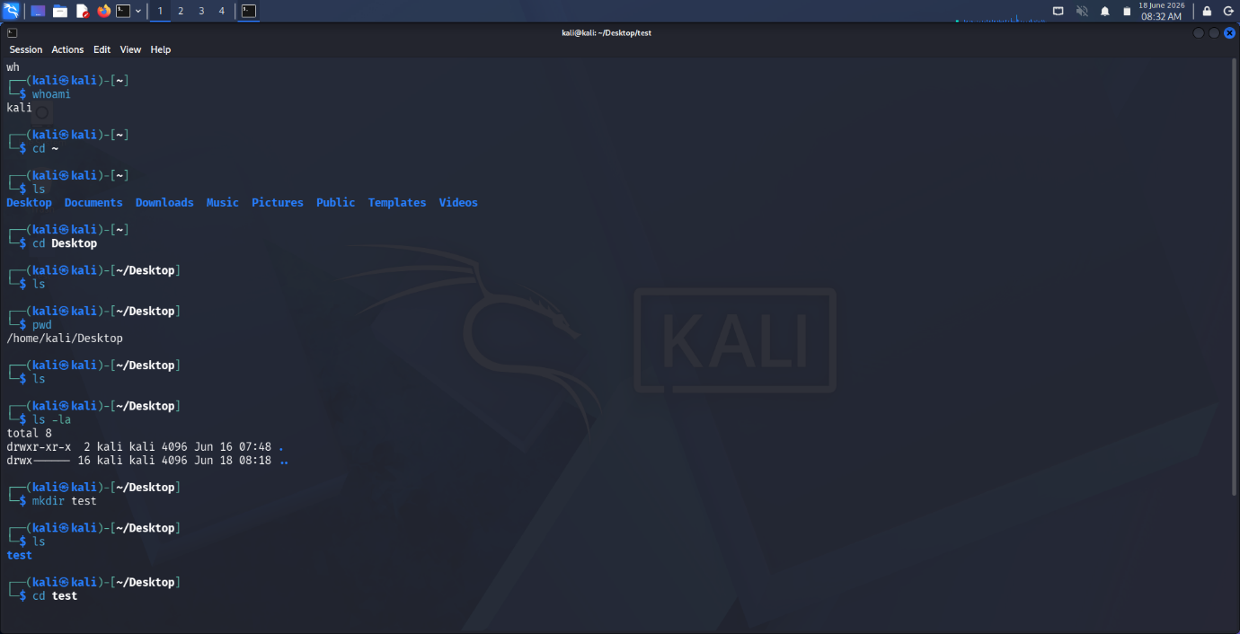
## 5. Proof of work
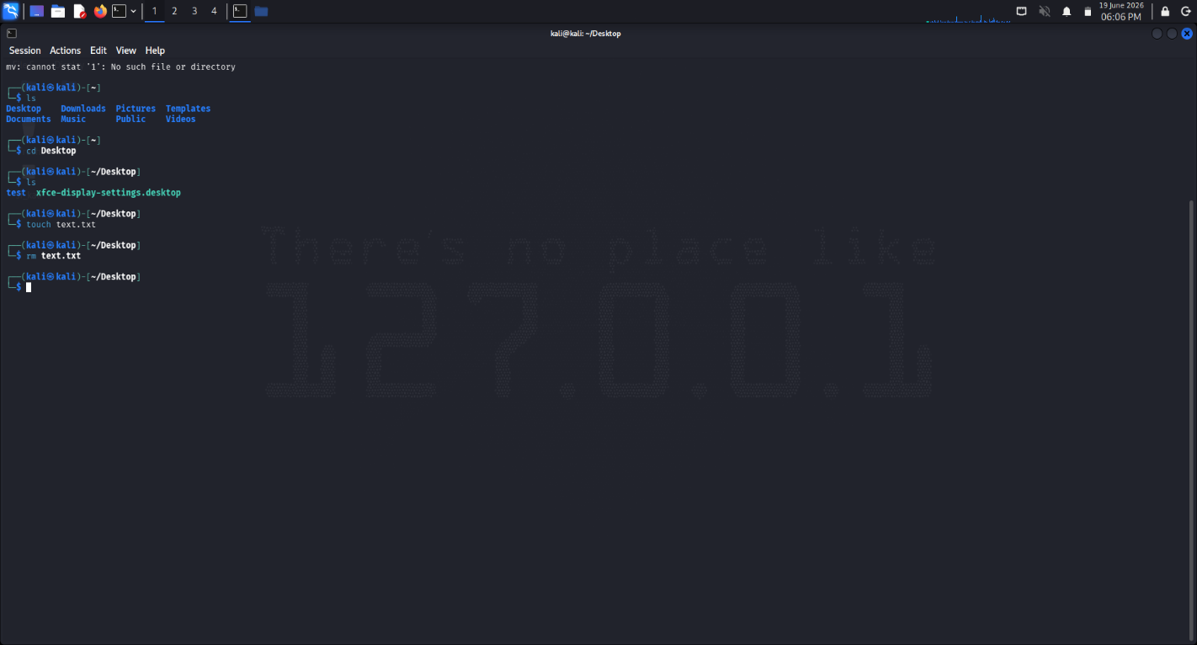

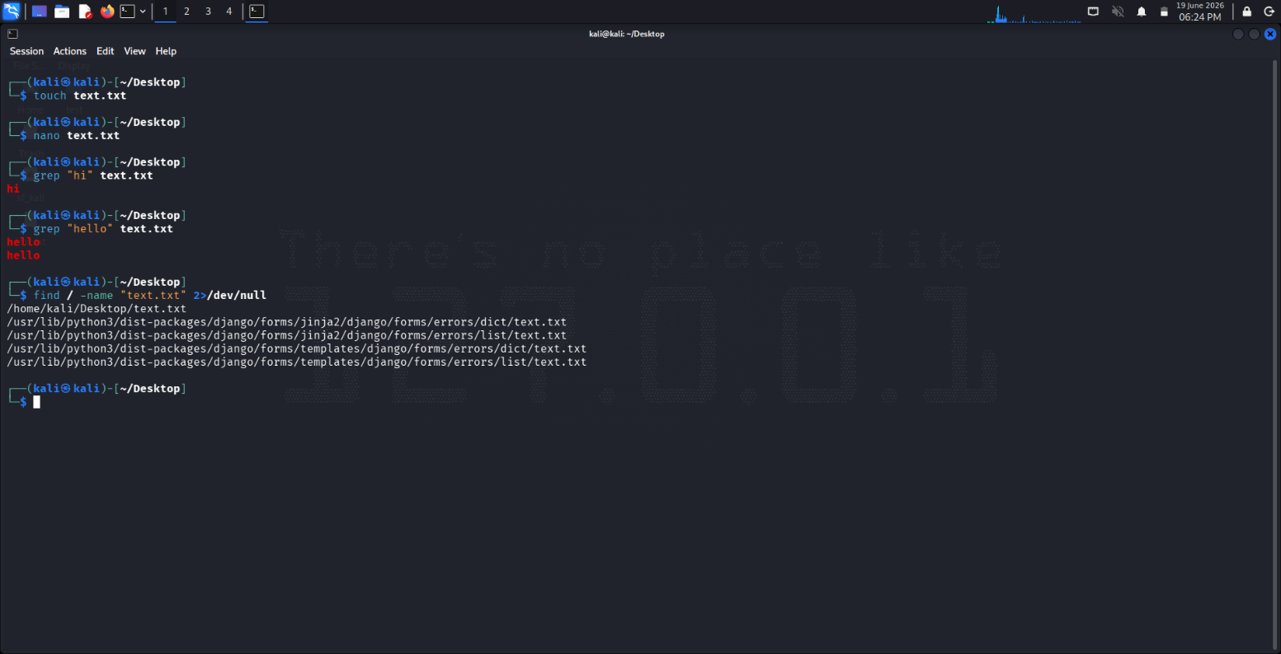

## 6. Summary

In Week 3 I built the basic muscle memory for moving around Linux and working with files and text from the terminal. I also created my own cheat sheet so I don’t have to Google every basic command and can build speed for future SOC and Cloud Security labs.

