Assignment 2 (15M)
The following image is distorted due to the atmospheric turbulence:
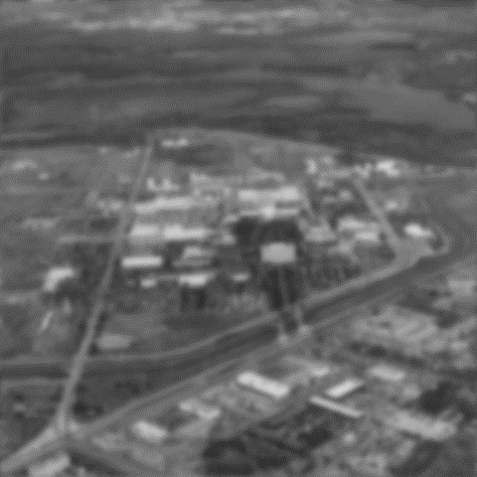
It is determined experimentally that the distortion can be modeled by Gaussian function. Apply inverse filtering method to restore the image using MATLAB.
Provide MATLAB code with comments after each line of code. A sample code is provided below: [10]
Sample MATLAB Code:
clear all;
f1 = imread ('autumn.tif'); % reads an image and stores in f1
f2 = rgb2gray(f1); %converts the image f1 into grayscale image f2
imshow(f1), title ('Original RGB'); %displays the image f1 with a given title

NOTE:
- The assignment should be neatly submitted on A4 sheets only, clearly mentioning Name and ID No. .
- Submit the screen shots for the results as obtained from MATLAB and attach it into the main submission report.
- Submit MATLAB codes at the last page of the report.

Instructor in charge

