**ScreenShot:**

**This will display after running in localhost 2 links given one to submit feedback to database another one is to see all feedback submitted**

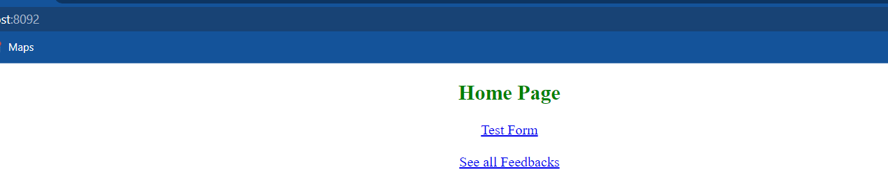

**After clicking test form link this will display**

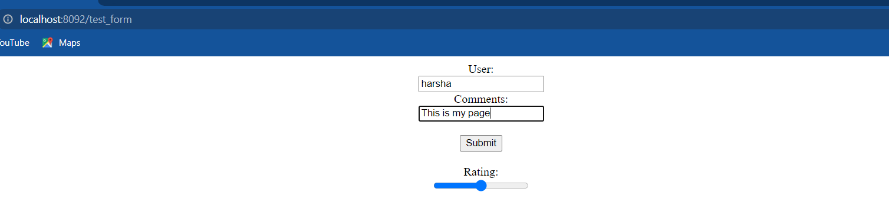

**After clicking submit above this will display and it added to database.**

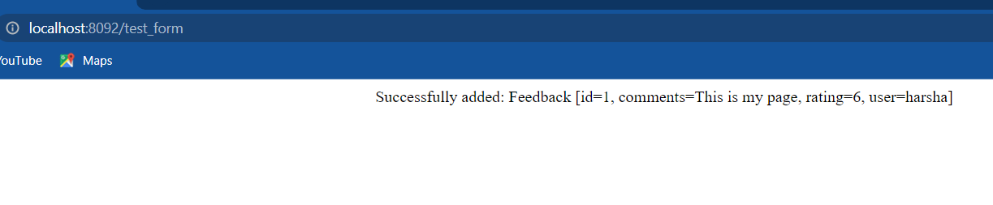

**If we see click second link**



**Here we can confirms the feedback that are stored are displayed.**

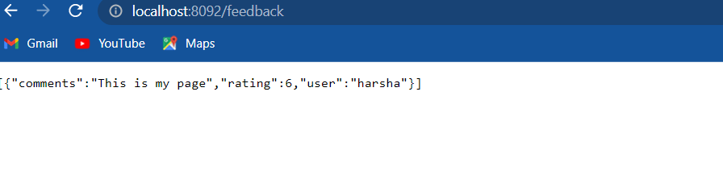

**If you want to enter another set of data.**

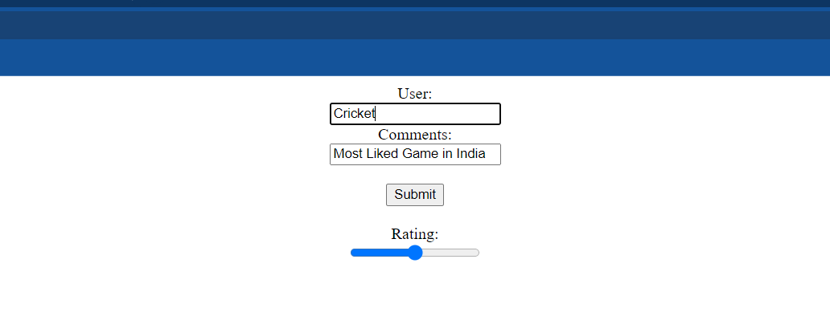

**After clicking submit above this will display and it added to database.**

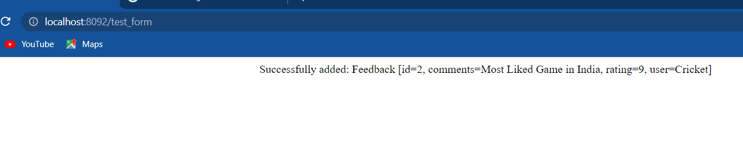

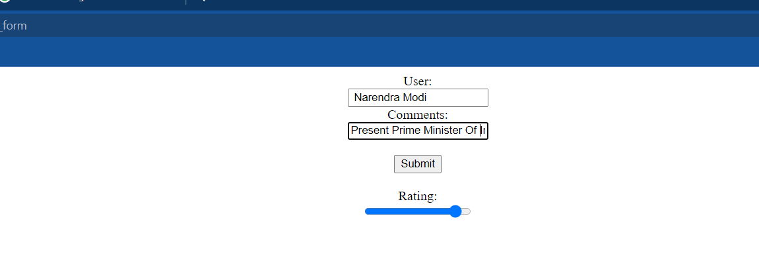

**After clicking submit above this will display and it added to database.**

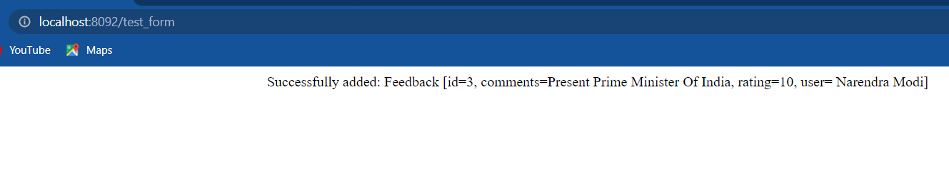

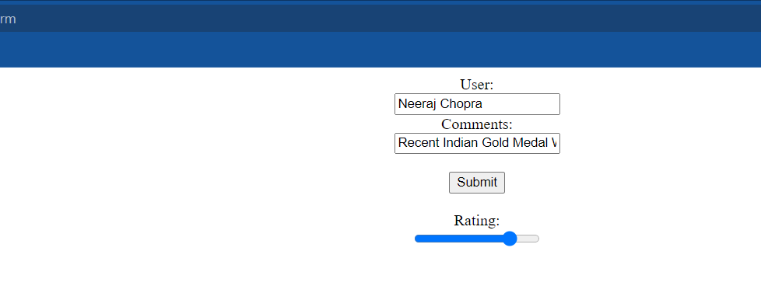

**After clicking submit above this will display and it added to database.**

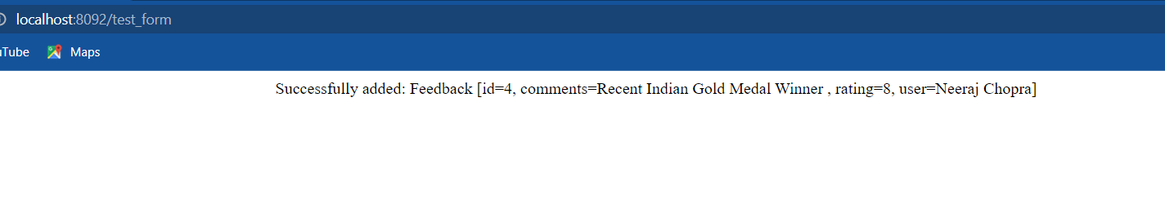

**We can see here in database.**

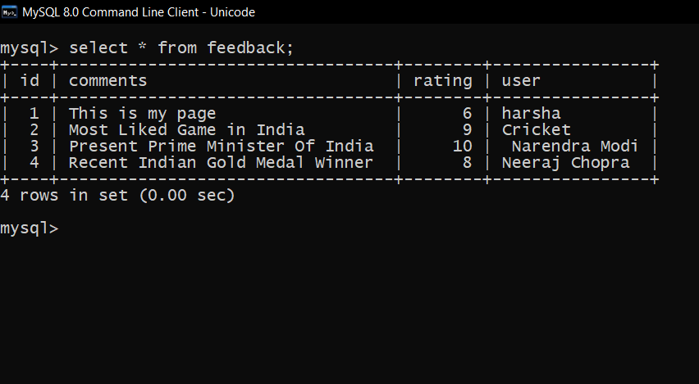



**Here we can confirms the feedback that are stored are displayed.**

